Capstone Project
EN.535.762.81.SP26
Dimitri Medina

1. Introduction
Aerobraking has been investigated as a viable maneuver in spacecraft trajectory design for a few decades now [1]. Essentially, it is the usage of a planet’s atmosphere to apply drag and lift onto a spacecraft’s body in order to slow its movement and adjust its orbit. This project follows a simplified 2D aerobraking maneuver that minimizes fuel costs to transfer from a large circular orbit to a smaller circular orbit around the Earth. This is done by performing an injection burn that puts the spacecraft onto an elliptical orbit that will interact with Earth’s atmosphere, and then performing an additional recircularization burn, as shown in Figure 1.
Phase 1
Phase 2
Phase 3

Figure 1: Aerobraking Trajectory for optimal control problem
The scope of this project will be mainly concerned with phase 2. By controlling the angle of attack during atmospheric flight, the spacecraft will exit the atmosphere with a velocity that is different from its incoming orbit. The new orbit should have an apogee at the height of the final circular orbit.
The vehicle in this problem will be modeled after an experimental high L/D delta-wing vehicle [1, 2]. It will be able to operate both in and out of the Earth’s atmosphere, as well as handle hypersonic conditions. Due to the scope of this project, an idealized version of the vehicle will be utilized, and will be represented as a point-mass system.
The goal of this paper is to study the optimal trajectory of a spacecraft to minimize heating during phase 2, atmospheric flight, and its feasibility when implemented in a closed-loop GNC simulation. The optimal solution and control scheme will be developed using ICLOCS2, an open-source optimal control software. This optimal control and trajectory will be then implemented in a closed-loop simulation of the spacecraft. The simulation will include control architecture, modeling of real-life sensors, and an Extended Kalman Filter (EKF). Finally, the closed-loop results from the simulation and the optimal solution will be compared to see if the implementation works.

2. Dynamics Modeling
2.1 Equations of Motion and Assumptions
During atmospheric flight, the vehicle will be under the influence of drag, lift, and gravity. Therefore, the dynamics of the system will be defined by the following equations.

$$\begin{aligned}\dot{r}=v\sin{γ}\#\left(1\right)\end{aligned}$$
$$\begin{aligned}\dot{v}=-\frac{ρv^{2}S}{2m}C_{D}-\frac{μ}{{(r+R_{E})}^{2}}\sin{γ}\#\left(2\right)\end{aligned}$$
$$\begin{aligned}\dot{γ}=\frac{1}{v}\left[-\frac{ρv^{2}S}{2m}C_{L}-\left[\frac{μ}{{(r+R_{E})}^{2}}-\frac{v^{2}}{r}\right]\cos{γ}\right]\#\left(3\right)\end{aligned}$$
Where $r$ is the altitude in km, $v$ is the velocity of the spacecraft in km/s, and $γ$ is the flight-path angle in rad. These are the states that will be observed. The control for this problem will be the angle of attack of the vehicle during atmospheric flight

$$\begin{aligned}u=α\#\left(4\right)\end{aligned}$$

Where $α$ is in rad. To make this a 2D problem, the assumptions are that the bank, latitude, and heading angle are all zero in this problem. This means that in this scenario, the vehicle is constrained on a coplanar trajectory and restricted to the equatorial plane. The Earth will be represented as a spherical non-moving object. This paper will be using the Earth-centered, Earth-fixed coordinate system, better known as the geocentric coordinate system.

2.2 Aerodynamic Model
For the purposes of analyzing an aero-assisted maneuver, this paper will be using an experimental high L/D delta-wing vehicle. The spacecraft will be modeled as a point-mass system, which will simplify the aerodynamic equations to

$$\begin{aligned} C_{L}=C_{Lα}u, C_{D}=C_{D0}+KC_{L}^{2}\#\left(5\right)\end{aligned}$$

Where $C_{L}$ is the coefficient of lift, and $C_{D}$ is the coefficient of drag. When the spacecraft interacts with the atmosphere, the density $ρ$ will follow a standard exponential model

$$\begin{aligned}ρ=ρ_{0}\exp{(-βh)}\#\left(6\right)\end{aligned}$$

Where $h=r-R_{e}$. The physical model of the high L/D delta-wing vehicle and the numerical values of all constants are shown in Table. 1. which were derived from Ref. 1

Table 1: Aerodynamic data, vehicle data, and sensor data of AOTV problem
Quantity |  |  | Numerical Value
$$R_{e}$$ | Radius of Earth |  | 6378400 m
$$μ$$ | Gravitational parameter |  | 3.9897$×{10}^{12}$ m³/s²
$$S$$ | Vehicle reference area |  | 11.69 m²
$$C_{D0}$$ | Zero-lift coefficient of drag |  | 0.032
$$K$$ | Drag polar parameter |  | 1.4
$$C_{L,α}$$ | Derivative of $C_{L}$ with respect of $α$ |  | 0.5699
$$C_{L,max}$$ | Maximum coefficient of lift |  | 0.6
$$h_{atm}$$ | Altitude of sensible atmosphere |  | 129600 m
$$I_{sp}$$ | Specific impulse |  | 310 s
$$\hat{\dot{Q}}$$ | Heating rate constant |  | 19987.44 W/ m²
$$ρ_{0}$$ | Standard atmospheric pressure |  | 1.225 kg/m³
$${\dot{Q}}_{\max{ }}$$ | Maximum instantaneous heat flux |  | 1 W/ m²
$$\frac{1}{β}$$ |  |  | 7.200 km
$$σ_{FPA}$$ | Flight Path Angle sensor noise |  | $±$0.1$°$
$$σ_{η_{gps,r}}$$ | GPS Gauss-Markov noise parameter for altitude |  | $±$0.004 km
$$σ_{η_{gps,v}}$$ | GPS Gauss-Markov noise parameter for speed |  | $±$0.001 km
$$σ_{bias_{GPS,r}}$$ | GPS Gauss-Markov bias parameter |  | 0.092 km
$$∆t_{GPS}$$ | GPS Sampling time |  | 10 s
$$τ_{FPA}$$ | Flight Path Angle sensor time constant |  | 1100 s
$$τ_{GPS}$$ | GPS time constant |  | 0.2 s

3. Optimal Control Problem
3.1. Problem Formulation
The goal is to determine the optimal trajectory during atmospheric flight that can transfer a small spacecraft between two highly elliptical low-medium Earth orbits. The trajectory sequence will be as follows:
1) the spacecraft lies along an elliptical orbit in exo-atmospheric flight
2) the spacecraft enters atmospheric flight
3) the spacecraft exits atmospheric flight onto a new elliptical orbit
This process is visualized in phase 2 of Figure 1. During this time, the spacecraft will experience high levels of heating due to speeds when traveling through Earth’s atmosphere at hypersonic speeds. Therefore, the optimal control problem is to determine the trajectory $\left[r\left(t\right),v\left(t\right),γ\left(t\right)\right]$ and the control $\left[u(t)\right]$, that minimizes the following cost functional

$$\begin{aligned}J=q_{U}\#\left(7\right)\end{aligned}$$

Subject to the dynamic and path constraints listed below.

3.2. Initial and Terminal Conditions
The initial and terminal conditions will be applied as equality constraints. The height of the “sensible atmosphere” will be 129.6 km and will be the initial and terminal condition for the position $r$. The speeds at which the spacecraft enters and exits the atmosphere will be based off the initial and desired elliptical orbit respectively. The initial elliptical orbit is the path the spacecraft takes after the first burn. This paper will assume that the spacecraft’s initial elliptical orbit is defined by the following orbital elements

$$\begin{aligned}a\left(t_{0}\right)=R_{e}+1547 km, Ω\left(t_{0}\right)=0, \\ ω\left(t_{0}\right)=0 , ν\left(t_{0}\right)=230.31°, i\left(t_{0}\right)= 0 \\ e\left(t_{0}\right)=0.1833\#\left(8\right)\end{aligned}$$

Where the values for $Ω\left(t_{0}\right), ω\left(t_{0}\right)$, and $i\left(t_{0}\right)$ are arbitrarily set to zero. The speed is calculated by using the orbital velocity formula as shown below

$$\begin{aligned}v\left(t\right)=\sqrt{μ\left[\frac{2}{r\left(t\right)+R_{E}}-\frac{1}{a\left(t\right)}\right]}\#\left(9\right)\end{aligned}$$

This results in an initial speed of $v\left(t_{0}\right)$ to be 8.5 km/s. The terminal speed condition is found in a similar way for the following elliptical orbit

$$\begin{aligned}a\left(t_{f}\right)=R_{e}+1050 km, Ω\left(t_{f}\right)=0 \\ ν\left(t_{f}\right)=77.74°, i\left(t_{f}\right)= 0 \\ e\left(t_{f}\right)=0.0202\#\left(10\right)\end{aligned}$$

Where the values for $i\left(t_{f}\right)$ and $Ω\left(t_{f}\right)$is set to zero and $ω\left(t_{f}\right)$ is free. This results in a desired speed $v(t_{f})$ of 8.3 km/s.
The initial and terminal conditions for gamma are free. However, they are constrained by the following vehicle path constraints.

3.2. Vehicle Path Constraints
The following path constraints will be imposed on the vehicle while in the atmosphere. A simple inequality constraint on the control as seen in Equation 11, will be implemented by limiting the lift coefficient.

$$\begin{aligned}-C_{L,max}≤C_{L}≤C_{L,max}\#\left(11\right)\end{aligned}$$

This model will be limited to convective heating [1], so the heating rate constraint is given as

$$\begin{aligned}\dot{Q}=\hat{\dot{Q}}{\left[\frac{ρ}{ρ_{0}}\right]}^{\frac{1}{2}}{\left[\frac{v}{v_{c}}\right]}^{3.15}\#\left(12\right)\end{aligned}$$
$$\begin{aligned}\dot{Q}≤ {\dot{Q}}_{\max{ }}\#\left(13\right)\end{aligned}$$

Where $\dot{Q}$ is the stagnation point heating rate.
To ensure that the vehicle can reach apogee after exiting the atmosphere [1, 2], it must be ensured that the flight path angle is positive when leaving atmospheric conditions

$$\begin{aligned}γ_{f}≥0\#\left(14\right)\end{aligned}$$

3.3. Interior Point Constraints
For the interior point constraint, the problem ensures that the heating limit is constrained via the formula

$$\begin{aligned}g_{1}\left(t\right)=q_{U}-\dot{Q}\left(t\right)≥0\#\left(15\right)\end{aligned}$$

Where $q_{U}$ is the optimization variable.

3.4. Optimal Trajectory Results
The optimal control problem was solved using the Hermite-Simpson direct-collocation method in the ICLOCS2 software. The total computation time was 0.8418s for a mesh of 50 points with a total cost of 4.606 W/km². The optimal control solution trajectory is visualized in Figures 2-4.

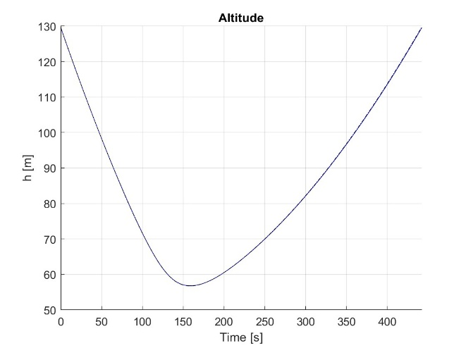
Figure 2: Optimal trajectory for altitude from ICLOCS2

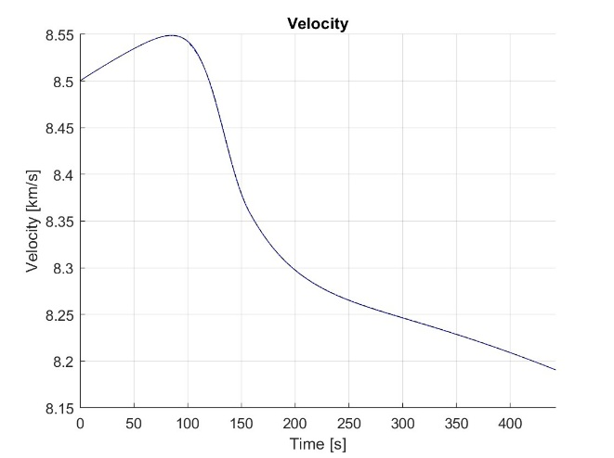
Figure 3: Optimal trajectory for velocity from ICLOCS2

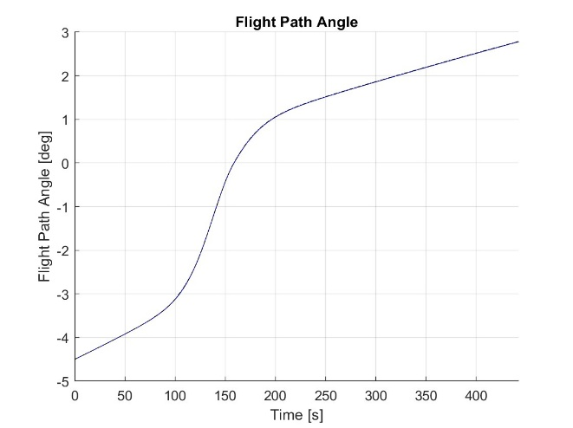
Figure 4: Optimal trajectory for flight path angle from ICLOCS2
The optimal trajectory for the altitude shows the spacecraft entering the sensible atmosphere $h_{atm}$, and immediately diving to get some meaningful drag. It speeds up using lift, and then as the drag increases the speed immediately goes down. The vehicle then does a steady climb while increasing its flight path angle to exit the atmosphere.
As shown in Figure 5, The control, at first, starts off at a high angle of attack to increase the vehicle’s speed while also diving. To take advantage of the high drag of the now thicker atmosphere, the control quickly starts to lower to slow down the craft. Once the vehicle reaches its lowest altitude, the control begins to settle down. During the climb, the angle of attack is low to slowly gain lift and limit any further sharp reductions in speed.

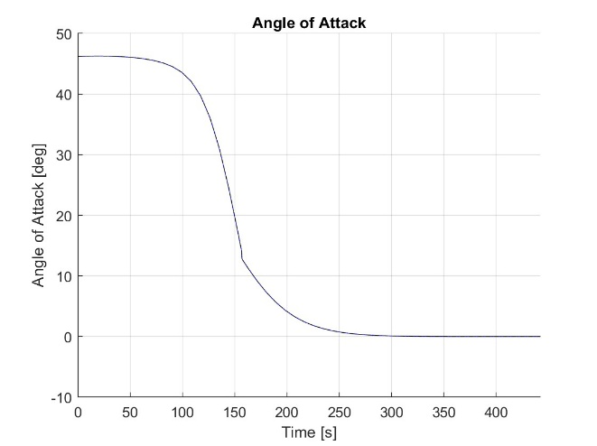
Figure 5: Optimal control solution from ICLOCS2
4. Control System Design
The control for this problem is the angle of attack of the vehicle, therefore this will be the only command output by the control system. The design for this paper’s control architecture will be cascaded control loops, due to the complex, non-linear dynamics of the hypersonic flight. Other control systems were tested, such as state feedback and a simple PID controller, however they failed to capture dynamics properly.
There are two loops, an inner and outer loop. The inner loop is designed to handle high-frequency dynamics by regulating the flight path angle through minor adjustments of the angle of attack. It uses the optimal trajectory of the flight path angle compared against the estimated states as a form of state-feedback. The inner loop uses a PI controller with $K_{i,γ}=0.75$ and a $K_{p,γ}=1.3$ after some testing to retrieve these gains. The outer loop regulates the altitude with a small $K_{p,r}=0.01$. The outer loop also uses the optimal trajectory for altitude for feedback. Finally, the feedforward component is the optimal control solution to ensure that the command is still adhering to the intended trajectory.

5. State Estimation
3.1. Measurement and Noise Model
Since there was only three states of interest, it was decided to measure all of the states. For the purposes of this paper, the measurement process was greatly simplified. The position and velocity measurements were gathered directly from a GPS system, whose parameters were chosen to greatly alter the states to test the control system’s robustness. For example, a GPS sampling time of 10 seconds was used to mimic temporary communication blackouts that associated with hypersonic flight. The GPS for the position measurement was given a bias and noise, as seen in Table 1, where as the velocity was just given a noise parameter. These were simply implemented by just adding the biases and noise to the states, and then providing measuring the states every 10 seconds.
The flight path angle was also measured directly, through a fictional flight path angle measurement tool that works at hypersonic speeds. The parameters for this tool are also listed in Table 1, with the measurement model only providing a simple noise to the measurement. This was meant to simplify the implementation, as the measurement model was not the key focus of this paper.

3.2. Low Pass Filter
To filter out some of the noise in the flight path angle reading, a Low Pass Filter was implemented.

$$\begin{aligned}γ_{LPF}=\exp\left(-\frac{t_{s}}{τ}\right)γ_{LPF}+\left[1+\exp\left(-\frac{t_{s}}{τ}\right)\right]γ_{meas}\#\left(16\right)\end{aligned}$$

Where $t_{s}$ is the sampling time of the simulation, and $τ$ is the filter time constant in seconds. This flight path angle was then subsequently used in the Kalman Filter for the rest of the state measurements.

3.3. Kalman Filter
To smoothen out the GPS measurements, the simulation will utilize an EKF due to the nonlinear dynamics. The EKF will predict the states between the large gaps in measurement data from the GPS, and then be updated when a new measurement comes in. The mathematics and parameters of the Kalman filter are listed below

$$\begin{aligned}f=\left[\begin{matrix}v∙\sin{γ} \\ -\frac{ρv^{2}S}{2m}C_{D}-\frac{μ}{{(r+R_{E})}^{2}}\sin{γ}\end{matrix}\right]\#\left(17\right)\end{aligned}$$

$$\begin{aligned}A=\left[\begin{matrix}0 & \sin{γ_{LPF}} \\ \frac{2μ}{{\left(r+R_{E}\right)}^{3}}\sin{γ_{LPF}} & -\frac{ρvS}{m}C_{D}\end{matrix}\right]\#\left(18\right)\end{aligned}$$

$$\begin{aligned}Q=\left[\begin{matrix}1×{10}^{-10} & 0 \\ 0 & 1×{10}^{-7}\end{matrix}\right]\#\left(19\right)\end{aligned}$$

$$\begin{aligned}R=\left[\begin{matrix}{σ_{η}}_{GPS,r}^{2} & 0 \\ 0 & {σ_{η}}_{GPS,v}^{2}\end{matrix}\right]\#\left(20\right)\end{aligned}$$

Where $σ_{η_{gps,r}}$ and $σ_{η_{gps,v}}$ are the noise parameters for the GPS measurements for altitude and speed respectively. The values for the continuous-time process noise matrix Q were chosen experimentally within the simulation.

$$\begin{aligned}y_{meas}=\left[\begin{matrix}r_{GPS} \\ v_{GPS}\end{matrix}\right]\#\left(21\right)\end{aligned}$$

$$\begin{aligned}C=\left[\begin{matrix}1 & 0 \\ 0 & 1\end{matrix}\right]\#\left(22\right)\end{aligned}$$

Where $r_{GPS}$ and $v_{GPS}$ are the GPS measurements for altitude and velocity respectively. Since the states were measured directly, the Jacobian is an identity matrix of size 2, as seen in equation 22.

6. Integrated GNC Simulation
6.1. Closed-loop Simulink Model
Once the optimal control scheme was derived, it was implemented in a closed-loop GNC Simulink Model. The model recreates the realistic forces and sensor readings the spacecraft might encounter during real flight, as well as implements the control architecture and estimation scheme discusses in sections 4 and 5. As seen in Figure 6, the model passes its states through the measurement subsystem, which are then read by the estimates, smoothing the measured state data to be read by the control system and then simulated.

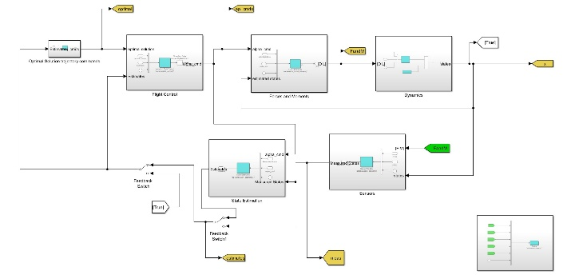
Figure 6: Image of the Simulink model used for the closed-loop simulation.
6.2. Closed Loop Results
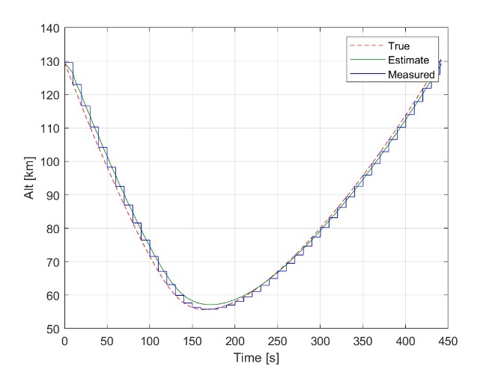
Figure 7: Altitude History (True, Estimated, and Measured)
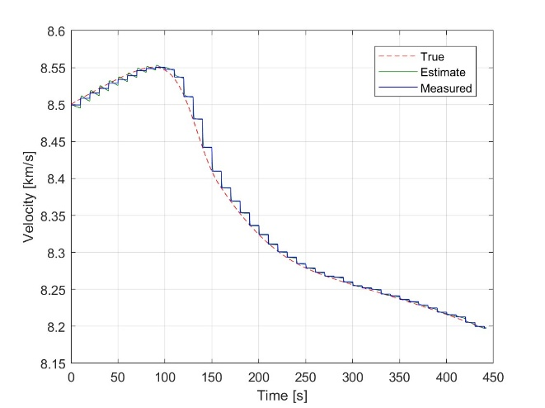
Figure 8: Velocity History (True, Estimated, and Measured)
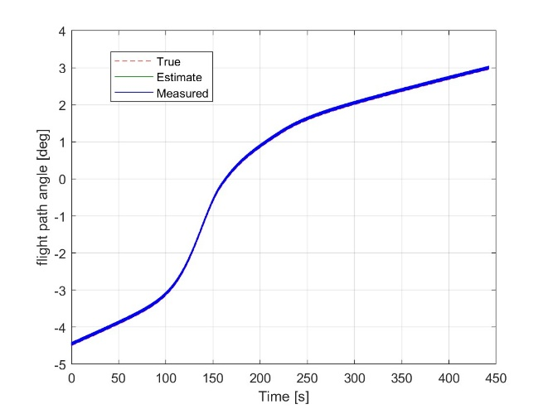
Figure 9: Flight Path Angle History (True, Estimated, and Measured)
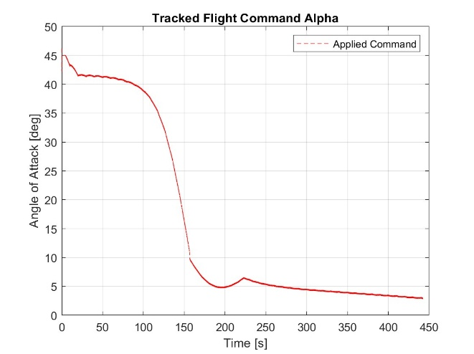
Figure 10: Applied Angle of Attack History
6.3. Estimate Performance
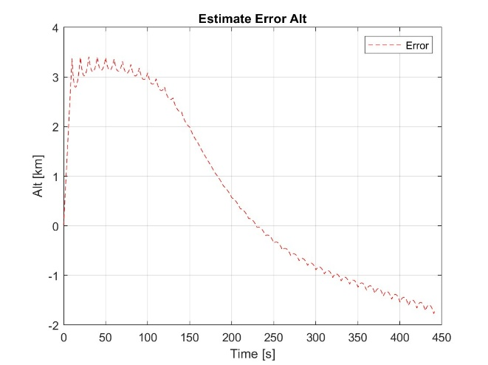
Figure 11: Estimate error between the estimated altitude trajectory and the true altitude
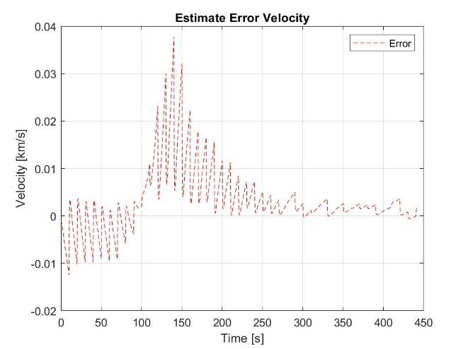
Figure 12: Estimate error between the estimated velocity trajectory and the true velocity
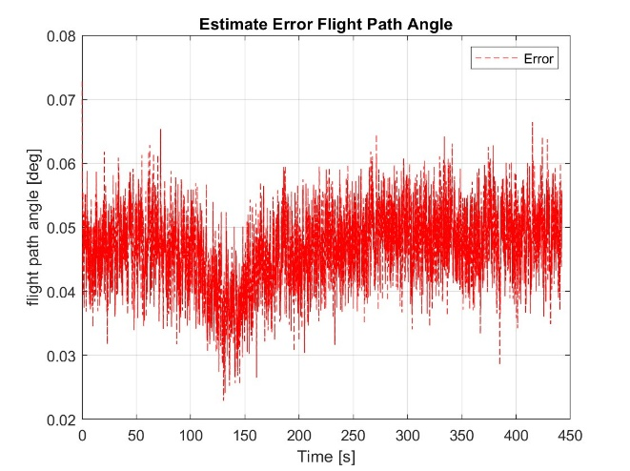
Figure 13: Estimate error between the estimated flight path angle trajectory and the true flight path angle
The estimate errors for the flight path angle were quite small, as seen in Figure 13, with a magnitude of only hundredths of a degree. This shows that the low pass filter worked well in removing some of the noise present from the measurement sensors. This can also be said for the velocity measurement as well, with errors ranging from tens of meters due to the EKF smoothing. However, the altitude seems to have the most error, especially at the beginning. Although it is just a few meters, this is mostly likely due to the bias in the GPS measurements.

6.4. Tracking Performance
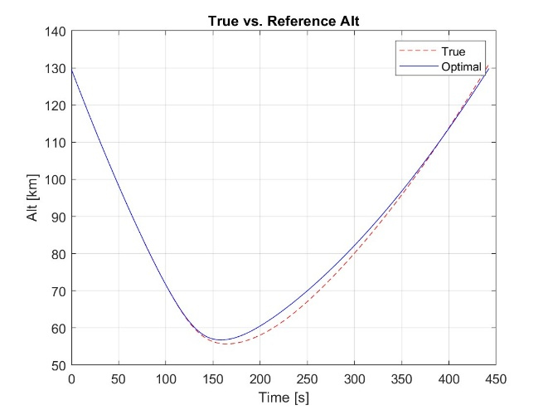
Figure 14: Optimal Solution for Altitude overlayed on top of the closed loop results
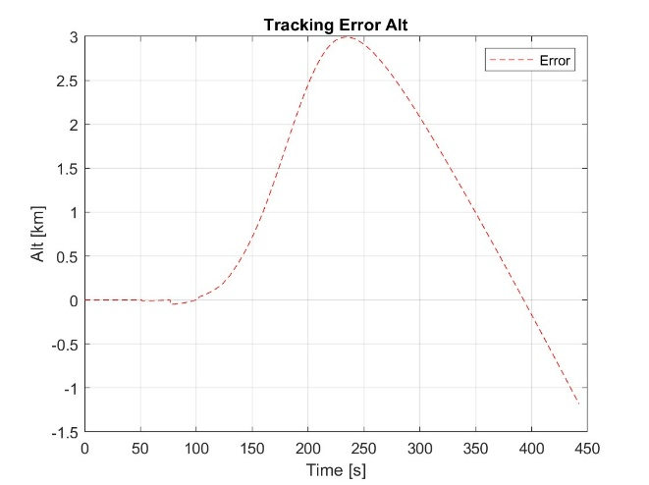
Figure 15: Tracking error between the optimal altitude trajectory and the closed loop altitude
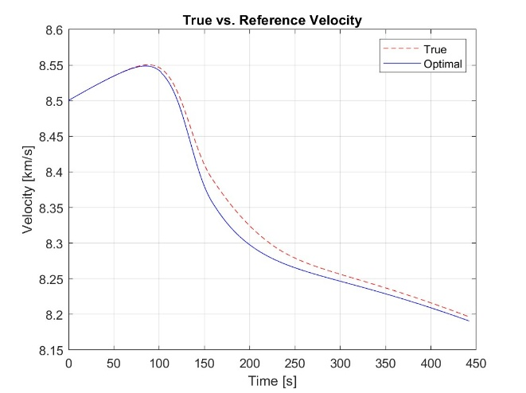
Figure 16: Optimal Solution for velocity overlayed on top of the closed loop results
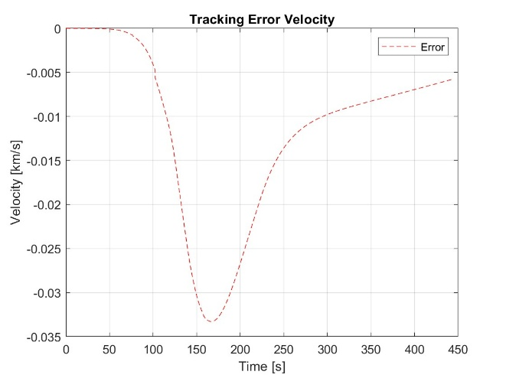
Figure 17: Tracking error between the optimal velocity trajectory and the closed loop velocity
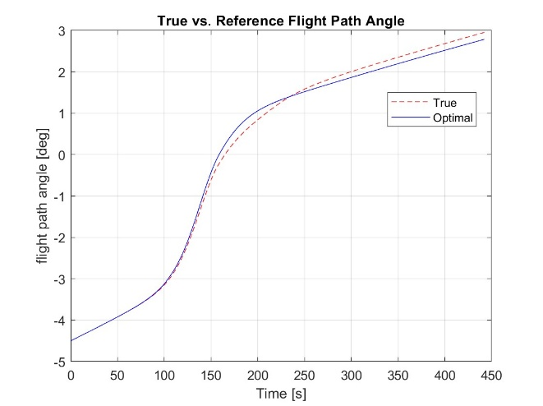
Figure 18: Optimal Solution for Flight Path Angle overlayed on top of the closed loop results
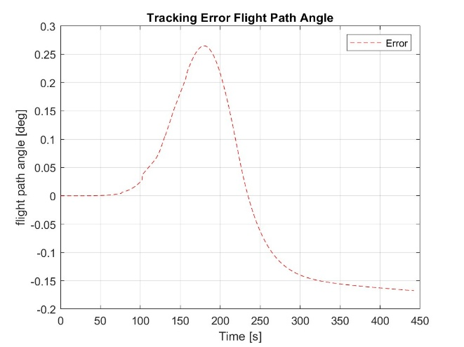
Figure 19: Tracking error between the optimal flight path angle trajectory and the closed loop flight path angle
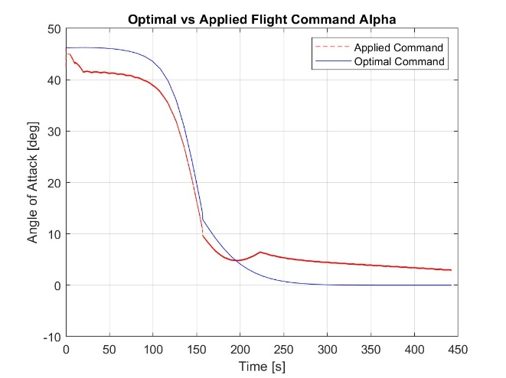
Figure 20: Optimal Solution for Angle of Attack overlayed on top of the closed loop results
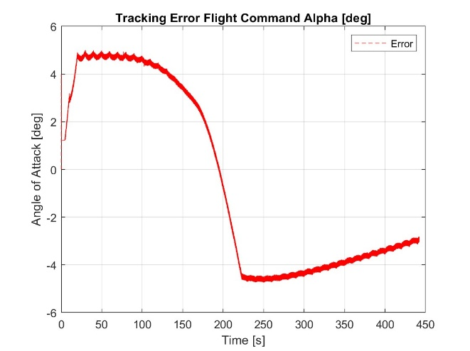
Figure 21: Tracking error between the optimal flight path angle trajectory and the closed loop flight path angle
The tracking errors show non-negligible errors from the optimal trajectory compared to the true states. The command was different due to the noise and gaps of data in the measurement. However, while the tracking errors were present, for the purposes of the vehicle exiting the atmosphere at a lower velocity, it does show that the closed-loop simulation was able to follow the optimal trajectory despite the measurement.
7. Conclusions and Future Work
The problem of developing a trajectory that transfers a vehicle from one elliptical orbit to smaller elliptical orbit through the use of atmospheric drag while minimizing heating has been considered. The trajectory and its resulting control scheme as generated by the optimal control software ICLOCS2 was implemented in a closed-loop GNC simulation for a small high lift-to-drag ratio vehicle along a 2D planar path. It was found that despite the difficulties in the measurements and hypersonic dynamics, the control scheme was able to adequately bring the vehicle outside the atmosphere at a slower trajectory and within the path constraints.
However, there are still some aspects to this optimal control problem and the closed-loop GNC simulation that can still be improved. For one, although the optimal trajectory was found, it might still be possible to reduce the heating even more through a relaxation of constraints and adjustments to initial conditions. The control scheme obviously has some issues, with the error between the reference and simulated velocity being off by a few meters. Although it seems small, this might result in a higher fuel burn necessary due to the smaller orbit the spacecraft has been placed on. Otherwise, the initial goal of the paper, determining the feasibility of such a maneuver was shown to be viable for the simplified dynamics provided.

References
- C. L. Darby and A. V. Rao, “Minimum-fuel low-earth orbit aeroassisted orbital transfer of small spacecraft,” Journal of Spacecraft and Rockets, vol. 48, no. 4, pp. 618–628, Jul. 2011. doi:10.2514/1.a32011
- C. Gogu, T. Matsumura, R. T. Haftka, and A. V. Rao, “Aeroassisted orbital transfer trajectory optimization considering thermal protection system mass,” Journal of Guidance, Control, and Dynamics, vol. 32, no. 3, pp. 927–938, May 2009. doi:10.2514/1.37684
- J. T. Betts, Practical Methods for Optimal Control Using Nonlinear Programming. Philadelphia: Society for Industrial and Applied Mathematics, 2020.

