**Database Design**

**From Concept to Implementation**

**Project Objective**  
The primary aim of this project is to convert specified requirements into a relational database using MySQL. The process involves several key stages, each contributing to the clarity, organization, and efficiency of the resulting database.

**Requirements**

You are tasked with designing and implementing a database for clubs, matches, players, and fans. Each club has a unique name and includes players, a captain (who is one of the players), a country, and colors (which may be one or more). Each player is uniquely identified by a name, a jersey number, and a birth year. Fans are uniquely identified by a name, a country, and a city of residence. They support clubs and players. A fan is not required to support a specific player but must support at least one club. Additionally, the players supported by a fan may belong to different clubs. Lastly, a match occurs between two clubs. The database records which club is the host, the score, and the date of the match.

**ER Diagram**

Initially, we'll analyze the paragraph to identify essential elements such as names and relationships. This understanding forms the basis for creating an Entity-Relationship (ER) diagram, a visual representation illustrating the connections within the relational database.

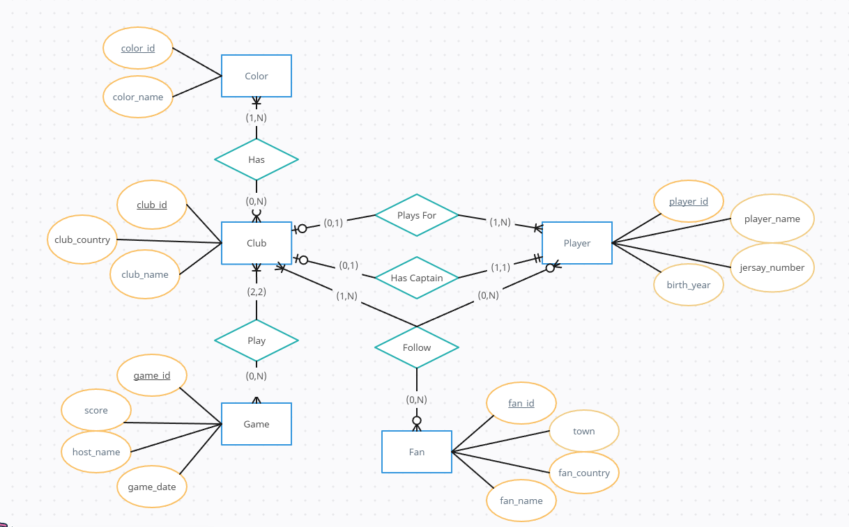

**Schema**

Following the analysis of the paragraph, we will proceed to craft a schema—a descriptive list outlining the structure of the relational database. To optimize organization and efficiency, normalization rules will be implemented, serving as guidelines to maintain a tidy and error-resistant database. This approach, in addition to the schema, ensures that data is stored in a manner minimizing redundancy and mitigating potential pitfalls related to data consistency.

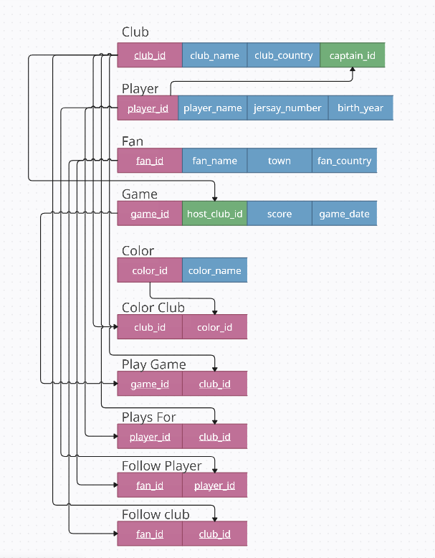

**MySQL**

Once the schema is established, the next step involves the creation of MySQL scripts. These scripts act as instructions that the database understands, bringing our planned structure to life. They play a crucial role in executing the creation of relational tables and relationships as defined in our schema. All the necessary code for implementing these scripts will be conveniently accessible via the provided link, ensuring a streamlined and accessible process for database setup.

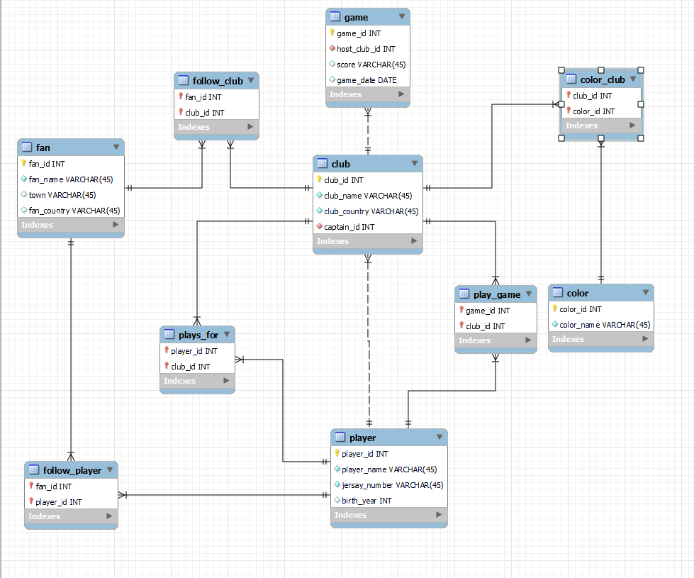

**Summary**

In summary, this project is a systematic process that transforms a paragraph into a well-organized relational database. By incorporating the steps of creating an ER diagram, developing a schema with normalization, and scripting with MySQL, we ensure not only accuracy in representing the original information but also adherence to best practices for relational database design.