## ITC 6230: Deep Learning Homework Assignment #2

**DUE-DATE: Sunday, FEBRUARY 18, 2024, 23:59.**

Consider the following neural network:

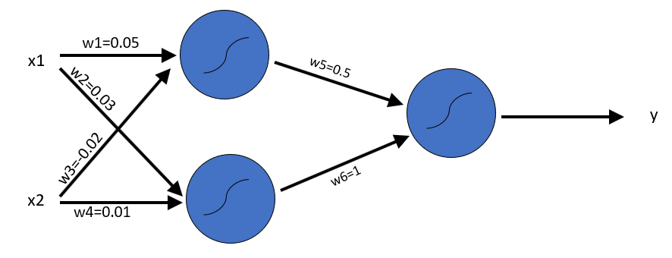

Consider the following dataset:

|  |  |  |
| --- | --- | --- |
| **x1** | **x2** | **y (label)** |
| -1 | 1 | 0 |
| 0.5 | 0.5 | 1 |
| 1 | -1 | 1 |
| 0 | 0.5 | 0 |

**Question 1**

**a. (30 pts):** Using the Back-Propagation algorithm, compute the gradient (a vector of 6 components) of the loss function $L\left(w;X,y\right)=\frac{1}{\left|X\right|}\sum_{(x,y)∈(X,y)}{{\left(net\left(x;w\right)-y\right)}^{2}}$ where the function $net(x;w)$ is the output of the neural network when the input is the vector $x$, and **all** nodes in the network use as activation function the ReLU function $a\left(x\right)=x_{+}=max⁡(x,0)$.

**b. (10 pts)** Check your answer in step a. by computing the difference quotient $\frac{L\left(w+he_{1};X,y\right)-L(w;X,y)}{h}$ where $h=0.1, 0.01, 0.001$ and $e_{1}={\left[1,0,0,0,0,0\right]}^{T}$ (the unit vector in the first dimension). What is the different between your computed value of $\frac{∂L}{∂w_{1}}$ and the difference quotient for the three proposed values of $h$?

**Question 2 (25 pts):** Using a step-size $h=0.001$, use the GD equation:

$$w'←w-h∇L(w;X,y)$$

to compute a new set of weights $w'$ given the gradient computed at Question 1.a. Now, compute the value of the loss function $L(w^{'};X,y)$ of the neural network in the figure above, evaluated at the point $w'$. How does the new loss value compare to the original value $L\left(w;X,y\right)$?

**Question 3 (35 pts):** For the network in the figure above, compute the gradient function of the single-instance mini-batch:

|  |  |  |
| --- | --- | --- |
| **x1** | **x2** | **y (label)** |
| -1 | 1 | 0 |

The activation function of the two hidden nodes is the rectified linear unit (ReLU): $a\left(x\right)=x_{+}=max⁡\{x,0\}$ and the activation function for the output node is the hyperbolic tangent function $a\left(x\right)=\tanh{x}$. The loss function whose gradient we seek is again the same as in Question 1 (mean square error)