
Athens University of Economy and Business
School of Information Sciences & Technology: Department of Informatics
Master of Science in “Data Science”

Course: Text Analytics

“ASSIGNMENT 5”

Students: 1) Dionysios Voulgarakis (f3352307)
2) Rafail Mpalis (f3352308)
3) Dimitrios Stathopoulos (f3352318)

Instructor: Prof. Ion Androutsopoulos
Grader: Foivos Charalampakos

Assignment 4(Exercise 2)
In this project our aim is to build a classifier for sentiment Analysis. In order to train our model we use the Large Movie Review Dataset, which contains 50,000 binary labeled movie reviews. The classes are two, 0 for negative and 1 for positive sentiment.
We decided to keep 30,000 reviews for training and we split the rest 20,000 in half for development and test sets. In each of the sets we kept the balance of positive and negative even.
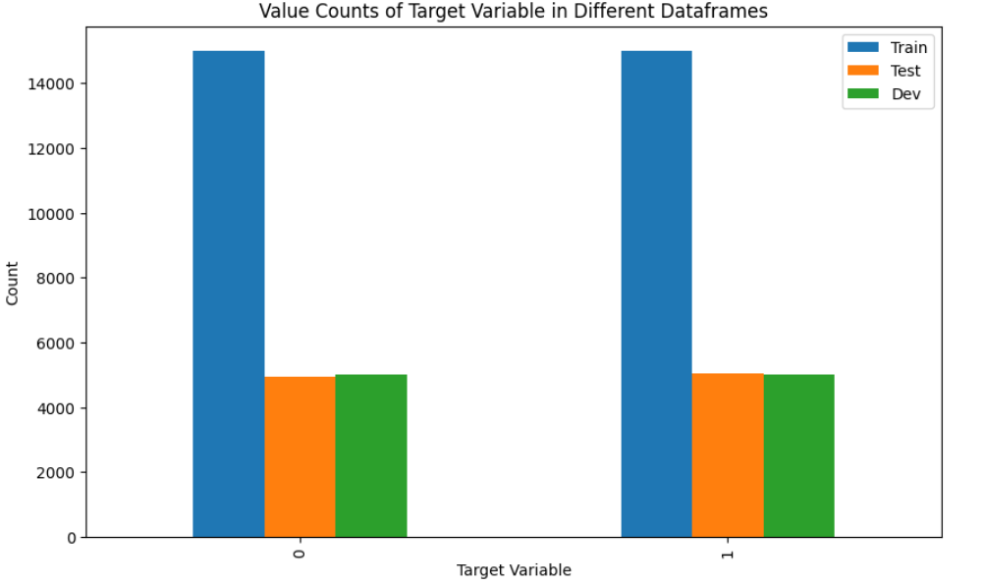

The length of the of documents in train and development set is seen below.
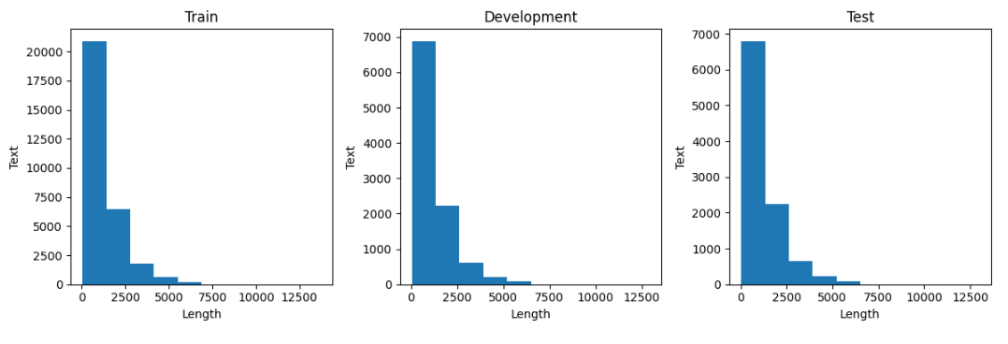
Preprocessing
We used nltk library to preprocess our data. For each of the above sets we performed:
- Removing of non-word characters,
- Removing of single characters,
- Removing of Numerical values,
- Converting into lowercase, to achieve homogeneity,
- Remove stop words,
- We didn't use Lemmatization, as it didnt seem to improve our model.

Baseline Model
TF-IDF
We based our model in tf-idf representation of the reviews. We used:
Unigrams and bigrams
max features 5000
SVD
To reduce the features, we used truncated svd. We kept 500 components.
Results
We started using Logistic regression as our baseline model, which achieved accuracy of 88%.

BERT Model (‘bert-base-uncased’)

We used BERT as our base model using Tensorflow/keras, as explained below:
BERT AutoTokenizer tokenization.

For the tokenization:
We added special tokens, padding, max length(266) and truncation.
Global Max Pooling
Top 2 layers frozen
Dropout layer (0.5)
Dense output Layer 1 neuron and sigmoid activation.
Batch size 16.
- 15 epochs with early stopping(patience=2) after 5 epochs with not improvement.
We achieved accuracy of 92% on test set. 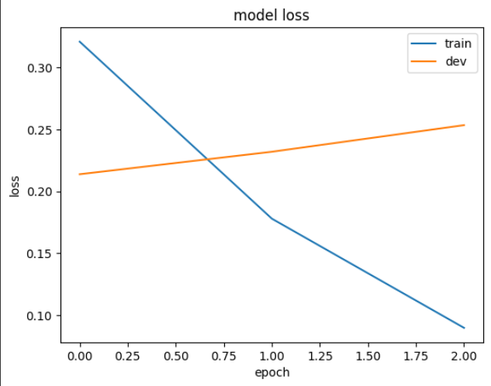
Results
PR - AUC Curve BERT versus Logistic Regression
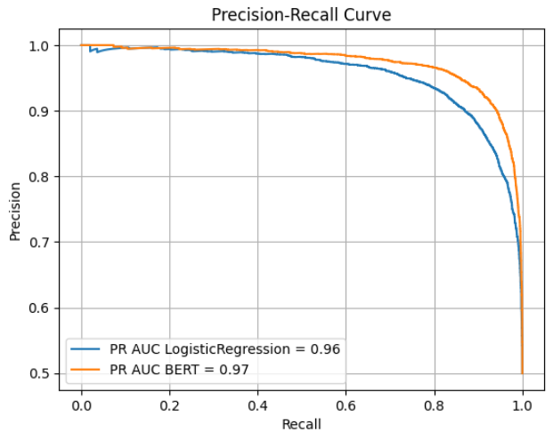

Train, Development and Test Class Metrics:
