LatexEditor
Release Report
<Fill here the Group Name>
<Fill here the Group Members, Name and AM>

Versions History
Date | Version | Description | Author

Introduction
This document provides information concerning the <1> release of the project.

Purpose
Latex is a well known high quality document preparation markup language. It provides a large variety of styles and commands that enable advanced document formatting. Typically, a Latex document is compiled with a tool like MikTex, Lyx, etc. to produce a respective formatted document in pdf, ps, etc. Formatting documents with Latex is a programming like process as it involves the proper usage of Latex commands which are embedded in the document contents. The objective of this project is to develop a simple Latex editor for inexperienced Latex users. The goal of the editor is to facilitate the usage of Latex commands for the preparation of Latex documents. One of the prominent features that distinguishes the LatexEditor from other similar applications is its multi-strategy version tracking functionalities that enable undo and redo actions.

Document Structure
The rest of this document is structured as follows. Section 2 specifies the acceptance tests that have been employed for this release of the project. Section 3 specifies the main design concepts for this release of the project.

Tests

Tests for User Story <1>
Test ID | 1
User Story | US 1
Test Class | CreateCommandTest
Description | Test the creation of a document. The class takes as input the type “artcileTemplate” and checks the contents of the newly created document if they are identical with the respective template.

Test ID | 2
User Story | US 1
Test Class | CreateCommandTest
Description | Test the creation of a document. The class takes as input the type “letterTemplate” and checks the contents of the newly created document if they are identical with the respective template.

Test ID | 3
User Story | US 1
Test Class | CreateCommandTest
Description | Test the creation of a document. The class takes as input the type “reportTemplate” and checks the contents of the newly created document if they are identical with the respective template.

Test ID | 4
User Story | US 1
Test Class | CreateCommandTest
Description | Test the creation of a document. The class takes as input the type “bookTemplate” and checks the contents of the newly created document if they are identical with the respective template.

Test ID | 5
User Story | US 1
Test Class | CreateCommandTest
Description | Test the creation of a document. The class takes as input the type “empty” and checks the contents of the newly created document if they are identical with the respective template.

Tests for User Story <2>
Test ID | 6
User Story | US 2
Test Class | EditCommandTest
Description | Test the editing of a document’s contents. The class creates a document and edits its contents. Then it checks if the document contents are identical with the new contentss

Tests for User Story <8>
Test ID | 7
User Story | US 8
Test Class | SaveCommandTest
Description | Test the save file to disk command. The class takes as input a filename, creates a document and saves its contents to a file with name the given filename. Then reads the contents of the file and checks if they are identical with the contents of the document.

Tests for User Story <4>
Test ID | 8
User Story | US 4
Test Class | EnableVersionsManagementCommandTest
Description | Test the volatile version tracking mechanism. The class creates a document, enables the mechanism and call the edit command. Then gets the contents of the last document in history and checks if they are identical with the contents of the initial document.

Test ID | 8
User Story | US 4
Test Class | EnableVersionsManagementCommandTest
Description | Test the stable version tracking mechanism. The class creates a document, enables the mechanism and call the edit command. Then gets the contents of the last document in history and checks if they are identical with the contents of the initial document.

Tests for User Story <5>
Test ID | 9
User Story | US 5
Test Class | ChangeVersionsStrategyCommandTest
Description | Test the mechanism change to stable. The class takes as input the new type of mechanism and calls the Change command. Then checks if the strategy has been changed

Test ID | 10
User Story | US 5
Test Class | ChangeVersionsStrategyCommandTest
Description | Test the mechanism change to volatile. The class takes as input the new type of mechanism and calls the Change command. Then checks if the strategy has been changed

Tests for User Story <6>
Test ID | 11
User Story | US 6
Test Class | DisableVersionsManagementCommandTest
Description | Test if the mechanism is disabled. The class calls the disable command then creates a document and calls the edit command. Then checks if a document has been added to the history.

Tests for User Story <7>
Test ID | 12
User Story | US 7
Test Class | RollbackToPreviousVersionCommandTest
Description | Test the rollback mechanism. The class creates a document, keeps its contents, enables the mechanism and call the edit command. Then calls the rollback command and checks if the contents of the current document are identical with the contents of the initial document.

Tests for User Story <9>
Test ID | 13
User Story | US 9
Test Class | LoadCommandTest
Description | Test the load from file command. The class takes as input a filename and calls the load command. Then reads the contents of the file and checks if they are identical with the contents of the document.

Design

Architecture
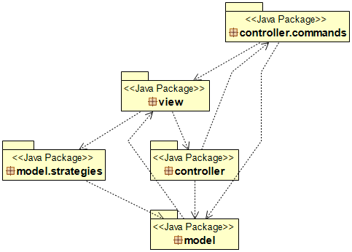

Design
Controller class diagram
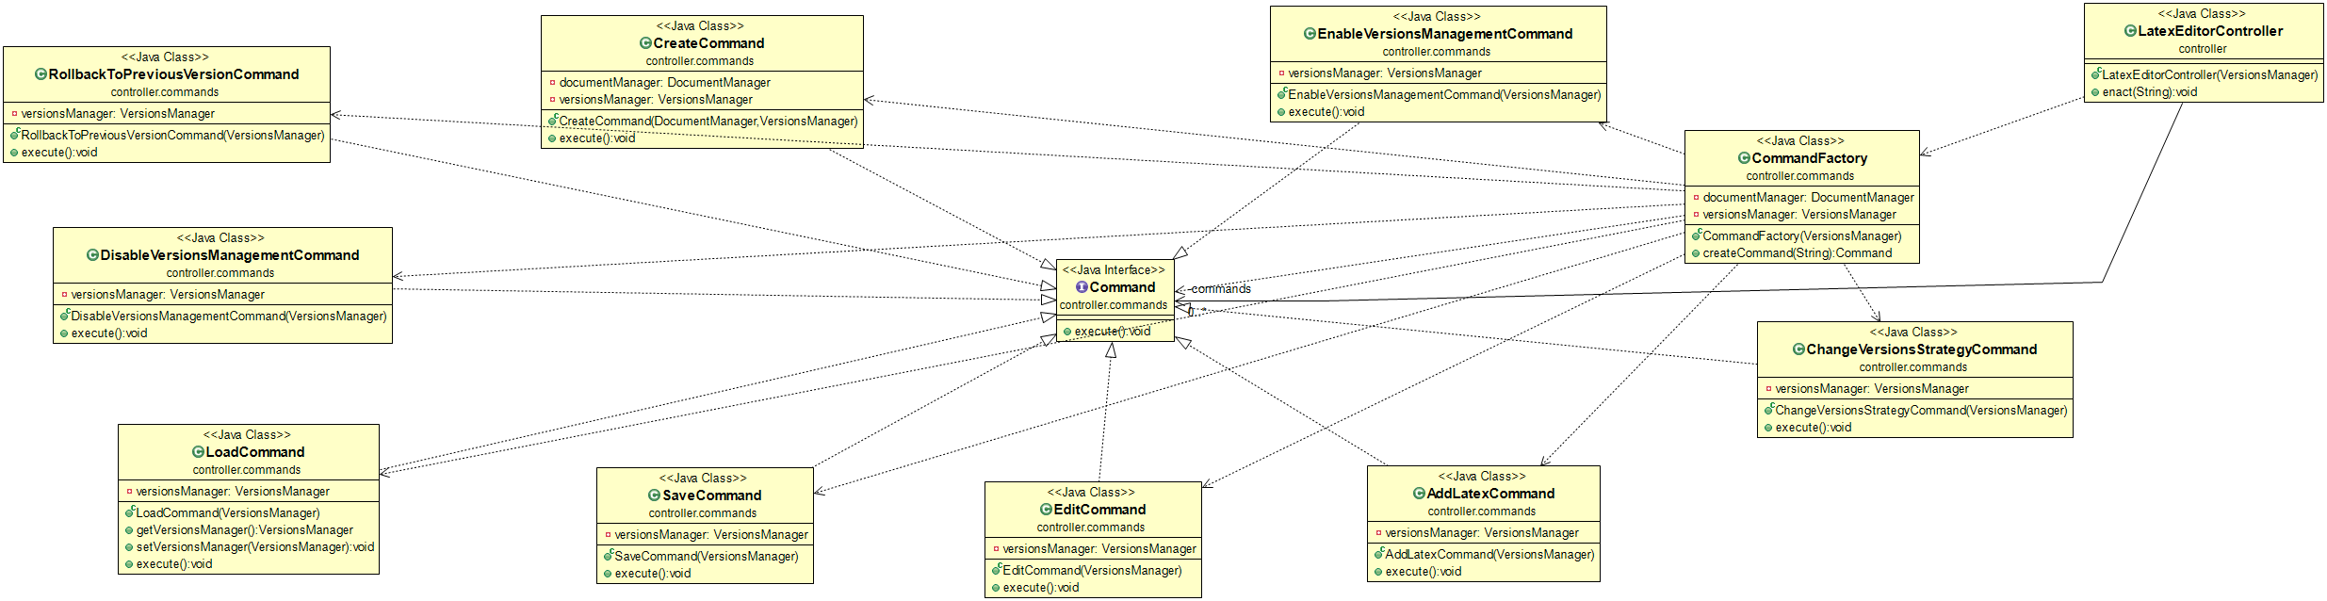

Model class diagram

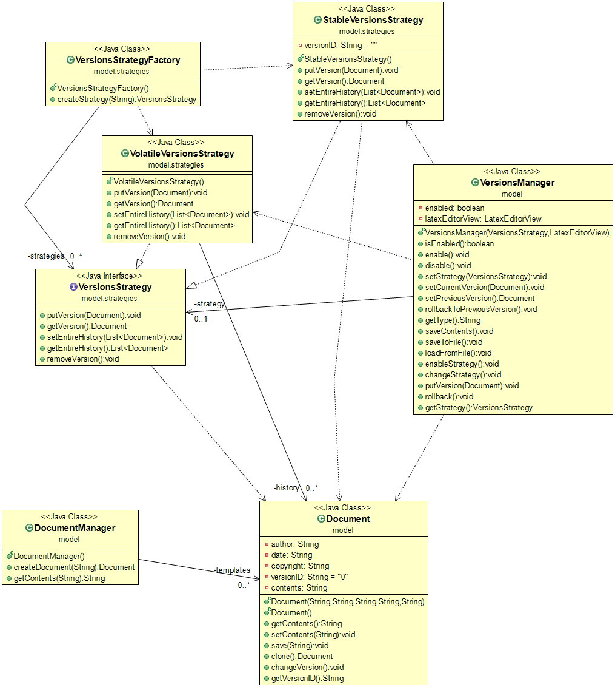

View class diagram

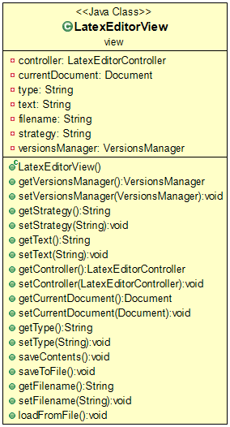

Class Name: LatexEditorController
Responsibilities:  - Executes the commands  - Keeps a map with the commands | Collaborations:  - LatexEditorView  - CommandsFactory  - Command  - VersionsManager

Class Name: AddLatexCommand
Responsibilities:  - Calls the methods to add a latex command to document | Collaborations:  - CommandsFactory  - VersionsManager

Class Name: CommandsFactory
Responsibilities:  - Create Command objects | Collaborations:  - AddLatexCommand  - CreateCommand  - EditCommand  - SaveCommand  - DocumentManager  - VersionsManager  - DisableVersionsManagementCommand  - EnableVersionsManagementCommand  - RollbackToPreviousVersionCommand  - ChangeVersionsStrategyCommand  - LoadCommand

Class Name: CreateCommand
Responsibilities:  - Calls the methods to create a document | Collaborations:  - Document  - DocumentManager  - VersionsManager

Class Name: EditCommand
Responsibilities:  - Calls the methods to edit a document | Collaborations:  - VersionsManager  - CommandsFactory

Class Name: SaveCommand
Responsibilities:  - Calls the methods to save a document to disk | Collaborations:  - CommandsFactory  - VersionsManager

Class Name: Document
Responsibilities:  - Keeps the information for a document  - Writes the contents to a file | Collaborations:  - CreateCommand  - DocumentManager  - LatexEditorView  - VersionsManager

Class Name: DocumentManager
Responsibilities:  - Keeps the templates to a map  - Creates new documents | Collaborations:  - CommandsFactory  - Document  - CreateCommand

Class Name: LatexEditorView
Responsibilities:  - Keeps the current document  - Keeps information from user that is needed to execute the commands | Collaborations:  - Document  - LatexEditorController  - VersionsManager

Class Name: VersionsManager
Responsibilities:  - Create Command objects | Collaborations:  - AddLatexCommand  - CreateCommand  - EditCommand  - SaveCommand  - DocumentManager  - CommandsFactory  - DisableVersionsManagementCommand  - EnableVersionsManagementCommand  - RollbackToPreviousVersionCommand  - ChangeVersionsStrategyCommand  - LoadCommand  - LatexEditorView  - LatexEditorController  - VersionsStrategy  - VolatileVersionsStrategy  - StableVersionsStrategy

Class Name: DisableVersionManagementCommand
Responsibilities:  - Disables the tracking mechanism | Collaborations:  - VersionsManager  - CommandsFactory

Class Name: EnableVersionManagementCommand
Responsibilities:  - Enables the tracking mechanism | Collaborations:  - VersionsManager  - CommandsFactory

Class Name: RollbackToPreviousVersionCommand
Responsibilities:  - Rollback to the previous version | Collaborations:  - VersionsManager  - CommandsFactory

Class Name: ChangeVersionsStrategyCommand
Responsibilities:  - Changes the tracking mechanism | Collaborations:  - VersionsManager  - CommandsFactory

Class Name: LoadCommand
Responsibilities:  - Calls the methods to load a document from disk | Collaborations:  - CommandsFactory  - VersionsManager

Class Name: VersionsStrategy
Responsibilities:  - Interface for strategy implementation | Collaborations:  - VersionsStrategyFactory  - VersionsManager  - Document

Class Name: VolatileVersionsStrategy
Responsibilities:  - Implements the volatile strategy | Collaborations:  - VersionsStrategyFactory  - VersionsManager  - Document

Class Name: StableVersionsStrategy
Responsibilities:  - Implements the volatile strategy | Collaborations:  - VersionsStrategyFactory  - VersionsManager  - Document

