1. histogram(d)

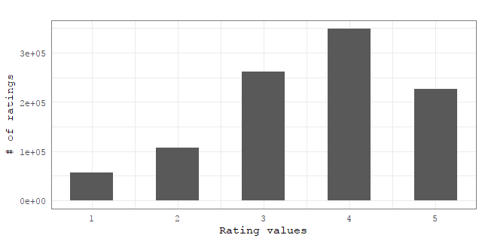

1. dataChart(d, x = “items”, y = “num_of_ratings”)

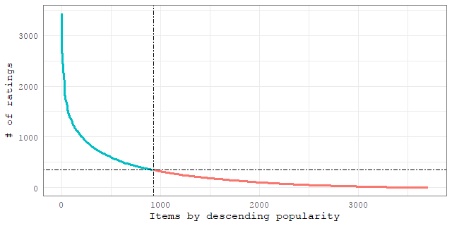

1. dataChart(d, x= “%_of_items”, y = ”%_of_ratings”)
2. evalChart(res, x = “items”, y = “num_of_recommendations”, y_range = c(0,500,100))
3. evalChart(res, x = “items”, y = “prediction_error”)
4. evalChart(res, x = “users”, y = “prediction _error”)
5. evalChart(res, x = “topN”, y = “num_of_ratings”)
6. 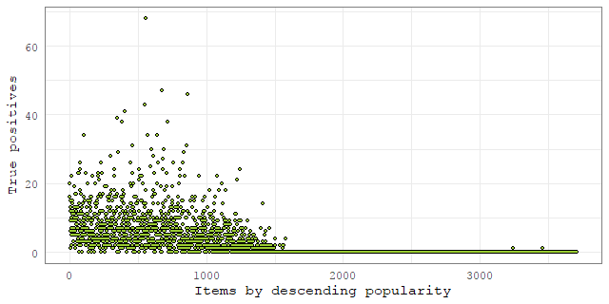evalChart(res, x = “items_based_on_explenability_power”, y = “tp”, y_range = c(0,500,100))
7. evalChart(res, x = “items_based_on_explenability_power”, y = “num_of_recommedations”)
8. evalChart(res, x = “topN”, y = “number of times an item from the recommendation list is rated”)