PUZZLES CHOSEN FOR THE PROJECT

Puzzle-board0: Απο http://www.kakuro.com/techniques.php
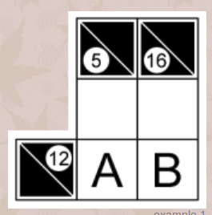
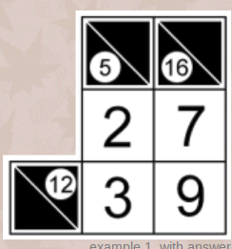

Puzzle-board1: Απο εκφώνηση

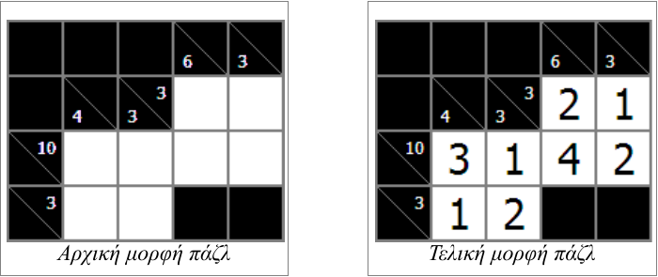

Puzzle-board2: Απο http://www.kakuros.com/?s=5x5

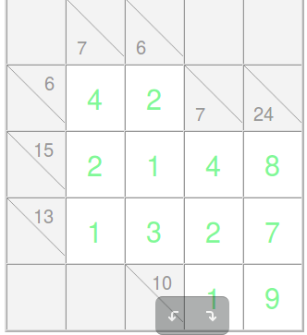

Puzzle-board3: Απο wikipedia
