The pupose of this program(written in java language)is to create a monthly calendar for a place in booking(it can also create a calndar for smaller periods than a month but not for longer).It takes for input two xls files to output a new xls file. The first xls file is downloaded directly from bookings extranet, and the second is created by copying a certain sheet and creating a new xls.
The first file looks like this
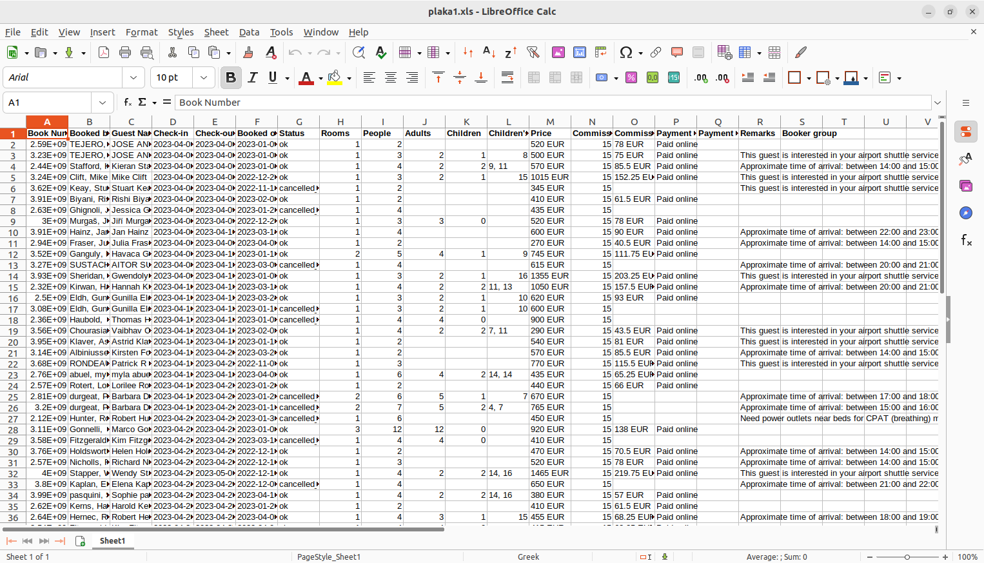
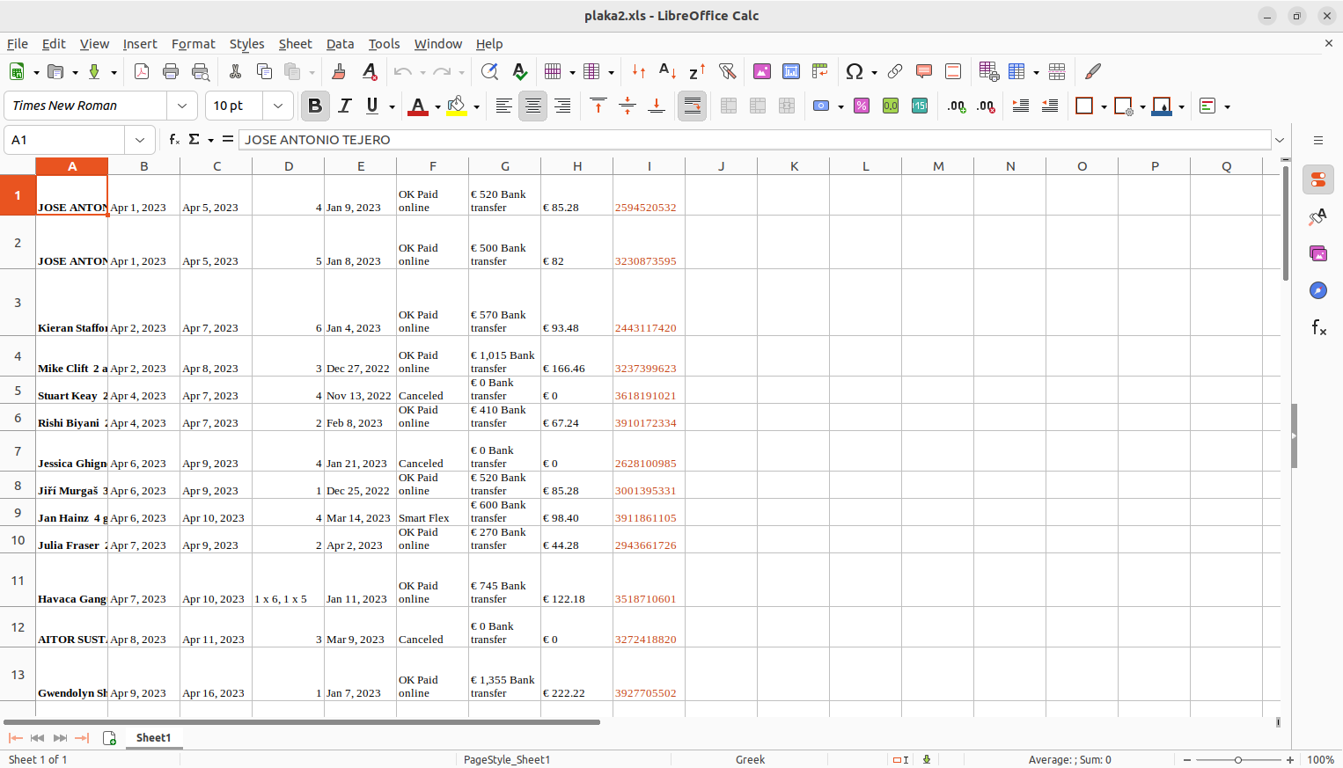
the second like this
That certain building provides 6 rooms. In the first file(the one downloaded from bookings extranet) in the collumn “rooms” it only shows the amount of rooms booked in that certain booking, and not the actuall numbers of the rooms (for example 2 means two rooms but you cant know wich rooms just by that collumn). That is why the second file is needed which actually shows exactly which rooms are booked(collumn D.for example 1 x 6 , 1 x 5 means a double booking for rooms 6 and 5).

Now the output file has two collumns in the beginning (name of day, number of day) and two at the end (number of day, name of day). In the middle it has three collumns for each room (so 6 rooms * 3 collumns, a total of 18 collumns for the rooms). In each room the first collumn shows if the room is booked or not, the second shows how many people are (if the number has no decimals means only adults. For example 5 means 5 adults whereas the decimals are children, for example 5.2 means 5 adults 2 children) and the third shows the time of check in, if available. If a book has mulltiple rooms then the first cell of the first collumn of each room, indicates so(for example it will say “GroupRoom4” in the first cell of the first collumn of room 4 , 5 and 2 for 1 x 4 , 1 x 5 ,1 x 2 book).If a book starts at a certain month and finishes in another then in the last cell of the first collumn of the book (last cell of the month) it will indicate that the book continues to the next month, and also say untill when (for example “continues(day/month)”).
The output excel looks like this

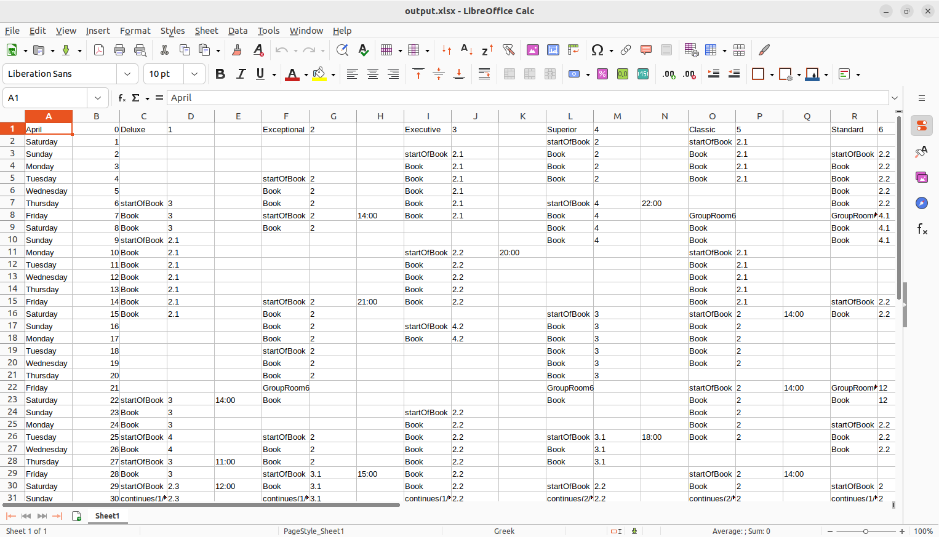
inside the folder there are 3 xls files of an old montht that cna be used to test te programm. The program uses the apache POI libraries for excel parsing, manipulating and creating. It is a maven project, and i used VSCODE. The whole project is the “plakaproj” folder. It reads plaka1 in line 32 and plaka2 in line 36 so one just has to put the correct filepaths there for the files to be read.

