Subnets

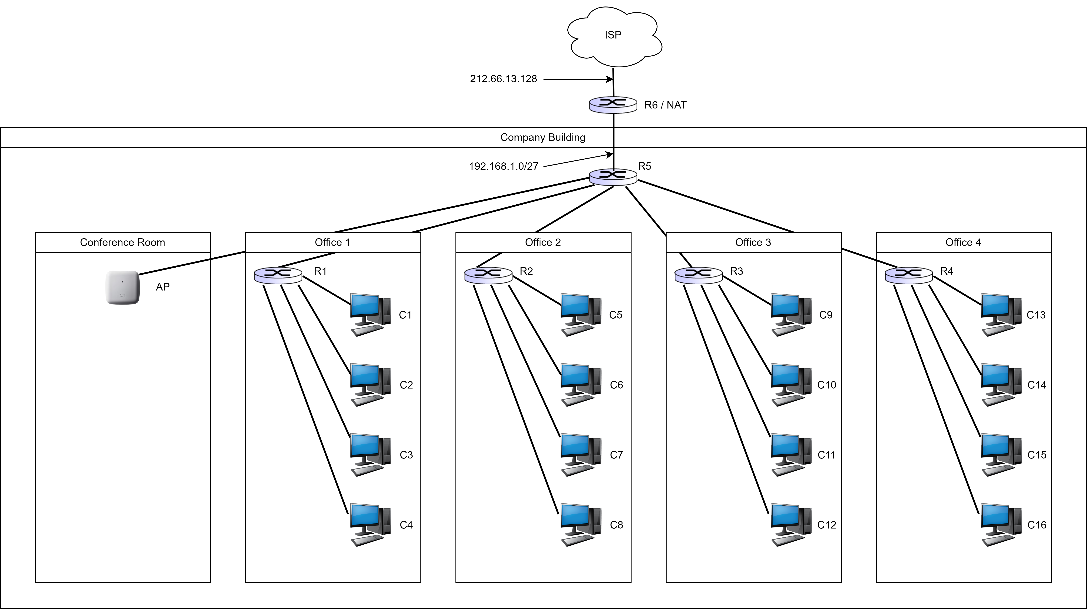

You have been asked to set up the LAN for a company building and you have been given the subnet 192.168.1.0/27. The building has 4 offices with routers and a conference room with a wireless access point. The conference room should be able to support 16 wireless devices simultaneously. Ignore the broadcast IP address and the IP addresses that should be assigned to the router interfaces. Answer the following questions in both decimal and binary notation:
1) Can the given subnet 192.168.1.0/27 support all the devices necessary? Show your calculations.
2) What is the subnet you would assign to each of the 5 rooms in the company building (wireless AP and routers R1-R4)? (Hint: You can use 1 bit to designate whether the room is an office or the conference room).
3) What are the IP addresses you would assign to the computers C1-C16?

