Subnets
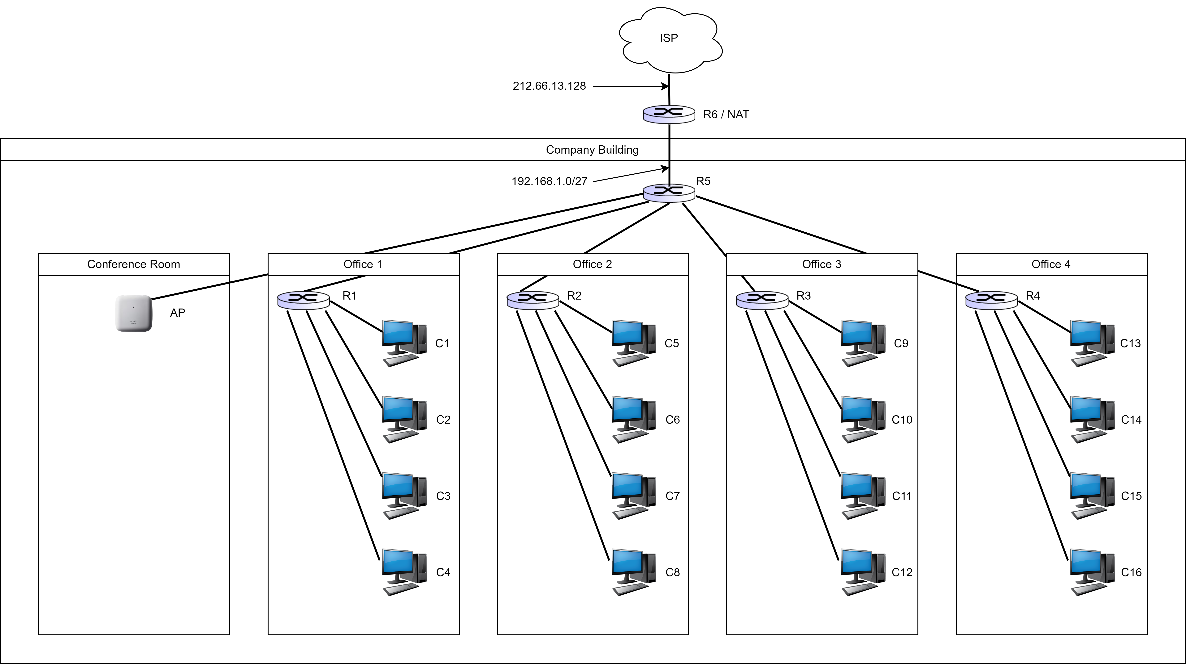

You have been asked to set up the LAN for a company building and you have been given the subnet 192.168.1.0/27. The building has 4 offices with routers and a conference room with a wireless access point. The conference room should be able to support 16 wireless devices simultaneously. Ignore the broadcast IP address and the IP addresses that should be assigned to the router interfaces. Answer the following questions in both decimal and binary notation:
1) Can the given subnet 192.168.1.0/27 support all the devices necessary? Show your calculations.
2) What is the subnet you would assign to each of the 5 rooms in the company building (wireless AP and routers R1-R4)? (Hint: You can use 1 bit to designate whether the room is an office or the conference room).
3) What are the IP addresses you would assign to the computers C1-C16?

Answers

The subnet we have been given (at router R5) is 192.168.1.0/27. A subnet is a range of IP addresses. In binary, this range is
11000000.10101000.00000001.00000000 - 11000000.10101000.00000001.00011111
I have underlined the bits that are common. As the decimal subnet suggests, there are 27 common bits (subnet part) in this range. This leaves us with 32-27=5 bits to work with for the company building network. Therefore, we have 2⁵=32 addresses (all possible combinations of those 5 bits) to assign to the computers in the company network. We are asked to provide IP addresses for 16 wireless devices in the conference room and 16 IP addresses in the other rooms (4 computers per room). We are also asked to ignore the broadcast IP address and the IP addresses that would be assigned to the router interfaces. Thus, 32 addresses should be enough to cover our needs.

Subnet in the conference room in binary and decimal notations.

Binary: 11000000.10101000.00000001.00000000 - 11000000.10101000.00000001.00001111
Decimal: 192.168.1.0/28

Subnets in the offices in binary and decimal notations.

Office 1
Binary: 11000000.10101000.00000001.00010000 - 11000000.10101000.00000001.00010011
Decimal: 192.168.1.16/30

Office 2
Binary: 11000000.10101000.00000001.00010100 - 11000000.10101000.00000001.00010111
Decimal: 192.168.1.20/30

Office 3
Binary: 11000000.10101000.00000001.00011000 - 11000000.10101000.00000001.00011011
Decimal: 192.168.1.24/30

Office 4
Binary: 11000000.10101000.00000001.00011100 - 11000000.10101000.00000001.00011111
Decimal: 192.168.1.28/30

From question 1, we already have the subnets for the offices. Here are the exact IPs that would be assigned to computers C1-C16:

C1
Binary: 11000000.10101000.00000001.00010000
Decimal: 192.168.1.16

C2
Binary: 11000000.10101000.00000001.00010001
Decimal: 192.168.1.17

C3
Binary: 11000000.10101000.00000001.00010010
Decimal: 192.168.1.18

C4
Binary: 11000000.10101000.00000001.00010011
Decimal: 192.168.1.19

C5
Binary: 11000000.10101000.00000001.00010100
Decimal: 192.168.1.20

C6
Binary: 11000000.10101000.00000001.00010101
Decimal: 192.168.1.21

C7
Binary: 11000000.10101000.00000001.00010110
Decimal: 192.168.1.22

C8
Binary: 11000000.10101000.00000001.00010111
Decimal: 192.168.1.23

C9
Binary: 11000000.10101000.00000001.00011000
Decimal: 192.168.1.24

C10
Binary: 11000000.10101000.00000001.00011001
Decimal: 192.168.1.25

C11
Binary: 11000000.10101000.00000001.00011010
Decimal: 192.168.1.26

C12
Binary: 11000000.10101000.00000001.00011011
Decimal: 192.168.1.27

C13
Binary: 11000000.10101000.00000001.00011100
Decimal: 192.168.1.28

C14
Binary: 11000000.10101000.00000001.00011101
Decimal: 192.168.1.29

C15
Binary: 11000000.10101000.00000001.00011110
Decimal: 192.168.1.30

C16
Binary: 11000000.10101000.00000001.00011111
Decimal: 192.168.1.31

Note: As the hint suggests, you can assign the 5th least significant bit (the 5th bit from the end) to be 1 for the conference room and 0 for the 4 offices. I have done the opposite, but both are valid solutions. In any case, we must make sure that no two machines have the same IP.

How did we determine the subnets and the individual IP addresses?
The idea is the following: First, we count how many IPs we need for each subnet. We need 16 IPs for the conference room. We solve the equation 2^{x}=16. It turns out that x=4, therefore, we need 4 bits for the conference room. The other 28 bits are common bits. The leftmost 27 bits were already common bits, because that was the subnet that was given to us by router R5. We now have 1 more common bit among all 16 IPs in the conference room, which can be either 1 or 0. Let’s choose it to be 0. The range that is produced is 11000000.10101000.00000001.00000000 - 11000000.10101000.00000001.00001111. In decimal, this subnet is 192.168.1.0/28.
Therefore, we have used all IPs which have 0 in their 5th least significant bit (5th bit from the right). The IPs that will be assigned to the offices will have their 5th least significant bit be 1.
Subsequently, we determine that we need 4 IP addresses per office, since there are 4 computers in each office. From that, we can calculate how many bits we need per office, by solving the equation 2^{x}=4, so x=2. This means we need two bits that designate the office. Thus, we can set the first 27 bits (original subnet), then the next bit is 1, to designate that we have an office and not the conference room, then the next 2 bits to designate the specific office. This gives us 30 bits that are common for all computers in each office. For example, the first office is assigned the subnet 192.168.1.16/30 in decimal or
11000000.10101000.00000001.00010000 - 11000000.10101000.00000001.00010011 in binary. This range includes the IPs 192.168.1.16, 192.168.1.17, 192.168.1.18, and 192.168.1.19. Similarly, we can determine the individual addresses of computers C1-C16 for question 3.

