Naive Bayes

|  |  |  |
| --- | --- | --- |
|  | Accuracy | |
| No. of Training Data | Train | Test |
| 4000 | 0.562 | 0.537 |
| 8000 | 0.789 | 0.751 |
| 12000 | 0.794 | 0.784 |
| 16000 | 0.789 | 0.778 |
| 20000 | 0.823 | 0.814 |

|  |  |  |
| --- | --- | --- |
|  | Precision (Positive) | |
| No. of Training Data | Train | Test |
| 4000 | 0.988 | 0.97 |
| 8000 | 0.911 | 0.898 |
| 12000 | 0.732 | 0.726 |
| 16000 | 0.726 | 0.717 |
| 20000 | 0.799 | 0.795 |

|  |  |  |
| --- | --- | --- |
|  | Recall (Positive) | |
| No. of Training Data | Train | Test |
| 4000 | 0.125 | 0.077 |
| 8000 | 0.640 | 0.568 |
| 12000 | 0.927 | 0.911 |
| 16000 | 0.929 | 0.918 |
| 20000 | 0.863 | 0.845 |

|  |  |  |
| --- | --- | --- |
|  | F1 (Positive) | |
| No. of Training Data | Train | Test |
| 4000 | 0.223 | 0.143 |
| 8000 | 0.753 | 0.696 |
| 12000 | 0.819 | 0.808 |
| 16000 | 0.815 | 0.805 |
| 20000 | 0.83 | 0.82 |

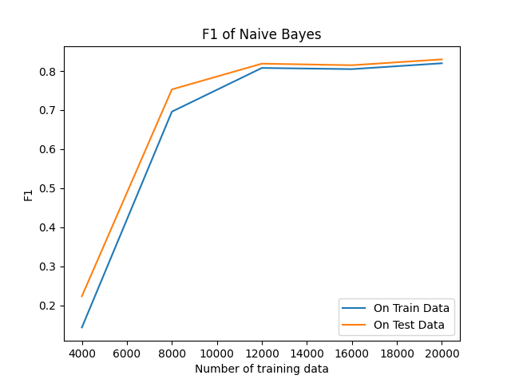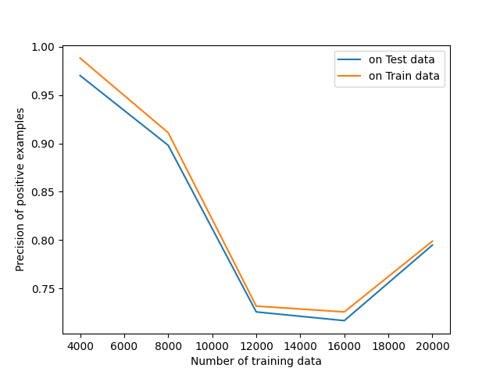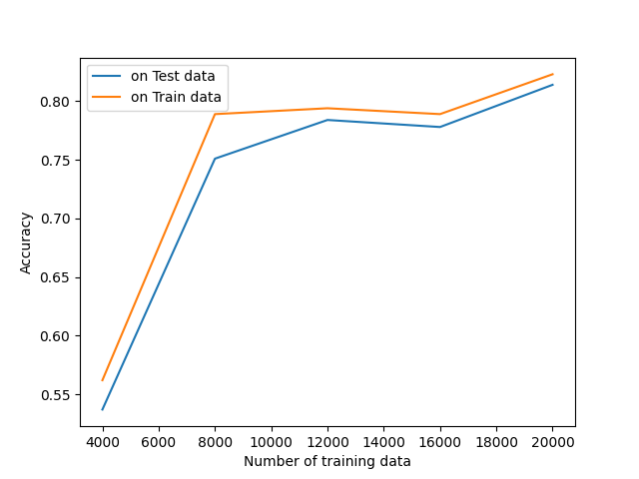

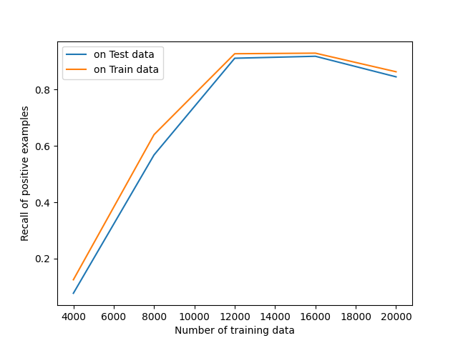

Random Forest

|  |  |  |
| --- | --- | --- |
|  | Accuracy | |
| No. of Training Data | Train | Test |
| 4000 | 0.855 | 0.856 |
| 8000 | 0.933 | 0.934 |
| 12000 | 0.939 | 0.94 |
| 16000 | 0.895 | 0.895 |
| 20000 | 0.902 | 0.903 |

|  |  |  |
| --- | --- | --- |
|  | Precision (Positive) | |
| No. of Training Data | Train | Test |
| 4000 | 0.916 | 0.919 |
| 8000 | 0.987 | 0.986 |
| 12000 | 0.987 | 0.986 |
| 16000 | 0.91 | 0.911 |
| 20000 | 0.923 | 0.927 |

|  |  |  |
| --- | --- | --- |
|  | Recall (Positive) | |
| No. of Training Data | Train | Test |
| 4000 | 0.782 | 0.781 |
| 8000 | 0.878 | 0.88 |
| 12000 | 0.889 | 0.892 |
| 16000 | 0.877 | 0.876 |
| 20000 | 0.878 | 0.876 |
|  | F1 (Positive) | |
| No. of Training Data | Train | Test |
| 4000 | 0.844 | 0.844 |
| 8000 | 0.929 | 0.93 |
| 12000 | 0.935 | 0.937 |
| 16000 | 0.893 | 0.893 |
| 20000 | 0.9 | 0.901 |

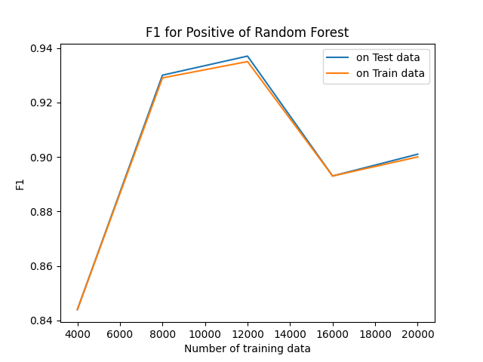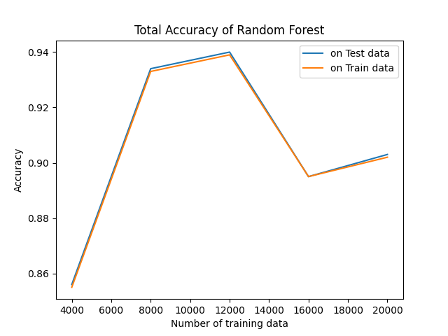

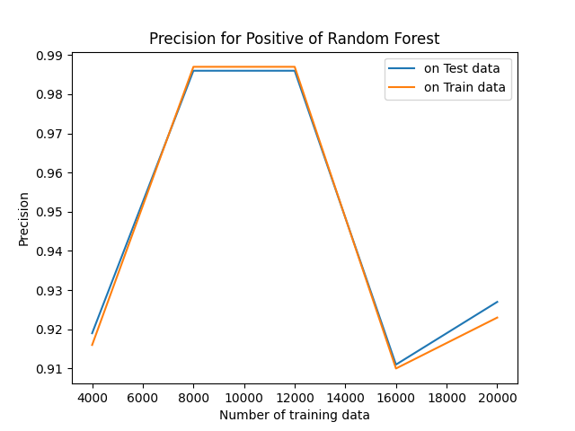

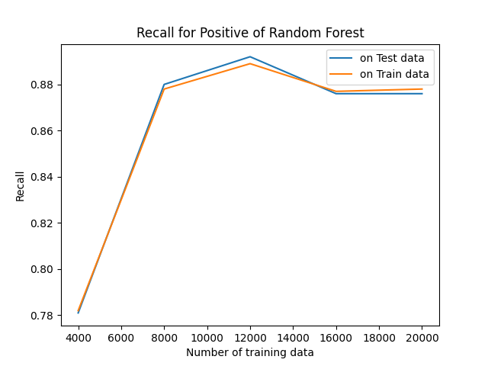

AdaBoost

|  |  |  |
| --- | --- | --- |
|  | Accuracy | |
| No. of Training Data | Train | Test |
| 4000 | 0.81 | 0.783 |
| 8000 | 0.809 | 0.79 |
| 12000 | 0.801 | 0.794 |
| 16000 | 0.801 | 0.794 |
| 20000 | 0.803 | 0.799 |

|  |  |  |
| --- | --- | --- |
|  | Precision (Positive) | |
| No. of Training Data | Train | Test |
| 4000 | 0.789 | 0.773 |
| 8000 | 0.797 | 0.784 |
| 12000 | 0.778 | 0.771 |
| 16000 | 0.782 | 0.775 |
| 20000 | 0.781 | 0.775 |

|  |  |  |
| --- | --- | --- |
|  | Recall (Positive) | |
| No. of Training Data | Train | Test |
| 4000 | 0.847 | 0.8 |
| 8000 | 0.83 | 0.803 |
| 12000 | 0.842 | 0.835 |
| 16000 | 0.834 | 0.827 |
| 20000 | 0.843 | 0.841 |

|  |  |  |
| --- | --- | --- |
|  | F1 (Positive) | |
| No. of Training Data | Train | Test |
| 4000 | 0.817 | 0.786 |
| 8000 | 0.813 | 0.793 |
| 12000 | 0.809 | 0.802 |
| 16000 | 0.807 | 0.8 |
| 20000 | 0.811 | 0.807 |

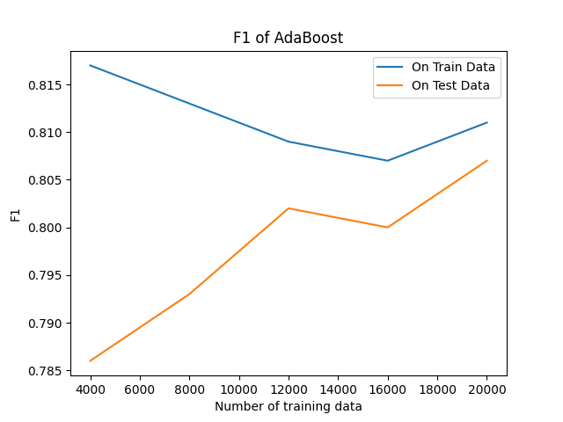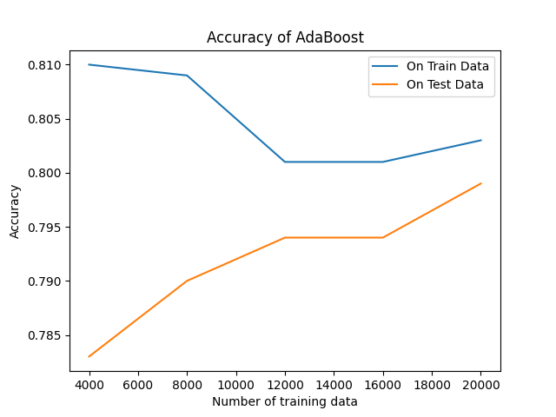

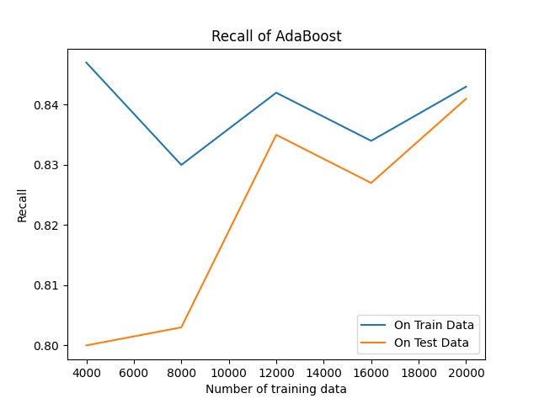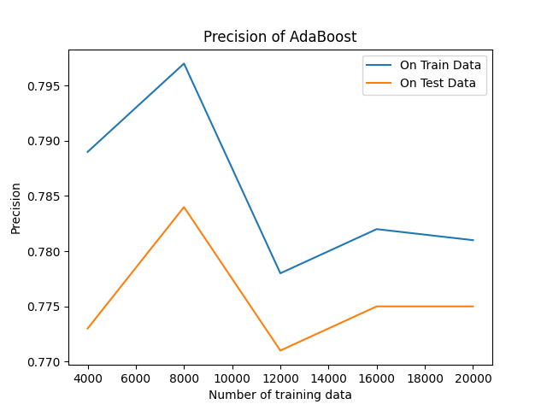

Bayes - Scikit

|  |  |  |
| --- | --- | --- |
|  | Accuracy | |
| No. of Training Data | Train | Test |
| 4000 | 0.846 | 0.775 |
| 8000 | 0.842 | 0.796 |
| 12000 | 0.832 | 0.8 |
| 16000 | 0.831 | 0.807 |
| 20000 | 0.826 | 0.808 |

|  |  |  |
| --- | --- | --- |
|  | Precision (Positive) | |
| No. of Training Data | Train | Test |
| 4000 | 0.877 | 0.819 |
| 8000 | 0.854 | 0.821 |
| 12000 | 0.844 | 0.82 |
| 16000 | 0.844 | 0.824 |
| 20000 | 0.843 | 0.828 |

|  |  |  |
| --- | --- | --- |
|  | Recall (Positive) | |
| No. of Training Data | Train | Test |
| 4000 | 0.804 | 0.706 |
| 8000 | 0.824 | 0.756 |
| 12000 | 0.815 | 0.769 |
| 16000 | 0.811 | 0.779 |
| 20000 | 0.801 | 0.777 |

|  |  |  |
| --- | --- | --- |
|  | F1 (Positive) | |
| No. of Training Data | Train | Test |
| 4000 | 0.839 | 0.758 |
| 8000 | 0.839 | 0.787 |
| 12000 | 0.829 | 0.794 |
| 16000 | 0.827 | 0.801 |
| 20000 | 0.821 | 0.802 |

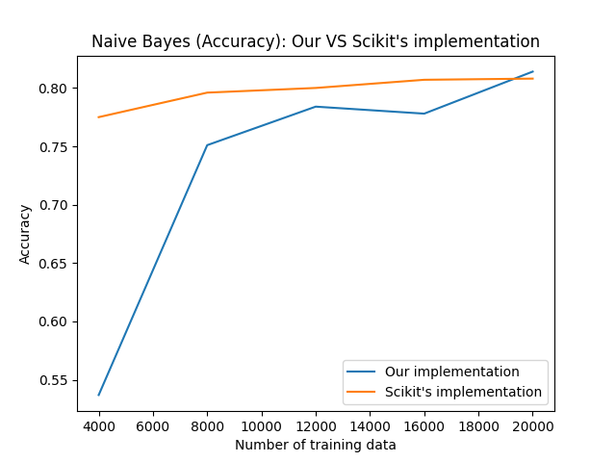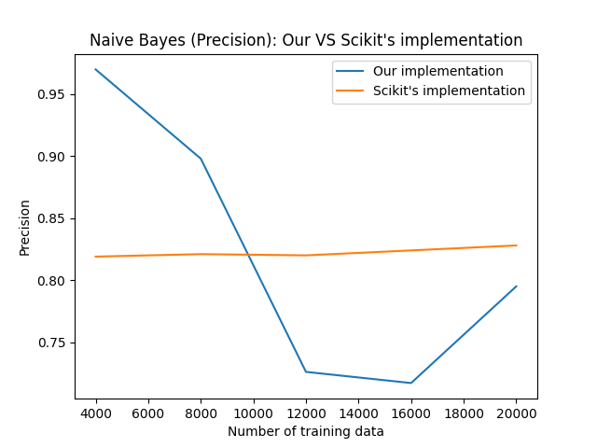

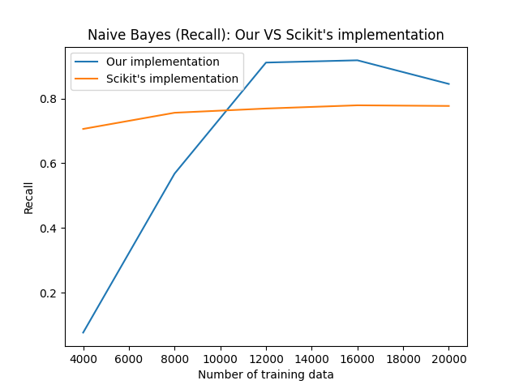

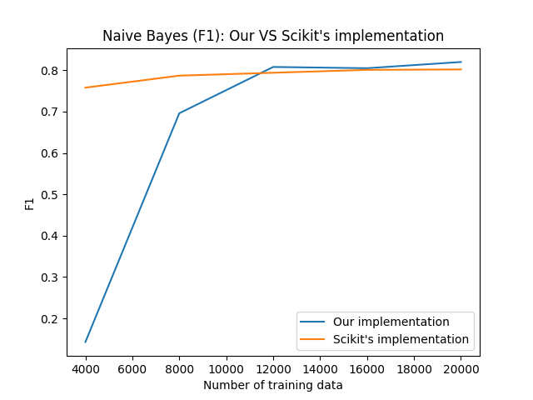

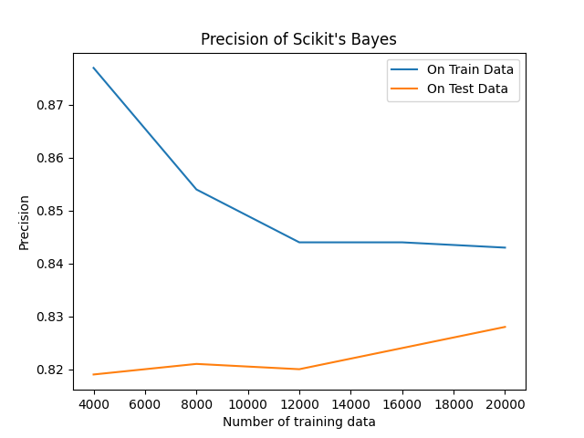

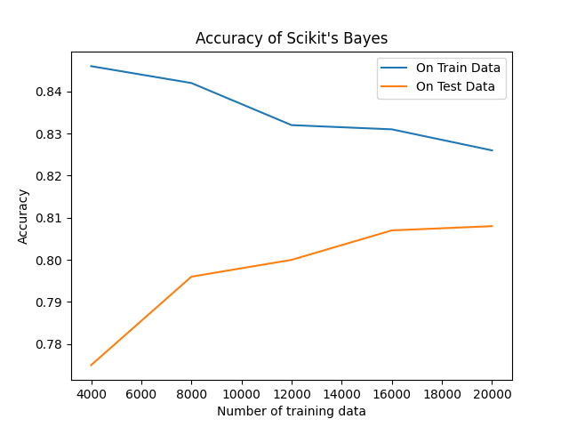

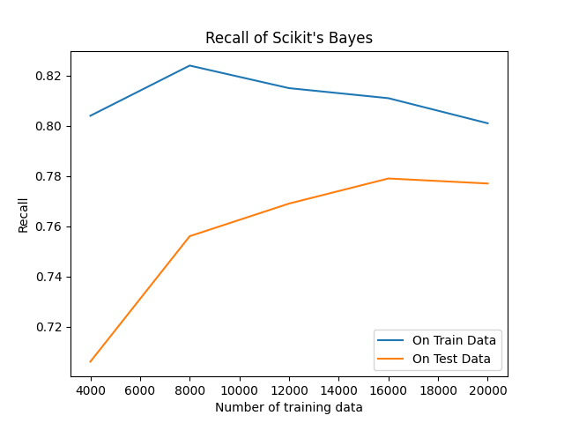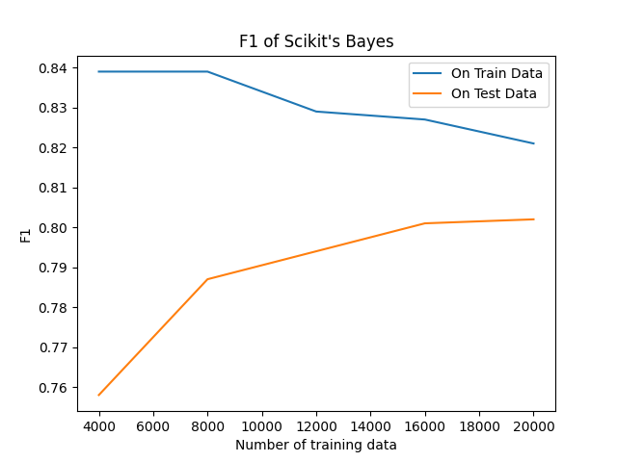

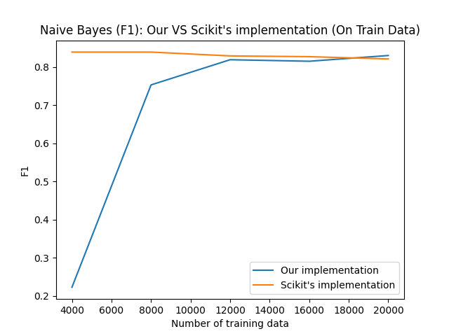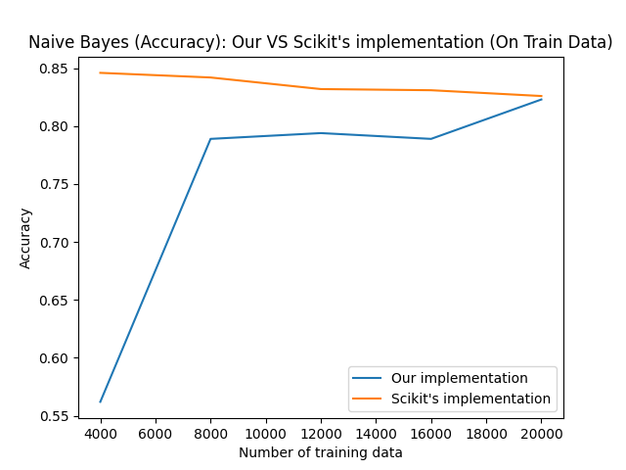

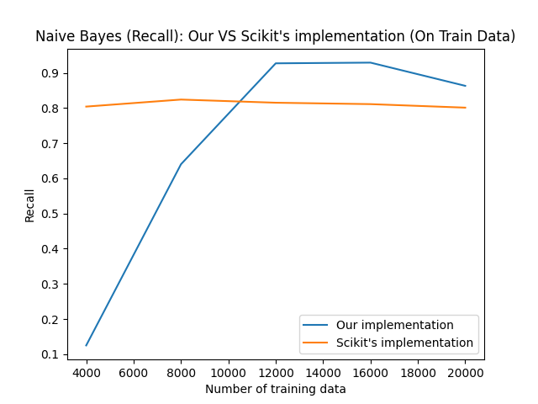

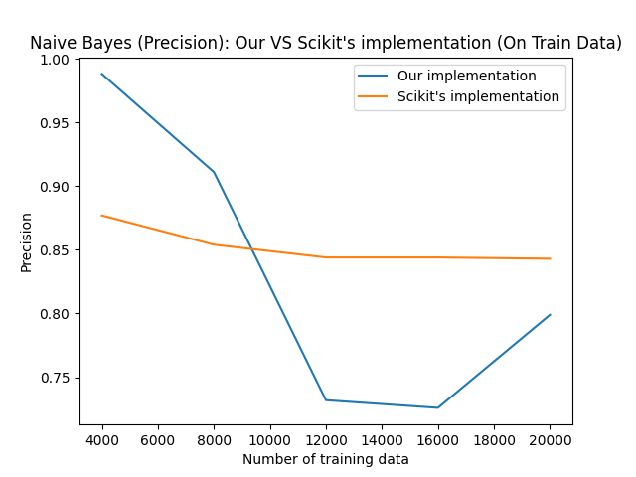

Random Forest - Scikit

|  |  |  |
| --- | --- | --- |
|  | Accuracy | |
| No. of Training Data | Train | Test |
| 4000 | 0.797 | 0.784 |
| 8000 | 0.791 | 0.776 |
| 12000 | 0.777 | 0.77 |
| 16000 | 0.772 | 0.768 |
| 20000 | 0.775 | 0.77 |

|  |  |  |
| --- | --- | --- |
|  | Precision (Positive) | |
| No. of Training Data | Train | Test |
| 4000 | 0.756 | 0.75 |
| 8000 | 0.742 | 0.731 |
| 12000 | 0.727 | 0.723 |
| 16000 | 0.72 | 0.717 |
| 20000 | 0.725 | 0.722 |

|  |  |  |
| --- | --- | --- |
|  | Recall (Positive) | |
| No. of Training Data | Train | Test |
| 4000 | 0.876 | 0.852 |
| 8000 | 0.894 | 0.875 |
| 12000 | 0.887 | 0.877 |
| 16000 | 0.891 | 0.886 |
| 20000 | 0.885 | 0.878 |

|  |  |  |
| --- | --- | --- |
|  | F1 (Positive) | |
| No. of Training Data | Train | Test |
| 4000 | 0.812 | 0.798 |
| 8000 | 0.811 | 0.797 |
| 12000 | 0.799 | 0.793 |
| 16000 | 0.796 | 0.793 |
| 20000 | 0.797 | 0.792 |

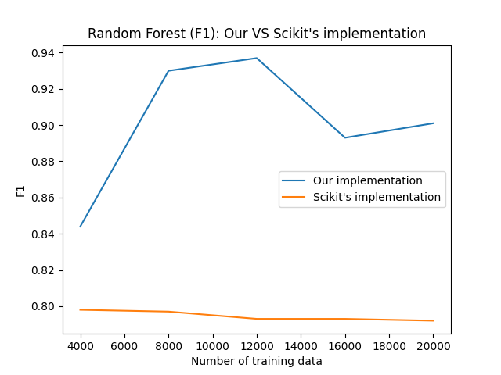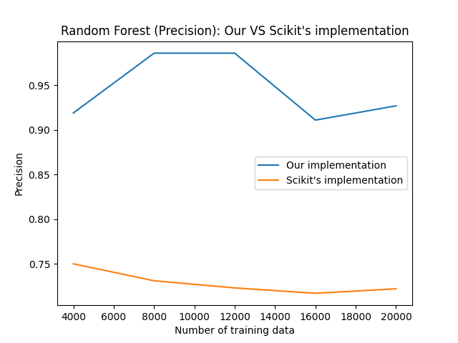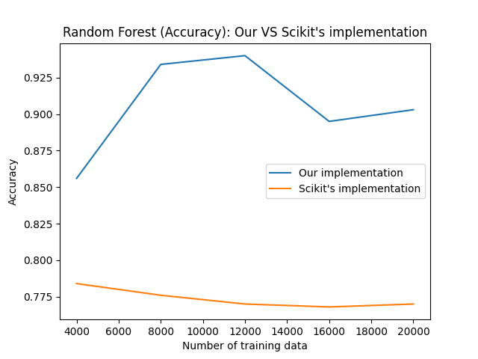

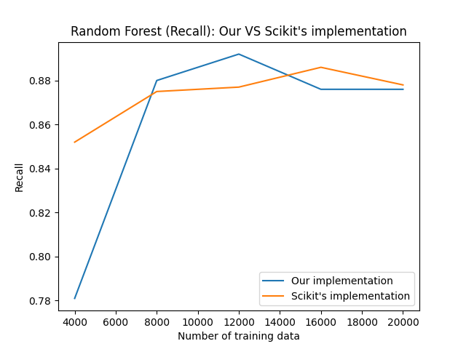

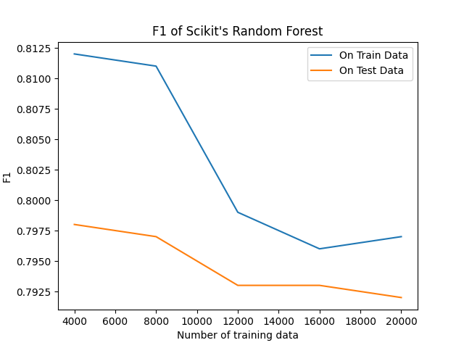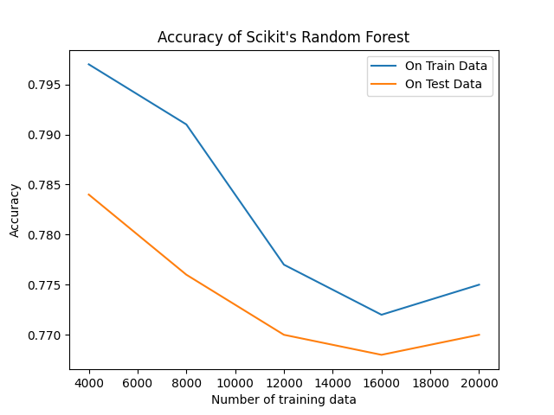

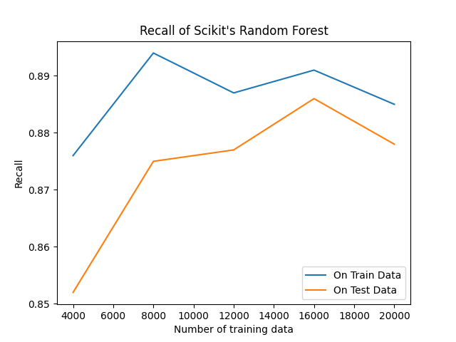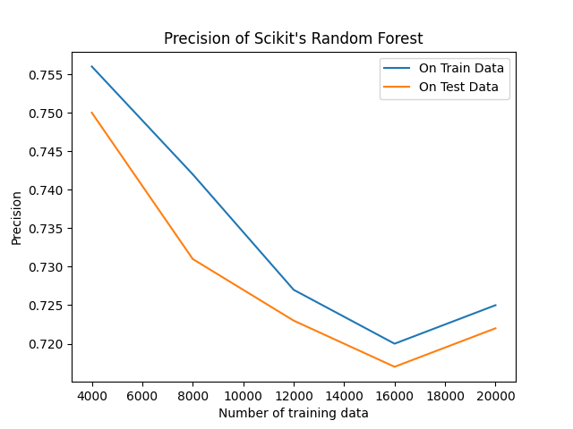

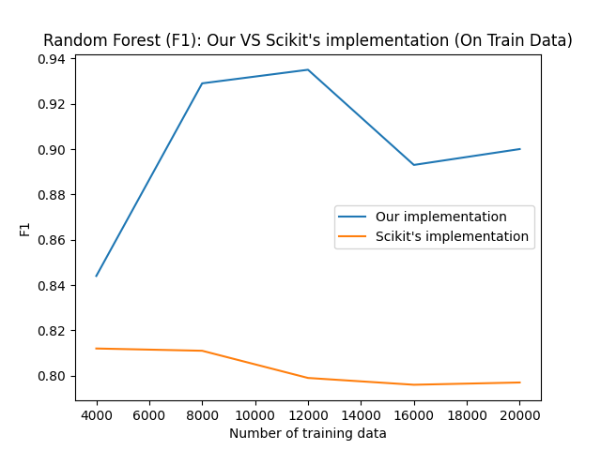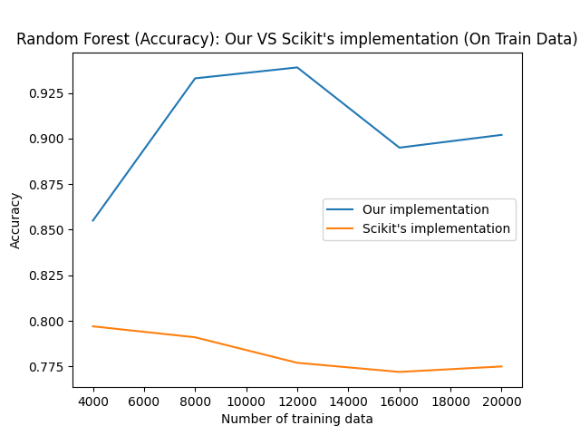

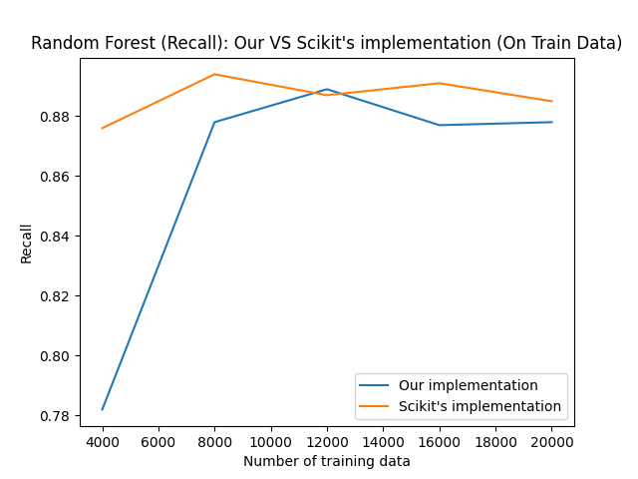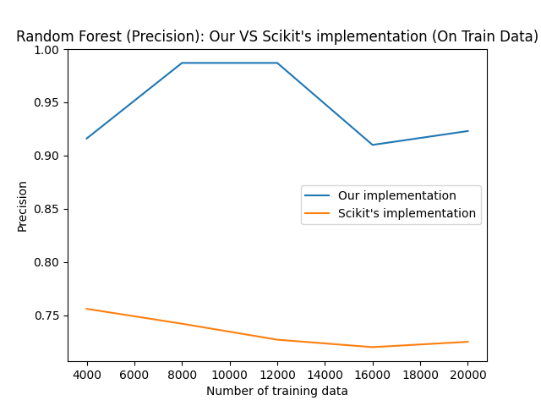

AdaBoost - Scikit

|  |  |  |
| --- | --- | --- |
|  | Accuracy | |
| No. of Training Data | Train | Test |
| 4000 | 0.803 | 0.774 |
| 8000 | 0.798 | 0.782 |
| 12000 | 0.79 | 0.785 |
| 16000 | 0.795 | 0.784 |
| 20000 | 0.794 | 0.787 |

|  |  |  |
| --- | --- | --- |
|  | Precision (Positive) | |
| No. of Training Data | Train | Test |
| 4000 | 0.771 | 0.751 |
| 8000 | 0.772 | 0.759 |
| 12000 | 0.761 | 0.757 |
| 16000 | 0.764 | 0.754 |
| 20000 | 0.762 | 0.754 |

|  |  |  |
| --- | --- | --- |
|  | Recall (Positive) | |
| No. of Training Data | Train | Test |
| 4000 | 0.862 | 0.818 |
| 8000 | 0.847 | 0.827 |
| 12000 | 0.847 | 0.839 |
| 16000 | 0.853 | 0.844 |
| 20000 | 0.856 | 0.852 |

|  |  |  |
| --- | --- | --- |
|  | F1 (Positive) | |
| No. of Training Data | Train | Test |
| 4000 | 0.814 | 0.783 |
| 8000 | 0.808 | 0.792 |
| 12000 | 0.802 | 0.796 |
| 16000 | 0.806 | 0.796 |
| 20000 | 0.806 | 0.8 |

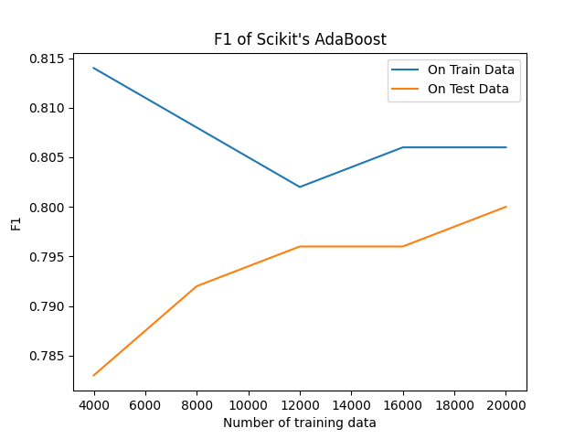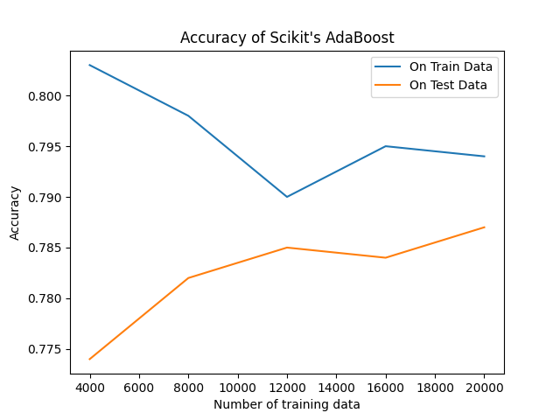

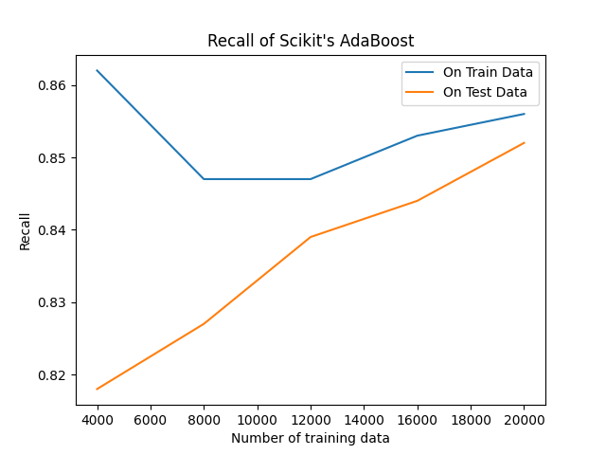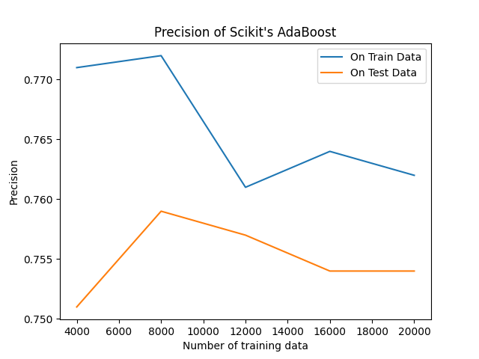

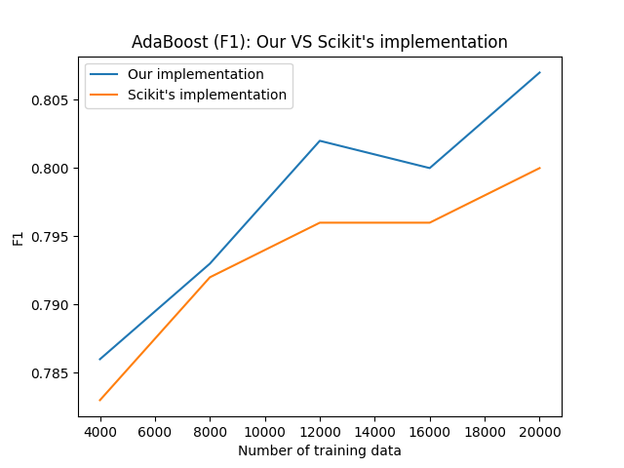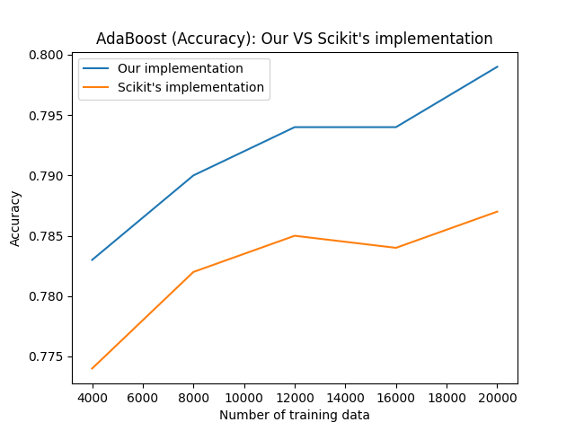

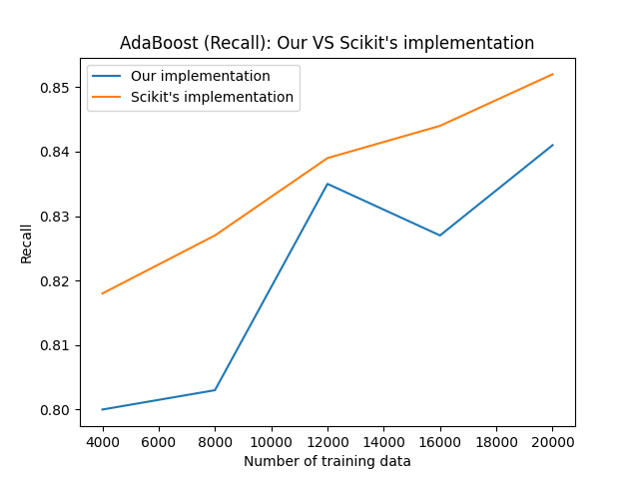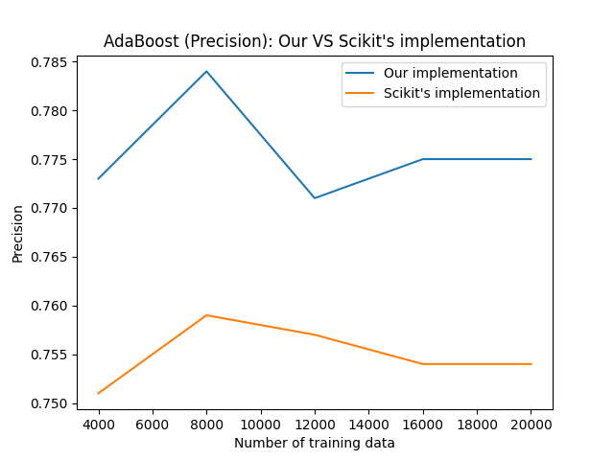

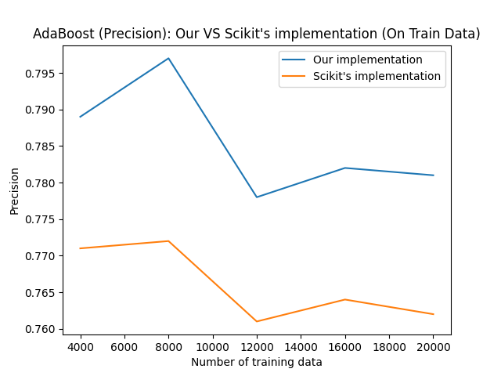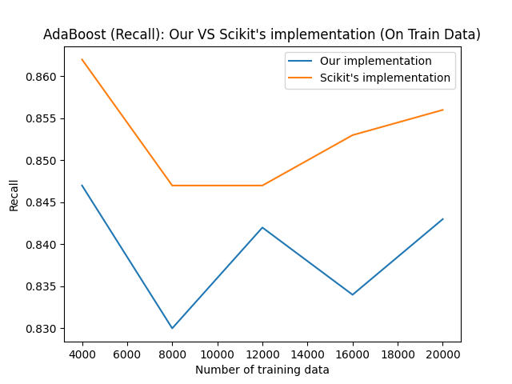

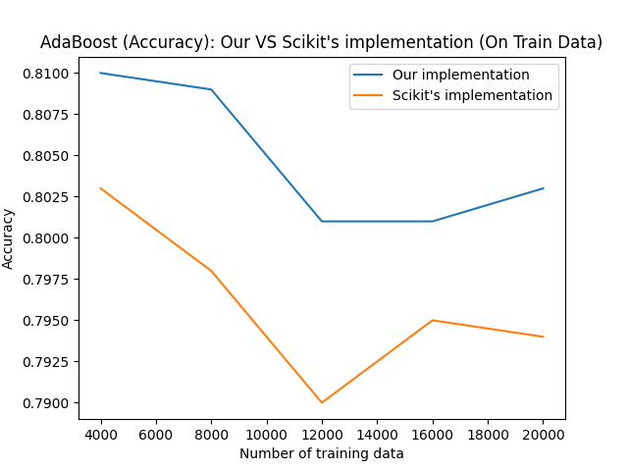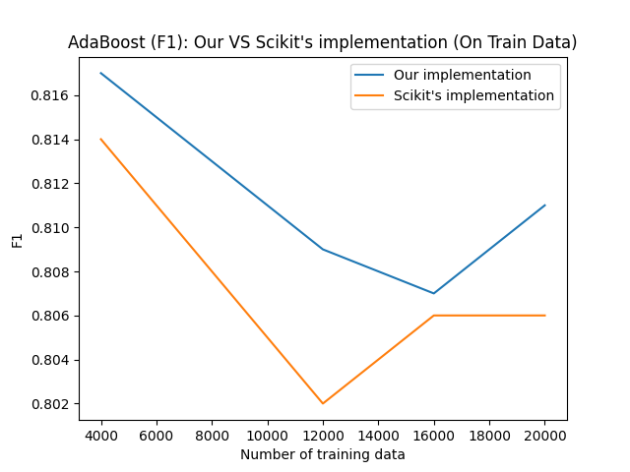

RNN

|  |  |  |
| --- | --- | --- |
|  | Accuracy | |
| No. of Training Data | Train | Test |
| 4000 | 0.651 | 0.5 |
| 8000 | 0.502 | 0.5 |
| 12000 | 0.735 | 0.503 |
| 16000 | 0.558 | 0.733 |
| 20000 | 0.545 | 0.54 |

|  |  |  |
| --- | --- | --- |
|  | Precision (Positive) | |
| No. of Training Data | Train | Test |
| 4000 | 0.651 | 0.5 |
| 8000 | 0.502 | 0.5 |
| 12000 | 0.734 | 0.503 |
| 16000 | 0.559 | 0.735 |
| 20000 | 0.544 | 0.54 |

|  |  |  |
| --- | --- | --- |
|  | Recall (Positive) | |
| No. of Training Data | Train | Test |
| 4000 | 0.652 | 0.495 |
| 8000 | 0.505 | 0.505 |
| 12000 | 0.737 | 0.501 |
| 16000 | 0.549 | 0.729 |
| 20000 | 0.546 | 0.542 |

|  |  |  |
| --- | --- | --- |
|  | F1 (Positive) | |
| No. of Training Data | Train | Test |
| 4000 | 0.651 | 0.497 |
| 8000 | 0.503 | 0.502 |
| 12000 | 0.735 | 0.502 |
| 16000 | 0.554 | 0.732 |
| 20000 | 0.545 | 0.541 |

RNN

|  |  |  |
| --- | --- | --- |
|  | Error (4000 Training Examples) | |
| No. Age | Train | Test |
| 2 | 0.684 | 0.698 |
| 4 | 0.669 | 0.696 |
| 6 | 0.652 | 0.702 |
| 8 | 0.61 | 0.689 |
| 10 | 0.511 | 0.693 |

RNN

|  |  |  |
| --- | --- | --- |
|  | Error (8000 Training Examples) | |
| No. Age | Train | Test |
| 2 | 0.687 | 0.693 |
| 4 | 0.674 | 0.686 |
| 6 | 0.661 | 0.688 |
| 8 | 0.633 | 0.688 |
| 10 | 0.695 | 0.690 |

RNN

|  |  |  |
| --- | --- | --- |
|  | Error (12000 Training Examples) | |
| No. Age | Train | Test |
| 2 | 0.685 | 0.694 |
| 4 | 0.655 | 0.692 |
| 6 | 0.603 | 0.674 |
| 8 | 0.676 | 0.703 |
| 10 | 0.693 | 0.695 |

RNN

|  |  |  |
| --- | --- | --- |
|  | Error (16000 Training Examples) | |
| No. Age | Train | Test |
| 2 | 0.687 | 0.692 |
| 4 | 0.658 | 0.668 |
| 6 | 0.568 | 0.694 |
| 8 | 0.579 | 0.645 |
| 10 | 0.687 | 0.582 |

RNN

|  |  |  |
| --- | --- | --- |
|  | Error (20000 Training Examples) | |
| No. Age | Train | Test |
| 2 | 0.685 | 0.685 |
| 4 | 0.657 | 0.580 |
| 6 | 0.508 | 0.708 |
| 8 | 0.626 | 0.610 |
| 10 | 0.643 | 0.691 |



