Head Tails:

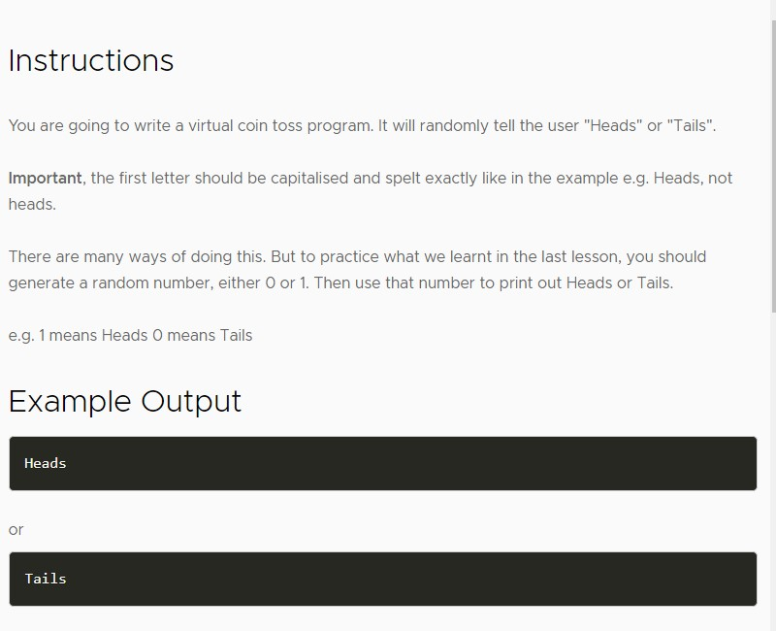

Banker Roulette

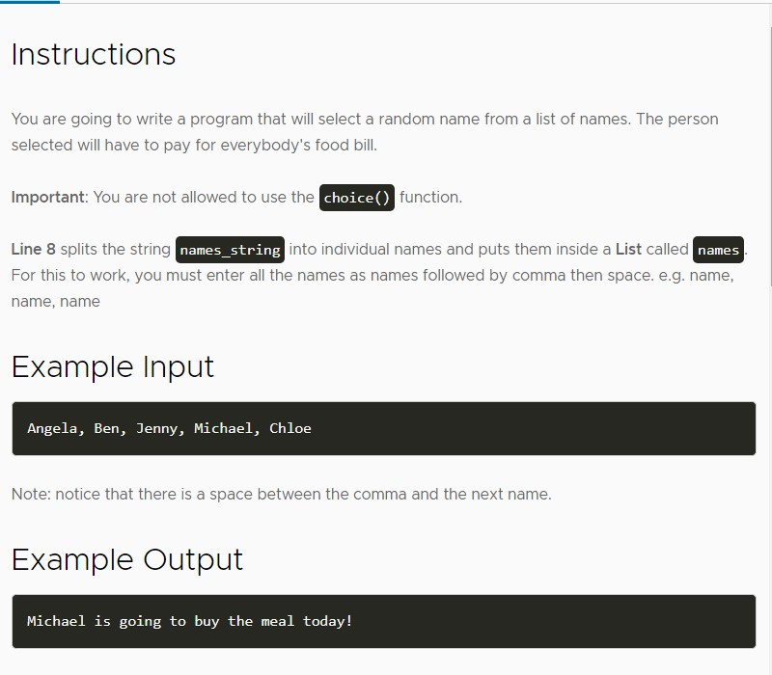

Treasure Map

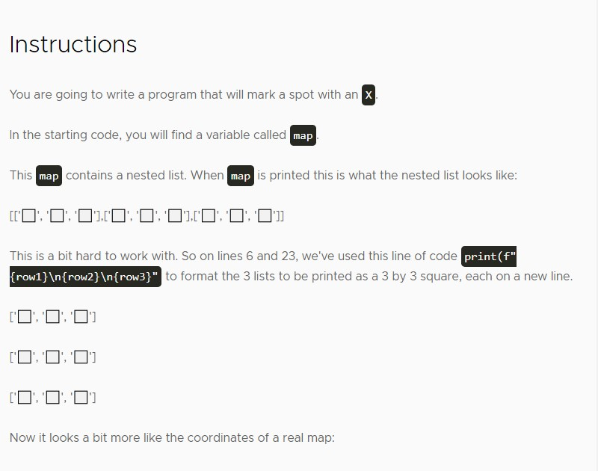

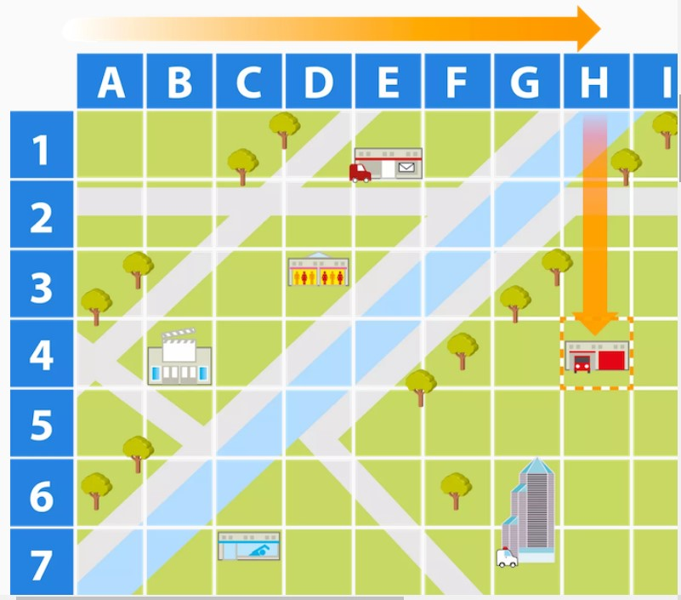

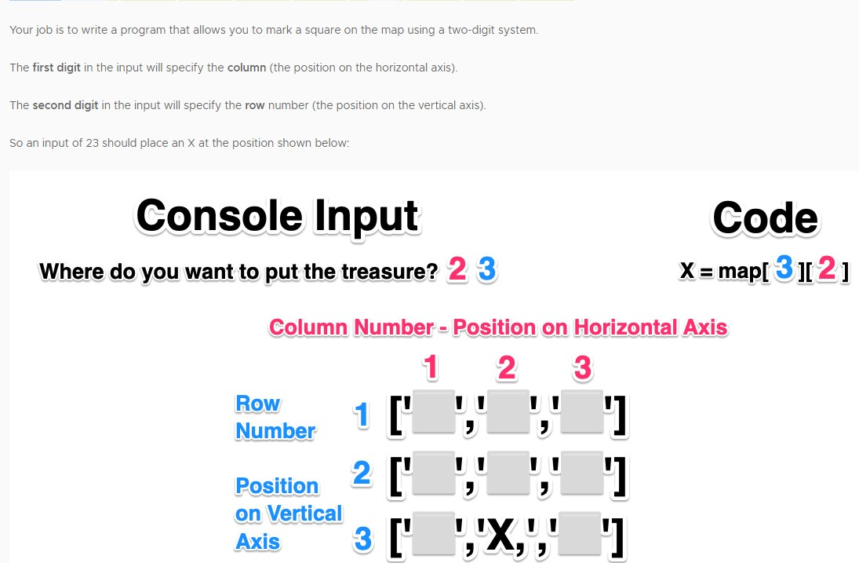

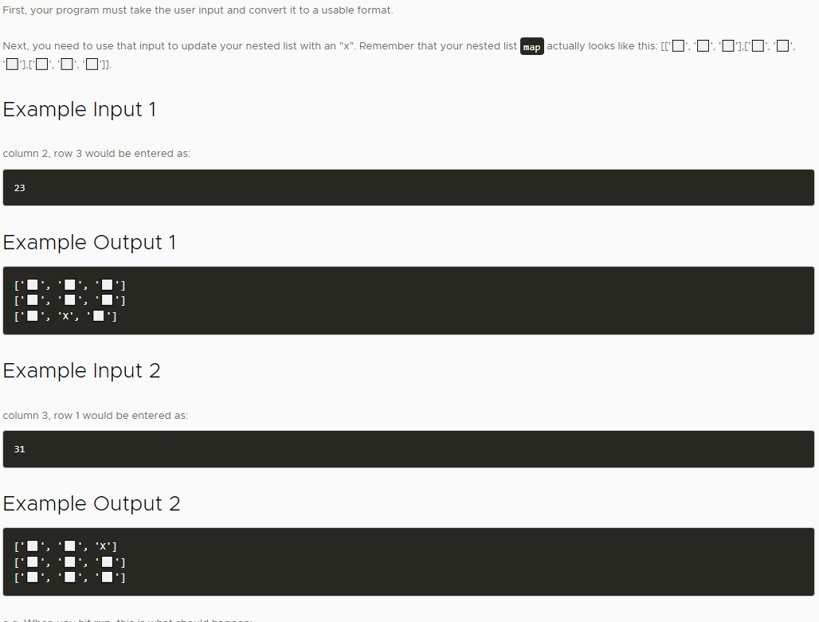

Rock Paper Scissors

**Instructions**

Make a rock, paper, scissors game.

Inside the main.py file, you'll find the ASCII art for the hand signals already saved to a corresponding variable: rock, paper, and scissors. This will make it easy to print them out to the console.

Start the game by asking the player:

*"What do you choose? Type 0 for Rock, 1 for Paper or 2 for Scissors."*

From there you will need to figure out:

* How you will store the user's input.
* How you will generate a random choice for the computer.
* How you will compare the user's and the computer's choice to determine the winner (or a draw).
* And also how you will give feedback to the player.

You can find the "official" rules of the game on [the World Rock Paper Scissors Association website.](https://wrpsa.com/the-official-rules-of-rock-paper-scissors/" \t "_blank)