# Team Project Assignment

# You are given a web application, an online store, and a rough specification regarding the requirements. Your task is to find the misconceptions in the specification, the broken functionalities, user experience problems, ad security issues. You can use any tools for test planning, test execution, and bug reporting. But it's very important to document all your work in corresponding issues in the issue tracker you are given.

## Project Team Members

The Development Lead​, the Lead of Design and Art, and the Project Manager are the project members​. Communicate well with them in the issue tracker and address issues to the relevant department.

## Software Requirements

1. Introduction
   1. Purpose

The purpose of this document is to present a detailed description of the Online Web Store application (from now on called Online Store, Store, or simply Project). It will explain some of the key features at a very high level.

* 1. Scope

The document will cover the basic functionality on a high level regarding the Online Store. The user-management system, the Orders creation and operation, and its respective details. The administrative part – what the special user (Administrator) is not in the scope.

1. Overall description
   1. System environment

The Store has two active actors and one cooperating system. All of them are accessing their parts from the internet. The Unregistered user can access the basic functionality of the project. One can view products and pictures. The Registered user can access some of the basic CRUD operations over the orders. One can create order, edit its own orders, add and remove details from it.

* 1. Vocabulary
     1. Product page

A product page is the main information block regarding a product. Below the search field, there is a logo picture with the product's name, and below it, there is a navigation pane with hyperlinks to the home page and the category of the product. Here is an image of the described so far:

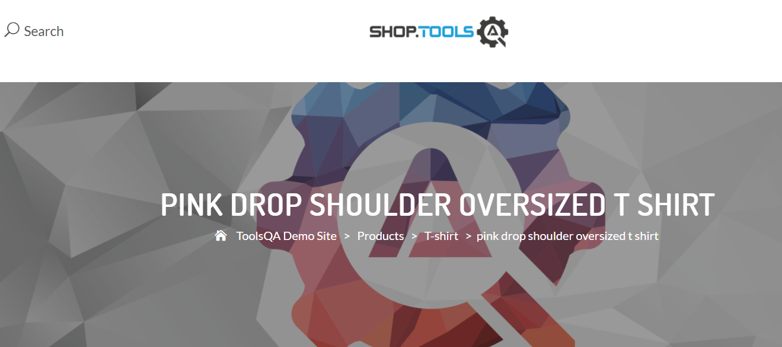

Below, the page consists of the product picture on the left and the product name on its right. There is a price and a short description of the product below the name. There are options for the product, and they are color, size, and quantity. There is an **"ADD TO CART"** button next to the quantity option. Also, there is a button for adding the item to favorites and a button for comparison between two products.

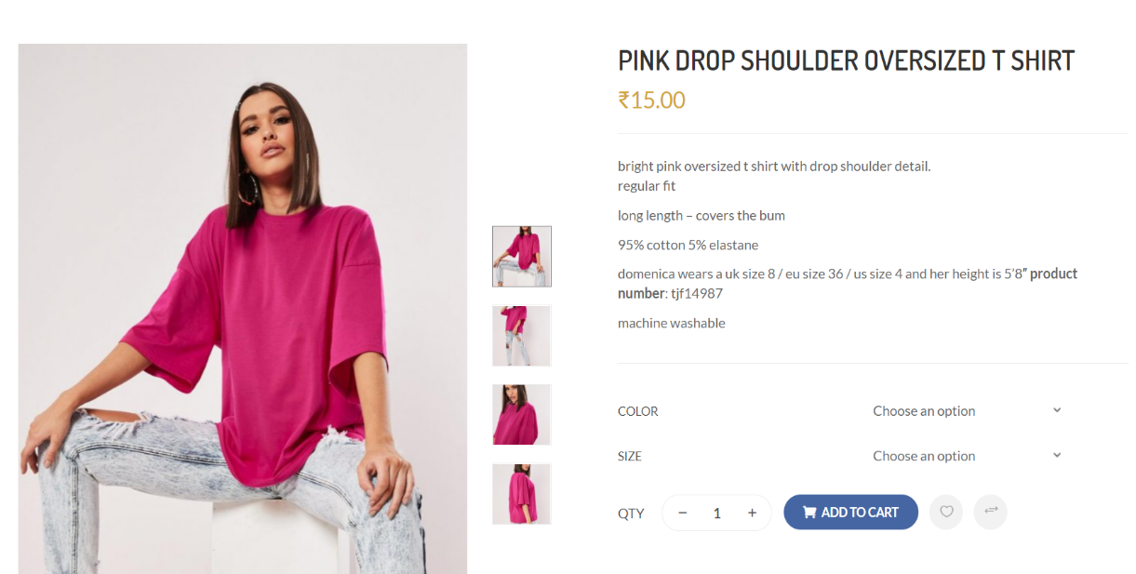

The link of the category and related product's tags are below, and under them are positioned share links to social media sites.



Additional information about the product can be seen below, as well as a section called **"RELATED PRODUCTS"**, which contains listed products that can rely on the currently viewed one. Here is an image of the described section:

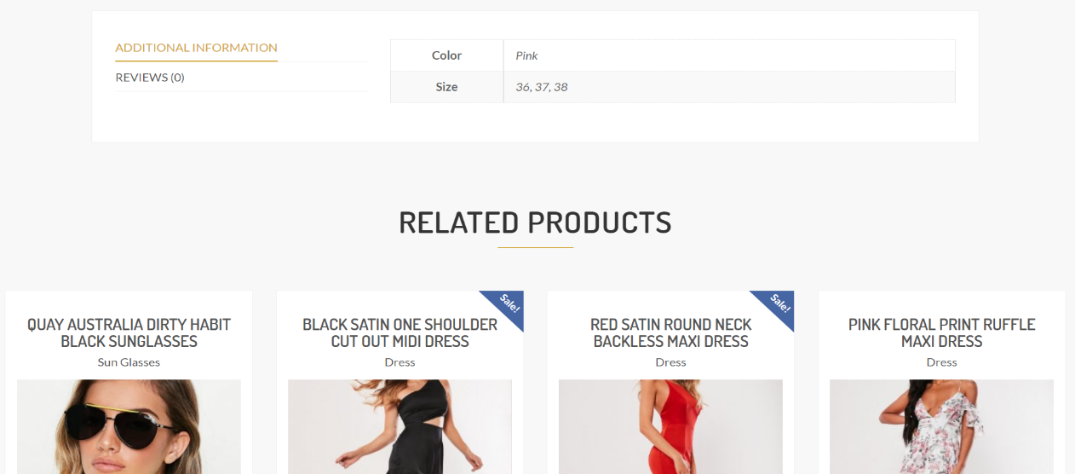

* + 1. Simple view​

A simple view is the main short information block regarding a product. It is accessible on mouse hover from the home page, and it consists of the blurred picture of the product along with options (links) for zooming, adding to favorites, and comparing the product with another. Below the picture, the price is visible and next to it is an option for rating the product with stars. There is a triangle figure with dots inside on the upper left corner, which hold no functionality.

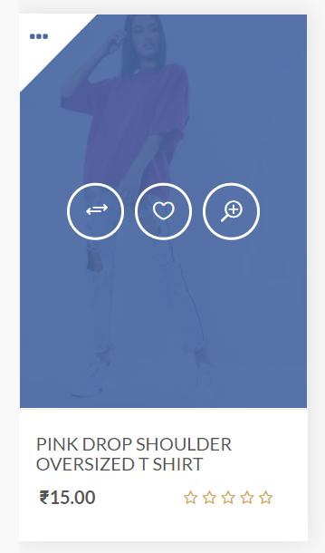

* + 1. Products view

It is accessible through a link on the logo below the search field on the product page. It presents a list or a grid (it is optional) with the products in the category. There is a filter for color and size and sorting options in a menu above the products.

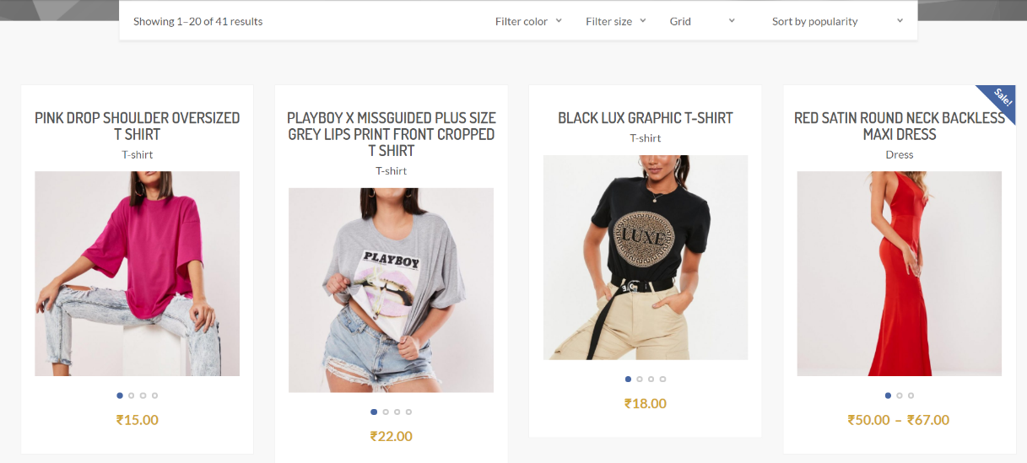

* 1. Functional requirement specification  
     1. Use Case 1 (Accessing the system)

The system is accessed through the internet from its initial URL. It loads the header, navigation bar, and home page.

* + 1. Use Case 2 (Navigation bar)

The navigation bar has navigational hyperlinks to the Home page, My Wishlist, My Account, Checkout, contacts (displayed email and phone), Cart, and a Search field.

* + - 1. Navigation bar – Checkout

When the visitor is unregistered, the Checkout hyperlink should redirect to the Cart. When the visitor is registered and logged in, the behavior stays the same.

* + - 1. Navigation bar – User Management

When the visitor is unregistered, the My Account hyperlink should redirect to the Login and Register form. When the visitor is registered, the hyperlink to the My Account page should navigate to the current account page.

When the user is successfully logged out, there should be a redirect to the My Account page with the Login and Register form.

* + 1. Use Case 3 (Home page)

The home page shows the Product blocks in а certain order. Below them, there is a **"FASHION NEWS"** section, which consists of blog articles that can be accessed from both registered and unregistered users.

* + 1. Use Case 4 (Products Page)

Information regarding the category is shown as links (e.g., t-shirts) in the navigation pane, where the user can choose where to go next. Display functionality offers the possibility to show how products are shown, based on the following views:  
-Grid  
-List  
The respective information regarding the products is shown on the page in the form of random results. A simple view should display the products. When the filter is applied (sub-category), the page should display the respective products found. If the input data is invalid, a respective error box is shown, indicating that products are **"Not Found"** and **"Apologies, but the page you requested could not be found. Perhaps searching will help."** tip.

* + 1. Use Case 5 (Add product to Cart)

In order to add the product to Cart, one needs to log in to the site. By clicking **"Add to cart"** from any product view, the user is informed that the item is added to its Cart – **"{product} has been added to your cart"**. Next to the message, some options are given: either **"View Cart"** or go back to **"Continue Shopping"**.

* + - 1. Add product to Cart – Cart Page

Cart is displayed when a logged user chooses the **"View cart"** option when a product is added. On the page the following options are available: **"Clear shopping cart"**, **"Update shopping cart"**, **"Go to favorites"**, **"Continue shopping"**, and below the there are two more options: **"Apply coupon"** and **"Proceed to checkout"**. When the user chooses to checkout, they are redirected to the checkout page.

* + - 1. Add product to Cart – Checkout Page

The checkout page shows the billing details section and your order section. The user is asked to fill in the following billing details:

* First name
* Last name
* Email Address – This field should be automatically filled with the user email
* Additional information (Optional)

The order section contains the chosen product or products as well as the total price for them. There is the option to **"Place order"**. Upon clicking it, the user is redirected to another page and is notified that his order was successful, as well as the billing information.

* + 1. Use Case 6 (My account)

Clicking on the My Account hyperlink from the header navigates to the My account page. The links available on the account page are:

* Dashboard
* Orders
* Downloads
* Addresses
* Favorites
* Account details
* Logout  
  + - 1. My Account – Orders

My Account hyperlink navigates to the Order History page. Here we show all transactions for the current month. If there are no such transactions – the user is informed through a friendly message.

* + - 1. My Account – Account Details

My Account hyperlink navigates to the User details page. Here we allow edition and update of the Billing/contact details and Shipping Address.

* + - 1. My account – Downloads

My Account hyperlink navigates to the Downloads page. Here we show all purchased downloadable products for the current month. If there are no such transactions - the user is informed through a friendly message.

* + 1. Use Case 7 (Search)

Clicking on the Search form in the header allows for product finds by given keywords. If we have such products, we should show a list with the results. If no product is found, we should display an error message stating, **"Sorry, but nothing matched your search criteria. Please try again with some different keywords."**

## Tasks

* Create enough test cases to test the functionalities described in the SRS.
* Save those test cases in simple files (TXT or XLS/X) or a test management system. You can use the templates. Add screenshots to your test cases if necessary. Upload all the files as a single zip file in the SoftUni system.
* Set correct priority to your test cases depending on the functionality importance. The most important test cases that have to be run are the highest priority. The least important test cases are the lowest priority.

## Resources

The project is located at: http://shop.demoqa.com/