Lab3 Report Dimitry

## Pedump:

First we will view the MZ header for the provided executable.

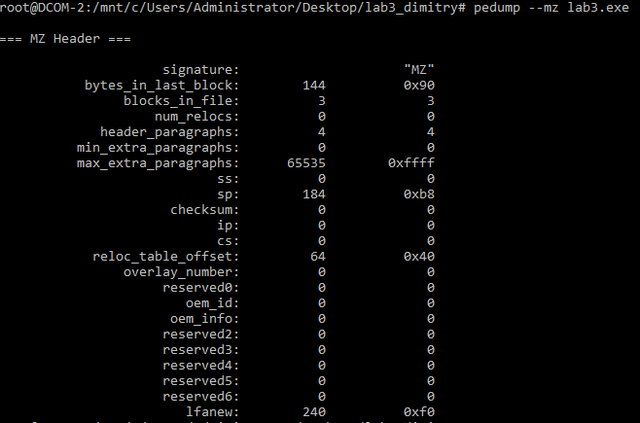

We can see that this is in fact a MZ header file.

Now we will inspect the DOS stub.

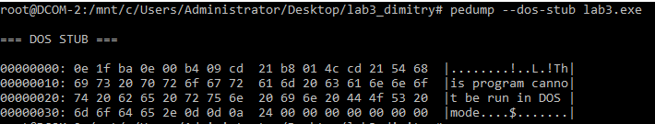

This program cannot be run in DOS mode after all.

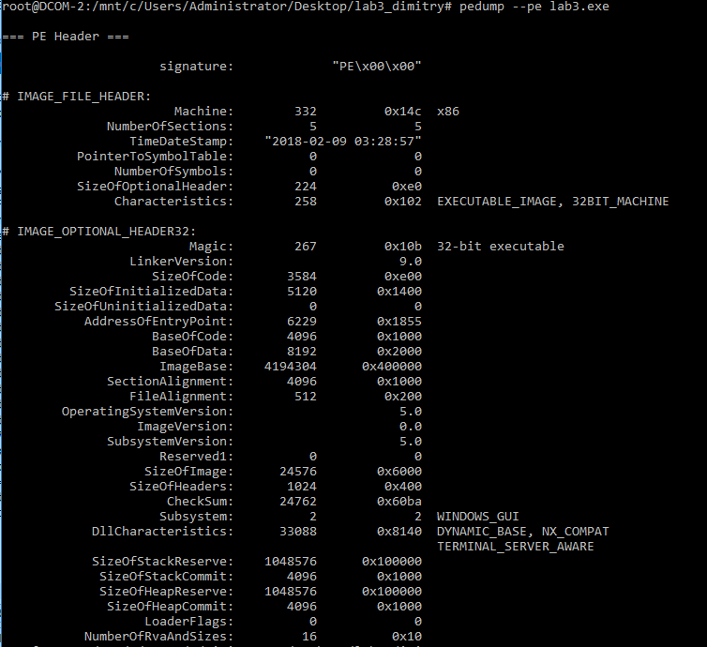

This provides us with some useful info. We find out that this is a 32 bit executable. We get the size of code, bss and data sections. File alignment is default at 512 bytes. Pedump is telling us that this application has graphical elements via the subsystem.

We can view the data directory.

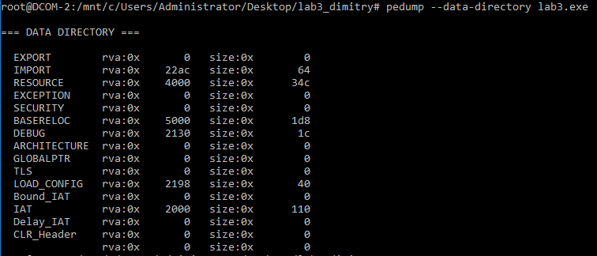

We will also check the Sections.

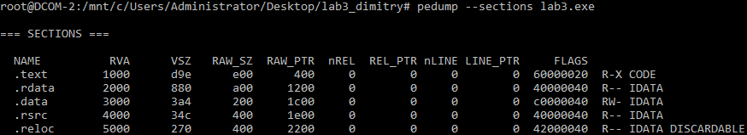

So far nothing seems out of the ordinary.

Now we will check the resources.

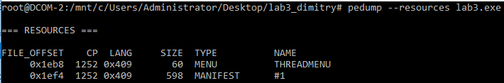

This application appears to have no resources and is threaded.

Now we will check the imports.

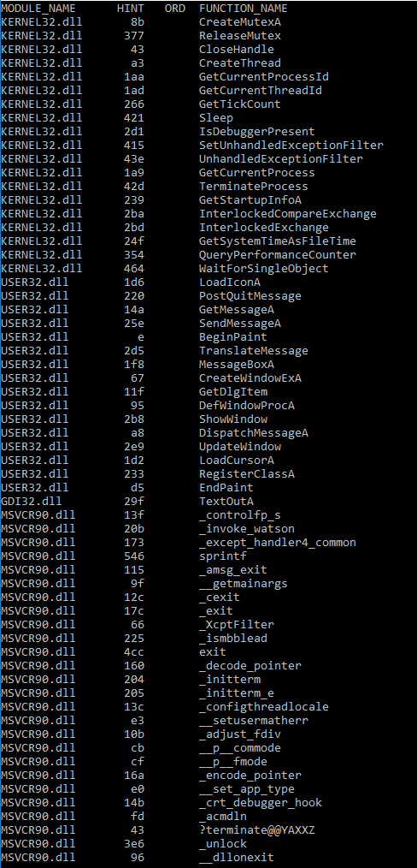

From experience with win32 I can say that something odd is going on here based on imports. The process wants to create threads and new windows by calling CreateWindExA. There is a possibility that this is a simple win32 application.

Let’s check for a packer.

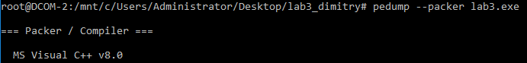

Nothing too suspicious on this front.

## WinDbg

After opening the executable we see this output.

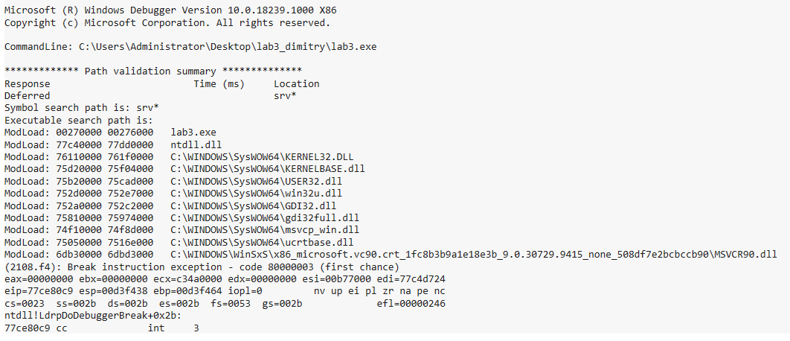

This time all the symbols loaded successfully.

Here we can extract the following info.

|  |  |  |
| --- | --- | --- |
| Base | End | Name |
| 00270000 | 00276000 | lab3.exe |
| 77c40000 | 77dd0000 | ntdll.dll |
| 76110000 | 761f0000 | KERNEL32.DLL |
| 75d20000 | 75f04000 | KERNELBASE.dll |
| 6db30000 | 6dbd3000 | C:\WINDOWS\WinSxS\  \x86_microsoft.vc90.crt_1fc8b3b9a1e18e3b_9  .0.30729.9415_none_508df7e2bcbccb90\MSVCR90.dll |

These were the most suspicious DLLs I found. Many of these provide low level access to system level functions.

Using the lm command we get another printout of similar information.

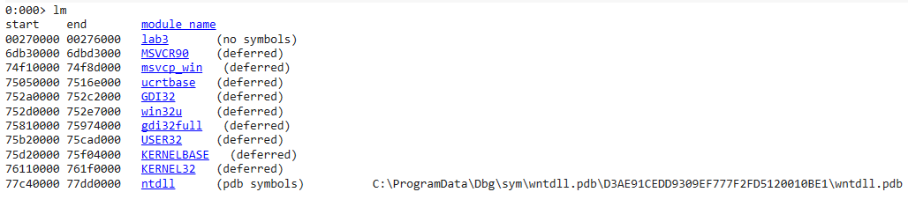

Listing the lab3 we see that there is no information in the resource tables.

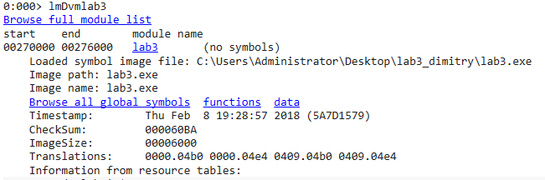

Next we will examine the file headers for the main executable.

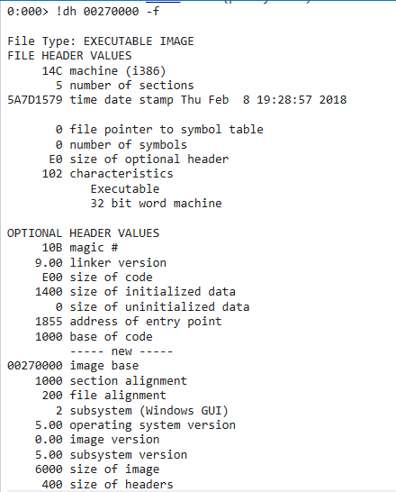

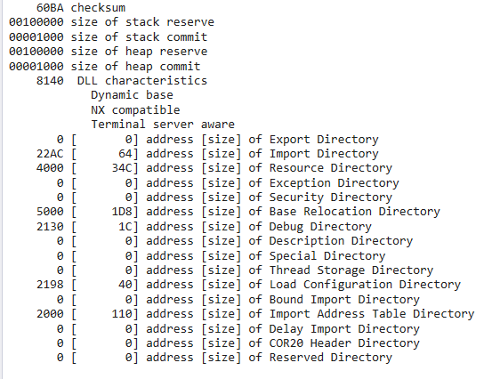

From this output we can see some of the Virtual addresses and sizes of different data directories. Import directory, resource directory, base relocation directory, debug directory, load configuration directory and import address table directory are used.

Now we will take a closer look at the IAT and the Export Directory.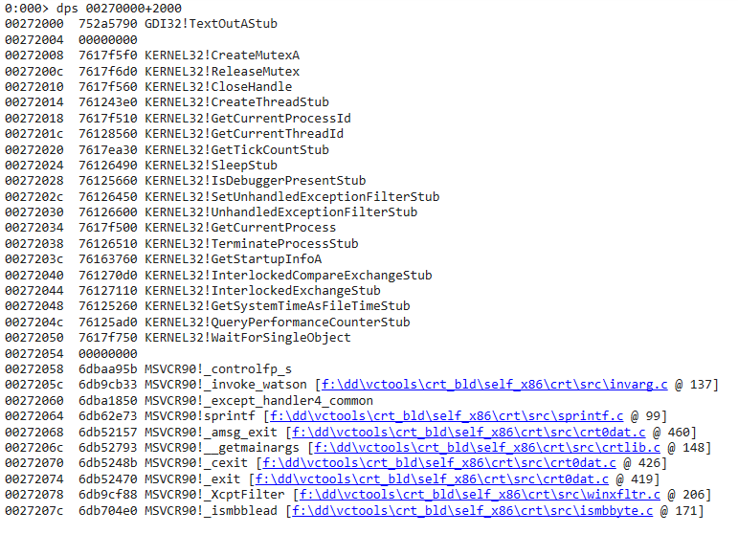

Looks like the application creates threads and uses a mutex to manage some kind of multi-threaded operation.

Now all that is left is to check the exports for some of the suspicious DLLs.

We listed them at the start but let’s put them here again for convenience.

|  |  |  |
| --- | --- | --- |
| Base | End | Name |
| 00270000 | 00276000 | lab3.exe |
| 77c40000 | 77dd0000 | ntdll.dll |
| 76110000 | 761f0000 | KERNEL32.DLL |
| 75d20000 | 75f04000 | KERNELBASE.dll |
| 6db30000 | 6dbd3000 | C:\WINDOWS\WinSxS\  \x86_microsoft.vc90.crt_1fc8b3b9a1e18e3b_9  .0.30729.9415_none_508df7e2bcbccb90\MSVCR90.dll |

Lab3.exe  
Turns out it has no exports which makes sense. It is the main application.

Ntdll.dll

IMAGE_EXPORT_DIRECTORY:

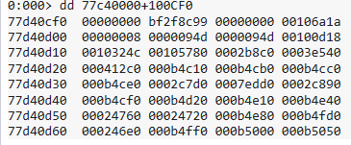

AddressOfNames:

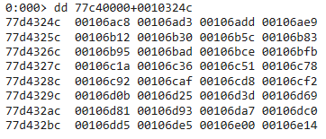

List of String Names

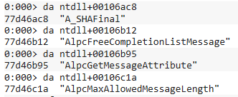

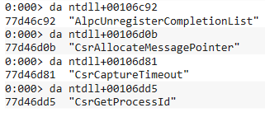

**This is really suspicious. The process is exporting cryptographic functions.**

Script:

r? @$t0 = ((int *) (0x77D4324C))

.for (r @$t1 = 0; @$t1 < 100; r @$t1 = @$t1 + 1) {da ntdll+(@@c++(@$t0[@$t1]));}

Running the customized script, I got:

0:000> $$><C:\Users\Administrator\Desktop\lab3_dimitry\script.wds

77d46ac8 "A_SHAFinal"

77d46ad3 "A_SHAInit"

77d46add "A_SHAUpdate"

77d46ae9 "AlpcAdjustCompletionListConcurre"

77d46b09 "ncyCount"

77d46b12 "AlpcFreeCompletionListMessage"

77d46b30 "AlpcGetCompletionListLastMessage"

77d46b50 "Information"

77d46b5c "AlpcGetCompletionListMessageAttr"

77d46b7c "ibutes"

77d46b83 "AlpcGetHeaderSize"

77d46b95 "AlpcGetMessageAttribute"

77d46bad "AlpcGetMessageFromCompletionList"

77d46bcd ""

77d46bce "AlpcGetOutstandingCompletionList"

77d46bee "MessageCount"

77d46bfb "AlpcInitializeMessageAttribute"

77d46c1a "AlpcMaxAllowedMessageLength"

77d46c36 "AlpcRegisterCompletionList"

77d46c51 "AlpcRegisterCompletionListWorker"

77d46c71 "Thread"

77d46c78 "AlpcRundownCompletionList"

77d46c92 "AlpcUnregisterCompletionList"

77d46caf "AlpcUnregisterCompletionListWork"

77d46ccf "erThread"

77d46cd8 "ApiSetQueryApiSetPresence"

77d46cf2 "CsrAllocateCaptureBuffer"

77d46d0b "CsrAllocateMessagePointer"

77d46d25 "CsrCaptureMessageBuffer"

77d46d3d "CsrCaptureMessageMultiUnicodeStr"

77d46d5d "ingsInPlace"

77d46d69 "CsrCaptureMessageString"

77d46d81 "CsrCaptureTimeout"

77d46d93 "CsrClientCallServer"

77d46da7 "CsrClientConnectToServer"

77d46dc0 "CsrFreeCaptureBuffer"

77d46dd5 "CsrGetProcessId"

77d46de5 "CsrIdentifyAlertableThread"

77d46e00 "CsrSetPriorityClass"

77d46e14 "CsrVerifyRegion"

77d46e24 "DbgBreakPoint"

77d46e32 "DbgPrint"

77d46e3b "DbgPrintEx"

77d46e46 "DbgPrintReturnControlC"

77d46e5d "DbgPrompt"

77d46e67 "DbgQueryDebugFilterState"

77d46e80 "DbgSetDebugFilterState"

77d46e97 "DbgUiConnectToDbg"

77d46ea9 "DbgUiContinue"

77d46eb7 "DbgUiConvertStateChangeStructure"

77d46ed7 ""

77d46ed8 "DbgUiConvertStateChangeStructure"

77d46ef8 "Ex"

77d46efb "DbgUiDebugActiveProcess"

77d46f13 "DbgUiGetThreadDebugObject"

77d46f2d "DbgUiIssueRemoteBreakin"

77d46f45 "DbgUiRemoteBreakin"

77d46f58 "DbgUiSetThreadDebugObject"

77d46f72 "DbgUiStopDebugging"

77d46f85 "DbgUiWaitStateChange"

77d46f9a "DbgUserBreakPoint"

77d46fac "EtwCheckCoverage"

77d46fbd "EtwCreateTraceInstanceId"

77d46fd6 "EtwDeliverDataBlock"

77d46fea "EtwEnumerateProcessRegGuids"

77d47006 "EtwEventActivityIdControl"

77d47020 "EtwEventEnabled"

77d47030 "EtwEventProviderEnabled"

77d47048 "EtwEventRegister"

77d47059 "EtwEventSetInformation"

77d47070 "EtwEventUnregister"

77d47083 "EtwEventWrite"

77d47091 "EtwEventWriteEndScenario"

77d470aa "EtwEventWriteEx"

77d470ba "EtwEventWriteFull"

77d470cc "EtwEventWriteNoRegistration"

77d470e8 "EtwEventWriteStartScenario"

77d47103 "EtwEventWriteString"

77d47117 "EtwEventWriteTransfer"

77d4712d "EtwGetTraceEnableFlags"

77d47144 "EtwGetTraceEnableLevel"

77d4715b "EtwGetTraceLoggerHandle"

77d47173 "EtwLogTraceEvent"

77d47184 "EtwNotificationRegister"

77d4719c "EtwNotificationUnregister"

77d471b6 "EtwProcessPrivateLoggerRequest"

77d471d5 "EtwRegisterSecurityProvider"

77d471f1 "EtwRegisterTraceGuidsA"

77d47208 "EtwRegisterTraceGuidsW"

77d4721f "EtwReplyNotification"

77d47234 "EtwSendNotification"

77d47248 "EtwSetMark"

77d47253 "EtwTraceEventInstance"

77d47269 "EtwTraceMessage"

77d47279 "EtwTraceMessageVa"

77d4728b "EtwUnregisterTraceGuids"

77d472a3 "EtwWriteUMSecurityEvent"

77d472bb "EtwpCreateEtwThread"

77d472cf "EtwpGetCpuSpeed"

77d472df "EvtIntReportAuthzEventAndSourceA"

77d472ff "sync"

77d47304 "EvtIntReportEventAndSourceAsync"

77d47324 "KiFastSystemCall"

77d47335 "KiFastSystemCallRet"

77d47349 "KiIntSystemCall"

77d47359 "KiRaiseUserExceptionDispatcher"

77d47378 "KiUserApcDispatcher"

77d4738c "KiUserCallbackDispatcher"

77d473a5 "KiUserExceptionDispatcher"

77d473bf "LdrAccessResource"

77d473d1 "LdrAddDllDirectory"

77d473e4 "LdrAddLoadAsDataTable"

77d473fa "LdrAddRefDll"

77d47407 "LdrAppxHandleIntegrityFailure"

77d47425 "LdrCallEnclave"

77d47434 "LdrControlFlowGuardEnforced"

77d47450 "LdrCreateEnclave"

77d47461 "LdrDeleteEnclave"

77d47472 "LdrDisableThreadCalloutsForDll"

77d47491 "LdrEnumResources"

77d474a2 "LdrEnumerateLoadedModules"

77d474bc "LdrFastFailInLoaderCallout"

77d474d7 "LdrFindEntryForAddress"

77d474ee "LdrFindResourceDirectory_U"

77d47509 "LdrFindResourceEx_U"

77d4751d "LdrFindResource_U"

77d4752f "LdrFlushAlternateResourceModules"

77d4754f ""

77d47550 "LdrGetDllDirectory"

77d47563 "LdrGetDllFullName"

77d47575 "LdrGetDllHandle"

77d47585 "LdrGetDllHandleByMapping"

77d4759e "LdrGetDllHandleByName"

77d475b4 "LdrGetDllHandleEx"

77d475c6 "LdrGetDllPath"

77d475d4 "LdrGetFailureData"

77d475e6 "LdrGetFileNameFromLoadAsDataTabl"

77d47606 "e"

77d47608 "LdrGetProcedureAddress"

77d4761f "LdrGetProcedureAddressEx"

77d47638 "LdrGetProcedureAddressForCaller"

77d47658 "LdrInitShimEngineDynamic"

77d47671 "LdrInitializeEnclave"

77d47686 "LdrInitializeThunk"

77d47699 "LdrLoadAlternateResourceModule"

77d476b8 "LdrLoadAlternateResourceModuleEx"

77d476d8 ""

77d476d9 "LdrLoadDll"

77d476e4 "LdrLoadEnclaveModule"

77d476f9 "LdrLockLoaderLock"

77d4770b "LdrOpenImageFileOptionsKey"

77d47726 "LdrParentInterlockedPopEntrySLis"

77d47746 "t"

77d47748 "LdrParentRtlInitializeNtUserPfn"

77d47768 "LdrParentRtlResetNtUserPfn"

77d47783 "LdrParentRtlRetrieveNtUserPfn"

77d477a1 "LdrProcessRelocationBlock"

77d477bb "LdrProcessRelocationBlockEx"

77d477d7 "LdrQueryImageFileExecutionOption"

77d477f7 "s"

77d477f9 "LdrQueryImageFileExecutionOption"

77d47819 "sEx"

77d4781d "LdrQueryImageFileKeyOption"

77d47838 "LdrQueryModuleServiceTags"

77d47852 "LdrQueryOptionalDelayLoadedAPI"

77d47871 "LdrQueryProcessModuleInformation"

77d47891 ""

77d47892 "LdrRegisterDllNotification"

77d478ad "LdrRemoveDllDirectory"

77d478c3 "LdrRemoveLoadAsDataTable"

77d478dc "LdrResFindResource"

77d478ef "LdrResFindResourceDirectory"

77d4790b "LdrResGetRCConfig"

77d4791d "LdrResRelease"

77d4792b "LdrResSearchResource"

77d47940 "LdrResolveDelayLoadedAPI"

77d47959 "LdrResolveDelayLoadsFromDll"

77d47975 "LdrRscIsTypeExist"

77d47987 "LdrSetAppCompatDllRedirectionCal"

77d479a7 "lback"

77d479ad "LdrSetDefaultDllDirectories"

77d479c9 "LdrSetDllDirectory"

77d479dc "LdrSetDllManifestProber"

77d479f4 "LdrSetImplicitPathOptions"

77d47a0e "LdrSetMUICacheType"

77d47a21 "LdrShutdownProcess"

77d47a34 "LdrShutdownThread"

77d47a46 "LdrStandardizeSystemPath"

77d47a5f "LdrSystemDllInitBlock"

77d47a75 "LdrUnloadAlternateResourceModule"

77d47a95 ""

77d47a96 "LdrUnloadAlternateResourceModule"

77d47ab6 "Ex"

77d47ab9 "LdrUnloadDll"

77d47ac6 "LdrUnlockLoaderLock"

77d47ada "LdrUnregisterDllNotification"

77d47af7 "LdrUpdatePackageSearchPath"

77d47b12 "LdrVerifyImageMatchesChecksum"

77d47b30 "LdrVerifyImageMatchesChecksumEx"

77d47b50 "LdrpChildNtdll"

77d47b5f "LdrpResGetMappingSize"

77d47b75 "LdrpResGetResourceDirectory"

77d47b91 "MD4Final"

77d47b9a "MD4Init"

77d47ba2 "MD4Update"

77d47bac "MD5Final"

77d47bb5 "MD5Init"

77d47bbd "MD5Update"

77d47bc7 "NlsAnsiCodePage"

77d47bd7 "NlsMbCodePageTag"

77d47be8 "NlsMbOemCodePageTag"

77d47bfc "NtAcceptConnectPort"

77d47c10 "NtAccessCheck"

77d47c1e "NtAccessCheckAndAuditAlarm"

77d47c39 "NtAccessCheckByType"

77d47c4d "NtAccessCheckByTypeAndAuditAlarm"

77d47c6d ""

77d47c6e "NtAccessCheckByTypeResultList"

77d47c8c "NtAccessCheckByTypeResultListAnd"

77d47cac "AuditAlarm"

77d47cb7 "NtAccessCheckByTypeResultListAnd"

77d47cd7 "AuditAlarmByHandle"

77d47cea "NtAcquireProcessActivityReferenc"

77d47d0a "e"

77d47d0c "NtAddAtom"

77d47d16 "NtAddAtomEx"

77d47d22 "NtAddBootEntry"

77d47d31 "NtAddDriverEntry"

77d47d42 "NtAdjustGroupsToken"

77d47d56 "NtAdjustPrivilegesToken"

77d47d6e "NtAdjustTokenClaimsAndDeviceGrou"

77d47d8e "ps"

77d47d91 "NtAlertResumeThread"

77d47da5 "NtAlertThread"

77d47db3 "NtAlertThreadByThreadId"

77d47dcb "NtAllocateLocallyUniqueId"

77d47de5 "NtAllocateReserveObject"

77d47dfd "NtAllocateUserPhysicalPages"

77d47e19 "NtAllocateUuids"

77d47e29 "NtAllocateVirtualMemory"

77d47e41 "NtAllocateVirtualMemoryEx"

77d47e5b "NtAlpcAcceptConnectPort"

77d47e73 "NtAlpcCancelMessage"

77d47e87 "NtAlpcConnectPort"

77d47e99 "NtAlpcConnectPortEx"

77d47ead "NtAlpcCreatePort"

77d47ebe "NtAlpcCreatePortSection"

77d47ed6 "NtAlpcCreateResourceReserve"

77d47ef2 "NtAlpcCreateSectionView"

77d47f0a "NtAlpcCreateSecurityContext"

77d47f26 "NtAlpcDeletePortSection"

77d47f3e "NtAlpcDeleteResourceReserve"

77d47f5a "NtAlpcDeleteSectionView"

77d47f72 "NtAlpcDeleteSecurityContext"

77d47f8e "NtAlpcDisconnectPort"

77d47fa3 "NtAlpcImpersonateClientContainer"

77d47fc3 "OfPort"

77d47fca "NtAlpcImpersonateClientOfPort"

77d47fe8 "NtAlpcOpenSenderProcess"

77d48000 "NtAlpcOpenSenderThread"

77d48017 "NtAlpcQueryInformation"

77d4802e "NtAlpcQueryInformationMessage"

77d4804c "NtAlpcRevokeSecurityContext"

77d48068 "NtAlpcSendWaitReceivePort"

77d48082 "NtAlpcSetInformation"

77d48097 "NtApphelpCacheControl"

77d480ad "NtAreMappedFilesTheSame"

77d480c5 "NtAssignProcessToJobObject"

77d480e0 "NtAssociateWaitCompletionPacket"

77d48100 "NtCallEnclave"

77d4810e "NtCallbackReturn"

77d4811f "NtCancelIoFile"

77d4812e "NtCancelIoFileEx"

77d4813f "NtCancelSynchronousIoFile"

77d48168 "NtCancelTimer"

77d48159 "NtCancelTimer2"

77d48176 "NtCancelWaitCompletionPacket"

77d48193 "NtClearEvent"

77d481a0 "NtClose"

77d481a8 "NtCloseObjectAuditAlarm"

77d481c0 "NtCommitComplete"

77d481d1 "NtCommitEnlistment"

77d481e4 "NtCommitRegistryTransaction"

There are a lot of functions that can be used for malicious intents. This does not mean that they are being used in that way. We will have to perform more analysis before making a definitive statement.

Kernel32.dll

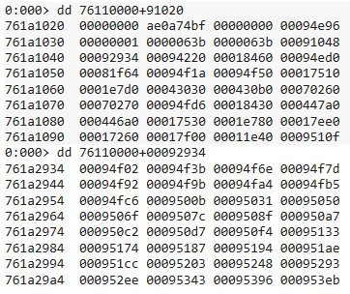

From here we get the function addresses.

Script:

r? @$t0 = ((int *) (0x761A2934))

.for (r @$t1 = 0; @$t1 < 100; r @$t1 = @$t1 + 1) {da KERNEL32+(@@c++(@$t0[@$t1]));}

We will output the functions here:

0:000> $$><C:\Users\Administrator\Desktop\lab3_dimitry\script.wds

761a4f02 "AcquireSRWLockExclusive"

761a4f3b "AcquireSRWLockShared"

761a4f6e "ActivateActCtx"

761a4f7d "ActivateActCtxWorker"

761a4f92 "AddAtomA"

761a4f9b "AddAtomW"

761a4fa4 "AddConsoleAliasA"

761a4fb5 "AddConsoleAliasW"

761a4fc6 "AddDllDirectory"

761a500b "AddIntegrityLabelToBoundaryDescr"

761a502b "iptor"

761a5031 "AddLocalAlternateComputerNameA"

761a5050 "AddLocalAlternateComputerNameW"

761a506f "AddRefActCtx"

761a507c "AddRefActCtxWorker"

761a508f "AddResourceAttributeAce"

761a50a7 "AddSIDToBoundaryDescriptor"

761a50c2 "AddScopedPolicyIDAce"

761a50d7 "AddSecureMemoryCacheCallback"

761a50f4 "AddVectoredContinueHandler"

761a5133 "AddVectoredExceptionHandler"

761a5174 "AdjustCalendarDate"

761a5187 "AllocConsole"

761a5194 "AllocateUserPhysicalPages"

761a51ae "AllocateUserPhysicalPagesNuma"

761a51cc "AppPolicyGetClrCompat"

761a5203 "AppPolicyGetCreateFileAccess"

761a5248 "AppPolicyGetLifecycleManagement"

761a5293 "AppPolicyGetMediaFoundationCodec"

761a52b3 "Loading"

761a52ee "AppPolicyGetProcessTerminationMe"

761a530e "thod"

761a5343 "AppPolicyGetShowDeveloperDiagnos"

761a5363 "tic"

761a5396 "AppPolicyGetThreadInitialization"

761a53b6 "Type"

761a53eb "AppPolicyGetWindowingModel"

761a542c "AppXGetOSMaxVersionTested"

761a546b "ApplicationRecoveryFinished"

761a5487 "ApplicationRecoveryInProgress"

761a54a5 "AreFileApisANSI"

761a54b5 "AssignProcessToJobObject"

761a54ce "AttachConsole"

761a54dc "BackupRead"

761a54e7 "BackupSeek"

761a54f2 "BackupWrite"

761a54fe "BaseCheckAppcompatCache"

761a5516 "BaseCheckAppcompatCacheEx"

761a5530 "BaseCheckAppcompatCacheExWorker"

761a5550 "BaseCheckAppcompatCacheWorker"

761a556e "BaseCheckElevation"

761a5581 "BaseCleanupAppcompatCacheSupport"

761a55a1 ""

761a55a2 "BaseCleanupAppcompatCacheSupport"

761a55c2 "Worker"

761a55c9 "BaseDestroyVDMEnvironment"

761a55e3 "BaseDllReadWriteIniFile"

761a55fb "BaseDumpAppcompatCache"

761a5612 "BaseDumpAppcompatCacheWorker"

761a562f "BaseElevationPostProcessing"

761a564b "BaseFlushAppcompatCache"

761a5663 "BaseFlushAppcompatCacheWorker"

761a5681 "BaseFormatObjectAttributes"

761a569c "BaseFormatTimeOut"

761a56ae "BaseFreeAppCompatDataForProcessW"

761a56ce "orker"

761a56d4 "BaseGenerateAppCompatData"

761a56ee "BaseGetNamedObjectDirectory"

761a570a "BaseInitAppcompatCacheSupport"

761a5728 "BaseInitAppcompatCacheSupportWor"

761a5748 "ker"

761a574c "BaseIsAppcompatInfrastructureDis"

761a576c "abled"

761a5772 "BaseIsAppcompatInfrastructureDis"

761a5792 "abledWorker"

761a579e "BaseIsDosApplication"

761a57b3 "BaseQueryModuleData"

761a57c7 "BaseReadAppCompatDataForProcessW"

761a57e7 "orker"

761a57ed "BaseSetLastNTError"

761a4ea3 "BaseThreadInitThunk"

761a5800 "BaseUpdateAppcompatCache"

761a5819 "BaseUpdateAppcompatCacheWorker"

761a5838 "BaseUpdateVDMEntry"

761a584b "BaseVerifyUnicodeString"

761a5863 "BaseWriteErrorElevationRequiredE"

761a5883 "vent"

761a5888 "Basep8BitStringToDynamicUnicodeS"

761a58a8 "tring"

761a58ae "BasepAllocateActivationContextAc"

761a58ce "tivationBlock"

761a58dc "BasepAnsiStringToDynamicUnicodeS"

761a58fc "tring"

761a5902 "BasepAppContainerEnvironmentExte"

761a5922 "nsion"

761a5928 "BasepAppXExtension"

761a593b "BasepCheckAppCompat"

761a594f "BasepCheckWebBladeHashes"

761a5968 "BasepCheckWinSaferRestrictions"

761a5987 "BasepConstructSxsCreateProcessMe"

761a59a7 "ssage"

761a59ad "BasepCopyEncryption"

761a59c1 "BasepFreeActivationContextActiva"

761a59e1 "tionBlock"

761a59eb "BasepFreeAppCompatData"

761a5a02 "BasepGetAppCompatData"

761a5a18 "BasepGetComputerNameFromNtPath"

761a5a37 "BasepGetExeArchType"

761a5a4b "BasepInitAppCompatData"

761a5a62 "BasepIsProcessAllowed"

761a5a78 "BasepMapModuleHandle"

761a5a8d "BasepNotifyLoadStringResource"

761a5aab "BasepPostSuccessAppXExtension"

761a5ac9 "BasepProcessInvalidImage"

761a5ae2 "BasepQueryAppCompat"

761a5af6 "BasepQueryModuleChpeSettings"

761a5b13 "BasepReleaseAppXContext"

761a5b2b "BasepReleaseSxsCreateProcessUtil"

761a5b4b "ityStruct"

761a5b55 "BasepReportFault"

761a5b66 "BasepSetFileEncryptionCompressio"

761a5b86 "n"

761a5b88 "Beep"

761a5b8d "BeginUpdateResourceA"

761a5ba2 "BeginUpdateResourceW"

761a5bb7 "BindIoCompletionCallback"

761a5bd0 "BuildCommDCBA"

761a5bde "BuildCommDCBAndTimeoutsA"

761a5bf7 "BuildCommDCBAndTimeoutsW"

761a5c10 "BuildCommDCBW"

761a5c1e "CallNamedPipeA"

761a5c2d "CallNamedPipeW"

761a5c3c "CallbackMayRunLong"

761a5c4f "CancelDeviceWakeupRequest"

761a5c69 "CancelIo"

761a5c72 "CancelIoEx"

761a5c7d "CancelSynchronousIo"

761a5c91 "CancelThreadpoolIo"

761a5cc3 "CancelTimerQueueTimer"

761a5cd9 "CancelWaitableTimer"

761a5ced "CeipIsOptedIn"

761a5d14 "ChangeTimerQueueTimer"

761a5d2a "CheckAllowDecryptedRemoteDestina"

761a5d4a "tionPolicy"

761a5d55 "CheckElevation"

761a5d64 "CheckElevationEnabled"

761a5d7a "CheckForReadOnlyResource"

761a5d93 "CheckForReadOnlyResourceFilter"

761a5db2 "CheckNameLegalDOS8Dot3A"

761a5dca "CheckNameLegalDOS8Dot3W"

761a5de2 "CheckRemoteDebuggerPresent"

761a5dfd "CheckTokenCapability"

761a5e12 "CheckTokenMembershipEx"

761a5e29 "ClearCommBreak"

761a5e38 "ClearCommError"

761a5e47 "CloseConsoleHandle"

761a5e5a "CloseHandle"

761a5e66 "ClosePackageInfo"

761a5e93 "ClosePrivateNamespace"

761a5ea9 "CloseProfileUserMapping"

761a5ec1 "CloseState"

761a5ee2 "CloseThreadpool"

761a5f06 "CloseThreadpoolCleanupGroup"

761a5f3e "CloseThreadpoolCleanupGroupMembe"

761a5f5e "rs"

761a5f84 "CloseThreadpoolIo"

761a5fb2 "CloseThreadpoolTimer"

761a5fdc "CloseThreadpoolWait"

761a6004 "CloseThreadpoolWork"

761a602c "CmdBatNotification"

761a603f "CommConfigDialogA"

761a6051 "CommConfigDialogW"

761a6063 "CompareCalendarDates"

761a6078 "CompareFileTime"

761a6088 "CompareStringA"

761a6097 "CompareStringEx"

761a60a7 "CompareStringOrdinal"

761a60bc "CompareStringW"

761a60cb "ConnectNamedPipe"

761a60dc "ConsoleMenuControl"

761a60ef "ContinueDebugEvent"

761a6102 "ConvertCalDateTimeToSystemTime"

761a6121 "ConvertDefaultLocale"

761a6136 "ConvertFiberToThread"

761a614b "ConvertNLSDayOfWeekToWin32DayOfW"

761a616b "eek"

761a616f "ConvertSystemTimeToCalDateTime"

761a618e "ConvertThreadToFiber"

761a61a3 "ConvertThreadToFiberEx"

761a61ba "CopyContext"

761a61c6 "CopyFile2"

761a61d0 "CopyFileA"

761a61da "CopyFileExA"

761a61e6 "CopyFileExW"

761a61f2 "CopyFileTransactedA"

761a6206 "CopyFileTransactedW"

761a621a "CopyFileW"

761a6224 "CopyLZFile"

761a622f "CreateActCtxA"

761a623d "CreateActCtxW"

761a624b "CreateActCtxWWorker"

761a625f "CreateBoundaryDescriptorA"

761a6279 "CreateBoundaryDescriptorW"

761a6293 "CreateConsoleScreenBuffer"

761a62ad "CreateDirectoryA"

761a62be "CreateDirectoryExA"

761a62d1 "CreateDirectoryExW"

761a62e4 "CreateDirectoryTransactedA"

761a62ff "CreateDirectoryTransactedW"

761a631a "CreateDirectoryW"

761a632b "CreateEnclave"

761a6366 "CreateEventA"

761a6373 "CreateEventExA"

761a6382 "CreateEventExW"

761a6391 "CreateEventW"

761a639e "CreateFiber"

761a63aa "CreateFiberEx"

761a63b8 "CreateFile2"

761a63c4 "CreateFileA"

761a63d0 "CreateFileMappingA"

761a63e3 "CreateFileMappingFromApp"

761a6433 "CreateFileMappingNumaA"

761a644a "CreateFileMappingNumaW"

761a6461 "CreateFileMappingW"

761a6474 "CreateFileTransactedA"

761a648a "CreateFileTransactedW"

761a64a0 "CreateFileW"

761a64ac "CreateHardLinkA"

761a64bc "CreateHardLinkTransactedA"

761a64d6 "CreateHardLinkTransactedW"

761a64f0 "CreateHardLinkW"

761a6500 "CreateIoCompletionPort"

761a6517 "CreateJobObjectA"

761a6528 "CreateJobObjectW"

761a6539 "CreateJobSet"

761a6546 "CreateMailslotA"

761a6556 "CreateMailslotW"

761a6566 "CreateMemoryResourceNotification"

761a6586 ""

761a6587 "CreateMutexA"

761a6594 "CreateMutexExA"

761a65a3 "CreateMutexExW"

761a65b2 "CreateMutexW"

761a65bf "CreateNamedPipeA"

761a65d0 "CreateNamedPipeW"

761a65e1 "CreatePipe"

761a65ec "CreatePrivateNamespaceA"

761a6604 "CreatePrivateNamespaceW"

761a661c "CreateProcessA"

761a662b "CreateProcessAsUserA"

761a6640 "CreateProcessAsUserW"

761a6655 "CreateProcessInternalA"

761a666c "CreateProcessInternalW"

761a6683 "CreateProcessW"

761a6692 "CreateRemoteThread"

761a66a5 "CreateRemoteThreadEx"

761a66f5 "CreateSemaphoreA"

761a6706 "CreateSemaphoreExA"

761a6719 "CreateSemaphoreExW"

761a672c "CreateSemaphoreW"

761a673d "CreateSocketHandle"

761a6750 "CreateSymbolicLinkA"

761a6764 "CreateSymbolicLinkTransactedA"

761a6782 "CreateSymbolicLinkTransactedW"

761a67a0 "CreateSymbolicLinkW"

761a67b4 "CreateTapePartition"

761a67c8 "CreateThread"

761a67d5 "CreateThreadpool"

761a67e6 "CreateThreadpoolCleanupGroup"

761a6803 "CreateThreadpoolIo"

761a6816 "CreateThreadpoolTimer"

761a682c "CreateThreadpoolWait"

761a6841 "CreateThreadpoolWork"

761a6856 "CreateTimerQueue"

761a6867 "CreateTimerQueueTimer"

761a687d "CreateToolhelp32Snapshot"

761a6896 "CreateWaitableTimerA"

761a68ab "CreateWaitableTimerExA"

761a68c2 "CreateWaitableTimerExW"

761a68d9 "CreateWaitableTimerW"

761a68ee "CtrlRoutine"

The kernel DLL provides a lot of functions that can be used to create/modify files, check for elevation etc.