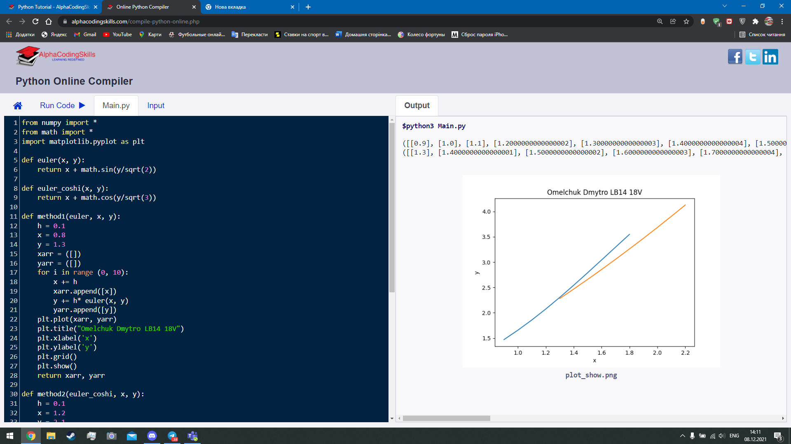

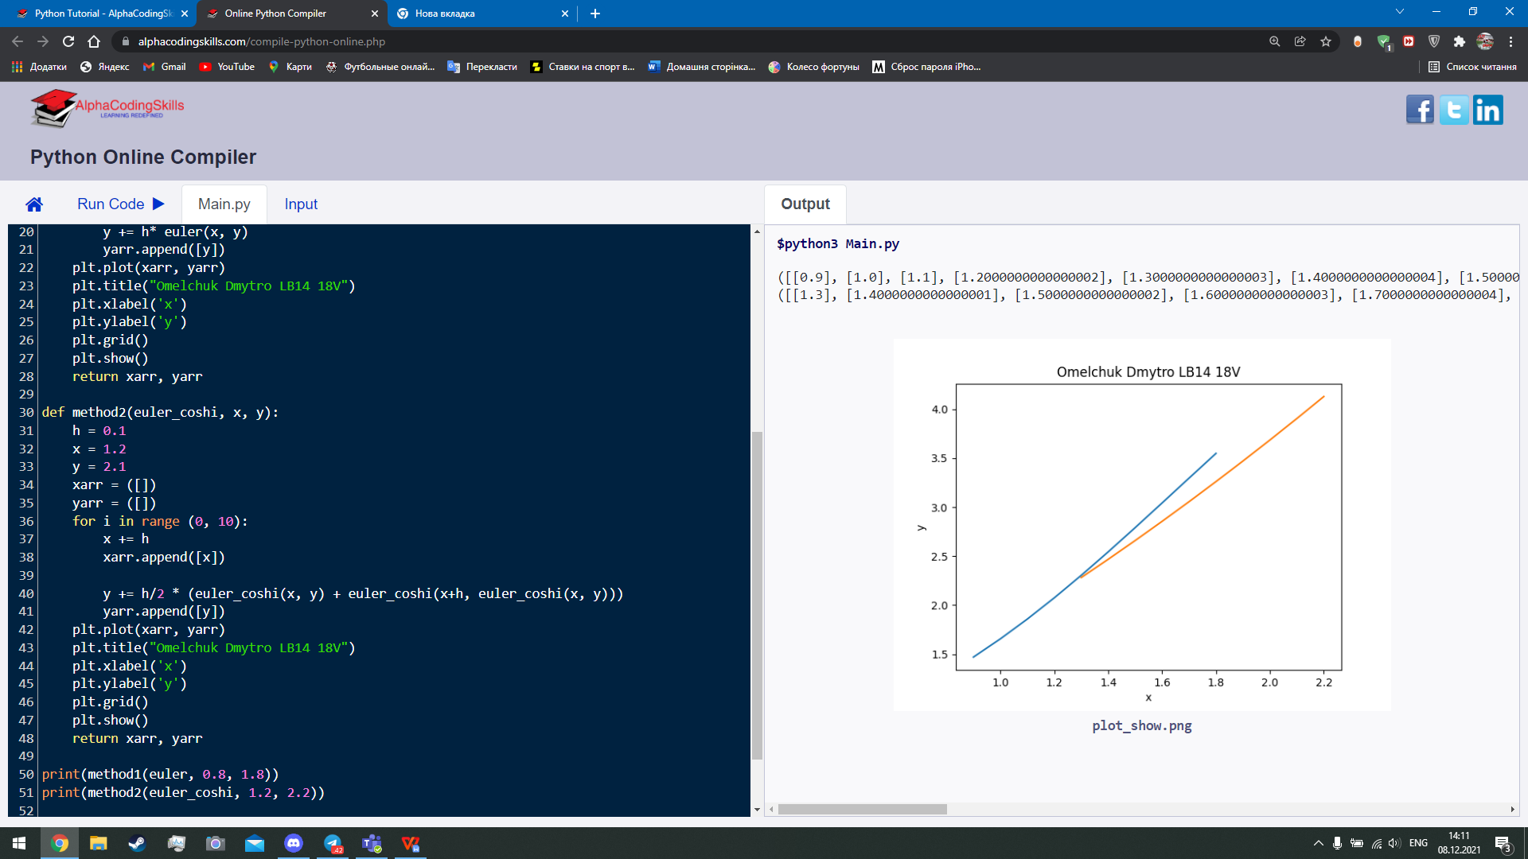

from numpy import *

from math import *

import matplotlib.pyplot as plt

def euler(x, y):

return x + math.sin(y/sqrt(2))

def euler_coshi(x, y):

return x + math.cos(y/sqrt(3))

def method1(euler, x, y):

h = 0.1

x = 0.8

y = 1.3

xarr = ([])

yarr = ([])

for i in range (0, 10):

x += h

xarr.append([x])

y += h* euler(x, y)

yarr.append([y])

plt.plot(xarr, yarr)

plt.title("Omelchuk Dmytro LB14 18V")

plt.xlabel('х')

plt.ylabel('y')

plt.grid()

plt.show()

return xarr, yarr

def method2(euler_coshi, x, y):

h = 0.1

x = 1.2

y = 2.1

xarr = ([])

yarr = ([])

for i in range (0, 10):

x += h

xarr.append([x])

y += h/2 * (euler_coshi(x, y) + euler_coshi(x+h, euler_coshi(x, y)))

yarr.append([y])

plt.plot(xarr, yarr)

plt.title("Omelchuk Dmytro LB14 18V")

plt.xlabel('х')

plt.ylabel('y')

plt.grid()

plt.show()

return xarr, yarr

print(method1(euler, 0.8, 1.8))

print(method2(euler_coshi, 1.2, 2.2))