

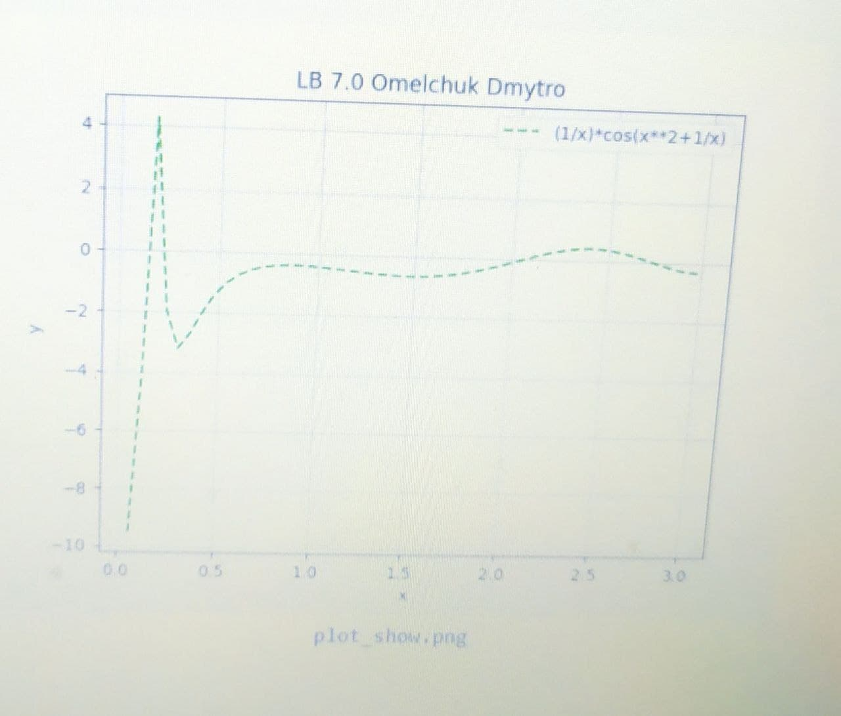

from numpy import \*

linspace

import matplotlib.pyplot as plt

def sd(x):

return (1/x)\*cos(x\*\*2+1/x)

x = linspace(0,3,51)

y = sd(x)

plt.plot(x,y,'g--', label='(1/x)\*cos(x\*\*2+1/x)')

plt.title('LB 7.0 Omelchuk Dmytro')

plt.legend(loc='upper right')

plt.xlabel('x')

plt.ylabel('y')

plt.grid()

plt.show()