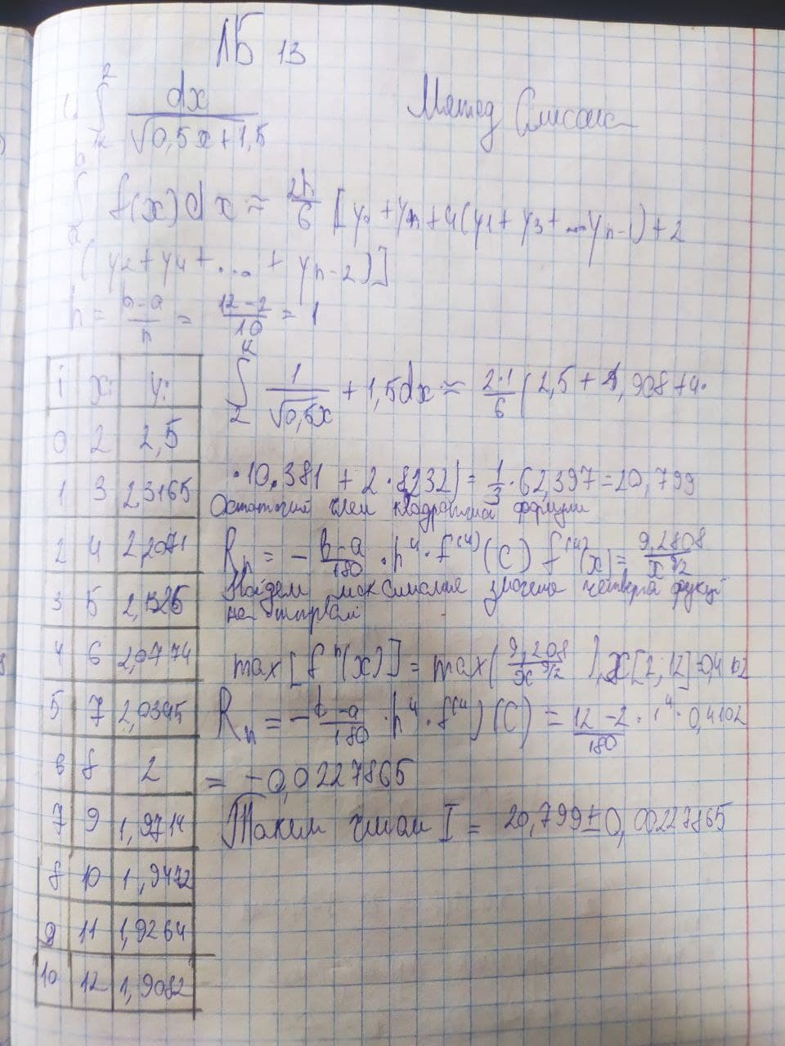

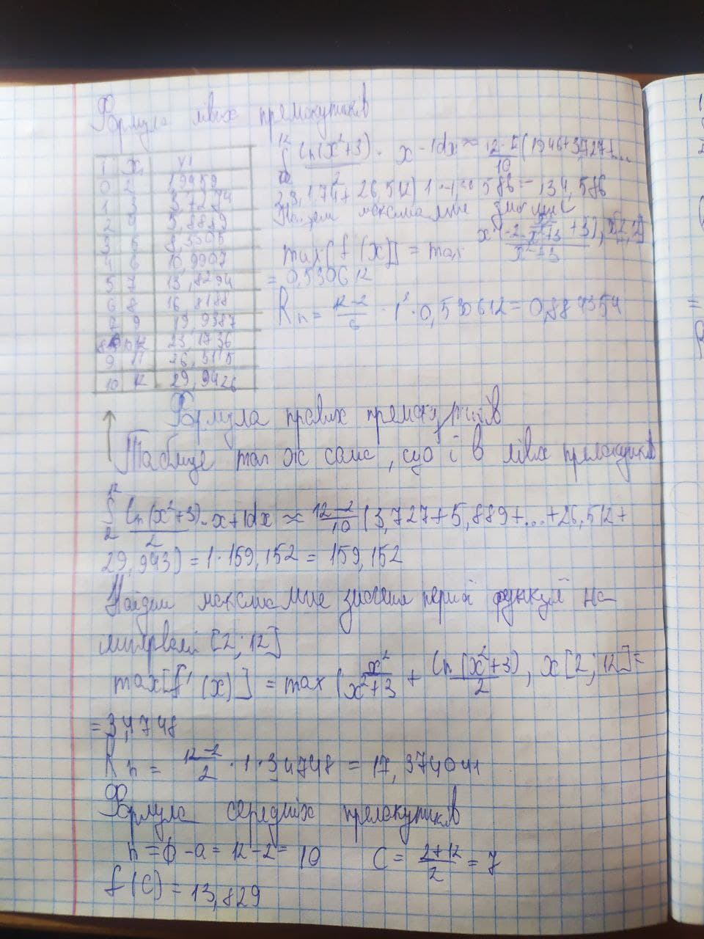

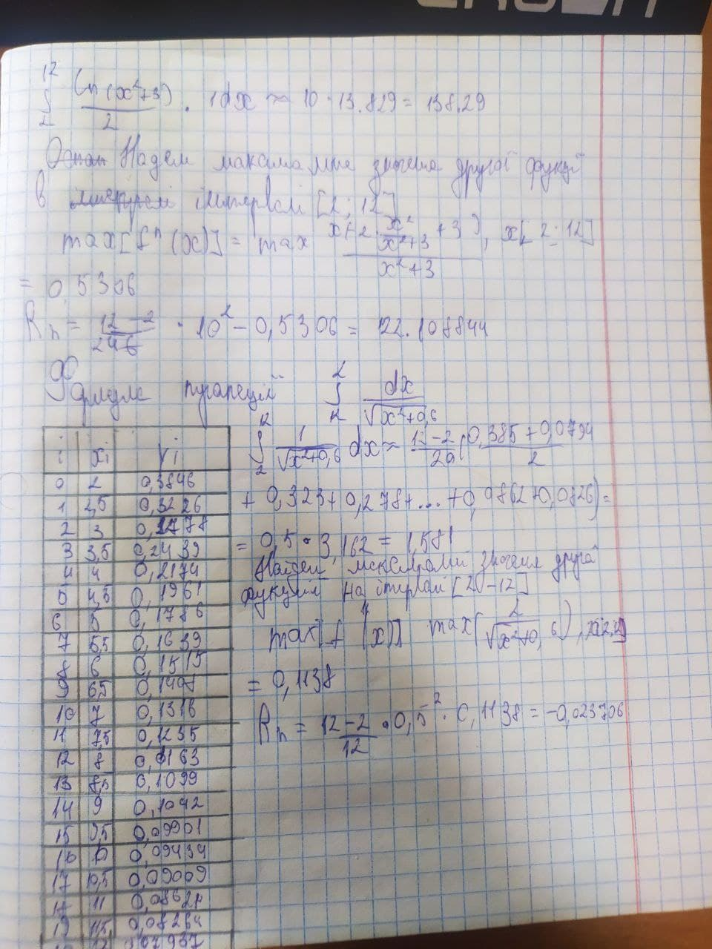

from scipy import integrate

from numpy import *

from math import *

def rectangl(x):

return lg(x**2 + 3) / 2*x *x

v, err = integrate.quad(rectangl, 12, 2)

def rt_fun(rectangl, a, b, n):

h = (b - a) / n

rt = h * ((rectangl(a)+h/2) + (rectangl(b - h)+h/2))

for i in range(1, n - 1):

rt += rectangl(a + i * h)/10

return rt

def rtright_fun(rectangl, a, b, n):

h = (b - a) / n

rtr = h * (rectangl(a) + rectangl(b - h))

for i in range(2, n):

rtr += rectangl(a + i * h) / 10

return rtr

def rtleft_fun(rectangl, a, b, n):

h = (b - a) / n

rtl = h * (rectangl(a) + rectangl(b - h))

for i in range(1, n-1):

rtl += rectangl(a + i * h) / 10

return rtl

print("middle rectangle method = ", rt_fun(rectangl, 12, 2, 10))

print("left rectangle method = ", rtleft_fun(rectangl, 12, 2, 10))

print("right rectangle method = ", rtright_fun(rectangl, 12, 2, 10))

print('Check for the rectangle method = ', v)

def trapezoid(x):

return x / (sqrt(x**2 + 0.6)

def tr_fun(trapezoid, a, b, n):

h = (b - a) / n

sum = 0.5 * (trapezoid(a) + trapezoid(b))

for i in range(1, n):

sum += trapezoid(a + i * h)

return sum * h

v, err = integrate.quad(trapezoid, 12, 2)

print("Trapezoid method = ", tr_fun(trapezoid, 12, 2, 20))

print('Check for trapezoid method = ', v)

def simpson(x):

return x / (sqrt(0.5x+1.5))

def sp_fun(simpson, a, b, n):

h = (b - a) / n

k = 0.0

x = a + h

for i in range(1, n // 2 + 1):

k += 4 * simpson(x)

x += 2 * h

x = a + 2 * h

for i in range(1, n // 2):

k += 2 * simpson(x)

x += 2 * h

return (h / 3) * (simpson(a) + simpson(b) + k)

print("Simpson method= ", sp_fun(simpson, 12, 2, 10))

v, err = integrate.quad(simpson, 12, 2)

print('Check for simpson method= ', v)