Text2SpeechEditor
Final Release Report
ADID Inc.
Athanasios Dimosiaris - 3216, Ioannis Dimitriou - 3214

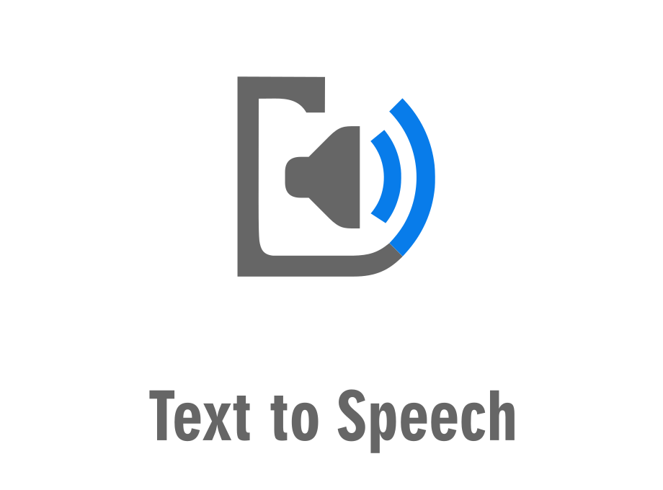
Versions History
Date | Version | Description | Author
24/05/2020 | Final | Final release of Text2SpeechEditor | Athanasios Dimosiaris  Ioannis Dimitriou

- Introduction
This document provides information concerning the final release of our Text2Speech Editor project.
  - Purpose
The Text2Speech Editor is a useful tool that allows the computer to convert a given text into speech. Our objective is to create a simple editor that allows preparing text documents and transforming them to audio. The application can have many uses, such as helping people with speaking problems. It consists of a graphical user interface, a back-end that enables the text editing and transforming to speech process, with the later being based on external libraries.
  - Document Structure
The rest of this document is structured as follows. Section 2 describes out Scrum team and specifies the this Sprint's backlog. Section 3 specifies the main design concepts for this release of the project.
- Scrum team and Sprint Backlog
  - Scrum team
Product Owner | Apostolos Zarras
Scrum Master | Athanasios Dimosiaris
Development Team | Ioannis Dimitriou

  - Sprint Backlog
Test ID | Rot13Test
User Story | The user can encode the text using the Rot13 cipher.
Test Class | Rot13Encoding.java

Test ID | AtBashTest
User Story | The user can encode the text using the AtBash cipher
Test class | AtBashEncoding.java

Test ID | DocumentTest
User Story | The user can create a document by giving a specific path
Test Class | Document.java

Test ID | DocumentTest
User Story | The user can edit and save a document
Test Class | Document.java

Test ID | DocumentTest
User Story | The user can open an existing document
Test Class | Document.java

Test ID | DocumentTest
User Story | The user can tune a document by changing volume, rate and pitch
Test Class | Document.java

Test ID | FakeTextToSpeechAPI
User Story | Just for developer testing
Test Class | Document.java

- Design
  - Architecture
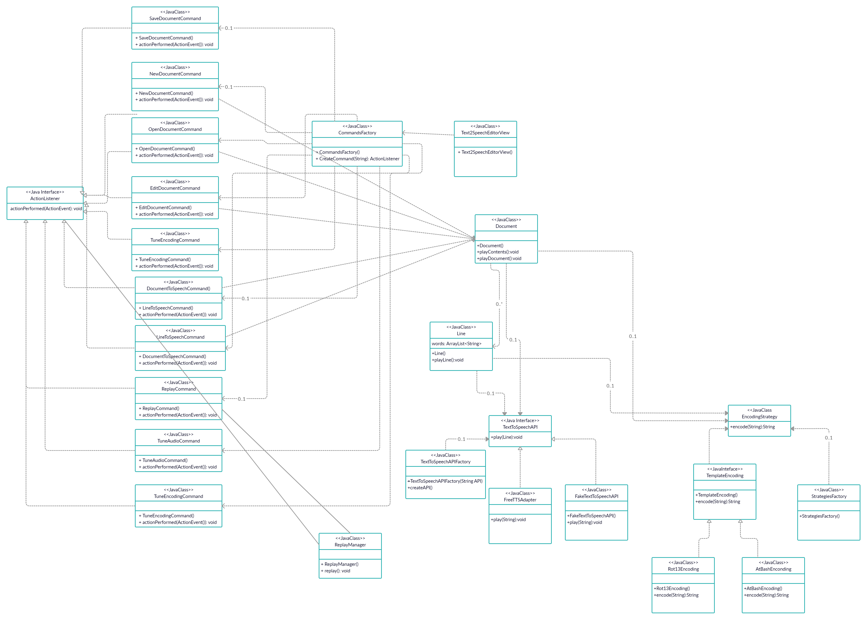

  - Design
All Java classes according to CRC cards.
Class Name: AtBashEncoding
Responsibilities:  - Encode text by using the AtBash cipher | Collaborations:  - Document Class

Class Name: Encoding Strategy
Responsibilities:  - Implement chosen strategy | Collaborations:  - Rot13Encoding Class  - AtBashEncoding class

Class Name: FakeTextToSpeechAPI
Responsibilities:  - Creating a fake API | Collaborations:  - Document class

Class Name: FreeTTSAdapter
Responsibilities:  - FreeTTS library adapter | Collaborations:  - Document class

Class Name: Rot13Encoding
Responsibilities:  - Encode text by using the Rot13 cipher | Collaborations:  - Document class

Class Name: StrategiesFactory
Responsibilities:  - Choosing encoding strategy | Collaborations:  - Document class

Class Name: TemplateEncoding
Responsibilities:  - Makes encoding template | Collaborations:  - Document class

Class Name: TextToSpeechAPI
Responsibilities:  - Set the API | Collaborations:  - Document class

Class Name: TextToSpeechAPIFactory
Responsibilities:  - Chose the FreeTTS or Fake API | Collaborations:  - Document class  - TextToSpeechAPI

Class Name: Document
Responsibilities:  - Processes documents | Collaborations:  - Line class

Class Name: Line
Responsibilities:  - Processes lines | Collaborations:  - Document class

Class Name: EditDocPanel
Responsibilities:  - Edit document panel for the graphic user interface | Collaborations:  - Document class

Class Name: OpenDocPanel
Responsibilities:  - Open document panel for the graphic user interface | Collaborations:  - Document class

Class Name: SettingsPanel
Responsibilities:  - Settings panel for the graphic user interface | Collaborations:  - Document class

Class Name: Speech2TextEditorView
Responsibilities:  - Graphic user interface | Collaborations:  - All

