MACHINE LEARNING PREDICTION SYSTEM
Employee Attrition Prediction
Predicting Employee Turnover Using Supervised Machine Learning Algorithms
Project Report
Machine Learning Prediction System — Team Assignment
Submitted by
Dimple Sharma
Vaibhav Magar

Team Member Details
Sr. No. | Team Member Name | Role / Contribution Area
1 | Dimple Sharma | Data Preprocessing, Exploratory Data Analysis, Report Documentation
2 | Vaibhav Magar | Model Development, Model Evaluation, GitHub Collaboration

Both team members contributed equally to the design, development, and documentation of this project, and collaborated actively through regular discussions and GitHub commits.

Table of Contents
Team Member Details 2
1. Introduction 4
2. Problem Statement 4
3. Objectives 4
4. Dataset Description 4
5. Data Preprocessing Steps 6
6. Exploratory Data Analysis 6
7. Machine Learning Algorithms Used 11
8. Model Evaluation 11
9. Result Analysis 13
10. GitHub Repository Link 14
11. Team Contributions 14
12. Output Screenshots 14
13. Challenges Faced 14
14. Learning Outcomes 15
15. Conclusion 15
16. References 15

1. Introduction
Employee attrition is one of the most critical challenges faced by organizations today. Losing skilled and experienced employees leads to increased recruitment costs, loss of productivity, and disruption of team dynamics. Being able to anticipate which employees are at risk of leaving allows an organization to take proactive retention measures rather than reactive ones.
This project applies supervised Machine Learning techniques to build a predictive system that estimates the likelihood of an employee leaving a company based on HR-related attributes. The complete workflow — from data collection to model evaluation — was implemented using Python, Pandas, NumPy, Matplotlib, Seaborn, and Scikit-learn in a Jupyter Notebook environment.

2. Problem Statement
Predict whether an employee is likely to leave the company (Attrition = Yes/No) based on HR-related features such as age, job role, monthly income, overtime, education, work experience, and job satisfaction. This is framed as a binary classification problem, where the target variable “Attrition” takes the value 1 (employee left) or 0 (employee stayed).

3. Objectives
- To collect and understand a real-world HR dataset containing employee attributes and attrition status.
- To preprocess the dataset by handling missing values, duplicate records, categorical encoding, and feature scaling.
- To perform Exploratory Data Analysis (EDA) to identify patterns and relationships influencing attrition.
- To train and compare multiple Machine Learning classification algorithms for predicting employee attrition.
- To evaluate model performance using Accuracy, Confusion Matrix, Precision, Recall, and F1 Score.
- To identify the best-performing model and derive actionable insights for HR decision-making.

4. Dataset Description
The project uses the IBM HR Analytics Employee Attrition dataset (WA_Fn-UseC_-HR-Employee-Attrition.csv), a widely used, publicly available HR dataset that simulates employee records for a fictitious organization.
Attribute | Details
Total Records | 1,470 employees
Total Features | 35 columns (34 features + 1 target variable)
Target Variable | Attrition (Yes / No)
Feature Types | 26 numerical (int64), 9 categorical (str)
Sample Numerical Features | Age, MonthlyIncome, TotalWorkingYears, DistanceFromHome, YearsAtCompany
Sample Categorical Features | BusinessTravel, Department, Gender, JobRole, MaritalStatus, OverTime, EducationField
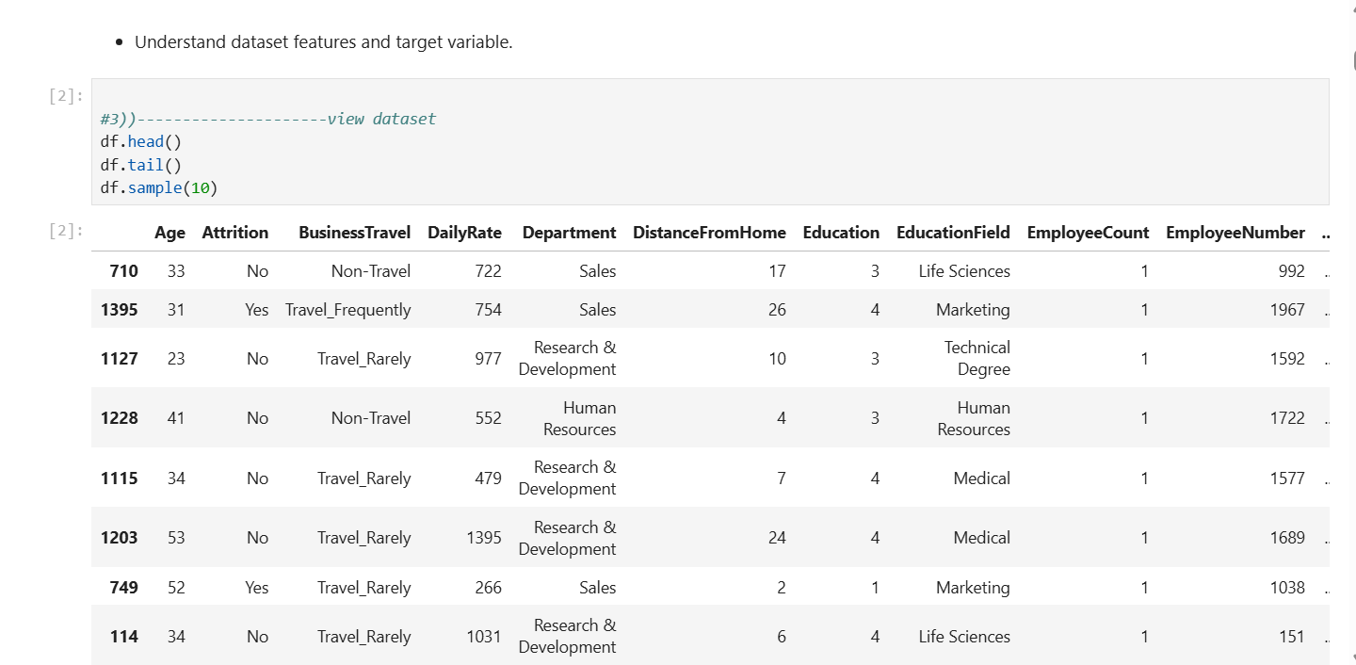
Fig 4.1 — Preview of the dataset (df.head())
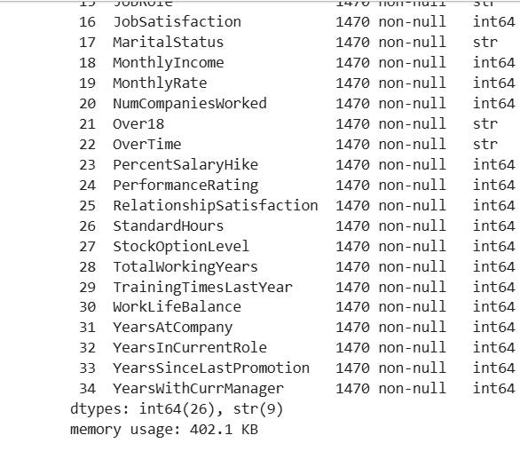
Fig 4.2 — Dataset information (df.info())

5. Data Preprocessing Steps

5.1 Handling Missing Values
The dataset was checked for missing values using df.isnull().sum(). The analysis showed that there were no missing values in any feature, so no imputation was required.

5.2 Removing Duplicate Records
The dataset was checked for duplicate records using df.duplicated().sum(). No duplicate records were found, so the dataset remained unchanged.

5.3 Encoding Categorical Variables
Since Machine Learning algorithms cannot process text-based categorical variables directly, all categorical features were converted into numerical values using Scikit-learn's LabelEncoder. This transformed columns such as BusinessTravel, Department, Gender, JobRole, MaritalStatus, Over18, OverTime, and EducationField into numeric representations suitable for model training.

5.4 Feature Scaling
Feature scaling was applied using StandardScaler, which standardizes numerical features to have a mean close to zero and a standard deviation close to one. This ensures that all features contribute equally during model training and prevents features with larger numeric ranges (such as MonthlyIncome) from dominating the learning process.

6. Exploratory Data Analysis
Exploratory Data Analysis (EDA) was performed to understand the distribution of data and identify relationships among variables.

6.1 Summary Statistics
The df.describe() function was used to generate summary statistics for all numerical features, revealing the mean, standard deviation, minimum, and maximum values. The average employee age was approximately 37 years, while the average total working experience was about 11 years. Monthly income showed a wide variation among employees, indicating differences in job levels and positions.

6.2 Correlation Analysis
A correlation matrix was generated using df.corr() and visualized as a heatmap. Age showed a strong positive correlation with Total Working Years, while Job Level was strongly correlated with Monthly Income. Attrition exhibited relatively weak correlations with individual variables, suggesting that employee turnover is influenced by multiple factors rather than a single feature.
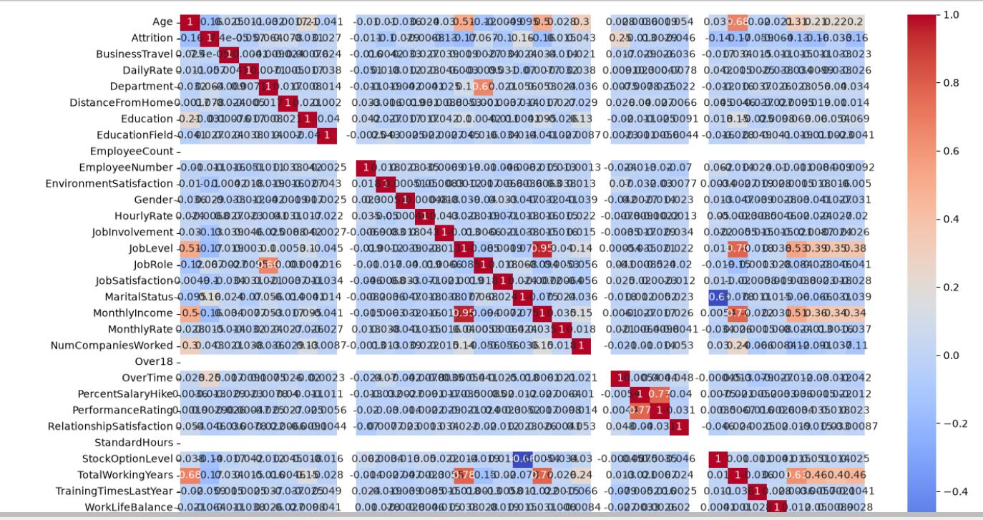
Fig 6.1 — Correlation heatmap of dataset features

6.3 Data Visualizations
The target distribution shows that most employees belong to the No Attrition category, indicating a slightly imbalanced dataset — around 83.9% stayed while 16.1% left.
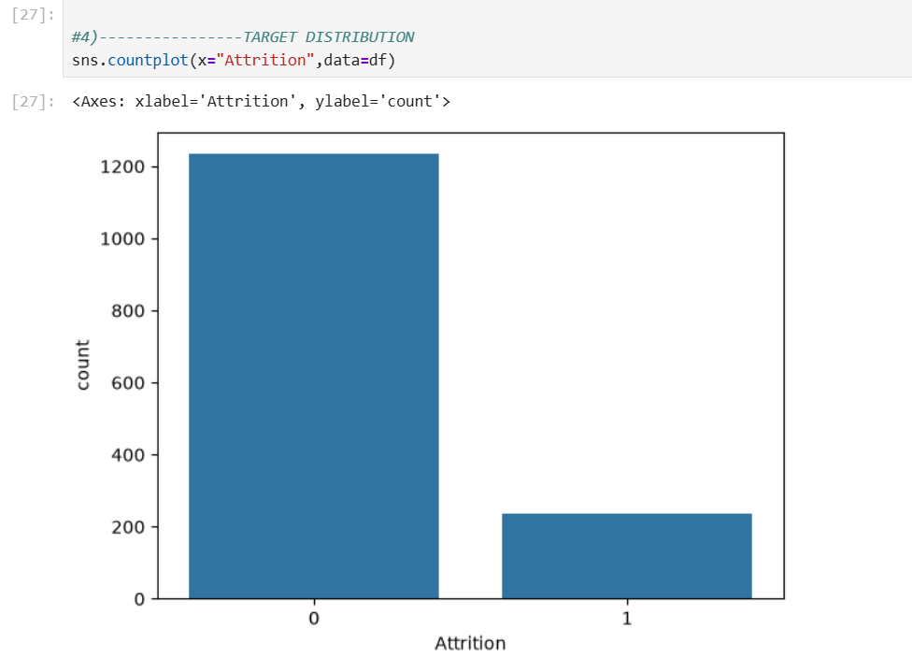
Fig 6.2 — Target variable (Attrition) distribution
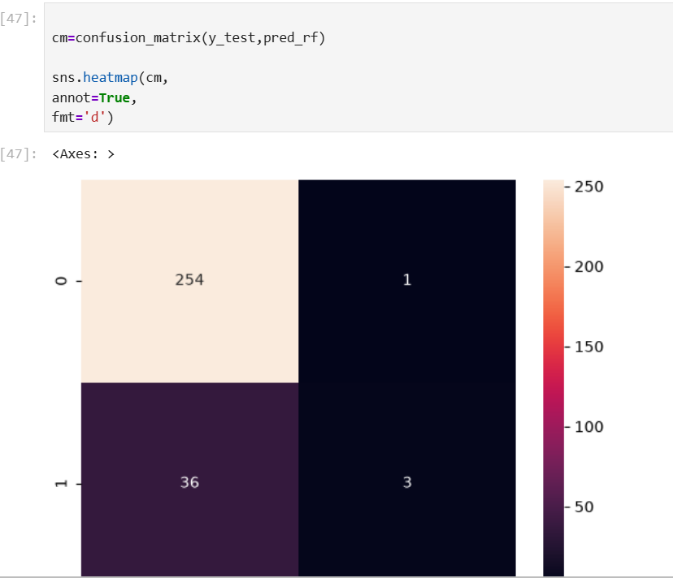
Fig 6.3 — Attrition proportion (pie chart)
The age distribution reveals that most employees are between 30 and 40 years old.
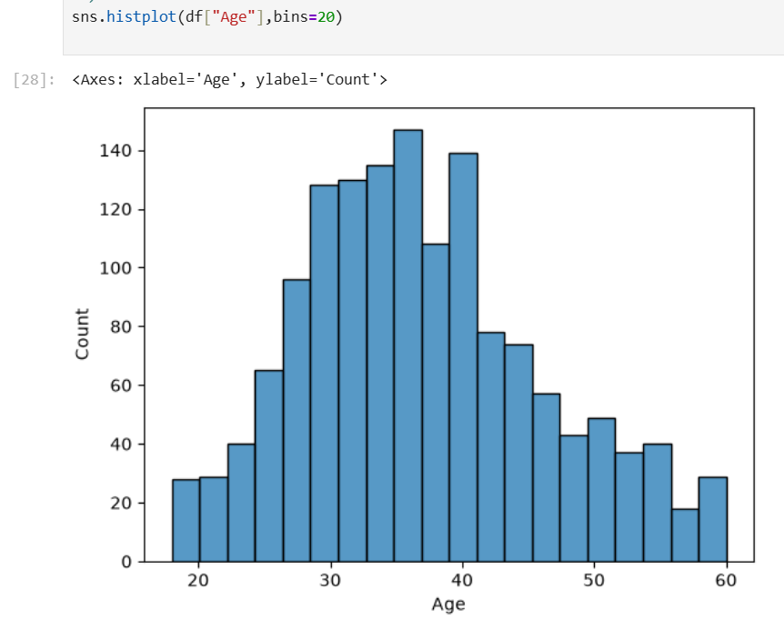
Fig 6.4 — Age distribution of employees
Monthly income displays a right-skewed distribution, where only a few employees receive very high salaries.
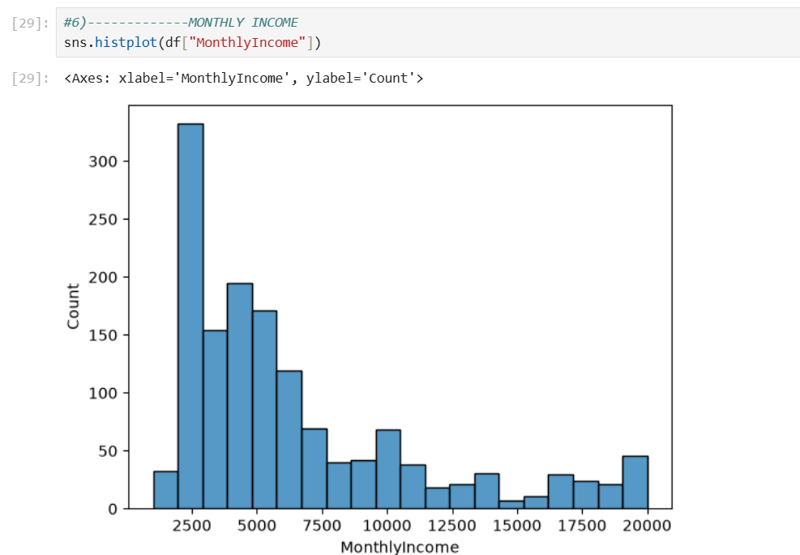
Fig 6.5 — Monthly income distribution
Gender-wise analysis indicates similar attrition patterns across male and female employees.
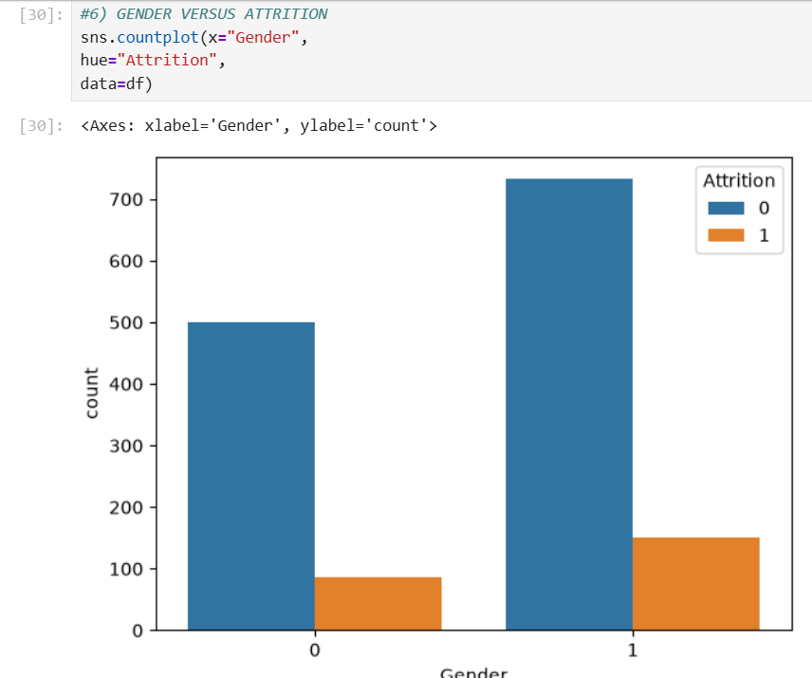
Fig 6.6 — Gender vs Attrition
The box plot demonstrates that employees with higher monthly incomes generally show lower attrition rates.
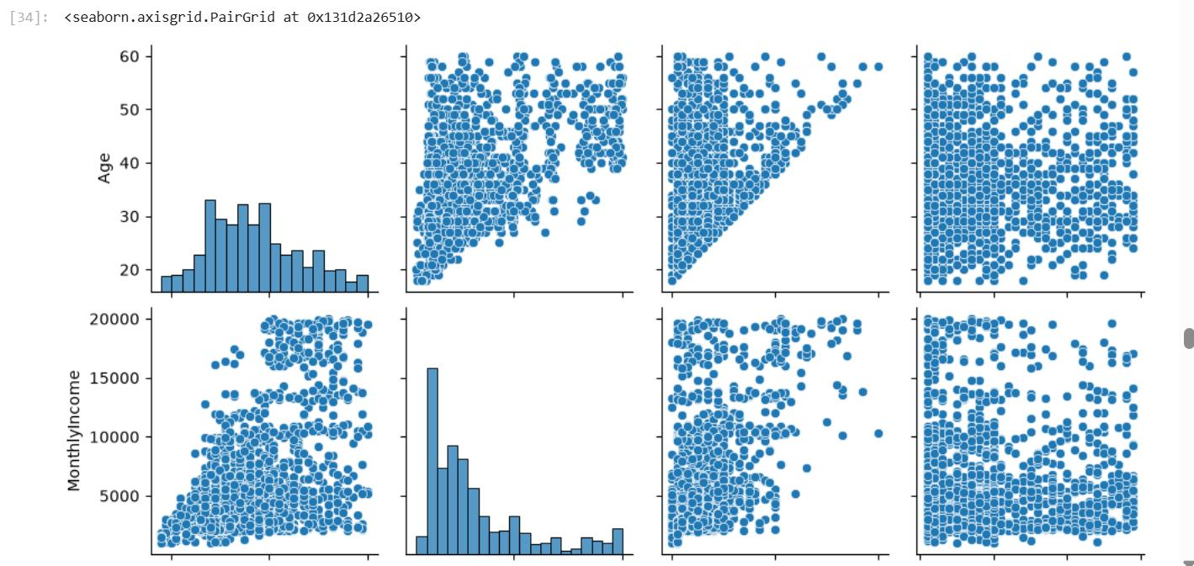
Fig 6.7 — Monthly income vs Attrition (boxplot)
Pair plots were used to visualize relationships among Age, Monthly Income, Years at Company, and Distance From Home.
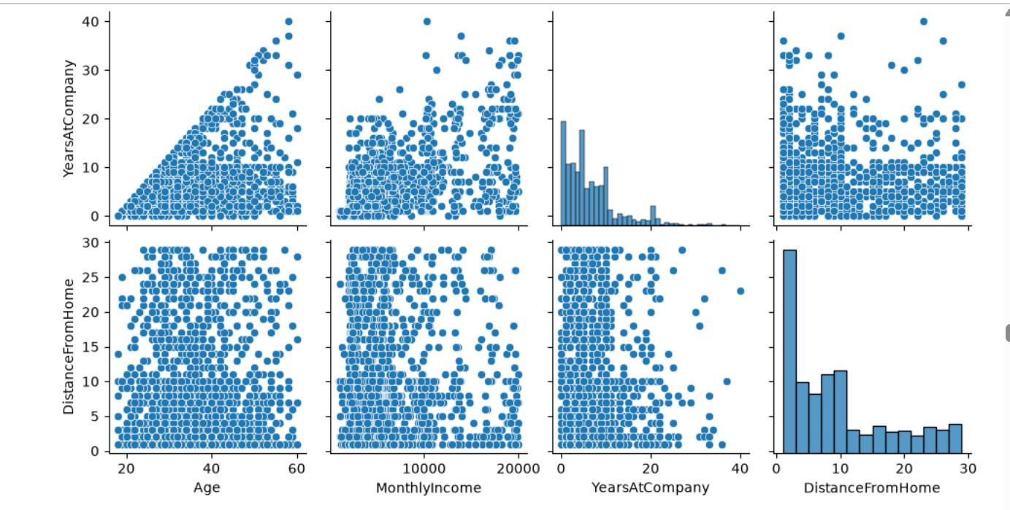
Fig 6.8 — Pairwise relationships (Age, Monthly Income)
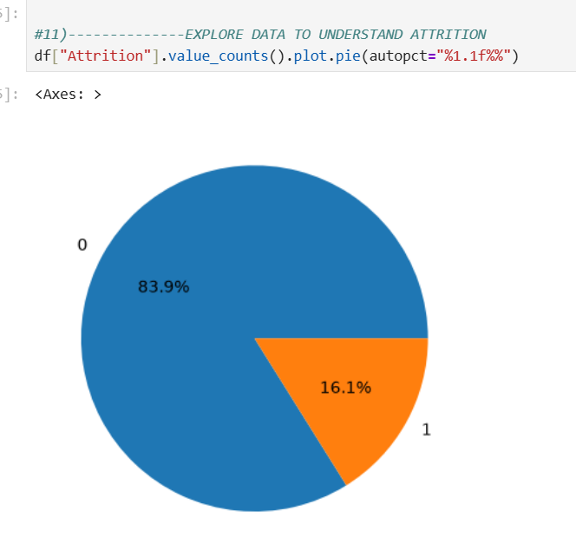
Fig 6.9 — Pairwise relationships (Years at Company, Distance from Home)

7. Machine Learning Algorithms Used
The dataset was split into 80% training data and 20% testing data using train_test_split (random_state = 42). Five different supervised classification algorithms were trained and evaluated on the same split:
- Logistic Regression — a linear model used as a baseline classifier.
- Decision Tree Classifier — a rule-based, interpretable tree model.
- Random Forest Classifier — an ensemble of decision trees to reduce overfitting.
- Support Vector Machine (SVM) — a margin-based classifier effective on scaled features.
- K-Nearest Neighbors (KNN) — a distance-based, instance-learning classifier.
Each model learned patterns from the training data and generated predictions for the testing dataset.

8. Model Evaluation

8.1 Accuracy Comparison
Model | Accuracy
Logistic Regression | 87.41%
Decision Tree | 76.19%
Random Forest | 87.41%
Support Vector Machine (SVM) | 88.44%
K-Nearest Neighbors (KNN) | 87.41%


Fig 8.1 — Accuracy comparison across all five models
Among all the trained algorithms, the Support Vector Machine (SVM) achieved the highest accuracy of 88.44%, making it the best-performing model for this dataset. Logistic Regression, Random Forest, and KNN also produced strong results with accuracies above 87%, while the Decision Tree model achieved the lowest accuracy of 76.19%.

8.2 Confusion Matrix (Random Forest)
A confusion matrix was generated to evaluate the Random Forest model in detail. It compares predicted attrition values against actual values, capturing True Positives, True Negatives, False Positives, and False Negatives.
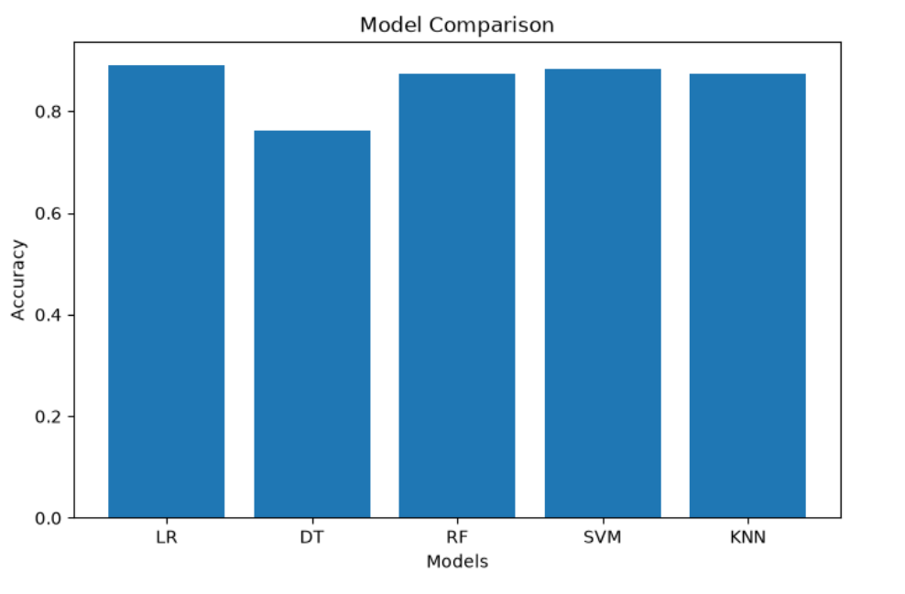
Fig 8.2 — Confusion matrix for the Random Forest model
The confusion matrix shows that the model correctly classified 254 employees who stayed (True Negatives) and only 3 employees who actually left (True Positives), while missing 36 employees who left (False Negatives) and misclassifying 1 employee who stayed (False Positive).

8.3 Precision, Recall and F1 Score (Random Forest)
Metric | Value
Precision | 0.75
Recall | 0.0769
F1 Score | 0.1395

The precision value of 75% indicates that when the model predicts an employee will leave, it is correct most of the time. However, the recall value is quite low, meaning the model fails to identify many employees who actually leave the company. Consequently, the F1 Score is also low because it combines both precision and recall into a single metric. These results indicate that although the Random Forest model achieves good overall accuracy, it struggles to detect the minority attrition class due to class imbalance in the dataset.

9. Result Analysis
The Employee Attrition Prediction System was successfully developed using the IBM HR Analytics Employee Attrition dataset. The complete machine learning workflow was implemented, including data collection, preprocessing, exploratory data analysis, model training, evaluation, and comparison of multiple classification algorithms.
Overall accuracy across models was strong and fairly close (76%–88%), with SVM performing best. However, accuracy alone can be misleading on an imbalanced dataset like this one, where roughly 84% of employees did not leave. The precision, recall, and F1 analysis on the Random Forest model reveals that while the model is good at overall classification, it struggles specifically with correctly identifying the minority “Attrition = Yes” class — a common challenge in real-world HR attrition datasets.
Techniques such as SMOTE (oversampling), class weighting, or hyperparameter tuning could be applied in future iterations to improve recall for the minority class without significantly harming overall accuracy.

10. GitHub Repository Link
GitHub Repository: [Insert GitHub Repository Link Here]
The repository contains the complete source code (.ipynb), the dataset, the README.md file, and the commit history reflecting contributions from both team members.

11. Team Contributions
Team Member | Contribution
Dimple Sharma | Dataset research & selection, data preprocessing (missing values, duplicates, encoding, scaling), Exploratory Data Analysis and visualizations, report documentation
Vaibhav Magar | Model implementation (Logistic Regression, Decision Tree, Random Forest, SVM, KNN), model evaluation (accuracy, confusion matrix, precision/recall/F1), GitHub repository setup & collaboration, presentation preparation

Both members participated in regular discussions to review progress, jointly reviewed and merged code on GitHub, and contributed to writing the final project report and presentation.

12. Output Screenshots
Key output screenshots from the notebook execution — dataset preview, correlation heatmap, EDA visualizations, confusion matrix, and model comparison chart — are included in Sections 4, 6, and 8 above. A consolidated set of screenshots is also submitted separately as part of the submission requirements.

13. Challenges Faced
- Handling class imbalance in the target variable, which affected recall for the minority “Attrition = Yes” class.
- Selecting appropriate preprocessing techniques (encoding vs scaling) for a mix of categorical and numerical HR features.
- Comparing multiple classification algorithms fairly on the same train-test split and interpreting evaluation metrics beyond accuracy.
- Coordinating GitHub collaboration and merging contributions from both team members smoothly.

14. Learning Outcomes
- Gained hands-on experience with the complete Machine Learning workflow, from data collection to model evaluation.
- Learned practical data preprocessing techniques including Label Encoding and Standard Scaling.
- Developed skills in Exploratory Data Analysis using Matplotlib and Seaborn to uncover patterns in real-world HR data.
- Understood the trade-offs between accuracy, precision, recall, and F1 score, especially on imbalanced datasets.
- Improved collaborative software development skills through Git and GitHub-based teamwork.

15. Conclusion
This project successfully developed a complete Employee Attrition Prediction System using machine learning techniques. The dataset was preprocessed, explored through visualization, and used to train five classification models. Among all models, the Support Vector Machine (SVM) achieved the highest prediction accuracy of 88.44%, demonstrating its effectiveness for this dataset. The project highlights how machine learning can assist organizations in identifying employees who are at risk of leaving, enabling proactive retention strategies and better workforce management. Although the overall performance is strong, future improvements such as class imbalance handling, hyperparameter optimization, and advanced ensemble methods can further enhance the predictive capability of the system.

16. References
- IBM HR Analytics Employee Attrition & Performance Dataset — Kaggle / IBM Watson Analytics.
- Scikit-learn Documentation — https://scikit-learn.org/stable/documentation.html
- Pandas Documentation — https://pandas.pydata.org/docs/
- Matplotlib Documentation — https://matplotlib.org/stable/contents.html
- Seaborn Documentation — https://seaborn.pydata.org/

