**Blog Management**

* For Setup project need to clone from git.

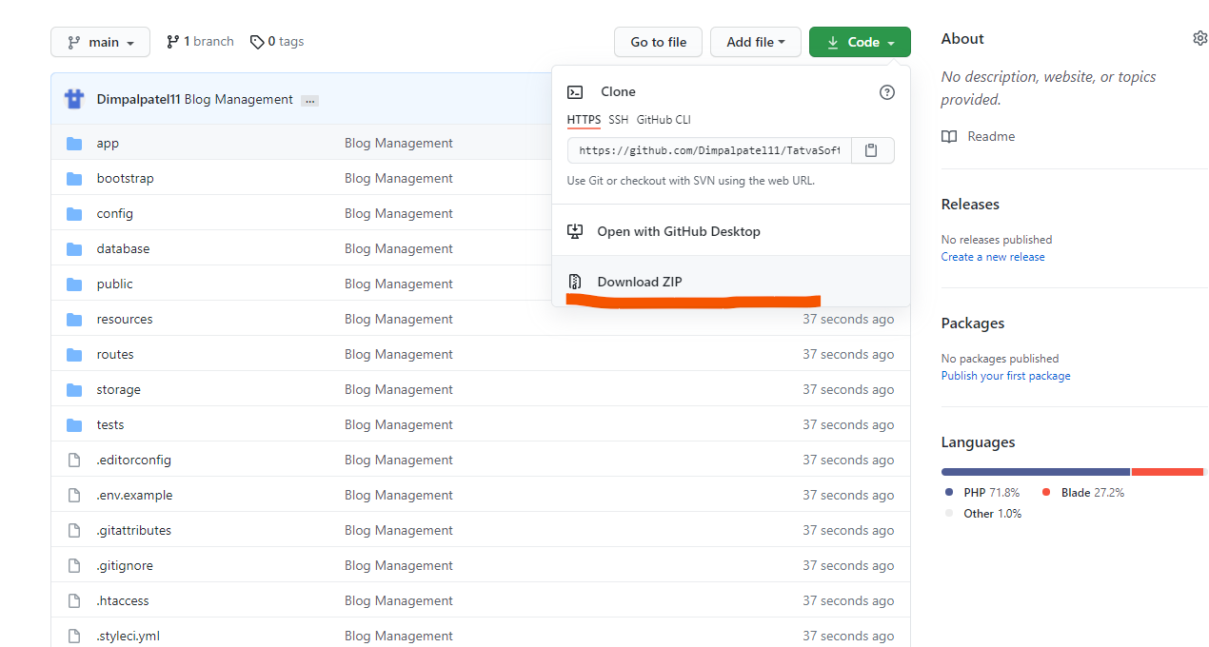

From here you can clone project or download zip file.

* After that import Database in your MySQL db. (Database file added in database folder of project)
* After project run you will see all the uploaded blogs.

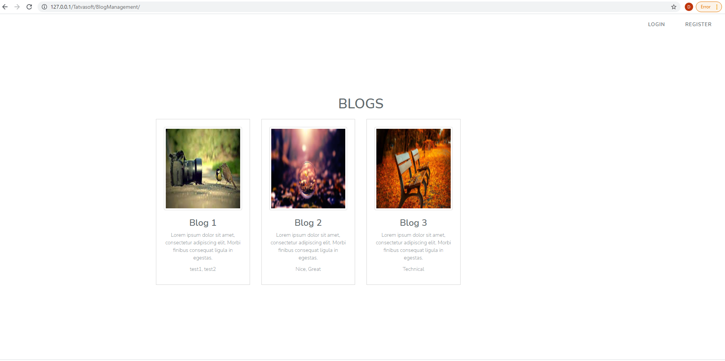

* For add your blog you need to Do register and Login.

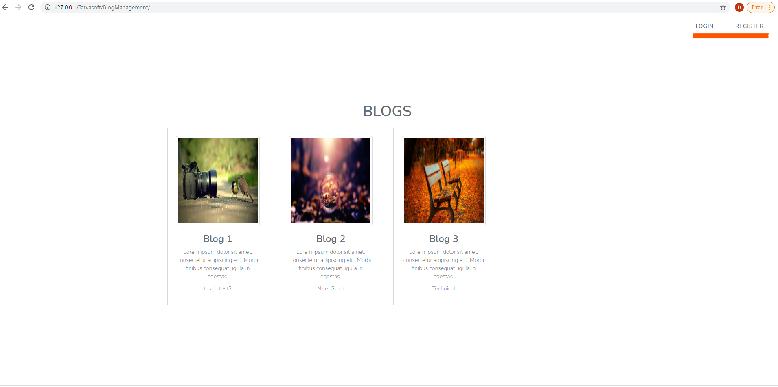

* After Registration you can see Add, Edit, Delete option of Blogs.

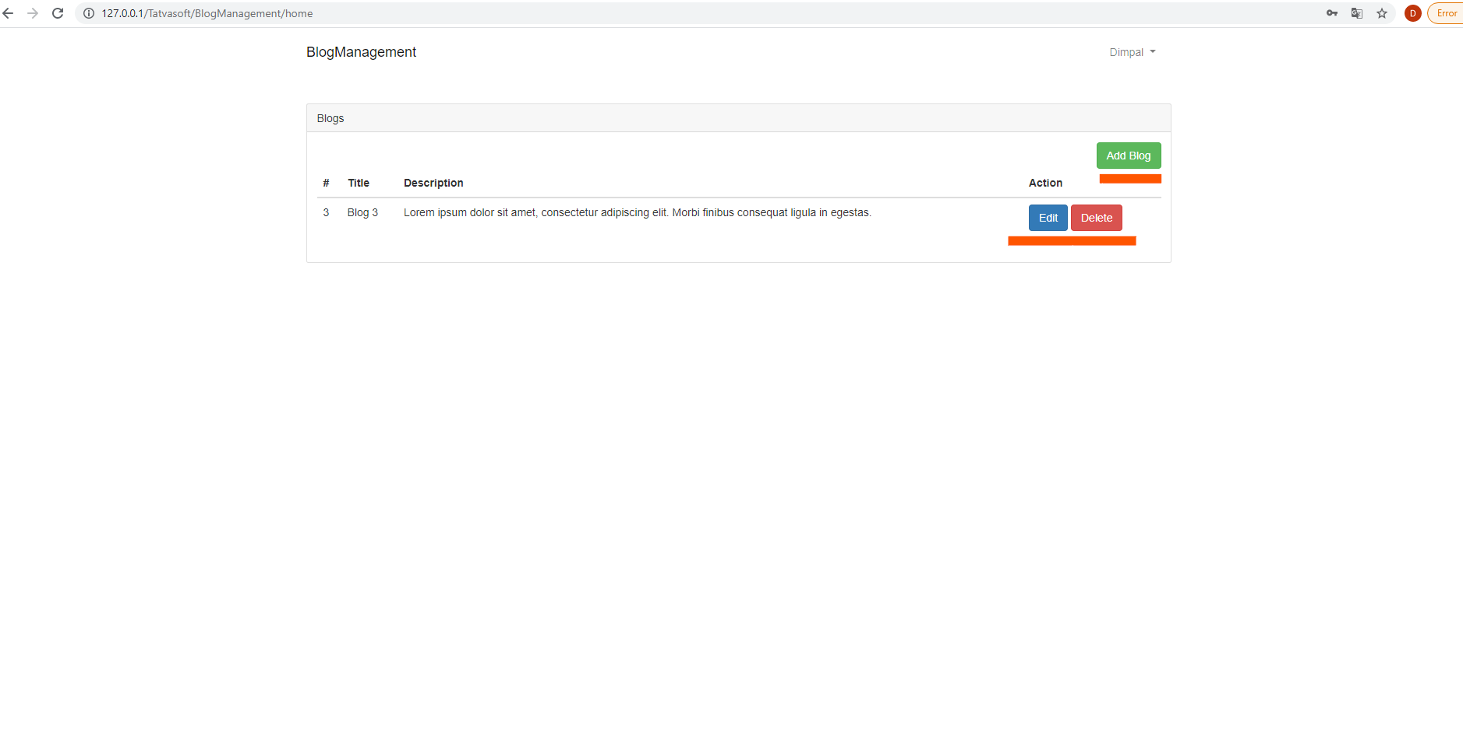

* Here You can add your All blogs.