SDM PRACTICAL
Name: Dimpho Sekhosana
Student number:2442463

PART 1
Current Outputs

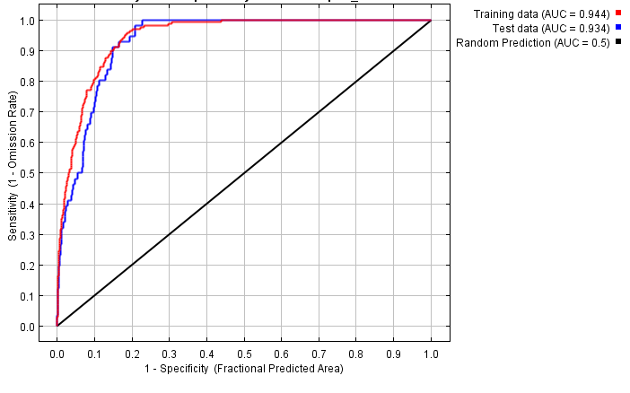
Figure 1 : graph showing fraction value plotted against cumulative value, and specifity plotted against sensitivity, the receiver operating curve (ROC) for the maximum entropy model of P. latifolius in South Africa with AUC measures of model performance during current climatic conditions

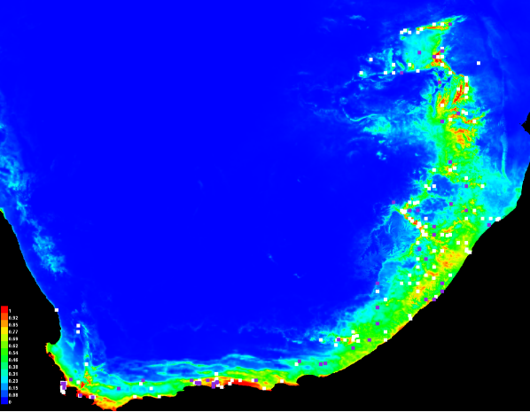
Figure 2. Species distribution map of P. latifolius in South Africa the background colour represent the probability of the species occurring the will dark blue being zero and red being highest probability, the dots represent the actual distribution of the species in current time.
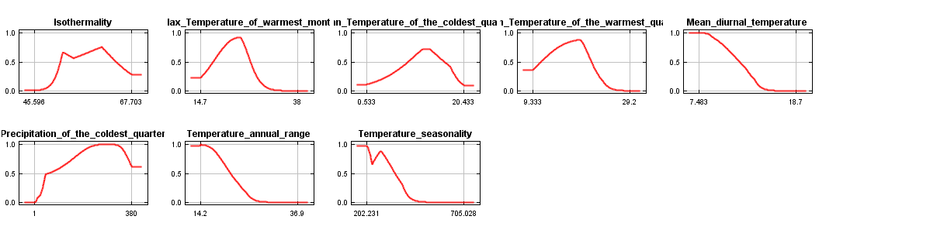
Figure 3. Graphical showing response curves of environmental predictor variables for P. latifolius the x-axis represent the probability of occurrence current.
Table 1. . the predictor variables percentage contribution they have towards the generated model of P. latifolius distribution in Maxent during the current.
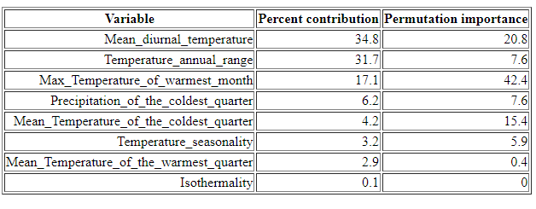
Future Output
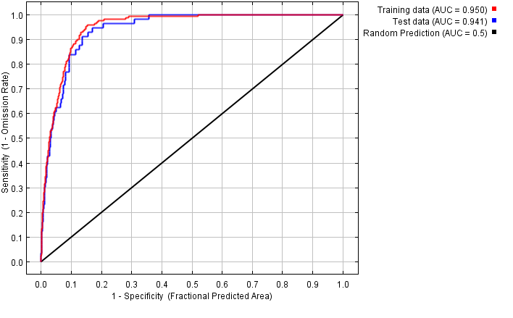
Figure 4. Graphical showing the receiver operating curve (ROC) for the maximum entropy model of P. latifolius in South Africa with AUC measures of model performance in the future.
.

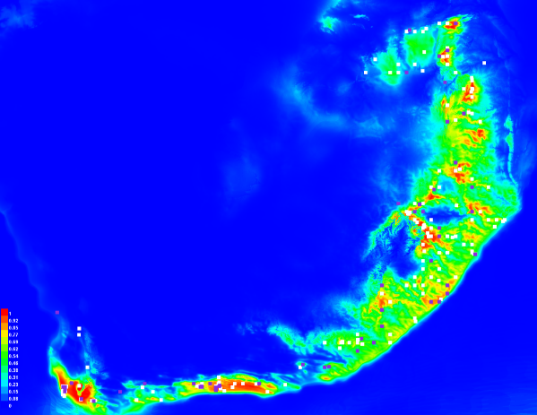
Figure 5. Species distribution map of P. latifolius in South Africa the background colour represent the probability of the species occurring the will dark blue being zero and red beign highst probability, the dots represent the actual distribution of the species in future.

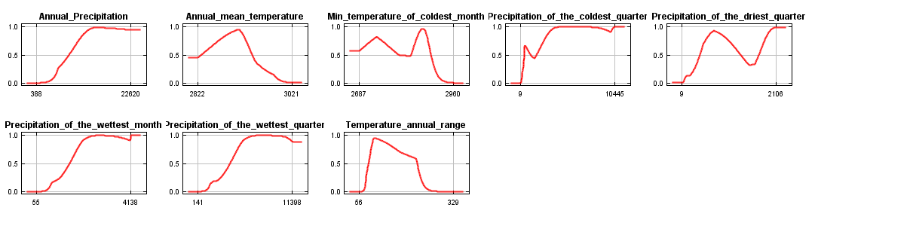
Figure 6 Graphical showing response curves of environmental predictor variables for P. latifolius the x-axis represent the probability of occurrence future.

Table 2.the predictor variables percentage contribution they have towards the generated model of P. latifolius distribution in Maxent during the future.

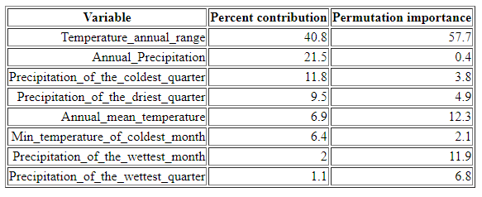
Holocene Output
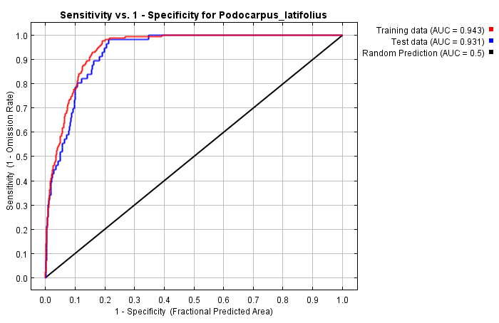
Figure 7. Graphical showing the receiver operating curve (ROC) for the maximum entropy model of P. latifolius in South Africa with AUC measures of model performance during the Holocene.

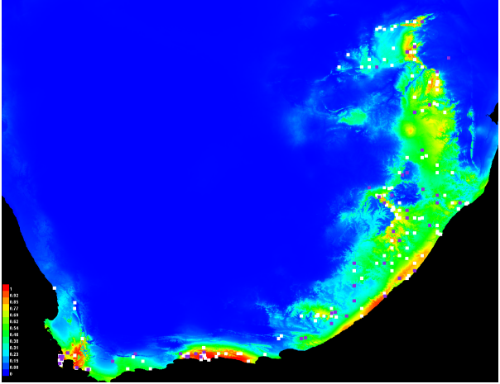
Figure 8. Species distribution map of P. latifolius in South Africa the background colour represent the probability of the species occurring the will dark blue being zero and red beign highst probability, the dots represent the actual distribution of the species.

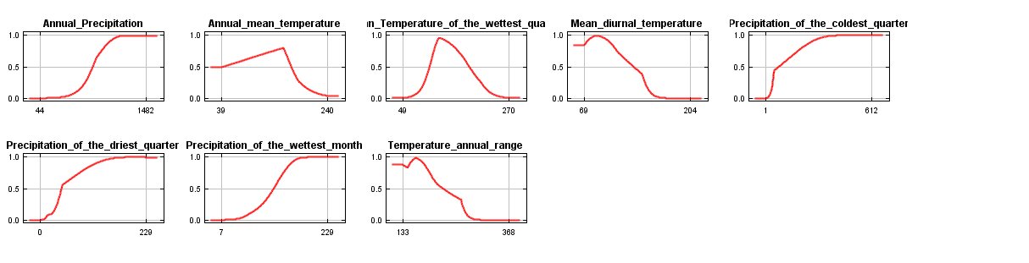
Figure 9. Graphical showing response curves of environmental predictor variables for P. latifolius the x-axis represent the probability of occurrence Holocene.
Table 3. the predictor variables percentage contribution they have towards the generated model of P. latifolius distribution in Maxent during the Holocene.
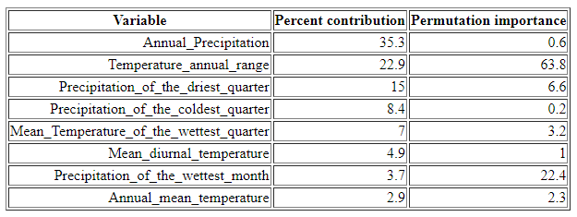

Part 1
- The mean diurnal temperature, the yearly temperature range, and the maximimum temperature in the warmest month are the three most crucial indicators under the current climate circumstances, in (table 1). 34.8%, 31.7%, and 17.1% of each have contributed in relation to the location of P. latifolius. Combined with figure 3 graphical representations of the top three predictor variables are shown in e, g, and that the highest likelihood of occurrence occurs between the lower and middle scales of temperature indicators showing that P. latifolius is more likely to appear in areas of Compared to more extreme heat ranges, intermediate and warm temperatures. The tree is naturally dispersed throughout South Africa's humid regions, such as the areas along the coast between KwaZulu Natal and the Western Cape, based to the literature (White, 1978), which is compatible with what is shown in figure 2. As observed in the species distribution map (figure 2), it is frequently described as a mountainous forest plant with a vast distribution that is extensively fragmented (Migliore et al., 2020). Plants experience greater heat stress at higher elevations than they do at the mountain's base because high altitude regions are more susceptible to the sun's short-wavelength rays. Podocarpus_latifolius is a C3 plant and these plants are sensitive to temperature and have a small optimum temperature range. These plants a slow growing, when temperature are higher fires are more frequent this leaves this plant vulnerable to topkill because they do not grow fast enough to be above the fire line. The seed has a thin leathery epimedium (C, 1993), this leaves the embryo exposes to external factors such as temperature. High temperature also lead to dominance of trees in order to reserve water. The roots are non-aggressive in habitats that are occupied by a lot of tress, they are sensitive to frost (Stoker, 2018). P. latifolius has a unique phenotype that aids in its survival in these higher altitude geographic areas. For example, it exhibits a high wood density, allowing it to prevent cavitation due to extreme heat during high yearly temperatures and temperature spikes in January,(Brown, 2006; (kang et al., 2022). Reduced transpiration rates are aided by the small, narrow leaves' higher stomatal density (Liu et al., 2020). In order to maximize water conductivity in locations with poor drainage, such as mountains, and to avoid vessel embolism brought on by freezing temperatures and dryness, a tree's xylem and phloem narrow at its height and widen at its base (Konrad et al., 2019).

- Yes, in the current climate temperature is the major predator with 4 of the 5 being temperature related factors. In the future and Holocene precipitation in the major predictor and temperature is the second major predictor with 3 of the 5 being precipitation related factors. The difference between the Holocene and future is that in the future temperature annual range is the most predictor and annual mean temperature is the least top 5 predictor. While in the Holocene the annual precipitation is the most predictor and mean temperature of the wettest quarter is the least top 5 predictor. there is a little differences between past and future response curves that suggests that P. latifolius could occasionally grow in temperature ranges that were not found in past climatic conditions. In comparison to prior environmental factors, the probability of P. latifolius occurring appears to modestly increase at both lower and higher temperatures. In addition, P. latifolius is now found in higher ranges of precipitation than it did in the past, which is a modest change in the probability of occurrence in precipitation variables. This may be a sign that the climate has changed, which has affected P. latifolius's reaction and distribution. This may be a sign that the climate has changed, which has affected P. latifolius's reaction and distribution. It is well known that climate change is causing annual temperatures to rise.This ultimately has an impact on rainfall patterns, as evidenced by the increased frequency of floods and more intense downpour). These impacts are anticipated to intensify as time. Increasing likelihood of occurrence at these higher temperatures and precipitation patterns may indicate how well P. latifolius has adapted to its environmental factors, or possibly a shift in the vegetation (competing).P. latifolius was able to take up more of its realized niche as a result of its vegetative declining.

3. yes the three predictors are what we would expect according to the ecology because this species grow in areas with a low varying temperature.
Podocarpus latifolius grows in mountainous forests; it likes higher elevations and more humid conditions, typically choosing locations with higher annual precipitation. Together with Olea spp., Podocarpus latifolius may predominate in the climax vegetation of the lower and middle montane zone. Podocarpus latifolius is drought sensitive. Little frost is tolerated, although young seedlings are vulnerable. It is classified as a species that tolerates medium levels of shading. It functions optimally in deep, nutrient-rich soils that are well-drained. A layer of mulch on the ground aids in cultivation. Podocarpus latifolius has a high rate of natural regrowth, particularly in tiny and medium-sized gaps in the forest, according to research conducted in South Africa. Given that juveniles have same environmental needs to adults, the predictor variables wouldn't change significantly for them. What could alter is that precipitation variables might be more important than temperature variables because P. latifolius seeds are susceptible to dehydration and fail to germinate when they are dried out. Additionally, because juveniles possess more broad leaves than adults, they have a lower water potential and thus require more water compared to adult species.

4 it only predicts species distribution using climatic models, it does not consider species biology and ability to adapt.
. bias may result from samples being collected from distinct places and by various organizations.
. Inaccurate depictions of species distributions can also be caused by financial inequity (countries lacking enough money to carry out sampling operations) and inadequate exchange of information between nations.
it is including species in zoo’s and game reserves, this is not an accurate representation of natural distribution.
. climatic predictions may be incorrect.

5. As an organism's sensitivity for heat varies and its distribution of consumers and their prey shifts spatially due to temperature variations, there are spatial mismatches. When one source is collected by standardized surveys and the other source was not collected using the same procedure. Temporal mismatches include whereby one covariate may be recorded with an alternative temporal resolution than a second covariate (. e., daily and annually). Spatial mismatch can occur in a situation in which one characteristic, like as elevation, is assessed at one spatial scale, such as county, while another, such as population density, is determined at a different spatial scale, such as zip code. Mismatches This occurs when data sources have fluctuating geographic coverage, varying spatial scales and resolutions, and differing sources of bias and sparsity.
6. past to current
There was fewer zones of high species density in earlier SDMs. Along the east coast, there is also a noticeable rise in species (greater regions of yellow and green color). But farther east of the shore, there is a bigger decline in species occurrence (figure). As indicated by a drop in the light blue density of the designated regions (figures 2 and 5), there's a decrease of the distribution of species north of the map as well as inland of the east coast. This shows that there was a rise in the frequency of the species from the past climatic circumstances to the future. The future SDM has more white and purple squares across the expected areas of occurrence than in the past.
Future to current
In accordance with the SDM models of figures 2 and 8, the presence of species rose from the past to the present as evidenced by the growth of green regions inland and near the coast, but the density of species and connectivity appear to have been estimated to decline from the past to the present climatic conditions as evidenced by the reduction in connectivity of yellow regions inland and along the coast. In contrast, the emergence of red patches in figure 2 indicates that there appears to be an anticipated incidence of small P. latifolius hotspots as we approach north inland and to the tip of the west coast. The purple and white dots show that the species has undergone changes in climate from earlier times to the present.

7. the species would do worse, because climate prediction say that not only will it get hotter but annual rainfall will be less, this prevents the species from using evaporative cooling because it might be able to replace that lost water for some time.

Part 2
Current to future projection
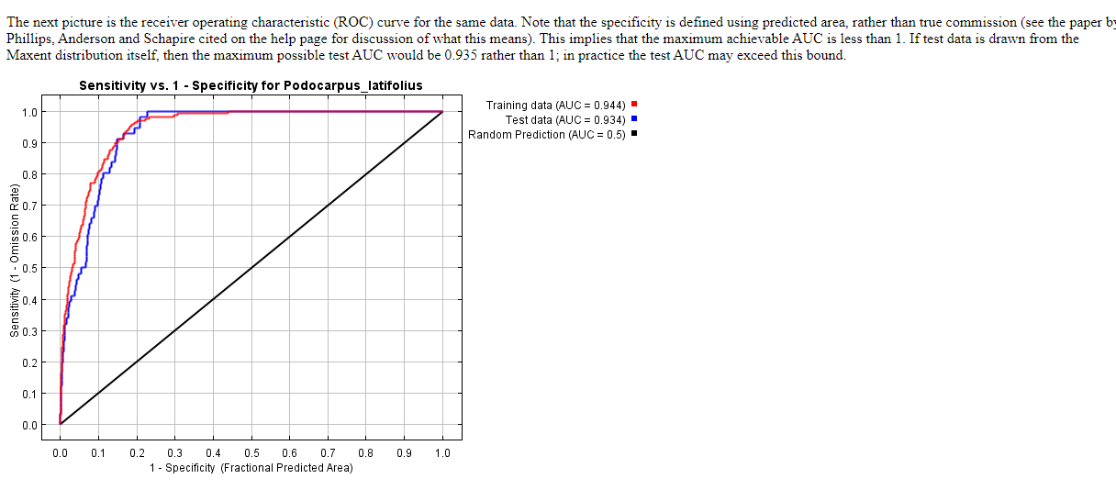
Figure 2.1: : graph showing fraction value plotted against cumulative value, and specifity plotted against sensitivity, the receiver operating curve (ROC) for the maximum entropy model of P. latifolius in South Africa with AUC measures of model performance during future projection.

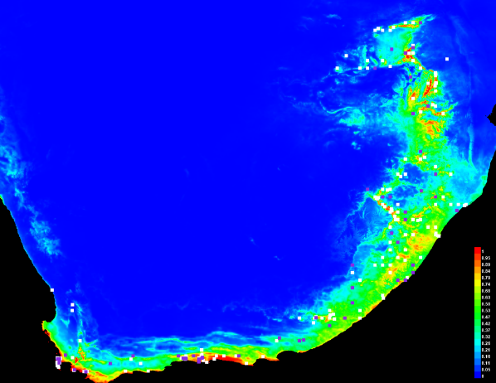
Figure 2.2
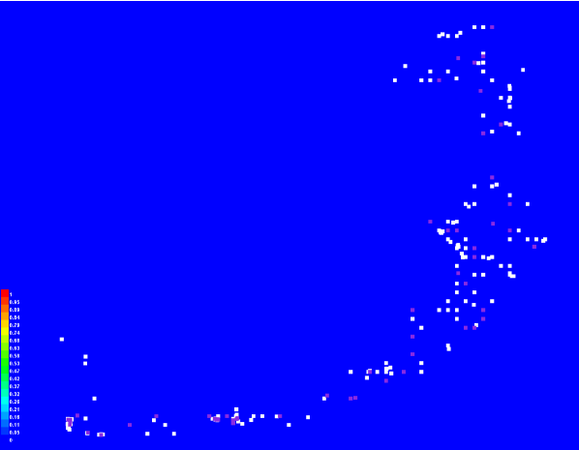
Figure 2.3 Species distribution map of P. latifolius in South Africa the background color represent the probability of the species occurring the will dark blue being zero and red being highest probability, the dots represent the actual distribution of the species.

Current to Holocene projection
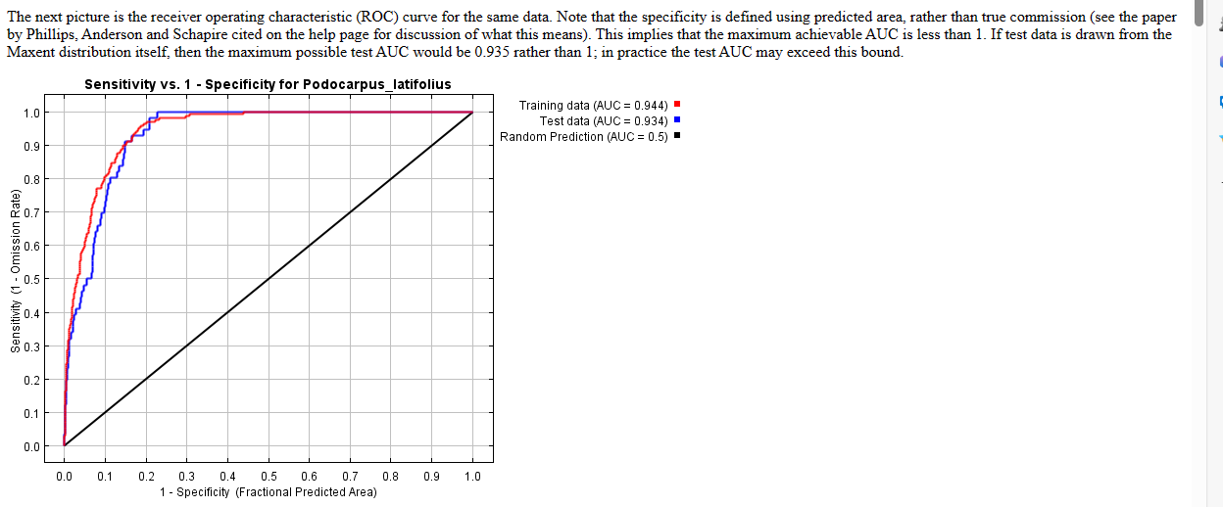
Figure 2.4: graph showing fraction value plotted against cumulative value, and specifity plotted against sensitivity, the receiver operating curve (ROC) for the maximum entropy model of P. latifolius in South Africa with AUC measures of model performance during Holocene projection

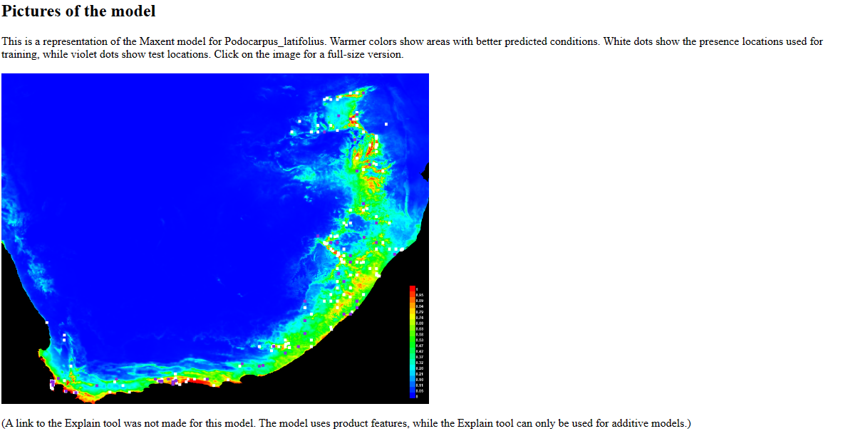
Figure 2.5
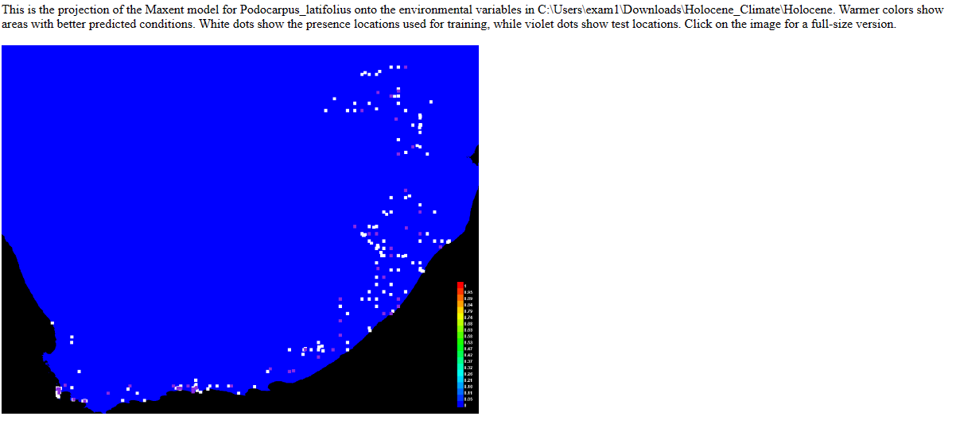
Figure 2.6 Species distribution map of P. latifolius in South Africa the background colour represent the probability of the species occurring the will dark blue being zero and red being highest probability, the dots represent the actual distribution of the species.

Answers
- Based on the projected distributions, do you think the change in range is realistic, based on the
species biology and ecology, and explain why?

Based on the distribution map for the Holocene projection, the species would have not be found in that period in time( figure 2.6). Three phases of natural climate fluctuations can be seen in the Holocene climate history: short-term cold periods associated with deglaciation during a stable positive temperature trend; a hot and steady climate with air temperature 1.0–3.5 °C above current levels; and increased climatic instability. The varying lake levels and vegetation during the Holocene indicate climatic fluctuation (Irena Borzenkova, 2015). The character of first development of soils is suggested by Holocene sediments (Gile, 1975). The mean annual temperature was about 2.5° C above current climate. The species ecology is sunny mountainous forests areas with moderate water availability deep and fertile, rich soils. It favours a mean yearly temperature of 9–19 °C and a typical yearly rainfall of 1000–2000 mm. At higher altitudes in humid climates, it frequently predominates. The projected distribution is realistic, given the constant changes in the Holocene period, this would lead to unpredictable temperature condition that the species would not be able to adapt too. The species has a narrow-preferred temperature range of 9–19 °C, the Holocene has a mean annual temperature was about 2.5° C above current climate, this would put heat stress on the species. The Holocene is marked as the beginning of soil formation, it would not mee the soil requirement such as deep and fertile, rich soils.

For the future projection it also predicted the species will not be found, characterised the pure blue background (figure2.3). In the past 150 years, the topsoil on the earth has been degraded. The quality of the soil is impacted by agriculture in additional ways besides erosion. Compaction, destruction of soil structure, degradation of nutrients, and salinity of the soil are a few of these effects (Millet, 2022). By 2100, worldwide average temperatures are predicted to rise by 0.5°F to 8.6°F. because of the rise in temperature we would expect unpredictable rainfall patterns, with some areas experiencing little to no rainfall while other areas will experience excessive rainfall. The projection is very realistic when we take into account that the species prefers deep and fertile, rich soils, but the future is expected to have degraded soils due to soil erosion. The rise in temperature and unpredictable rainfall would cause heat stress and water stress to the tree. The tree also has a high economic value such as the wood is used to build furniture and in Kenya the seeds are used to core stomach aches. If there is the proper management, the species can go extinct.

2.describe how the how the projected SDMs differ for the past and future in part 1
In the future SDM of part 1 P. latifolitus in part 1 the species distribution is along the coast of South Africa, with a distinct flare of the species distribution west of the coast. The tree seems to not be found in land of South Africa. The future SDM compared to the current SDM the has less connectivity and it seems to be migrating east coast. There are less false negative, the probability of the species occurring there matching the actual distribution of the species. In the future SDM OF part 2, the probability of species occurring in south Africa in zero. There are 100% false negatives in which the probability of the species occurring there and the actual distribution are not matching. In this SDM the species does not occur in the projected future with a full disappearance of the species in South Africa.
In the SDM of Holocene in part 1 the species if is found along the coast of South Africa, with distinct flares of high species distribution on the west and north of the coast. The species seems to be migrating on land, connectivity among the species in increasing. There is a decrease in false negative, the probability of the species occurring there matching the actual distribution of the species. For the projected Holocene SDM the probability of the species occurring there is zero. There are 100% false negatives in which the probability of the species occurring there and the actual distribution are not matching. In this SDM the species does not occur in the projected future with a full disappearance of the species in South Africa.

Part 3 answers
- Salmon fish

- Based on your species biology and ecology, which three bioclimatic variables would you expect to be
most important in predicting its distribution? Would the variables change for the juvenile versus adult
stage of the organism, and explain why
- Salmon are fish that live in cold waters; thus they typically thrive around mid-teens temps and strained at temperatures above 20 C. Salmon is harmed by warm water in a number of ways. One reason is that fish have a harder time breathing in warmer water because it stores a lesser amount of oxygen. They cannot regulate their body temperature in response to the environment whether it becomes too hot or too cold since they are cold-blooded. Warmer weather speeds up their metabolism, increasing their need for food and oxygen as well as their need to swim to locate colder waters, which uses greater amounts of energy (Chung, 2023).
- mean annual temperature, mean temperature at warmest month and temperature annual range.
- Yes, they would vary, salmon are known as anadromous, which implies that they breed in freshwater, spend most of their adult lives in saltwater oceans, and then move back to the freshwater to lay their eggs. Ocean waters in high latitudes receive fewer rays from the sun; the north and south poles only get 40% of the heat that the equator does. Because of these differences in solar radiation, the temperature of the ocean's surface may vary from a balmy 30°C (86°F) in the tropics to a bitterly cold -2°C (28°F) towards the poles. Most freshwater biomes around worldwide experience summer temperatures of 65 to 75 degrees Fahrenheit and winter temperatures of 35 to 45 degrees. Because of the varying in habitat at adult and juvenile stage, the temperature factors of each environment would be different. For example, because of its large and shallow characteristics, ocean temperature is constant with very little the difference throughout the year, so the mean annual temperature for an ocean would be slightly constant. while in freshwater is less large and not as shallow as an ocean, the annual temperature will vary significantly. So in juvenile stage the 3 most important predictors will be mean temperature at warmest month, mean annual temperature and temperature annual range in that order. In adult stage it would be mean annual temperature, temperature annual range and mean temperature at the warmest month.
- Do you think SDMs accurately predict species distributions based on the species biology? Justify your
answer with specific insights based on literature.
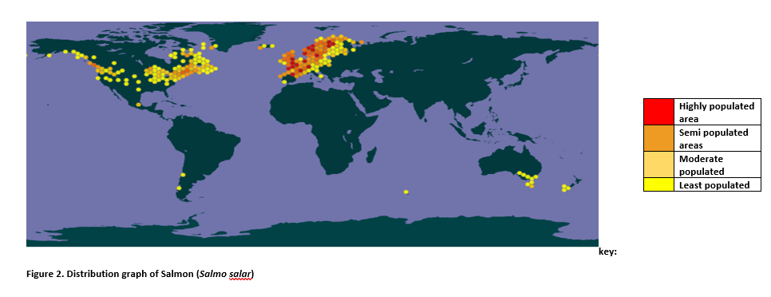

From the SDM Model the salmon fish is found in continent like Canada, Russia and Australia, the species are highly populated in west coast of Russia and majority on the east coast of Canada with some pollution also found on the west coast of Canada. There a small population of salmon fish found on the north of Australia. The Bering Sea which is located in between Canada and Russia, northernmost part of the Pacific Ocean, The northern and eastern regions have harsh winters with lows of -35° to -45° C). The north and east experience cold summers with little or no precipitation. Water temperatures average from 1° C and 5° C in the north and the south respectively (et.al, 2023). Salmon prefers cold water since it contains more oxygen than warm water, and oxygen is essential for fish growth. Salmon's metabolism is similarly slowed by cold water; as a result, they eat less and digest their food more thoroughly. Because a salmon's food takes some time to be entirely ingested. Because of it biology it prefers cold water like in the Bering sea, yes the SDMS did accurately predict its distribution. But there is a appearance of the species in continents like south America that a typical warm, this could a result of species introduction due to the fact that salmon is a very economically valued species.

References
C, J. G. (1993). reproductive biology and popuation structures of Podocarpus falcatus and P. latifolius in Southern Cape forest. ScienceDirect, 59-74.
Chung, E. (2023, July 2021). Salmon are getting cooked by climate change. Here's how they could be saved+. Retrieved from CBC News: https://www.cbc.ca/news/science/salmon-climate-change-1.6114328#:~:text=Warm%20water%20can%20harm%20salmon,too%20warm%20or%20too%20cold.
et.al, P. D. (2023). Bering Sea and Strait. Encyclopedia Britannica.
Gile, L. H. (1975). Holocene soils and soil-geomorphic relations in an arid region of southern New Mexico. ScienceDirect, 321-360.
Irena Borzenkova, E. Z. (2015). Climate Change During the Holocene (Past 12,000 Years). ResearchGate, 50-62.
Millet, J. (2022, july 20). soil erosion and degredation. Retrieved from World Wildlife Fund: https://www.worldwildlife.org/threats/soil-erosion-and-degradation#:~:text=Half%20of%20the%20topsoil%20on,nutrient%20degradation%2C%20and%20soil%20salinity.
Stoker, P. (2018). tree of the year 2018. ResearchDirect, 2-10.

