**📊 Results & Analysis Summary**

This section presents key findings from the time series analysis of forest cover over Pench Tiger Reserve (2010–2023), using image processing, machine learning, and climate data analytics. The project integrates satellite imagery, the Brovey Transform, and Support Vector Regression (SVR) modeling to analyze and predict forest cover dynamics in relation to seasonal and climatic variations.

**🛰️ Image Processing & Fusion**

Four main satellite image types were used: Multispectral (MS), Panchromatic (Pan), Brovey-fused, and segmented images.

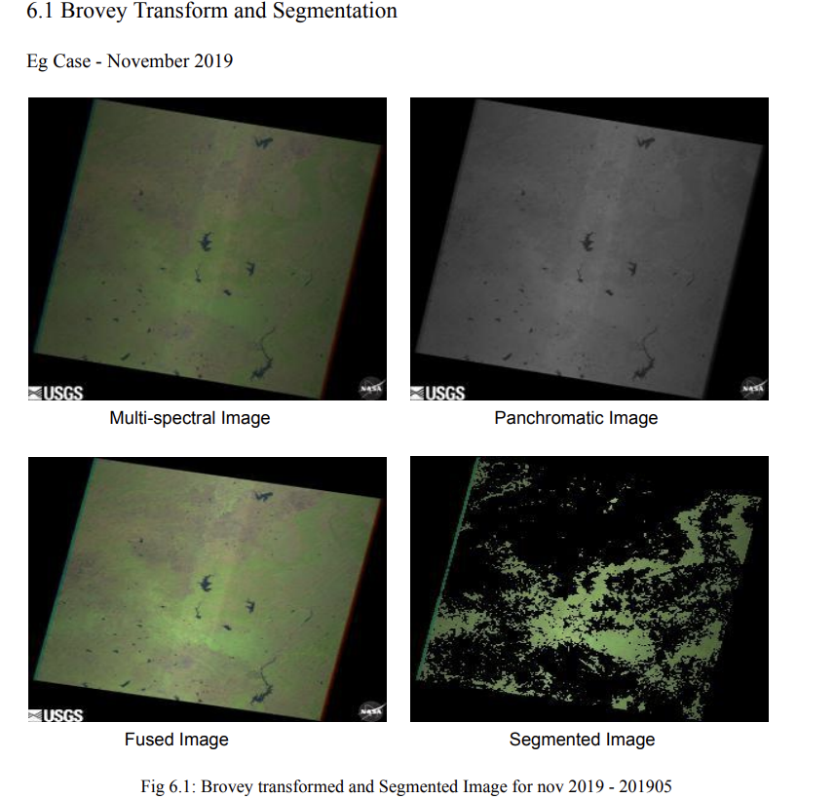

* **MS Images** (from Landsat-7) offered valuable spectral data but lacked spatial clarity.
* **Pan Images** had high spatial resolution but no spectral depth.
* The **Brovey Transform** successfully merged both, improving spatial detail while preserving spectral features.
* **Segmented Images** (via ratio-based thresholding) clearly distinguished vegetated from non-vegetated regions, aiding in accurate forest cover extraction.

To obtain the four spectral images used in this study, satellite imagery from the **Landsat-7** mission was accessed via open-source platforms such as **USGS EarthExplorer** or **Google Earth Engine**. The specific bands — typically **Band 1 (Blue), Band 2 (Green), Band 3 (Red), and Band 4 (NIR)** — were downloaded in GeoTIFF format for the study area (Pench Tiger Reserve) and filtered by cloud cover and acquisition date. Using the provided Python or MATLAB scripts, each band was individually extracted, resized to a uniform resolution, and stacked as separate grayscale images. These were then preprocessed to remove noise, enhance contrast, and align spatially for subsequent fusion and segmentation operations.

The Brovey Transform showed strong Pearson correlation coefficients (>0.75 in most cases), indicating high fidelity between original and transformed images, especially in .tiff formats. This fusion approach enhanced the resolution necessary for detailed vegetation mapping.

**Brovey Fusion**  
To enhance the spatial resolution of the multispectral images, Brovey Transform was applied using the available code. This technique combines high-resolution panchromatic (or the average of RGB bands) with multispectral data to produce sharper, visually enriched images. Each spectral band (Red, Green, Blue) was normalized and fused using the Brovey formula:  
**Fused Band = (MS Band / (Red + Green + Blue)) × Pan**  
This process preserved key spectral information while improving the visualization of forested and non-forested zones, making the images suitable for precise segmentation.

**Vegetation Index Calculation**  
After fusion, vegetation indices were computed using **Green-to-Red (GR)** and **Green-to-Blue (GB)** ratios, as these were most effective in distinguishing vegetated areas. These indices were calculated pixel-wise using the formulae:  
**GR = Green / Red** and **GB = Green / Blue**  
The resulting index maps enhanced vegetation contrast, where higher values typically indicated dense vegetation. These indices served as the basis for thresholding in the segmentation step.

**Segmentation**  
A **ratio-based thresholding** approach was used to segment the image and extract forest cover. Based on histogram analysis and visual inspection, optimal threshold values for GR and GB ratios were selected. Pixels with ratio values above the set thresholds were classified as forest, while others were categorized as non-forest. The segmentation results were validated by comparing with on-ground data and visual references, ensuring accuracy in the extracted forest regions.

**🌿 Forest Cover & Climate Trends (2010–2023)**

Forest cover was evaluated across seasons and years:

* **Lowest Cover**: January–March (dry season), often due to heatwaves, drought, and forest fires.
* **Highest Cover**: October–December (post-monsoon), reflecting natural regeneration.

A declining trend in forest cover peaks was observed post-2015. For example, October 2015 had 55.50% forest cover, while October 2023 dropped to just 20.31%. This decline may be attributed to deforestation, climate change, and anthropogenic pressures like encroachment and logging.

Notable factors influencing vegetation health:

* Dew point and soil moisture had a **positive effect** on forest cover.
* Wind speed, high temperature, and water scarcity had a **negative impact**.

Despite seasonal regrowth, a gradual loss of vegetation suggests increasing vulnerability and ecosystem stress, reinforcing the need for sustainable forest and water management policies.

**🤖 SVR Modeling Insights**

An SVR model was trained using climatic variables to predict forest cover:

* **Dew Point** had the **strongest positive correlation** (0.7462), indicating moisture is critical for vegetation.
* **Wind Speed** showed a **negative correlation** (-0.37), reflecting the drying effects of strong winds.
* **Temperature** and **Sea Level Pressure** had weak correlations, suggesting minimal direct impact.

The SVR model demonstrated high reliability in modeling forest cover dynamics based on meteorological data. It provides a valuable framework for future forest health monitoring and policy planning.

**🔍 Key Takeaways**

* The Brovey Transform enhanced spatial-spectral quality, aiding accurate segmentation.
* Seasonal forest cover cycles correspond to rainfall and climate patterns.
* Long-term decline points to rising environmental stressors.
* SVR modeling confirms dew point and wind speed as critical predictors of vegetation health.

This integrated approach demonstrates the power of remote sensing and machine learning for ecological monitoring and supports data-driven conservation strategies.

**Summary of Findings and Contributions**

This study presents a novel integration of image processing and machine learning to forecast forest cover dynamics in the Pench Tiger Reserve between 2010 and 2023. The Brovey Transform significantly enhanced the spatial resolution of Landsat-7 multispectral images, aiding effective segmentation through ratio-based thresholding using green-red and green-blue indices. The resulting forest cover maps were validated with input from forest officials.

Support Vector Regression (SVR), trained on normalized meteorological variables (wind speed and dew point), demonstrated superior forecasting capability over the baseline Multiple Linear Regression (MLR) model. Cross-validation and hyperparameter tuning helped optimize SVR performance. Model evaluation metrics are as follows:

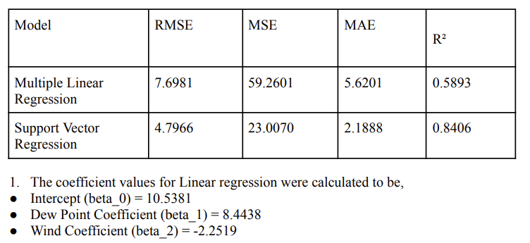

* **SVR outperformed MLR** significantly, reducing prediction errors and explaining ~84% of the variance in forest cover, compared to ~59% with MLR.
* SVR successfully captured the **non-linear relationships** between dew point, wind speed, and forest cover, which the linear model could not.
* While SVR was more accurate overall, it slightly **underestimated at low cover** and **overestimated at high cover**, indicating room for improvement in modeling extremes.

**Conclusions**

The application of SVR with satellite-derived and climatic data proves to be an effective approach for modeling forest cover in ecologically sensitive regions. Its superior performance over linear models highlights the importance of using **non-linear, data-driven models** in environmental forecasting. Key takeaways include:

* **SVR is robust** in predicting forest cover using limited meteorological inputs.
* **Improved accuracy** (lower RMSE, MAE) suggests SVR can support better forest management decisions.
* Despite limitations (limited climate variables, regional scope), the study sets a **baseline benchmark** for forest cover analysis in Pench

Despite its effectiveness, the study is limited by the number of climatic variables and its region-specific focus. Nevertheless, it establishes the first benchmark of forest cover percentage in Pench using advanced remote sensing and machine learning techniques, bridging a crucial research gap.

**Policy Implications and Future Work**

The findings inform adaptive policy-making with a focus on climate-resilient forest conservation, sustainable land use, and technology-driven transparency. Recommendations for future work include:

* Integration of high-spectral resolution data (e.g., Sentinel-2, Landsat-8)
* Inclusion of additional environmental variables (e.g., soil moisture, solar radiation)
* Longitudinal and seasonal trend analysis
* Adoption of ensemble models (e.g., Random Forest, Gradient Boosting) for enhanced accuracy
* Real-time monitoring systems and ground-truth validation
* Assessing socio-economic impacts of forest cover changes on local communities

In summary, this study offers a scalable framework for remote forest monitoring and contributes actionable insights for conservation strategy, sustainable development, and environmental resilience.