**MOBILE COMPUTING LAB**

A Practical Lab Manual Submitted in Fulfillment of the Degree of

**MASTER**

**In COMPUTER APPLICATION**

**Year 2022-2023**

By

**Ms. Borole Dimple Dattatraya Harshala**

**(Seat No: 806214)**

**(Application Id: 169913)**

Under the Guidance of

**Mr. Dyaneshwar Deore**



Institute of Distance and Open Learning

Vidya Nagari, Kalina, Santacruz East – 400098.

University of Mumbai

**PCP Center**

**Satish Pradhan Dnyanasadhana College**

Off Eastern Express Highway,Dnyanasadhana Marg, Thane – 400604, Maharashtra, India



**Institute of Distance and Open Learning**

Vidya Nagari, Kalina, Santacruz East – 400098.

CERTIFICATE

This is to certify that, this Practical Lab Manual for Subject **Mobile Application Programming Lab** is a record of work carried out by **Ms. Borole Dimple Dattatraya Harshala (Seat No.: 806214),** student of **MCA Semester - III** class and is submitted to University of Mumbai, in partial fulfilment of the requirement for the award of the degree of **Master in Computer Application**. The Practical Lab Manual has been approved.

Subject Teacher External Examiner Coordinator – M.C.A

**ACKNOWLEDGMENT**

After the completion of this work, words are not enough to express my feelings about all those who helped me to reach my goal; feeling above this is my indebtedness to the almighty for providing me this moment in my life.

It’s a great pleasure and moment of immense satisfaction for me to express my profound gratitude to my practical lab manual guide, **Mr. Dyaneshwar Deore** whose constant encouragement enabled me to work enthusiastically. His perpetual motivation, patience and excellent expertise in discussion during progress of dissertation work have benefited me to an extent, which is beyond expression. His depth and breadth of knowledge of Engineering field made me realize that theoretical knowledge always helps to develop efficient operational software, which is a blend of all core subjects of the field. The completion of this practical lab manual would not have been possible without his encouragement, patient guidance and constant support.

I would like to thank all staff members for their valuable cooperation and permitting me to work in the computer labs.

Special thanks to my colleagues and friends for providing me useful comments, suggestions and continuous encouragement.

Finally, I thank my family members, for their support and endurance during this work.

# Ms. Borole Dimple Dattatraya Harshala

**(Seat No: 806214)**

**INDEX**

|  |  |  |  |
| --- | --- | --- | --- |
| **Sr.**  **No.** | **Title** | **Date** | **Sign** |
| 1 | **INTRODUCTION TO ANDROID**   1. Create a simple Hello World application. 2. Creating android application for generating user interface for student Registration and feedback form by using all basic UI controls. |  |  |
| 2 | **BASIC CONTROLS AND UI COMPONENT**  A. Program to demonstrate use of Spinner, AutoCompleteTextView, multiline text and TextView control by creating Feedback form Create a basic  calculator app using android studio |  |  |
| 3 | **DATA BASE CONNECTIVITY**   1. Creating android program to demonstrate the use of Internal Storage. 2. Creating android program to demonstrate the use of Shared   preferences. |  |  |
| 4 | **INTRODUCTION TO GRAPHICS, ANIMATION AND MULTIMEDIA**   1. Write a Program to draw basic graphics construction like line, circle, arc, ellipse and rectangle. 2. Write a Program to draw animation using increasing circles   filled with different colors and patterns |  |  |
| 5 | **LOCATION BASED SERVICES**  A. Write a program to find your location in the Map |  |  |
| 6 | **SOCKET PROGRAMMING IN C/C++** |  |  |

# Practical No. 1

**Aim: Introduction to Android**

**1.A] Aim:** Create a simple Hello World application.

# Source Code:

**activity_main.xml**

<?xml version="1.0" encoding="utf-8"?>

<RelativeLayout xmlns:android="<http://schemas.android.com/apk/res/android>" xmlns:tools="<http://schemas.android.com/tools>" android:layout_width="match_parent" android:layout_height="match_parent"

tools:context=".MainActivity">

<TextView android:id="@+id/textView" android:layout_width="wrap_content"

android:layout_height="wrap_content" android:layout_centerHorizontal="true" android:layout_marginTop="300dp" android:text="Hello World!" android:textSize="30sp" android:textStyle="bold" />

<Button

android:id="@+id/btn_click" android:layout_width="wrap_content" android:layout_height="wrap_content" android:layout_centerHorizontal="true" android:layout_marginTop="400dp" android:backgroundTint="@color/purple_200" android:text="Click Me" android:textColor="@color/black" android:textSize="30sp" />

<TextView android:id="@+id/textView2" android:layout_width="wrap_content" android:layout_height="wrap_content" android:layout_centerHorizontal="true" android:layout_marginTop="200dp"

android:text="Hello Android Application" android:textColor="#FF5722" android:textSize="30sp" android:textStyle="bold" />

</RelativeLayout>

# MainActivity.java

package com.idol.helloworld;

import androidx.appcompat.app.AppCompatActivity; import android.os.Bundle;

import android.view.View; import android.widget.Button; import android.widget.Toast;

public class MainActivity extends AppCompatActivity { Button btnCLick;

@Override

protected void onCreate(Bundle savedInstanceState) { super.onCreate(savedInstanceState); setContentView(R.layout.activity_main);

btnCLick = (Button) findViewById(R.id.btn_click); btnCLick.setOnClickListener(new View.OnClickListener() {

@Override

public void onClick(View view) { Toast.makeText(getApplicationContext(), "Welcome to Android",

Toast.LENGTH_LONG).show();

}

});

}

}

**Output:**

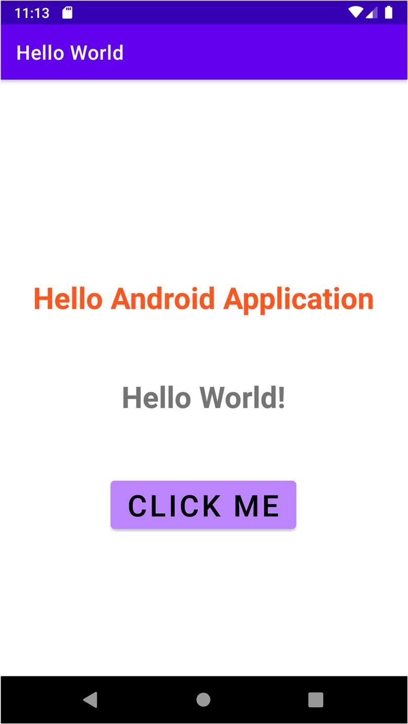

**1.B] Aim:** Creating android application for generating user interface for student Registration and feedback form by using all basic UI controls.

# Source Code:

**activity_main.xml**

<?xml version="1.0" encoding="utf-8"?>

<RelativeLayout xmlns:android="<http://schemas.android.com/apk/res/android>" xmlns:app="<http://schemas.android.com/apk/res-auto>" xmlns:tools="<http://schemas.android.com/tools>" android:layout_width="match_parent" android:layout_height="match_parent"

android:gravity="center" tools:context=".MainActivity" android:background="#95E4DD">

<LinearLayout android:layout_width="match_parent" android:layout_height="wrap_content" android:orientation="vertical">

<ImageButton android:id="@+id/imageButton" android:layout_width="300dp" android:layout_height="150dp" android:layout_centerHorizontal="true" android:layout_marginTop="10dp" android:layout_marginLeft="50dp" android:layout_marginRight="50dp" app:srcCompat="@drawable/student"

/>

<EditText android:id="@+id/editTextTextPersonName" android:layout_width="wrap_content" android:layout_height="wrap_content" android:layout_alignParentTop="true" android:layout_centerHorizontal="true" android:layout_marginTop="10dp" android:layout_marginLeft="100dp" android:ems="10" android:inputType="textPersonName" android:hint="Enter UserName :" android:text="" />

<EditText

android:id="@+id/editTextTextEmailAddress" android:layout_width="wrap_content" android:layout_height="wrap_content" android:layout_alignParentTop="true" android:layout_centerHorizontal="true" android:layout_marginTop="10dp" android:layout_marginLeft="100dp"

android:ems="10" android:hint="Enter Email ID :"

android:inputType="textEmailAddress" />

<EditText android:id="@+id/editTextPhone" android:layout_width="wrap_content" android:layout_height="wrap_content" android:layout_centerHorizontal="true" android:layout_marginTop="10dp" android:layout_marginLeft="100dp" android:ems="10"

android:hint="Enter Mobile Number :" android:inputType="phone" />

<EditText android:id="@+id/editTextTextPostalAddress" android:layout_width="wrap_content" android:layout_height="wrap_content" android:layout_centerHorizontal="true" android:layout_marginTop="10dp" android:layout_marginLeft="100dp" android:ems="10" android:inputType="textPostalAddress" android:hint="Enter Postal Address :"/>

<CheckBox android:id="@+id/checkBox" android:layout_width="wrap_content" android:layout_height="wrap_content" android:layout_marginTop="10dp" android:layout_marginLeft="100dp" android:text="Reading" />

<CheckBox android:id="@+id/checkBox2" android:layout_width="wrap_content" android:layout_height="wrap_content" android:layout_marginLeft="100dp" android:layout_marginTop="10dp" android:text="Writing" />

<RadioGroup android:layout_width="200dp" android:layout_height="wrap_content" android:orientation="horizontal" android:layout_marginTop="10dp" android:layout_marginLeft="100dp">

<RadioButton android:id="@+id/radioButton" android:layout_width="wrap_content" android:layout_height="wrap_content" android:text="Male" />

<RadioButton

android:id="@+id/radioButton2" android:layout_width="wrap_content" android:layout_height="wrap_content" android:layout_marginLeft="20dp" android:text="Female" />

</RadioGroup>

<Button

android:id="@+id/button" android:layout_width="200dp" android:layout_height="wrap_content" android:layout_marginTop="10dp" android:text="Submit" android:layout_gravity="center"/>

</LinearLayout>

</RelativeLayout>

# Output:

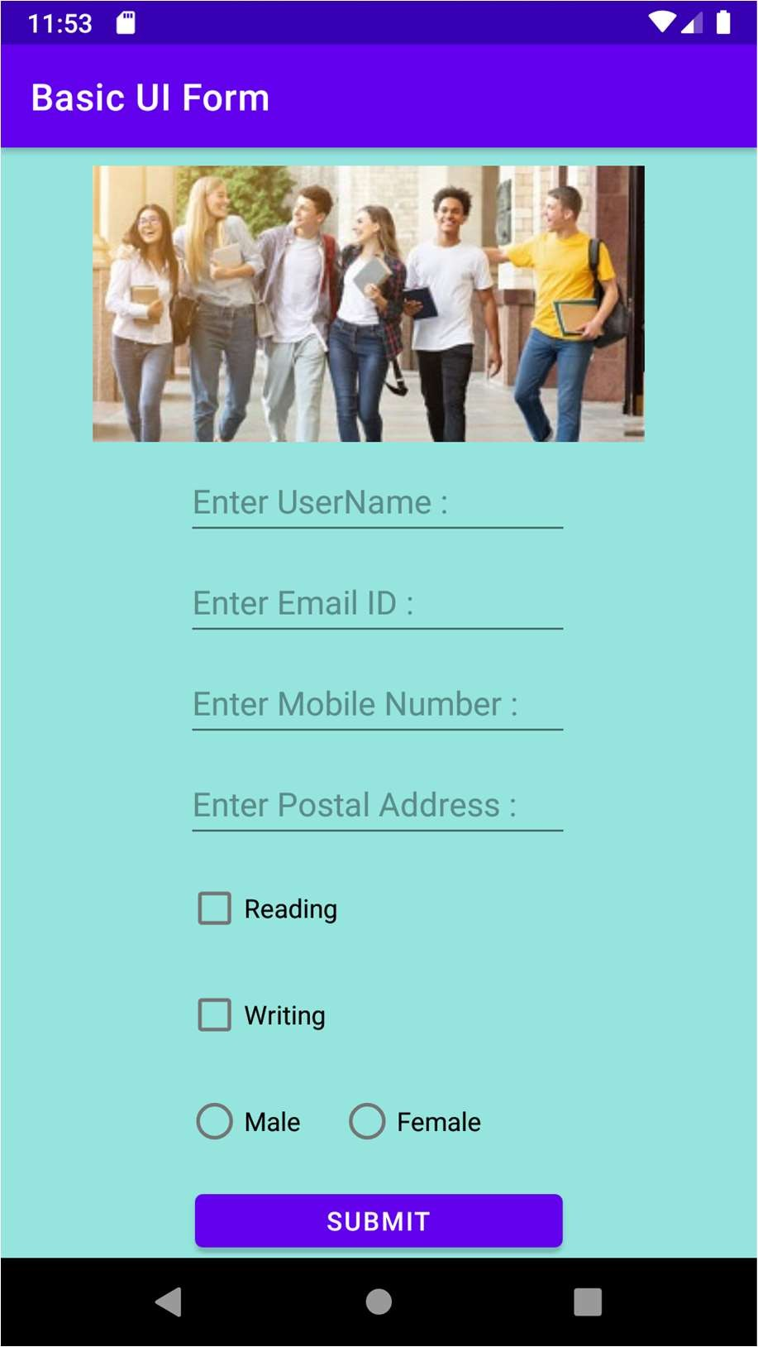

**Practical No. 2 Aim: Basic Controls and UI Component**

**2.A] Aim:** Program to demonstrate use of Spinner, AutoCompleteTextView, multiline text and TextView control by creating Feedback form.

# Source Code:

**activity_main.xml**

<?xml version="1.0" encoding="utf-8"?>

<RelativeLayout xmlns:android="<http://schemas.android.com/apk/res/android>" xmlns:tools="<http://schemas.android.com/tools>" android:layout_width="match_parent" android:layout_height="match_parent"

tools:context=".MainActivity">

<LinearLayout android:layout_width="match_parent" android:layout_height="wrap_content" android:layout_marginLeft="20dp" android:layout_marginRight="30dp" android:layout_marginTop="20dp" android:orientation="vertical" tools:ignore="MissingConstraints">

<TextView android:id="@+id/textView" android:layout_width="match_parent"

android:layout_height="wrap_content" android:layout_marginTop="30dp" android:gravity="center" android:text="Thank You For Visiting!!!!" android:textColor="@color/black" android:textSize="20sp" android:textStyle="bold" />

<TextView android:id="@+id/text_View" android:layout_width="match_parent" android:layout_height="wrap_content" android:gravity="center" android:text="Nexon Auto Shop" android:textColor="@color/black" android:textSize="20sp" android:textStyle="bold" />

<LinearLayout android:layout_width="match_parent" android:layout_height="wrap_content" android:layout_marginBottom="40dp" android:orientation="horizontal">

<TextView

android:id="@+id/textView2" android:layout_width="90dp" android:layout_height="wrap_content" android:layout_weight="1" android:text="Name" android:textSize="15sp" />

<EditText android:id="@+id/editTextTextPersonName" android:layout_width="wrap_content" android:layout_height="wrap_content" android:layout_weight="1" android:ems="10" android:inputType="textPersonName" />

</LinearLayout>

<LinearLayout android:layout_width="match_parent" android:layout_height="wrap_content" android:layout_marginBottom="40dp" android:orientation="horizontal">

<TextView android:id="@+id/textView4" android:layout_width="150dp" android:layout_height="wrap_content" android:layout_weight="1" android:text="Country" android:textSize="15sp" />

<Spinner android:id="@+id/spinner"

android:layout_width="match_parent" android:layout_height="wrap_content" android:layout_weight="1" />

</LinearLayout>

<LinearLayout android:layout_width="match_parent" android:layout_height="wrap_content" android:layout_marginBottom="40dp" android:orientation="horizontal">

<TextView android:id="@+id/textView5" android:layout_width="100dp" android:layout_height="wrap_content" android:layout_weight="1" android:text="This Feedback is :" android:textSize="15sp" />

<AutoCompleteTextView android:id="@+id/autoCompleteTextView" android:layout_width="wrap_content" android:layout_height="wrap_content" android:layout_weight="1" />

</LinearLayout>

<LinearLayout android:layout_width="match_parent" android:layout_height="wrap_content" android:layout_marginBottom="40dp" android:orientation="horizontal">

<TextView android:id="@+id/textView6" android:layout_width="200dp" android:layout_height="wrap_content" android:layout_weight="1" android:text="Additional Comment" android:textSize="15sp" />

<EditText android:id="@+id/editTextTextMultiLine" android:layout_width="wrap_content" android:layout_height="wrap_content" android:layout_weight="1" android:ems="10" android:gravity="start|top" android:inputType="textMultiLine" />

</LinearLayout>

<Button

android:id="@+id/button" android:layout_width="match_parent" android:layout_height="wrap_content" android:text="Submit" />

</LinearLayout>

</RelativeLayout>

# MainActivity.java

package com.idol.basicuicomponent;

import androidx.appcompat.app.AppCompatActivity; import android.os.Bundle;

import android.view.View;

import android.widget.AdapterView;

import android.widget.AdapterView.OnItemSelectedListener; import android.widget.ArrayAdapter;

import android.widget.Spinner;

import android.widget.AutoCompleteTextView;

public class MainActivity extends AppCompatActivity implements OnItemSelectedListener

{

String[] Country = {"India", "Nepal", "China", "Srilanka", "Australia"}; String[] feedback = {"suggestion", "compliment", "complaint", "other"}; @Override

protected void onCreate(Bundle savedInstanceState) { super.onCreate(savedInstanceState); setContentView(R.layout.activity_main);

Spinner spin = (Spinner) findViewById(R.id.spinner); spin.setOnItemSelectedListener(this);

ArrayAdapter aa = new ArrayAdapter(this, android.R.layout.simple_spinner_item, Country);

ArrayAdapter<String> adapter = new ArrayAdapter<String>(this, android.R.layout.simple_dropdown_item_1line, feedback);

AutoCompleteTextView autoCompleteTextView = (AutoCompleteTextView) findViewById(R.id.autoCompleteTextView);

autoCompleteTextView.setThreshold(1); autoCompleteTextView.setAdapter(adapter); aa.setDropDownViewResource(android.R.layout.simple_spinner_dropdown_item);

//Setting the ArrayAdapter data on the Spinner spin.setAdapter(aa);

}

@Override

public void onItemSelected(AdapterView<?> adapterView, View view, int i, long l) {

}

@Override

public void onNothingSelected(AdapterView<?> adapterView) {

}

}

**Output:**

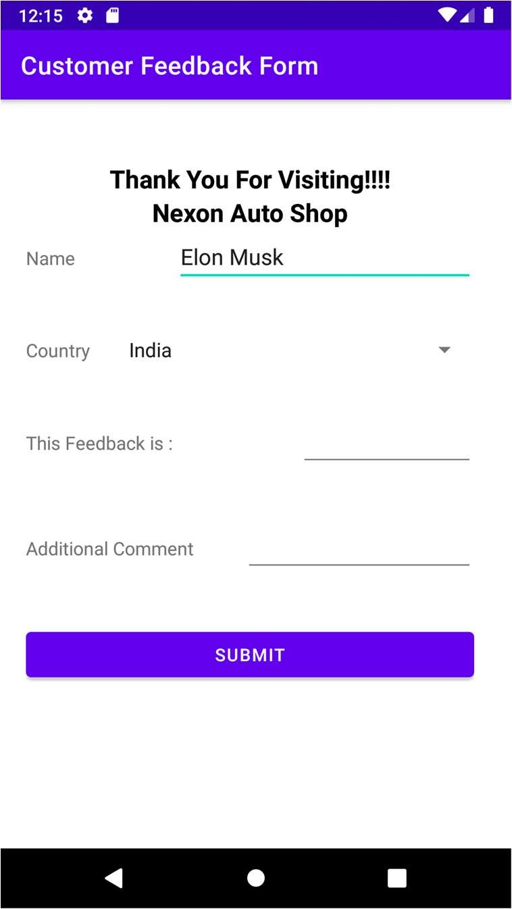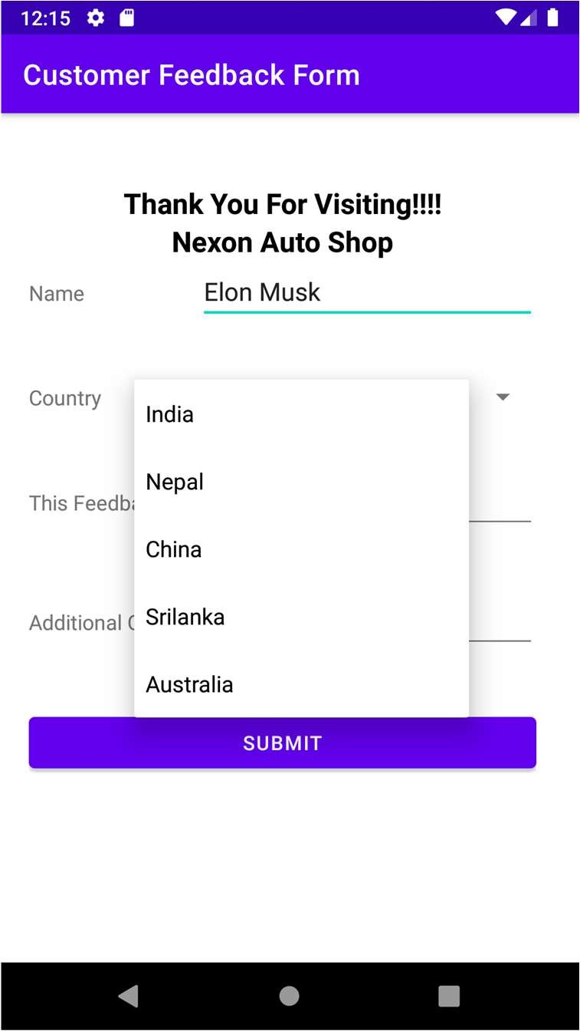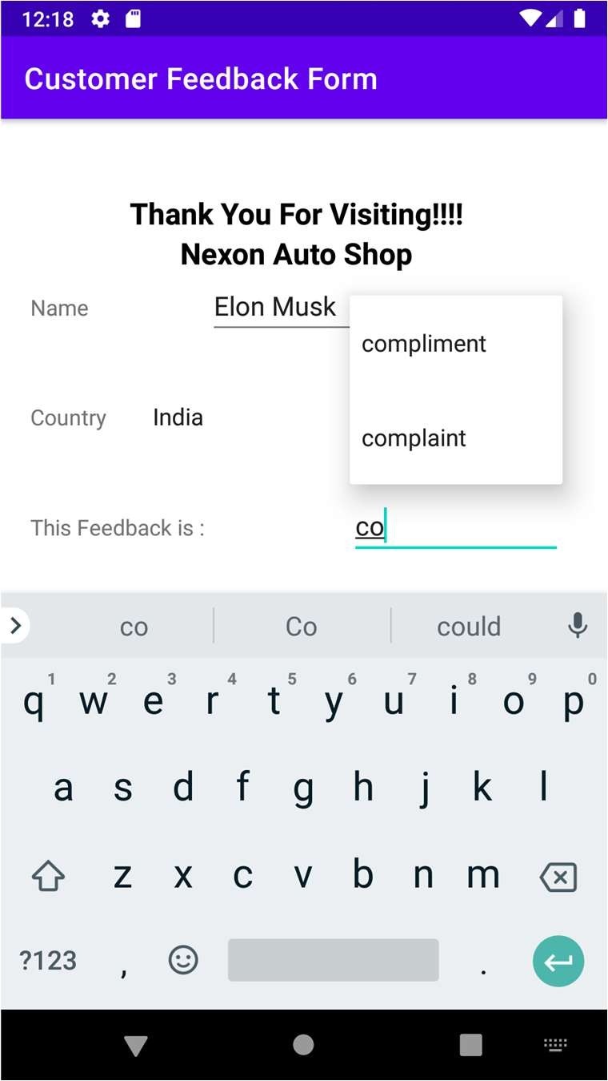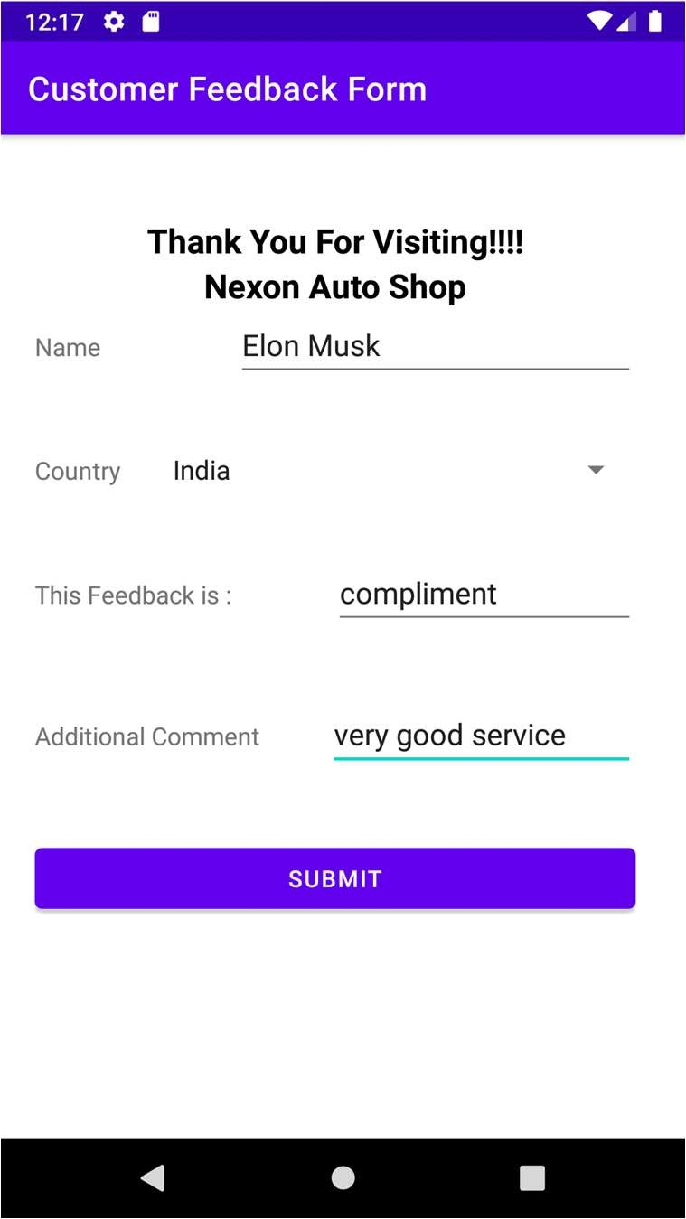

**2.B] Aim:** Create a basic calculator app using android studio.

# Source Code:

**activity_main.xml**

<?xml version="1.0" encoding="utf-8"?>

<RelativeLayout xmlns:android="<http://schemas.android.com/apk/res/android>" xmlns:tools="<http://schemas.android.com/tools>" android:layout_width="match_parent" android:layout_height="match_parent"

tools:context=".MainActivity">

<TextView android:id="@+id/textView" android:layout_width="wrap_content"

android:layout_height="wrap_content" android:text="Calculator" android:textColor="@color/purple_700" android:textSize="40sp" android:textStyle="bold" android:layout_marginTop="30dp" android:layout_centerHorizontal="true"/>

<EditText android:id="@+id/editTextTextPersonName" android:layout_width="wrap_content" android:layout_height="wrap_content" android:layout_centerHorizontal="true" android:layout_marginTop="110dp" android:ems="10"

android:hint="Enter Number 1" android:inputType="textPersonName" />

<EditText android:id="@+id/editTextTextPersonName2" android:layout_width="wrap_content" android:layout_height="wrap_content" android:layout_centerHorizontal="true" android:layout_marginTop="170dp" android:ems="10"

android:hint="Enter Number 2" android:inputType="textPersonName" />

<EditText android:id="@+id/editTextTextPersonName3" android:layout_width="wrap_content" android:layout_height="wrap_content" android:layout_centerHorizontal="true" android:layout_marginTop="230dp" android:ems="10"

android:hint="Result" android:inputType="textPersonName" />

<Button

android:id="@+id/btn_add" android:layout_width="wrap_content" android:layout_height="wrap_content" android:layout_marginStart="100dp" android:layout_marginTop="300dp" android:text="Add (+)"/>

<Button

android:id="@+id/btn_sub" android:layout_width="wrap_content" android:layout_height="wrap_content" android:layout_marginStart="220dp" android:layout_marginTop="300dp" android:text="Sub (-)" />

<Button

android:id="@+id/btn_mul" android:layout_width="wrap_content" android:layout_height="wrap_content" android:layout_marginStart="100dp" android:layout_marginTop="370dp" android:text="Mul (*)" />

<Button

android:id="@+id/btn_div" android:layout_width="wrap_content" android:layout_height="wrap_content" android:layout_marginStart="220dp" android:layout_marginTop="370dp" android:text="Div (/)" />

</RelativeLayout>

# MainActivity.java

package com.idol.calculatorapp;

import androidx.appcompat.app.AppCompatActivity; import android.os.Bundle;

import android.view.View; import android.widget.Button; import android.widget.EditText;

public class MainActivity extends AppCompatActivity { EditText text1, text2, text3;

Button btn1, btn2, btn3, btn4; @Override

protected void onCreate(Bundle savedInstanceState) { super.onCreate(savedInstanceState);

setContentView(R.layout.activity_main);

//Inputs

text1= (EditText)findViewById(R.id.editTextTextPersonName); text2= (EditText)findViewById(R.id.editTextTextPersonName2); text3= (EditText)findViewById(R.id.editTextTextPersonName3);

//Buttons

btn1 = (Button) findViewById(R.id.btn_add); btn2 = (Button) findViewById(R.id.btn_sub); btn3 = (Button) findViewById(R.id.btn_mul); btn4 = (Button) findViewById(R.id.btn_div);

btn1.setOnClickListener(new View.OnClickListener() { @Override

public void onClick(View view) {

Integer a= Integer.parseInt(text1.getText().toString()); Integer b= Integer.parseInt(text2.getText().toString()); Integer c = a + b;

text3.setText("" + c);

}

});

btn2.setOnClickListener(new View.OnClickListener() { @Override

public void onClick(View view) {

Integer a= Integer.parseInt(text1.getText().toString()); Integer b= Integer.parseInt(text2.getText().toString()); Integer c = a - b;

text3.setText("" + c);

}

});

btn3.setOnClickListener(new View.OnClickListener() { @Override

public void onClick(View view) {

Integer a= Integer.parseInt(text1.getText().toString()); Integer b= Integer.parseInt(text2.getText().toString()); Integer c = a * b;

text3.setText("" + c);

}

});

btn4.setOnClickListener(new View.OnClickListener() { @Override

public void onClick(View view) {

Integer a= Integer.parseInt(text1.getText().toString()); Integer b= Integer.parseInt(text2.getText().toString()); Integer c = a / b;

text3.setText("" + c);

}

});

}

}

# Output:

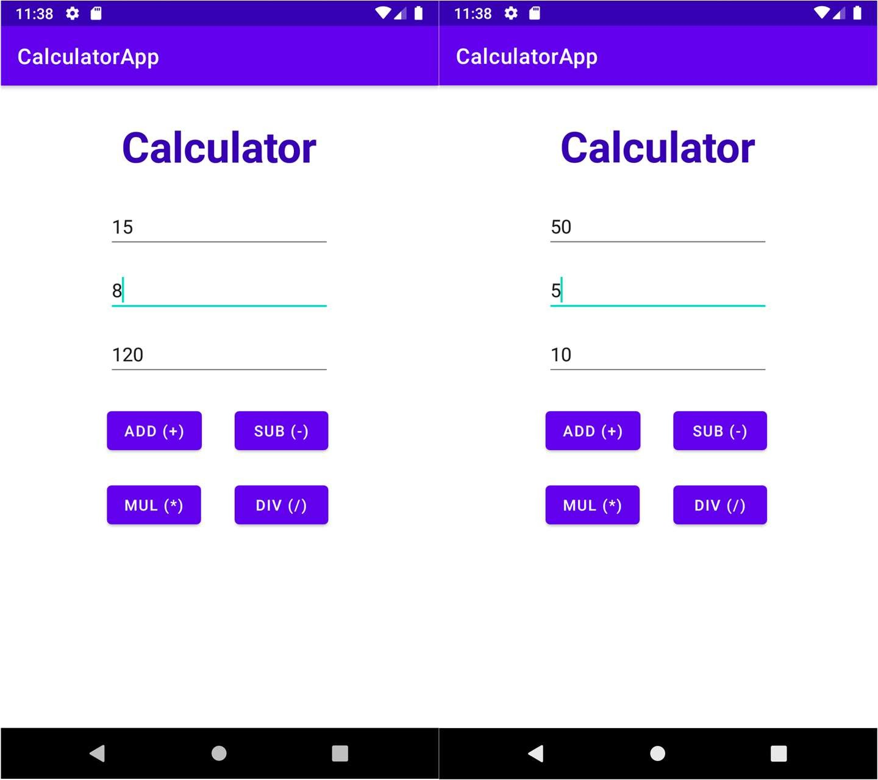

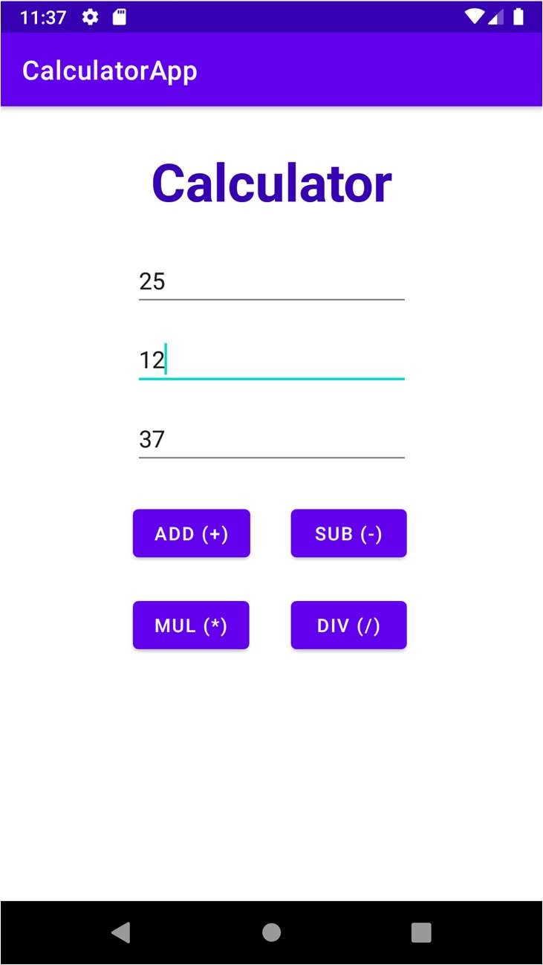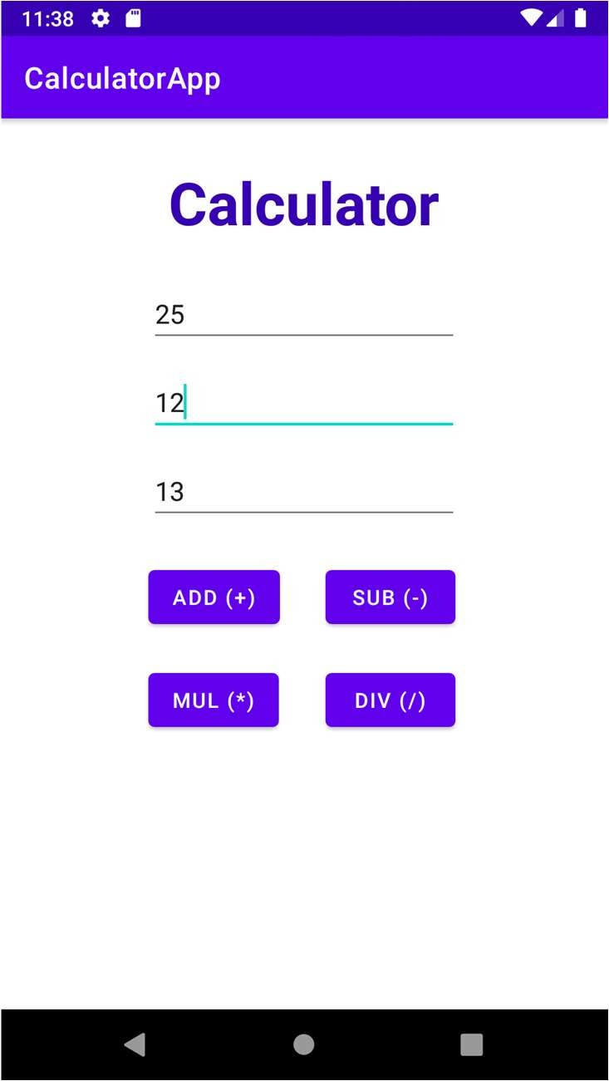

**Practical No. 3**

# Aim: Data Base Connectivity

**3.A] Aim:** Creating android program to demonstrate the use of Internal Storage.

# Source Code:

**activity_data.xml**

<?xml version="1.0" encoding="utf-8"?>

<RelativeLayout xmlns:android="<http://schemas.android.com/apk/res/android>" xmlns:tools="<http://schemas.android.com/tools>" android:layout_width="match_parent" android:layout_height="match_parent"

tools:context=".DataActivity">

<LinearLayout android:layout_width="match_parent" android:layout_height="wrap_content" android:orientation="vertical">

</LinearLayout>

<TextView android:id="@+id/txtLabel"

android:layout_width="match_parent" android:layout_height="wrap_content" android:layout_alignParentTop="true" android:textSize="30dp" android:layout_centerHorizontal="true" android:layout_marginTop="49dp" android:text="Internal Storage" android:gravity="center"/>

<EditText android:id="@+id/txtMessage" android:layout_width="match_parent" android:layout_height="wrap_content" android:layout_marginTop="150dp" android:ems="10" android:textSize="30dp" android:inputType="textPersonName" android:hint="Enter Message" android:text="" />

<TextView android:id="@+id/txtResult" android:layout_width="match_parent"

android:layout_height="wrap_content" android:layout_marginTop="250dp" android:hint="Result" android:textSize="30dp" android:ems="10"

android:text="" />

<LinearLayout

android:layout_width="match_parent" android:layout_height="wrap_content" android:orientation="horizontal">

<Button

android:id="@+id/btnSave" android:layout_width="150dp" android:layout_height="wrap_content" android:layout_marginTop="350dp" android:layout_marginLeft="50dp" android:textSize="30dp" android:text="SAVE" />

<Button

android:id="@+id/btnLoad" android:layout_width="150dp" android:layout_height="wrap_content" android:layout_marginTop="350dp" android:layout_marginLeft="10dp" android:textSize="30dp" android:text="LOAD" />

</LinearLayout>

</RelativeLayout>

# DataActivity.java

package com.idol.internalstorage;

import androidx.appcompat.app.AppCompatActivity; import android.view.View;

import android.widget.*; import android.os.Bundle; import java.io.FileInputStream;

import java.io.FileOutputStream;

public class DataActivity extends AppCompatActivity { Button save, load;

TextView res; EditText msg;

private String file = "mydata"; @Override

protected void onCreate(Bundle savedInstanceState) { super.onCreate(savedInstanceState); setContentView(R.layout.activity_data);

save= (Button) findViewById(R.id.btnSave); load= (Button) findViewById(R.id.btnLoad);

msg = (EditText) findViewById(R.id.txtMessage); res = (TextView) findViewById(R.id.txtResult);

save.setOnClickListener(new View.OnClickListener() { @Override

public void onClick(View view) { String data = msg.getText().toString(); try {

FileOutputStream fOut = openFileOutput(file,MODE_APPEND);

fOut.write(data.getBytes()); fOut.close();

Toast.makeText(getBaseContext(),"file saved",Toast.LENGTH_SHORT).show();

}

catch (Exception e) {

// TODO Auto-generated catch block e.printStackTrace();

}

}

});

load.setOnClickListener(new View.OnClickListener() { @Override

public void onClick(View view) { try {

FileInputStream fin = openFileInput(file); int c = 0;

String t="";

while( (c= fin.read()) != -1) t += Character.toString((char) c); res.setText(t);

Toast.makeText(getBaseContext(),"file read",Toast.LENGTH_SHORT).show();

}

});

}

}

}

catch(Exception e){

}

# Output:

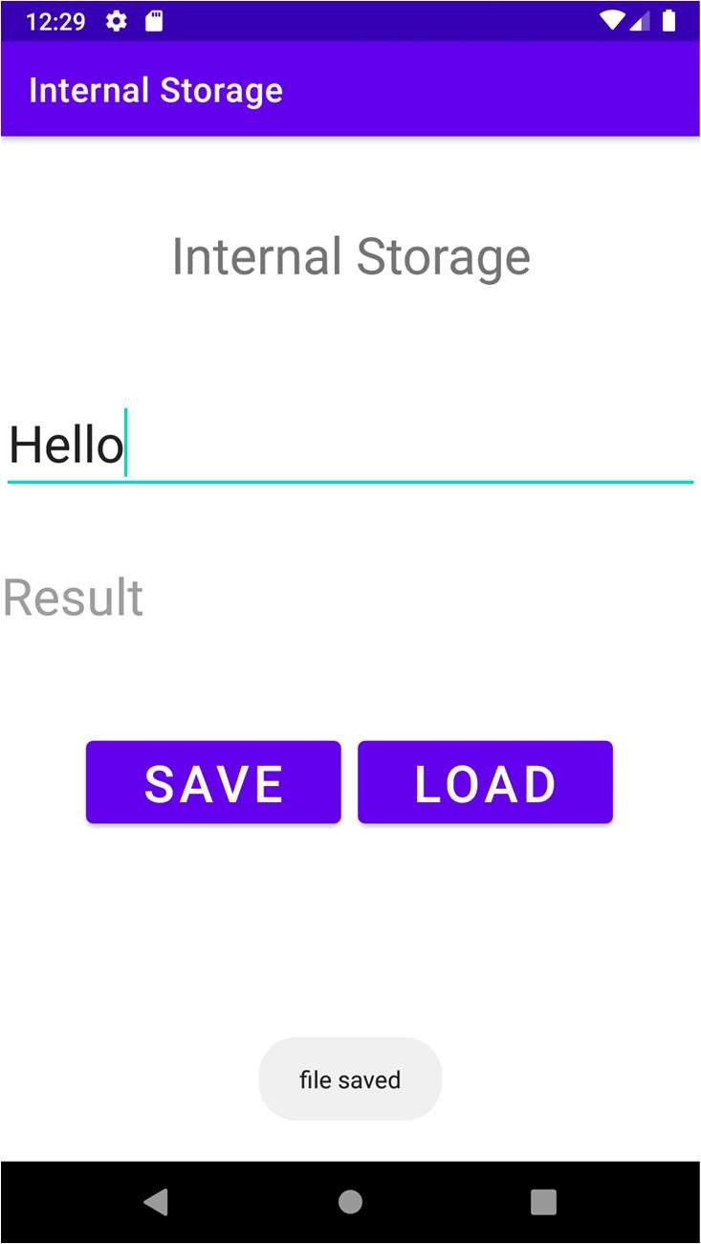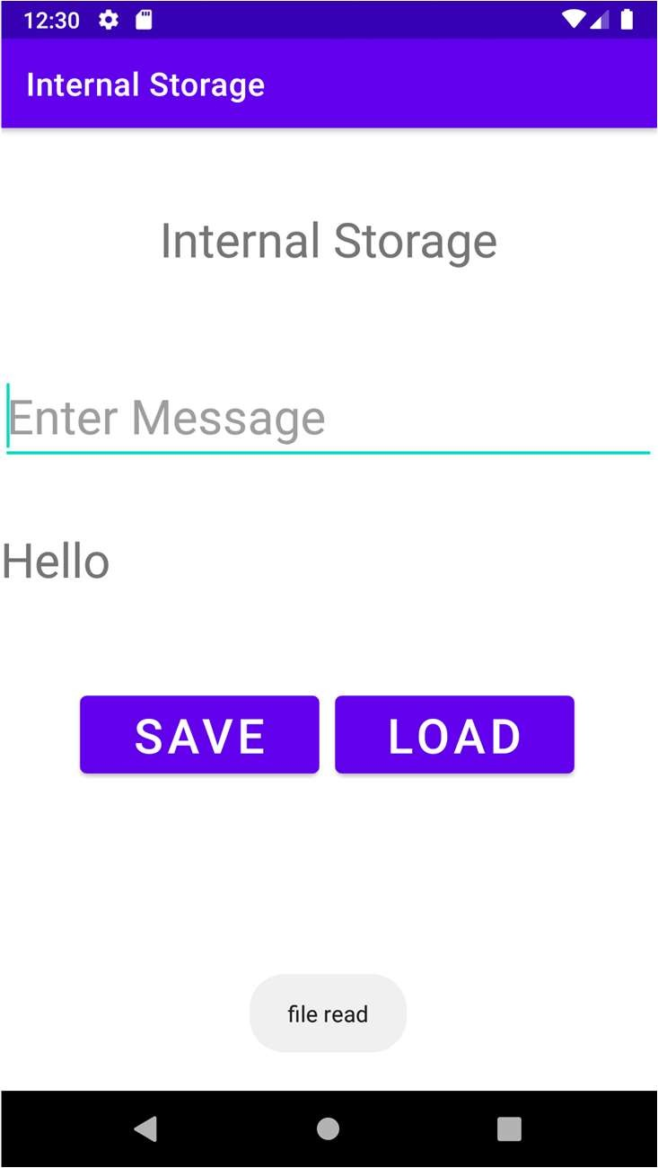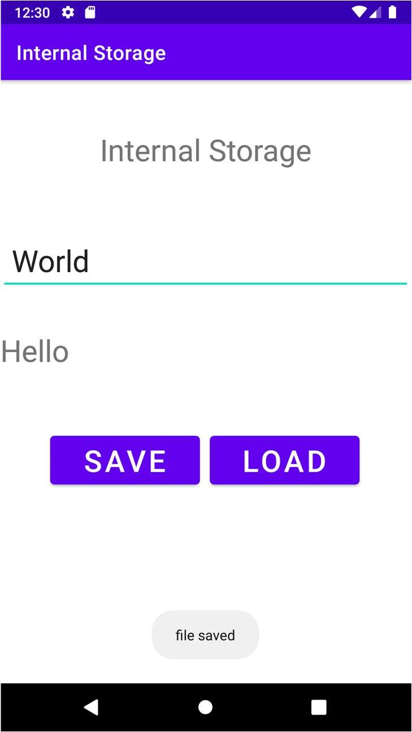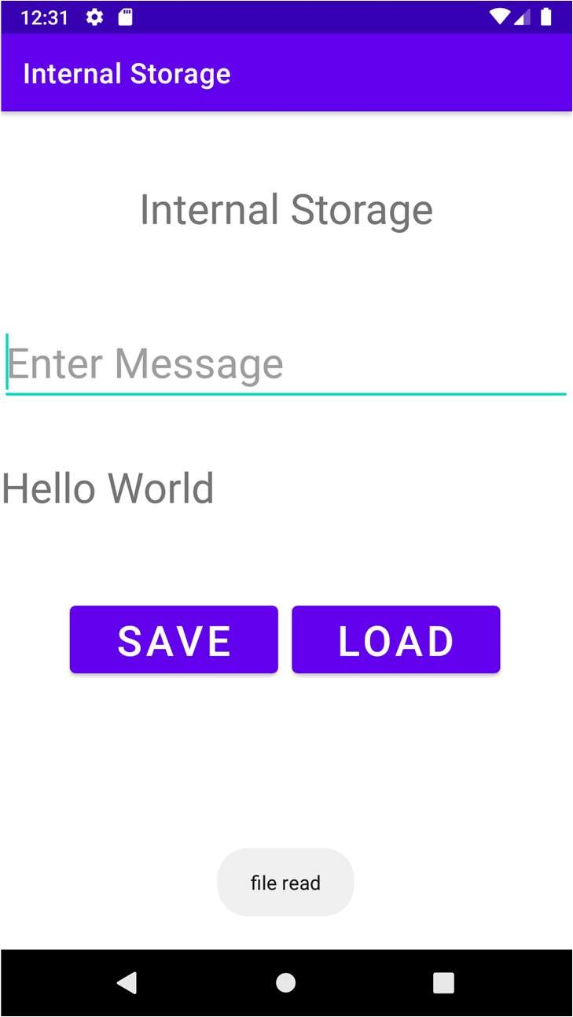

**3.B] Aim:** Creating android program to demonstrate the use of Shared preferences.

# Source Code:

**activity_shared.xml**

<?xml version="1.0" encoding="utf-8"?>

<RelativeLayout xmlns:android="<http://schemas.android.com/apk/res/android>" xmlns:tools="<http://schemas.android.com/tools>" android:layout_width="match_parent" android:layout_height="match_parent"

tools:context=".SharedActivity">

<LinearLayout android:layout_width="match_parent" android:layout_height="match_parent" android:orientation="vertical" android:layout_marginLeft="30sp" android:layout_marginRight="30sp">

<TextView android:id="@+id/textView" android:layout_width="match_parent"

android:layout_height="wrap_content" android:text="Shared Preferences" android:layout_marginTop="10px" android:textSize="35sp" android:textStyle="bold" android:gravity="center" android:textColor="@color/black"/>

<EditText android:id="@+id/edit_name"

android:layout_width="match_parent" android:layout_height="wrap_content" android:layout_marginTop="20dp" android:layout_marginBottom="20dp" android:ems="10"

android:hint="Enter your Name" android:inputType="textPersonName" />

<EditText android:id="@+id/edit_age"

android:layout_width="match_parent" android:layout_height="wrap_content" android:ems="10" android:inputType="textPersonName" android:hint="Enter your Age" android:layout_marginTop="20dp" android:layout_marginBottom="20dp"/>

<EditText android:id="@+id/edit_email" android:layout_width="match_parent"

android:layout_height="wrap_content" android:ems="10" android:inputType="textEmailAddress" android:hint="Enter Your Email" android:layout_marginTop="20dp" android:layout_marginBottom="20dp"/>

<Button

android:id="@+id/btn_save"

android:layout_width="match_parent" android:layout_height="wrap_content" android:text="Save" android:layout_marginTop="20dp" android:layout_marginBottom="20dp"/>

</LinearLayout>

</RelativeLayout>

# SharedActivity.java

package com.idol.internalstorage;

import androidx.appcompat.app.AppCompatActivity; import android.content.Context;

import android.content.SharedPreferences; import android.os.Bundle;

import android.view.View; import android.widget.*; import java.io.*;

public class SharedActivity extends AppCompatActivity { private EditText name, age,email;

Button saveButton;

public static final String MyPREFERENCES = "MyPrefsData" ; public static final String Name = "nameKey";

public static final String Age = "ageKey"; public static final String Email = "emailKey"; SharedPreferences sharedpreferences; @Override

protected void onCreate(Bundle savedInstanceState) { super.onCreate(savedInstanceState); setContentView(R.layout.activity_shared);

name =(EditText) findViewById(R.id.edit_name); age = (EditText)findViewById(R.id.edit_age); email=(EditText) findViewById(R.id.edit_email); saveButton=(Button) findViewById(R.id.btn_save);

sharedpreferences = getSharedPreferences(MyPREFERENCES, Context.MODE_PRIVATE);

saveButton.setOnClickListener(new View.OnClickListener() { @Override

public void onClick(View v) {

String n = name.getText().toString(); String a = age.getText().toString(); String e = email.getText().toString();

SharedPreferences.Editor editor = sharedpreferences.edit();

editor.putString(Name, n); editor.putString(Age, a); editor.putString(Email, e); editor.commit();

Toast.makeText(SharedActivity.this,"Data Saved Successfully",Toast.LENGTH_LONG).show();

}

});

}

}

# Output:

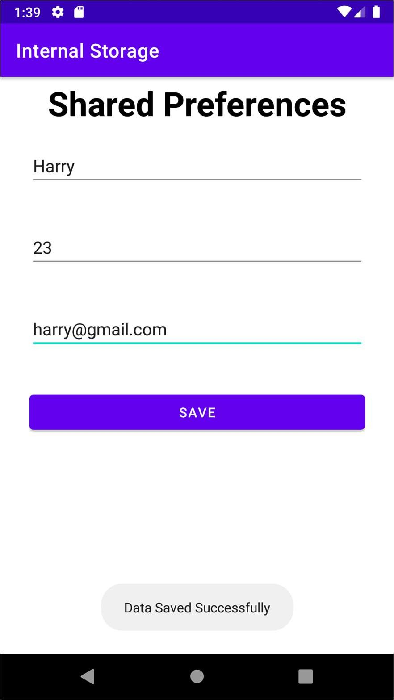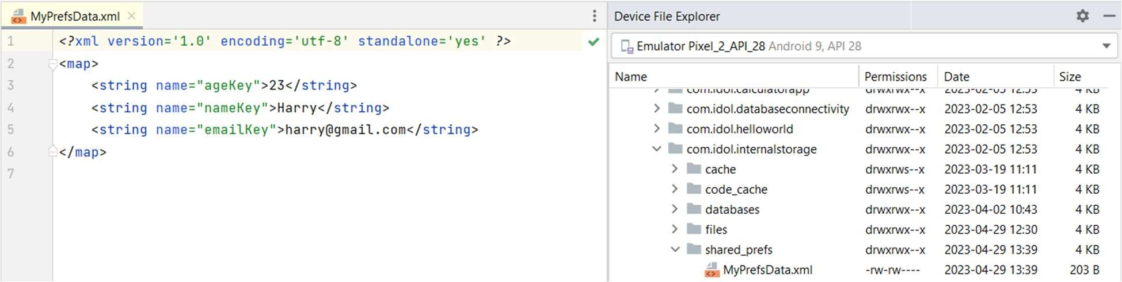

**Practical No. 4**

# Aim: Introduction to Graphics, Animation and Multimedia

**4.A] Aim:** Write a Program to draw basic graphics construction like line, circle, arc, ellipse and rectangle.

# Source Code:

#include<graphics.h> #include<conio.h> void main()

{

int gd=DETECT, gm, i, x, y; initgraph(&gd, &gm, "C:\\TurboC3\\BGI"); x=getmaxx()/3;

y=getmaxx()/3; setbkcolor(WHITE); setcolor(BLUE); for(i=1;i<=8;i++)

{

setfillstyle(i,i); delay(20); circle(x, y, i*20);

floodfill(x-2+i*20,y,BLUE);

}

getch(); closegraph();

}

**Output:**

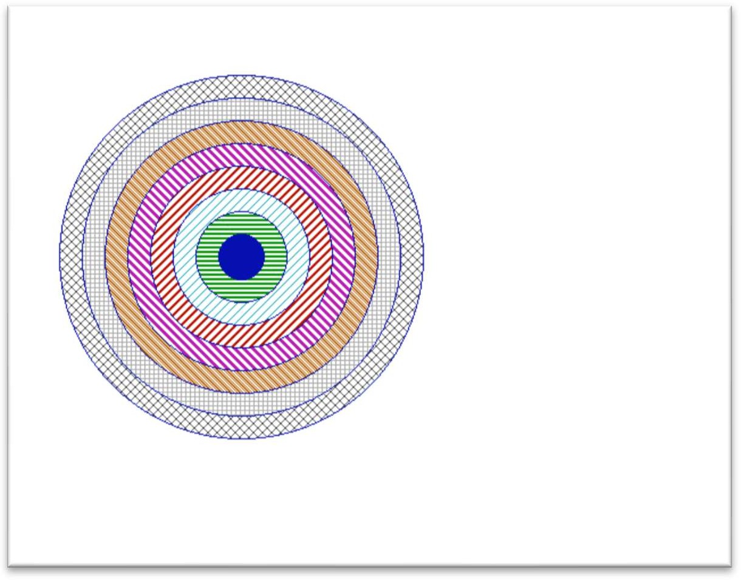

**4.B] Aim:** Write a Program to draw animation using increasing circles filled with different colors and patterns.

# Source Code:

#include <stdio.h> #include <conio.h> #include <graphics.h> #include <dos.h>

int main()

{

int gd = DETECT, gm; int i, x, y, flag = 0;

initgraph(&gd, &gm, "C:\\TurboC3\\BGI");

/* set background color to white */ setbkcolor(WHITE);

/* get mid positions in x and y-axis */ x = getmaxx() / 2;

y = 30;

while (!kbhit())

{

if (y >= getmaxy() - 30 || y <= 30) flag = !flag;

/* draws the red board */ setcolor(RED); setfillstyle(SOLID_FILL, RED); circle(x, y, 30);

floodfill(x, y, RED);

/* delay for 50 milli seconds */ delay(50);

/* clears screen */ cleardevice();

if (flag)

y = y + 5; else

y = y - 5;

}

getch(); closegraph(); return 0;

}

**Output:**

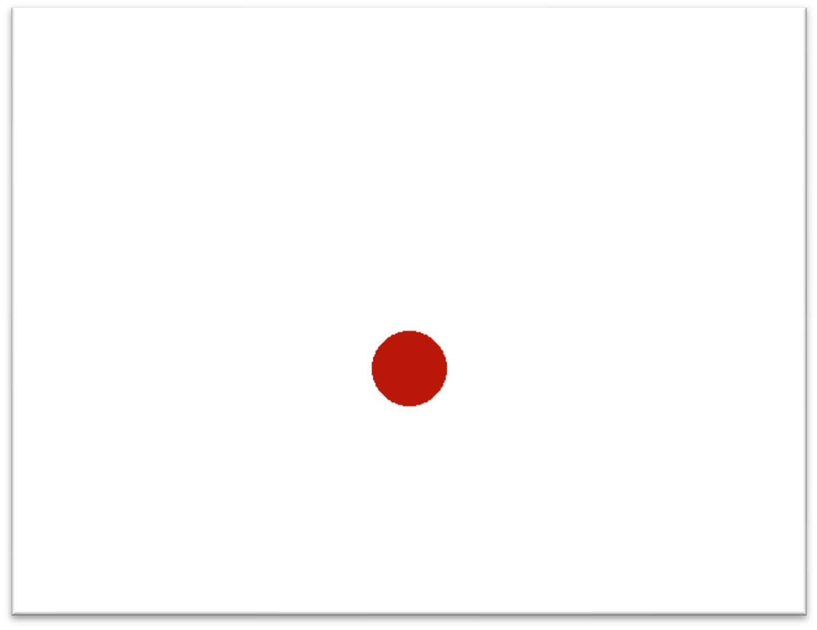

# Practical No. 5

**Aim: Location Based Services**

**5.A] Aim:** Write a program to find your location in the Map.

# Source Code: activity_main.xml

<?xml version="1.0" encoding="utf-8"?>

<RelativeLayout xmlns:android="<http://schemas.android.com/apk/res/android>" xmlns:tools="<http://schemas.android.com/tools>" android:orientation="vertical" android:layout_width="match_parent" android:layout_height="match_parent" tools:context=".MainActivity">

<TextView android:layout_marginTop="20dp" android:layout_width="fill_parent" android:layout_height="wrap_content"

android:text="Get Current Location and City Name" android:textAlignment="center" android:textStyle="bold" android:layout_centerHorizontal="true" android:textSize="20sp" />

<TextView android:layout_width="wrap_content" android:layout_height="wrap_content" android:id="@+id/textView" android:layout_centerInParent="true" android:textSize="16sp" android:textStyle="bold"/>

</RelativeLayout>

**MainActivity.java**

package com.idol.locationservice;

import androidx.appcompat.app.AppCompatActivity; import androidx.annotation.NonNull;

import androidx.core.app.ActivityCompat; import androidx.core.content.ContextCompat; import android.Manifest;

import android.content.Intent;

import android.content.pm.PackageManager; import android.location.Geocoder;

import android.location.Location; import android.os.Bundle;

import android.os.Handler;

import android.os.ResultReceiver; import android.util.Log;

import android.widget.TextView; import android.widget.Toast;

import com.google.android.gms.location.FusedLocationProviderClient; import com.google.android.gms.location.LocationCallback;

import com.google.android.gms.location.LocationRequest; import com.google.android.gms.location.LocationResult; import com.google.android.gms.location.LocationServices; public class MainActivity extends AppCompatActivity {

private FusedLocationProviderClient fusedLocationClient;

private static final int LOCATION_PERMISSION_REQUEST_CODE = 2; private LocationAddressResultReceiver addressResultReceiver;

private TextView currentAddTv; private Location currentLocation;

private LocationCallback locationCallback; @Override

protected void onCreate(Bundle savedInstanceState) { super.onCreate(savedInstanceState); setContentView(R.layout.activity_main);

addressResultReceiver = new LocationAddressResultReceiver(new Handler());

currentAddTv = findViewById(R.id.textView); fusedLocationClient =

LocationServices.getFusedLocationProviderClient(this); locationCallback = new LocationCallback() {

@Override

public void onLocationResult(LocationResult locationResult) { currentLocation = locationResult.getLocations().get(0); getAddress();

}

};

startLocationUpdates();

}

@SuppressWarnings("MissingPermission") private void startLocationUpdates() {

if (ContextCompat.checkSelfPermission(this, Manifest.permission.ACCESS_FINE_LOCATION) != PackageManager.PERMISSION_GRANTED) {

ActivityCompat.requestPermissions(this, new String[]{Manifest.permission.ACCESS_FINE_LOCATION},

LOCATION_PERMISSION_REQUEST_CODE);

}

else {

LocationRequest locationRequest = new LocationRequest(); locationRequest.setInterval(2000); locationRequest.setFastestInterval(1000);

locationRequest.setPriority(LocationRequest.PRIORITY_HIGH_ACCURACY); fusedLocationClient.requestLocationUpdates(locationRequest,

locationCallback, null);

}

}

@SuppressWarnings("MissingPermission") private void getAddress() {

if (!Geocoder.isPresent()) {

Toast.makeText(MainActivity.this, "Can't find current address, ", Toast.LENGTH_SHORT).show();

return;

}

Intent intent = new Intent(this, GetAddressIntentService.class); intent.putExtra("add_receiver", addressResultReceiver); intent.putExtra("add_location", currentLocation); startService(intent);

}

@Override

public void onRequestPermissionsResult(int requestCode, @NonNull String[] permissions, @NonNull

int[] grantResults) {

if (requestCode == LOCATION_PERMISSION_REQUEST_CODE) { if (grantResults.length > 0 && grantResults[0] ==

PackageManager.PERMISSION_GRANTED) { startLocationUpdates();

}

else {

Toast.makeText(this, "Location permission not granted, "

+ "restart the app if you want the feature", Toast.LENGTH_SHORT).show();

}

}

}

private class LocationAddressResultReceiver extends ResultReceiver { LocationAddressResultReceiver(Handler handler) {

super(handler);

}

@Override

protected void onReceiveResult(int resultCode, Bundle resultData) { if (resultCode == 0) {

Log.d("Address", "Location null retrying"); getAddress();

}

if (resultCode == 1) {

Toast.makeText(MainActivity.this, "Address not found, ", Toast.LENGTH_SHORT).show();

}

String currentAdd = resultData.getString("address_result"); showResults(currentAdd);

}

}

private void showResults(String currentAdd) {

currentAddTv.setText(currentAdd);

}

@Override

protected void onResume() { super.onResume(); startLocationUpdates();

}

@Override

protected void onPause() { super.onPause();

fusedLocationClient.removeLocationUpdates(locationCallback);

}

}

# GetAddressIntentService.java

package com.idol.locationservice; import android.app.IntentService; import android.content.Intent; import android.location.Address; import android.location.Geocoder; import android.location.Location; import android.os.Bundle;

import android.os.ResultReceiver; import android.util.Log;

import java.util.List; import java.util.Locale; import java.util.Objects;

import androidx.annotation.Nullable;

public class GetAddressIntentService extends IntentService {

private static final String IDENTIFIER = "GetAddressIntentService"; private ResultReceiver addressResultReceiver;

public GetAddressIntentService() { super(IDENTIFIER);

}

@Override

protected void onHandleIntent(@Nullable Intent intent) { String msg;

addressResultReceiver = Objects.requireNonNull(intent).getParcelableExtra("add_receiver");

if (addressResultReceiver == null) {

Log.e("GetAddressIntentService", "No receiver, not processing the request further"); return;

}

Location location = intent.getParcelableExtra("add_location"); if (location == null) {

msg = "No location, can't go further without location"; sendResultsToReceiver(0, msg);

return;

}

Geocoder geocoder = new Geocoder(this, Locale.getDefault()); List<Address> addresses = null;

try {

addresses = geocoder.getFromLocation(location.getLatitude(), location.getLongitude(), 1);

}

catch (Exception ioException) {

Log.e("", "Error in getting address for the location");

}

if (addresses == null || addresses.size() == 0) { msg = "No address found for the location"; sendResultsToReceiver(1, msg);

}

else {

Address address = addresses.get(0);

String addressDetails = address.getFeatureName() + "\n" + address.getThoroughfare() + "\n" +

"Locality: " + address.getLocality() + "\n" + "County: " + address.getSubAdminArea() + "\n" +

"State: " + address.getAdminArea() + "\n" + "Country: " + address.getCountryName() + "\n" +

"Postal Code: " + address.getPostalCode() + "\n"; sendResultsToReceiver(2, addressDetails);

}

}

private void sendResultsToReceiver(int resultCode, String message) { Bundle bundle = new Bundle();

bundle.putString("address_result", message); addressResultReceiver.send(resultCode, bundle);

}

}

# AndroidManifest.xml

<?xml version="1.0" encoding="utf-8"?>

<manifest xmlns:android="<http://schemas.android.com/apk/res/android>" xmlns:tools="<http://schemas.android.com/tools>" >

<uses-permission android:name="android.permission.ACCESS_FINE_LOCATION" />

<uses-permission android:name="android.permission.INTERNET" />

<uses-permission android:name="android.permission.ACCESS_COARSE_LOCATION"

/>

<application android:allowBackup="true"

android:dataExtractionRules="@xml/data_extraction_rules" android:fullBackupContent="@xml/backup_rules" android:icon="@mipmap/ic_launcher" android:label="@string/app_name" android:supportsRtl="true"

android:theme="@style/Theme.LocationService" tools:targetApi="31" >

<activity android:name=".MainActivity" android:exported="true" >

<intent-filter>

<action android:name="android.intent.action.MAIN" />

<category android:name="android.intent.category.LAUNCHER" />

</intent-filter>

</activity>

<service android:name=".GetAddressIntentService" />

</application>

</manifest>

**Add the following dependency in Gradle Location Based Services**

implementation 'com.google.android.gms:play-services-location:17.0.0'

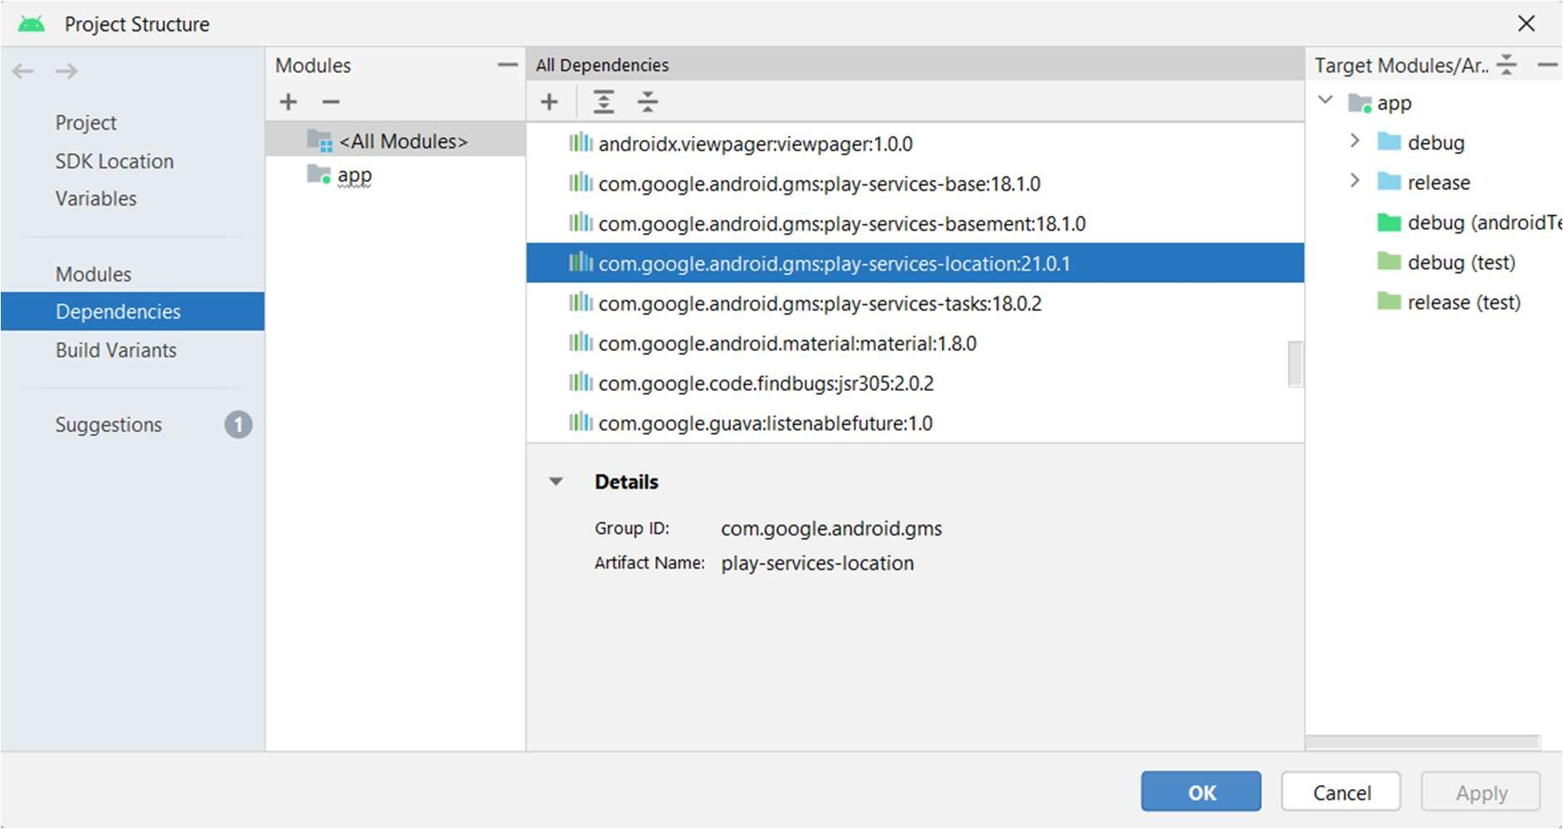

# Output:

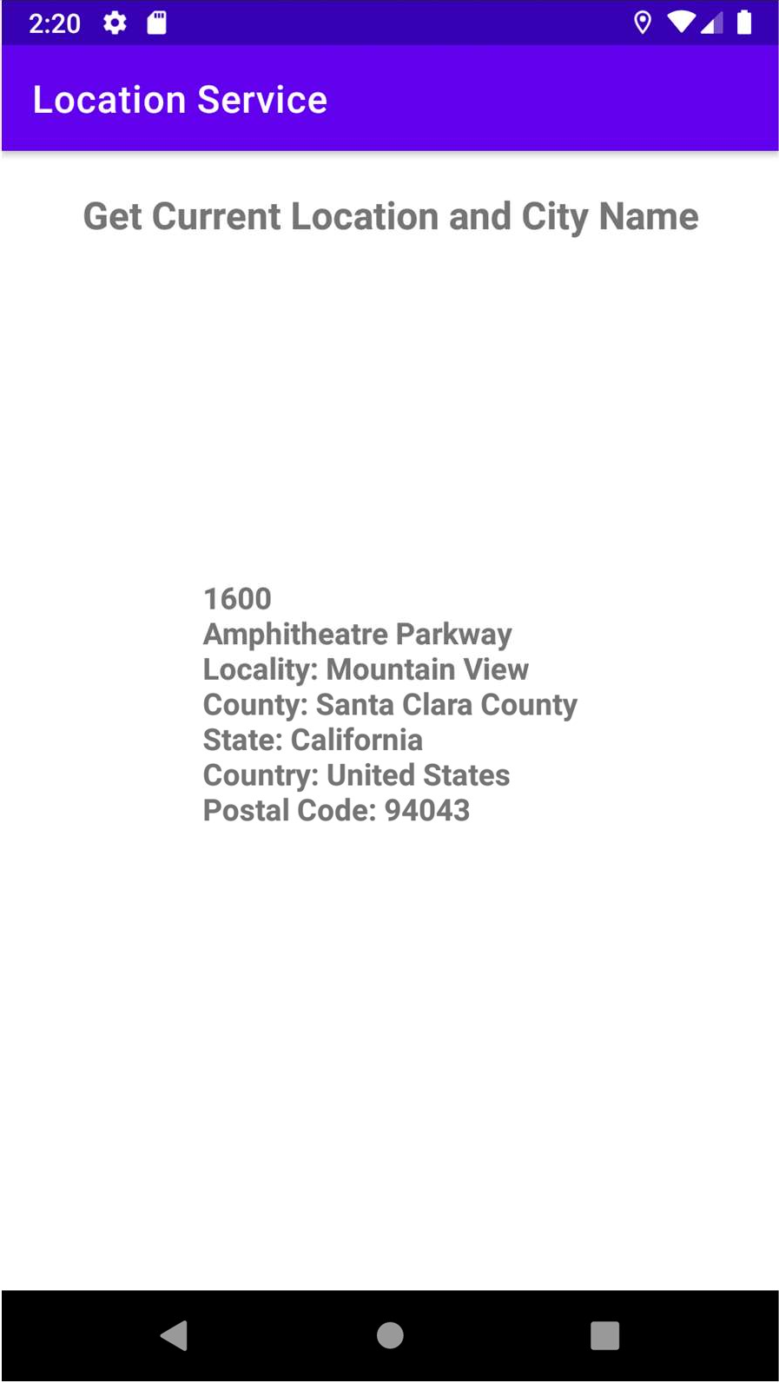

**Practical No. 6**

**Aim:** Socket Programming in C/C++.

# Source Code: Server.c

// Server side C/C++ program to demonstrate Socket

// programming #include <netinet/in.h> #include <stdio.h> #include <stdlib.h> #include <string.h> #include <sys/socket.h> #include <unistd.h> #define PORT 8080

int main(int argc, char const *argv[])

{

int server_fd, new_socket, valread; struct sockaddr_in address;

int opt = 1;

int addrlen = sizeof(address); char buffer[1024] = {0};

char *hello = "Hello from server";

// Creating socket file descriptor

if ((server_fd = socket(AF_INET, SOCK_STREAM, 0)) == 0)

{

perror("socket failed"); exit(EXIT_FAILURE);

}

// Forcefully attaching socket to the port 8080 if (setsockopt(server_fd, SOL_SOCKET,

SO_REUSEADDR | SO_REUSEPORT, &opt,

sizeof(opt)))

{

perror("setsockopt"); exit(EXIT_FAILURE);

}

address.sin_family = AF_INET; address.sin_addr.s_addr = INADDR_ANY; address.sin_port = htons(PORT);

// Forcefully attaching socket to the port 8080 if (bind(server_fd, (struct sockaddr *)&address,

sizeof(address)) < 0)

{

perror("bind failed"); exit(EXIT_FAILURE);

}

if (listen(server_fd, 3) < 0)

{

perror("listen"); exit(EXIT_FAILURE);

}

if ((new_socket = accept(server_fd, (struct sockaddr *)&address, (socklen_t *)&addrlen)) < 0)

{

perror("accept"); exit(EXIT_FAILURE);

}

valread = read(new_socket, buffer, 1024); printf("%s\n", buffer);

send(new_socket, hello, strlen(hello), 0); printf("Hello message sent\n");

// closing the connected socket close(new_socket);

// closing the listening socket shutdown(server_fd, SHUT_RDWR); return 0;

}

# Client.c

// Client side C/C++ program to demonstrate Socket

// programming #include <arpa/inet.h> #include <stdio.h> #include <string.h> #include <sys/socket.h> #include <unistd.h> #define PORT 8080

int main(int argc, char const *argv[])

{

int sock = 0, valread, client_fd; struct sockaddr_in serv_addr; char *hello = "Hello from client"; char buffer[1024] = {0};

if ((sock = socket(AF_INET, SOCK_STREAM, 0)) < 0)

{

printf("\n Socket creation error \n"); return -1;

}

serv_addr.sin_family = AF_INET; serv_addr.sin_port = htons(PORT);

// Convert IPv4 and IPv6 addresses from text to binary

// form

if (inet_pton(AF_INET, "127.0.0.1", &serv_addr.sin_addr) <= 0)

{

printf(

"\nInvalid address/ Address not supported \n"); return -1;

}

if ((client_fd = connect(sock, (struct sockaddr *)&serv_addr, sizeof(serv_addr))) < 0)

{

printf("\nConnection Failed \n"); return -1;

}

send(sock, hello, strlen(hello), 0); printf("Hello message sent\n"); valread = read(sock, buffer, 1024); printf("%s\n", buffer);

// closing the connected socket close(client_fd);

return 0;

}

**Output:**

Hello from client Hello message sent

Hello message sent Hello from server