**SOFTWARE TESTING & QUALITY ASSURANCE LAB**

A Lab Manual Submitted in Fulfilment

of the Degree of

**MASTER**

**In**

**COMPUTER APPLICATION**

**Year 2022-2023**

By

**Ms. Borole Dimple Dattatraya Harshala**

**(Seat No.: -806214)**

**(Application Id: - 169913)**

Under the Guidance of

**Asst. Prof. Ms. Richa Kulal.**



Institute of Distance and Open Learning

Vidya Nagari, Kalina, Santacruz East – 400098.

University of Mumbai

**PCP Center**

**Satish Pradhan Dnyanasadhana College,**

**Thane.**



**Institute of Distance and Open Learning**

Vidya Nagari, Kalina, Santacruz East – 400098.

***CERTIFICATE***

This is to certify that, this Lab Manual entitled **“Software Testing & Quality Assurance Lab”** is a record of work carried out by **Ms. Borole Dimple Dattatraya Harshala (Seat no: -806214),** student of **MCA Semester-III** class and is submitted to University of Mumbai, in partial fulfilment of the requirement for the award of the degree of **Master in Computer Application**. The Lab Manual has been approved.

___________ ____________ ____________

Guide External Examiner Coordinator – M.C.A

**Approval of Lab Manual**

This is to certify that the Lab Manual entitled **“Software Testing & Quality Assurance Lab”,** for **Master in Computer Application** submitted to University of Mumbai by **Ms. Borole Dimple Dattatraya Harshala (Seat no:-806214)** abonafide student of Institute of Distance and Open Learning, Vidyanagari,Kalina, Santracruz East has been approvedfor the award of **Master in Computer Application**.

**Examiner**

**1.**

**2.**

Date:

Place:

**Declaration**

I declare that this written submission represents my ideas in my own words and where other's ideas or words have been included, I have adequately cited and referenced the original sources. I also declare that I have adhered to all principles of academic honesty and integrity and have not misrepresented or fabricated or falsified any idea/data/fact/source in my submission. I understand that any violation of the above will be cause for disciplinary action by the Institute and can also evoke penal action from the sources which have thus not been properly cited or from whom proper permission has not been taken when needed.

-----------------------------------------

(Signature)

**Ms. Borole Dimple Dattatraya Harshala**

**Seat No: - 806214**

Date:

Place:

**ACKNOWLEDGMENT**

After the completion of this work, words are not enough to express my feelings about all those who helped me to reach my goal; feeling above this is my indebtedness to the almighty for providing me this moment in my life.

It’s a great pleasure and moment of immense satisfaction for me to express my profound gratitude to my Practical guide, **Asst. Prof. Ms. Richa Kulal.** whose constant encouragement enabled me to work enthusiastically. Her perpetual motivation, patience and excellent expertise in discussion during progress of dissertation work have benefited me to an extent, which is beyond expression. Her depth and breadth of knowledge of Engineering field made me realize that theoretical knowledge always help to develop efficient operational software, which is a blend of all core subjects of the field. The completion of this project would not have been possible without her encouragement, patient guidance and constant support.

I would like to thank all staff members for their valuable cooperation and permitting me to work in the computer labs.

Special thanks to my colleagues and friends for providing me useful comments, suggestions and continuous encouragement.

Finally, I thanks my family members, for their support and endurance during this work.

----------------------------------

**Ms. Borole Dimple Dattatraya Harshala**

**(Seat No: - 806214)**

|  |  |  |
| --- | --- | --- |
| **Sr No** | **Aim** | **Sign** |
| 1 | To write a simple test case. |  |
| 2 | Implementing Web Drivers on Multiple Browser i.e chrome |  |
| 3 | Implementing handling multiple frames |  |
| 4 | Implementing Selenium WebDriver - Browser Commands |  |
| 5 | Implementing Selenium WebDriver - find element command, Locator (id, css selector, Xpath), Input Box, Buttons, Submit Buttons |  |
| 6 | Demonstrate different types of alerts |  |
| 7 | Demonstrate Checkbox and Radio Button in Selenium WebDriver |  |
| 8 | Demonstrate synchronization in selenium (Implicit wait) |  |
| 9 | Demonstrate: Select Value from Dropdown using Selenium Web driver. |  |
| 10 | Demonstrate action classes using Selenium Web driver (Mouse Events) |  |

**INDEX**

**Practical no: 1**

**Aim: To write Simple test case.**

**Practical No: 2**

**Aim: Implementing Web Drivers on Multiple Browser i.e chrome**

**Code:**

System.setProperty("webdriver.chrome.driver","D:\\ChromeDriver\\chrom

edriver.exe");

// Instantiate a ChromeDriver class.

WebDriver driver=new ChromeDriver()

Step5. Now it is time to code. We have embedded comments for each

block of code to explain the steps clearly.(Third.java)

import org.openqa.selenium.By;

import org.openqa.selenium.JavascriptExecutor;

import org.openqa.selenium.WebDriver;

import org.openqa.selenium.chrome.ChromeDriver;

public class Third {

public static void main(String[] args) {

// System Property for Chrome Driver

System.setProperty("webdriver.chrome.driver","D:\\ChromeDriver\\chrom

edriver.exe");

// Instantiate a ChromeDriver class.

WebDriver driver=new ChromeDriver();

// Launch Website

driver.navigate().to("http://www.news.yahoo.com/");

//Maximize the browser

driver.manage().window().maximize();

//Scroll down the webpage by 5000 pixels

JavascriptExecutor js = (JavascriptExecutor)driver;

js.executeScript("scrollBy(0, 5000)");

// Click on the Search button

driver.findElement(By.linkText("Core Java")).click();

}

}

**Output :**

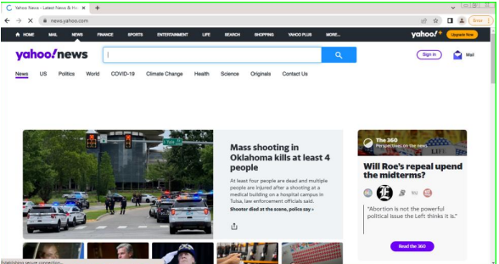

**Practical No: 3**

**AIM: - Implementing handling multiple frames**

**Code:**

package selenium;

import org.openqa.selenium.By;

import org.openqa.selenium.WebDriver;

import org.openqa.selenium.WebElement;

import org.openqa.selenium.chrome.ChromeDriver;

import java.util.concurrent.TimeUnit;

import org.openqa.selenium.chrome.ChromeDriver;

import org.openqa.selenium.chrome.ChromeOptions;

public class Selenium {

public static void main(String[] args) {

System.setProperty("webdriver.chrome.driver","C:\\Users\\spdc\\Desktop\\MCA_Praticals\\selenium\\chromedriver.exe");

ChromeOptions option = new ChromeOptions();

option.addArguments("--remote-allow-origins=*");

WebDriver driver = new ChromeDriver(option);

String url = "https://the-internet.herokuapp.com/frames";

driver.get(url);

driver.manage().timeouts().implicitlyWait(5, TimeUnit.SECONDS);

driver.findElement(By.linkText("Nested Frames")).click();

driver.switchTo().frame("frame-bottom");

WebElement l = driver.findElement(By.cssSelector("body"));

System.out.println("Bottom frame text: " +l.getText());

driver.switchTo().defaultContent();

driver.quit();

}

}

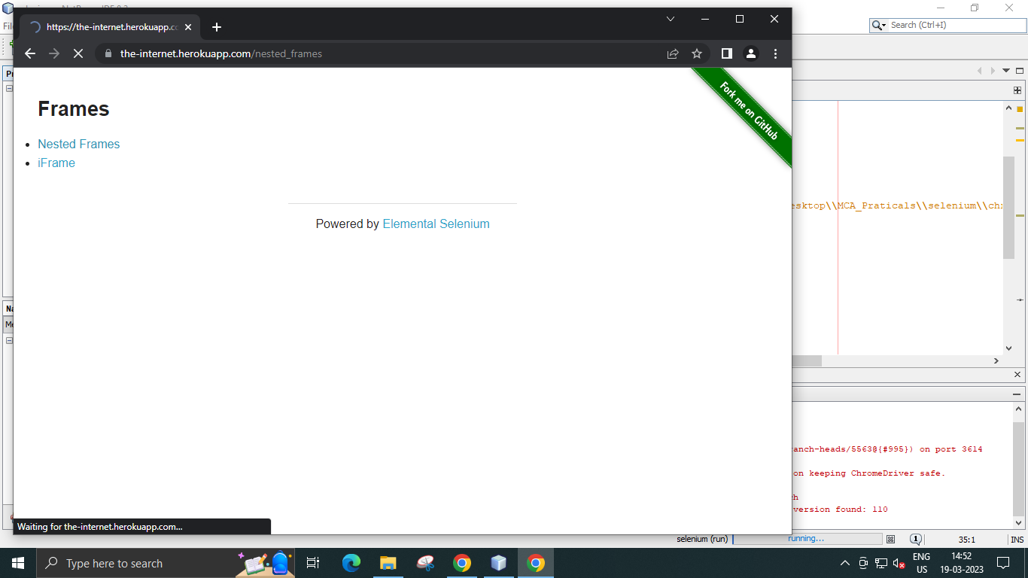

**Practical No: 4**

**AIM:- Implementing Selenium WebDriver - Browser Commands**

**Code:**

package selenium;

import org.openqa.selenium.By;

import org.openqa.selenium.WebDriver;

import org.openqa.selenium.WebElement;

import org.openqa.selenium.chrome.ChromeDriver;

import java.util.concurrent.TimeUnit;

import org.openqa.selenium.chrome.ChromeDriver;

import org.openqa.selenium.chrome.ChromeOptions;

import org.openqa.selenium.*;

public class Selenium {

public static void main(String[] args) {

System.setProperty("webdriver.chrome.driver","C:\\Users\\spdc\\Desktop\\MCA_Praticals\\selenium\\chromedriver.exe");

ChromeOptions option = new ChromeOptions();

option.addArguments("--remote-allow-origins=*");

WebDriver driver = new ChromeDriver(option);

String url = ("https://www.google.co.in/");

//Launch the ToolsQA WebSite

driver.get(url);

// Storing Title name in the String variable

String title = driver.getTitle();

// Storing Title length in the Int variable

int titleLength = driver.getTitle().length();

// Printing Title & Title length in the Console window

System.out.println("Title of the page is : " + title);

System.out.println("Length of the title is : "+ titleLength);

// Storing URL in String variable

String actualUrl = driver.getCurrentUrl();

if (actualUrl.equals("https://www.google.co.in/")){

System.out.println("Verification Successful - The correct Url is opened.");

}

else{

System.out.println("Verification Failed - An incorrect Url is opened.");

}

// Storing Page Source in String variable

String pageSource = driver.getPageSource();

// Storing Page Source length in Int variable

int pageSourceLength = pageSource.length();

// Printing length of the Page Source on console

System.out.println("Total length of the Pgae Source is : " +

pageSourceLength);

//Closing browser

driver.close();

}

}

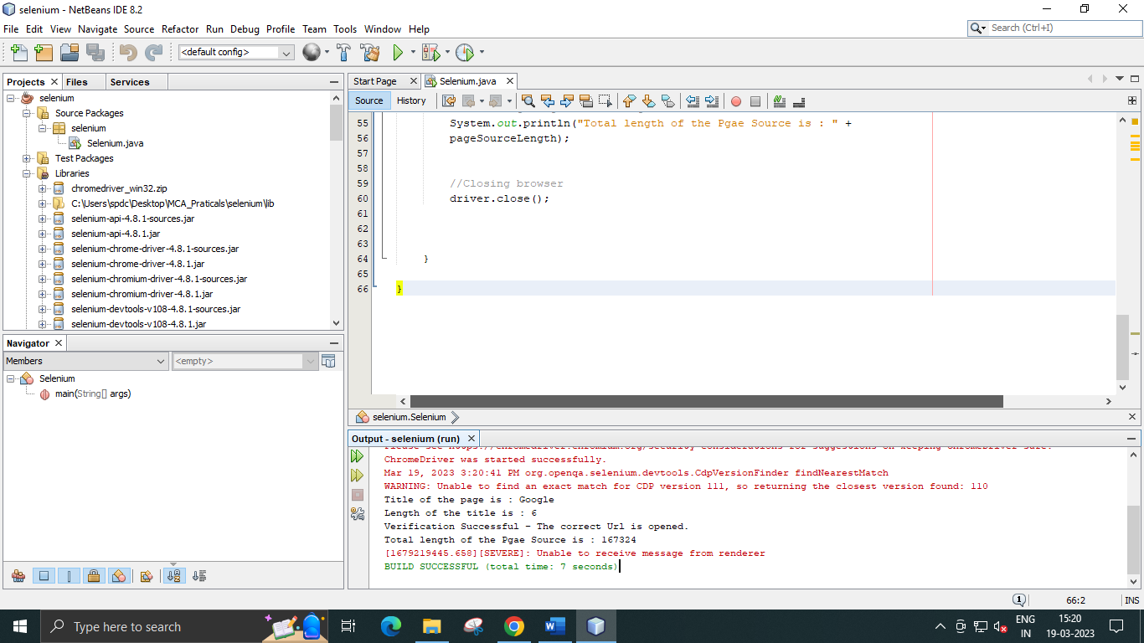

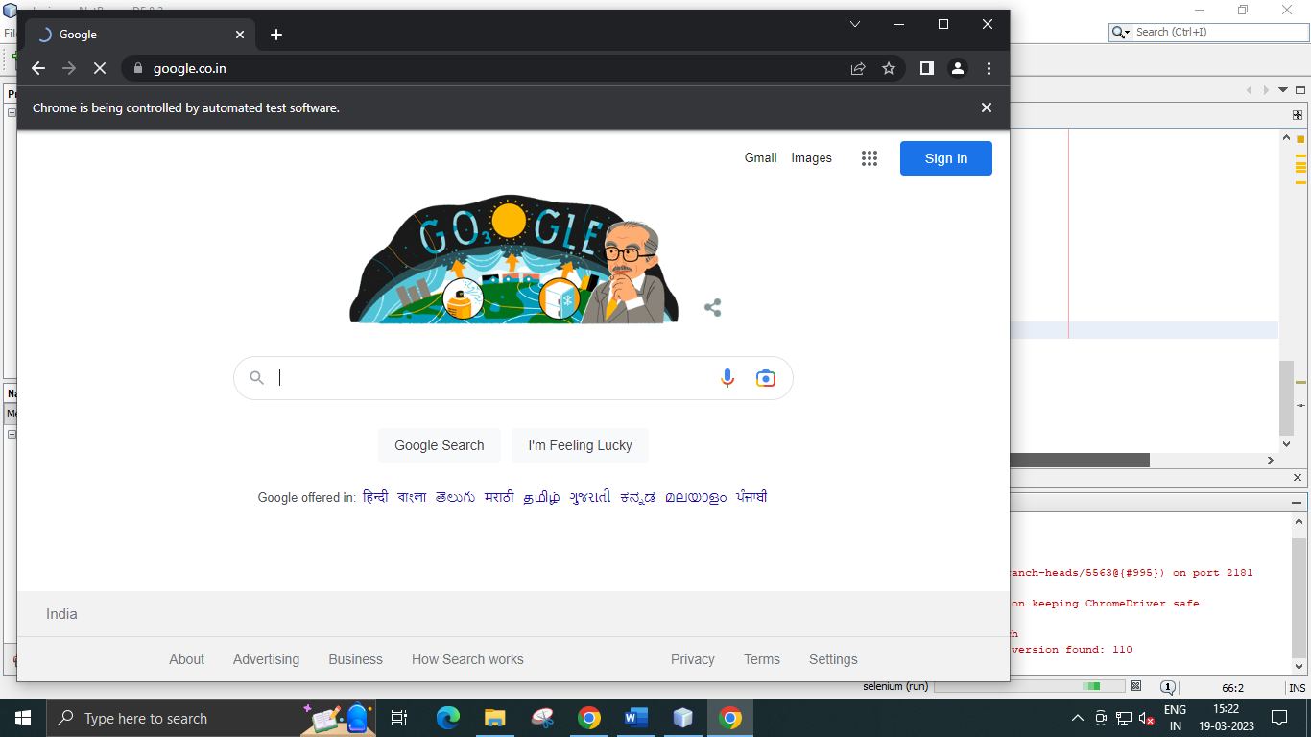

**Practical No: 5**

**AIM: - Implementing Selenium WebDriver - find element command, Locator (id, css selector, Xpath), Input Box, Buttons, Submit Buttons**

**Code:**

package selenium;

import org.openqa.selenium.By;

import org.openqa.selenium.WebDriver;

import org.openqa.selenium.WebElement;

import org.openqa.selenium.chrome.ChromeDriver;

import java.util.concurrent.TimeUnit;

import org.openqa.selenium.chrome.ChromeDriver;

import org.openqa.selenium.chrome.ChromeOptions;

import org.openqa.selenium.*;

public class Selenium {

public static void main(String[] args) {

System.setProperty("webdriver.chrome.driver","C:\\Users\\spdc\\Desktop\\MCA_Praticals\\selenium\\chromedriver.exe");

ChromeOptions option = new ChromeOptions();

option.addArguments("--remote-allow-origins=*");

WebDriver driver = new ChromeDriver(option);

String baseUrl = "http://demo.guru99.com/test/login.html";

driver.get(baseUrl);

WebElement email = driver.findElement(By.id("email"));

WebElement password = driver.findElement(By.name("passwd"));

email.sendKeys("abcd@gmail.com");

password.sendKeys("abcdefghlkjl");

System.out.println("Text Field Set");

email.clear();

password.clear();

System.out.println("Text Field Cleared");

WebElement login = driver.findElement(By.id("SubmitLogin"));

email.sendKeys("abcd@gmail.com");

password.sendKeys("abcdefghlkjl");

login.click();

System.out.println("Login Done with Click");

driver.get(baseUrl);

driver.findElement(By.id("email")).sendKeys("abcd@gmail.com");

driver.findElement(By.name("passwd")).sendKeys("abcdefghlkjl");

driver.findElement(By.id("SubmitLogin")).submit();

System.out.println("Login Done with Submit")

} }

**OutPut:**

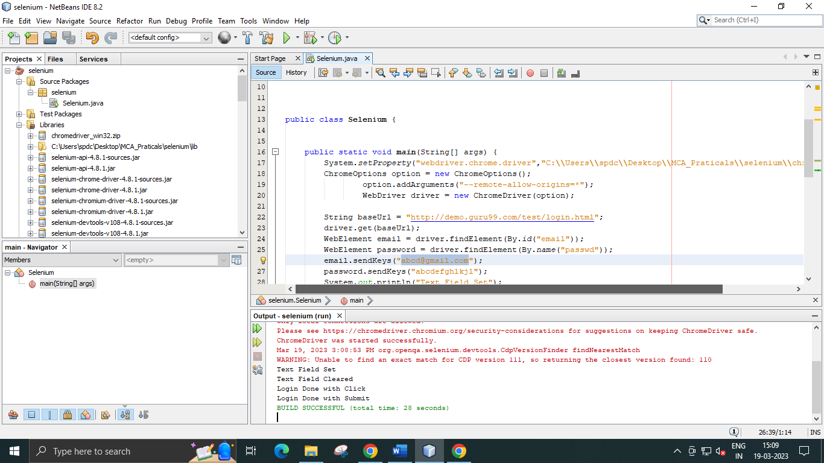

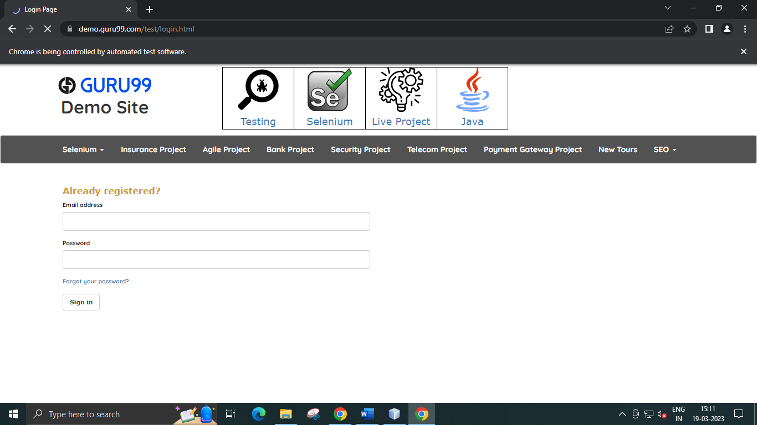

**Practical No: 6**

**Aim: - Demonstrate different types of alerts**

**Code:**

import org.openqa.selenium.By;

import org.openqa.selenium.WebDriver;

import org.openqa.selenium.chrome.ChromeDriver;

import org.openqa.selenium.NoAlertPresentException;

import org.openqa.selenium.Alert;

import org.openqa.selenium.chrome.ChromeOptions;

public class NewClass {

public static void main(String[] args) throws

NoAlertPresentException,InterruptedException {

System.setProperty("webdriver.chrome.driver","C:\\Users\\spdc\\Desktop\\MCA_Praticals\\selenium\\chromedriver.exe");

ChromeOptions option = new ChromeOptions();

option.addArguments("--remote-allow-origins=*");

WebDriver driver = new ChromeDriver(option);

//Alert Message handling

driver.get("http://demo.guru99.com/test/delete_customer.php");

driver.findElement(By.name("cusid")).sendKeys("53920");

driver.findElement(By.name("submit")).submit();

// Switching to Alert

Alert alert = driver.switchTo().alert();

// Capturing alert message.

String alertMessage= driver.switchTo().alert().getText();

// Displaying alert message

System.out.println(alertMessage);

Thread.sleep(5000);

// Accepting alert

alert.accept();

}

}

**Output: -**

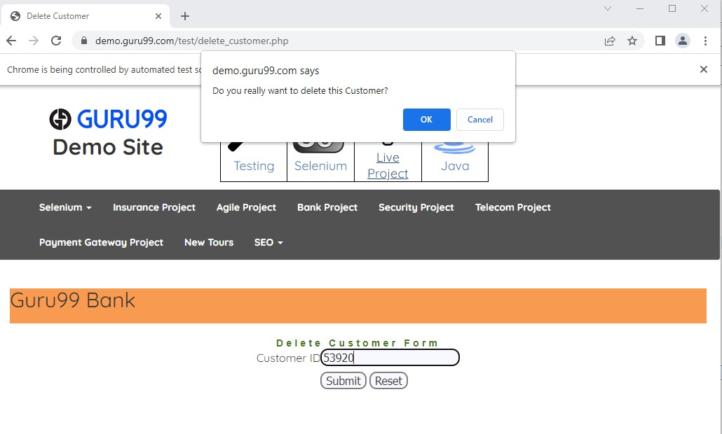

**Practical No: 7**

**Aim: - Demonstrate Checkbox and Radio Button in Selenium WebDriver.**

**Code:**

import org.openqa.selenium.By;

import org.openqa.selenium.WebDriver;

import org.openqa.selenium.chrome.ChromeDriver;

import org.openqa.selenium.*;

import org.openqa.selenium.chrome.ChromeOptions;

public class NewClass {

public static void main(String[] args) {

// declaration and instantiation of objects/variables

System.setProperty("webdriver.chrome.driver","C:\\Users\\spdc\\Desktop\\MCA_Praticals\\selenium\\chromedriver.exe");

ChromeOptions option = new ChromeOptions();

option.addArguments("--remote-allow-origins=*");

WebDriver driver = new ChromeDriver(option);

driver.get("http://demo.guru99.com/test/radio.html");

WebElement radio1 = driver.findElement(By.id("vfb-7-1"));

WebElement radio2 = driver.findElement(By.id("vfb-7-2"));

//Radio Button1 is selected

radio1.click();

System.out.println("Radio Button Option 1 Selected");

//Radio Button1 is de-selected and Radio Button2 is selected

radio2.click();

System.out.println("Radio Button Option 2 Selected");

// Selecting CheckBox

WebElement option1 = driver.findElement(By.id("vfb-6-0"));

// This will Toggle the Check box

option1.click();

// Check whether the Check box is toggled on

if (option1.isSelected()) {

System.out.println("Checkbox is Toggled On");

} else {

System.out.println("Checkbox is Toggled Off");

}

//Selecting Checkbox and using isSelected Method

driver.get("http://demo.guru99.com/test/facebook.html");

WebElement chkFBPersist = driver.findElement(By.id("persist_box"));

for (int i=0; i<2; i++) {

chkFBPersist.click ();

System.out.println("Facebook Persists Checkbox Status is -"+chkFBPersist.isSelected());

}

driver.close();

}

}

**Output: -**

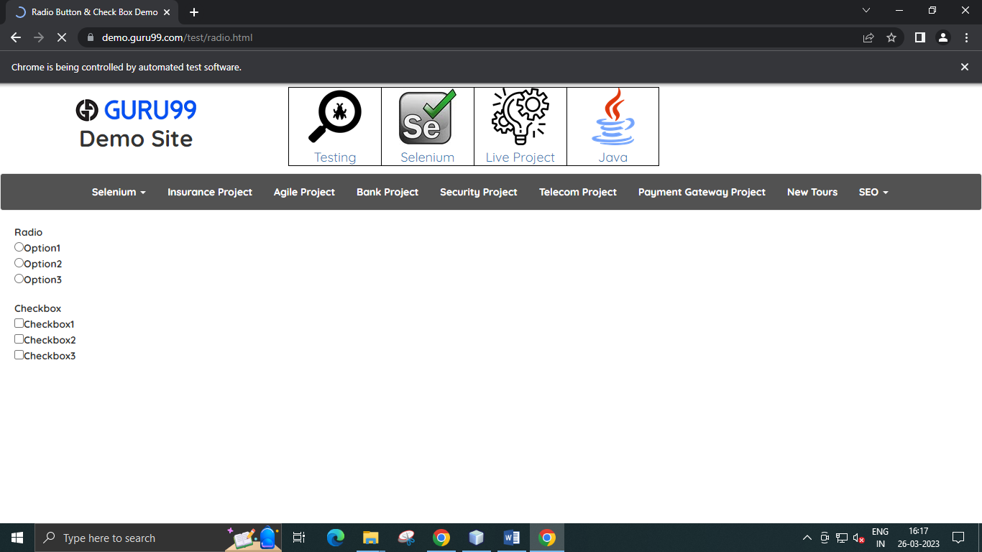

**Practical No: 8**

**Aim: - Demonstrate synchronization in selenium (Implicit wait).**

**Code:**

package JavaTpoint;

import java.util.concurrent.TimeUnit;

import org.openqa.selenium.By;

import org.openqa.selenium.WebDriver;

import org.openqa.selenium.WebElement;

import org.openqa.selenium.chrome.ChromeDriver;

import org.openqa.selenium.chrome.ChromeOptions;

import org.openqa.selenium.support.ui.ExpectedConditions;

import org.openqa.selenium.support.ui.WebDriverWait;

public class NewClass{

public static void main(String[] args) throws InterruptedException

{

System.setProperty("webdriver.chrome.driver", "C:\\Users\\spdc\\Desktop\\MCA_Praticals\\selenium\\chromedriver.exe");

ChromeOptions option = new ChromeOptions();

option.addArguments("--remote-allow-origins=*");

WebDriver driver = new ChromeDriver(option);

driver.manage().window().maximize();

driver.manage().deleteAllCookies();

driver.manage().timeouts().pageLoadTimeout(40,

TimeUnit.SECONDS); // pageload timeout

driver.manage().timeouts().implicitlyWait(20, TimeUnit.SECONDS);

// Implicit Wait for 20 seconds

driver.get("https://login.google.com/");

driver.findElement(By.xpath("//input[@id='loginusername']")).sendKeys("JavaTpoint.com"); //Finding element and sending values

Thread.sleep(1000);

driver.findElement(By.xpath("//input[@id='login-signin']")).click();

//Clicking on the next button if element is located

}

}

**Output: -**

In the code snippet given above, the Implicit Wait is defined for only 20 seconds, implying that the output will load or arrive within the maximum waiting time of 20 seconds for the particular element.

**Practical No: 9**

**Aim: - Demonstrate: Select Value from Dropdown using Selenium Web driver**.

**Code:**

import java.util.List;

import org.openqa.selenium.By;

import org.openqa.selenium.WebDriver;

import org.openqa.selenium.WebElement;

import org.openqa.selenium.chrome.ChromeDriver;

import org.openqa.selenium.chrome.ChromeOptions;

import org.openqa.selenium.support.ui.Select;

public class NewClass {

public static void main(String[] args) throws InterruptedException {

//Creating instance of Chrome driver

ChromeOptions option = new ChromeOptions();

option.addArguments("--remote-allow-origins=*");

WebDriver driver = new ChromeDriver(option);

//Step#2- Launching URL

driver.get("https://demoqa.com/select-menu");

//Maximizing window

driver.manage().window().maximize();

//Step#3- Selecting the dropdown element by locating its id

Select select = new

Select(driver.findElement(By.id("oldSelectMenu")));

//Step#4- Printing the options of the dropdown

//Get list of web elements

List<WebElement> lst = select.getOptions();

//Looping through the options and printing dropdown options

System.out.println("The dropdown options are:");

for(WebElement options: lst)

System.out.println(options.getText());

//Step#5- Selecting the option as 'Purple'-- selectByIndex

System.out.println("Select the Option by Index 4");

select.selectByIndex(4);

System.out.println("Select value is: " +

select.getFirstSelectedOption().getText());

//Step#6- Selecting the option as 'Magenta'-- selectByVisibleText

System.out.println("Select the Option by Text Magenta");

select.selectByVisibleText("Magenta");

System.out.println("Select value is: " +

select.getFirstSelectedOption().getText());

//Step#7- Selecting an option by its value

System.out.println("Select the Option by value 6");

select.selectByValue("6");

System.out.println("Select value is: " +

select.getFirstSelectedOption().getText());

driver.quit();

}

}

**Output: -**

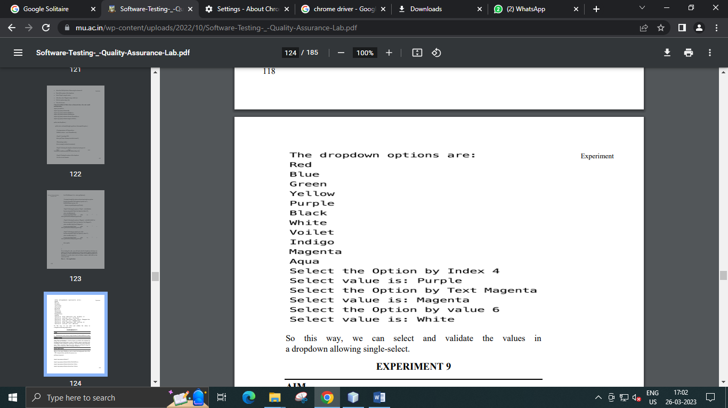

**Practical No: 10**

**Aim: - Demonstrate action classes using Selenium Web driver (Mouse Events)**

**Code:**

import org.openqa.selenium.*;

import org.openqa.selenium.chrome.ChromeDriver;

import org.openqa.selenium.chrome.ChromeOptions;

import org.openqa.selenium.firefox.FirefoxDriver;

import org.openqa.selenium.interactions.Action;

import org.openqa.selenium.interactions.Actions;

public class NewClass {

public static void main(String[] args) {

String baseUrl = "http://demo.guru99.com/test/newtours/";

System.setProperty("webdriver.gecko.driver", "C:\\geckodriver.exe");

ChromeOptions option = new ChromeOptions();

option.addArguments("--remote-allow-origins=*");

WebDriver driver = new ChromeDriver(option);

driver.get(baseUrl);

WebElement link_Home

= driver.findElement(By.linkText("Home"));

WebElement td_Home = driver

.findElement(By

.xpath("//html/body/div"

+ "/table/tbody/tr/td"

+ "/table/tbody/tr/td"

+ "/table/tbody/tr/td"

+ "/table/tbody/tr"));

Actions builder = new Actions(driver);

Action mouseOverHome = builder

.moveToElement(link_Home)

.build();

String bgColor = td_Home.getCssValue("background-color");

System.out.println("Before hover: " + bgColor);

mouseOverHome.perform();

bgColor = td_Home.getCssValue("background-color");

System.out.println("After hover: " + bgColor);

driver.close();

}

}

**Output: -**

