**CLIENT-SYNC**

**Objective:**

* It is difficult to filter out clients based on the cases they bring to the law firm and on their history.
* So, I thought of a parameter which could be brought by which clients could be filtered out and a system which could decide whether the client’s case is to be accepted or not based on various parameters.
* The gap that is being bridged here is assessing the expectations of client and evaluating if this can be something which the legal team shares a possible expectation.
* A metric for the client and lawyer to be on the same page for the lawyer to deliver as per the best interests of the client is our main objective.
* So, for that I have used stored Procedure, Triggers, DML, DDL functions.

**Overview:**

* I have developed an evaluation algorithm that considers the clients various factors such as a Profitability metric, we give the client a survey, clients background and Decisions for similar case type.
* All these parameters have their individual score, we a decision must be made each parameter has a different weightage like the profitability has 40%, survey has 30%, client background has 25% and previous decisions has 5%, so the final decision is made by adding the scores and if all the criteria matches we can take the client.

**ER Diagram:**

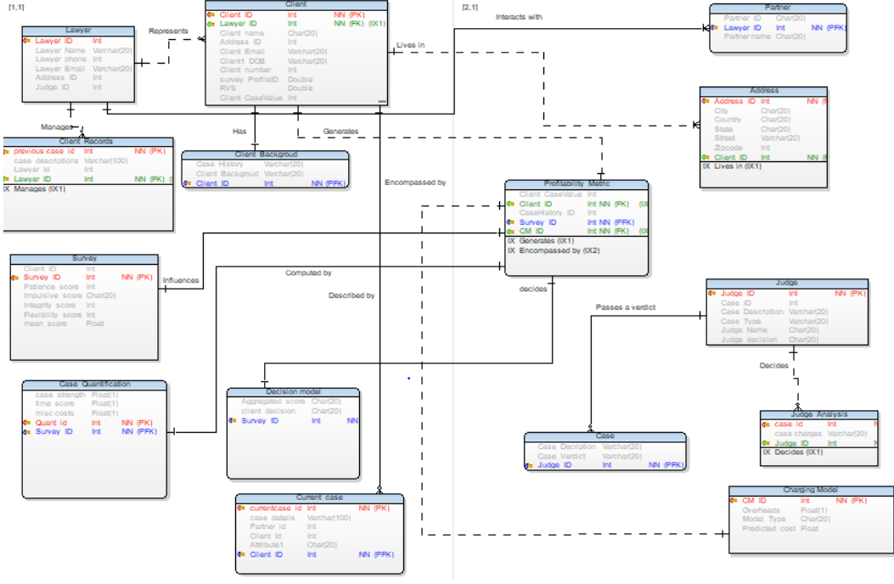

**SEQUENCE DIAGRAM:**

