**Data visualization of diet patterns and their effects using Tableau**

Dietary Patterns and Global Health explores the crucial link between what we eat and our overall well-being on a global scale. It delves into the challenges posed by rising non-communicable diseases, with a particular focus on obesity. Despite established dietary guidelines, deceptive marketing practices and lifestyle changes contribute to unhealthy eating habits. Through the analysis of datasets, the project aims to uncover the impact of these dietary patterns on health outcomes and emphasize the importance of adhering to recommended guidelines. Ultimately, the goal is to raise awareness and empower individuals to make informed choices for a healthier, more sustainable future.

Following dietary pattern is important due to the global health crisis stemming from rising rates of non-communicable diseases, including obesity and diabetes. The project emphasizes the need for individuals to adhere to dietary guidelines set by authoritative bodies like the USDA to mitigate health risks. By understanding the implications of an unhealthy diet, the project seeks to empower individuals to make informed choices for themselves and their loved ones.

The problem addressed in this project is the escalating prevalence of non-communicable diseases worldwide, particularly linked to issues of obesity and diabetes. Despite existing dietary guidelines from organizations like the USDA and WHO, deceptive marketing practices by manufacturers, increased consumption of sugar, vegetable oils, and processed foods have contributed to health concerns. The COVID-19 pandemic further highlighted the vulnerability of individuals with pre-existing conditions like obesity.

The target audience for this project is the general public. The project aims to create awareness about the critical importance of maintaining a balanced diet to prevent health issues related to poor nutrition.

**Project datasets**

The project utilized datasets from Kaggle, incorporating information on various dietary aspects such as protein and fat consumption, food item consumption in terms of kcal and kilograms, and country-specific GDP (Gross Domestic Product) data. The analysis focused on exploring the correlation between dietary patterns and health outcomes, particularly in the context of the COVID-19 pandemic. By examining these datasets, the project aimed to highlight deviations from recommended dietary guidelines and demonstrate how unhealthy diets contribute to the rise in obesity and undernourishment percentages globally.

The imported dataset from Kaggle had 90% clean data, and there were countries which had null undernourishment rates and some of column values were null. Since the dataset had good accuracy rate, dataset cleaning was done manually omitting the null values

All the 4 dataset we use has the same columns and values but the measure of these values varies in terms of kilograms, kilocalorie, protein supply and fat supply. We have also used one more dataset that shows GDP value across countries. This sheet served in identifying and comparing each countries economical value with respect to the list of health issues they are facing.

**1. What are the current diet patterns across different countries?**

**1.1 Descriptive:** How do food supply quantities in kilograms vary across countries for different food categories?

This visualization shows how food supply quantities in kilograms vary across countries for different food categories such as Animal product, category cereals, milk, pulses, sugar and sweeteners, vegetable oil, vegetable products. The data reveals significant differences in consumption patterns between countries and food categories. This analysis can help us understand global food supply trends and identify areas for improvement.

The trend across the countries for the consumption of dietary products looks poor, as the percentage consumption of processed foods like animal and vegetable products are more than whole foods like Vegetables, milk, and meat. The trend is compared across high, medium and low-income countries.

**1.2 Predictive**: What will be the future health outcomes on obesity rates based on current diet patterns and other demographic factors?

Our exploration into the diet patterns of different countries harnesses historical data on food supply to unveil the ebb and flow of global dietary habits. Through meticulous visualization using Tableau Cloud, bar and line graphs have been constructed to reveal the nuances of these patterns over time and across nations

.

The dataset Food_Supply_Quantity_kg_Data.csv by using the create calculated field feature, we have added four different measures called AGG(PROTIEN x USDA), AGG(GRAINS x USDA), AGG(VEGETABLES x USDA), AGG(FRUITS x USDA). We have observed a trend where the underdeveloped countries consume more of grains and vegetables. Whereas the developed countries consumed more of protein and nutrient rich foods.

The bar graph captures a moment in time, displaying the assortment of food commodities consumed across various regions. The variance in bar heights not only reflects the diversity in dietary preferences but also underscores the influence of regional agricultural practices and cultural predilections. For instance, disparities in the consumption of starchy foods versus high-protein foods are indicative of deeper societal and economic forces at play.

Complementing the bar graph, the line graph traces the trajectory of these dietary inclinations over an extended period. The trend lines serve as a testament to the dynamic nature of food consumption, where the steepness of ascent or descent speaks volumes about the pace of change.

By extrapolating from the rich tapestry of historical data, we predict future trends in the alimentary landscape. The predictive modelling inherent to Tableau's analytical tools suggests a continuation of existing patterns into the foreseeable future. This projection into the coming years reveals potential steady increases in specific dietary components, with ramifications for global health and nutritional standards. The visualization anticipates these shifts, hinting at a future where certain food groups may dominate the supply chain while others wane.

The value of this predictive modelling lies in its capacity to inform and guide. It enables stakeholders to map out scenarios that might arise from current dietary trajectories and to consider the ripple effects these trends may have on health outcomes, agricultural demands, and ecological sustainability. It is through this lens of foresight that we can better understand the interplay between past dietary behaviours and future nutritional realities.

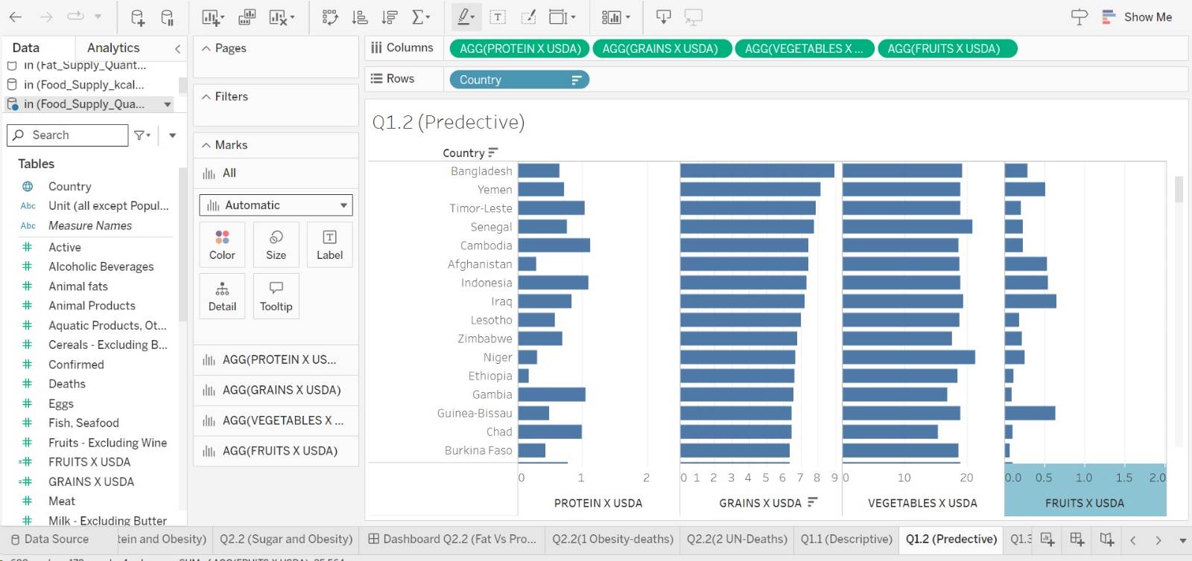

**1.3 Prescriptive:** What dietary changes can be recommended to countries with a high level of undernourishment?

Despite numerous initiatives, undernourishment remains a critical challenge in various regions. Through rigorous analysis of the `Food_Supply_Quantity_kg_Data.csv` dataset, we have pinpointed countries where undernourishment is most prevalent (above 30% undernourishment range of the total population).

Upon comparison with the USDA's recommended dietary intake — 30% grains, 40% vegetables, 10% fruits, and 20% protein, it became evident that the dietary patterns in these countries showed substantial deficits, particularly in the consumption of fruits and vegetables. To illustrate these disparities, we have employed scatter plot which shows the level of undernourishment and obesity rate for all the low-income countries

The visualizations serve as a foundation for our recommendations, which are tailored to address the specific dietary insufficiencies of each country. For nations with a grain-dominant diet lacking in fruits and vegetables, we recommend bolstering agricultural initiatives that encourage diverse crop production. In areas where protein is scarce, introducing sustainable farming practices for poultry and fish can provide a much-needed supply of essential nutrients.

Also, it is evident from the visualization that, countries that are economically poor are the one that have higher undernourishment rates.

**2. How do diet patterns relate to health outcomes and obesity rates in different countries?**

**2.1 Descriptive:** Are there significant correlations between diet patterns and undernourishment rates?

We can notice that geographic, cultural, and economic variables influence different countries eating habits. High-income nations typically have diets heavy on processed foods and high-calorie drinks, which raises the prevalence of undernourishment. According to the data, undernourishment rates are influenced by dietary diversity, economic considerations, and availability of high-quality food. Unexpectedly, undernourishment is common in certain nations with high obesity rates, suggesting complicated dietary issues.

The study investigated relationships between undernourishment rates and particular dietary habits. Preliminary results indicate that the persistence of undernourishment in some populations may be significantly correlated with the frequency of dietary practices.

To determine significant correlations between diet patterns and undernourishment rates, we perform a statistical analysis using the provided dataset (Food_supply_kg_Data) with relevant columns by pivoting them in Tableau such as animal products, cereal-excluding beer, milk-excluding butter, starchy root, vegetables, and vegetable products.

* The dataset is clean and missing values are handled appropriately.
* Extracted the columns related to food consumption in kilograms (e.g., animal products, cereal-excluding beer, etc.) and undernourishment rates.
* Created visualizations by using **symbol maps**, to better understand the patterns and correlations between different food categories and undernourishment rates.

The type of food what the people consume directly relates with the undernourishment rates. We do see a pattern where the underdeveloped countries are more undernourished ranging upto 50% population in countries such as Yemen, Zimbabwe, North Korea etc. When compared to developed countries like USA, UK, South Korea etc. Though the consumption of processed food is high in developed countries they are often fortified to reduce the undernourishment rate. We do see an interesting pattern between two identical countries lying in the same region, having the same geographic and agricultural conditions, But different undernourishment rates like North Korea & South Korea

**2.2 Predictive:** What will be the future health outcomes on obesity rates based on current diet patterns and other demographic factors?

Dietary patterns and obesity rates are correlated, nations with Westernized diets tend to have a greater incidence of obesity-related health problems. Conditions including diabetes, heart disease, and some types of cancer are more common when diets are high in calories and poor in nutrients.

Predicting future health outcomes, especially obesity rates, based on current diet patterns and demographic factors involves a combination of statistical modelling and analysis. Below is a general guideline on how you might approach this using the provided datasets: "food in Kg," "Protein consumption," and "Fat consumption" tables with the specified data columns.

We have used 3 different data sets by pivoting the data columns – Animal Products, Meat, Milk, Cereal, Vegetable Products, Sugar. Vegetables. In the 2.2 story we have combined three worksheets.

Worksheet 1 – plotted against Fat consumption with the obesity rates

Worksheet 2- Plotted against Protein Consumption with obesity rates

Worksheet 3 – Plotted against Sugar and Obesity rates.

From the story we can analyse that fat consumption directly influences obesity rates. Though a similar pattern can be observed with sugar consumption to.

With the obesity rates we can analyse that it coincides with covid related deaths as you can observe in the dashboard 2.2. This is not the same with respect to undernourished and deaths.

The future health outcomes related to obesity rates based on current diet patterns and demographic factors are complex and multifaceted.

Analysing the prevalent dietary habits can help predict future health outcomes. This includes the consumption of processed foods, sugary beverages, and high-fat diets.

Examining current trends in physical activity and sedentary behaviour is crucial. A sedentary lifestyle, coupled with poor dietary choices, can contribute significantly to obesity.

Evaluating ongoing and future public health initiatives aimed at combating obesity. This includes policies addressing food labelling, advertising, and educational programs promoting healthy lifestyles.

To comprehensively address future health outcomes related to obesity, a multidisciplinary approach considering social, economic, cultural, and individual factors is essential. Ongoing research, policy interventions, and community engagement play pivotal roles in shaping a healthier future.

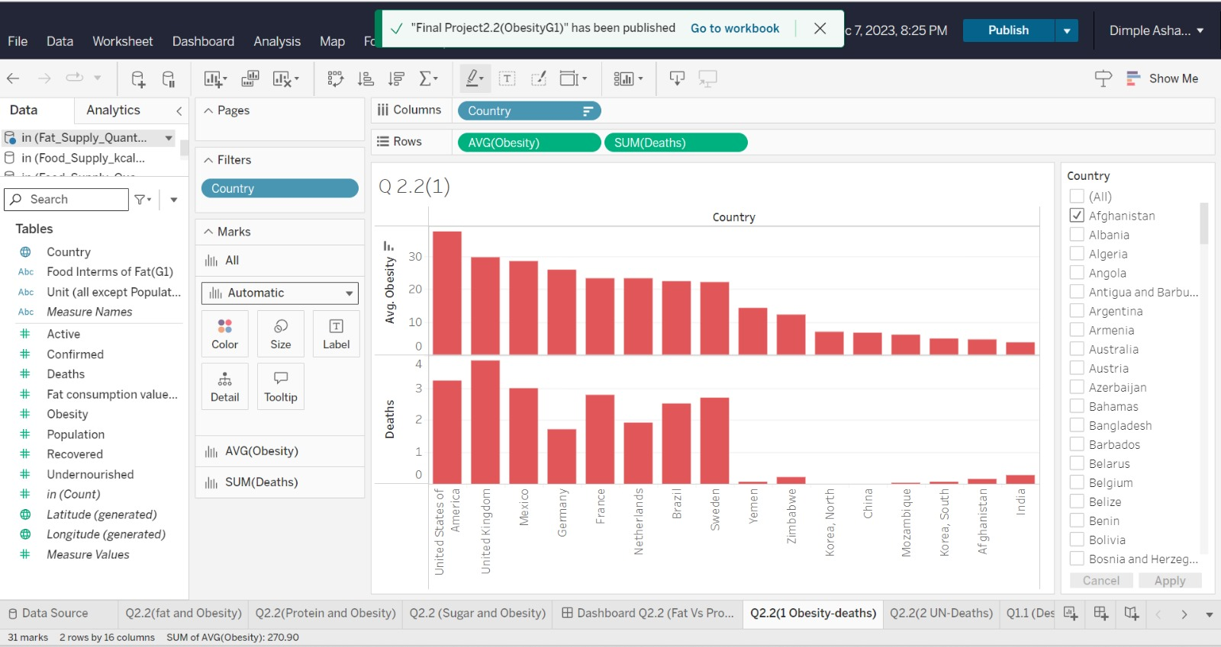

**2.3 Prescriptive:** How can countries with high obesity rates use data-driven insights to develop targeted public health interventions?

The global obesity epidemic poses a significant threat to public health, economic productivity, and overall quality of life. In response to this, our project leverages the `Food Supply in Kg.xlsx’ datasets to identify countries facing the most severe obesity challenges. By correlating dietary data with obesity statistics, we aim to understand the impact of fat and calorie consumption on obesity rates.

The data columns such as Animal Products, Meat, Milk, Vegetable products and vegetables were made into pivot table to see a trend.

Initial data analysis revealed a set of countries with disproportionately high fat and calorie supplies. Further statistical examination confirmed a strong correlation between these dietary factors and the prevalence of obesity, suggesting that high-fat and high-calorie diets are contributing to this growing health issue.

To visualize these findings, we created graphs that elucidate the relationship between dietary patterns and obesity rates. There was a positive correlation between increased fat and calorie supply and higher obesity prevalence.

Based on these insights, we propose a multi-faceted approach to public health interventions:

- Promotion of Healthier Diets: Implement nationwide campaigns to educate the population about the benefits of a balanced diet rich in whole grains, lean proteins, fruits, and vegetables, while limiting saturated fats and sugars.

- Reduction of High-Calorie Food Consumption: Introduce policies that encourage food manufacturers to reformulate products to contain fewer calories and unhealthy fats. This could be complemented by fiscal policies, such as taxing sugar-sweetened beverages and subsidizing healthier options.

- Public Awareness Programs: Launch comprehensive awareness initiatives to inform citizens about the dangers of obesity and the importance of maintaining a healthy diet. These programs should be culturally tailored to resonate with the local population and may include collaborations with community leaders, healthcare providers, and schools.

- Legislative Actions: Advocate for legislation that mandates clearer nutritional labelling, sets standards for healthy school lunches, and restricts marketing of high-fat and high-calorie foods, especially to children.

The proposed interventions are designed to create an environment that supports healthy food choices, thereby reducing obesity rates. It is crucial that these interventions are not standalone but part of an integrated strategy that includes healthcare policy, community planning, and individual behavioural change. By taking decisive, data-driven action, we can turn the tide on obesity and foster a healthier future for the affected countries.

In contrast, undernourishment and rising obesity rates coexist in several lower-income nations, adding to the double burden of malnutrition.

**Q3. How do diet patterns and their effects relate to the economic well-being of different countries**

**3.1 Descriptive:** How does the prevalence of obesity and undernourishment vary across countries and how is it related to their GDP?

The prevalence of obesity and undernourishment varies significantly across countries, and the relationship with Gross Domestic Product (GDP) can be complex. High-income countries often experience higher rates of obesity. This is associated with increased access to processed foods, sedentary lifestyles, and the prevalence of desk jobs. However, there are exceptions, and some middle-income countries may also face rising obesity rates due to urbanization and changing dietary patterns. In low-income countries, obesity rates can coexist with undernourishment, creating a "double burden" of malnutrition. Undernourishment is more prevalent in low-income countries, particularly in regions with food insecurity, poverty, and limited access to nutritious foods. There is a positive correlation between GDP per capita and obesity rates in many cases. As countries experience economic growth, there is often an increase in the consumption of energy-dense and processed foods, contributing to obesity. Generally, as GDP per capita increases, undernourishment tends to decrease. Economic development can contribute to changes in dietary patterns and health outcomes, it is essential to consider the broader context and adopt holistic approaches to address both ends of the malnutrition spectrum.

The two datasets were used namely Food_supply_kg_Data and GDP dataset in 2020. We have compared GDP with obesity and GDP with undernourishment. Whether it is the higher income country or lower income country, the obesity is high. With the case of comparison with undernourishment, the lower income country has higher undernourishment & the higher ones have lower undernourishment.

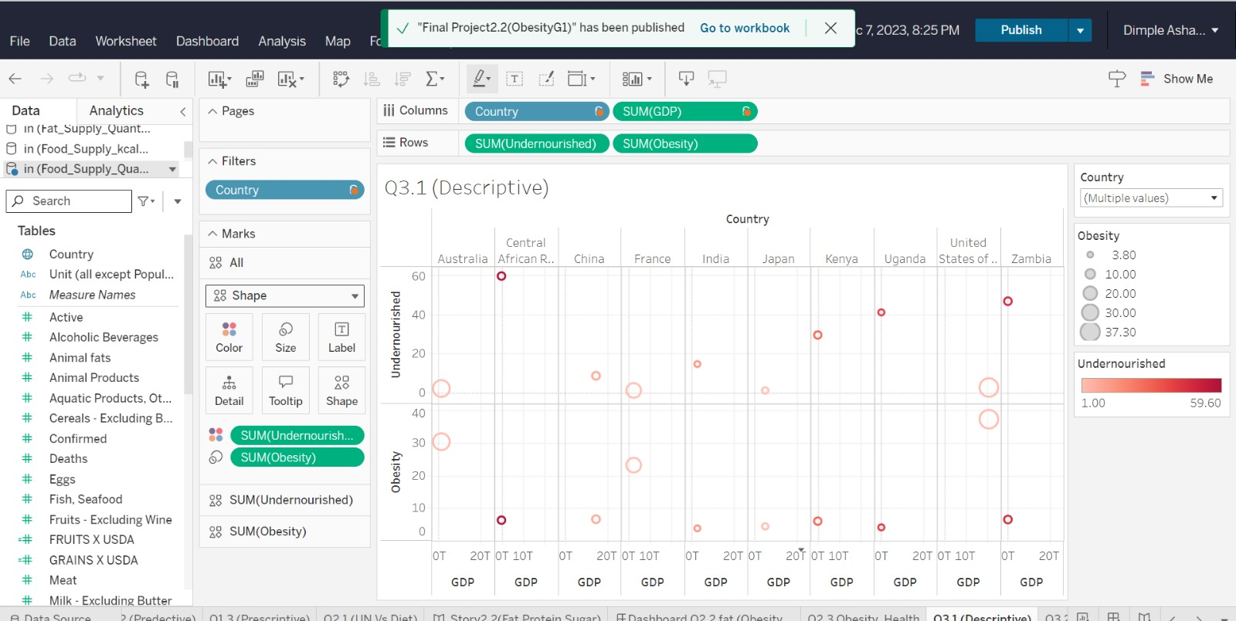

**3.2 Predictive:** How will shifts in diet patterns impact a country's economic health, and can we forecast these changes?

Shifts in diet patterns can have profound impacts on a country's health, influencing various aspects of well-being and contributing to both positive and negative health outcomes.

Unhealthy diet patterns, characterized by excessive consumption of processed foods, sugars, and high-calorie diets, can contribute to rising obesity rates. This, in turn, increases the risk of chronic diseases.

Food in Kcal dataset with GDP percapita were used to get an insight into the dietary pattern.

There is a hidden insight where the processed foods such as animal products and vegetable products are higher irrespective of their GDP.

The health impacts of diet patterns can place a significant burden on healthcare systems. Increased rates of obesity and diet-related diseases can lead to higher healthcare costs and resource allocation.

Poor diet can affect productivity and overall well-being. A workforce with a higher prevalence of diet-related health issues may experience reduced productivity and increased absenteeism.

Understanding and addressing shifts in diet patterns require comprehensive strategies involving education, public policy, and community engagement. Encouraging healthier food choices, promoting nutritional education, and implementing policies that support access to nutritious foods are essential components of efforts to improve a country's overall health.

By systematically considering these factors, you can develop a nuanced understanding of how shifts in diet patterns may impact a country's economic health and work towards forecasting these changes.

**3.3 Prescriptive:** How can international organizations and governments collaborate to address the effects of diet patterns on global well-being?

The well-being of the global population is intrinsically linked to dietary patterns, particularly the consumption of vital nutrients like protein. Our comprehensive analysis of the `Protein_Supply_Quantity_Data.xlsx` dataset provides a lens through which we can assess the current state of protein consumption worldwide and its impact on health outcomes.

Initial investigations have uncovered significant variations in protein supply across different regions. In particular, we found that lower protein intake is often associated with poorer health outcomes, including higher rates of infectious diseases and slower recovery from illnesses.

To effectively communicate these findings, we have developed visualizations; Box and whisker, map, and text table, these visualizations starkly represent the uneven distribution of protein sources and its correlation with health disparities.

In response to these findings, we propose a set of collaborative strategies designed to ensure a more equitable protein distribution:

- International Nutritional Programs: Collaborate with international organizations like the World Health Organization and the Food and Agriculture Organization to develop programs aimed at increasing the availability of protein-rich foods in undernourished regions.

- Educational Initiatives: Work alongside local governments to create educational campaigns that emphasize the importance of protein in the diet and provide guidance on how to access and prepare protein-rich foods, even in resource-limited settings.

- Agricultural Support: Support policies that incentivize local production of protein sources, such as legumes, poultry, and fish, and facilitate their integration into the local food systems.

- Policy Frameworks: Encourage the development of global and national policy frameworks that prioritize nutrition security, emphasizing the role of protein in a balanced diet and in the prevention of disease.

Through these recommendations, we aim to address the global disparities in diet patterns and their impact on health. It is only through international collaboration and a commitment to equity that we can hope to improve global well-being through better nutrition.

**Conclusion:**

In conclusion, the exploration of dietary patterns and their resulting issues reveals a complex interplay between individual choices, global health, and economic factors. The rising prevalence obesity and undernourishment poses significant challenges to public health worldwide. Despite established dietary guidelines from authoritative bodies, deceptive marketing practices and lifestyle changes contribute to unhealthy eating habits, further exacerbating health concerns.

The impact of dietary patterns on health outcomes, as evidenced by datasets and analyses, underscores the need for heightened awareness and adherence to recommended guidelines. Shifts in diet patterns not only affect individual well-being but also have broader implications for the economic health of countries. The relationship between food consumption and GDP per capita emphasizes the interconnectedness of nutrition and economic prosperity.

Addressing dietary patterns and their resulting issues requires a comprehensive, interdisciplinary approach that considers health, economic, and societal factors. By fostering awareness, understanding correlations, and leveraging predictive analytics, society can strive towards a healthier, more sustainable future. Ultimately, individual empowerment, informed decision-making, and strategic policy interventions are key components in the quest for improved global health through better dietary practices.