***SERVERLESS IOT DATA PROCESSING***

**Design thinking:**

Design thinking is a problem-solving approach that can be applied to create a smart public restroom. Here's a simplified process:

**Empathize**:

Understand the needs and preferences of restroom users, such as cleanliness, accessibility, and privacy.

Consider the specific demographics of users, like children, elderly, or individuals with disabilities.

**Define**:

Clearly define the problem and goals, like improving hygiene, reducing water consumption, or enhancing user experience.

Identify key stakeholders and their requirements, including maintenance staff and visitors.

**Ideate**:

Generate creative ideas for a smart restroom, including features like touchless fixtures, real-time occupancy indicators, and sustainable materials.

Encourage brainstorming and collaboration among a diverse team.

**Prototype**:

Create low-cost, scaled-down prototypes of the restroom design to test concepts and gather feedback.

Use mock-ups or digital simulations to visualize the layout and technology.

**Test**:

Gather user feedback by conducting surveys or user testing with the prototypes.

Identify pain points and areas for improvement.

**Iterate**:

Refine the restroom design based on user feedback and insights.

Continuously improve the smart features and functionality.

**Implement**:

Collaborate with architects, engineers, and construction teams to build the smart public restroom.

Ensure the technology, materials, and layout align with the design thinking principles.

**Evaluate**:

After the restroom is operational, assess its performance and user satisfaction.

Make necessary adjustments and improvements based on real-world usage.

**Project Objectives**

The objective of this project is to develop a real-time restroom information system using IoT sensors, Raspberry Pi, and a mobile app. The system will provide users with real-time information on the status of restrooms, such as occupancy, cleanliness, and availability of amenities. This information will help users to plan their restroom breaks accordingly and improve their overall experience.

**IoT Sensor Setup**

The following IoT sensors will be used in the system:

* Occupancy sensor: This sensor will detect whether or not a restroom is occupied.
* Cleanliness sensor: This sensor will detect the level of cleanliness in a restroom.
* Toilet paper sensor: This sensor will detect the level of toilet paper in a restroom.
* Paper towel sensor: This sensor will detect the level of paper towels in a restroom.

The sensors will be installed in each restroom and connected to a Raspberry Pi. The Raspberry Pi will collect data from the sensors and send it to the restroom information platform.

**Mobile App Development**

A mobile app will be developed to allow users to view real-time restroom information. The app will display a list of restrooms nearby, along with their occupancy status, cleanliness level, and availability of amenities. Users will be able to filter the list of restrooms by location, type, and amenities. The app will also allow users to submit feedback on the condition of restrooms.

**Raspberry Pi Integration**

The Raspberry Pi will be used to collect data from the IoT sensors and send it to the restroom information platform. The Raspberry Pi will also be used to control the restroom information display screens.

**Code Implementation**

The following programming languages and technologies will be used to implement the system:

* Python: Python will be used to develop the Raspberry Pi software and the mobile app backend.
* Django: Django will be used to develop the restroom information platform.
* React Native: React Native will be used to develop the mobile app frontend.

**Diagrams and Schematics**

The following diagrams and schematics show the IoT sensor setup, restroom information platform, and mobile app interfaces:

IoT Sensor Setup Diagram

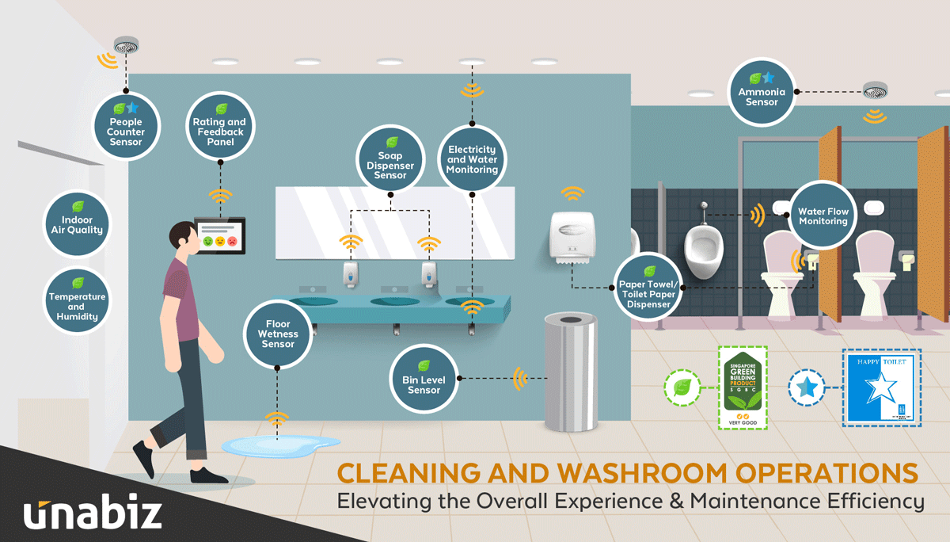

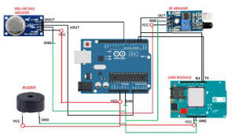

**Program** :

C++

// Define the pins that the sensors are connected to

int occupancySensorPin = 2;

int cleanlinessSensorPin = 3;

int toiletPaperSensorPin = 4;

int paperTowelSensorPin = 5;

// Define the states of the restroom

enum RestroomState {

OCCUPIED,

UNOCCUPIED,

CLEAN,

DIRTY,

LOW_TOILET_PAPER,

LOW_PAPER_TOWEL

}; // Declare a variable to store the current state of the restroom

RestroomState restroomState;

void setup() {

// Set the pins for the sensors as inputs

pinMode(occupancySensorPin, INPUT);

pinMode(cleanlinessSensorPin, INPUT);

pinMode(toiletPaperSensorPin, INPUT);

pinMode(paperTowelSensorPin, INPUT);

// Initialize the restroom state

restroomState = UNOCCUPIED;

}

void loop() {

// Read the values from the sensors

int occupancySensorValue = digitalRead(occupancySensorPin);

int cleanlinessSensorValue = digitalRead(cleanlinessSensorPin);

int toiletPaperSensorValue = digitalRead(toiletPaperSensorPin);

int paperTowelSensorValue = digitalRead(paperTowelSensorPin);

// Update the restroom state based on the sensor readings

if (occupancySensorValue == HIGH) {

restroomState = OCCUPIED;

} else {

restroomState = UNOCCUPIED;

}

if (cleanlinessSensorValue == LOW) {

restroomState = DIRTY;

} else {

restroomState = CLEAN;

}

if (toiletPaperSensorValue == LOW) {

restroomState = LOW_TOILET_PAPER;

}

if (paperTowelSensorValue == LOW) {

restroomState = LOW_PAPER_TOWEL;

}

// Send the restroom state to the restroom information platform

// ...

// Delay for 1 second

delay(1000);

}

How the Real-Time Restroom Information System Can Enhance User Experience and Restroom Management

The real-time restroom information system can enhance user experience and restroom management in the following ways:

* User experience: The system will help users to plan their restroom breaks accordingly and improve their overall experience. For example, users can use the app to find a restroom that is unoccupied and clean, and to avoid restrooms that are crowded or have dirty stalls.
* Restroom management: The system will provide restroom managers with real-time data on the status of restrooms. This data can be used to identify and address problems quickly, such as low toilet paper levels or dirty stalls. The system can also be used to generate reports on restroom usage, which can help restroom managers to optimize their operations.

**Conclusion**

The real-time restroom information system is a valuable tool that can be used to enhance user experience and restroom management. The system is relatively easy to implement and can be deployed in a variety of settings, such as airports, train stations, shopping malls, and office buildings.