**Homoglyph Link checker**



**Tool Name:** Homoglyph Link Checker

**By:** Dimple Pawarl (Intern ID: 306)

**Organisation:** DigiSuraksha — Parhari Foundation



**What’s This Tool All About?**

The **Homoglyph Link Checker** is a web-based tool (built using Python + Flask) designed to detect sketchy, lookalike links (aka homoglyph attacks) that try to trick users into clicking them. You paste text or upload a .txt file, and it’ll **detect all links + flag the shady ones** using Unicode confusion detection.

(e.g., gοοgle.com instead of google.com).



**Why Does It Matter?**

Phishing emails, scam messages, and fake login pages often use **visually identical but malicious URLs**. A single Cyrillic or Greek character swap can create an evil twin of your trusted site.

This tool:

* Finds and flags homoglyph (visually confusing) domains
* Helps in threat triage, email audits, and awareness training
* Supports English, Greek, Russian — all the sneaky Unicode boys



# Core Features

* Detects homoglyphs (script mixing like Cyrillic “о” vs Latin “o”)
* Supports both **text input** and **file upload**
* Shows both **all links** and **suspicious links**
* Simple, clean Flask web interface (no command line needed)
* Uses homoglyphs Python package internally
* Easy to extend into full anti-phishing automation

# How It Works

When you paste or upload text:

1. The app extracts all URLs using regex
2. It checks each link using the **homoglyphs** module
3. Suspicious ones (i.e., not ASCII-normalized) are flagged



# Dependencies & Setup

To get started, install the required dependencies:

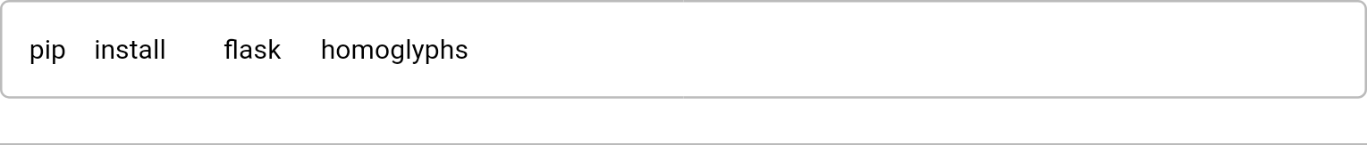

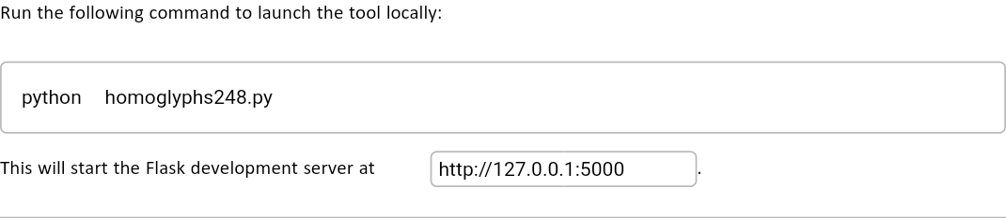

# Web UI Output:



# Sample Input & Output

You already got this thanks to the UI:

**Input Sample:**

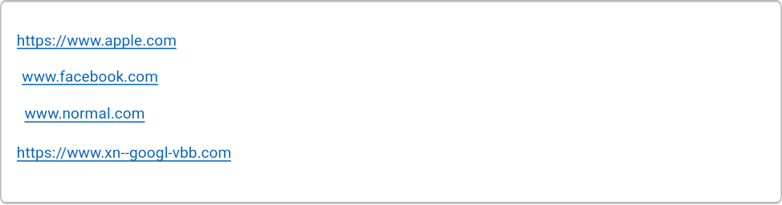

**Output:**

**All Links Found:**

* [www.apple.com](http://www.apple.com/)
* www.facebоok.com
* [www.normal.com](http://www.normal.com/)
* [www.microsoft.com](http://www.microsoft.com)
* www.instagram.com
* [https://www.xn--googl-vbb.com](https://www.xn--googl-vbb.com/)

**Suspicious Links:**

* www.facebоok.com
* [www.microsoft.com](https://www.xn--googl-vbb.com/)
* www.instagram.com



**Who Should Use This?**

* SOC Analysts
* Cybersecurity Investigators
* Threat Intel Teams
* Trainers for cyber awareness



**When to Use?**

* Triage during phishing incident reports
* Email/message audits before sending/receiving
* Red teaming or blue teaming exercises
* As part of CI/CD pipeline security checks



# Limitations

* Doesn’t support HTML or rich email parsing yet
* Might miss new Unicode tricks (needs regular script DB updates)
* No “threat score” or integration with real-time threat feeds



**What Makes It Good?**

* Simple to run, even for non-coders
* Portable across OSes
* Great for awareness + automation
* Lightweight and clean interface



# Summary

The **Homoglyph Link Checker** helps you **catch phishy links** before they catch you. It’s a fast, lightweight, and powerful addition to any digital investigation toolkit or awareness training module. Whether you're a pro analyst or just checking sketchy links in an email, this tool’s got your back.