Book

* Title
* Author
* Age
* Picture
* Owner
* Bookings
* Status now (free/booked)
* Inquiries ()

Person

* Login
* Pass
* Address
* Books owned
* Bookings
* Inquiries
* Messages
* Permissions (add, delete…)

Bookings

* Book
* Person1
* Person2
* Dates
* Returned/not

Person functions:

Add to request

Cancel request

Confirm taking from smb

Confirm return to smb

Confirm return of own books

Sent message/ask book owner

Add own books to library

Add comments at common board (I search, I added, etc)

Search:

By name, by author, latest added, age, topic, owner

Messages: entry from book, search by name of person/book among all messages. Confirm taking/return можно там же + передавать информацию в карточку книги. Auto-reminder 2 days before end of terms.

Header:

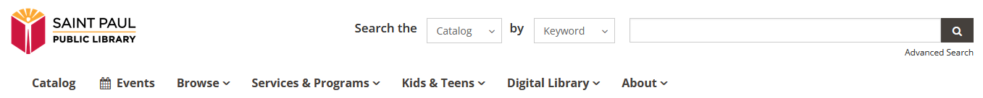

Login\register

Search

Menu

- Search books

- Add books

- About us (About us-Contact us-Help us)

- News

Home:

Foto+

**Building community.**

**Inspiring readers.**

**Expanding book access.**

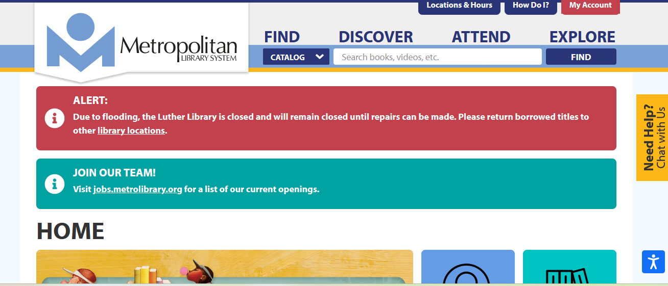

Или баннер и новости.

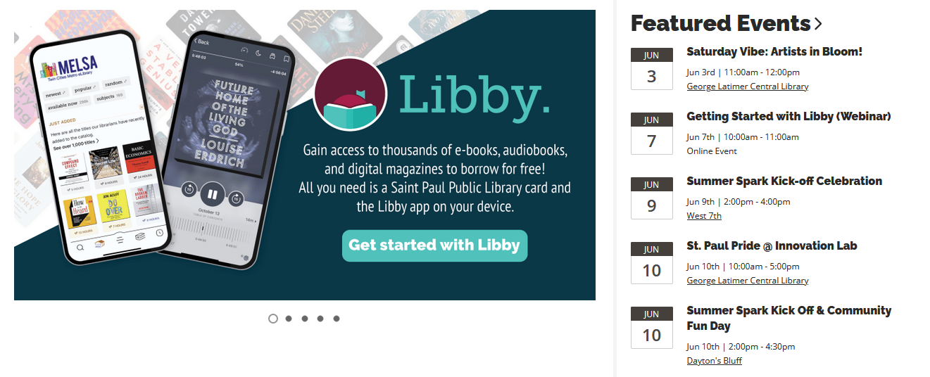

If you want to start a Free Library book exchange, you’re in the right place. We’re excited to have you join the network! We also recommend using the [own mobile app](https://littlefreelibrary.org/app/)  to find a Little Free Library near you.

Recently added:

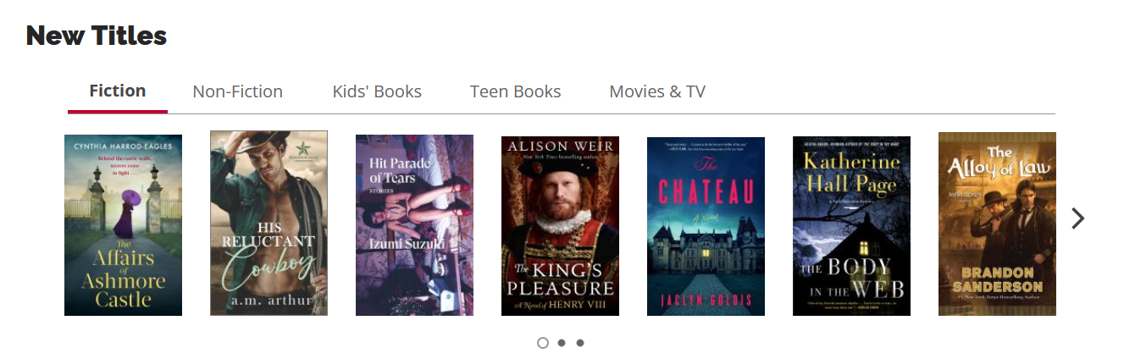

Login/register:

