How Tiny Plastic Polymers Spilled from Supply Chains Pollute the World
Copyright
Dimuthu Attanayake
2026

Advisor: Jo Craven McGinty
Every week, Diane Wilson, a fourth-generation shrimper, packs fishing nets and gear onto a fishing boat and goes out to the waterways of San Antonio Bay, Texas. Wilson no longer shrimps in these waters. Instead, almost every other day, the 80-year-old is scouring the bay water, the riverbeds, and the shores, for plastic pellets that escape the Union Carbide Seadrift Operations plant — a petrochemical complex, and the second-largest Dow facility in Texas — during its manufacturing process. She is searching to see if the tiny plastics — each roughly the size of a lentil — are now part of the waterways that serve fishing communities along the Texas coast.

Wilson and others from San Antonio Bay Estuarine Waterkeeper — the grassroots non-governmental organization that Wilson founded in 2012 to protect the Lavaca, Matagorda and San Antonio Bay estuary ecosystem and watershed — have been scavenging the pellets, with fishnets and pool nets, from the waterways of San Antonio Bay, in Calhoun County, Texas, since August 2024.

“These are the bays that we fished and crabbed and oystered, and now [we] are finding … pellets…,” Wilson says. She describes water from the bay as family — an old grandmother she is fighting fiercely to protect.

The volunteers record the pellets they say are released from Seadrift, by storing them in garbage bags, as evidence for the ongoing legal case. They record the date, time, location and the weather on the day the pellets were collected.

Weather has a large part to play in where the pellets appear, Wilson said “because when the weather changes, the tide changes, and [the nurdles] show up in another place.”

Called “nurdles,” these plastic pellets are made of chemicals derived from refining oil and gas, and are the basic building blocks of plastic production. They are less than 5 mm in size, often resembling fish eggs because of their translucent white coloring. They are not intended to enter the environment, experts say, but Wilson has been finding thousands of them scattered around, every week.

Because of their small size, nurdles remain elusive on the beaches, in riverbeds, and in marshes. Unlike other types of plastics, their size and color make efforts to remove them from the environment more challenging.

“If somebody goes to the beach or a lake or river they're not looking for [nurdles], they are probably not going to notice them. They will notice the water bottles or the bags in the trees because they are bigger, but these are so small and they look natural,” said Jace Tunnell, the director of community engagement at Texas A&M University-Corpus Christi’s Harte Research Institute and founder of Nurdle Patrol, a global volunteer network cleaning nurdles.
There are currently 31 different types of nurdles, according to Chapter 39 of the U.S. International Trade Commission's Harmonized Tariff Schedule. The nearly 50-page list of six-digit codes classifies nurdles for the purpose of import and export. Nurdles are transported from the manufacturing plants in the United States, the Middle East, China and others to destinations around the world, to be turned into different products. Polypropylene nurdles make bottle caps, microwave-safe containers, and plastic straws. Polyethylene terephthalate (PET) nurdles make water bottles and polyamide nurdles make nylon clothing. Many parts of cars are now made of different types of nurdles. Polypropylene makes battery casings. Polycarbonate is used for transparent parts such as headlamp lenses. Polyamide makes engine covers, and so on.

These polymers are also considered one of the most “pervasive forms” of microplastic pollution globally, according to the Great Nurdle Hunt, a global voluntary network documenting nurdle pollution, and a citizen science project of Fidra, the U.K.-registered environmental charity. An estimated 445,970 metric tons of nurdles are lost to the environment each year, according to a 2024 study published by Galgani and Rangel-Buitrago in the Journal of Hazardous Materials.

Research has shown that nurdles are highly absorbent and disintegrate into smaller microplastics. Marine pollution and environmental harm can last for hundreds of years, Galgani and Rangel-Buitrago’s research shows.

Marine life is known to consume nurdles, because in shape and size, these resemble seafood. One-quarter of all seabird species from around the world are known to ingest plastic debris, with those of polyethylene (a type of nurdles) in particular remaining in birds’ digestive tracts for 10 to 15 months, according to a report by the U.S. Environmental Protection Agency (EPA). They also have the potential to carry disease-causing bacteria such as E. coli or vibrio as they move from place to place, according to a study published in the Marine Pollution Bulletin in 2019.

“The question is, do those chemicals come off of the plastics through the stomach lining, and then into the muscle tissue inward?” Tunnell asked. If the answer is “yes” it would mean that some of these chemicals are ingested while consuming fish. Right now, there is a gap in concerted, long-term efforts to establish health impacts, if there are any from coming into contact with nurdles, either directly or indirectly.

“These things are kind of hard to tease out because we're exposed to so many things over a lifetime. Same with the fish, fish eat a lot of stuff too,” Tunnell says.
Nurdles escape from the stormwater outfalls
Wilson blames the accidental nurdle spills at the manufacturing plants on “bad housekeeping,” because when not cleaned up, nurdles spilled during factory production escape via stormwater outfalls when it rains. In December 2025, she and the environmental advocacy legal group Earthjustice filed a notice of intent to sue the Seadrift facility saying such failures are polluting San Antonio Bay.

The State of Texas sued Dow in February 2026 — just months after Wilson’s notice — for violating the Texas Water Code, the Texas Solid Waste Disposal Act and other regulations and permits. Lauren Godshall, senior attorney for Earthjustice and lead counsel for Wilson, filed an intervention into the state court enforcement action. Godshall said she wants the court to include additional dates that Wilson’s group located nurdles in the bay outside of the Seadrift facility currently not included in the state filings. Godshall aims for Earthjustice and Wilson “to participate in settlement talks, if any occur.”

The Texas Attorney General did not respond to requests for comment about its action against Dow and the Seadrift facility.
Under the current Texas permit system for instance, Seadrift is allowed to discharge trace amounts of floating solids under Texas Pollutant Discharge Elimination System.

“If you let a nurdle out, it's fine. The problem is when you let a lot of nurdles out every single day. We thought we might have more of a fight about the definition of trace, but because the nurdles are coming out in such large numbers, that really hasn't come up,” Godshall said.

But as Godshall points out, nurdles are not a waste product. “They are the primary plastic, the actual product,” which she said makes these spills “tricky.”

“You would think [the manufacturer] would do a better job … making sure that the product gets to the customer, not thrown on the ground, or in the ocean in large numbers,” she added.

Dow Chemical Company and Union Carbide Seadrift Operations did not respond to repeated requests for comment about the ongoing legal action on nurdle spills from their facility.
This is not the first time Wilson is fighting against nurdle spills from the factories on the Gulf Coast. In 2019, Wilson and her coalition won a $50 million settlement from Formosa Plastics, in Lavaca Bay in Texas, neighboring the Seadrift plant, after suing it for illegal discharge of plastic pellets.

Formosa voluntarily agreed to comply with “zero discharge” of all plastics, but
On March 31, 2026, the Texas Commission on Environmental Quality (TCEQ) issued a draft renewal of Formosa's wastewater permit, without including the zero-discharge limit.

The decision by the TCEQ baffled Godshall. “We think it's pretty appalling that a corporate actor could actually try to do the right thing, and the state can be like, nope … you have to pollute a little,” she said.

Responding to a request for further comment on its permit renewal process and ongoing efforts to mitigate nurdle spills at its Point Comfort facility on Lavaca Bay, Amy Blanchett, assistant manager of communications and new business development at Formosa Plastics Corporation, Texas, said, "In regards to these questions, please contact the Texas Commission on Environmental Quality."

TCEQ did not respond to requests for comment on Formosa's permit, or about its ongoing case with the Seadrift facility.

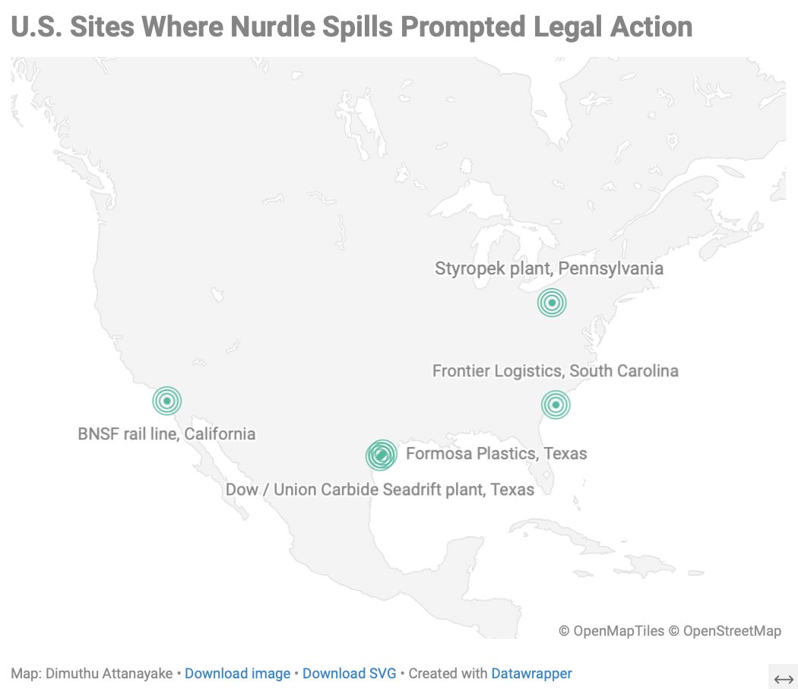

Regulating nurdle spills

The existing regulations mostly target releasing waste or effluents to the environment during the manufacturing process. In 2026, the U.S. federal Environmental Protection Agency announced that it would include microplastics as a priority contaminant group in its effort “to safeguard the nation's drinking water from microplastics, pharmaceuticals, forever chemicals, and dozens of other contaminants.” The agency did not respond to requests for further comment.

In March, Sen. Dick Durbin (D-Ill.), reintroduced Senate Bill 4181, the Plastic Pellet Free Waters Act, which, if it comes into force, would prohibit the discharge of plastic pellets by the “sources that make, use, package, or transport” them.

At the state level, California has been particularly vigilant. Since 2008, California has regulated facilities that manufacture, transport and handle pre-production plastics with Assembly Bill 258.

Outside of the United States, last year, the European Union adopted Regulation (EU) 2025/2365 on preventing plastic pellet losses, covering all operators handling five metric tons or more of pellets per year, as well as carriers and maritime transport. It also requires risk management plans covering packaging, handling, staff, training and equipment, with clean-up obligations after accidental losses.
Responding to the request for further comment, Maëlys Dreux, a press officer for environment and the New European Bauhaus at the European Commission's Spokesperson's Service, referred to a press release that said, “By 17 December 2026, the Commission will develop awareness-raising and training materials to support the Regulation’s implementation and will request European standardisation organisations to prepare harmonised standards for estimating quantities of losses.”

Citizen-led efforts against these industrial nurdle spills are growing in number. In 2020, Charleston Waterkeeper and the South Carolina Coastal Conservation League sued Frontier Logistics, L.P., a firm headquartered in La Porte, Texas, over nurdles spilled while they were being packaged at its packaging facility in Union Pier Terminal, South Carolina. According to the complaint filed in U.S. District Court in South Carolina in 2020, "in the summer of 2019, residents of Sullivan's Island and Isle of Palms, South Carolina began discovering BB-sized plastic pellets washing up along the shoreline of their beaches." Frontier Logistics denied that its facility was the source of nurdles, but agreed to contribute $1 million to Charleston Harbor environmental projects to settle the claims, according to court papers. The operation has since relocated to North Charleston.

Frontier Logistics LP and its defense firm, Willoughby & Hoefer, P.A., did not respond to questions on the nurdle spills and updates on how the $1 million settlement was distributed for environmental projects.

In 2025, Styropek facility in Monaca, in Beaver County, Pennsylvania reached a settlement to pay $2.6 million, of which $2 million would be spent on cleanup of plastic pellets, after being sued by the watchdog groups, PennEnvironment and Three Rivers Waterkeeper for violating the federal Clean Water Act over nurdle spills. The suit was filed for nurdle spills in Raccoon Creek and the Ohio River, and the state regulator, the Pennsylvania Department of Environmental Protection, had joined the suit in a legal intervention to say that Styropek violated two state laws by discharging nurdles to the environment.

The Pennsylvania Department of Environmental Protection did not respond to questions about the intervention or whether it would continue legal action on any future nurdle spills.

Dr. Heather Hulton VanTassel, executive director of Three Rivers Waterkeeper, said their investigation of the nurdles started by “accident.” One day, the Waterkeepers were monitoring a nearby Shell cracker plant that was manufacturing pellets. They pulled in a net to see a bunch of leaves, with nurdles trapped in their folds.
“These were much, much smaller,” she said about the tiny plastic pellets, adding that their usual nets were not capturing nurdles smaller than 5 mm in diameter, and these would have gone unnoticed if not for the leaves. The Waterkeepers documented the spills for a year starting September 2022 before taking legal action in December 2023, according to VanTassel.

Styropek’s permit allowed no suspended solids — and nurdles floating in the water are, in fact, suspended solids, VanTassel said. Styropek's settlement included a requirement to update its system to achieve zero plastic pellet loss, VanTassel says.

“Otherwise, they're getting automatic fines for each plastic pellet released,” she says.

Responding to questions about the upgrades to its system, Alpek, the Mexican petrochemical company that owns Styropek, referred to a press release committing to “remediation of plastics in Raccoon Creek and for further remediation and cleanup efforts to Raccoon Creek and along the Ohio River,” including “measures to prevent further discharge.”
Nurdle spills during transportation
Jamie Clarkson, a project officer at Fidra working on nurdle pollution, says that chronic pollution occurs at all points throughout the plastic pellet supply chain. This includes nurdle production, transportation by land and sea, conversion into plastic products, recycling, and during handling at all points in between. These are ongoing spills over a long period of time, where nurdles accumulate in the environment, according to him.
Acute spills release a large number of plastic pellets into the environment at one time, he adds.

Nurdle spills also take place away from the manufacturing facilities. They can spill along the value chain, during loading, rail transport and during shipping.

Tunnell of Texas A&M said that in the U.S., a small number of nurdles are released during rail transport, during loading and when the nurdles are being inspected.

“Some of the nurdles melt [during transportation] because of the friction,” Tunnell said, creating thin strands of plastics called angel hairs.

These angel hairs trap nurdles inside rail cars, but mostly remain hidden, resulting in silos carrying nurdles not being properly sealed during the trip back to the production site. “Whenever it starts going back down the railroad, it's bouncing around, and all those nurdles are just falling out," he said.

Accidents during transportation are a source of acute spills, Clarkson said, releasing a large volume of nurdles into the environment within a shorter span of time and this happens during rail transportation.

In 2022, a Norfolk Southern train collided with a truck near Harmar Township in Allegheny County, near Pittsburgh, and cars that contained nurdles derailed and fell into the Guys Run, a tributary of the Allegheny River, the main drinking water source in Pittsburgh. VanTassel says if the nurdles remain in the water long enough to break down into smaller particles, these have the potential to end up in tap water.

Nurdles spread along the river because the multi-tier boom system set up by Norfolk Southern could not contain the spill because it was opened to let the boats cleaning up the derailment through, according to Three Rivers Waterkeeper’s VanTassel, who says that there were nurdles “all over” the boats that were going in and out. Norfolk Southern did not respond to requests for comment on the spill.

Eventually, the nurdles were vacuumed, but the “damage was already done,” because they were already released downstream, VanTassel said.

“Unfortunately, you still find those nurdles today, both at the derailment site and downstream,” she added.

Nurdles produced elsewhere arrive in western New York via tractor trailers, to be blown or molded into hollow plastic containers such as water bottles, at the secondary manufacturing plants scattered along the Niagara river tributaries, Elizabeth Cute, senior program manager for Buffalo Niagara Waterkeeper, says. Buffalo Niagara Waterkeeper has been recovering nurdles for years, she said, sometimes in partnership with locals and student volunteers from the University at Buffalo in upstate New York, along the Niagara river and tributaries. Unlike nurdles spotted in most other locations, some of the nurdles they find are opaque, colored brown, yellow, blue, green and sometimes even red, with some sporting a more cylindrical shape, according to the images shared by Cute.

In 2025, they collected 10,000 nurdles between May and October, Cute said.

But she also says that it is difficult to determine an exact source for the nurdles. She said the expanse of the pellet terrain is vast: the Niagara river takes water from the Great Lakes system spanning Illinois, Indiana, Michigan, Minnesota, New York, Ohio, Pennsylvania, Wisconsin and parts of Canada, all locations with plastic manufacturing facilities.

“We could just be receiving a ton from upstream sources that are out of state,” Cute says. “There are a lot of unknowns.”

Nurdles spilled into the oceans
Maritime transport is considered the biggest source of acute nurdle spills and transboundary pollution globally, with at least seven spills from 2020 to 2026. Nurdles are among the largest sources of microplastic pollution in the ocean, second only to tire dust.
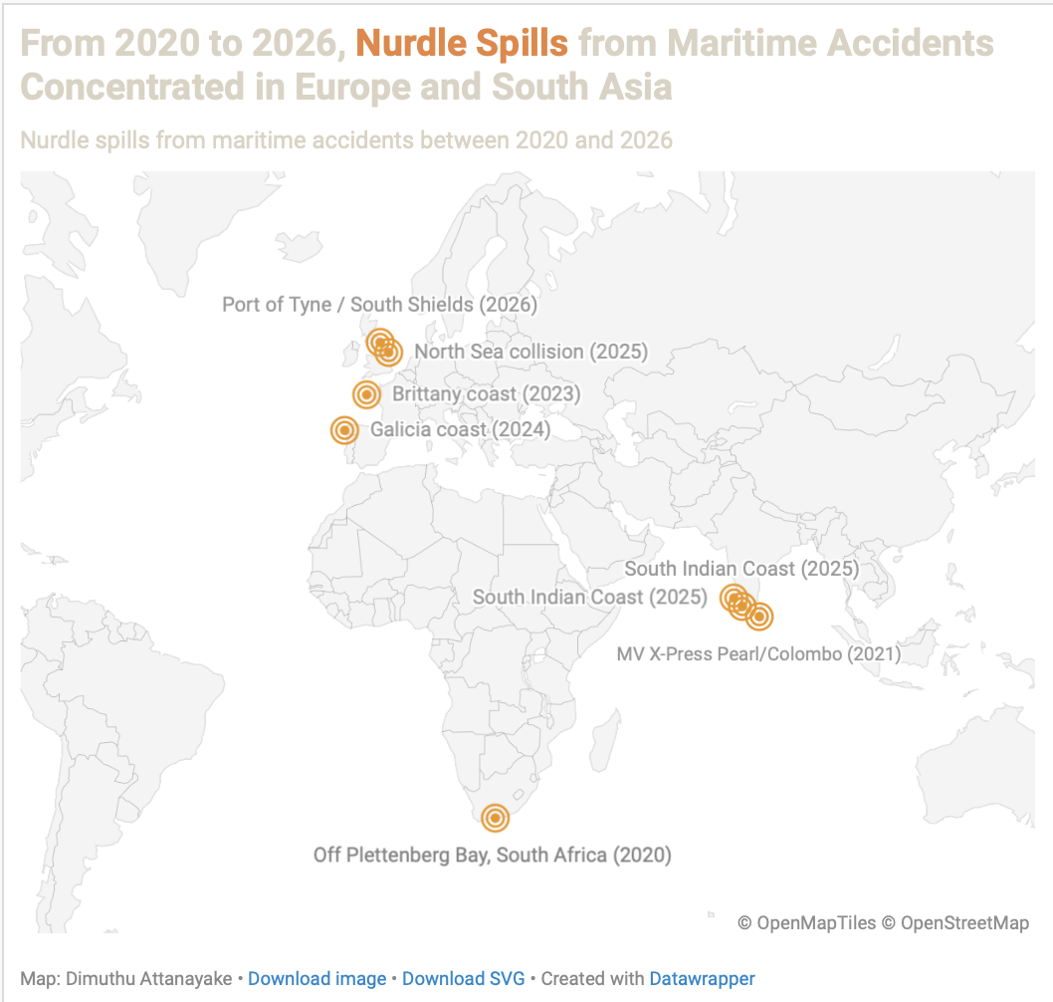

In 2021, the MV X-Press Pearl, a Singapore-flagged container ship, caught fire off the western coast of Sri Lanka, and released 1,680 metric tons of plastic pellets, the largest ever plastic spill from a maritime disaster to date according to the United Nations. A staggering number of nurdles washed up on the Sri Lankan beaches and also spilled into the Indian Ocean.

The consequences of the fire extended beyond the initial spill. Following the complex chemical fire on board the X-Press Pearl, with hazardous chemicals such as epoxy resin, caustic soda and nitric acid, and metals such as copper, were detected in burnt lumps of nurdles, according to a 2022 report by International Pollutants Elimination Network (IPEN), a global network of NGOs working to eliminate hazardous chemicals and pollutants, and Centre for Environmental Justice, an environmental justice watchdog in Sri Lanka. Another study published in ACS Environmental Au, in 2021, noted that during the fire, the nurdles were exposed to "carcinogenic combustion products" such as polycyclic aromatic hydrocarbons (PAHs), and benzotriazole UV stabilizers, potentially making them carriers of carcinogens and other pollutants.

In 2025, the Supreme Court of Sri Lanka found the owner, operator, and local agent of the MV X-Press Pearl liable for environmental and economic damage. While the courts ruled for an interim payment of $1 billion for the damage caused by the ship disaster, X-Press Feeders, the ship’s operator, refused to pay the initial installment of $250 million, with its CEO Shmuel Yoskovitz calling the ruling a “dangerous precedent” for the shipping industry.

Yoskovitz did not personally respond to requests for further comment. Instead, Andrew Leahy, director, Asia-Pacific of MTI Pte Ltd, X-Press Feeders’ spokesperson said in a statement, “X-Press Feeders and our insurers carefully considered the July ruling of the Supreme Court of Sri Lanka and were unable to make the initial payment because liability is not accepted and the ruling leaves open the possibility of additional and potentially unlimited compensation orders.” The statement added that $170 million had already been paid by the company toward wreck removal, environmental remediation and compensation claims.

Leahy’s statement further said that the judgment by the Sri Lankan court “relied heavily on a flawed environmental damage report,” produced by the Marine Environment Protection Authority (MEPA) of Sri Lanka. MEPA did not immediately respond to requests for comment.

More recently, large swaths of nurdles arrived on the beaches of northeast England after a ship collision on July 19, 2026, at the Port of Tyne, South Shields.

Clarkson of Fidra, who was on the ground at the Port of Tyne, says that the nurdles are “spreading far from the original source.” He says that the spill poses a major risk to wildlife and protected areas, referring to video footage of seabirds picking up nurdles with their beaks.

In 2025, millions of pellets ended up on the Norfolk coast in the United Kingdom when a cargo ship collided with a U.S.-registered tanker off East Yorkshire. Also in 2025, ship accidents near southern India released large volumes of nurdles, including bags of nurdles that were intact, that ended up on the South Indian and Sri Lankan beaches. There was a spill in South Africa in 2020 that released 175 metric tons of nurdles. In 2023, nurdles believed to be from shipping containers lost in the Atlantic Ocean covered the coastline of Brittany, France. The French government called it an “environmental nightmare” and sought legal action. In 2024, 1,000 sacks of nurdles from a Liberian-flagged ship ended up on the Galician coast in Spain, according to media reports.

Tunnell says these frequent nurdle spills stem from the increased production of raw plastics over the years, while studies say that “irregularities” of the plastic supply chain are considered the source of the increasing number of nurdle spills since the 1970s.

“If you look [at data] just over the last 10 years, it's really ramped up, and supposed to double in like the next 20 years, so [the spills] are only going to get worse,” he said. Data from Our World in Data shows that production of primary plastics grew from 2 million metric tons in 1950 to 460 million metric tons in 2019. Their production is expected to reach 589 million metric tons by 2030, according to projections from the Organisation for Economic Co-operation and Development (OECD).

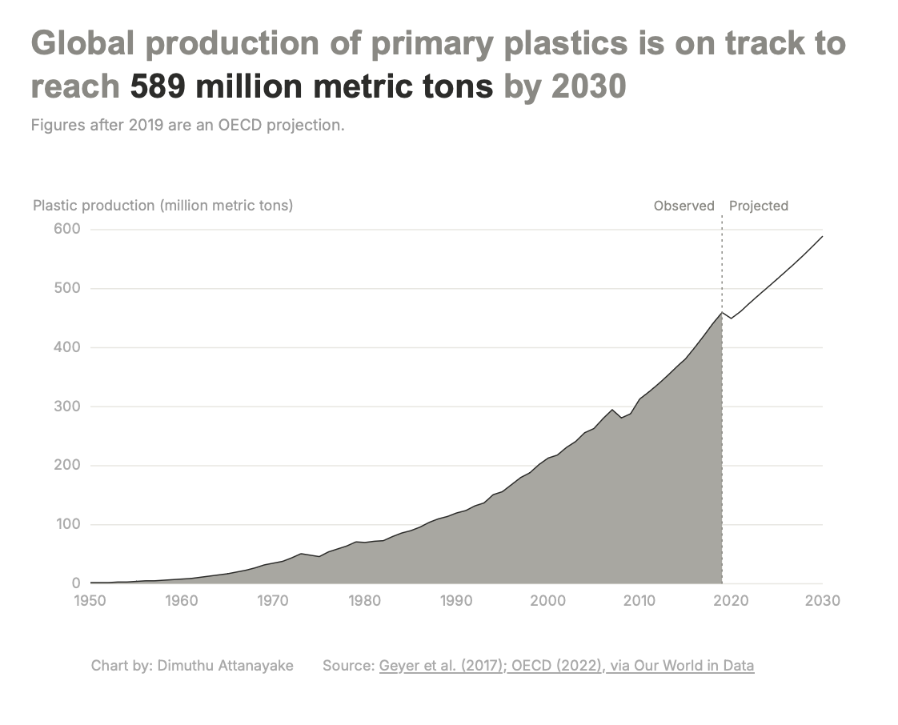
Part of the reason for maritime nurdle spills lies in packaging, according to advocacy groups. This is because nurdles in packaged form are not classified as “harmful substances” by international shipping regulations [Annex III of the International Convention for the Prevention of Pollution from Ships (MARPOL), concentrating on preventing pollution by harmful substances carried by sea in packaged form], Dr. Stephanie Lavelle, waste and marine litter expert of GRID-Arendal, says.

“Not unless contaminated. So, they are not subject to strict packaging, labeling, or transport requirements,” she says.

In a recent development, the Marine Environment Protection Committee (MEPC), a key environmental committee under the International Maritime Organization (IMO), agreed to develop a mandatory code for maritime transport of pellets in containers, under MARPOL Annex III and/or SOLAS. Since 2022, the United Nations has also been attempting to draft a global plastics treaty with the aim to regulate how to address accidental spills, and also to reduce plastic production at the source. But negotiations have made little headway.

Tunnell says that getting the word out on what these nurdles are and what their impacts are, would be the first steps toward mitigating these spills.

“If people haven't heard of it, why would they care about it? The plastics industry doesn't want you to know about it, and it is not good for them to show that they are discharging their product out into the environment.”

Digital version:https://dimuthuattanayake.github.io/Interactives-Nurdle-V2/
Sources
Name | Title | Organization | Email | Phone
Diane Wilson | Founder | San Antonio Bay Estuarine Waterkeeper | wilsonalamobay@aol.com | (361) 218-2353
Jace Tunnell | Director of community engagement; founder, Nurdle Patrol | Harte Research Institute, Texas A&M University–Corpus Christi | jace.tunnell@tamucc.edu
Lauren Godshall | Senior attorney | Earthjustice | lgodshall@earthjustice.org
Dr. Heather Hulton VanTassel | Executive director | Three Rivers Waterkeeper | heather@threeriverswaterkeeper.org | (412) 589-9411
Jamie Clarkson | Project officer | Fidra | Jamie.Clarkson@fidra.org.uk
Elizabeth Cute | Senior program manager | Buffalo Niagara Waterkeeper | ecute@bnwaterkeeper.org
Dr. Stephanie Lavelle | Waste and marine litter expert | GRID-Arendal | stephanie.lavelle@grida.no
Maëlys Dreux | Press officer, Environment & New European Bauhaus | European Commission, Spokesperson’s Service | Maelys.DREUX@ec.europa.eu
Texas Attorney General’s Office |  | Office of the Texas AG | press@oag.texas.gov | (512) 463-2050
TCEQ media relations | Spokesperson: Ricky Richter | Texas Commission on Environmental Quality | media@tceq.texas.gov | (512) 239-5000
Dow / Union Carbide media |  | The Dow Chemical Co. / Union Carbide | media@dow.com
Amy Blanchett | Communications contact | Formosa Plastics Corp., Texas | ABlanchett@ftpc.fpcusa.com | (361) 746-3874 / (361) 987-7000
media desk |  | Frontier Logistics, L.P. |  | 281-307-2000
Randolph R. Lowell | Attorney (Frontier defense counsel) | Willoughby & Hoefer, P.A. | rlowell@willoughbyhoefer.com | (843) 619-4426
Chad N. Johnston | Attorney (Frontier defense counsel) | Willoughby & Hoefer, P.A. | cjohnston@willoughbyhoefer.com | (843) 619-4426
J. Joseph Owens | Attorney (Frontier defense counsel) | Willoughby & Hoefer, P.A. | jowens@willoughbyhoefer.com | (843) 619-4426
PA DEP media (Laina Aquiline, region) |  | Pennsylvania Dept. of Environmental Protection | RA-EPNEWS@pa.gov; laquiline@pa.gov | (717) 787-1323
Alpek (Styropek parent) | Investor relations / corporate comms | Alpek S.A.B. de C.V. | ir@alpek.com | +52 (81) 8748 1111
Norfolk Southern | Media relations team | Norfolk Southern | media.relations@nscorp.com | (855) 667-3655
Shmuel Yoskovitz | CEO | X-Press Feeders | enquiry.asia@xpf.com | +65 6223 9033
Andrew Leahy | Director, APAC, MTI Pte Ltd | spokesperson for X-Press Feeders |  | andrew.leahy@mtinetwork.com

Data sources

● Nurdle Patrol: crowdsourced pellet cleanup data compiled by Jace Tunnell https://nurdlepatrol.org
● Our World in Data: global plastics production over time https://ourworldindata.org/plastic-pollution
● USITC Harmonized Tariff Schedule, Chapter 39: the six-digit HS codes for plastics in primary form https://www.usitc.gov/publications/docs/tata/hts/bychapter/1401c39.pdf

Scientific Papers

● Galgani, F., & Rangel-Buitrago, N. (2024). "White tides: The plastic nurdles problem." Journal of Hazardous Materials, 470, 134250. DOI: 10.1016/j.jhazmat.2024.134250. https://www.sciencedirect.com/science/article/pii/S0304389424008291
● de Vos, A., Aluwihare, L., Youngs, S., DiBenedetto, M. H., Ward, C. P., Michel, A. P. M., et al. (2021). "The M/V X-Press Pearl Nurdle Spill: Contamination of Burnt Plastic and Unburnt Nurdles along Sri Lanka’s Beaches." ACS Environmental Au, 2(2), 128–135. DOI: 10.1021/acsenvironau.1c00031. https://pubs.acs.org/doi/10.1021/acsenvironau.1c00031
● Kühn, S., & van Franeker, J. A. (2020). "Quantitative overview of marine debris ingested by marine megafauna." Marine Pollution Bulletin, 151, 110858. DOI: 10.1016/j.marpolbul.2019.110858. https://www.sciencedirect.com/science/article/pii/S0025326X19310148
● Carney Almroth, B., et al. (2026). "Decades of scientific research show that plastic pellets pose hazards to the environment." Cambridge Prisms: Plastics. https://www.cambridge.org/core/journals/cambridge-prisms-plastics/article/decades-of-scientific-research-show-that-plastic-pellets-pose-hazards-to-the-environment/4CD2D51366EFD43DED7466F86AE6A7C6
● Tunnell, J., Dunning, K., Scheef, L., & Swanson, K. (2020). "Measuring plastic pellet (nurdle) abundance on shorelines throughout the Gulf of Mexico using citizen scientists." Marine Pollution Bulletin, 151, 110794. https://doi.org/10.1016/j.marpolbul.2019.110794
● Folbert, M., Stoorvogel, J., & Löhr, A. (2025). "Plastic pellet spills and leakages during maritime transportation: A transdisciplinary approach to understand the complex causal pathways." Marine Pollution Bulletin, 218, 118194. https://doi.org/10.1016/j.marpolbul.2025.118194

Reports
● U.S. EPA (1992). Plastic Pellets in the Aquatic Environment: Sources and Recommendations. EPA 842-B-92-010. https://www.waterboards.ca.gov/water_issues/programs/tmdl/docs/303d_policydocs/340.pdf
● UNEP (2021). X-Press Pearl Maritime Disaster, Sri Lanka: Report of the UN Environmental Advisory Mission. https://www.unep.org/resources/report/x-press-pearl-maritime-disaster-sri-lanka-report-un-environmental-advisory-mission
● IPEN & Centre for Environmental Justice (2021). X-Press Pearl: A "New Kind of Oil Spill." https://ipen.org/publication/x-press-pearl-new-kind-oil-spill/
● U.S. EPA (2026). Press release on the draft Sixth Contaminant Candidate List (CCL 6) proposing microplastics as a priority contaminant group. https://www.epa.gov/newsreleases/epa-takes-bold-action-ensure-drinking-water-safe-microplastics-pharmaceuticals-and
● U.S. PIRG / Public Interest Network (2025). International Plastic Pellet Count 2025 Report. https://publicinterestnetwork.org/wp-content/uploads/2025/09/International-Plastic-Pellet-Count-2025-Report_1.pdf

● IMO (2024). MEPC.1/Circ.909: Recommendations for the carriage of plastic pellets by sea in freight containers (voluntary); and the MARPOL Annex III framework. https://www.imo.org/en/mediacentre/hottopics/pages/marinelitter-default.aspx
Legal and Regulatory Documents

● SABEW v. Dow/Union Carbide: Petition in Intervention https://earthjustice.org/wp-content/uploads/2026/03/2026.03.19-sabew-petition-in-intervention-2.pdf
● State of Texas v. Union Carbide Corp., et al.: Original Petition and Application for Injunctive Relief (filed Feb. 13, 2026). https://stateimpactcenter.org/files/AG_Actions_Texas_v_Union_Carbide_Petition_02.13.2026.pdf
● SABEW / Earthjustice (May 18, 2026): Comment letter on Formosa’s draft permit renewal WQ0002436000, quoting TCEQ’s rejection of the zero-discharge limit. https://publicinterestnetwork.org/wp-content/uploads/2026/05/2026.05.18-00-SABEW-Formosa-Comments-1.pdf
● Charleston Waterkeeper v. Frontier Logistics: Complaint (2020), Case No. 2:20-cv-01089 (D.S.C.), and the 2021 settlement agreement ($1 million). https://legacy.uploads.southernenvironment.org/words_docs/2021-03-03_Settlement_Agreement_(Fully_Executed_with_Exhibits_-_To_File).pdf

● PennEnvironment & Three Rivers Waterkeeper v. Styropek: Complaint (Dec. 2023) and consent decree (Sept. 2025), Case No. 2:23-cv-02067-NR (W.D. Pa.). ($100k penalty, $2M remediation, $500k watershed.) https://www.nelc.org/cases/pennenvironment-three-rivers-waterkeeper-v-bvpv-styrenics-llc-and-styropek-usa-inc/
● Regulation (EU) 2025/2365: on preventing plastic pellet losses (in force 16 Dec. 2025). https://environment.ec.europa.eu/news/new-law-reducing-microplastic-pollution-enters-force-2025-12-16_en
● Plastic Pellet Free Waters Act: S.4181, 119th Congress (reintroduced March 2026 by Sen. Durbin). https://www.congress.gov/bill/119th-congress/senate-bill/4181
● California Assembly Bill 258 (2007): Preproduction Plastic Debris Program (effective Jan. 1, 2008). https://leginfo.legislature.ca.gov/faces/billNavClient.xhtml?bill_id=200720080AB258
Postscript
In 2021, when the X-Press Pearl disaster happened off the coast of Sri Lanka, I was there and observed how the impacts happened in real life. But in the beginning, most of the focus was on chemicals, and how the nurdles carried the chemicals. There was little attention to the nurdle spill by itself. Then, in 2024, I was at the UN headquarters in New York City on a reporting fellowship, and I spoke with Inger Andersen, the executive director of the UN Environment Programme (UNEP), about nurdle spills. It was right before the expected signing of the global plastics treaty (it's still not signed), but she told me about how the treaty is aiming to reduce plastic production at the source, and how this may reduce similar maritime accidents.
This made me more curious about nurdles, so after returning to Colombo, I checked whether nurdles were still there, on the beaches. They were hard to detect in the beginning, but after digging for a few minutes, I found plenty buried in the sand.
In 2025, I was again reporting on nurdle trade and spills in Asia, and two more ship accidents occurred off southern India. I saw fresh nurdles washing ashore with the monsoon winds and tides while I stood on the beach. Then, I travelled along the western and northwestern coast of Sri Lanka, chasing the new nurdles arriving on the beaches and documenting their locations.
When I was editing my draft and wanted to verify the volume of the nurdles on board one of the ships from the 2025 accidents, I realized that the reported numbers were not accurate. Then I got hold of the cargo manifest of that ship to add up the actual volumes being transported; this is when I realized just how many different types of nurdles there are.
When I arrived at Columbia last year, I had this grand idea in my head; I thought I would be able to get hold of lots of cargo manifests and then analyze them to understand the volumes of nurdles being transported. But after looking around for a while, I realized that cargo manifests are not so easy to get hold of.
I still wanted to work on this story about nurdle spills, and after doing some desk research and speaking to advocacy groups, I realized that these spills take place at different points in the value chain. Nurdles are spilled at the manufacturing facilities, during packaging, during conversion into secondary products, and during transportation.
I did some more desk research, found court cases and reached out to the defendants. I also reached out to the companies and authorities, then read a number of research papers to understand the ecological and health impacts.
This was a story where data was scarce, so I had to look around for data. I created an animated globe showing all the places where nurdles were discovered with the crowdsourced dataset from Nurdle Patrol quoted in the story. I also used the Our World in Data datasets and projections to create a chart on plastic production volumes over the years. I built a small dataset to create a map of the locations of maritime nurdle spills from 2020 to 2026. If I had more time, I would have liked to analyze and visualize nurdle trade data from the UN Comtrade database.
Overall, I am grateful for the many reporting trips and fellowships that fed into this. The data journalism skills I learned at Columbia brought it all together to make this a very interesting project!

