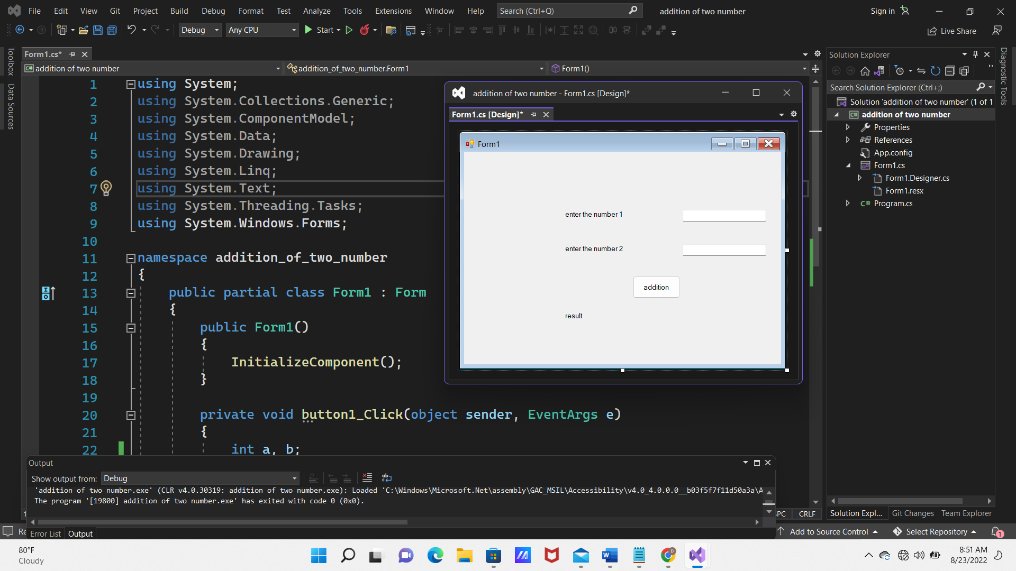using System;

using System.Collections.Generic;

using System.ComponentModel;

using System.Data;

using System.Drawing;

using System.Linq;

using System.Text;

using System.Threading.Tasks;

using System.Windows.Forms;

namespace addition_of_two_number

{

public partial class Form1 : Form

{

public Form1()

{

InitializeComponent();

}

private void button1_Click(object sender, EventArgs e)

{

int a, b;

a=Convert.ToInt32(textBox1.Text);

b=Convert.ToInt32(textBox2.Text);

int sum = a + b;

label3.Text = "Addition =" + sum;

}

}

}