**Assignment 4:**

**Facial Manipulation Detection**

Ben Solomon 204454615

Din Carmon 209325026

Chapter 2: Build Faces Dataset

Question 1:

__getitem__() and __len__() are implemented under faces_dataset.py

Question 2:

The results of plot_samples_of_faces_dataset.py:

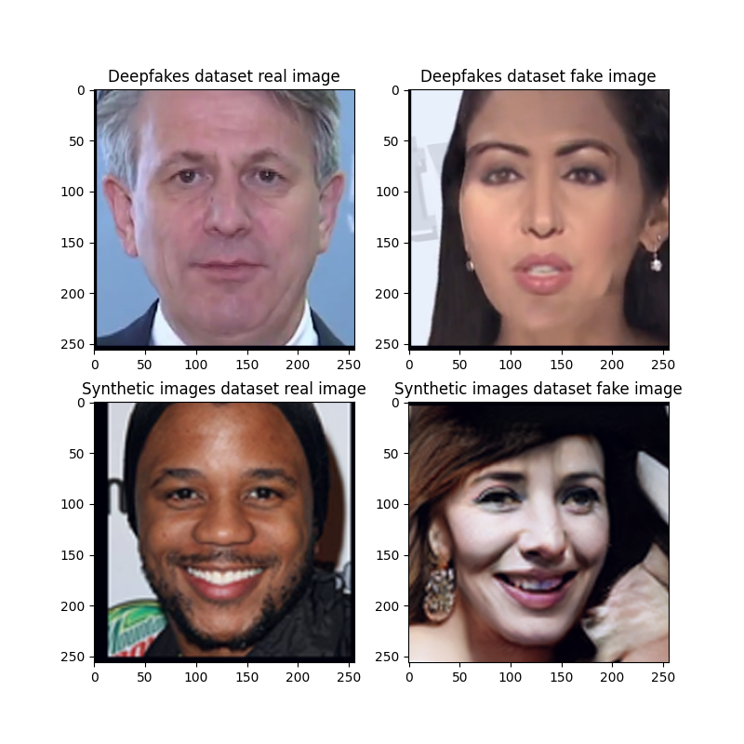

Chapter 3: Write an Abstract Trainer

Question 3:

train_one_epoch() is implemented under trainer.py

Question 4:

evaluate_model_on_dataloader() is implemented under trainer.py

Question 5:

We trained the SimpleNet architecture on the Deepfakes dataset, with lr of 1e-3,

batch size 32, 5 epochs and the Adam optimizer

Question 6:

The JSON contains the training, validation, and test results for a SimpleNet model trained on fakes_dataset using the Adam optimizer. It includes Optimizer settings (e.g learning rate and betas) and Train/Validation/Test Loss and Accuracy over 5 epochs. The results make sense to us because the model learns effectively on the training data (decreasing train loss and increasing train accuracy). However, validation and test losses increase after early epochs suggesting overfitting, meaning the model struggles to generalize.

Question 7:

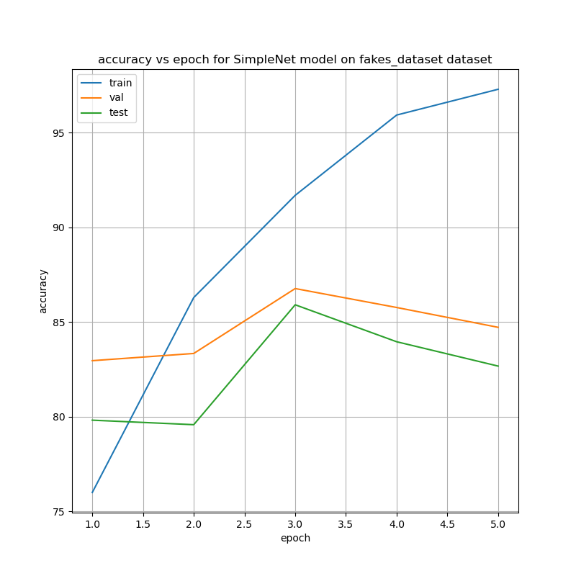The results of plot_accuracy_and_loss.py:

Loss vs epoch:

Train Loss decreases consistently over epochs, suggesting the model is learning from the training data. Validation Loss increasing after the first epoch, indicating potential overfitting. Test Lossfollows a similar trend as validation loss, with no consistent improvement.

Accuracy vs epoch:

Train Accuracy increases steadily, showing the model is improving its ability to correctly classify the training data. Test Accuracy and Validation Accuracy peaks at epoch 3, and fluctuates slightly afterward, suggesting the model might not generalize well unseen data – sign of overfitting.

Question 8:

The highest validation accuracy is 86.76% (at epoch 3).  
The corresponding test accuracy is 85.90%.

There is a good alignment between validation and test accuracy, but both are significantly lower than training accuracy, indicating overfitting.

Question 9:

The proportion of fake images to real images in the test set of "fakes_dataset" is 1/2 (700 fake images and 1400 real images).

Question 10:

ROC curve graph:

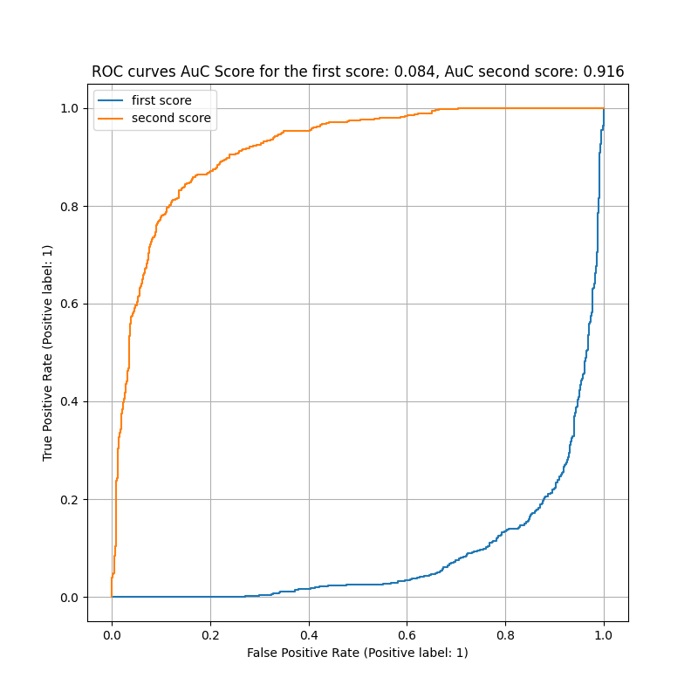

DET curve graph:

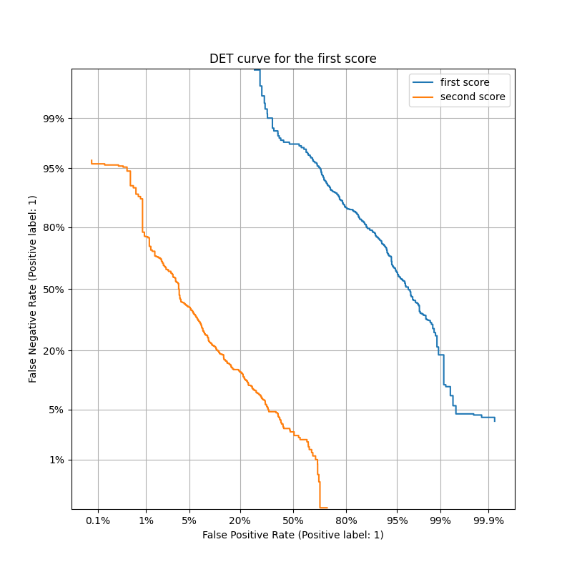

Question 11:

Considering the two soft scores groups:

1. soft scores obtained from the first output of the network corresponding to the

"real" class score.

1. soft scores obtained from the second output of the network corresponding to the "Fake/Synthetic" (not-real) class score.

The difference in results between (A) and (B) arises because the soft scores represent opposite class probabilities. For (A), the scores favor the "real" class, while for (B), they favor the "fake" class. This leads to mirrored curves in the ROC and DET graphs, as the thresholds adjust the tradeoff in opposite directions. in the ROC graph, the ROC curve approach the top-left corner, indicating high true positive rates with low false positive rates, and the second curve is mirrored diagonally. In the DET graph, for A, as the threshold increases, false negatives will rise while false positives decrease, and the curve will trend towards the top-left corner. For B, the opposite happens: as the threshold increases, false positives will rise while false negatives decrease, so the curve will trend toward the bottom-right corner.

Question 12:

We trained the SimpleNet architecture on the Synthetic faces dataset, with lr of 1e-3,

batch size 32, 5 epochs and the Adam optimizer

Question 13:

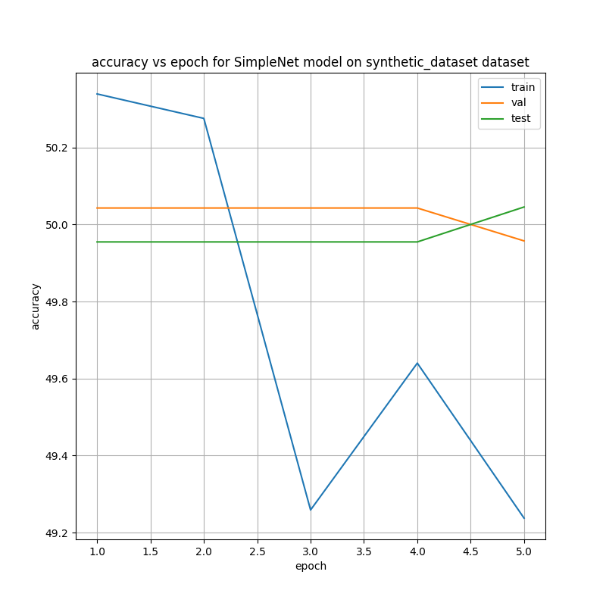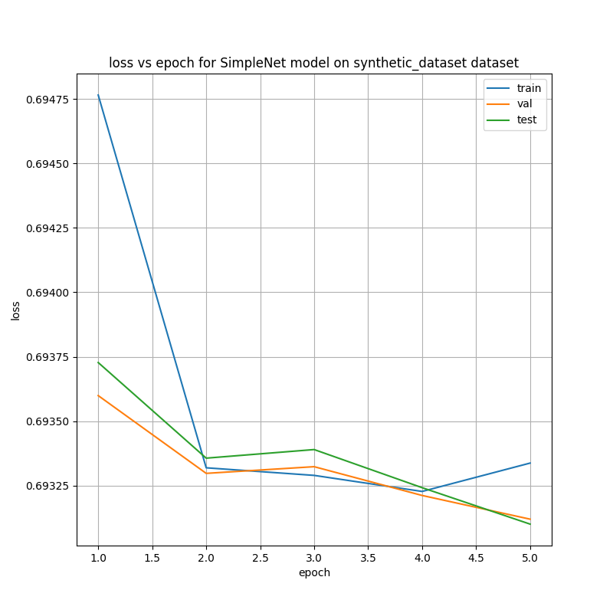The results of plot_accuracy_and_loss.py:

Loss vs epoch:

Train, Validation, and Test losses stay near 0.693, which is typical for a binary classification model making random guesses (cross-entropy loss for 50% probability = $-\ln\left(0.5\right)=0.693$)

Accuracy vs epoch:

Train, Validation, and Test accuracies stay around 50%, indicating the model fails to learn and is effectively guessing.

Question 14:

The highest validation accuracy is 50.04%, which occurs at epochs 1-4.  
The corresponding test accuracy is 49.95%.

Question 15:

The proportion of synthetic images to real images in the test set of " synthetic_dataset" is 552/551 (552 fake images and 551 real images).

Question 16:

The classifier is essentially a random guesser, as it achieves around 50% accuracy across training, validation, and testing. This suggests it fails to learn from the data and performs no better than random chance for the classification task.

Question 17:

The Synthetic Images dataset is significantly more realistic compared to the Deepfake dataset, making it harder to differentiate between real and fake images. In contrast, the Deepfake dataset contains artifacts like sharp color differences and unnatural straight lines or squares on faces, making fake images easier to spot. Thus, the results in this section make sense: as explained in questions 7,8 the model learns effectively on the Deepfake training data compared to questions 13,14 where the model fails to learn the synthetic training data and make random guesses.

Chapter 4: Fine Tuning a Pre-trained Model

Question 18: