# Project Touhou - the best way to kill your PC

In this game you need to dodge bullets. It may seem to you quite simple... until you reach the final boss.

In the screenshot below you can see different bullet types such as lasers or circles. Of course, touching any them will cause your death... in game.

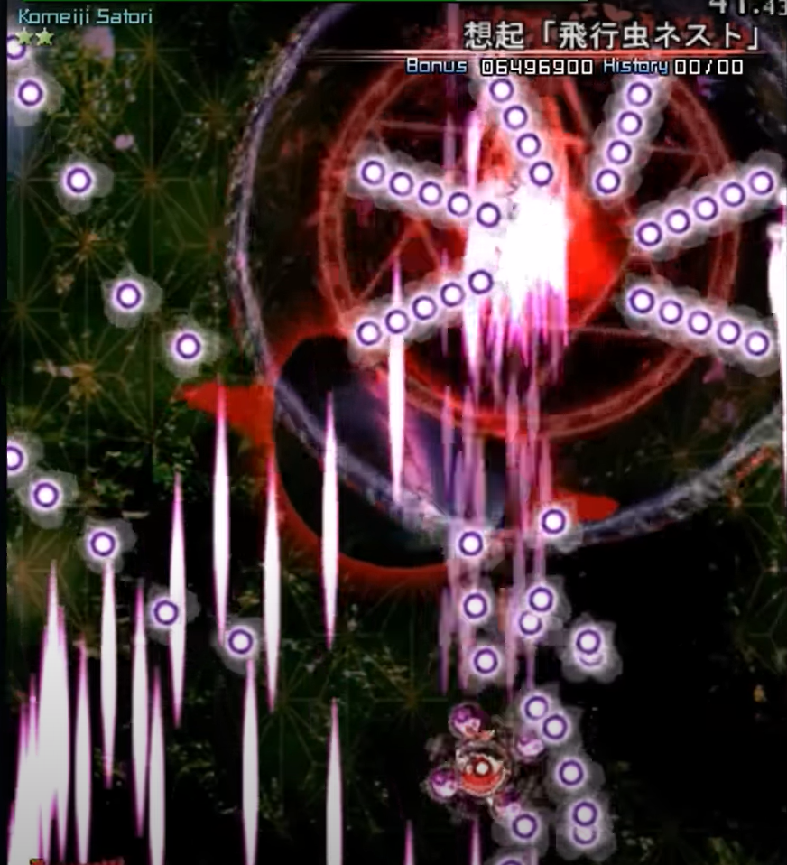

You may be wondering: "- and how is that game supposed to kill my computer??"

The answer is obvious: "- once you get hit by an extra boss you will instantly take your hammer and destroy the monitor of the PC."