**PRE LEC TUT 2**

2.1)

public class Ex1 {  
 public static void main(String[] args) {  
 System.*out*.print("a. ");  
 for (int i=0; i<=100; i+=5){  
 System.*out*.print(i);  
 if (i<100){  
 System.*out*.print(", ");  
 }  
 }  
  
 System.*out*.print("\nb. ");  
 for (int n=1; n<=1024; n=n*2){  
 System.*out*.print(n);  
 if (n<1024){  
 System.*out*.print(", ");  
 }  
 }  
 }  
}



2.2)

import java.util.Scanner;  
  
public class TempConversion {  
 public static void main(String[] args) {  
 Scanner input = new Scanner(System.*in*);  
 System.*out*.print("Enter starting value: ");  
 double start = input.nextDouble();  
  
 System.*out*.print("Enter finishing value: ");  
 double finish = input.nextDouble();  
  
 System.*out*.print("Enter increment value: ");  
 double increase = input.nextDouble();  
  
 System.*out*.println("Celsius Fahrenheit");  
 System.*out*.println("----------------------");  
 for (double i=start;i<=finish;i+=increase){  
 double fahrenheit = (i*9/5)+32;  
 System.*out*.println(start+" "+fahrenheit);  
 }  
 }  
}

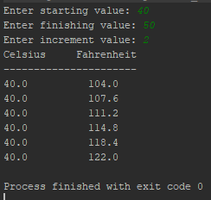

2.3)

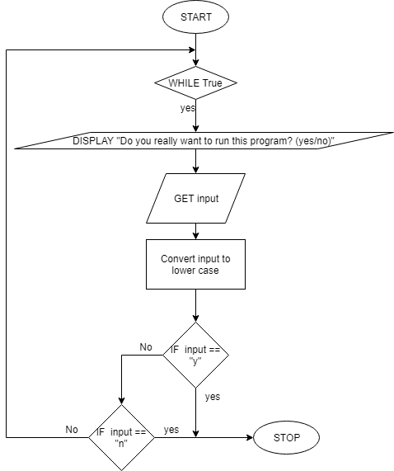

import java.util.Scanner;  
  
public class UserFriendliness {  
 public static void main(String[] args) {  
 while(true){  
 Scanner input = new Scanner(System.*in*);  
 System.*out*.println("Do you really want to run the program? (yes/no)");  
 String run = input.nextLine();  
  
 run = run.toLowerCase();  
  
 if (run.equals("y")){  
 break;  
 } else if(run.equals("n")){  
 break;  
 } else{  
 System.*out*.println("Invalid input, please try again.");  
 }  
 }  
 }  
}

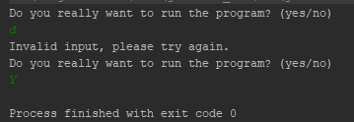

2.4)

import java.util.Scanner;  
  
public class Patterns {  
 public static void main(String[] args) {  
  
 Scanner input = new Scanner(System.*in*);  
 System.*out*.print("a. How many lines? ");  
 int turns = input.nextInt();  
  
 for (int i=0; i<=turns; i++) {  
 for(int n=0; n<=i;n++)  
 System.*out*.print('*');  
  
 System.*out*.println();  
 }  
 }  
}

