By: Din Sopheak Panha
ONEDIN Tech
How to create and load a random map into rviz?

NOTE: Make sure you already have a ROS 2 workspace set up and that all navigation packages are installed on your testing device. Then, navigate to your ROS 2 workspace, open the src folder, and create a new folder named maps.
REMEBER THIS LOCATION IS WHERE ALL OF YOUR MAPS ARE SAVED.

1. Download GNU Image Manipulation Program
2. Draw the map:
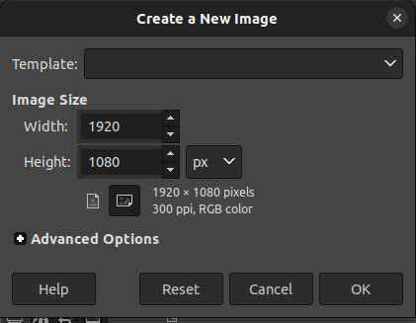
- Select on File → New, then it will solve the following tab

- Calculate the width and height depends on the resolution and real distance that you want. For example, real width distance is 10 meter and height is also 10meter and the resolution that is acceptable for rviz is 0.05 pixel/meter. So, the total pixel for both width and height will be 10 / 0.05 = 200.
- Make sure the panel below is the same:

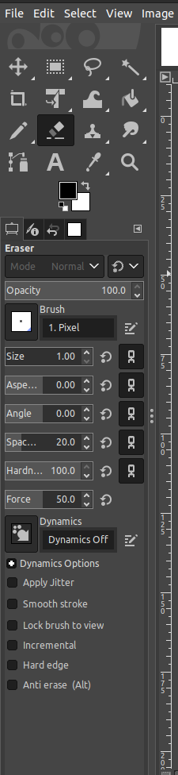

- You can start draw your map
3. Save the map
- Select on file → Export as and it will show the tab below:
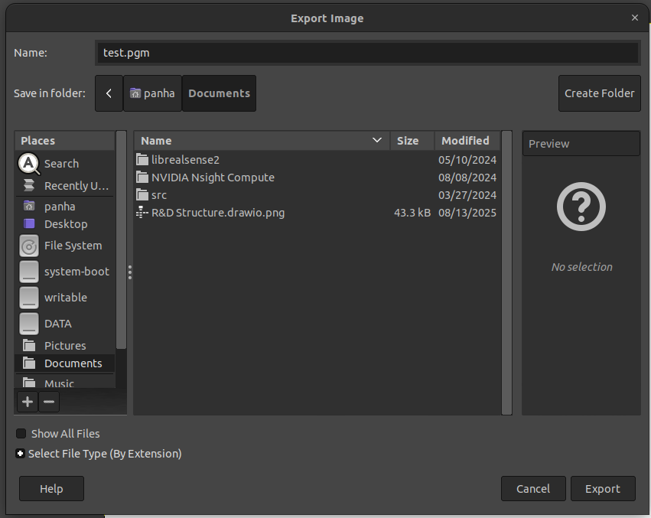

- Make sure save it to the ‘maps’ folder that you have created before.
- Click on ‘Export’
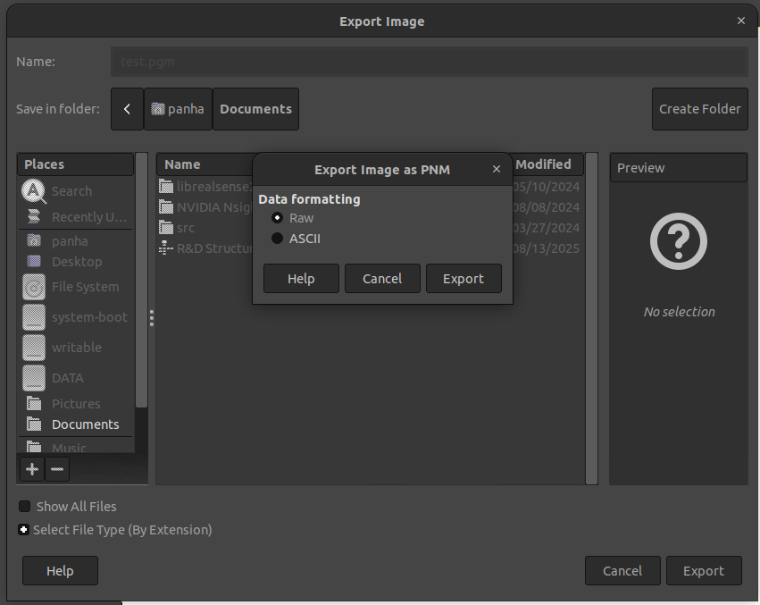

- Choose ‘Raw’ and click ‘Export’ again

4. Go in to the folder ‘maps’ and create a new file call ‘<your_map_name>.yaml’ and inside the folder, please copy the code below and paste :

image: <your_map_name>.pgm
mode: trinary
resolution: 0.05
origin: [0, 0, 0]
negate: 0
occupied_thresh: 0.65
free_thresh: 0.25

Parameters explanation :

Key | Meaning | Example / Effect
image | The filename of your map image (must be .pgm or .png). | image: imu.pgm
mode | How the map interprets pixel colors. • trinary: only black (occupied), white (free), gray (unknown). • scale: uses grayscale intensity. | Normally keep as trinary for GIMP-drawn maps.
resolution | How many meters per pixel in the map. Smaller = more detail. | 0.05 → each pixel = 5 cm
origin | The position [x, y, yaw] (or [x, y, z]) of the bottom-left corner of the map in world coordinates. | [0, 0, 0] means the map starts at the world’s origin (robot at (0,0)).
negate | Whether to invert black/white meaning. • 0 → black = occupied, white = free. • 1 → white = occupied, black = free. | Usually 0 (default).
occupied_thresh | Any pixel darker than this fraction (0–1) is considered occupied (wall). | 0.65 = pixels darker than 65 % gray → wall
free_thresh | Any pixel lighter than this fraction (0–1) is considered free space. | 0.25 = pixels lighter than 25 % gray → free

5. Run the map server

$ ros2 run nav2_map_server map_server --ros-args -p yaml_filename:=<your_path>/<your_map_name>.yaml

6. Load the map

$ ros2 lifecycle set /map_server configure

7. Activate the map

$ ros2 lifecycle set /map_server activate

8. Bring up the navigation
$ ros2 launch nav2_bringup navigation_launch.py use_sim_time:=true

9. Open rviz

$ rviz2

10. Add map

- In rviz, you select on add → Map :
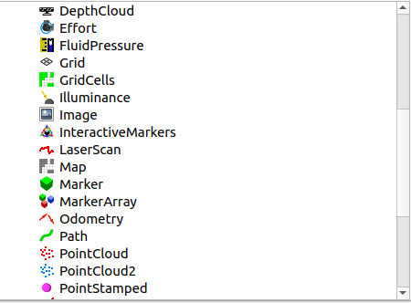

- Select on Topic and choose ‘/map’. Then, press ‘Enter’
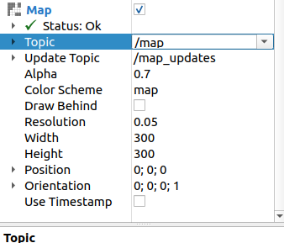

11. Congractulation
