ROS2 Nav2

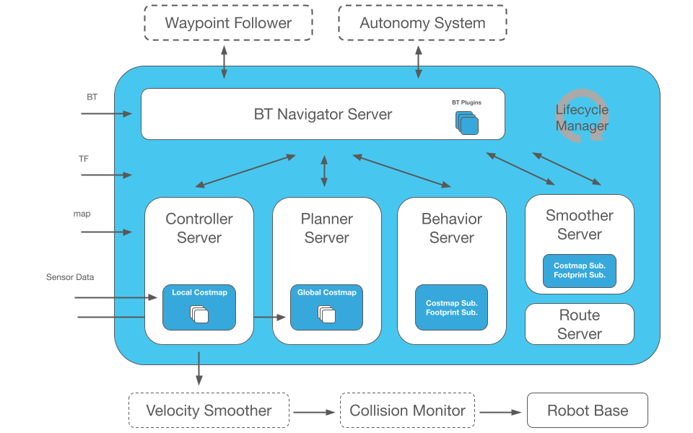
This diagram represents the Navigation2 (Nav2) system in ROS2. Nav2 is the “brain” that handle how a robot:
- Understands the map
- Localizes itself
- Plans a path
- Follows the path
- Avoids obstacles
- Moves safely
- BT Navigator Server (Behavior Tree Navigator)
This is the central controller.
It uses a Behavior Tree (BT) XML file.
It decides:
- When to compute a global path
- When to follow the path
- When to recover (spin, back up, wait)
- When the goal is reached
Example :
Robot receives a goal at (5,3).
BT Navigator will:
- Ask planner → “Give me a path”
- Ask Controller → “Follow this path”
- If something wrong → “Recovery, spin in place”
- Planner Server
This block computes the global path from robot to goal.
Uses:
- A global costmap (big map)
- A planning algorithm (A*, Smac, Theta*, etc)
Example:
You set a goal 10 meters away
Planner makes this path
Robot → hallway → corridor → goal
Path is a smooth list of poses
- Controller server
This block follows the path created by the planner
It converts the path into:
/cmd_vel (linear and angular velocities)
Uses:
- Local costmap (obstacles near robot)
- Controller plugin (DWB, TEB, Pure Pursuit, Vector Pursuit )
Example
Planner gives path
Controller generates:
vx = 0.4 m/s
vy = 0.0
omega = 0.2 rad/s
This moves the robot along the path
- Local costmap
A small map around the robot.
Used for:
- Local obstacle avoidance
- Collision checking
- Short-term navigation
Inputs:
- /scan (LiDAR)
- /pointcloud
- footprint of robot
Example
Obstacle appears 0.7m in front.
Local costmap marks it → Controller makes robot turn or slow down.
- Global costmap
A large map made from :
- Static map from map_server (AMCL)
- Inflation layer
Used only by planner server
Example
Planner uses global costmap to find a path that avoids walls and rooms.
- Behavior Server
This handles small behaviors:
- Spin
- Back-up
- Wait
- Clear costmap
These are called when something blocks the robot
Example
Robot gets stuck → Behavior server calls “BackUp”→ robot reverses.
- Smoother server
This smooths the planned path before following it.
Example
Planner produces a zig-zag path
Smoother makes it
smooth curve → easier to follow
- Route server
handles multi-waypoint navigation
Example
Robot must visit:
A→ B → C → D
Route server keeps the list and passes next goal to BT navigator

