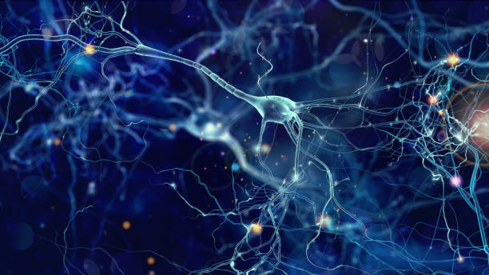

**Tongue, Hands, Idle**

**Online**

**Right, Left, Idle**

**Offline**

