Cairo University  
Faculty of Computers and Information



**CS251**

**Software Engineering I**

## GeniuStack

Software Requirements Specifications

## Dina Abdelhakam Qubese

## Radwa Khaled Attia

## Abdelrahman Mamdouh

## Abdelrahman Nasser

# November-2016

Contents

Team 3

Document Purpose and Audience 3

Introduction 4

Software Purpose 4

Software Scope 4

Definitions, acronyms, and abbreviations 4

Requirements 4

Functional Requirements 4

Non Functional Requirements 5

System Models 6

Use Case Model 6

Use Case Tables 7

Ownership Report 10

Policy Regarding Plagiarism: 15

# Team

|  |  |  |  |
| --- | --- | --- | --- |
| **ID** | **Name** | **Email** | **Mobile** |
| 20140113 | Dina Abdelhakam Qubese | dinaabdelhakam1997@gmail.com | 01117397855 |
| 20140119 | Radwa Khaled Attia | radwakhaled41@gmail.com | 01069071133 |
| 20140164 | Abd El-Rahman Mamdouh Mohamed | abdobelal201015@gmail.com | 01065142541 |
| 20140165 | Abd El-Rahman Nasser Ali | a.nasser07@hotmail.com | 01128265428 |

# Document Purpose:

This document represents the requirements and the analysis of a game-based educational platform.

It has been documented in the form of Requirements Analysis Document (RAD). Such that it can describes the platform in terms of functional and nonfunctional requirements and acts as a contractual basis between the client and the developers.

# Document Audience:

The audience for this RAD includes the TAs, designers, developers, client and the user.

# 

# Introduction

## Software Purpose

The primary purpose of this game-based educational platform is students’ self-learning, as it will teach them some basic educational concepts through playing games related to specific fields like Science, math, IQ…etc.

## Software Scope:

This project is creating game-based educational platform which offers an educational games on the website. The project will be completed by May, 2017. Modules of the game will include a simple calculation games, a way for self-education for students, and a way to motivate them to continue playing and learning.

# Requirements

## Functional Requirements:

|  |  |  |
| --- | --- | --- |
| **The Site should allow the user to be able to:** | Details | Complexity |
| 1. **Login.** | The user should have a unique account to play so the site enables him to sign up and then login. | 1 |
| 1. **Start the game.** | The user can choose the game he wishes to play from the chosen category. As the site has categories in which the games related to each others are gathered together so he can choose his preferred one. Then he can start playing the chosen game by clicking on the “play” button | 5 |
| 1. **Pause game.** | When the user finishes playing he can simply press pause game. | 1 |
| 1. **View his score.** | For each game the user played the site automatically saves his score. | 2 |
| 1. **Rate the game.** | After playing the game the user can rate the game out of five. | 1 |
| 1. **Write comment.** | The user shall write a comment with his opinion about the game which helps in the process of enhancement. | 1 |
| 1. **Create game.** | This is only for the user who sign up as a teacher he can create a specific game. | 5 |
| 1. **Edit game.** | When the user teacher read the user student feedback he can modify the game in order to meet the user student’s requirements. | 3 |
| 1. **Delete game.** | When user teacher recognizes that if a game he was previously created is not preferred by the user he can simply delete it. | 1 |
| 1. **Reply to a comment.** | This enables the teacher to communicate with the student in order to know the user student’s requirements. | 1 |

## Non Functional Requirements

|  |  |
| --- | --- |
|  | **details** |
| 1. **Usability** | Easy to use: The player can deal with this game through given instructions showing the user how the game being played.  Simple games: The games are easy for the sake of users’ enjoyment and understanding. |
| 1. **Reliability** | The probability of crashing or hacking is very weak may not exceed 10% |
| 1. **performance** | The time needed by the site for responding to user requirement doesn’t exceed 3 seconds |
| 1. **Scalability** | The website should be able to support up to ten thousand players. |
| 1. **portability** | The website could run on all platforms. |
| 1. **Supportability** | The website supports multiple choices game.  The user can rate any game and write comments.  The user can create, edit and remove any game without modification to the system. |
| 1. **Security** | The system makes sure that the password inserted by the user if it is valid, then it response authentication. |
| 1. **Availability** | The system is available 24 hours a day, 7 days a week |
| 1. **Interface** | It has a simple interface, which is: sign in page then another one after signing in contains the available categories and a multiple games included in each category which the user has to choose from the game they want. |
| 1. **Implementation** | Implementation will be in java. |

# 

# System Models

## Use Case Model

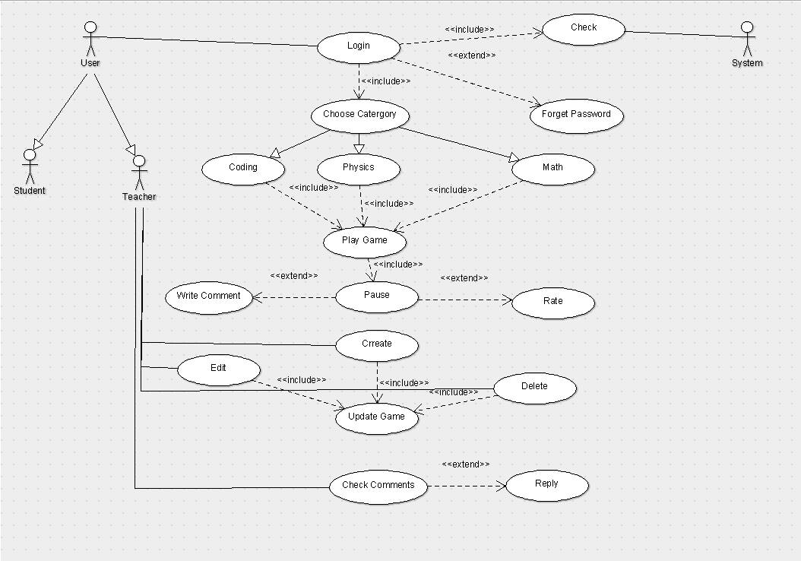

## Use Case Tables:

## Play Game:

|  |  |  |
| --- | --- | --- |
| Use Case ID: | 1 | |
| Use Case Name: | Play game | |
| Actors: | Student & Teacher | |
| Pre-conditions: | Choose special Category | |
| Post-conditions: | Pause the game | |
| Flow of events: | **User Action** | **System Action** |
| 1-User Login |  |
|  | 2-System lists available categories |
| 3-Users choose one of them from the list |  |
|  | 4-System lists the available games that’s includes in this category. |
| 5-Users select the game from this list. |  |
|  | 6-System starts this game |
| 7-User play and pass levels |  |
|  | 8-System saves the level passed |
| 9-User finishes his game |  |
| Exceptions: | **User Action** | **System Action** |
| 1- User open game and didn't play. |  |
|  | 2-System will close the game after 5 min. |
| Includes: | Stop Game | |
| Notes and Issues: |  | |

Pause Game:

|  |  |  |
| --- | --- | --- |
| Use Case ID: | 2 | |
| Use Case Name: | Pause Game | |
| Actors: | Student & Teacher | |
| Pre-conditions: | Play a game | |
| Post-conditions: | Rate or writing comment | |
| Flow of events: | **User Action** | **System Action** |
| 1- User pause the game |  |
|  | 2 -System saves his final score  3- System retrieves if he wants to rate or write comment |
| Exceptions: | **User Action** | **System Action** |
| 1-User didn't stop the game by write condition. |  |
|  | 2-system couldn’t save his last score. |
| extends: | Rate game, write comment | |
| Notes and Issues: |  | |

## Rate Game:

|  |  |  |
| --- | --- | --- |
| Use Case ID: | 3 | |
| Use Case Name: | Rate Game | |
| Actors: | Student & Teacher | |
| Pre-conditions: | Stop Game | |
| Post-conditions: | Exit | |
| Flow of events: | **User Action** | **System Action** |
| 1- User rate the game |  |
|  | 2 -System saves his rating  3- System retrieves the result of total rating |
| Exceptions: | **User Action** | **System Action** |
| 1-User press rate and didn't rate the game. |  |
|  | 2-system will not respond |
| Includes: |  | |
| Notes and Issues: |  | |

## Write Comment:

|  |  |  |
| --- | --- | --- |
| Use Case ID: | 4 | |
| Use Case Name: | Write comment | |
| Actors: | Student & Teacher | |
| Pre-conditions: | Stop | |
| Post-conditions: | Exit | |
| Flow of events: | **User Action** | **System Action** |
| 1- User writing a comment |  |
|  | 2 -System saves his comment |
| Exceptions: | **User Action** | **System Action** |
| 1-User enter blank comment |  |
|  | 2-system won’t accept. |
| Includes: |  | |
| Notes and Issues: |  | |

## Create Game:

|  |  |  |
| --- | --- | --- |
| Use Case ID: | 5 | |
| Use Case Name: | Create Game | |
| Actors: | Teacher | |
| Pre-conditions: | Choose Category | |
| Post-conditions: | Save changes | |
| Flow of events: | **User Action** | **System Action** |
| 1-Press create game. |  |
|  | 2- Website will respond with a page contains all tools needed. |
| 3- Collect the tools needed for creating the game together.  4-save changes. |  |
|  | 5-System accepts and publishes the game. |
| Exceptions: | **User Action** | **System Action** |
| 1- User saves changes without entering any details. |  |
|  | 2-This entry is invalid  3-System reject publishing the game. |
| Includes: | Update in system | |
| Notes and Issues: |  | |

## Edit Game:

|  |  |  |
| --- | --- | --- |
| Use Case ID: | 6 | |
| Use Case Name: | Edit Game | |
| Actors: | Teacher | |
| Pre-conditions: | Select game | |
| Post-conditions: | Save changes | |
| Flow of events: | **User Action** | **System Action** |
| 1- Select a game |  |
|  | 2- System show the game’s details |
| 3- User edits the game |  |
|  | 4- System saves changes and publishes it |
| Exceptions: | **User Action** | **System Action** |
| 1- User saves changes without entering any editing details. |  |
|  | 2-This entry is invalid  3-System reject publishing the game. |
| Includes: | Update in system | |
| Notes and Issues: |  | |

## Remove Game:

|  |  |  |
| --- | --- | --- |
| Use Case ID: | 7 | |
| Use Case Name: | Remove Game | |
| Actors: | Teacher | |
| Pre-conditions: | Select game | |
| Post-conditions: | Save changes | |
| Flow of events: | **User Action** | **System Action** |
| 1- select game |  |
|  | 2- System shows the game |
| 3- User Select delete game |  |
|  | 4- System deletes the game |
| Exceptions: | **User Action** | **System Action** |
| 1- User deletes an original game which belongs to the website. |  |
|  | 2- you can’t delete this game  3- System rejects applying delete action. |
| Includes: | Update in system | |
| Notes and Issues: |  | |

## Check Comments:

|  |  |  |
| --- | --- | --- |
| Use Case ID: | 8 | |
| Use Case Name: | Check Comments | |
| Actors: | Teacher | |
| Pre-conditions: | View the comments area | |
| Post-conditions: | Finish reading comments | |
| Flow of events: | **User Action** | **System Action** |
| 1- open comments area |  |
|  | 2- system views comments |
| 3-User read comments |  |
| Exceptions: | **User Action** | **System Action** |
|  |  |
|  |  |
| Extends: | Reply on a specific comment | |
| Notes and Issues: |  | |

## Reply:

|  |  |  |
| --- | --- | --- |
| Use Case ID: | 9 | |
| Use Case Name: | Reply on a specific comment | |
| Actors: | Teacher | |
| Pre-conditions: | Viewing comments’ area | |
| Post-conditions: | reply | |
| Flow of events: | **User Action** | **System Action** |
| 1- select reply |  |
|  | 2- System views a blank area to write the comment |
| 3- User writes his reply  4-select publish |  |
|  | 4- System accepts and writes it. |
| Exceptions: | **User Action** | **System Action** |
| 1- User Enter a blank reply |  |
|  | 2- this entry is invalid  3- System rejects saving the reply. |
| Includes: |  | |
| Notes and Issues: |  | |

# Ownership Report:

|  |  |
| --- | --- |
| **Item** | **Owners** |
| Document’s purpose and audience  Software’s purpose and scope | Dina Abdelhakam |
| Non-functional requirements | Radwa Khaled |
| UML-diagram | Abdelrahman Mamdouh |
| Functional requirements | Abdelrahman Nasser |
| Use case tables | Shared among us |

# 

# Policy Regarding Plagiarism:

1. تشجع الكلية على مناقشة الأفكار و تبادل المعلومات و مناقشات الطلاب حيث يعتبر هذا جوهريا لعملية تعليمية سليمة
2. ساعد زملاءك على قدر ما تستطيع و حل لهم مشاكلهم فى الكود و لكن تبادل الحلول غير مقبول و يعتبر غشا.
3. أى حل يتشابه مع أى حل آخر بدرجة تقطع بأنهما منقولان من نفس المصدر سيعتبر أن صاحبيهما قد قاما بالغش.
4. قد توجد على النت برامج مشابهة لما نكتبه هنا أى نسخ من على النت يعتبر غشا يحاسب عليه صاحبه.
5. إذا لم تكن متأكدا أن فعلا ما يعد غشا فلتسأل المعيد أو أستاذ المادة.
6. فى حالة ثبوت الغش سيأخذ الطالب سالب درجة المسألة ، و فى حالة تكرار الغش سيرسب الطالب فى المقرر.