KARIOS CubeSat — Model-Based Systems Engineering (MBSE) Process
An MBSE approach for the KAIST Intelligence & Reconnaissance Orbital Satellite (KARIOS), instantiated from the INCOSE Space Systems Working Group (SSWG) CubeSat Reference Model (CRM) and adapted from the RANDEV CubeSat programme.

1. Purpose and Rationale
Small satellites such as KARIOS are challenging to design: they have tightly constrained resources, strongly coupled subsystems, and must operate in a dynamic space environment. Model-Based Systems Engineering (MBSE) addresses this by building a single, authoritative system model that integrates requirements, architecture, behaviour, and analysis in one coherent source of truth.
Per the INCOSE MBSE Initiative (Systems Engineering Vision 2020), the KARIOS system model is initiated at the start of the project and evolves throughout development and into operations, providing a consistent basis for requirements, design, analysis, verification, and validation. The approach follows the INCOSE SSWG CubeSat Reference Model — the same lineage as the FireSat and Radio Aurora Explorer (RAX) reference models (Kaslow et al.) — and is tailored to KARIOS from the RANDEV CubeSat MBSE description.

2. CubeSat Domain and Enterprise (Context)
Following the CRM, the KARIOS model is framed within the CubeSat Domain, which comprises the Mission Enterprise, its Stakeholders, the External Environment, and External Constraints.
Domain element | KARIOS instantiation
Mission Enterprise | Development, deployment, and operation of the KARIOS SIGINT + cybersecurity CubeSat mission by KAIST ASCL.
Stakeholders & Concerns | KAIST ASCL; IITP (funding, AI-satellite-vulnerability project); spectrum & regulatory agencies; launch/deployer provider; Cal Poly CubeSat Design Specification; INCOSE / OMG (SysML).
External Environment | Space environment (radiation, thermal, vacuum, debris) and Earth environment (ground stations, atmosphere).
External Constraints | Licenses & regulations — radio-frequency spectrum authorisation and orbital-debris / disposal guidelines.
Segments are modelled at a common level: the Space Segment (KARIOS spacecraft), the Ground Segment (UHF and LoRaWAN ground-station services), and Transport / Launch / Deploy services procured from an external provider.

3. Stakeholders, Concerns, Viewpoints and Views
Per ISO/IEC/IEEE 42010, the model organises stakeholder concerns into viewpoints, and renders views that frame specific concerns. For KARIOS this means:
- Analyse mission requirements to identify enterprise-level use cases.
- Define the relationship between requirements and those use cases.
- Develop and capture use-case descriptions and scenarios in the model.
- Establish architecture viewpoints and render architecture views (structure, behaviour) that address regulatory, operational, and design concerns.
Regulatory viewpoints (spectrum authorisation, orbital-debris compliance) are captured explicitly, since licenses, timelines, and procedures must be well understood and traceable within the model.

4. The KARIOS SysML System Model — Four Pillars
The system model is authored in SysML (MagicDraw / Cameo Systems Modeler) and structured around the four SysML pillars. Each pillar is instantiated with KARIOS content:
Requirements. Mission requirements are decomposed to system and subsystem requirements. Satisfy relationships link requirements to the value properties they constrain, and Verify relationships link them to the verification actions that close them — forming the Requirements Verification Matrix (RVM).
Structure. Block Definition and Internal Block Diagrams (BDD / IBD) capture the architecture: Space, Ground, and Launch segments; the bus subsystems — OBC, EPS, ADCS, Communications (UHF + LoRaWAN), Structure, and Thermal Control; and the payloads — the SIGINT primary payload and the cybersecurity secondary payload — together with their interfaces.
Behaviour. Use cases, activity diagrams, and state machines model operations. A top-level 'Collect & Distribute Mission Data' activity decomposes into mission tasking, data collection, and downlink. A CubeSat state machine captures Orbit, Solar (sunlight / eclipse), Payload (collecting / idle), and Download (transmitting / not) states, which may overlap operationally.
Parametrics. Parametric diagrams express the engineering budgets as constraint blocks — power (generation vs. load and battery state), data (buffer fill vs. downlink volume), the communications link budget, and coverage / contact time — evaluated at each simulation time step.

5. Integrated Analyses — an Executable Model
The distinctive strength of the CRM/RAX approach is that the SysML model is executable: discipline analyses are linked to it and time-stepped so that behaviour and parametrics run as a simulation. KARIOS adopts the same integration pattern:
Tool | Role in the KARIOS model
STK | Spacecraft orbit, coverage, ground-station contacts, and eclipse timing (the pre-launch orbital dynamics & coverage analysis).
MATLAB | Analytical models — power generation/consumption, thermal, and link budgets.
ModelCenter + MBSE Analyzer | Bridge that imports integrated analyses into SysML as constraint blocks and executes parametric diagrams.
Cameo Simulation Toolkit | Time-steps the behavioural models (activities & state machine), calling the engineering analyses at each iteration.
Results flow back into the parametric diagrams, whose outputs satisfy — or violate — the requirements they are linked to. This closes the loop between design and analysis inside a single model, and lets operational trade studies (e.g. energy and data-collection capacity) be run directly on the model.

6. Verification and Validation within the Model
The CRM is described as 'a model of a model': a reference model that a mission team instantiates. For KARIOS the instantiated model supports both:
- Validation — objective evidence that the right system is being built, i.e. that it satisfies stakeholder needs.
- Verification — objective evidence that the system is built right, i.e. that each element performs its intended function and meets its allocated requirements. Verification methods are Inspection, Analysis, Demonstration, and Test.
Behavioural and parametric simulation results provide analysis evidence directly from the model; the results are recorded against the RVM and feed the KARIOS Verification Control Document and the broader Verification Process. Regulatory compliance (spectrum, debris) is verified through dedicated viewpoints into the model.

7. Schematic Block Diagram of the MBSE Process
The diagram below summarises the KARIOS MBSE process: the CubeSat Domain context frames an iterative SysML method (steps 1–6) that builds the four-pillar system model; integrated analyses (STK, MATLAB) are linked to the model as an executable co-simulation; and the results drive verification & validation, feeding the Verification Process. Feedback from V&V refines the model iteratively.
Figure 1 — KARIOS MBSE process (rendered from KARIOS_mbse_block_diagram.tex).
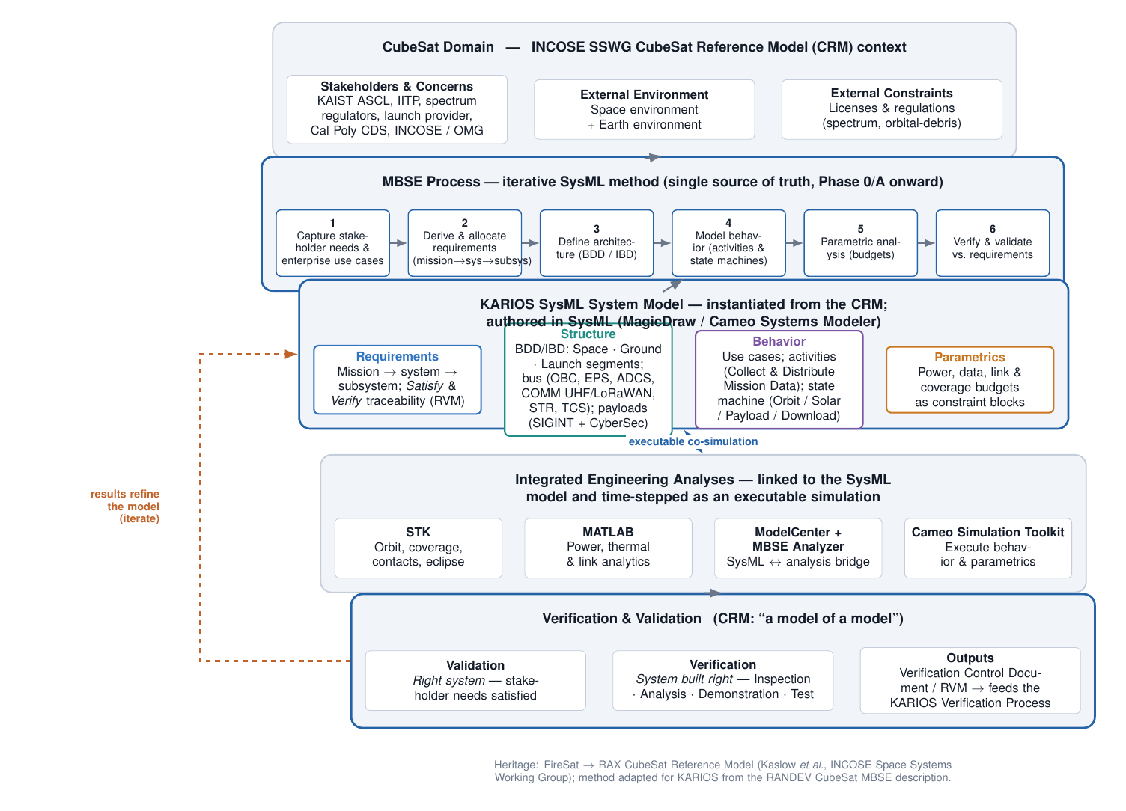

8. References
- D. Kaslow et al., "Integrated Model-Based Systems Engineering (MBSE) Applied to the Simulation of a CubeSat Mission" (RAX), IEEE Aerospace Conference.
- D. Kaslow et al., "Developing a CubeSat Model-Based System Engineering (MBSE) Reference Model — Interim Status," INCOSE / IEEE.
- INCOSE Space Systems Working Group (SSWG) CubeSat Reference Model (CRM); OMG SysML specification.
- INCOSE Systems Engineering Vision 2020 — MBSE Initiative.
- ISO/IEC/IEEE 42010 — Architecture description (stakeholders, concerns, viewpoints, views).
- Cal Poly CubeSat Design Specification (CDS).
- KARIOS mission draft (KAIST Intelligence & Reconnaissance Orbital Satellite); RANDEV CubeSat MBSE description.

