KARIOS CubeSat — SysML System Model
A SysML v2 model of the KAIST Intelligence & Reconnaissance Orbital Satellite (KARIOS), instantiated from the INCOSE SSWG CubeSat Reference Model. The authoritative model is the textual file KARIOS_system_model.sysml; this document describes it and renders its diagram views.

1. Model Organisation
The model is authored in SysML v2 textual notation and organised into packages that map onto the four SysML pillars plus the mission context:
Package | Content | SysML view
MissionContext | External entities: space/Earth environment, launch provider, regulators, SIGINT target, ground stations, operator, cyber researcher. | Domain / uc
Interfaces | Item, port and interface definitions (power, data, RF, command). | ibd
Structure | Part definitions & compositions: mission, spacecraft, bus, subsystems, payloads, with internal connections. | bdd / ibd
Behavior | Use cases, the Collect & Distribute Mission Data activity, and the operational state machine. | uc / act / stm
Analysis | Orbit attributes and the power/data/link/coverage constraint blocks. | par
Requirements | Mission & system requirements with satisfy/verify relationships. | req
The textual model is the single source of truth: it is version-controllable, diff-able, and importable into SysML v2 tooling (e.g. the pilot implementation / SysIDE). The diagrams in Section 3 are views generated from — and kept consistent with — this model.

2. Key Model Elements
Structure — the KARIOS_Spacecraft is a 6U CubeSat with a Bus and two payloads. The Bus internal block diagram wires EPS power to OBC/ADCS/Comms and routes the OBC data bus to Comms and command lines to ADCS.
Behaviour — the top-level activity CollectAndDistributeMissionData decomposes into generate-tasking, collect, store-on-board, and downlink actions; the state machine captures the concurrent orbit/solar/payload/download states used by the parametric simulation.
Analysis — four constraint blocks encode the mission budgets. Their parameters are bound to structural value properties and to STK/MATLAB analysis results, making the model executable: requirements are verified by evaluating the constraints over a simulated orbit.
Requirements — five system requirements each 'require' a constraint (power balance, data downlink, link margin, revisit) and are satisfied by specific parts, giving end-to-end traceability from mission need to design element to verification method.

3. Diagram Views

3.1 Block Definition Diagram (bdd) — Structure
The system decomposition. KARIOS_Mission composes the Space, Ground, and Launch segments; the KARIOS_Spacecraft composes the Bus and the two payloads (SIGINT primary, cybersecurity secondary); the Bus composes the six subsystems (OBC, EPS, ADCS, Comms with UHF + LoRaWAN, Structure, Thermal). Black diamonds denote composition.
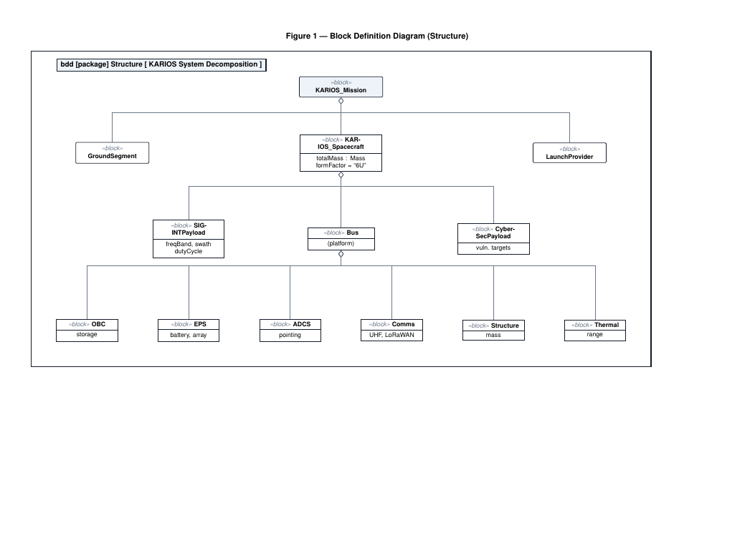

3.2 Requirements Diagram (req) — traceability
Mission requirements (MR) are refined into system requirements (SR-1..SR-5), each backed by a parametric constraint. Dashed open-arrow «satisfy» relationships link the requirements to the parts that satisfy them (EPS, Comms, the payloads), forming the basis of the Requirements Verification Matrix (RVM).
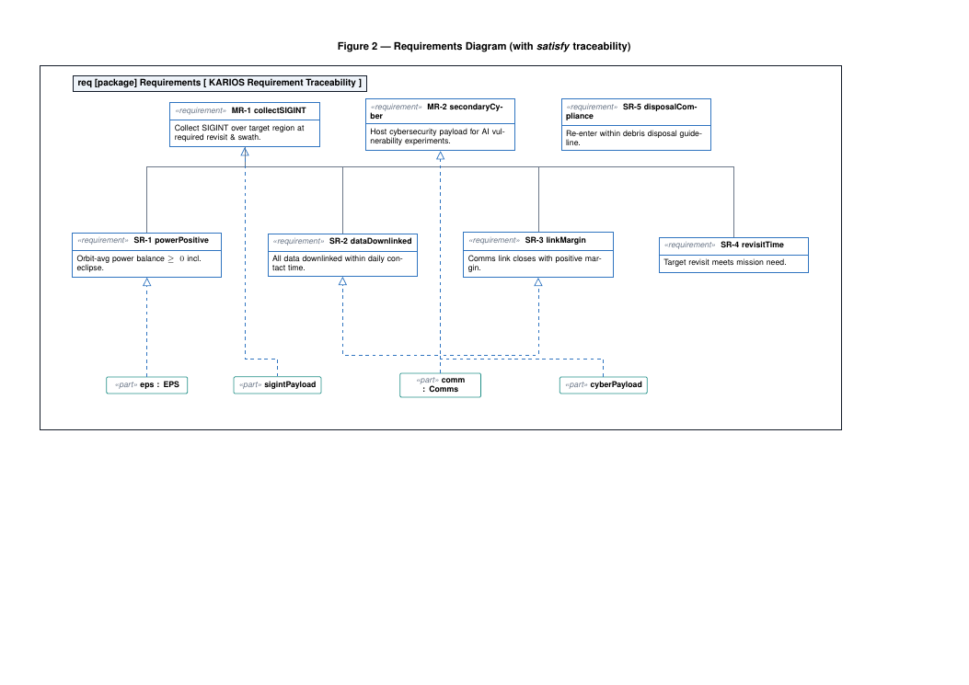

3.3 Use Case Diagram (uc) — behaviour context
The KARIOS system boundary with its four mission use cases (Collect SIGINT, Distribute Mission Data, Operate Spacecraft, Run Cyber Experiment) and the external actors (SIGINT Target, Ground Station, Mission Operator, Cyber Researcher).
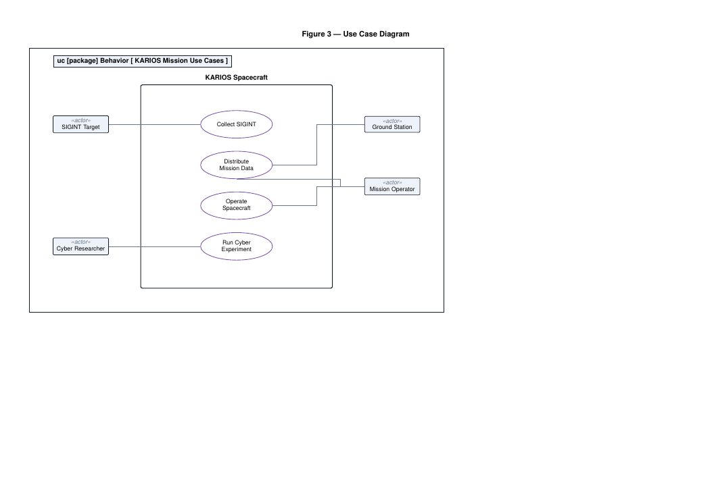

3.4 State Machine (stm) — operational states
Four concurrent state regions that may overlap operationally: orbitState (Launched/Operational), solarState (Sunlight/Eclipse), payloadState (Idle/Collecting), and downloadState (Transmitting only within a ground-station access window).
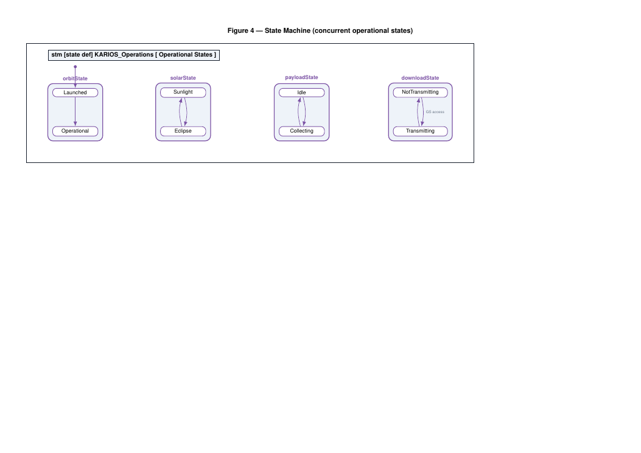

3.5 Parametric Diagram (par) — engineering budgets
The mission budgets expressed as «constraint» blocks — power, data, link, and coverage — with their parameters bound to value properties. STK- and MATLAB-computed values (contact time, eclipse fraction, revisit time) are bound in through ModelCenter as an executable co-simulation.
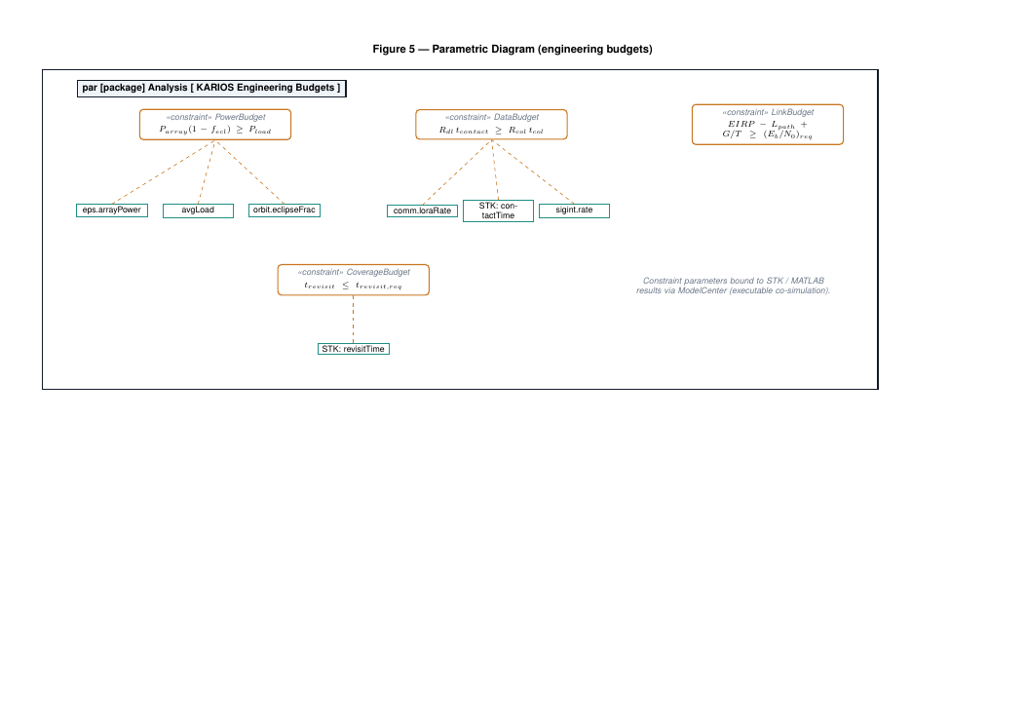

3.6 Internal Block Diagram (ibd) — internal connections
The internal wiring of the KARIOS_Spacecraft: EPS distributes power to the OBC, ADCS, Comms, and both payloads; the OBC data bus connects to Comms and receives payload data; the OBC issues commands to ADCS; and Comms drives the external UHF and LoRaWAN ports. Ports are shown as small squares and connectors as orthogonal item flows.
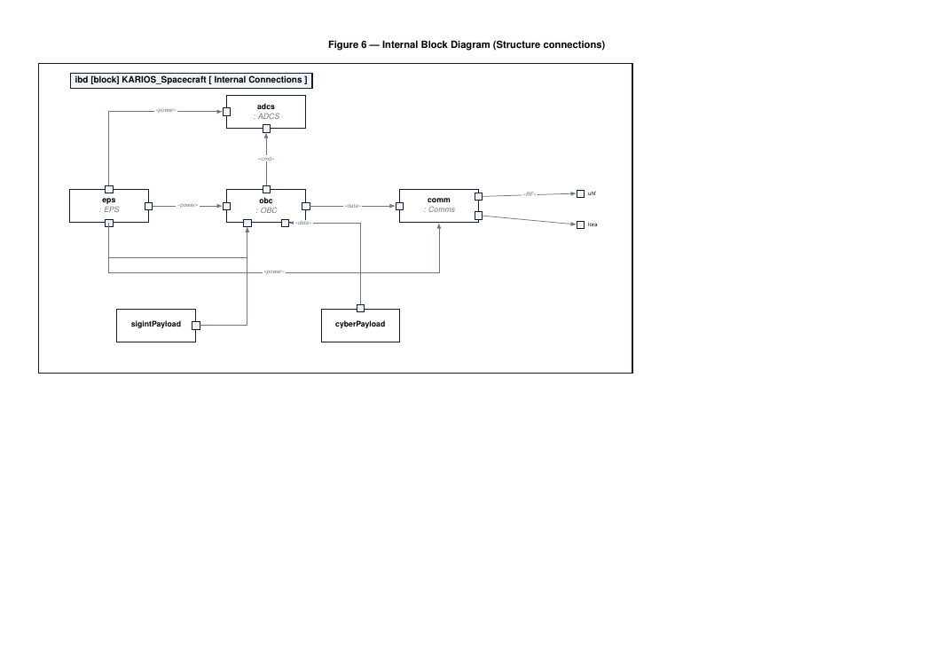

3.7 Activity Diagram (act) — Collect & Distribute Mission Data
The top-level mission activity across four partitions (Payload, OBC, Comms, Ground Station): generate tasking, collect data, store on-board, and — when a ground station is in view — downlink the data frame for receipt and distribution. Object flows carry the Raw Data and Data Frame items; the decision node guards downlink on station access.
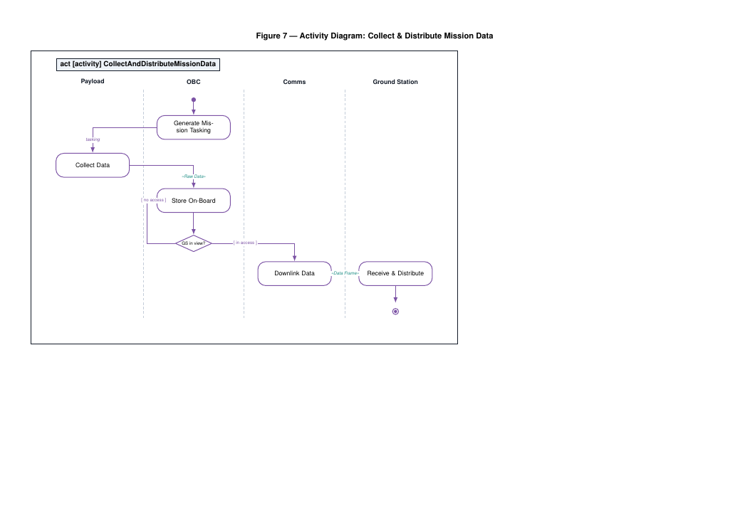

4. References
- KARIOS_system_model.sysml — the authoritative SysML v2 model (this document describes it).
- KARIOS_sysml_diagrams.tex / .pdf — rendered diagram views.
- INCOSE SSWG CubeSat Reference Model (CRM); OMG SysML v2 specification.
- D. Kaslow et al., MBSE applied to the RAX CubeSat mission (IEEE Aerospace).
- KARIOS mission draft (KAIST Intelligence & Reconnaissance Orbital Satellite).

