KARIOS CubeSat — Mission Verification Process Proposal
A structured, model-based verification programme demonstrating that the KARIOS CubeSat meets every mission requirement — from conceptual design through in-orbit commissioning (ECSS-E-ST-10, MBSE / SysML).
Model strategy: EM → EQM → PFM | Review gates: full ECSS set (MDR, PRR, PDR, CDR, QR, AR, FRR, CRR, ELR)

1. Purpose and Scope
This proposal defines the verification process for the KARIOS CubeSat mission, spanning initial conceptual design to in-orbit commissioning. Its purpose is to demonstrate that the delivered KARIOS spacecraft achieves all mission objectives — validating the design and verifying that the integrated system satisfies its requirements before launch.
The process is built on the ECSS space-engineering life-cycle (ECSS-E-ST-10), environmental testing standards, and CubeSat design specifications for structural and dimensional compliance. It is tailored for a small-satellite programme with constrained budget and schedule, and is executed within a Model-Based Systems Engineering (MBSE) framework using SysML, per the INCOSE Space Systems Working Group approach.

2. Verification Methods
Every requirement is closed by one or more of four verification methods. Each method is allocated in the Verification Control Document (VCD) and traced back to a mission or system requirement.
Method | Description | Primary use in KARIOS
Test (T) | Physical measurement on representative or flight hardware. | Structure, thermal, EMC/EMI, functional performance, deployment.
Analysis (A) | Analytical / computational prediction where test is impractical. | Orbital mechanics & coverage (STK), structural stress, thermal model, link & power budgets.
Review of Design (RoD) | Inspection of design documentation and heritage evidence. | Interface control, heritage / COTS component reuse justification.
Inspection (I) | Direct visual and dimensional examination. | Dimensional & mass-envelope compliance to the CubeSat Design Specification.
Orbital dynamics and coverage are closed primarily by Analysis (A): the pre-launch STK simulation of KARIOS orbital dynamics, sun-synchronicity, lighting, ground-station contacts, coverage, and lifetime forms the analytical evidence for this method.

3. Model Philosophy
KARIOS follows a three-model strategy adapted from the ECSS Proto-Flight Model (PFM) approach — chosen because it delivers full qualification confidence within the cost and schedule limits of a CubeSat programme by qualifying and flying representative hardware.
Model | Role | Test level
Engineering Model (EM) | Electrically & mechanically representative unit for early functional and interface verification. Flight-representative PCBs/panels; components need not be flight-grade. | Functional / development
Engineering Qualification Model (EQM) | Combined functional and qualification-level environmental testing (vibration, shock, thermal-vacuum at qualification margins) validating the design envelope. | Qualification
Proto-Flight Model (PFM) | The flight article, acceptance-tested at proto-flight levels (qualification amplitude, acceptance duration). Delivered for integration, launch campaign, and flight. | Proto-flight / acceptance

4. Life-Cycle Phases and Review Gates
The verification programme is executed against the ECSS-E-ST-10 life-cycle. Each phase closes at a formal review gate that dispositions the accumulated verification evidence.
Phase | Definition | Review gate(s)
0 / A | Mission analysis, needs identification & feasibility | MDR, PRR
B | Preliminary definition — verification planning baselined | PDR
C | Detailed definition — methods allocated & executed | CDR
D | Qualification & production — model + environmental campaign | QR, AR
E | Operations — launch, LEOP, in-orbit demonstration & commissioning | FRR, CRR
F | Disposal — end-of-life & re-entry | ELR

5. Verification Process — Schematic Block Diagram
The flow reads top-to-bottom against the ECSS phases and their gate reviews. Requirements drive verification planning; planning allocates the four methods; methods are executed across the model campaign and environmental test campaign; results are dispositioned in the VCD and closed at each review gate. Non-conformances (NCR / RID) feed back to design for re-verification.
Mission & System Requirements [Phase 0 / A / B]
Captured in the SysML MBSE model → Requirements Verification Matrix (RVM).
▼
Verification Planning [Phase B → PDR]
Verification Plan authored; each requirement allocated a method, level, and model. Baseline of the Verification Control Document (VCD).
▼
Verification Methods — allocation & execution [Phase C / D]
Four methods allocated per requirement and executed:
Test (T) Analysis (A) Review (RoD) Inspection (I)
▼
Model Campaign [Phase C / D]
Verification distributed across the three-model strategy:
EM → EQM → PFM
▼
Environmental Test Campaign [Phase D → QR / AR]
Functional/DITL · Sine & random vibration · Mechanical shock · Thermal-vacuum & balance · EMC/EMI · Mass properties · Deployment test · Bake-out/outgassing.
▼
Verification Close-out [QR · AR]
Results dispositioned in the VCD; Verification Control Board closes each requirement with objective evidence. Every RVM item marked verified.
▼
Flight Readiness → Launch → LEOP [Phase D → E · FRR]
Pre-ship review, launch campaign, separation, and Launch & Early-Orbit Phase acquisition.
▼
In-Orbit Demonstration & Commissioning [Phase E · CRR]
On-orbit performance confirmed against requirements (IOD); mission validation and hand-over to routine operations.
↺ Feedback: any non-conformance (NCR / RID) at test or review routes back to Design & the MBSE model for corrective action and re-verification.

Figure 1 — Schematic block diagram of the KARIOS verification process (rendered from KARIOS_verification_block_diagram.tex).
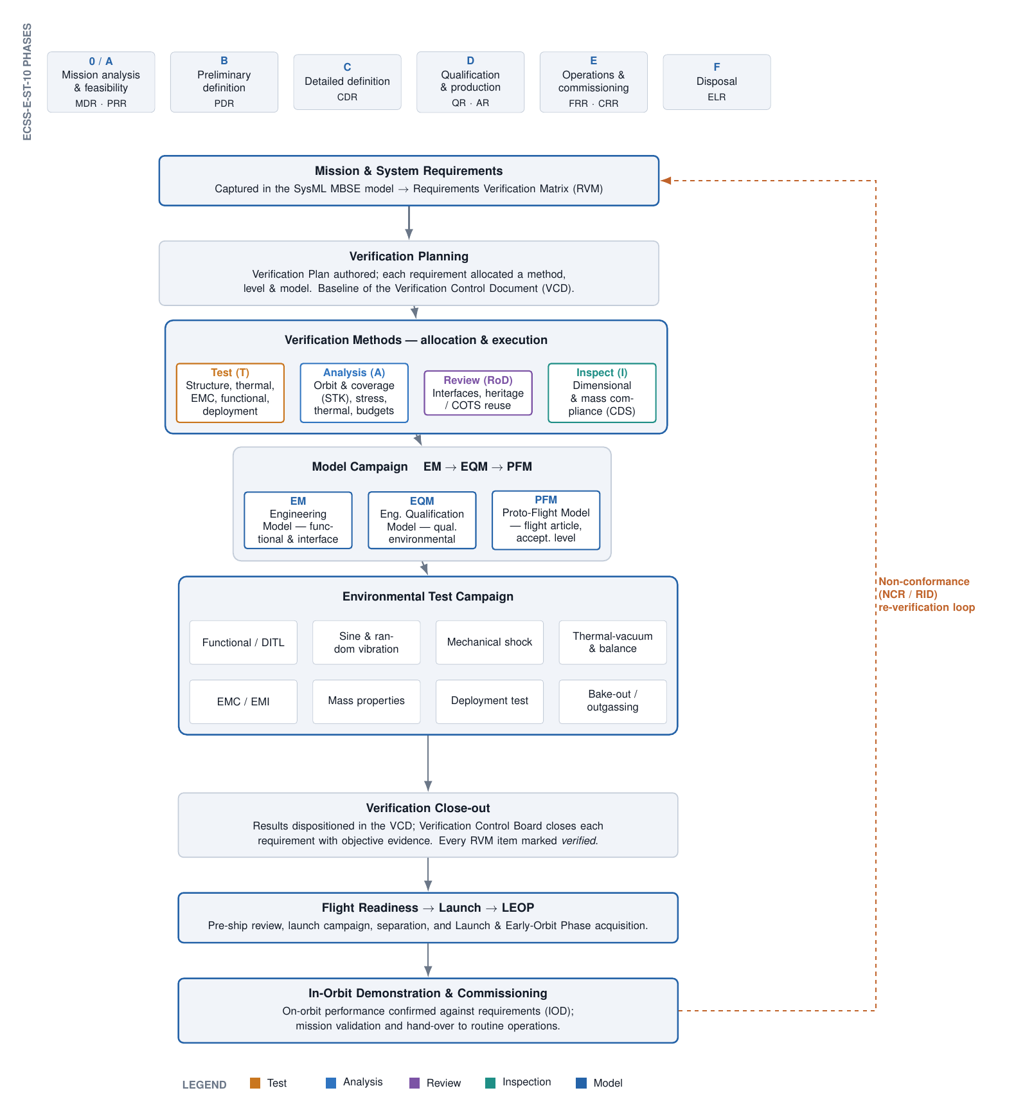

6. Environmental Test Campaign
The environmental campaign qualifies the design (EQM) and acceptance-tests the flight article (PFM) to launch-provider and CubeSat-deployer requirements:
- Functional / Day-in-the-Life (DITL) — end-to-end system performance and mode transitions.
- Sine & random vibration — to qualification levels (EQM) and proto-flight/acceptance (PFM).
- Mechanical shock — separation and deployment shock environments.
- Thermal-vacuum & thermal balance — hot/cold cycling and thermal-model correlation.
- EMC / EMI — self-compatibility and emissions.
- Mass properties — mass, CoG, and moments of inertia versus allocation.
- Deployment test — antennas, solar panels, and separation mechanisms.
- Bake-out / outgassing — contamination control before delivery.

7. Governing Standards and Close-out
- ECSS-E-ST-10 — system engineering life-cycle and verification framework (phases 0–F, gate reviews).
- ECSS-E-ST-10-02 / -03 — verification process and testing requirements.
- CubeSat Design Specification (CDS) — dimensional, mass, and mechanical-envelope compliance (Inspection).
- Launch-provider & deployer ICD — vibration/shock qualification levels and interface constraints.
- ISO 19683 — small-spacecraft design-qualification and acceptance test methods.
The programme is complete when every requirement in the RVM is closed with objective evidence in the VCD, all non-conformances are dispositioned, and in-orbit commissioning confirms mission performance — formally validating the KARIOS design and verifying the system against its requirements.

