**Project Details**

|  |  |
| --- | --- |
| Project number | *13* |
| Project title | *Mega store corporation* |
| Corresponding TA\LA | *Dina abbas* |
| Deliverable | *3* |

**Team Details**

|  |  |  |
| --- | --- | --- |
| **Student ID** | **Student name** | **Lab Group** |
| 20200186 | Reem Ayman Abdel-fattah | S7 |
| 20200228 | Salma Sherif Mostafa | S7 |
| 20201056 | Hasnaa Gamil Abdel-nabai | S7 |
| 20201064 | Rahma El-sayed Abo El-gheet | S7 |
| 20200140 | Habiba Ayman El-tahre | S1 |
| 20200173 | Dina Othman Emam | S1 |
| 20200734 | Sara Mahmoud Mohamed | S8 |

**DESIGN THE ENVIRONMENT**

1. **Using the project description then answer the following questions:**
2. With what external systems and databases will the system under development interact?

* External systems:

1. ‏Paymob to integrate with Bank (Paymob interacts with The bank system for the payment with credit card method to verify the credit card information and deduct the money from customer’s credit card).
2. Suppliers (we deal with various suppliers to provide the variations of products).
3. Fawry System (different payment technique, it makes the payment method easier).

* Databases:
* ProductDA ( PID , Type, Date, Quantity, Name, Weight, Category, Price, WalletID, StoreName)
* AccountDa ( accountID, userName, password, customerID)
* OrderDA (OrderID, CustomerName, Date, Quantity, accountNo, PID, WalletID, customerID)
* Store DA (Name, Address)
* Report ( ReportID, NumSoldProduct, MostWantedProducts, StoreName )

1. What devices will be used for automated inputs and outputs?

Input devices:

touch screen 🡪 mobile or tablet

mouse and keyboard 🡪 laptop

scanner

Bar code

Output devices :

printer

screen

1. What user-interface technology will be used?
2. **Where users will be located?**

Users’ physical location can be specified by using google maps and for virtual location maybe in data.

For onsite, in the main branch. For offsite, through system.

1. **What hardware devices will users use?**

For accessing system, they need for example mobile phone or laptop. If they need to take hard copy for product, printer is suggested.

**THE USER & SYSTEM INTERFACES**

**2.Using the system sequence diagrams developed during the analysis phase of your project:**

1. Identify the various screens and forms that may be needed for the user interface.

1-provide a product

List of user interfaces (screens/forms):

1. Input Screen for entering the product that the manager searches for.
2. Output Screen for viewing the matching products.
3. Input Screen to select products the manager wants to deal about.
4. Output Screen to ensure the deal.

2-return a product

List of user interfaces (screens/forms):

1. Input Screen for entering the product which the customer wants to return, the reason for returning it and when he bought it.
2. Output Screen for viewing the acceptance or not.



3-pay for product



List of user interfaces (screens/forms):

1. Input Screen for entering the product that the customer wants to buy.
2. Output Screen to show receipt.
3. Input Screen to select the payment method and its corresponding fields (if exist).
4. Output Screen to show the state of the payment process.

**3.From use case diagrams developed during the analysis phase of your project which related to the screens and forms identified in (2.a):**

1. Create a good menu design by following the principles you studied. This should start by defining how use case are grouped inside a menu in a tabular format, which is followed by the actual menu design and define which menu style will be used?

|  |  |  |
| --- | --- | --- |
| **Menu description** | **Menu choices (use cases)** | **Intended user(s)** |
| Product | -Change product price  -add product  -provide products  -return product  -Search and view product  -Sell product  -Check item | -manager  -supplier  -Customer  -Sub-system |
| Report | -Check reports | - manager |
| Offers | -Make offers  - Check offers  -make deals | - manager  - Customer  - supplier |
| Points | - view points  - Change point  - check reusable bag | - Customer  - Sub-system |
| Payment | -pay with credit  -pay in cash  -pay with point | - Customer |

shows a more complex menu design, with three menu levels displayed.

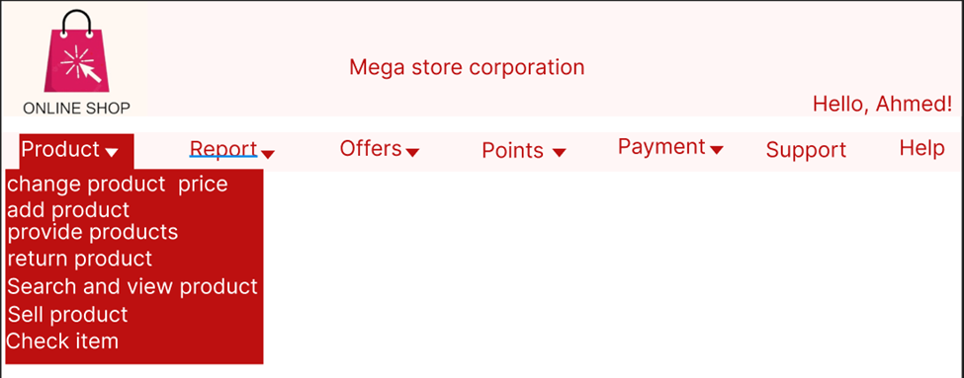

1. For the screens and forms identified in (2.a) create a **Storyboard** that captures the sequences of event. Storyboards may be designed using **wireframe tool or any low-fidelity** paper sketches, e.g. pencil tool, power points, etc.

First storyboard (provide a product)

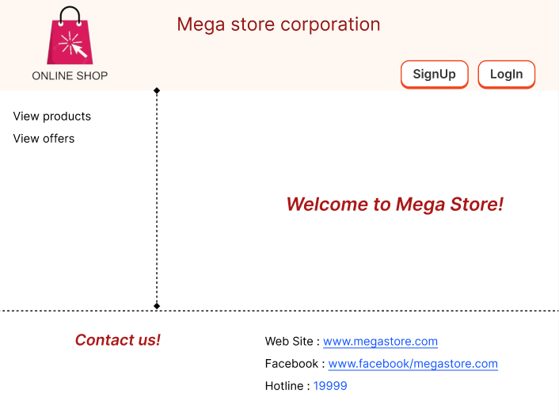

Second storyboard (return a product)



Third storyboard (pay for product)



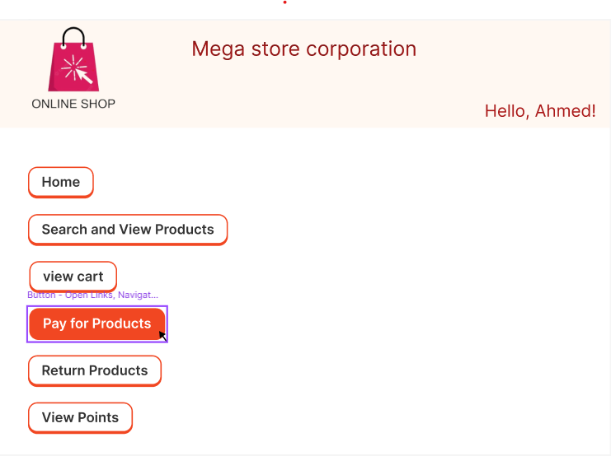

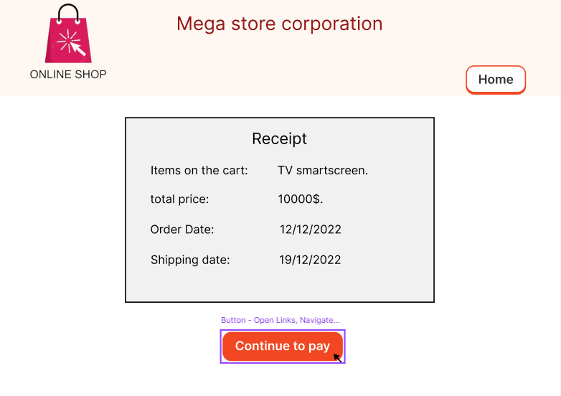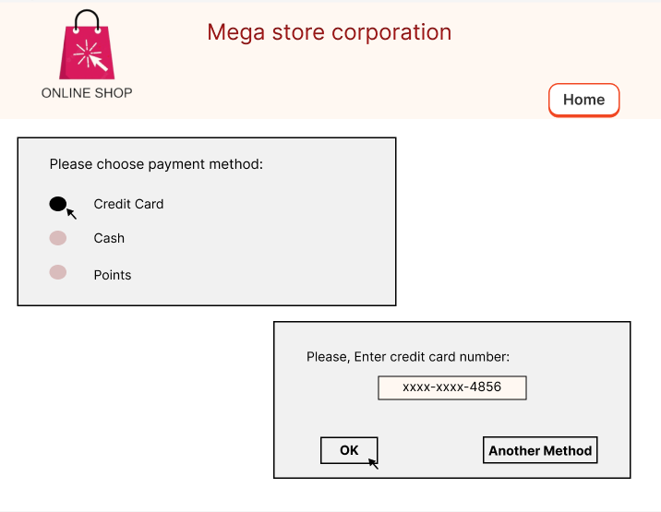

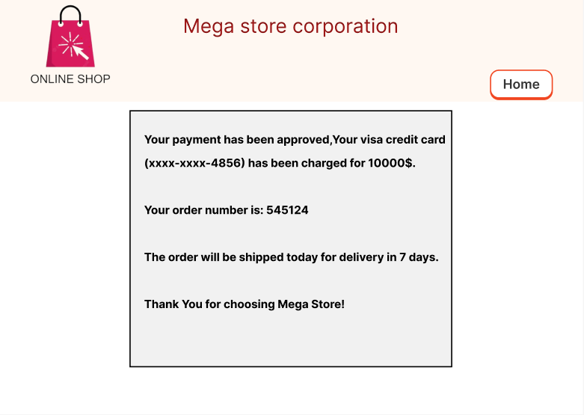

1. Design a web-based user interface (screen) and mobile/tablet interface for one of the screens from (2.a).

web-based

mobile

**4.Consider all User Interface Design Guidelines you studied and show how they addressed in your screens**

Reports:

* Design One electronic internal output reports of your choice.

* Design One electronic external output reports of your choice.

