3.1A

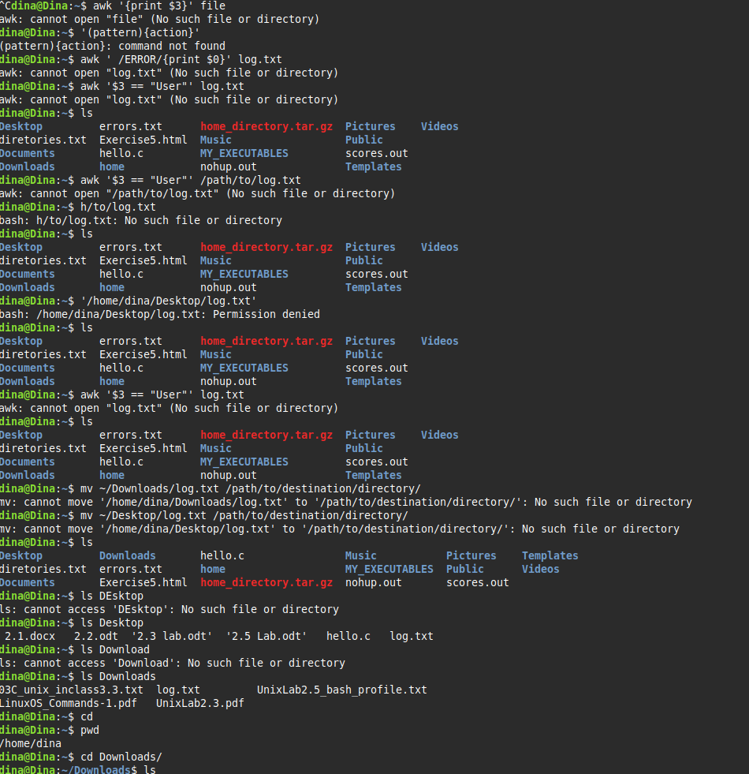

^Cdina@Dina:~$ awk '{print $3}' file
awk: cannot open "file" (No such file or directory)
dina@Dina:~$ '(pattern){action}'
(pattern){action}: command not found
dina@Dina:~$ awk ' /ERROR/{print $0}' log.txt
awk: cannot open "log.txt" (No such file or directory)
dina@Dina:~$ awk '$3 == "User"' log.txt
awk: cannot open "log.txt" (No such file or directory)
dina@Dina:~$ ls
Desktop errors.txt home_directory.tar.gz Pictures Videos
diretories.txt Exercise5.html Music Public
Documents hello.c MY_EXECUTABLES scores.out
Downloads home nohup.out Templates
dina@Dina:~$ awk '$3 == "User"' /path/to/log.txt
awk: cannot open "/path/to/log.txt" (No such file or directory)
dina@Dina:~$ h/to/log.txt
bash: h/to/log.txt: No such file or directory
dina@Dina:~$ ls
Desktop errors.txt home_directory.tar.gz Pictures Videos
diretories.txt Exercise5.html Music Public
Documents hello.c MY_EXECUTABLES scores.out
Downloads home nohup.out Templates
dina@Dina:~$ '/home/dina/Desktop/log.txt'
bash: /home/dina/Desktop/log.txt: Permission denied
dina@Dina:~$ ls
Desktop errors.txt home_directory.tar.gz Pictures Videos
diretories.txt Exercise5.html Music Public
Documents hello.c MY_EXECUTABLES scores.out
Downloads home nohup.out Templates
dina@Dina:~$ awk '$3 == "User"' log.txt
awk: cannot open "log.txt" (No such file or directory)
dina@Dina:~$ ls
Desktop errors.txt home_directory.tar.gz Pictures Videos
diretories.txt Exercise5.html Music Public
Documents hello.c MY_EXECUTABLES scores.out
Downloads home nohup.out Templates
dina@Dina:~$ mv ~/Downloads/log.txt /path/to/destination/directory/
mv: cannot move '/home/dina/Downloads/log.txt' to '/path/to/destination/directory/': No such file or directory
dina@Dina:~$ mv ~/Desktop/log.txt /path/to/destination/directory/
mv: cannot move '/home/dina/Desktop/log.txt' to '/path/to/destination/directory/': No such file or directory
dina@Dina:~$ ls
Desktop Downloads hello.c Music Pictures Templates
diretories.txt errors.txt home MY_EXECUTABLES Public Videos
Documents Exercise5.html home_directory.tar.gz nohup.out scores.out
dina@Dina:~$ ls DEsktop
ls: cannot access 'DEsktop': No such file or directory
dina@Dina:~$ ls Desktop
2.1.docx 2.2.odt '2.3 lab.odt' '2.5 Lab.odt' hello.c log.txt
dina@Dina:~$ ls Download
ls: cannot access 'Download': No such file or directory
dina@Dina:~$ ls Downloads
03C_unix_inclass3.3.txt log.txt UnixLab2.5_bash_profile.txt
LinuxOS_Commands-1.pdf UnixLab2.3.pdf
dina@Dina:~$ cd
dina@Dina:~$ pwd
/home/dina
dina@Dina:~$ cd Downloads/
dina@Dina:~/Downloads$ ls
03C_unix_inclass3.3.txt LinuxOS_Commands-1.pdf log.txt UnixLab2.3.pdf UnixLab2.5_bash_profile.txt
dina@Dina:~/Downloads$ ls
03C_unix_inclass3.3.txt LinuxOS_Commands-1.pdf log.txt UnixLab2.3.pdf UnixLab2.5_bash_profile.txt
dina@Dina:~/Downloads$ mv log.txt ~/
dina@Dina:~/Downloads$ cd
dina@Dina:~$ ls
Desktop diretories.txt Documents Downloads errors.txt Exercise5.html hello.c home home_directory.tar.gz log.txt Music MY_EXECUTABLES nohup.out Pictures Public scores.out Templates Videos
dina@Dina:~$ mv log.txt Downloads/
dina@Dina:~$ ls
Desktop diretories.txt Documents Downloads errors.txt Exercise5.html hello.c home home_directory.tar.gz Music MY_EXECUTABLES nohup.out Pictures Public scores.out Templates Videos
dina@Dina:~$ mv Downloads/log.txt
mv: missing destination file operand after 'Downloads/log.txt'
Try 'mv --help' for more information.
dina@Dina:~$ mv Downloads/log.txt ~/
dina@Dina:~$ ls
Desktop diretories.txt Documents Downloads errors.txt Exercise5.html hello.c home home_directory.tar.gz log.txt Music MY_EXECUTABLES nohup.out Pictures Public scores.out Templates Videos
dina@Dina:~$ mv log.txt Downloads/
dina@Dina:~$ mv Downloads/log.txt .
dina@Dina:~$ ls
Desktop Documents errors.txt hello.c home_directory.tar.gz Music nohup.out Public Templates
diretories.txt Downloads Exercise5.html home log.txt MY_EXECUTABLES Pictures scores.out Videos
dina@Dina:~$ awk '$3 == "User"' log.txt
1598853502 INFO User admin requested access for userlist
1598863888 ERROR User annonymous attempt to access protected resource without credentials
1598864411 INFO User admin logged out
dina@Dina:~$ awk '$3 == "User"' log.txt > user.log
dina@Dina:~$ awk '$3 == "User" { $3 == "Dina"; print}' log.txt > user.log
dina@Dina:~$ awk '$3 == "User" {count++} END {print count}' log.txt
3
dina@Dina:~$ #!/bin/bash
dina@Dina:~$ echo "Hello, World!"
Hello, World!
dina@Dina:~$ chmod +x simple_script.sh
chmod: cannot access 'simple_script.sh': No such file or directory
dina@Dina:~$ ./simple_script.sh
bash: ./simple_script.sh: No such file or directory
dina@Dina:~$ nano simple_script.sh
dina@Dina:~$ chmod +x simple_script.sh
dina@Dina:~$ ./simple_script.sh
./simple_script.sh: line 2: Hello: command not found
./simple_script.sh: line 4: syntax error near unexpected token `)'
./simple_script.sh: line 4: `This is Dina. I am trying to learn programing :) '
dina@Dina:~$ mkdir ~/BASH_SCRIPT
dina@Dina:~$ mv simple_script.sh complex_sxript.sh ~/Bash_SCRIPT/
mv: target '/home/dina/Bash_SCRIPT/': No such file or directory
dina@Dina:~$ ECHO 'EXPORT path=$path:~/bash_script' >> ~/.BASHRC
ECHO: command not found
dina@Dina:~$ ECHO 'EXPORT path=$path:~/bash_script' >> ~/.bashrc
ECHO: command not found
dina@Dina:~$ echo 'EXPORT path=$path:~/bash_script' >> ~/.bashrc
dina@Dina:~$ source ~/.bashrc
simple_script.sh
complex_script.sh
mv simple_script.sh complex_script.sh ~/BASH_SCRIPT/
echo 'EXPORT path=$path:~/bash_script' >> ~/.bashrc
source ~/.bashrc
simple_script
complex_script
print
^C
dina@Dina:~$ gzip zork-master.zip
gzip: zork-master.zip: No such file or directory
dina@Dina:~$ gzip user.txt
gzip: user.txt: No such file or directory
dina@Dina:~$ ls
BASH_SCRIPT Documents Exercise5.html home_directory.tar.gz MY_EXECUTABLES Public Templates
Desktop Downloads hello.c log.txt nohup.out scores.out user.log
diretories.txt errors.txt home Music Pictures simple_script.sh Videos
dina@Dina:~$ gzip user.log
dina@Dina:~$ nano store_data.sh

