**Twitter Buildings**

**Description**

The Twitter Buildings is a command-line tool that allows users to perform calculations related to building types. It provides options to calculate the area or perimeter of a rectangle and to calculate the perimeter of a triangle or print a triangle to the screen.

**Usage**

1. Run the program.
2. Select an action:

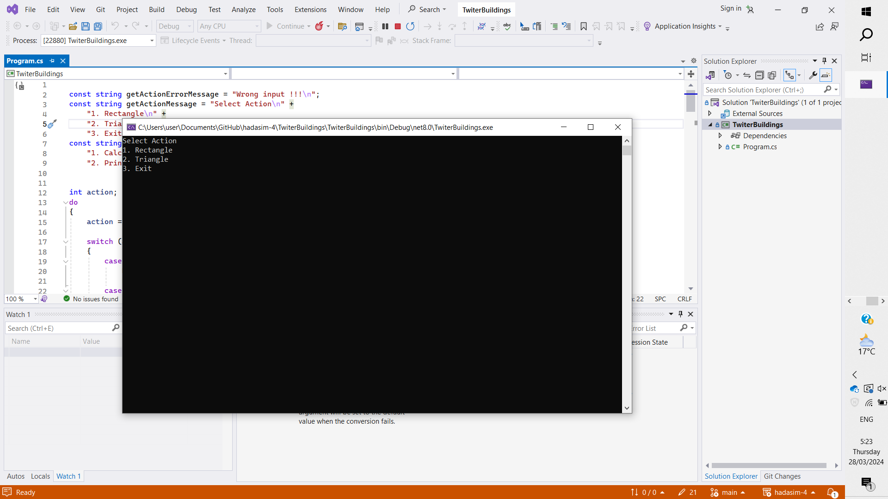

* + Select "1" to work with rectangles.
  + Select "2" to work with triangles.
  + Select "3" to exit the program.

1. If you choose to work with rectangles:
   * Input the height of the rectangle.
   * Input the width of the rectangle.

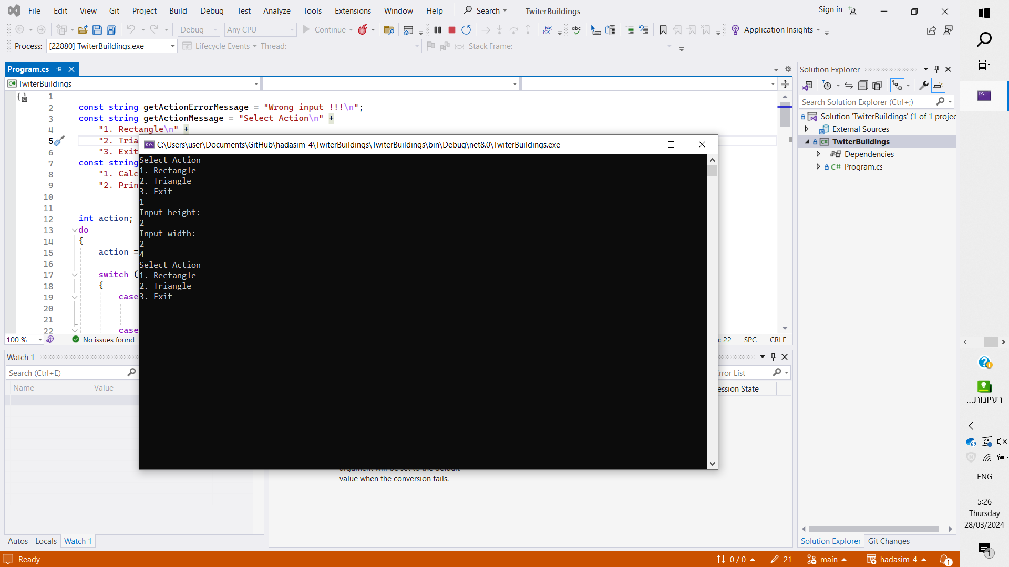

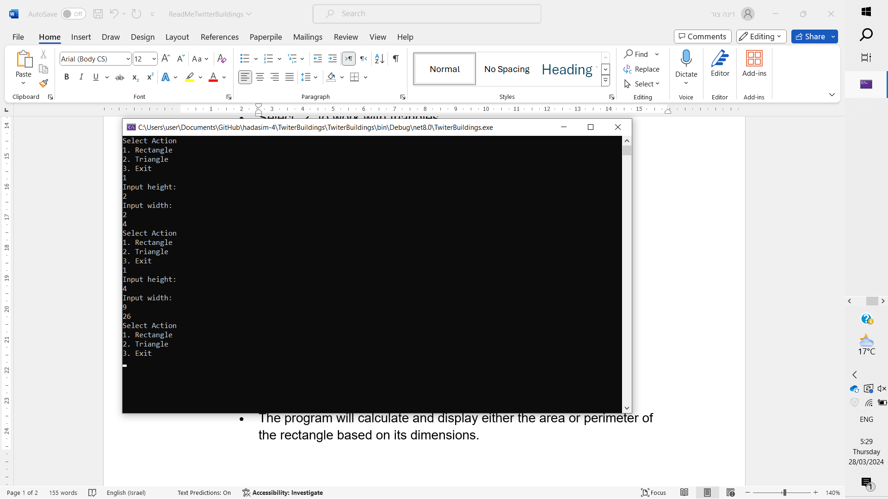

* + The program will calculate and display either the area or perimeter of the rectangle based on its dimensions.

1. If you choose to work with triangles:
   * Input the height of the triangle.
   * Input the width of the triangle.
   * Select an action:
     + Select "1" to calculate the perimeter of the triangle.

* + - Select "2" to print the triangle to the screen.

**Installation**

External dependencies:

Visual Studio -

You can download at:

https://visualstudio.microsoft.com/downloads/

Establishing the project:

The project must be opened using visual studio and run using run

**Discounts make it easier**

-The height of a tower is always greater than or equal to two.

-The entered height and width are always an integer.