1. Create manager machine
2. Create node1
3. Create playbook to setup apache in node1

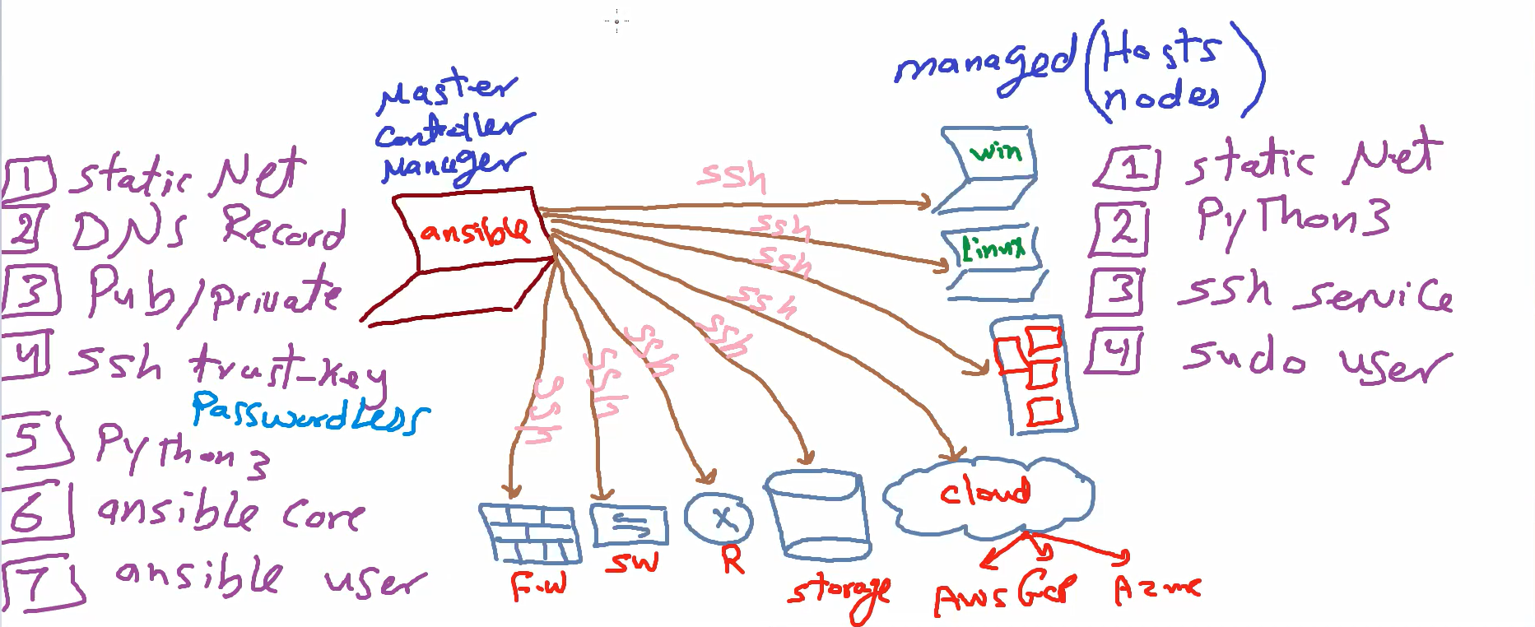

-Vagrant init

-Add the two machines configuration in vagrant file created after init:

-Vagrant up (machines ll be created) 🡪 to check : -vagrant box list

install manager :

1-ssh trust key (to login with it not the password)

-sudo -i

-apt/yum install update

- check if SSH exist in each vm 🡪 systemctl status sshd

i find it installed in rh and centos , and not exist in ububntu 🡪 so we need to install it

-sudo apt install openssh-server

2- static network 🡪ip a (ip and hostname already defined in vagrant file)

I need to make this Ips static 🡪nmtui -> edit connection ->IPV4 make it manual 🡪 show and change the ip in the same subnet

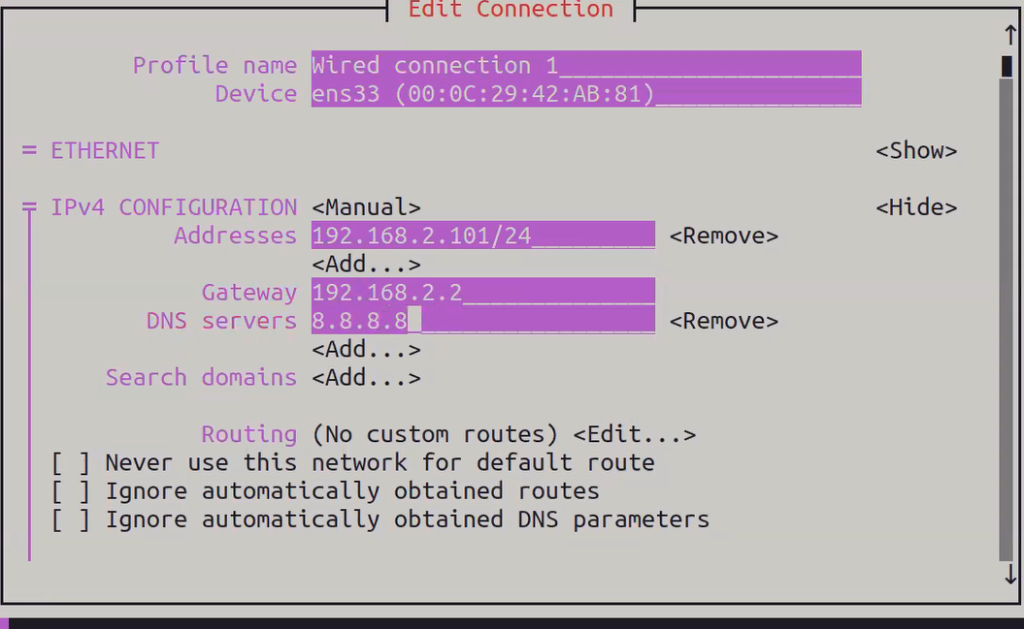

After that deactivate and activate

Host name 🡪 change to mnge -> -> ok ->quit

3-DNS record🡪 Vim /etc/hosts

Insert all nodes :  
192.168.80.50 mngr

192.168.80.51 node1

4-Install python3 🡪yum install python

5- ansible user:Create ansible user first because we need it to create public and private key

- adduser ansible

-passwd ansible 🡪 add password🡪retry

-vim /etc/sudoers 🡪 ansible ALL=(ALL) NOPASSWD: ALL

-su ansible

6-public/private key:Create public and private key for user manager 🡪 -ssh-keygen

send **public key** to allow the manager login without ask for a password anymore

* -Ssh-copy-id dina@node1

7-ansible core :- sudo dnf install ansible

<if couldn’t find the repo add it in EPEL manually>

a-find the current OS name and version num 🡪 hostnamectl

Rocky version 9 🡪x86_64

b-get the repo url (search for epel repo and get the index from search result 🡪v9🡪everything 🡪 x86_64) copy url

c-create file 🡪 sudo vim /etc/yum.repos.d/epel.repo



d- add description and url of the repo

d-install ansible 🡪 sudo dnf install ansible

Managed Node setup:

-Sudo -i

-Yum install update

1. static network 🡪ip a (ip and hostname already defined in vagrant file)
2. ssh service 🡪

check if SSH exist in each vm 🡪 systemctl status sshd

i find it installed in rh and centos , and not exist in ububntu 🡪 so we need to install it

-sudo apt install openssh-server

1. install python3 in node1 and node 2🡪-sudo apt install python3
2. sudo user in node 1 and node 2🡪 create user and add to sudoers

Sudo adduser dina in node 1 , sudo vim /etc/sudoers and🡪

-sudo adduser dina -sudo passwd dina 🡪enter dina password and confirm password 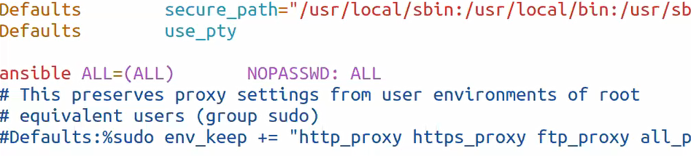Must nopasswd because it should run automated don’t stop and ask for password.

* Su mngr 🡪 ssh-keygen🡪 Ssh-copy-id dina@node1

**Create playbook to setup apache in node1**

1. Create configuration : in manager machine with ansible user

-mkdir ansible

-cd ansible

-vim ansible.cfg

Become=true (avail to dina to become sudo user (escalate his privilage))

Become_user=root

Become_ask_pass=false (no need to ask dina for a pass)

1. Create inventory 🡪vim inventory

[dev]

Node1

- To check if inventory created successfully 🡪ansible-inventory –list

-To ping any group 🡪 ansible dev -m ping

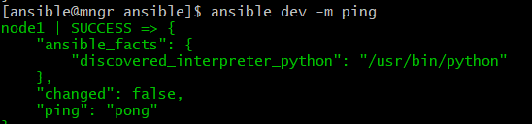

-try to run some commands in dev🡪ansible dev -m shell -a “ls /home”

1. Create playbook to install nginx



For any help in module package for example



After write the playbook check the syntax



And –check (simulate execution )



Run the playbook

