Tool used to apply CI/CD (integrate and automate deployment)

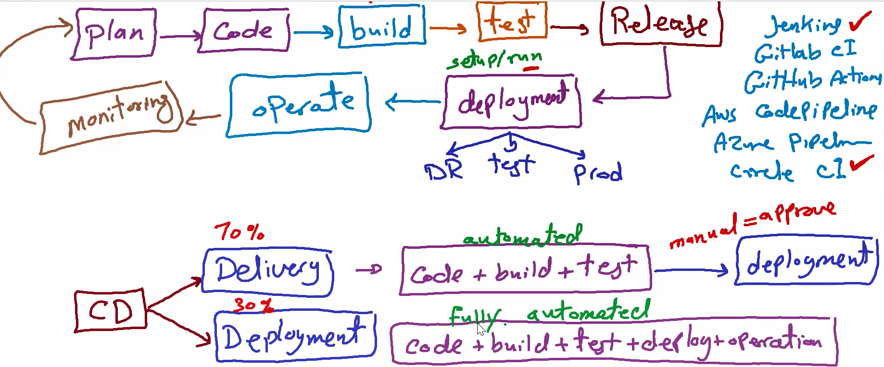

Similar tools : gitlab ci , github action,code pipeline(amazon service),azure pipline, circle ci

Git lab works only if my code in git

Github action works only if my code in git hub

Code pipline :works with code commit (amazon service)

Jenkins,circle ci : works in all version control system not related to any vendor

CI/CD meaning:

