VMRF(DU)
Vinayaka Mission's Research Foundation (Deemed to be University)

INSTITUTIONAL ACTIVITY PORTAL
Complete Screenshots Documentation
All Modules · All Pages · All User Interfaces

Document Type | Screenshots & UI Visual Reference — All User Roles
Screenshots | 42 Full-Page Screenshots captured from live portal
User Accounts | 7 Accounts | 7 User Roles | 9 Functional Modules
Technology Stack | Laravel 12 · PHP 8.2+ · MySQL 8.0 · Bootstrap 5.3
Prepared by | VMRFDU IT Team (Dhinakaran & Sanjai)
Guided by | Dr. A. Murugan
Version / Date | 1.0 | July 2026

Under the Guidance of : Dr. A. Murugan
Designed & Developed by : VMRFDU IT Team (Dhinakaran & Sanjai)
© 2026 VMRF(DU) – All Rights Reserved.

1 | 🌐 Public Access & Authentication  Login Page · Public Gallery — No login required

PUBLIC | Login Page | 01 / 50
Secure authentication gateway for all portal users. Validates email + password, checks account status (active / locked / suspended), enforces force-password-reset, and redirects each user to their role-specific dashboard. Login IP address and timestamp are recorded on every successful session.
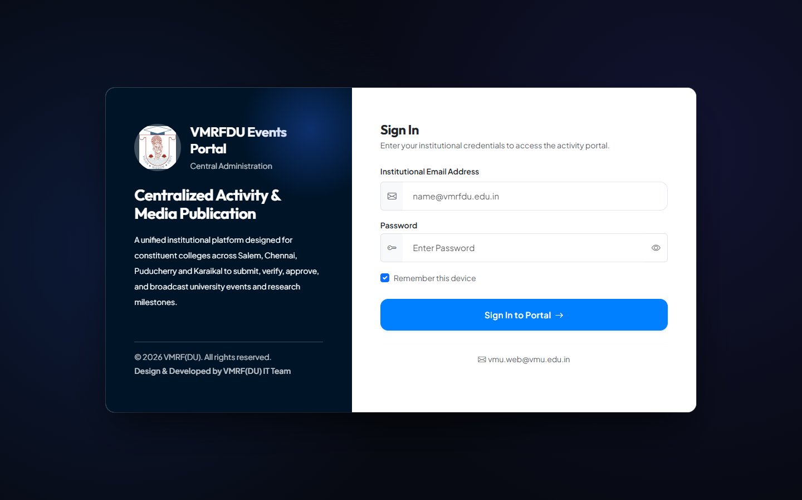
🔐 Email + Password Auth 🛡️ CSRF Protected 🚫 Locked/Suspended Detection 📍 IP & Timestamp Tracking

PUBLIC | Public Gallery | 02 / 50
Publicly accessible showcase of all published institutional activities — no login required. Visitors can browse using full-text search, category filter, college filter, and date-range filter. Responsive image grid layout with links to individual activity detail pages.
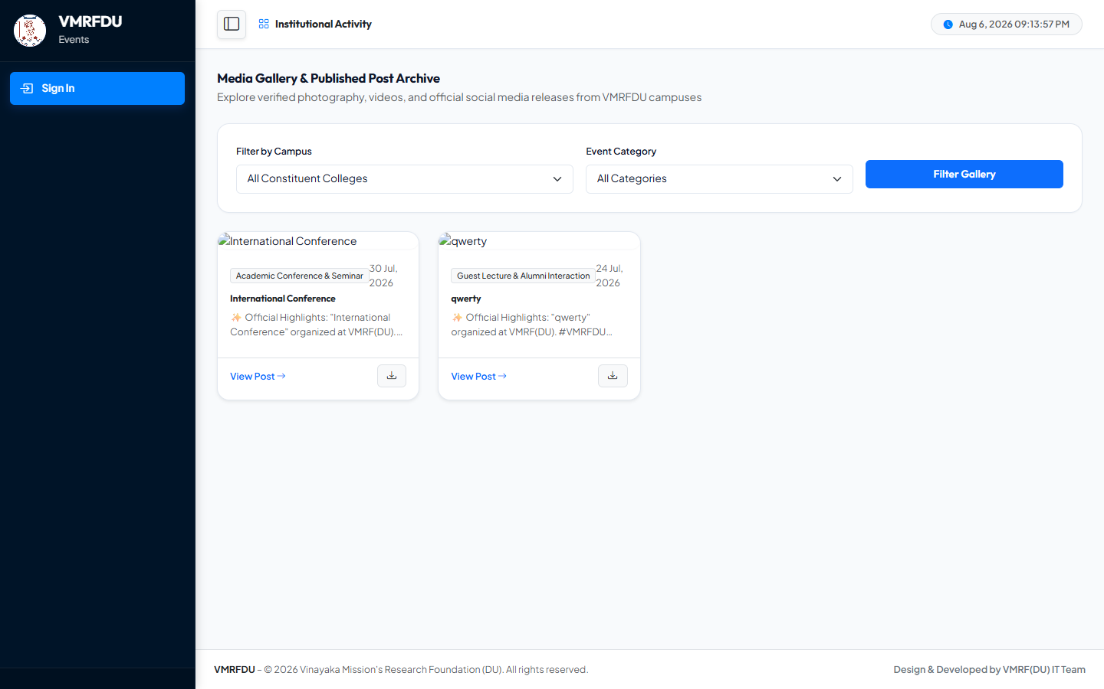
🔍 Full-Text Search 🏷️ Category Filter 📅 Date Range Filter 🏫 College Filter 🖼️ Responsive Image Grid

2 | 👑 Super Admin — Enterprise Control Panel  superadmin@vmrfdu.edu.in · Role: super_admin · Unrestricted system-wide access

SUPER ADMIN | Dashboard | 04 / 50
System-wide enterprise overview: total activities, users, colleges, workflow status, pending actions across all roles, recent activity feed, and quick-access navigation to every admin module.
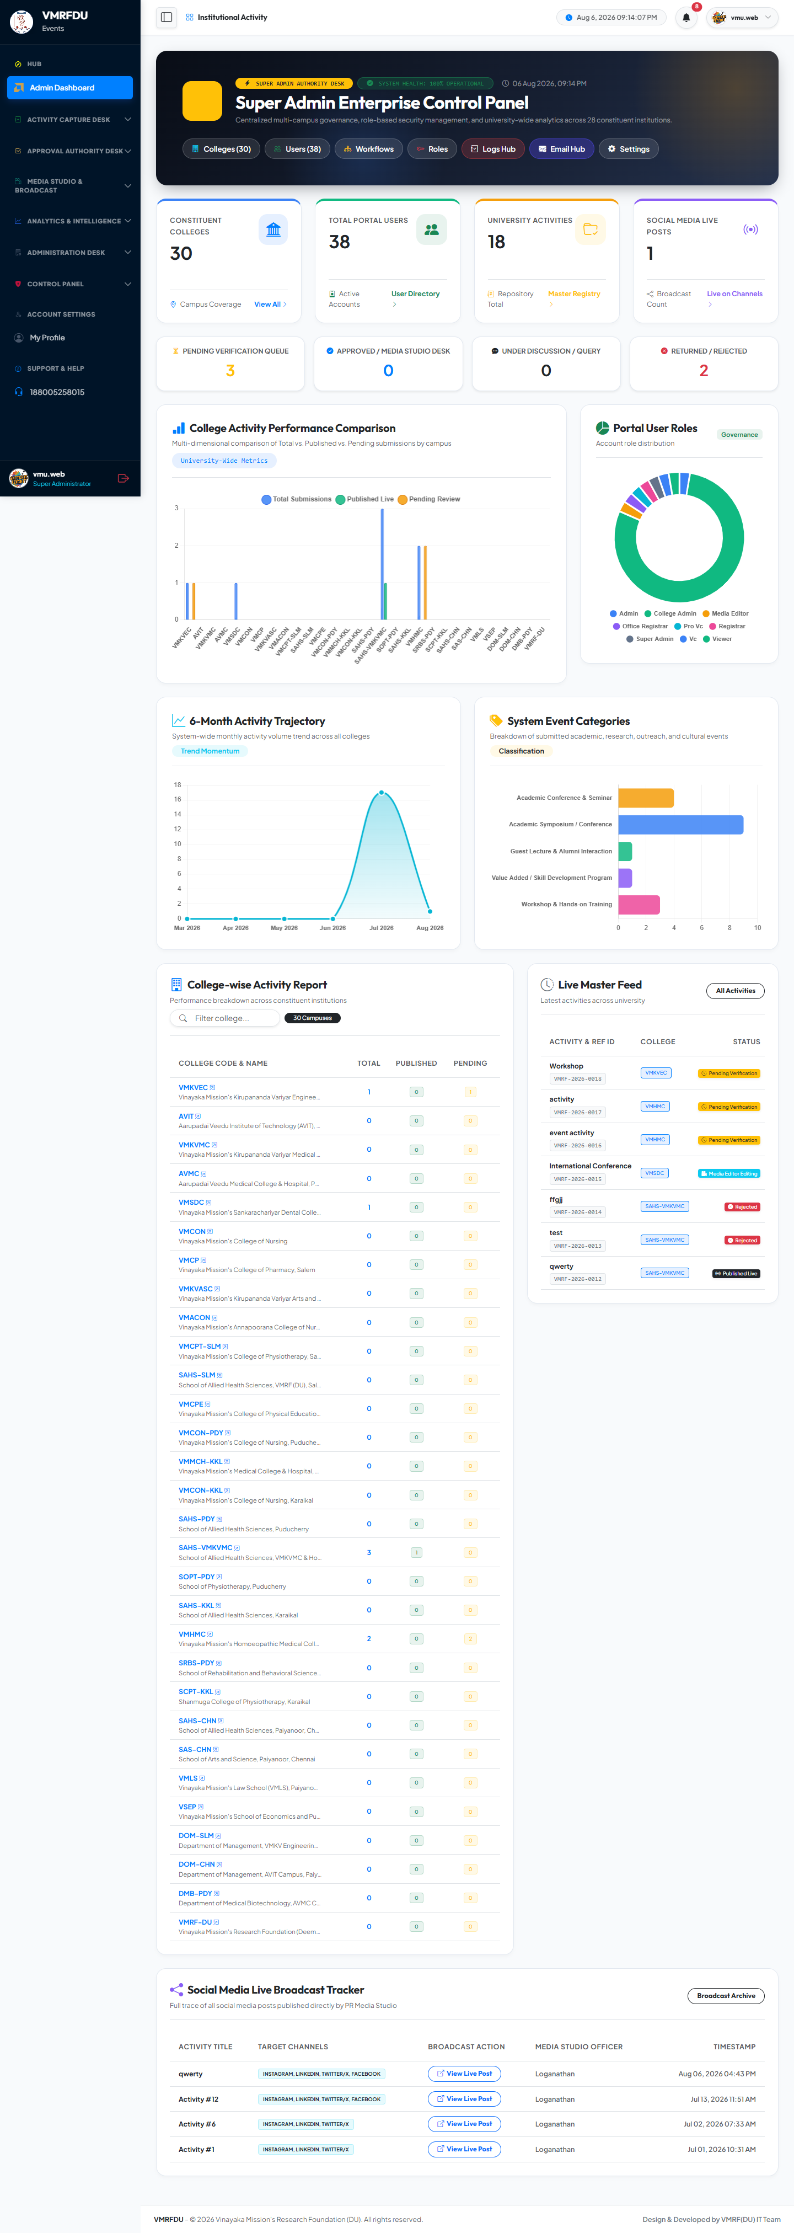
📊 System-Wide KPIs 👥 Total Users & Colleges 🔄 Workflow Status ⚡ Quick Actions

SUPER ADMIN | College Management | 05 / 50
Full CRUD management of all constituent colleges. Create with unique codes (e.g., VMKVEC, AVIT), set location, dean name, contact email and website. Toggle colleges active or inactive. All user and activity records reference these college entries.
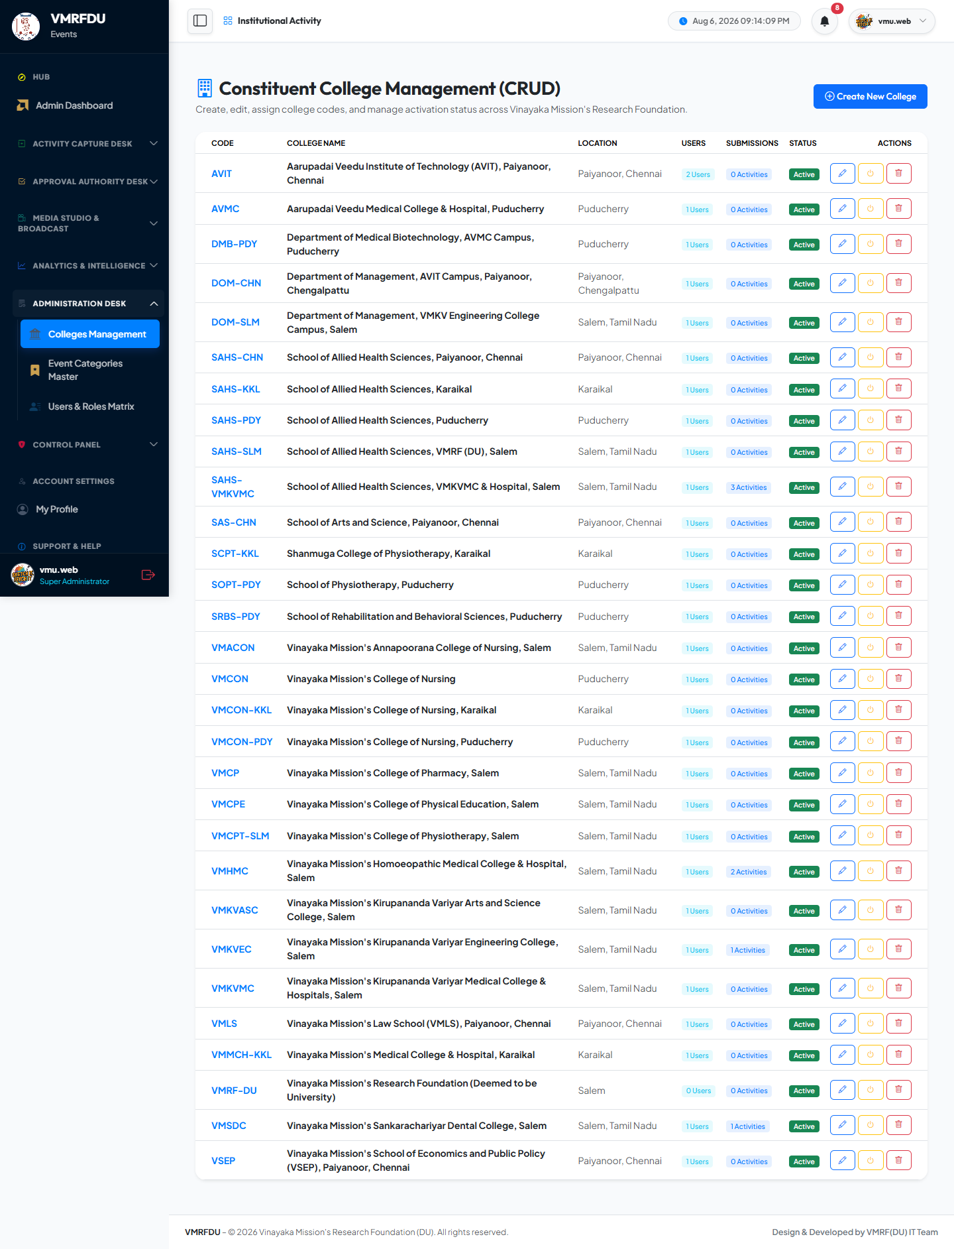
➕ Create College ✏️ Edit Details 🔘 Active/Inactive Toggle 🏫 Unique College Code

SUPER ADMIN | User Management | 06 / 50
Create and manage all portal user accounts across the entire university. Assign roles, link to colleges, set phone and designation, force password resets, lock or unlock accounts, change account status, and transfer users between colleges.
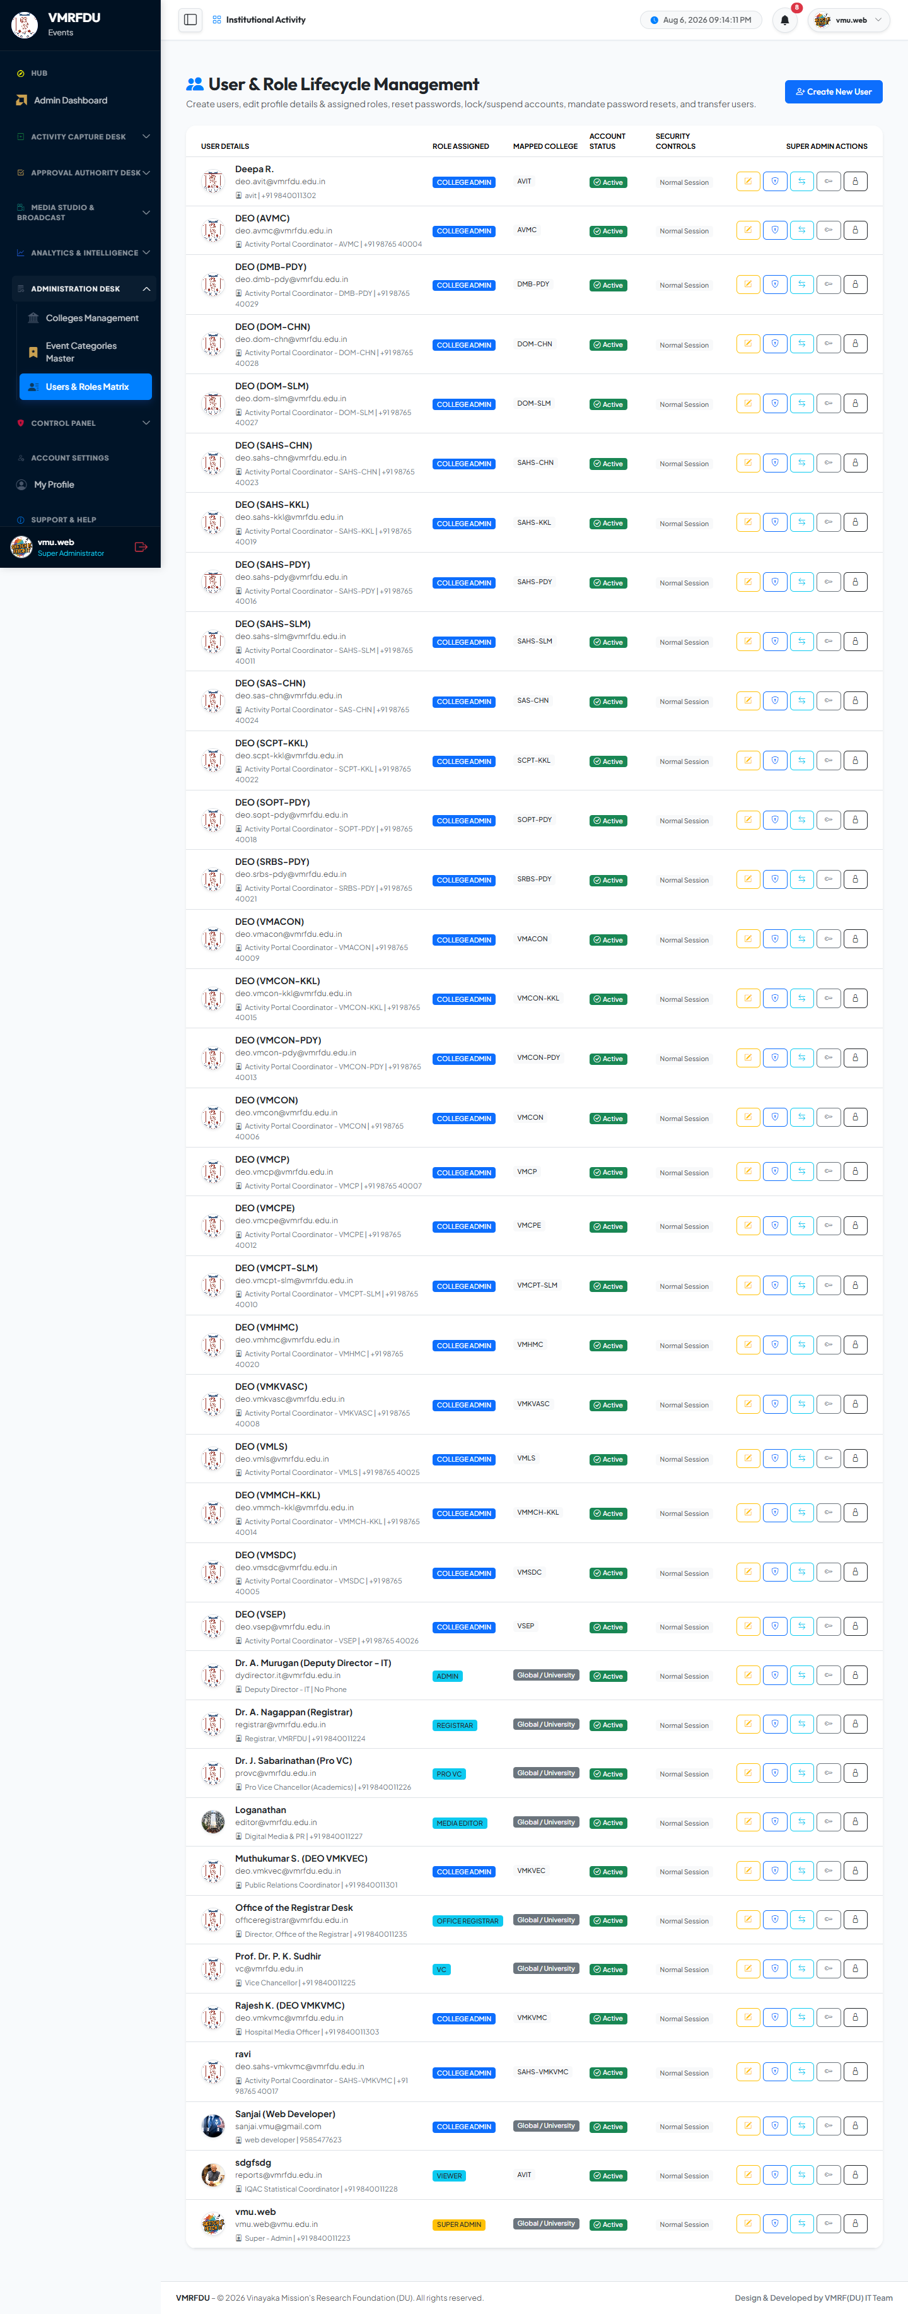
➕ Create User 🎭 Role Assignment 🔒 Lock/Unlock Account 🔑 Force Password Reset 🏫 College Transfer

SUPER ADMIN | Role & Permission Builder | 07 / 50
Create dynamic roles with granular JSON permission matrices. Assign data scopes (global vs. college-scoped). Define permissions for each module area: colleges, users, activities, workflows, approvals, media, analytics, settings, roles, and audit logs.
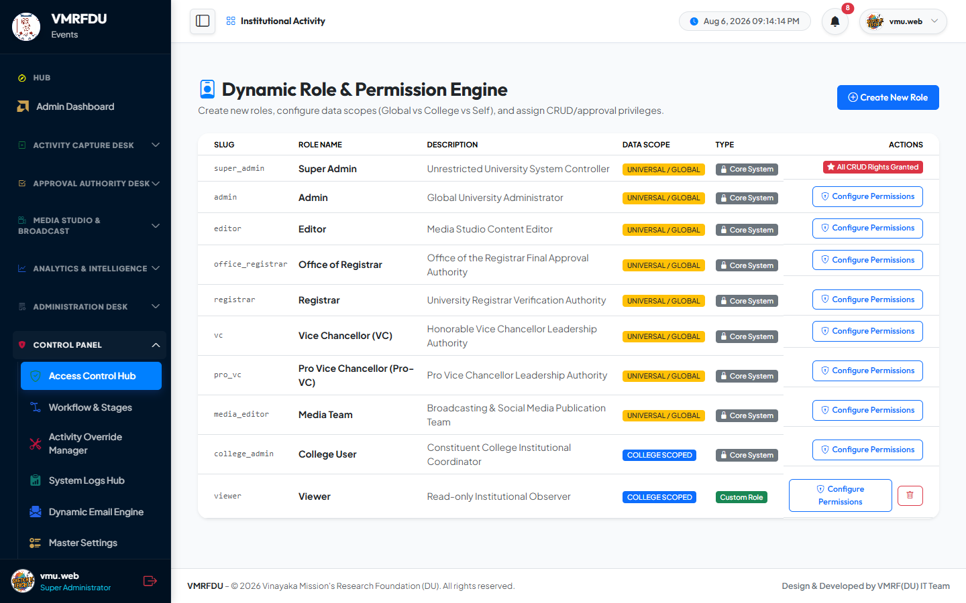
🎭 Role Definitions 🔑 JSON Permission Matrix 🌐 Data Scope (Global/College) ⚙️ Permission Overrides

SUPER ADMIN | Workflow Engine Configuration | 08 / 50
Create, edit, and duplicate complete approval workflow templates. Configure each stage: name, order, required role or specific user IDs, allowed actions (approve/discuss/reject), status transitions for each action, and approval conditions. Set routing rules by category, college, or activity type.
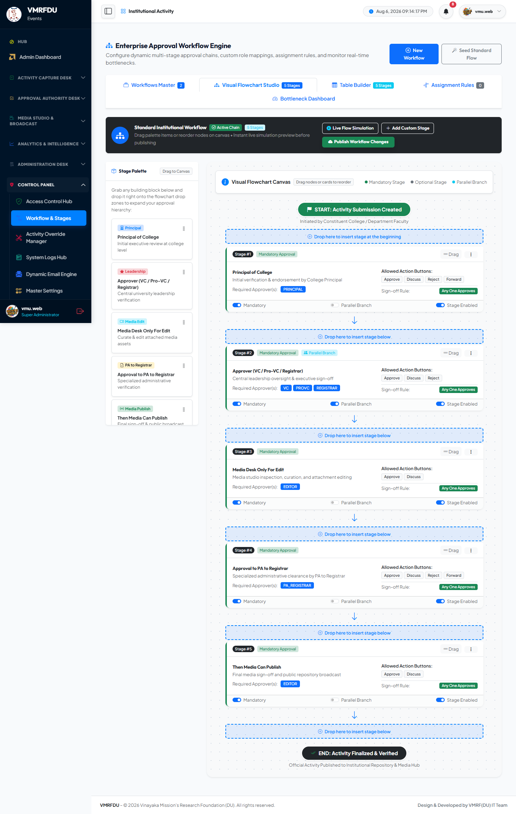
🔄 Multi-Stage Workflow ⚙️ Stage Configuration 📋 Action-to-Status Mapping 🌿 Routing Rules by Category

SUPER ADMIN | Enterprise Access Control Suite | 09 / 50
Fine-grained per-user permission overrides beyond role defaults. Copy a role's full permission set to multiple users simultaneously. View and manage the complete cross-user, cross-role permission matrix from one interface.
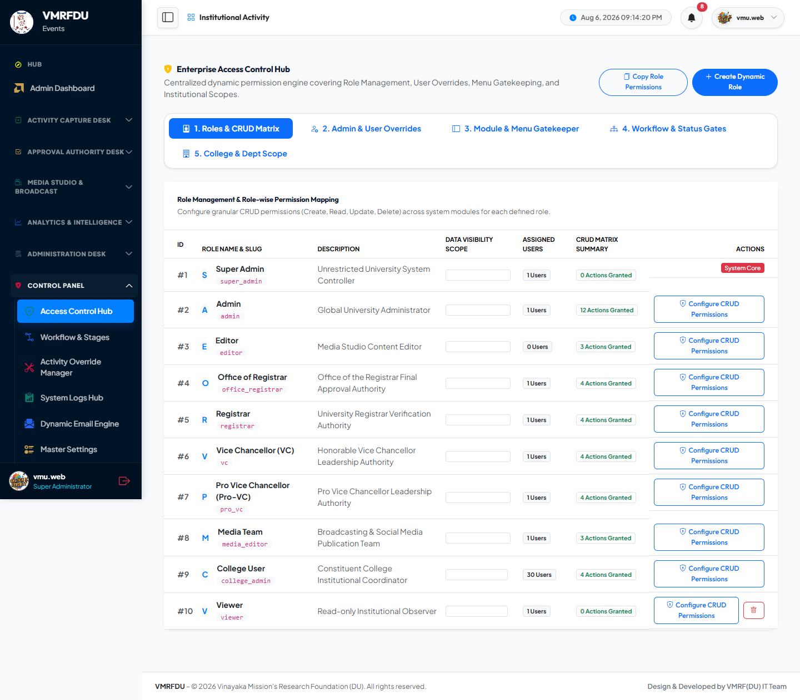
🔑 Per-User Permission Override 📋 Copy Role Permissions 🎭 Full Cross-Role Matrix

SUPER ADMIN | Unrestricted Activity Management | 10 / 50
Super Admin override view of all activity submissions across every college and every workflow stage. Force status changes, reassign activity ownership, restore soft-deleted records, and perform hard deletes — all without workflow restrictions.
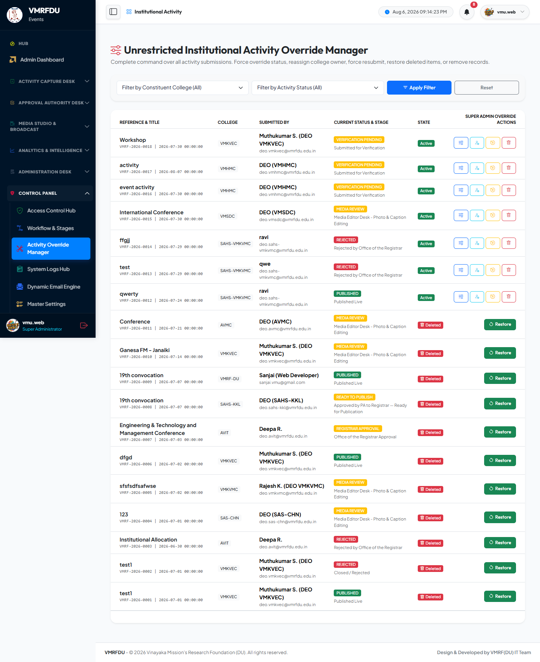
⚡ Force Status Change ♻️ Restore Soft-Deleted 👤 Reassign Ownership 🗑️ Hard Delete Authority

SUPER ADMIN | System Audit Logs | 11 / 50
Immutable system-wide audit trail. Every critical action logged with: acting user, action type, affected record ID, before/after values, IP address, and precise timestamp. These records cannot be edited or deleted — providing complete governance and compliance coverage.
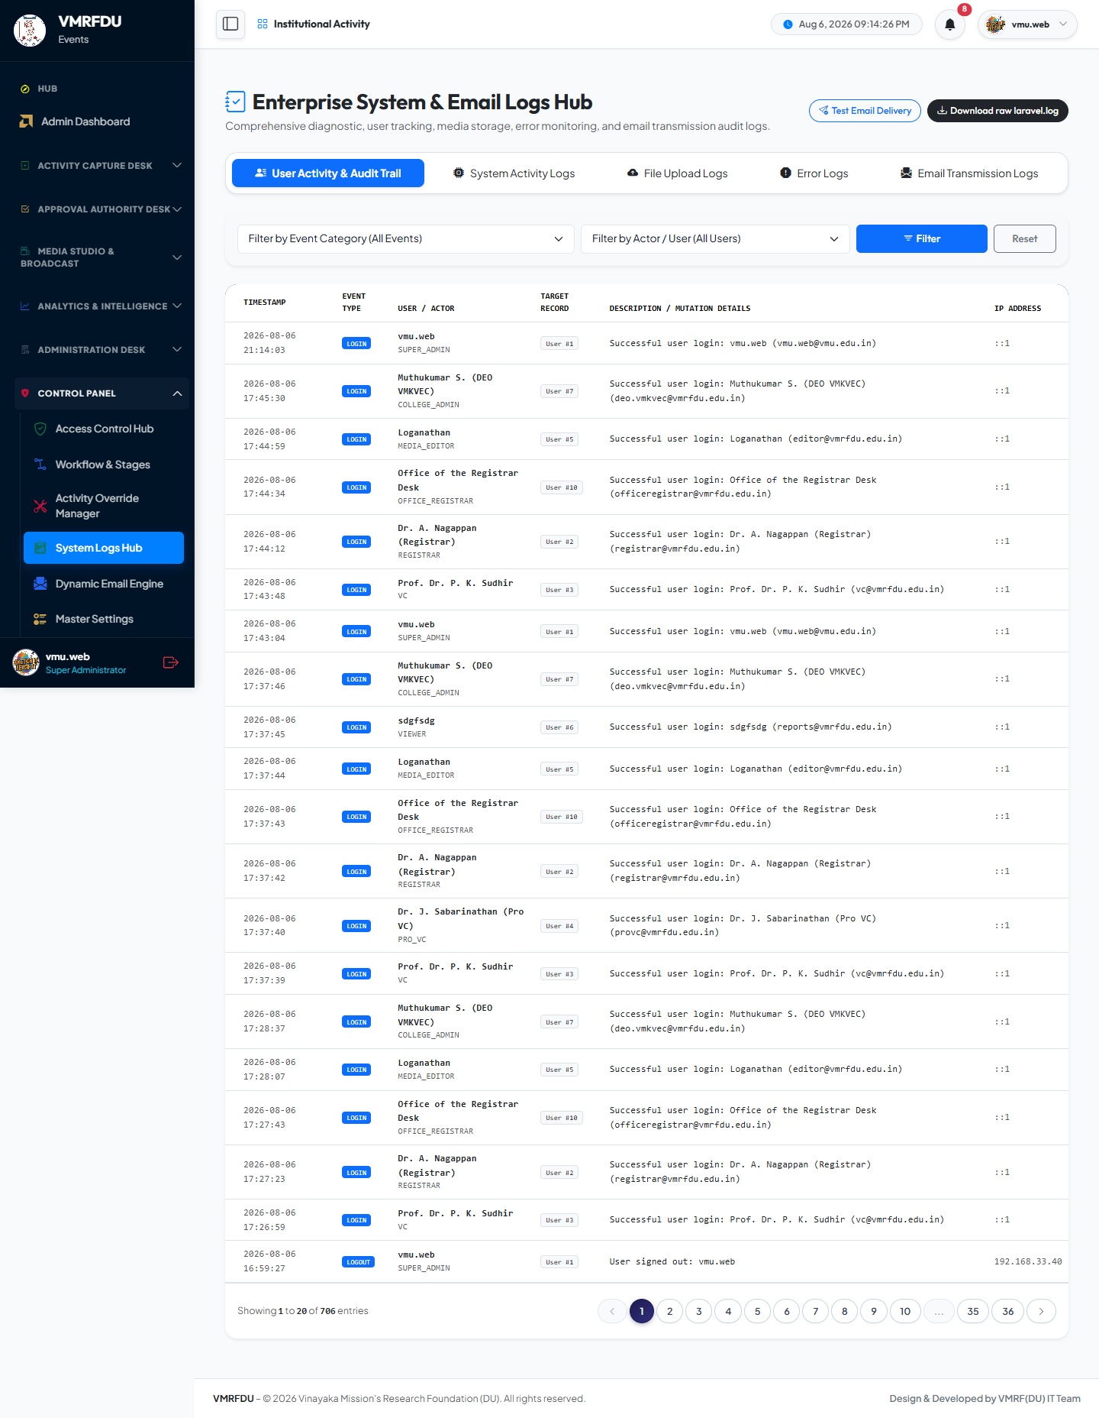
📜 Immutable Log Records 👤 User + IP Captured 🔍 Before/After Values 📅 Precise Timestamps

SUPER ADMIN | Master Settings & Branding | 12 / 50
Portal-wide configuration interface: upload the university logo and favicon, set the default user avatar image, configure NTP time-synchronisation settings, and manage session lifetime parameters — controlling the portal's visual identity and core behaviour.
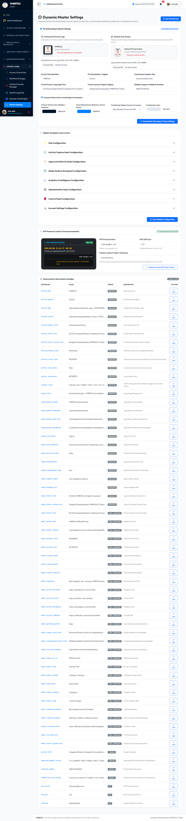
🖼️ Logo & Favicon Upload 🕐 NTP Time Sync Config ⏱️ Session Lifetime 🎨 Portal Branding

SUPER ADMIN | Analytics Dashboard (Super Admin) | 13 / 50
University-wide KPI dashboard with full cross-college data visibility. Charts: activities by category, by college, by workflow stage, and by month. Export options: filtered CSV download and a printable executive report with university branding.
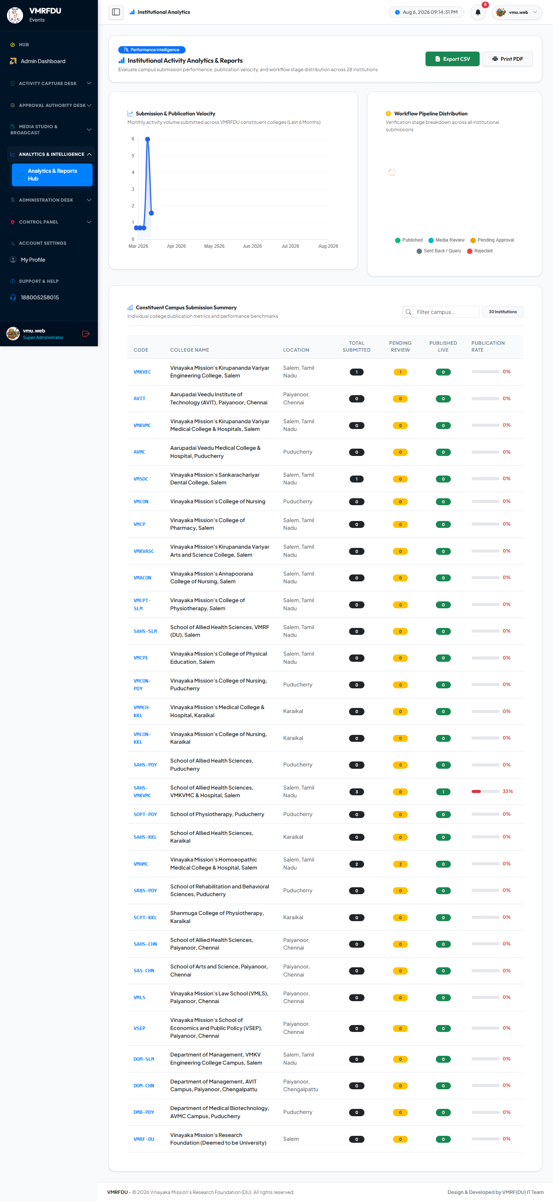
📊 University-Wide KPIs 📈 Category & College Charts 📥 CSV Export with Filters 🖨️ Printable Executive Report

SUPER ADMIN | In-App Notification Center | 14 / 50
System-wide notification inbox with read/unread status tracking. Mark individual notifications or all as read. Each notification includes an action link to the relevant activity, approval, or system event.
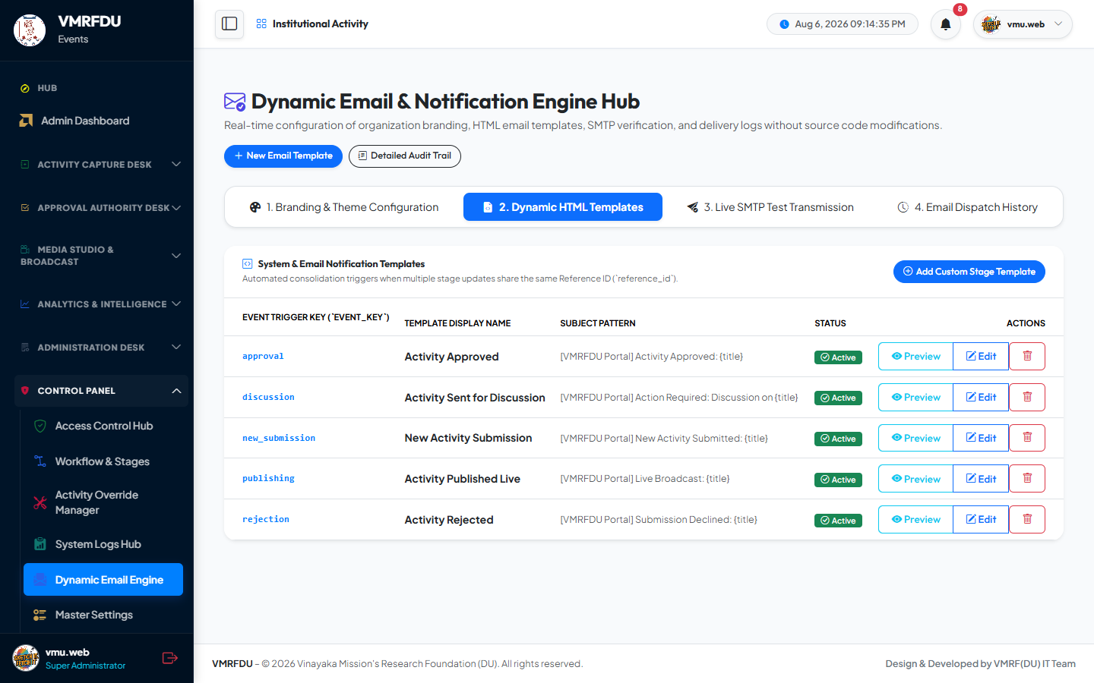
🔔 In-App Notification Inbox ✅ Mark Individual / All Read 🔗 Action Deep Links

SUPER ADMIN | Email Transmission Audit Log | 15 / 50
Complete record of every email sent by the portal at each workflow stage. Displays recipient address, subject line, workflow stage trigger, delivery status (sent / queued / failed), timestamps, and a full HTML body preview for troubleshooting and compliance verification.
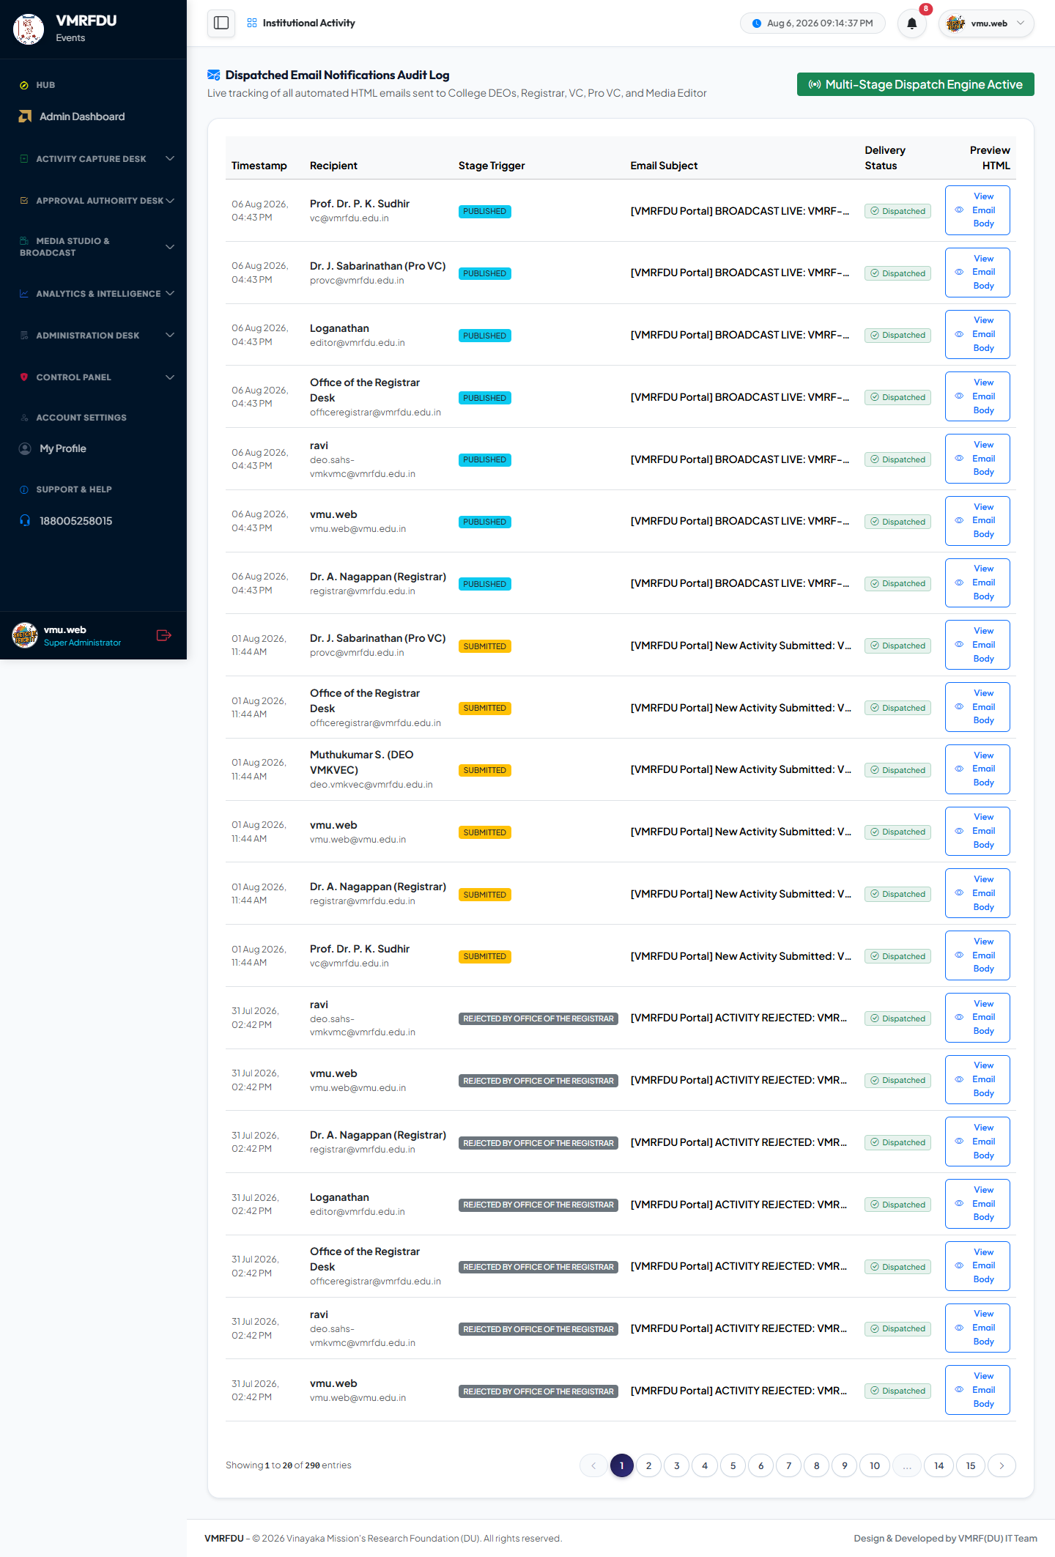
📧 Complete Email Audit Trail ✅ Sent / Queued / Failed Status 👁️ HTML Body Preview 🔍 Searchable History

SUPER ADMIN | User Profile — Super Admin | 16 / 50
Personal profile management for the Super Admin: update name, email, phone, designation, upload a profile avatar, and change the account password with current-password verification.
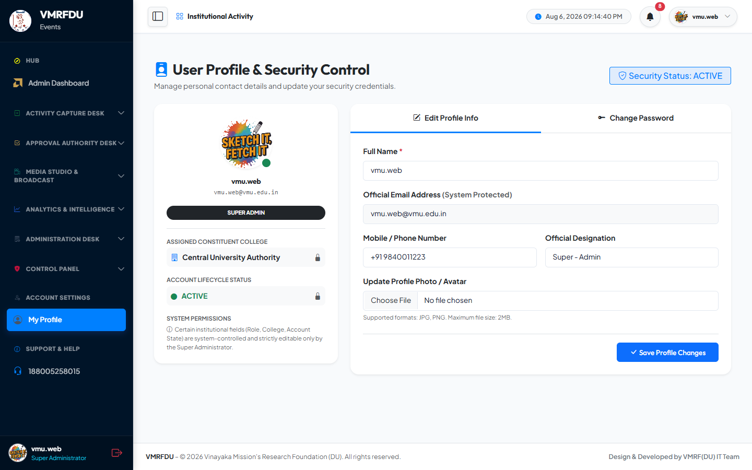
✏️ Edit Personal Information 🖼️ Profile Avatar Upload 🔑 Password Change

3 | 🏛️ Vice Chancellor (VC) — Verification & Oversight  vc@vmrfdu.edu.in · Role: vc · Stage 1 Verification Authority · Global data access

VICE CHANCELLOR | VC Dashboard | 17 / 50
Vice Chancellor's role-specific homepage: pending verification count, university-wide activity statistics, recent submission feed, approval rate indicators, and quick navigation to the verification queue and analytics dashboard.
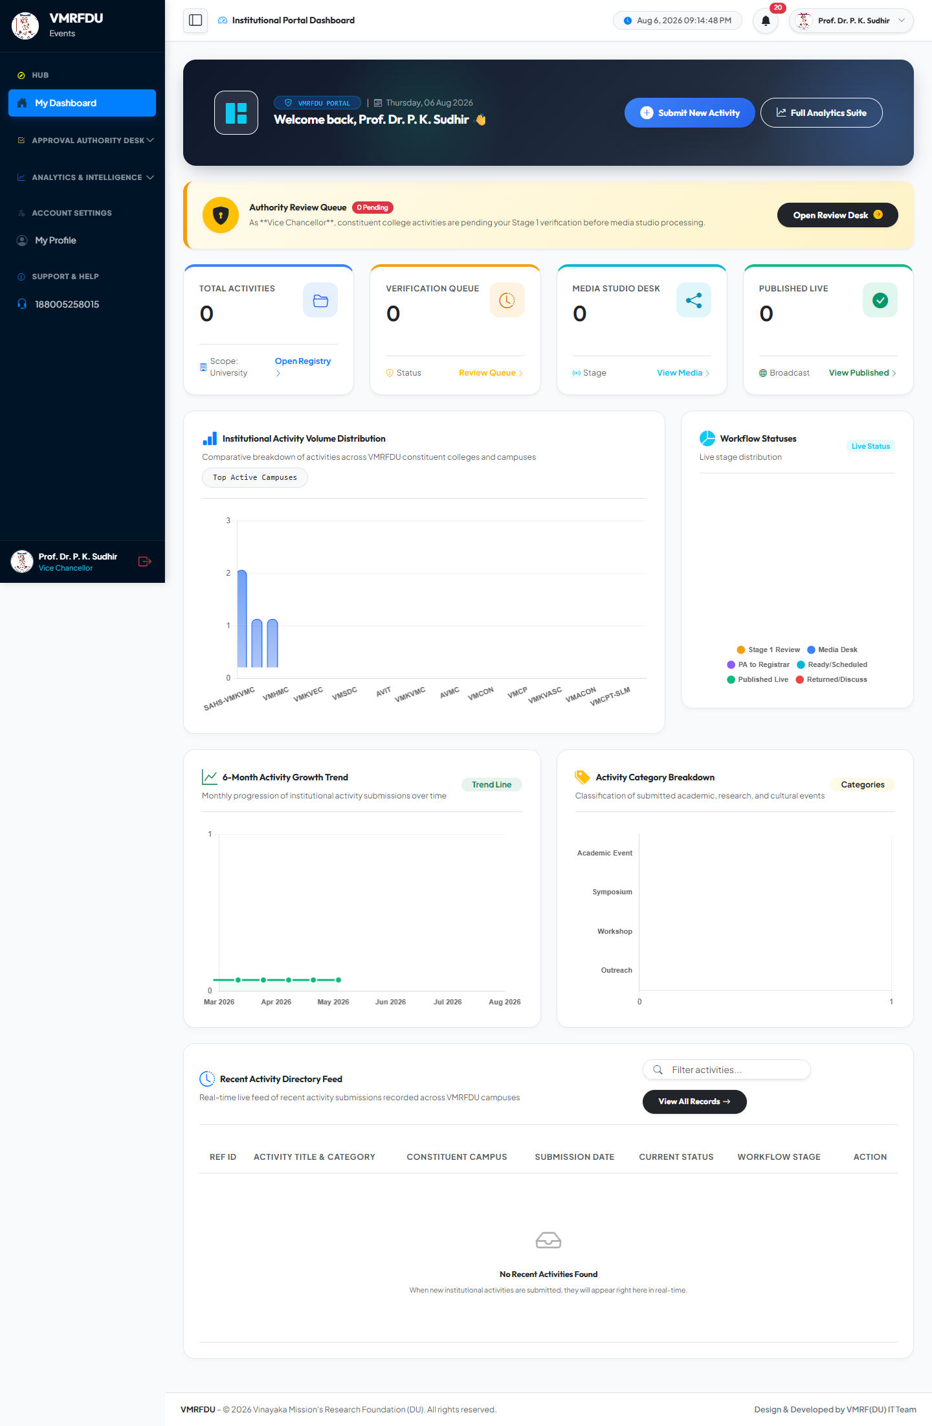
📋 Pending Queue Count 📊 University-Wide Stats 📈 Approval Rate Indicator ⚡ Quick Actions

VICE CHANCELLOR | Verification Queue — Pending Submissions | 18 / 50
Stage 1 verification dashboard listing all activities submitted by College Admins awaiting institutional review. Each record shows the activity title, submitting college, event category, date, faculty coordinator, and uploaded photos. Three actions available — Approve (status → media_review), Discuss (returns to College Admin with remarks), Reject (terminates with mandatory reason).
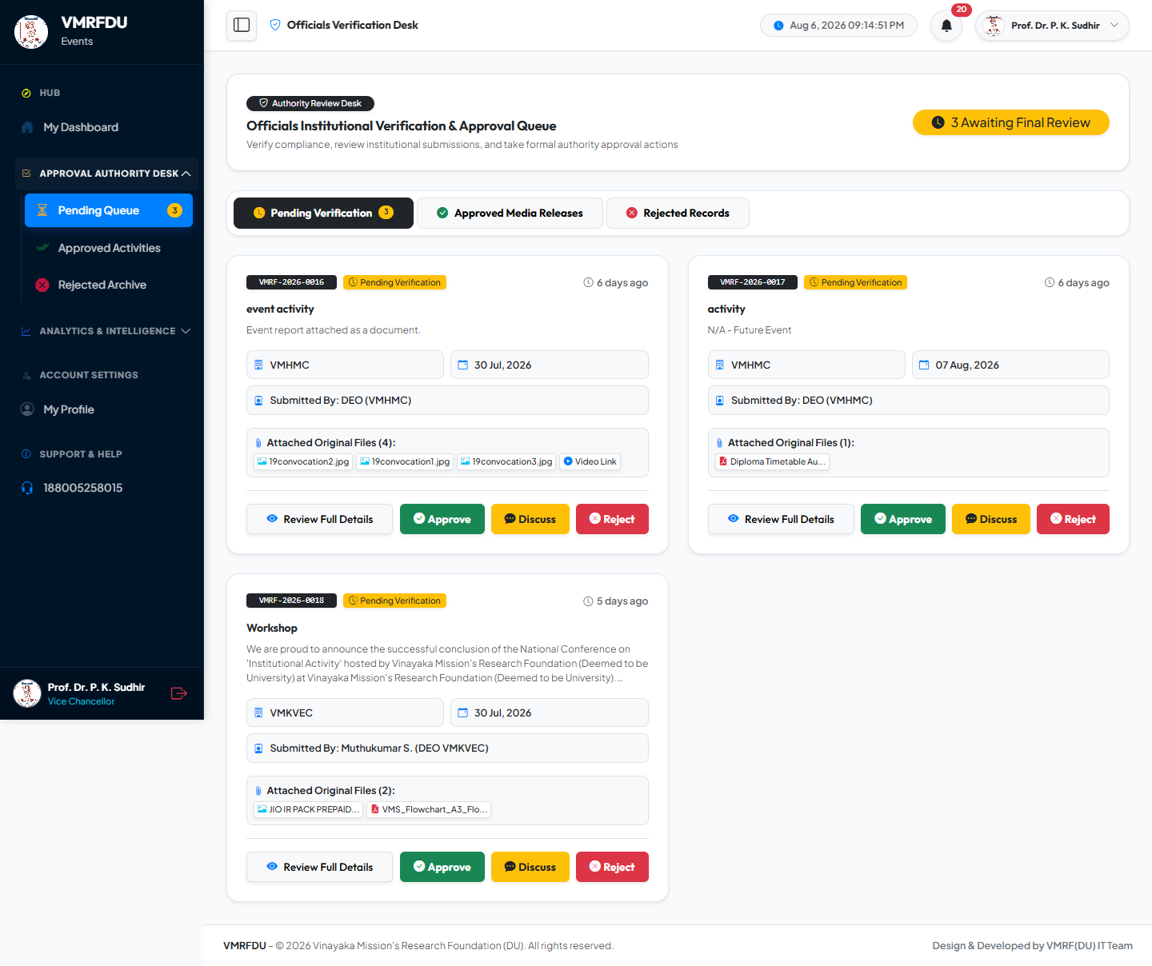
✅ Approve → media_review 💬 Discuss → Returned to College Admin ❌ Reject → Terminated (Mandatory Reason) 📝 Mandatory Remarks on Discuss / Reject

VICE CHANCELLOR | Approved Submissions List | 19 / 50
Historical record of all activities approved by the VC and forwarded to the Media Editor Studio for processing. Shows approval timestamp, remarks provided at time of approval, and the current downstream status of each record.
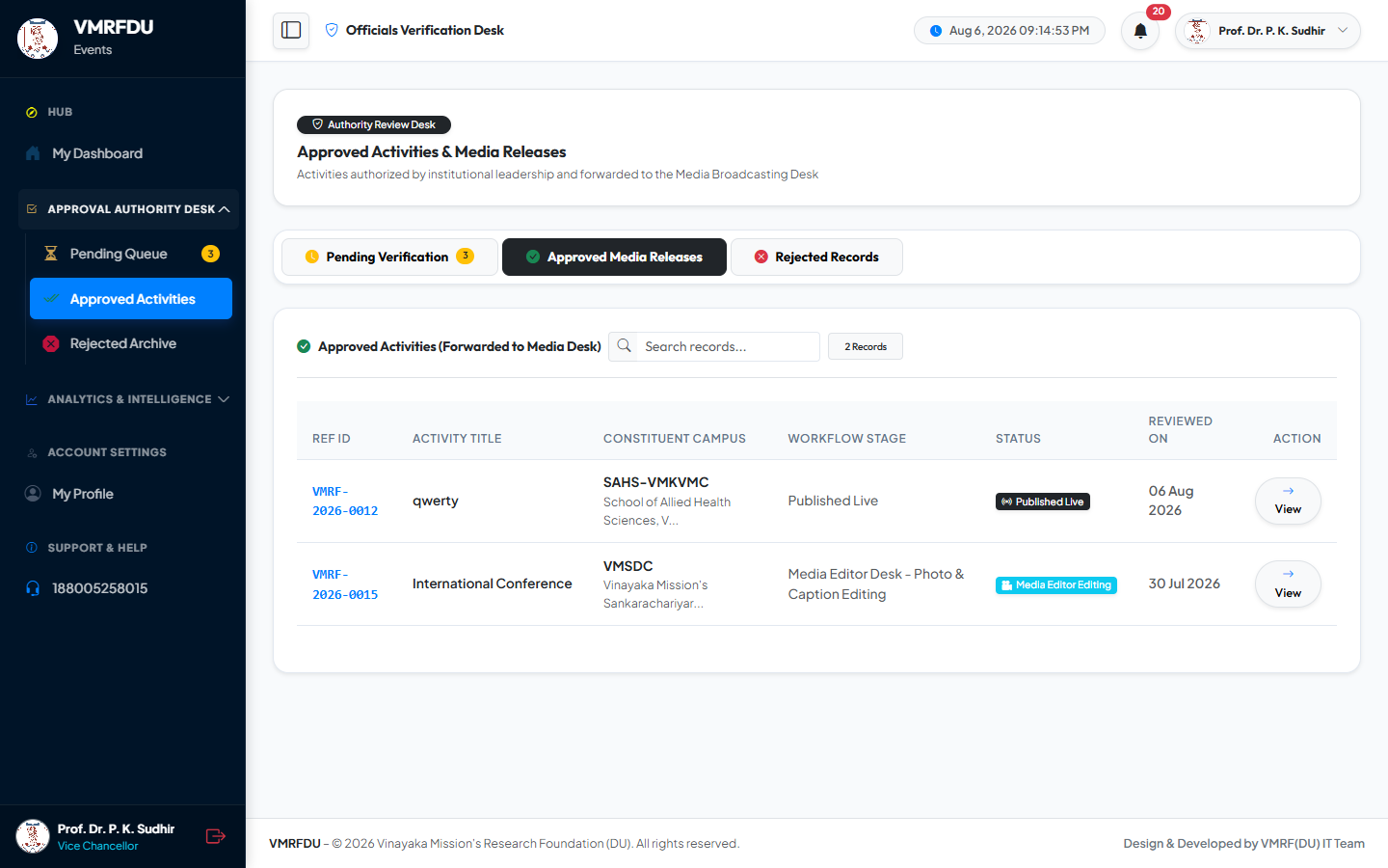
✅ Full Approved Records 📅 Approval Timestamps 🔄 Downstream Status Tracking

VICE CHANCELLOR | Rejected Submissions Archive | 20 / 50
Record of all activities rejected at Stage 1 with mandatory rejection reasons and precise timestamps. Provides full governance traceability and allows colleges to understand why specific activities were not approved.
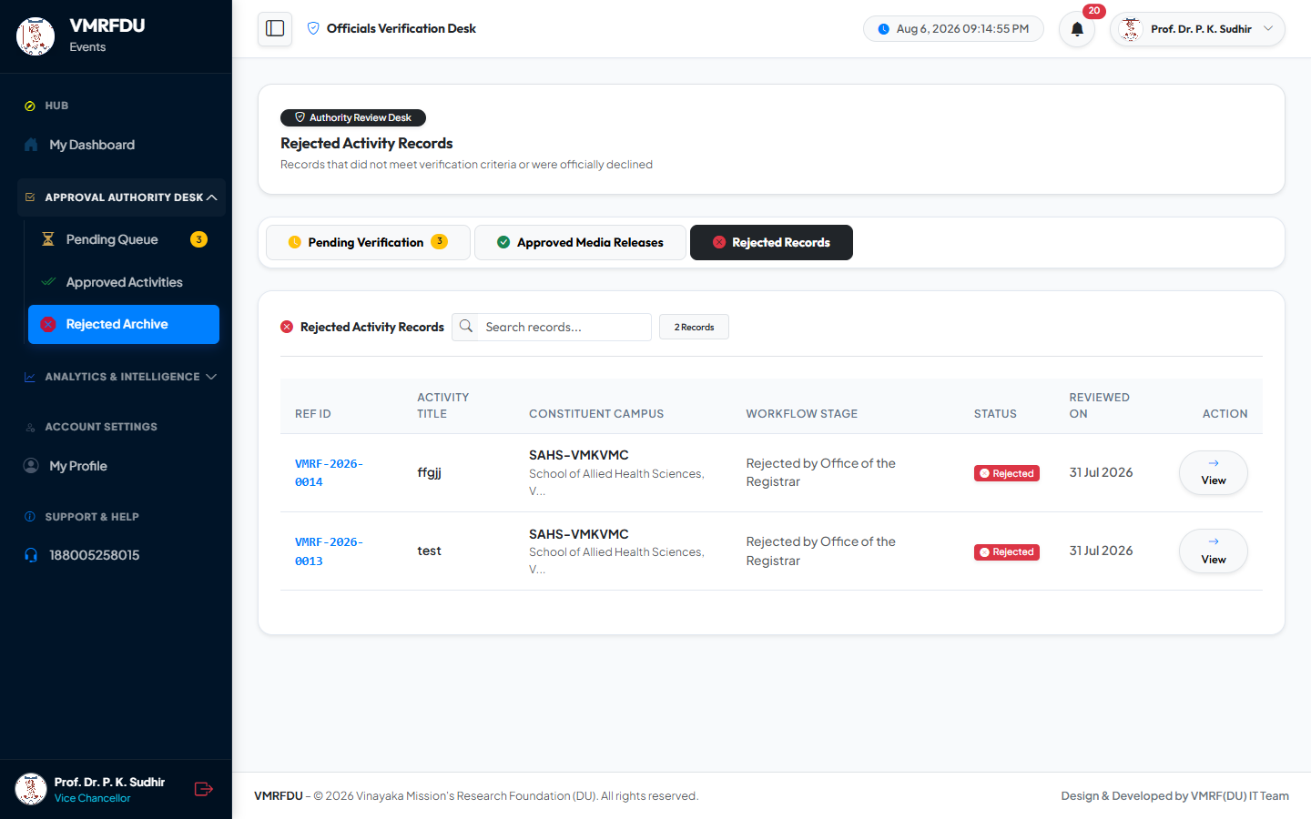
❌ Rejected Activity Records 📝 Mandatory Rejection Reasons 📅 Rejection Timestamps

VICE CHANCELLOR | Analytics Dashboard (VC View) | 21 / 50
University-wide analytics with full cross-college data visibility: overall approval rates, submission volumes broken down by category and college, stage-wise distribution, and monthly submission trends. Supports CSV download and printable executive report export.
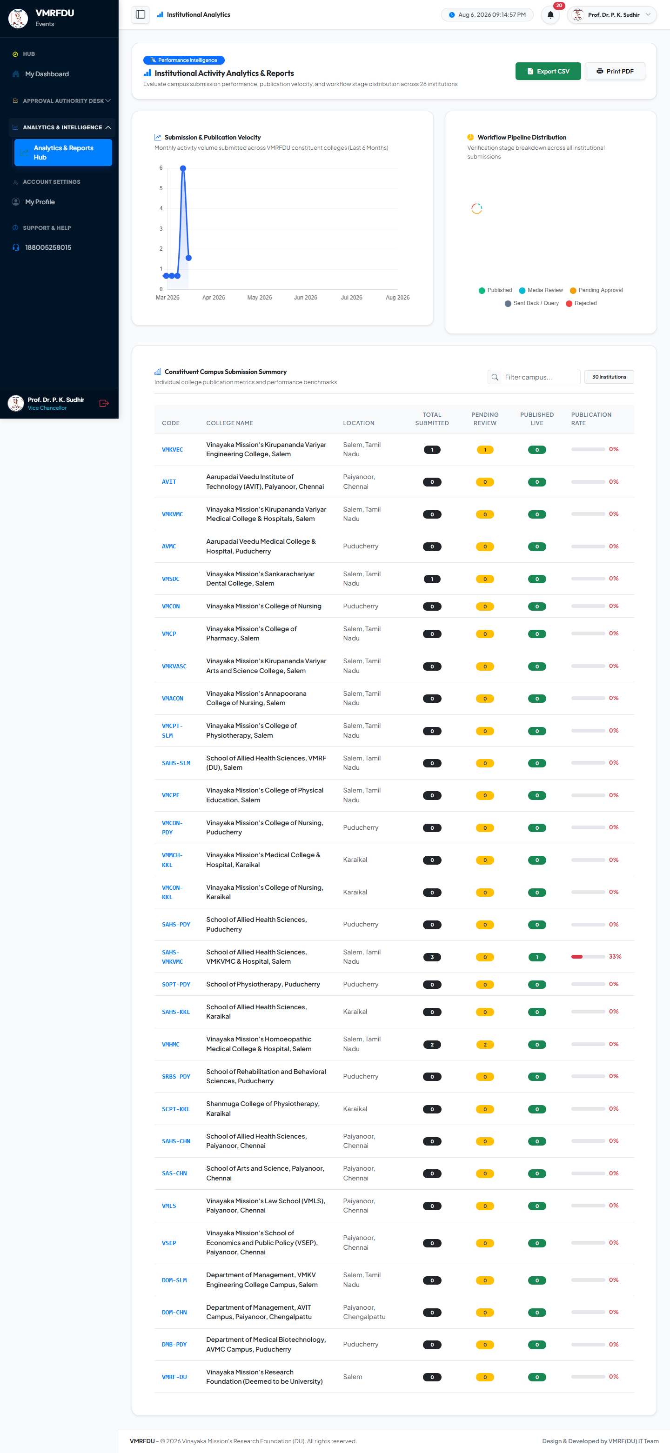
📊 University-Wide Analytics 📈 Category & College Breakdown 📥 CSV Download 🖨️ Printable Report

VICE CHANCELLOR | All Submissions — Global Overview | 22 / 50
Global read-only view of all activity submissions across every college and every workflow status — for monitoring and executive oversight without triggering any workflow transitions. Filterable by college, status, category, and date.
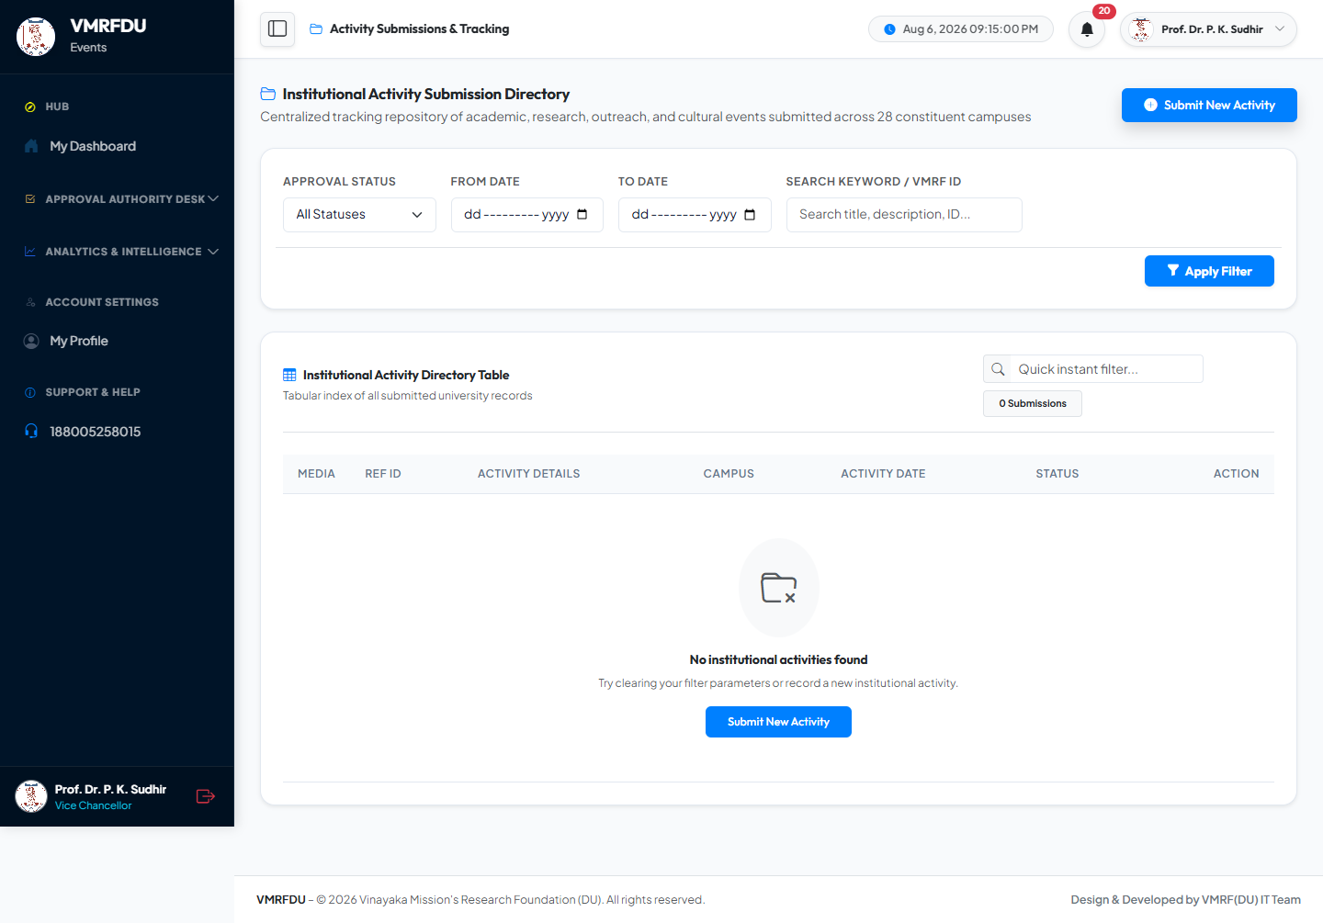
📋 All Colleges Visible 🌐 All Workflow Statuses 👁️ Read-Only Executive Oversight 🔍 Multi-Filter Support

VICE CHANCELLOR | Notifications (Vice Chancellor) | 23 / 50
In-app notification inbox for the VC: new activities submitted and awaiting verification, resubmissions by College Admins after discussion feedback, and system-level alerts.
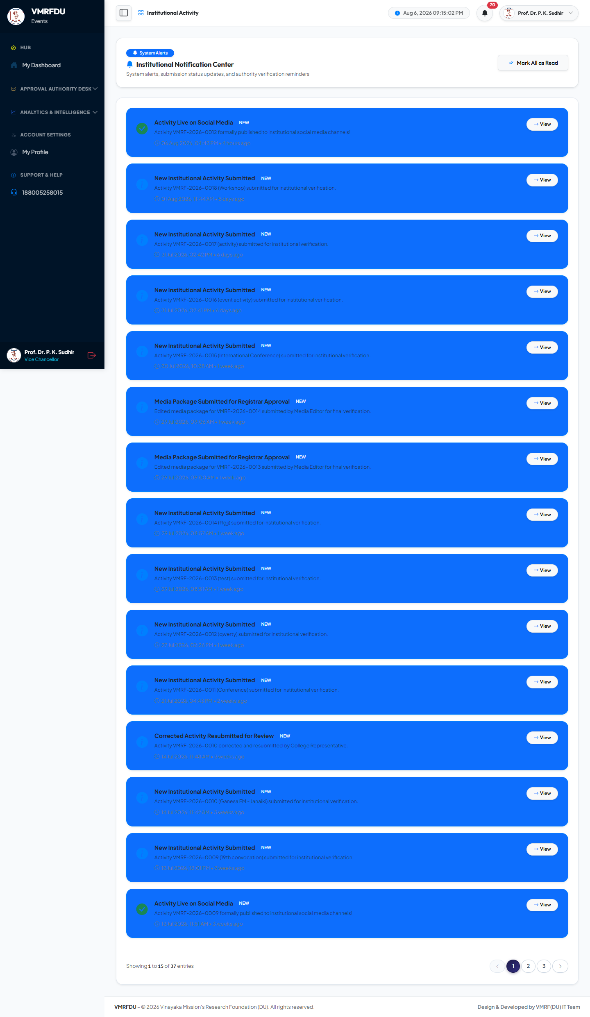
🔔 New Submission Alerts 🔄 Resubmission Notifications ✅ Mark Read

VICE CHANCELLOR | User Profile — Vice Chancellor | 24 / 50
Personal profile management for the Vice Chancellor: update name, phone, designation, upload profile avatar, and change account password with current-password confirmation.
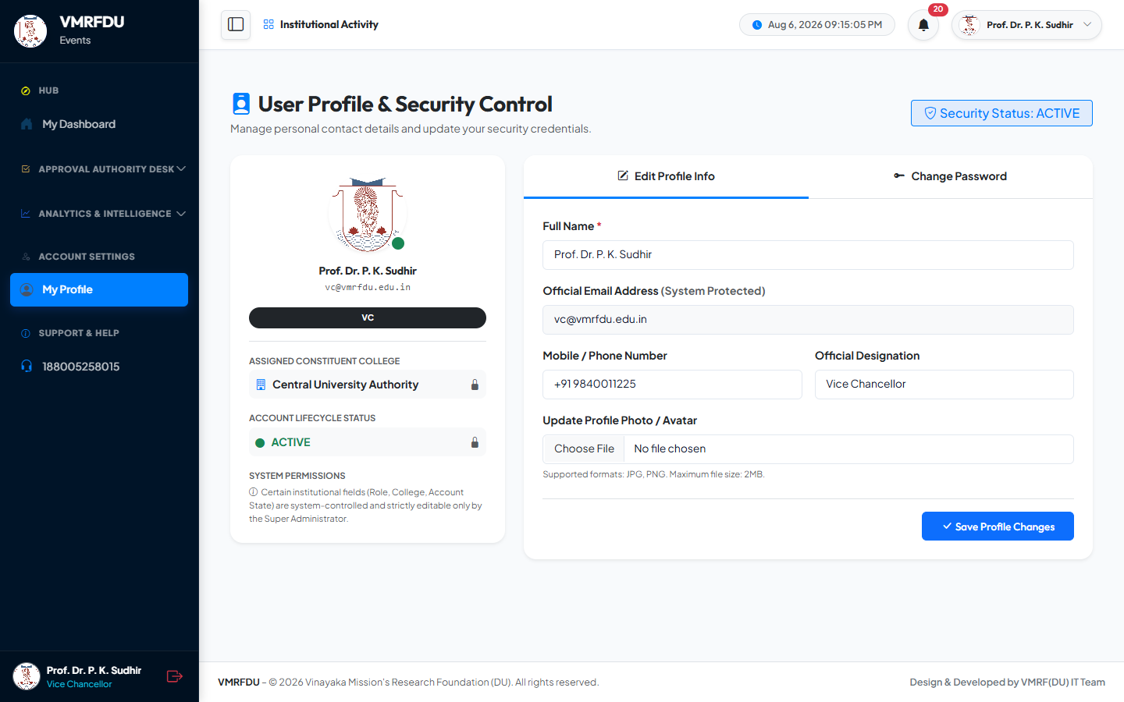
✏️ Edit Personal Information 🖼️ Profile Avatar Upload 🔑 Password Change

3.5 | 🏛️ Pro Vice Chancellor (Pro VC) — Verification & Oversight  provc@vmrfdu.edu.in · Role: pro_vc · Stage 1 Verification Authority · Global data access

PRO VICE CHANCELLOR | Pro VC Dashboard | 43 / 50
Pro Vice Chancellor's role-specific homepage: pending verification count, university-wide activity statistics, recent submission feed, approval rate indicators, and quick navigation to the verification queue and analytics dashboard.
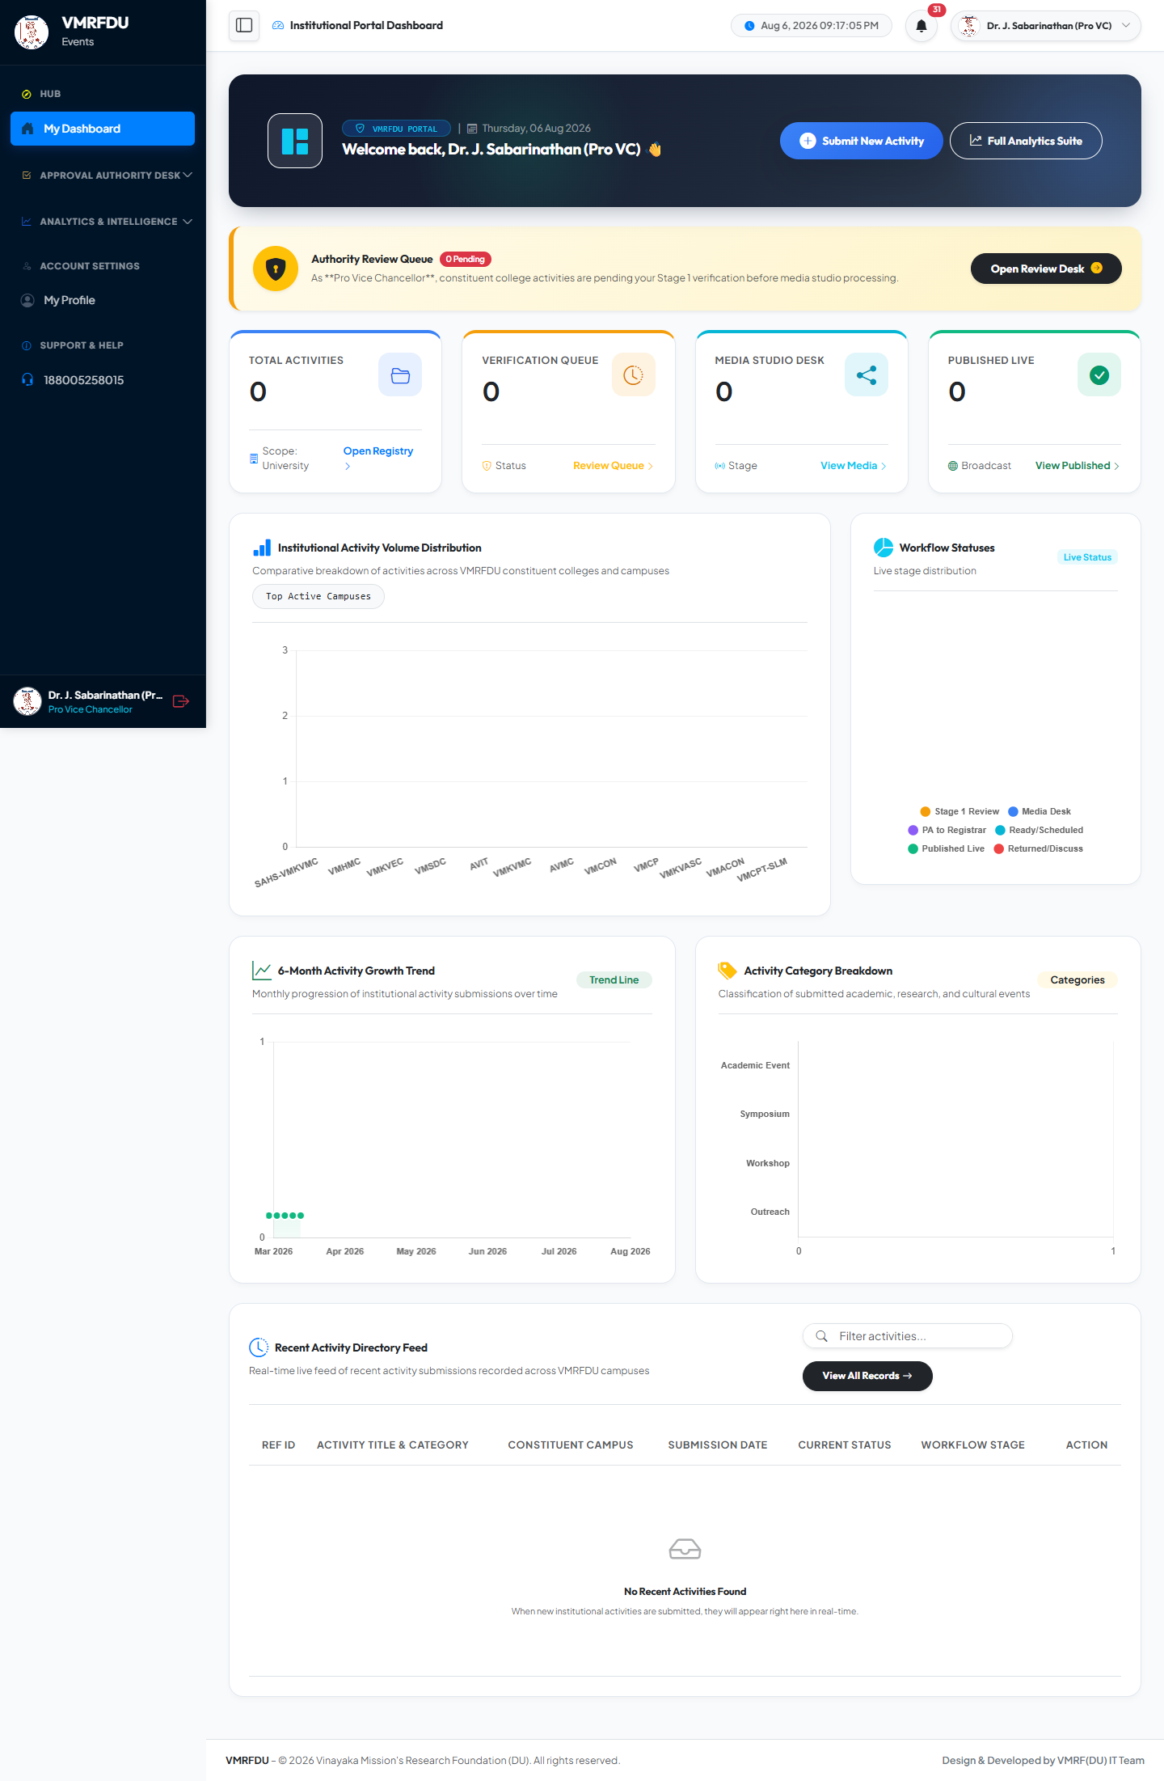
📋 Pending Queue Count 📊 University-Wide Stats 📈 Approval Rate Indicator ⚡ Quick Actions

PRO VICE CHANCELLOR | Verification Queue — Pending Submissions | 43 / 50
Stage 1 verification dashboard listing all activities submitted by College Admins awaiting institutional review. Each record shows the activity title, submitting college, event category, date, faculty coordinator, and uploaded photos. Three actions available — Approve (status → media_review), Discuss (returns to College Admin with remarks), Reject (terminates with mandatory reason).
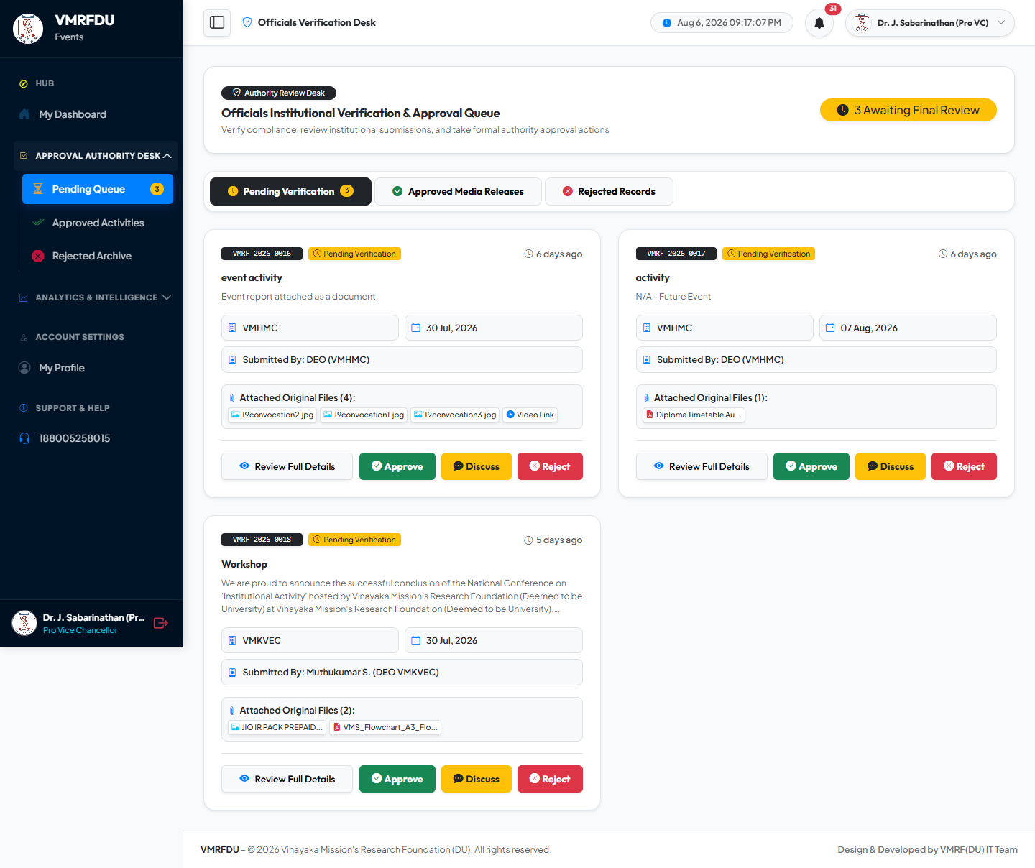
✅ Approve → media_review 💬 Discuss → Returned to College Admin ❌ Reject → Terminated (Mandatory Reason) 📝 Mandatory Remarks on Discuss / Reject

PRO VICE CHANCELLOR | Approved Submissions List | 44 / 50
Historical record of all activities approved by the Pro VC and forwarded to the Media Editor Studio for processing. Shows approval timestamp, remarks provided at time of approval, and the current downstream status of each record.
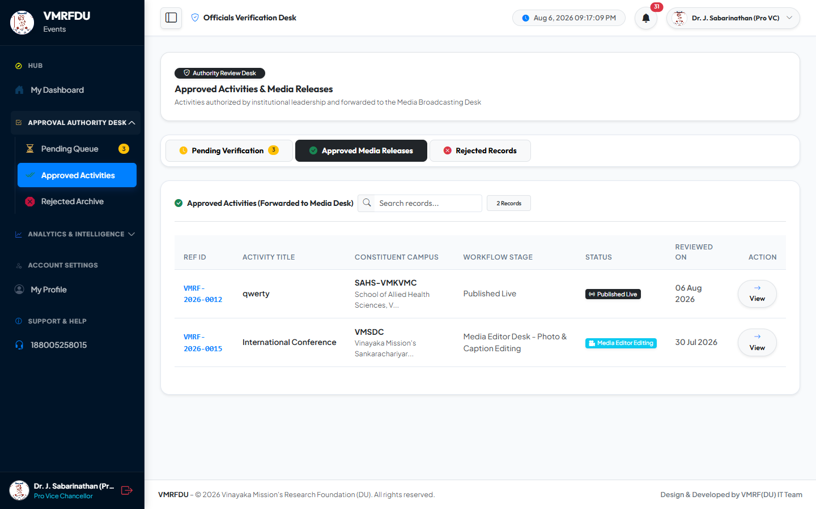
✅ Full Approved Records 📅 Approval Timestamps 🔄 Downstream Status Tracking

PRO VICE CHANCELLOR | Rejected Submissions Archive | 44 / 50
Record of all activities rejected at Stage 1 with mandatory rejection reasons and precise timestamps. Provides full governance traceability and allows colleges to understand why specific activities were not approved.
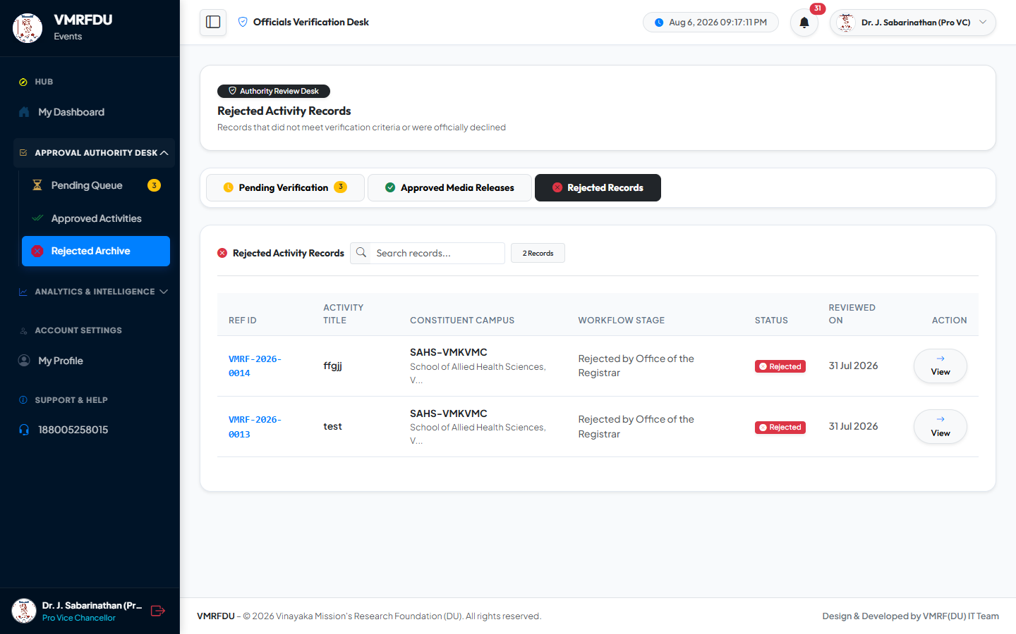
❌ Rejected Activity Records 📝 Mandatory Rejection Reasons 📅 Rejection Timestamps

PRO VICE CHANCELLOR | Analytics Dashboard (Pro VC View) | 45 / 50
University-wide analytics with full cross-college data visibility: overall approval rates, submission volumes broken down by category and college, stage-wise distribution, and monthly submission trends. Supports CSV download and printable executive report export.
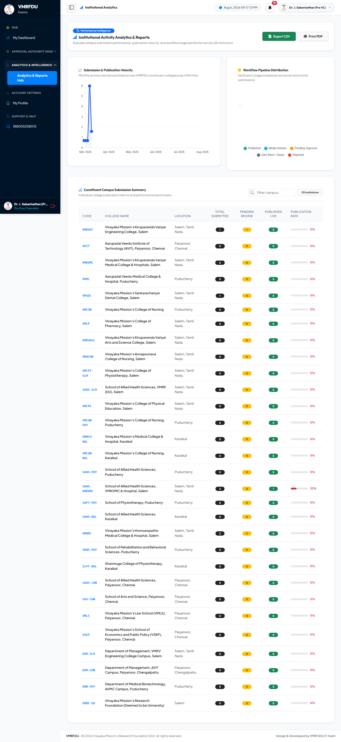
📊 University-Wide Analytics 📈 Category & College Breakdown 📥 CSV Download 🖨️ Printable Report

PRO VICE CHANCELLOR | All Submissions — Global Overview | 45 / 50
Global read-only view of all activity submissions across every college and every workflow status — for monitoring and executive oversight without triggering any workflow transitions. Filterable by college, status, category, and date.
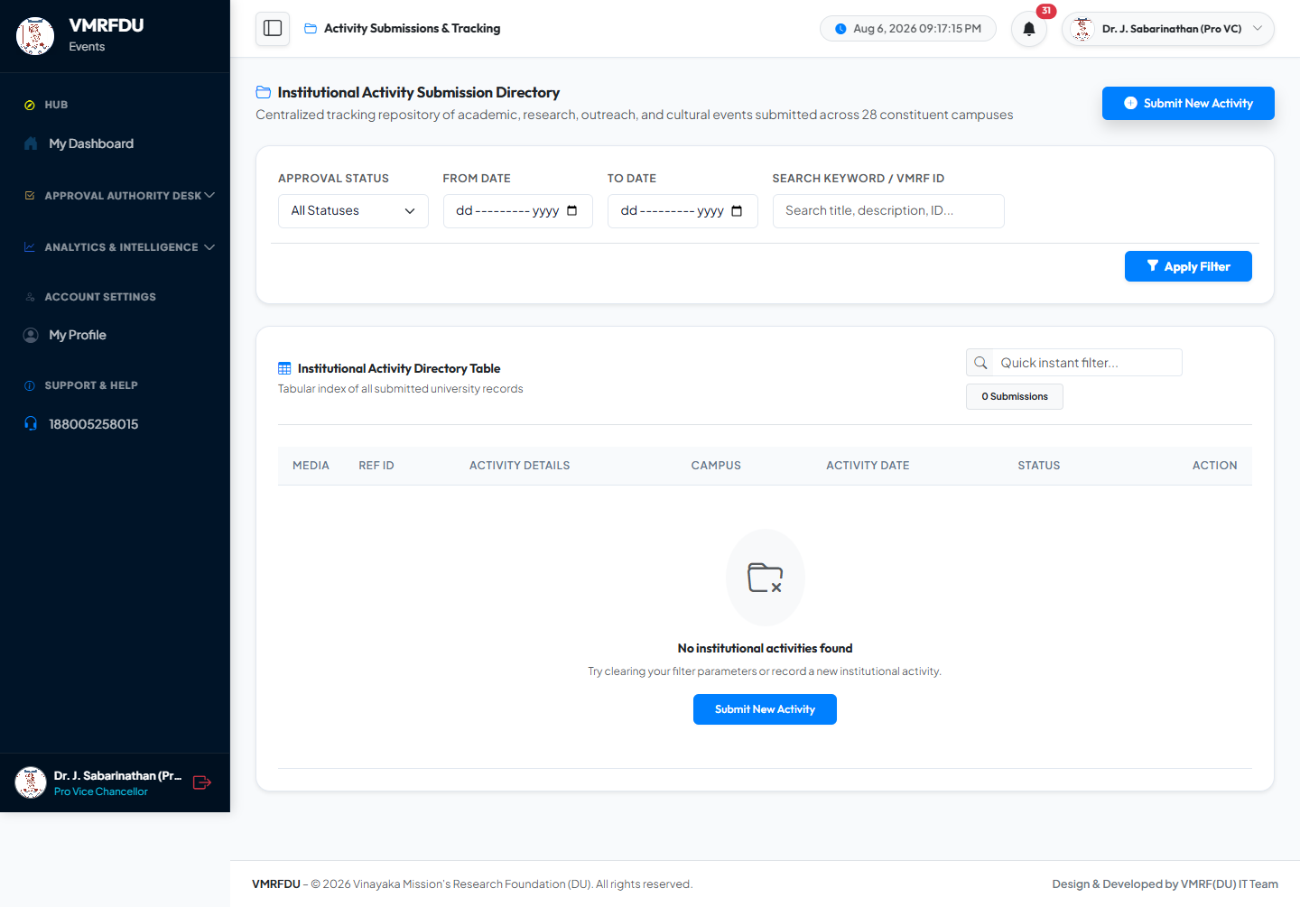
📋 All Colleges Visible 🌐 All Workflow Statuses 👁️ Read-Only Executive Oversight 🔍 Multi-Filter Support

PRO VICE CHANCELLOR | Notifications (Pro Vice Chancellor) | 46 / 50
In-app notification inbox for the Pro VC: new activities submitted and awaiting verification, resubmissions by College Admins after discussion feedback, and system-level alerts.
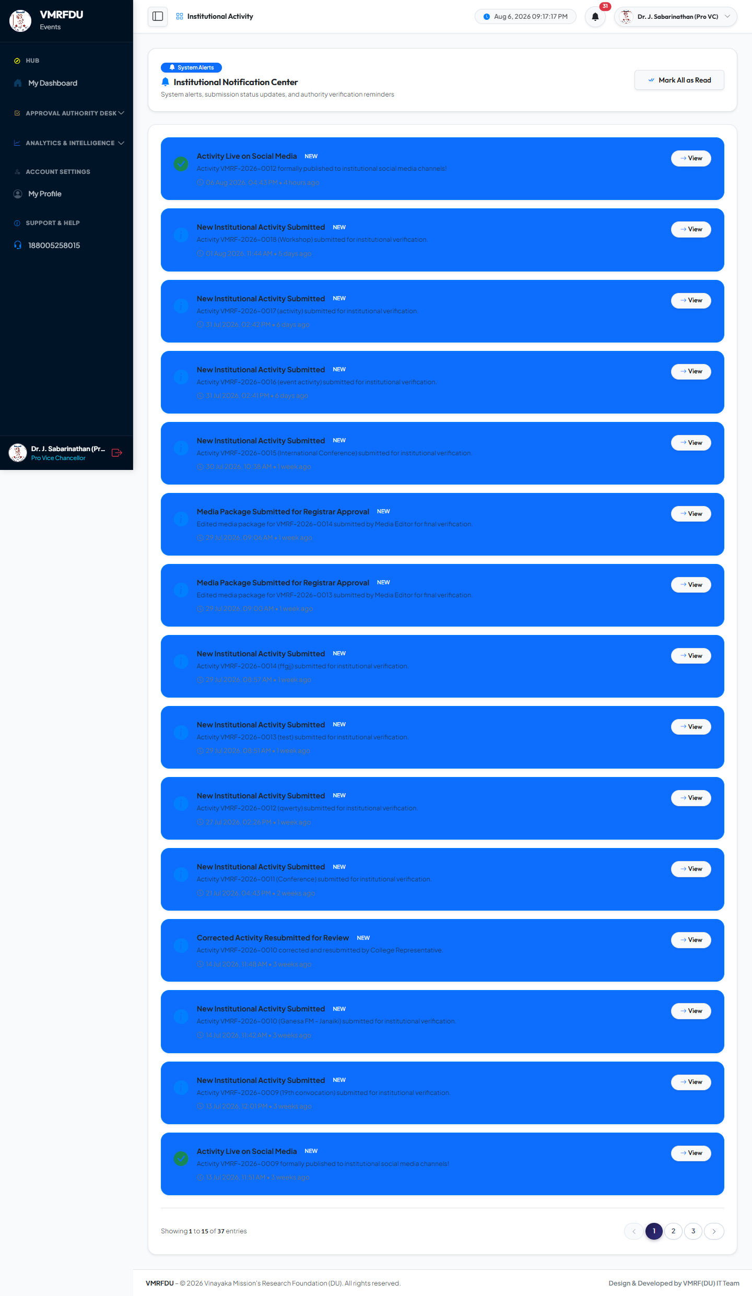
🔔 New Submission Alerts 🔄 Resubmission Notifications ✅ Mark Read

PRO VICE CHANCELLOR | User Profile — Pro Vice Chancellor | 46 / 50
Personal profile management for the Pro Vice Chancellor: update name, phone, designation, upload profile avatar, and change account password with current-password confirmation.
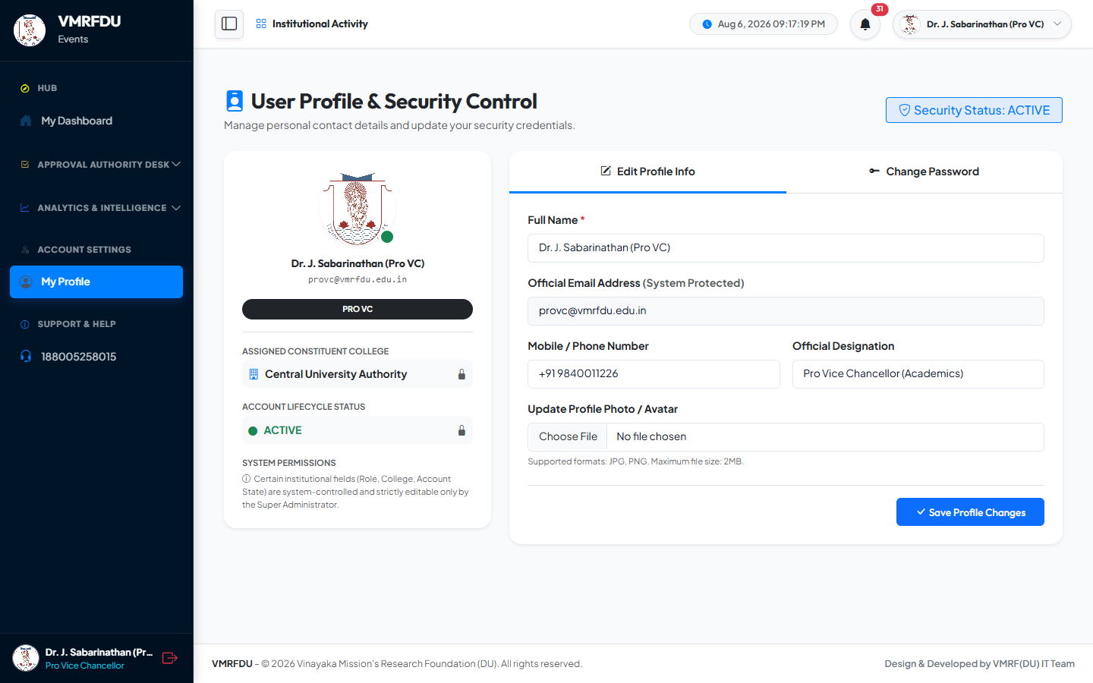
✏️ Edit Personal Information 🖼️ Profile Avatar Upload 🔑 Password Change

4 | 📋 Office of Registrar — Stage 2 Final Authorization  officeregistrar@vmrfdu.edu.in · Role: office_registrar · Executive review before broadcast

OFFICE REGISTRAR | Office of Registrar Dashboard | 25 / 50
Role-specific homepage showing locked submissions currently pending Stage 2 executive review (registrar_approval status), the executive approval action queue, and a summary of previously reviewed media packages.
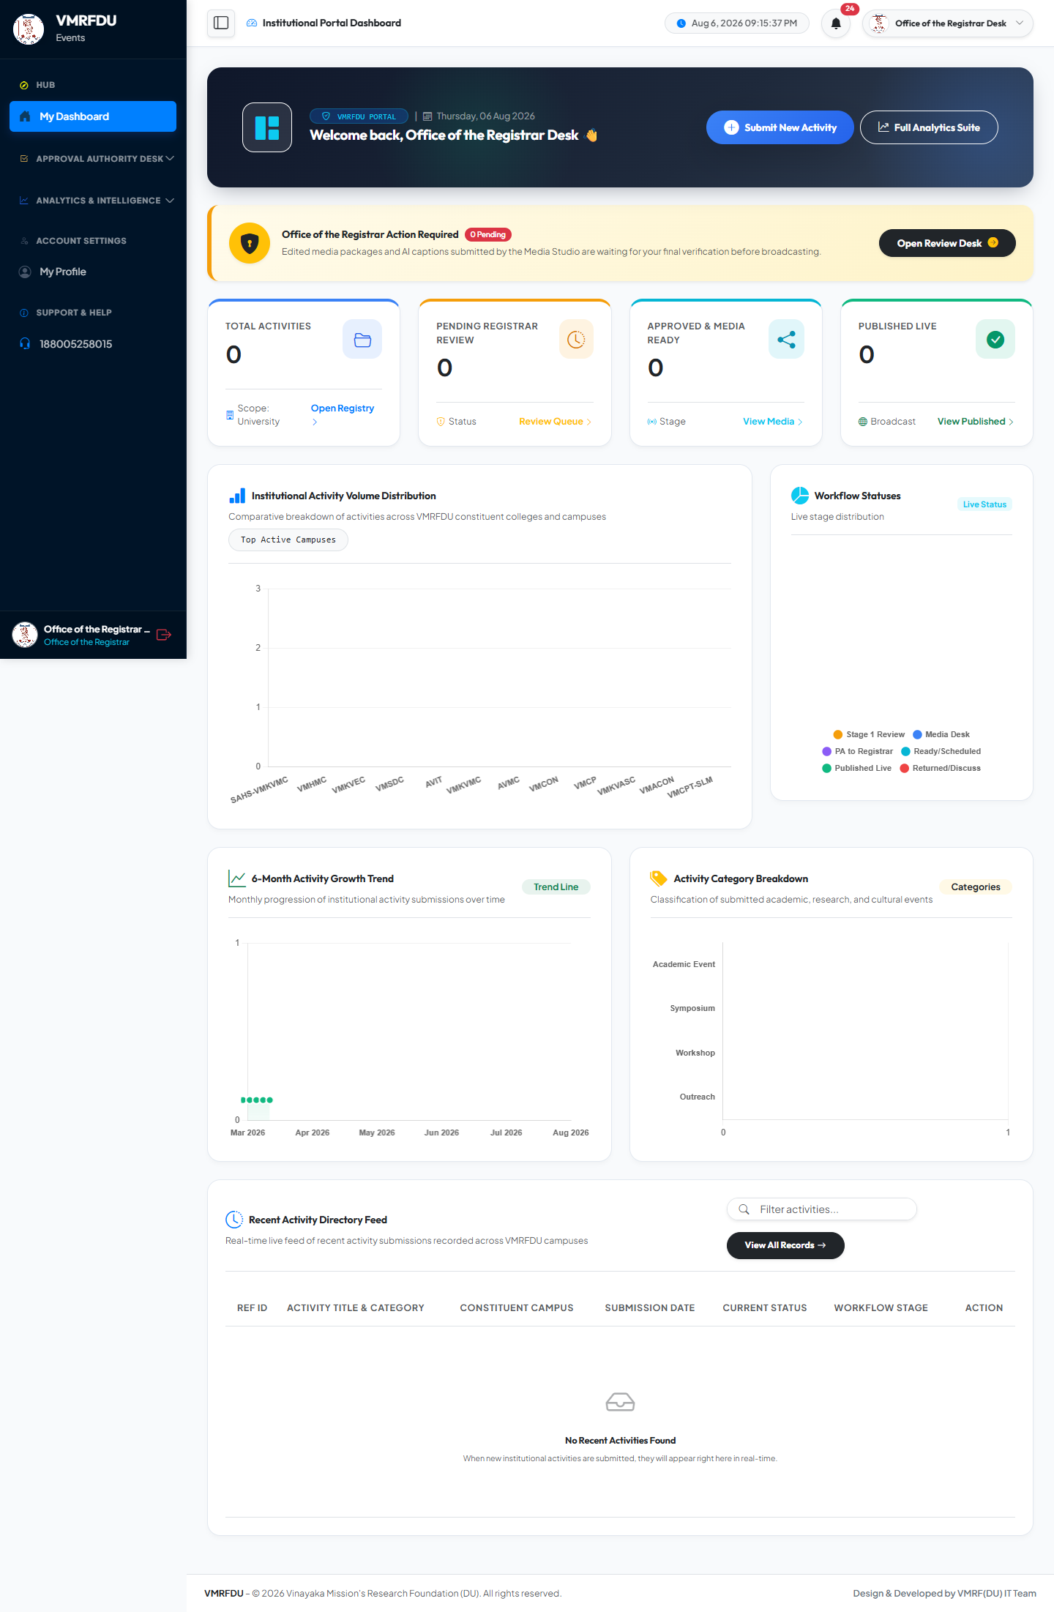
🔒 Locked Submissions Pending Review ✅ Executive Approval Queue 📊 Review Statistics

OFFICE REGISTRAR | Stage 2 Media Review Queue — Locked Packages | 26 / 50
Executive review interface for media packages submitted by the Media Editor and now locked (registrar_approval status). Each package displays the optimized photos, AI-generated social media captions, and the full activity details. Two actions: Approve (status → ready_to_publish) or Discuss (🔓 unlocks the record and returns it to the Media Editor's queue with feedback remarks).
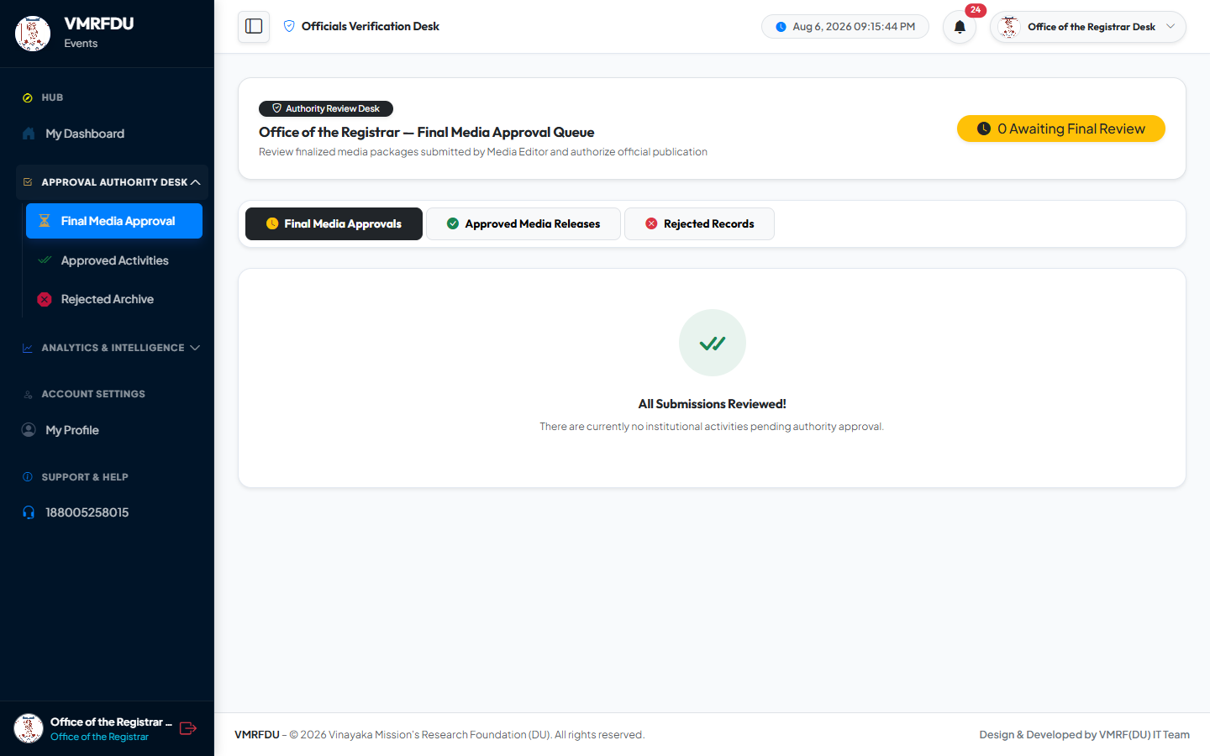
🔒 Locked / Read-Only Records ✅ Approve → ready_to_publish 💬 Discuss → 🔓 Unlocks & Returns to Editor 📸 Optimized Media Package Preview

OFFICE REGISTRAR | Approvals View (Office of Registrar) | 27 / 50
Historical view of all activities that the Office of Registrar has approved or sent for discussion, with the full audit trail of decisions and timestamps for each record.
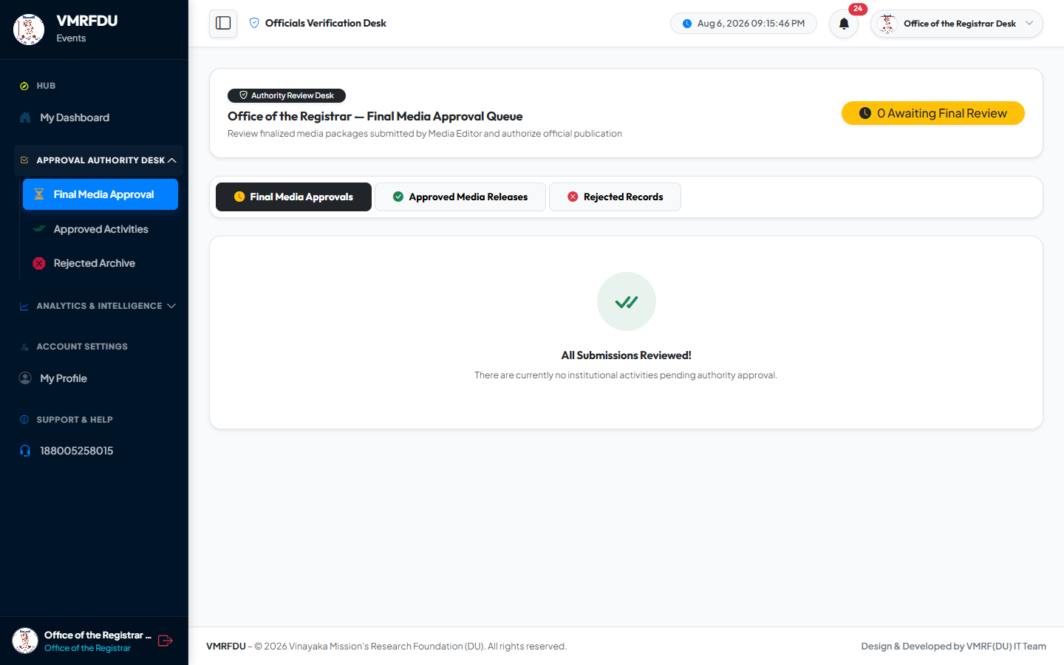
✅ Approved History 💬 Discuss / Return History 📅 Full Decision Timeline

OFFICE REGISTRAR | Analytics Dashboard (Office of Registrar) | 28 / 50
Stage 2 processing KPIs from the Office of Registrar perspective: media review throughput, approval and discussion rates, and average turnaround times for executive reviews.
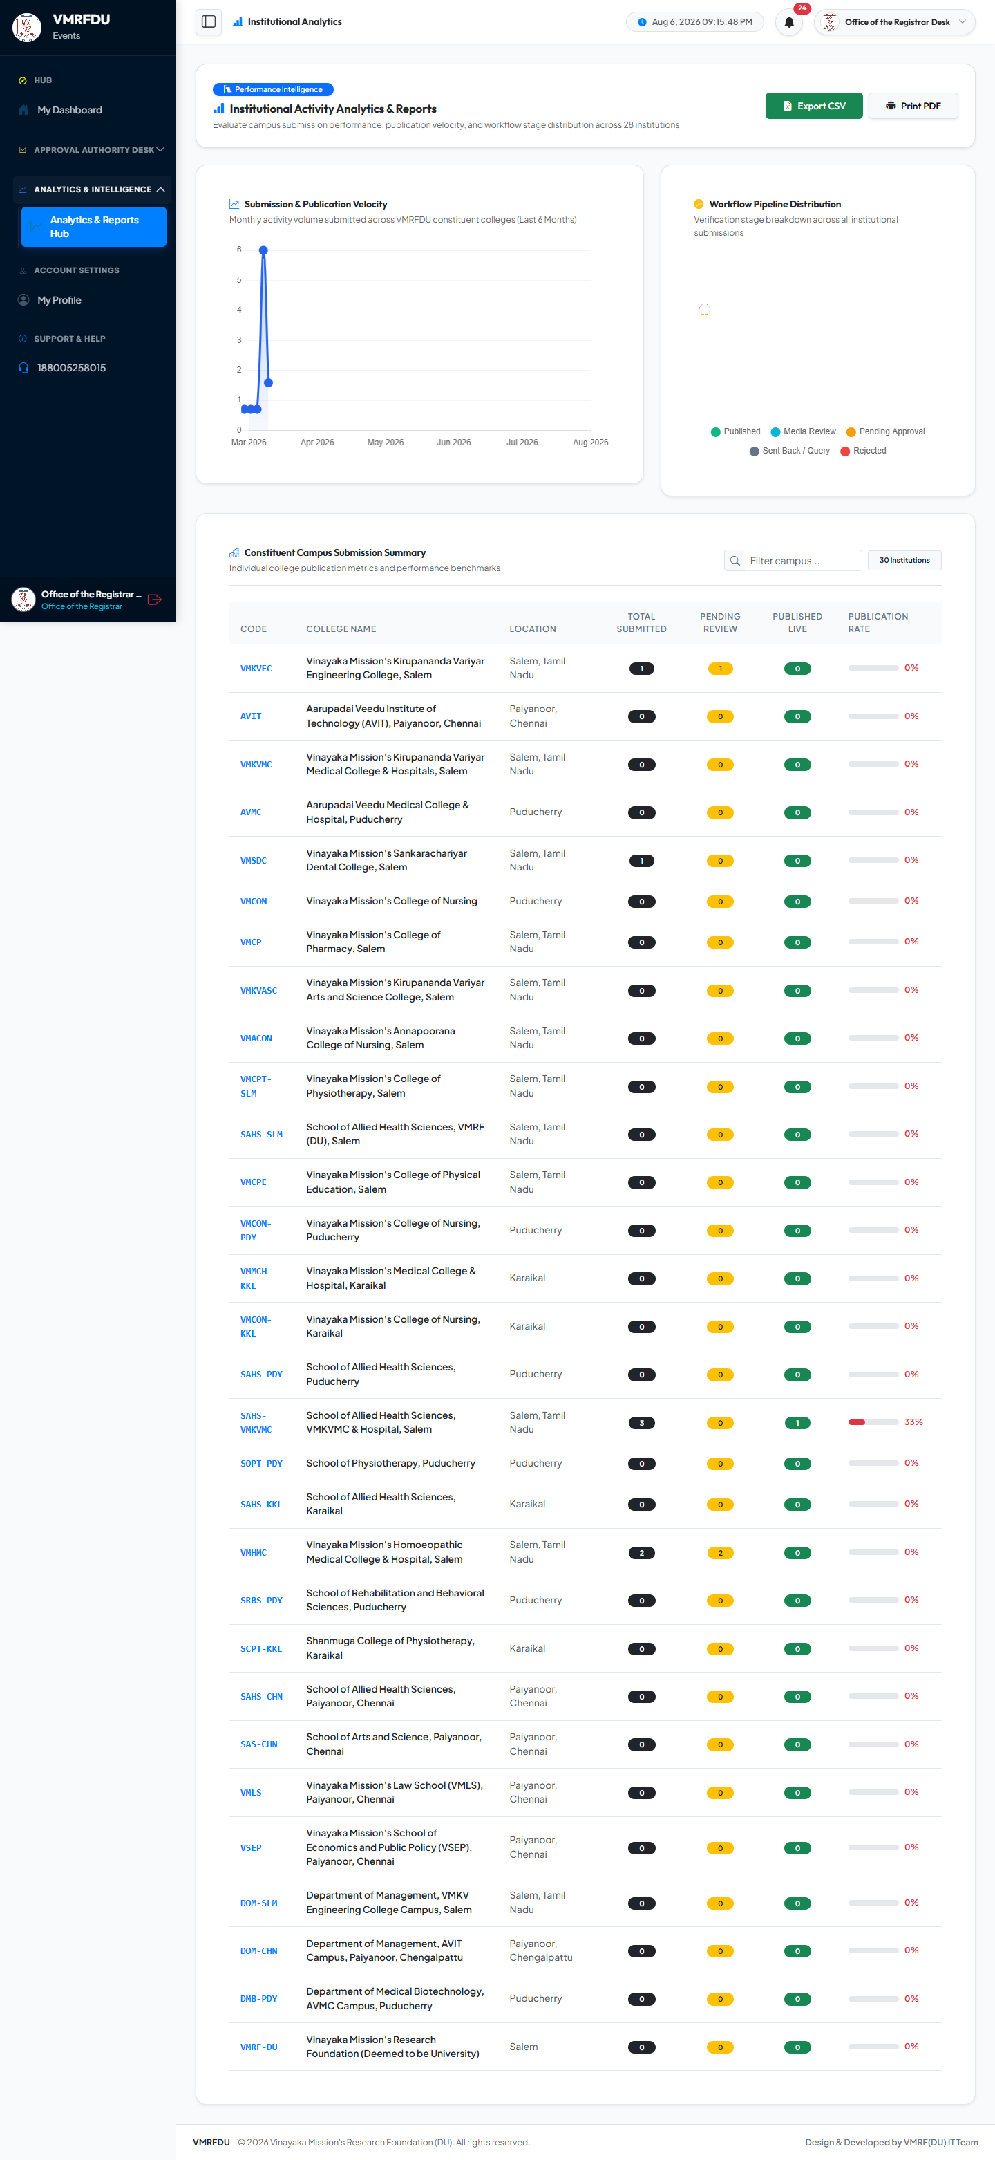
📊 Stage 2 Review KPIs 📈 Throughput Charts ⏱️ Turnaround Time Analysis

OFFICE REGISTRAR | Notifications (Office of Registrar) | 29 / 50
Alerts received when the Media Editor submits a new package for Stage 2 review, and confirmations when approval or discussion actions are completed.
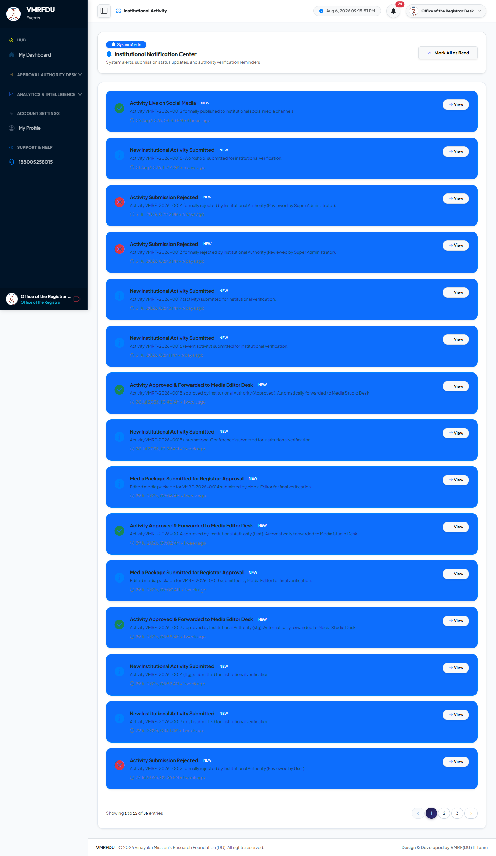
🔒 New Package for Review Alert ✅ Approval Confirmation 💬 Discussion Action Alert

OFFICE REGISTRAR | User Profile — Office of Registrar | 30 / 50
Personal profile management: update information, upload avatar, and change account password with current-password verification.
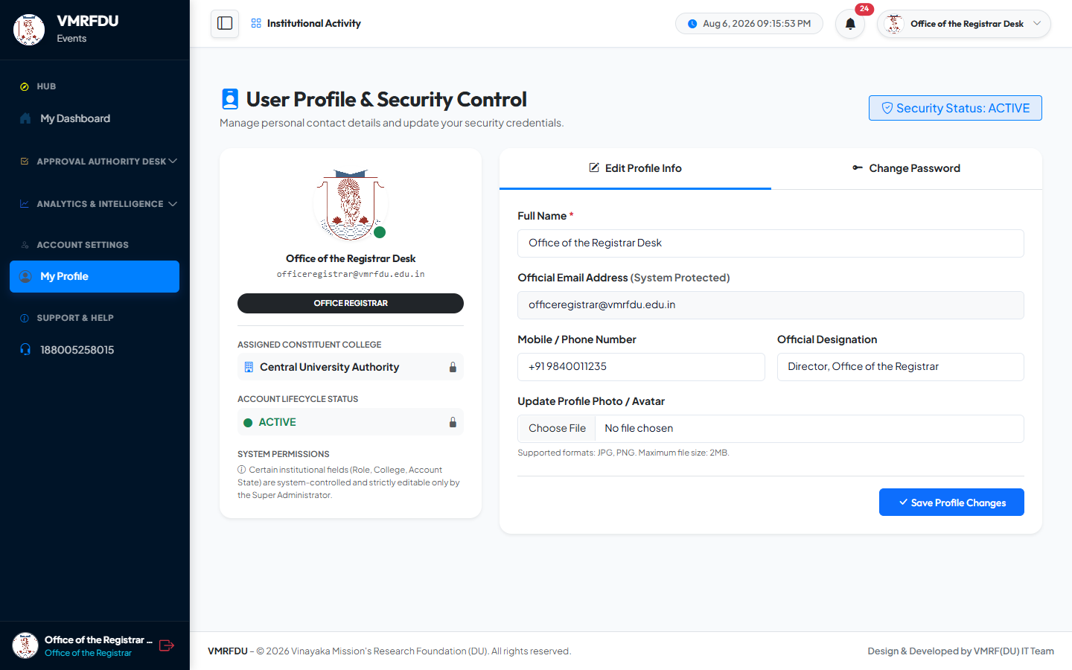
✏️ Edit Personal Information 🖼️ Profile Avatar Upload 🔑 Password Change

5 | 🎨 Media Editor Desk — Studio & Broadcast  editor@vmrfdu.edu.in · Role: media_editor · Karthik N. (Lead Media Editor) · Photo · Caption · ZIP · Publish

MEDIA EDITOR | Media Editor Dashboard | 31 / 50
The Media Editor's command centre — on login, the system lands directly on the Media Studio. Displays four queue counts at a glance: Editing Queue (media_review activities awaiting processing), Locked Submissions (registrar_approval 🔒 — submitted to Office of Registrar), Revision Queue (editor_discuss 🔓 — returned for corrections), and Ready to Publish count.
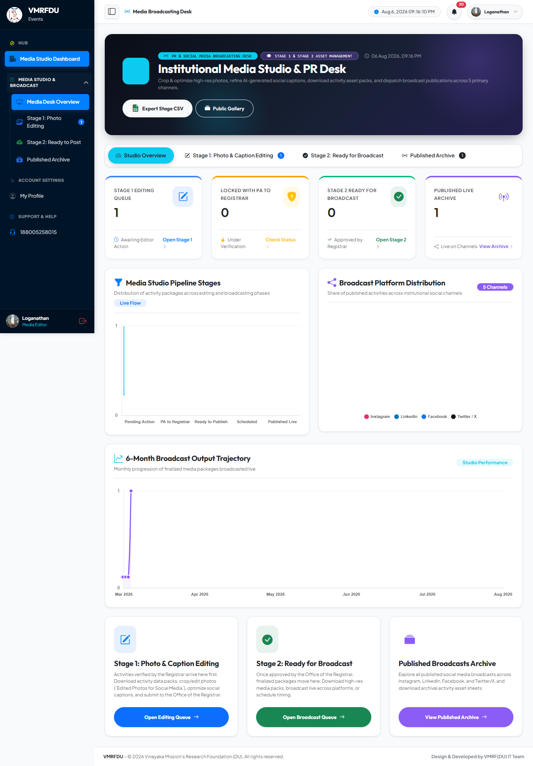
📸 Editing Queue Count 🔒 Locked Submissions Count ✅ Ready to Publish Count 🔓 Discuss / Revision Queue Count

MEDIA EDITOR | Media Studio — Editing Queue & Locked Submissions | 32 / 50
Main media processing workspace. Activities in media_review appear in the editing queue for photo optimization and AI caption refinement. After submitting to the Office of Registrar, records move to the Locked section (🔒 padlock visible — fully read-only). Activities returned via editor_discuss appear for revision. One-click ZIP media pack download available for any activity.
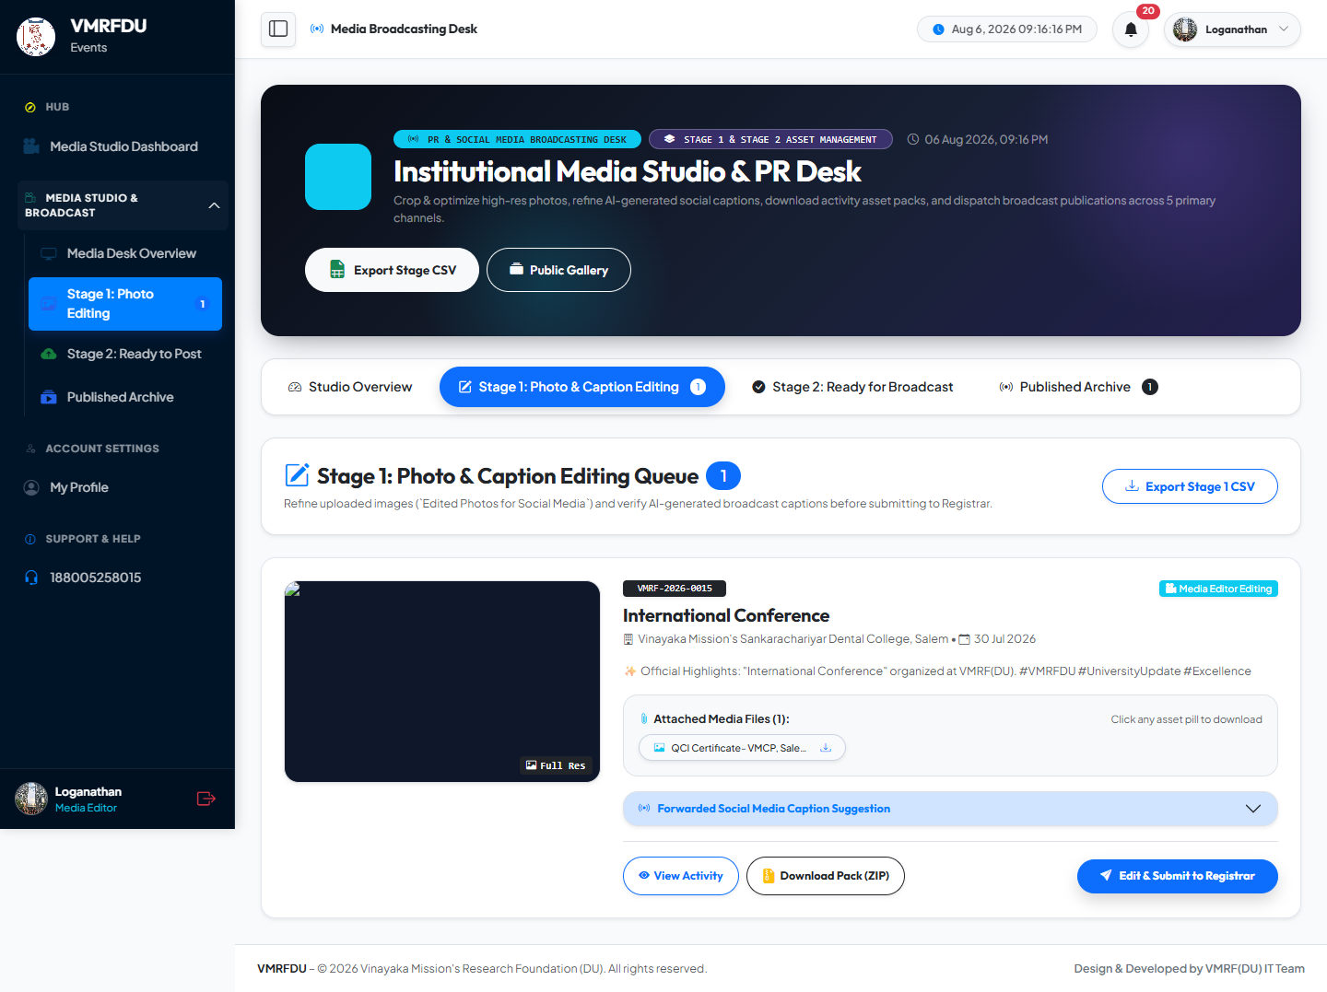
📸 Photo Optimization ✏️ AI Caption Refinement 🔒 Locked Read-Only Records (Padlock 🔒) 📤 Submit to Office of Registrar 📦 ZIP Media Pack Download 🔓 editor_discuss Revision Queue

MEDIA EDITOR | Submission History (Media Editor) | 33 / 50
Historical view of all activity submissions processed by this Media Editor, including their current downstream status after Stage 2 executive review and final publication on platforms.
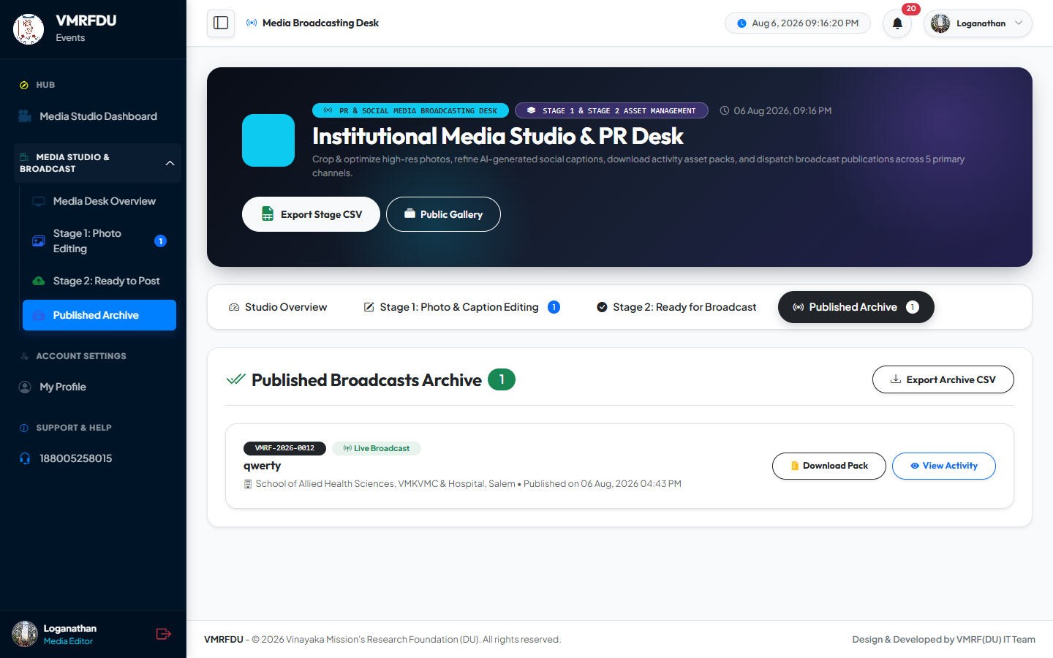
📋 Processed Activity History 🎉 Published Activity Records 🔄 Downstream Status Tracking

MEDIA EDITOR | Analytics Dashboard (Media Editor) | 34 / 50
Media processing performance KPIs: editing throughput, average processing time per activity, publishing rates, and distribution of published content across platforms (Instagram, LinkedIn, Twitter/X, Portal Archive).
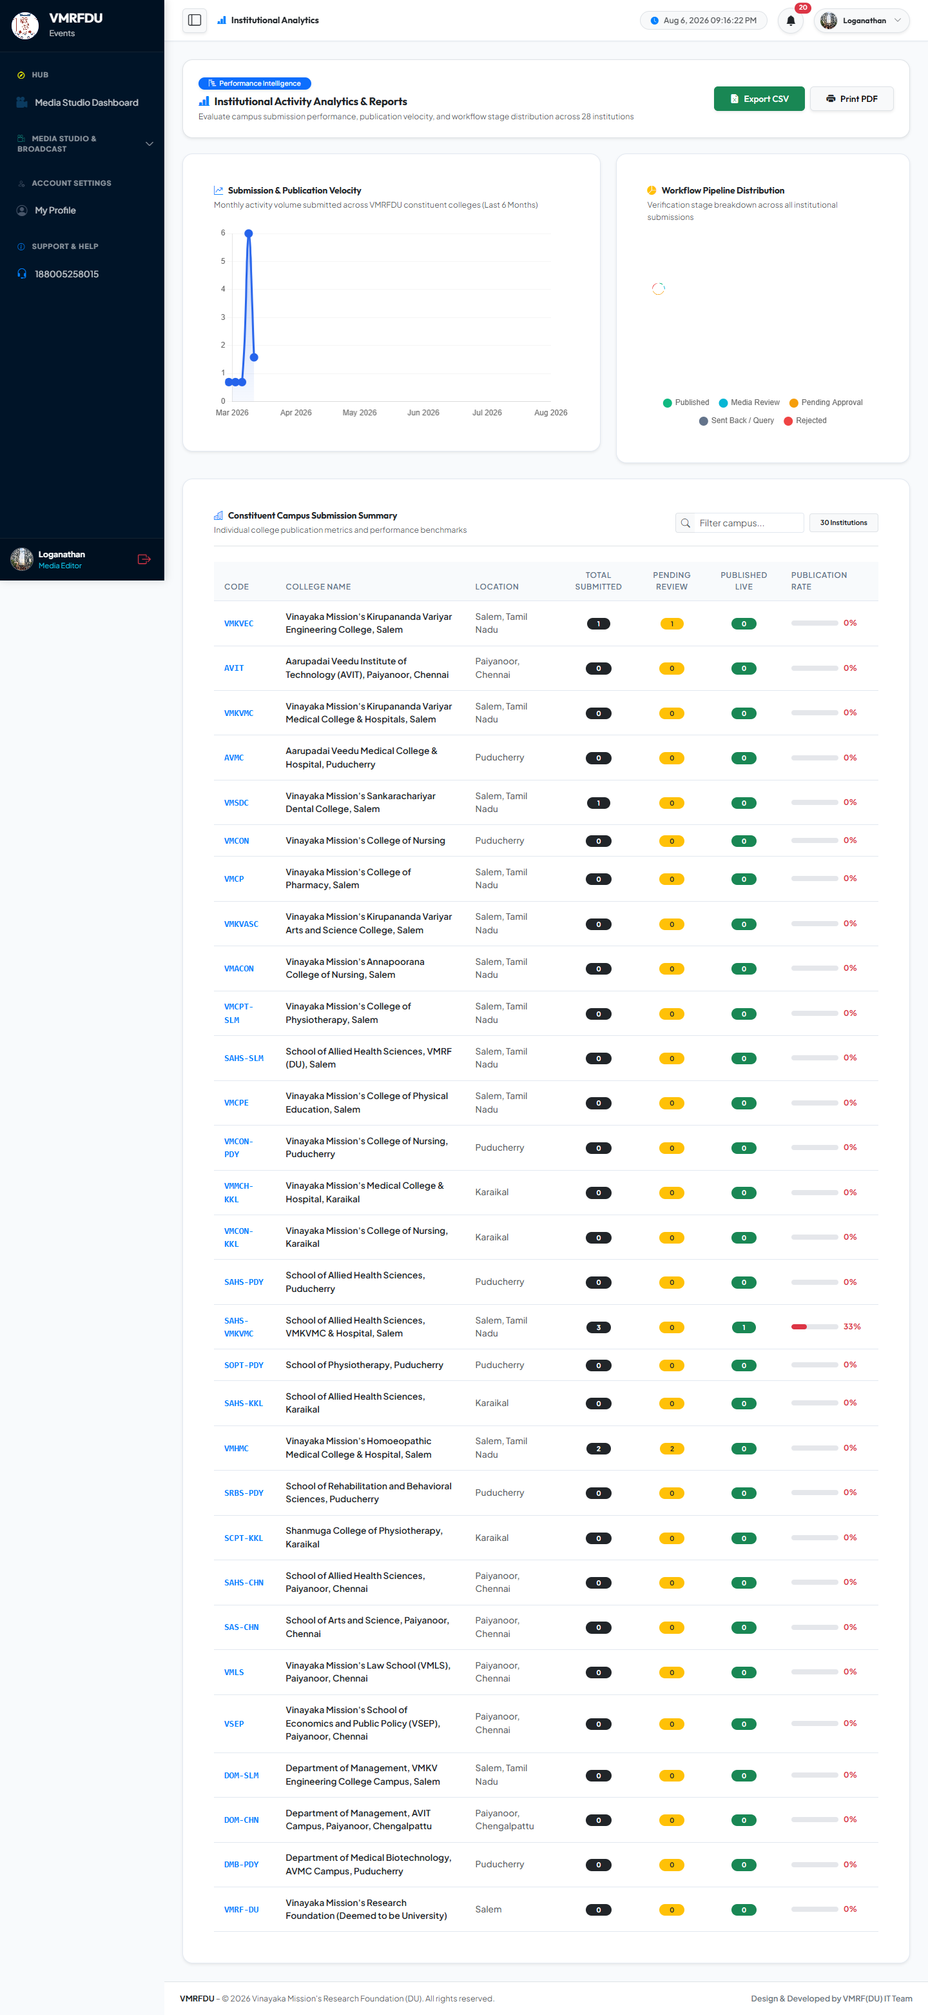
📊 Processing Performance KPIs 📈 Throughput Trend Charts 📡 Platform Publishing Distribution

MEDIA EDITOR | Notifications (Media Editor) | 35 / 50
Alert inbox for the Media Editor: new activities entering media_review queue (from Registrar/VC approval), notifications when the Office of Registrar sends packages back for revision (editor_discuss), and confirmations when ready_to_publish status is granted.
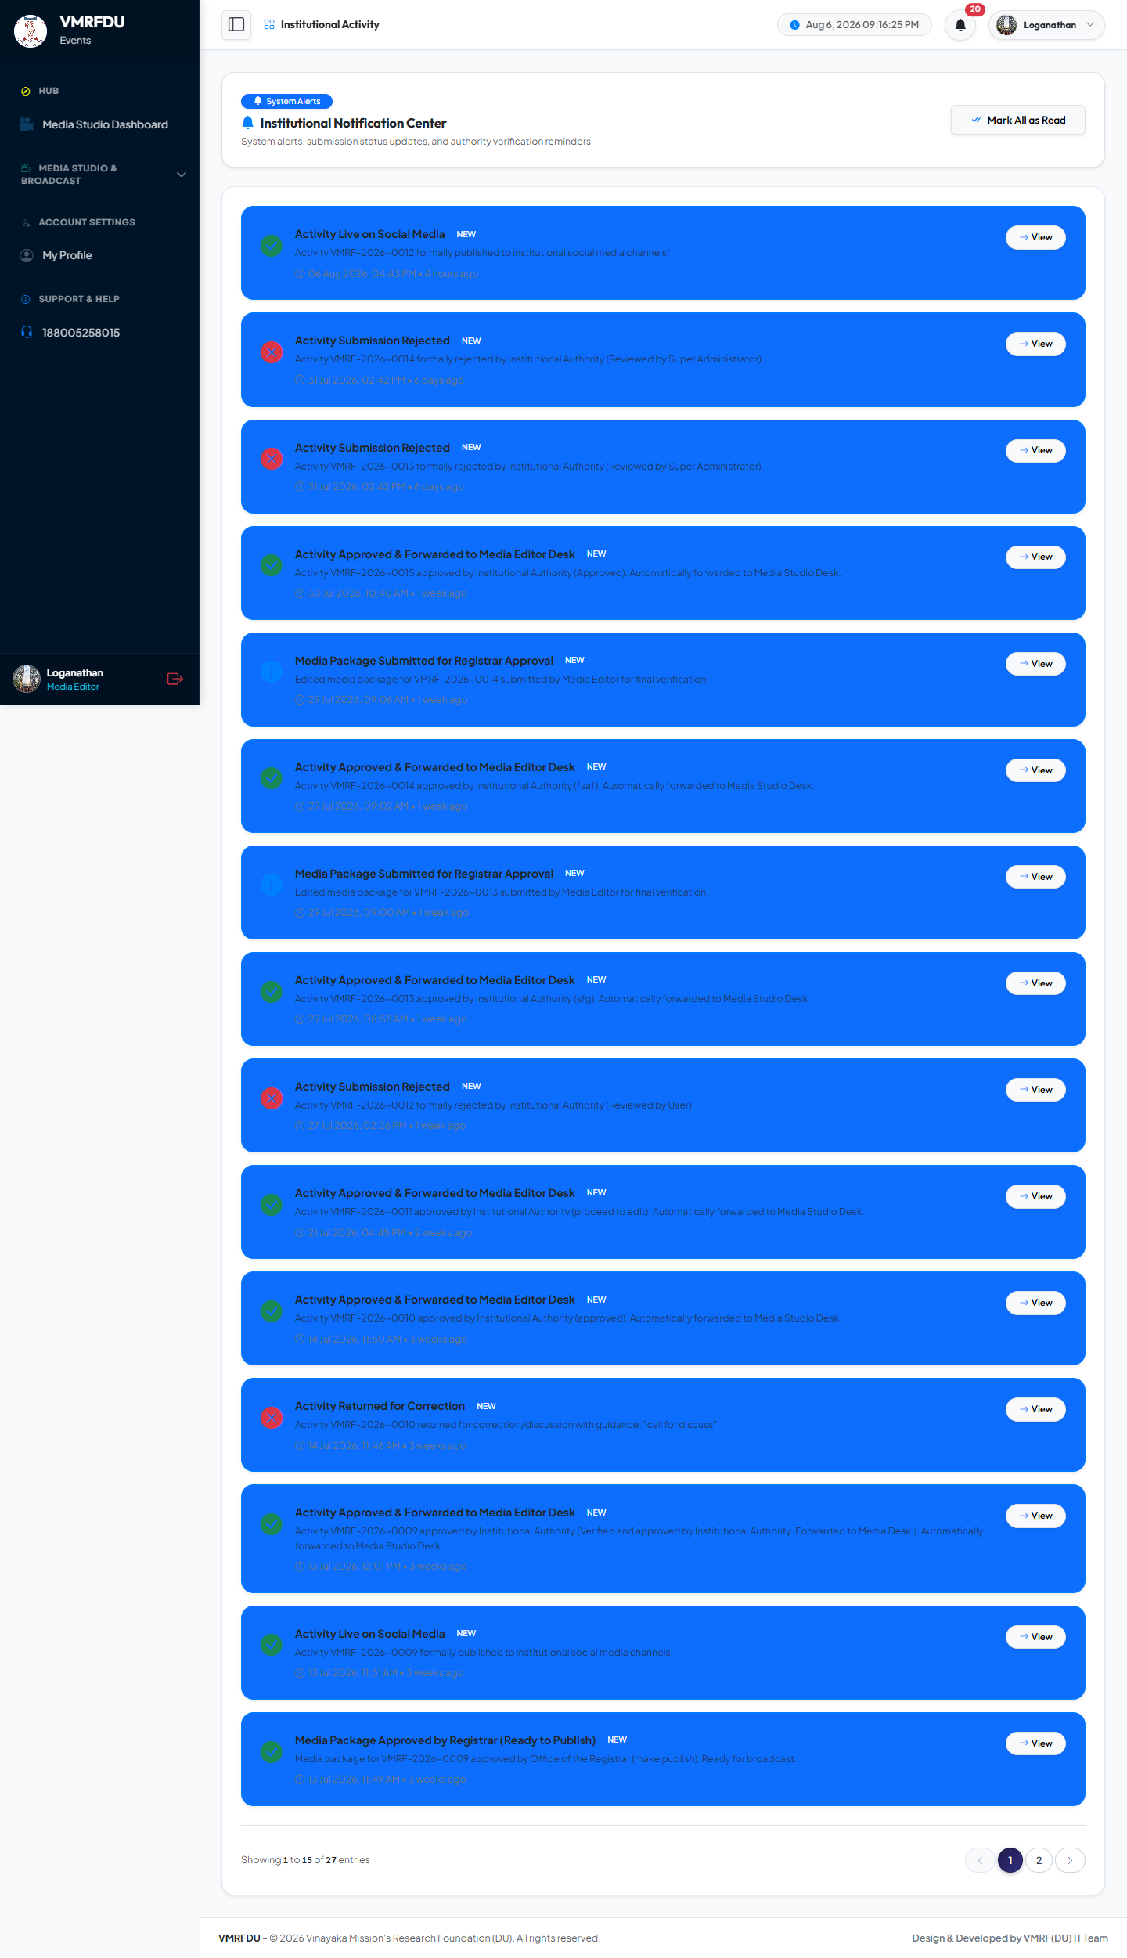
📸 New Media Review Queue Alert 🔓 editor_discuss Return Notification ✅ Ready to Publish Granted Alert

MEDIA EDITOR | User Profile — Media Editor (Karthik N.) | 36 / 50
Personal profile management for Karthik N. (Lead Media Editor): update name, phone, designation, upload profile avatar, and change account password.
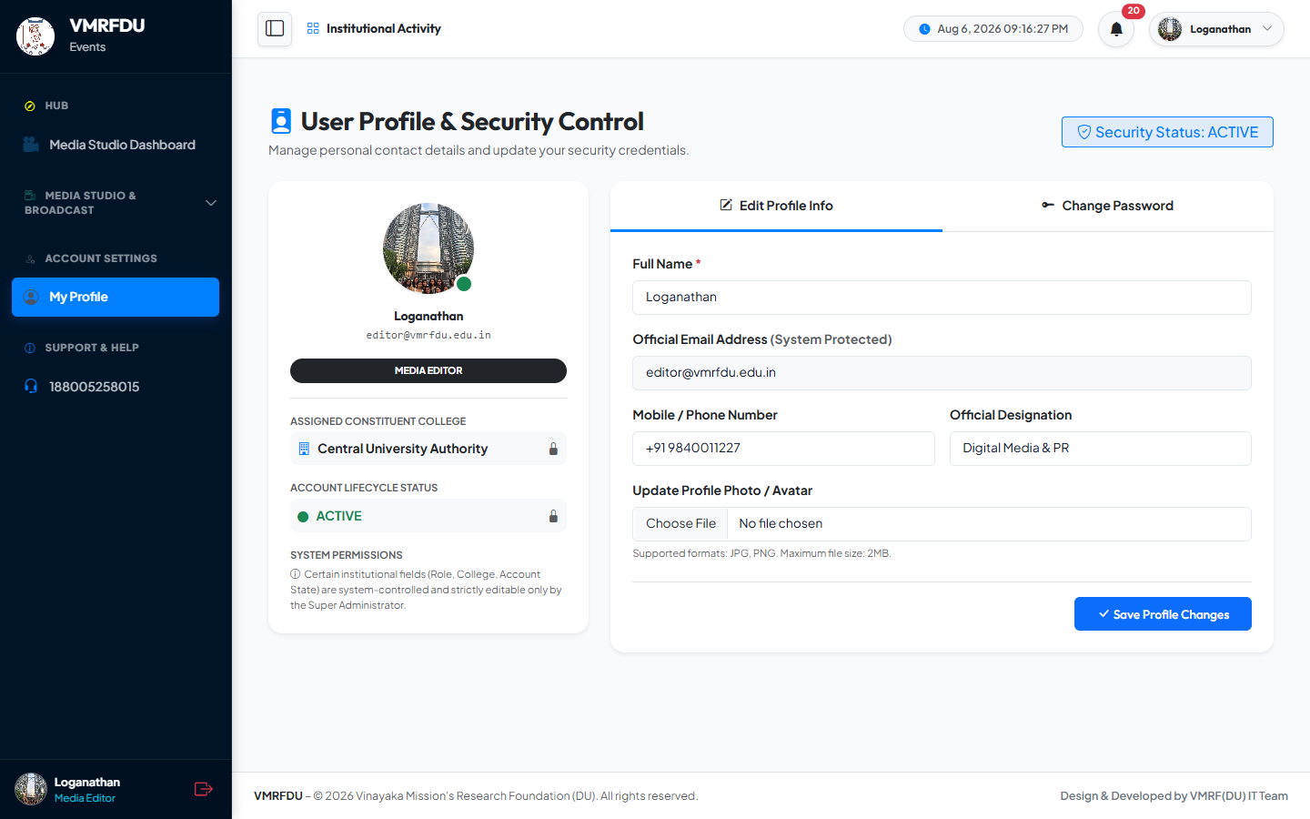
✏️ Edit Personal Information 🖼️ Profile Avatar Upload 🔑 Password Change

6 | 🏫 College Admin / DEO — Activity Submission & Tracking  deo.sahs-pdy@vmrfdu.edu.in · Role: college_admin · DEO, School of Allied Health Sciences (SAHS-PDY) · College-scoped

COLLEGE ADMIN | College Admin Dashboard | 37 / 50
Role-specific homepage for the DEO (SAHS-PDY). Displays submission counts by status (draft / pending verification / approved / rejected / published) scoped exclusively to SAHS-PDY college. Recent activity feed filtered to this college. Quick-submit action button for immediate activity creation.
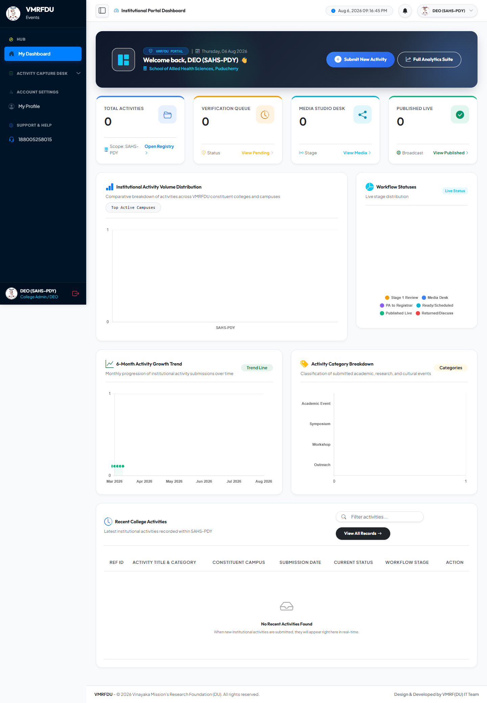
📊 SAHS-PDY College-Scoped Statistics 🏫 Own College Data Only ⚡ Quick Submit New Activity 🔄 Live Status Summary

COLLEGE ADMIN | Submissions List (College Admin) | 38 / 50
Complete list of all activities submitted by SAHS-PDY, filterable by status (All / Draft / Pending / Approved / Media Review / Published / Rejected). Each row shows the unique Reference ID (VMRF-2026-XXXX format), activity title, event date, and current status badge. The Edit button is enabled only when status is "discuss" — the activity has been returned for correction.
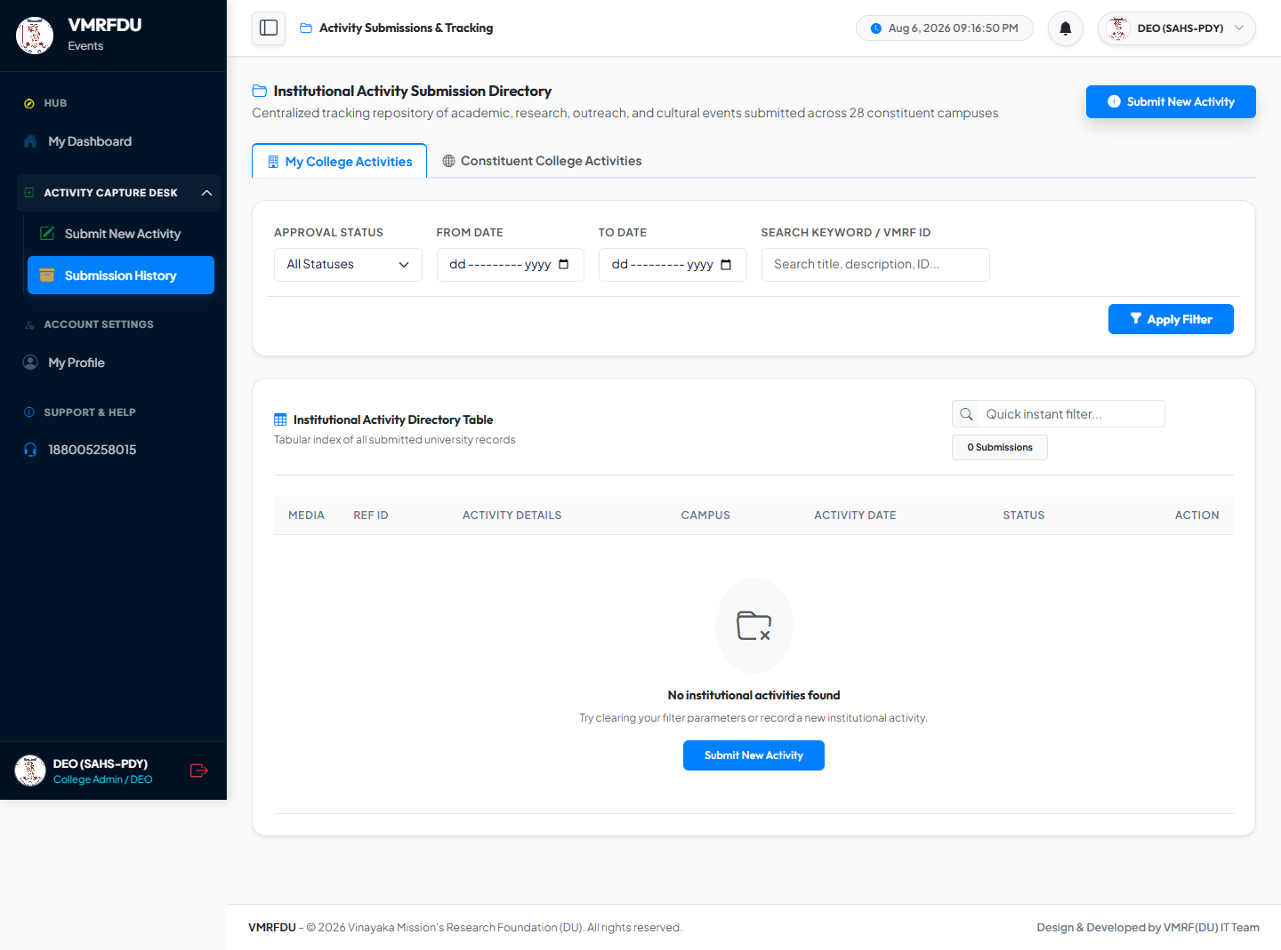
📋 Status-Filtered Submission List 🔑 VMRF-2026-XXXX Reference IDs 💬 View Registrar Feedback ✏️ Edit Enabled Only in Discuss State

COLLEGE ADMIN | Create New Activity Form | 39 / 50
The primary submission form for institutional activities. Mandatory fields: activity title, description, event date, event category (Symposium / Workshop / Health Camp / Guest Lecture / Cultural / MoU / Sports / NSS / NCC / Hackathon / etc.), event location, target audience, and faculty coordinator name, email, and phone. Mandatory photo upload (JPG / PNG / WEBP, max 10 MB each). Optional PDF document upload (max 15 MB). Integrated AI Caption Generator modal with 12+ professional institutional templates for instant social media caption creation. Save as Draft at any time, or Submit directly to the Stage 1 verification pipeline.
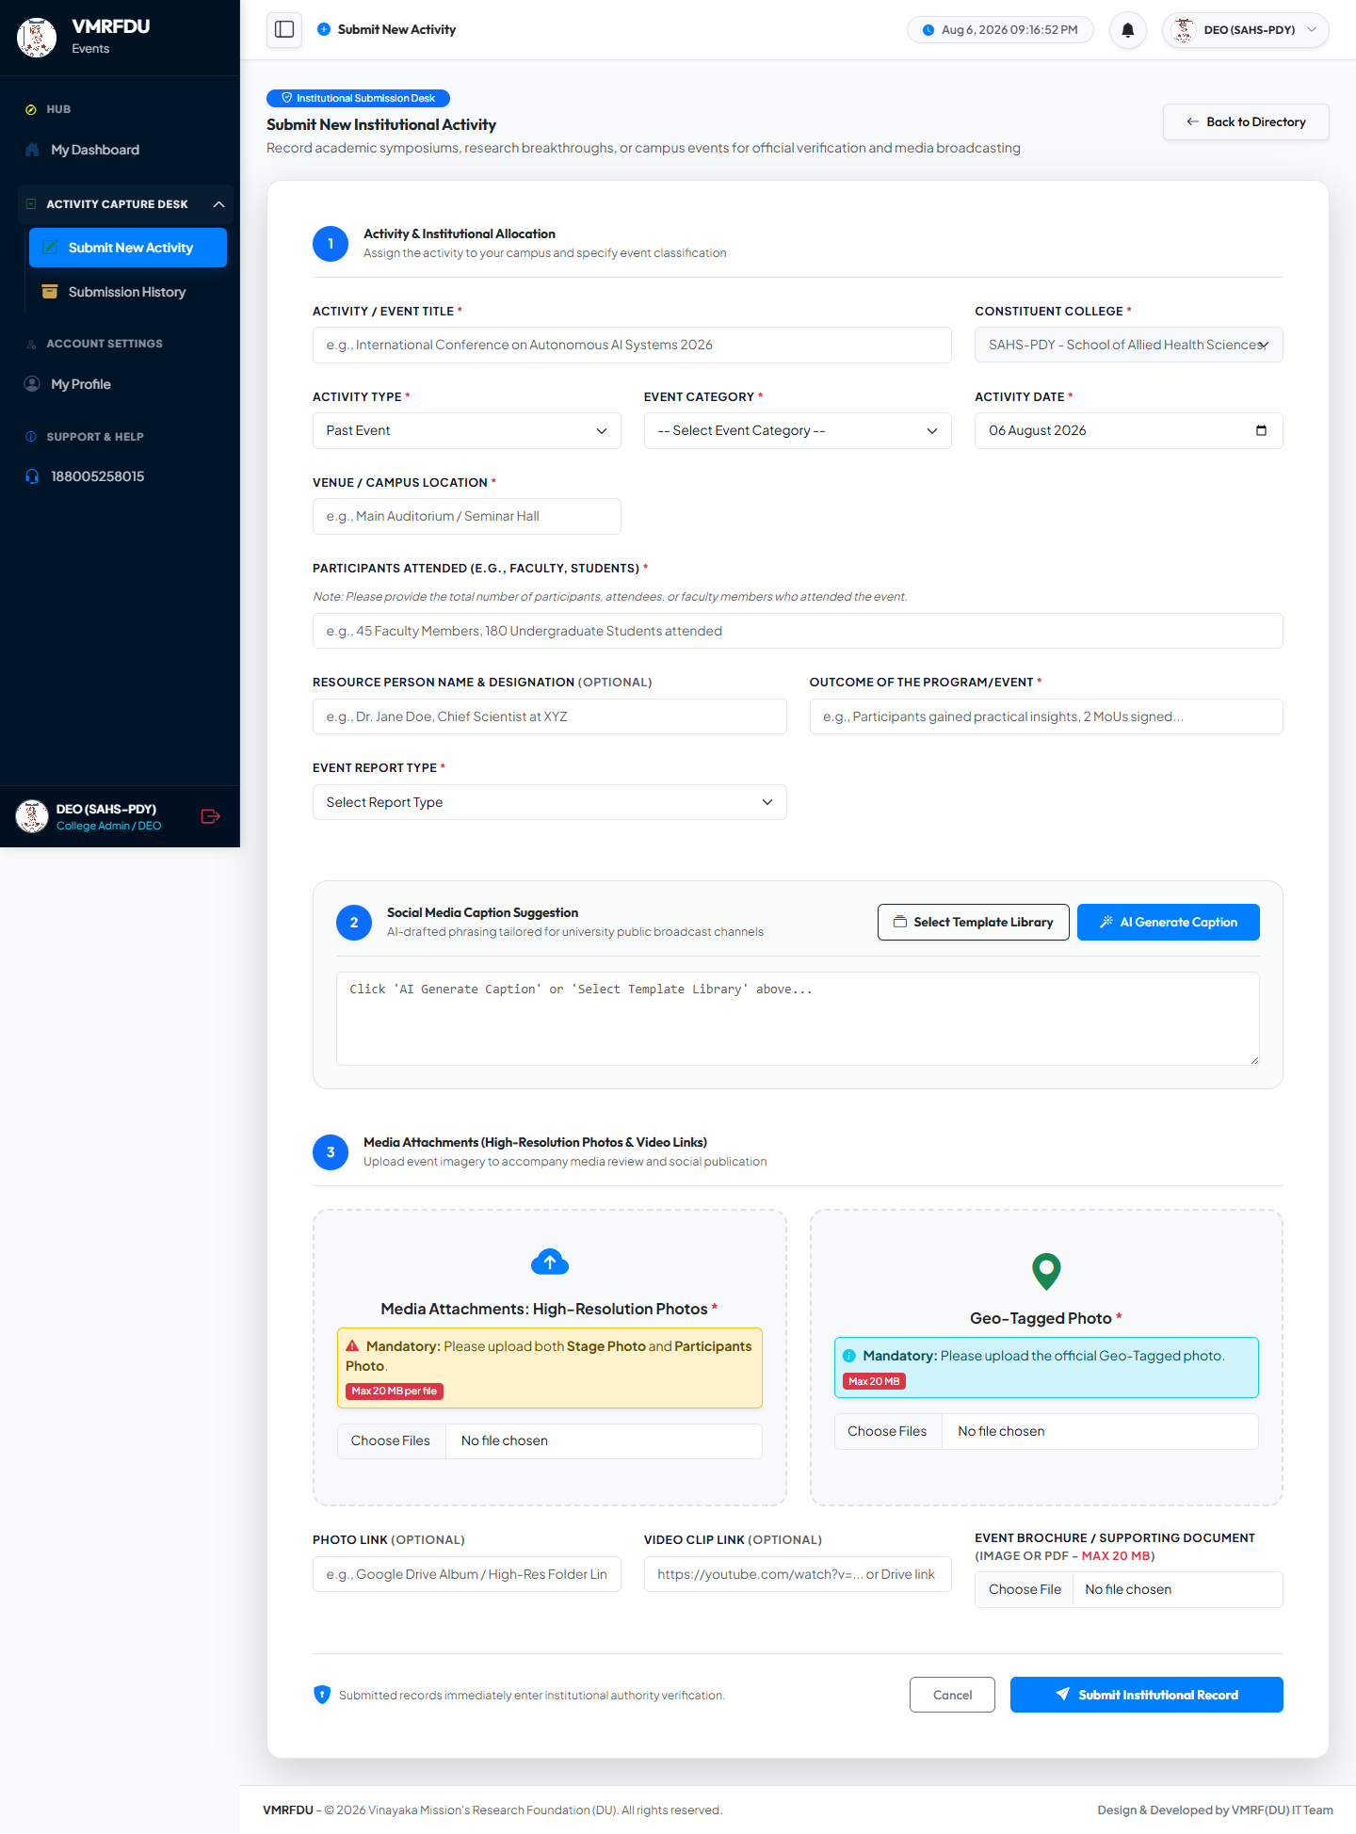
📝 Structured Submission Form 📸 Mandatory Photo Upload (10 MB max) 🤖 AI Caption Generator — 12+ Templates 💾 Save as Draft at Any Time 📄 Optional PDF Document Upload 🏷️ 12 Event Category Options

COLLEGE ADMIN | Analytics Dashboard (College Admin) | 40 / 50
College-scoped analytics for SAHS-PDY showing activity data for this college only: submission volume trends, category breakdown charts, approval/rejection statistics, and status distribution — helping college management understand their institutional activity profile.
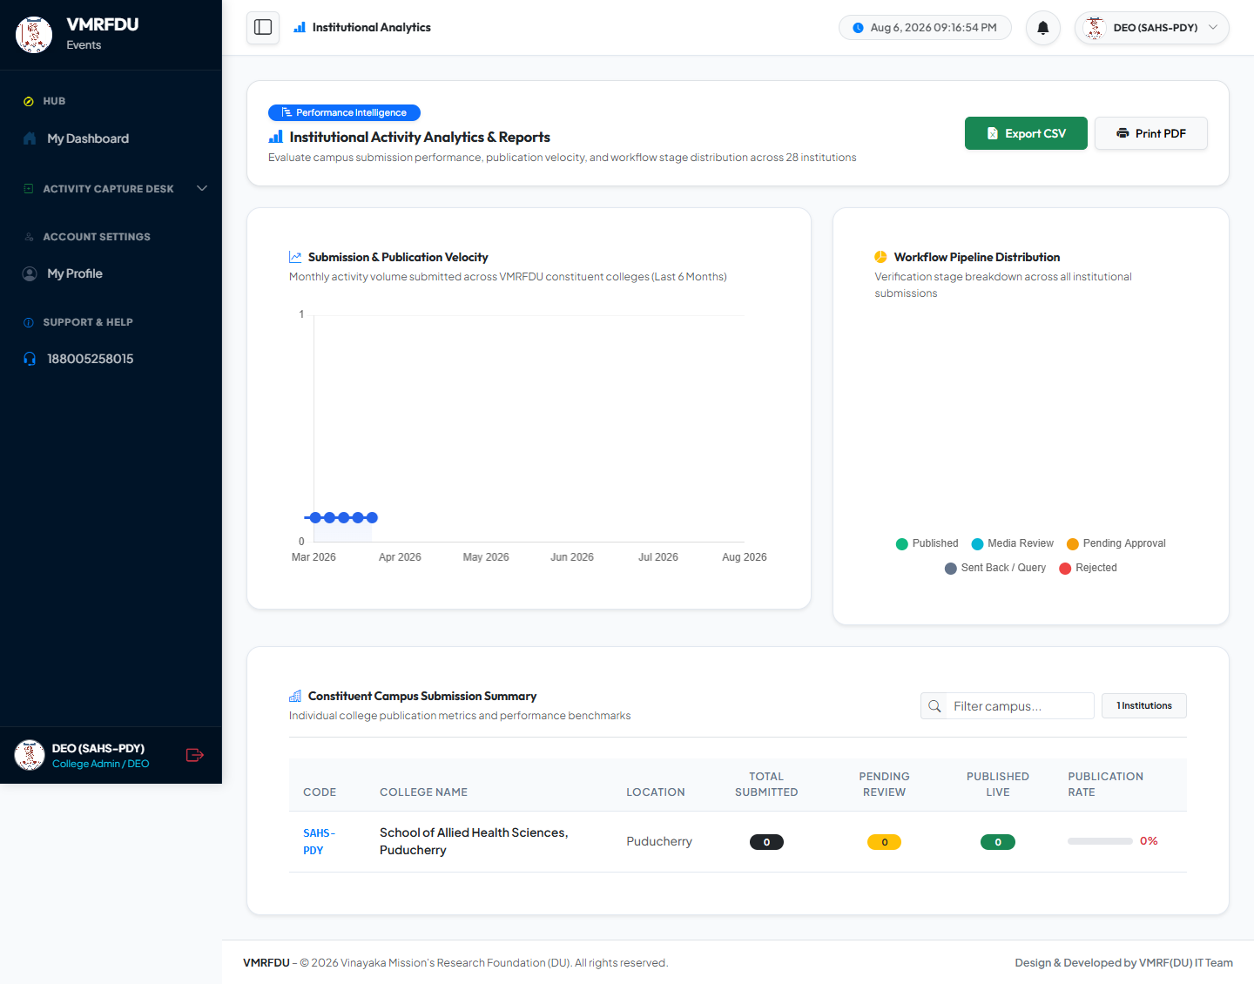
🏫 SAHS-PDY-Scoped Data Only 📊 Category Breakdown Charts 📈 Monthly Submission Trends 📥 CSV Export

COLLEGE ADMIN | Notifications (College Admin) | 41 / 50
In-app notification inbox for the DEO: alerts when submissions progress through workflow stages, when the VC/Registrar sends discussion feedback, when activities are approved and move to media processing, and when activities are published or rejected.
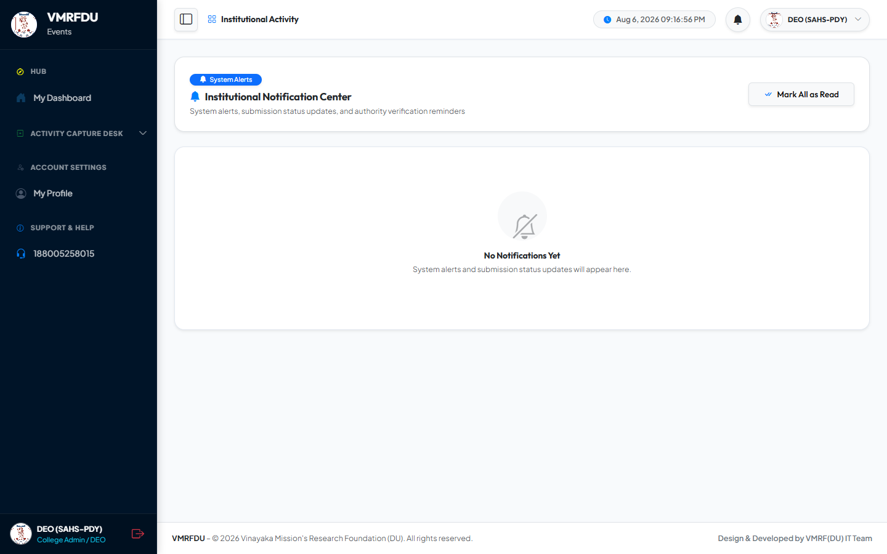
✅ Stage Approval Notifications 💬 Discuss / Feedback Alerts ❌ Rejection Notifications 🎉 Published Activity Alerts

COLLEGE ADMIN | User Profile — College Admin (DEO) | 42 / 50
Personal profile management for the DEO (SAHS-PDY): update name, phone, designation, upload profile avatar, and change account password with current-password confirmation.
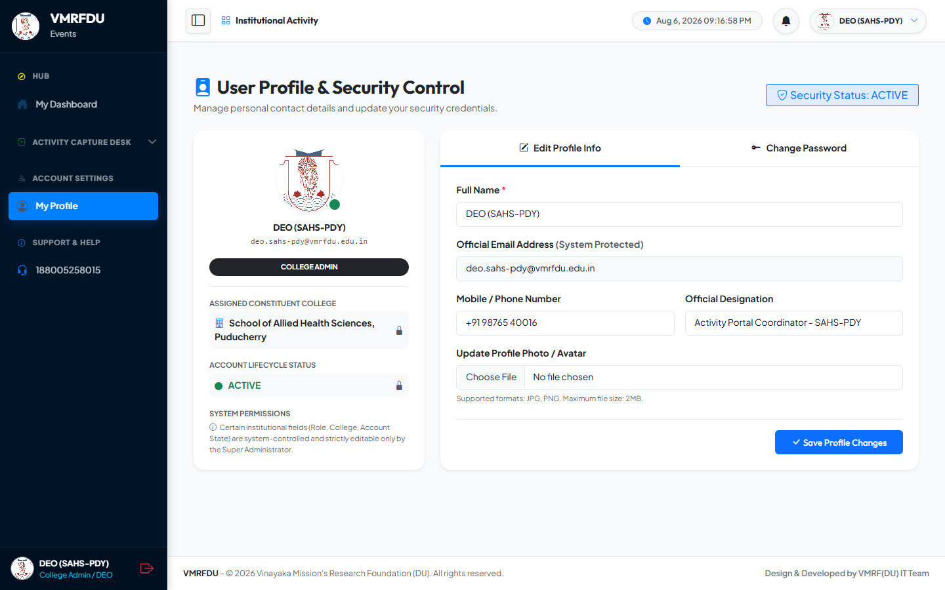
✏️ Edit Personal Information 🖼️ Profile Avatar Upload 🔑 Change Password 📞 Phone & Designation Update

COMPLETE SCREENSHOTS INDEX
50 Pages · 7 User Accounts · 7 Roles · All Portal Modules
# | User / Role | Page / Screen | Key Features
01 | Public | Login Page | Email/password auth, CSRF, IP tracking, force-reset
02 | Public | Public Gallery | Search, category, college, date filters, image grid
04 | Super Admin | Dashboard | System-wide KPIs, all users, workflow status
05 | Super Admin | College Management | CRUD colleges, codes, toggle active
06 | Super Admin | User Management | Create/edit users, role assign, lock, transfer
07 | Super Admin | Role & Permission Builder | JSON permissions, data scope, role hierarchy
08 | Super Admin | Workflow Engine | Stage config, action mapping, routing rules
09 | Super Admin | Access Control Suite | Per-user overrides, copy role permissions
10 | Super Admin | Activity Override | Force status, restore, reassign, hard delete
11 | Super Admin | System Audit Logs | Immutable trail, user/IP/before-after logging
12 | Super Admin | Master Settings | Logo, favicon, NTP, session config, branding
13 | Super Admin | Analytics Dashboard | University-wide KPIs, trend charts, CSV/print export
14 | Super Admin | Notification Center | In-app alerts, read tracking, action links
15 | Super Admin | Email Audit Log | Email trail, delivery status, HTML body preview
16 | Super Admin | User Profile | Edit info, avatar upload, password change
17 | Vice Chancellor | Dashboard | Pending queue, global stats, approval rate
18 | Vice Chancellor | Verification Queue | Approve / Discuss / Reject, mandatory remarks
19 | Vice Chancellor | Approved List | Historical approvals, downstream status tracking
20 | Vice Chancellor | Rejected Archive | Rejection records, mandatory reasons
21 | Vice Chancellor | Analytics | University-wide data, trends, CSV/print export
22 | Vice Chancellor | All Submissions View | Global read-only oversight, multi-filter
23 | Vice Chancellor | Notifications | New submission + resubmission alerts
24 | Vice Chancellor | User Profile | Edit info, avatar upload, password change
25 | Office Registrar | Dashboard | Locked submissions count, Stage 2 queue
26 | Office Registrar | Stage 2 Review Queue 🔒 | Locked packages, approve / discuss actions
27 | Office Registrar | Approvals View | Approved / discuss history, decision trail
28 | Office Registrar | Analytics | Review KPIs, throughput, turnaround analysis
29 | Office Registrar | Notifications | New package alerts, confirmation alerts
30 | Office Registrar | User Profile | Edit info, avatar upload, password change
31 | Media Editor | Dashboard | Queue counts: editing / locked 🔒 / ready / discuss 🔓
32 | Media Editor | Media Studio Queue | Photo edit, caption refine, 🔒 locked records, ZIP pack
33 | Media Editor | Submission History | Processed activities, downstream status
34 | Media Editor | Analytics | Processing KPIs, platform publishing distribution
35 | Media Editor | Notifications | New media review, editor_discuss return alerts
36 | Media Editor — Karthik N. | User Profile | Edit info, avatar upload, password change
37 | College Admin | Dashboard | VMKVEC-scoped stats, live status summary
38 | College Admin | Submissions List | Status filters, VMRF-IDs, edit on discuss only
39 | College Admin | Create Activity Form | Full form, AI captions (12+), photo upload, draft/submit
40 | College Admin | Analytics | College-scoped KPIs, category charts, CSV export
41 | College Admin | Notifications | Approval / discuss / reject / published alerts
42 | College Admin — Muthukumar S. | User Profile | Edit info, avatar upload, password change

Under the Guidance of : Dr. A. Murugan | Designed & Developed by : VMRFDU IT Team (Dhinakaran & Sanjai)
© 2026 VMRF(DU) – Vinayaka Mission's Research Foundation (Deemed to be University). All Rights Reserved.

