VMS System — Complete User Manual & Documentation
Vinayaka Mission's Research Foundation — Vendor Management System

VMS System — Complete User Manual & Documentation
Vinayaka Mission's Research Foundation — Vendor Management System (VMS)
Laravel 12 · MySQL · Blade + Tailwind + Alpine.js
This manual documents every screen in the application, organized by user role, the full tender/application/contract lifecycle with flowcharts inline, every automatic email notification the system sends, its readiness for a future mobile app and public website integration, and a genuine live end-to-end walkthrough — a real vendor registered, a real tender created and published, a real committee member added, a real application submitted, reviewed, shortlisted and awarded, and a real contract signed, all captured screen-by-screen as it happened on 2026-07-03.
Static screenshots (§3–§7) were captured against the live database (vms_db), so some show real tenders/vendors already in the system. The walkthrough in §13 created new, clearly-labeled demo records — additive only, nothing existing was altered.

Table of Contents
- System Overview
- User Roles & Permissions
- Authentication Screens
- Admin Manual
- Tender Owner Manual
- Vendor Manual
- Committee Member Manual
- Tender → Application → Contract Lifecycle (with flowcharts)
- Automatic Email Notifications
- Future-Ready: Mobile App & Public Website Integration
- Data Model
- Known Issues Found During This Review
- Live End-to-End Walkthrough
- Appendix: Test Credentials & Routes

1. System Overview
VMS is an end-to-end e-procurement platform: tenders are created and published, vendors browse and bid, applications go through eligibility screening → review → shortlisting → award, and awarded applications become contracts with generated Work/Purchase Orders. Every step notifies the right people automatically by email (§9), and the platform already exposes a public API ready for a future mobile app and a live tender feed on the university website (§10).
Four roles, each with its own dashboard and sidebar (resources/views/layouts/dashboard.blade.php):
Role | Scope
Admin | All tenders, vendors, applications, contracts, users, categories org-wide
Tender Owner | Full lifecycle, but scoped to tenders they own (e.g. the Digital Library, a department)
Committee Member | Read/evaluate access to tenders they're assigned to, with granular per-tender permissions
Vendor | Browse published tenders, apply, track applications/contracts, manage company profile

2. User Roles & Permissions
Permissions are managed with Spatie Permission (database/seeders/RolePermissionSeeder.php), and are live-editable by system administrators. Summary:
- admin — vendor approval; full tender/application/contract CRUD; documents; committee; reports; user management
- tender-owner — own-tender CRUD/publish/close; shortlist/reject/award on own tenders; own contracts; committee management; reports
- vendor — view published tenders; submit applications; view own applications/contracts; sign contracts
- committee-member — assigned per tender via the tender_committee pivot table, with a JSON permission set (e.g. shortlist_applications, reject_applications, upload_documents) that can differ per assignment

Below is the visual map of who can do what:
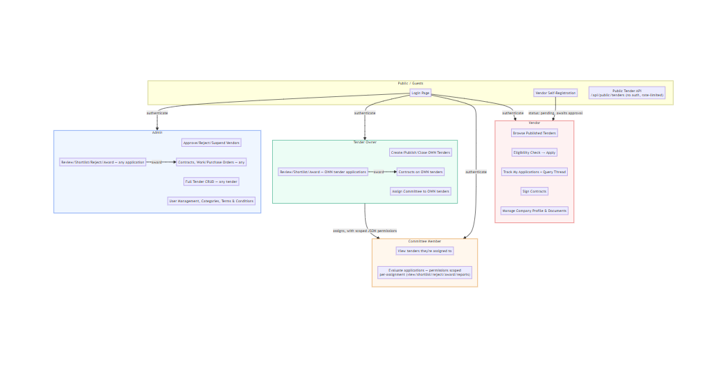

3. Authentication Screens

Login
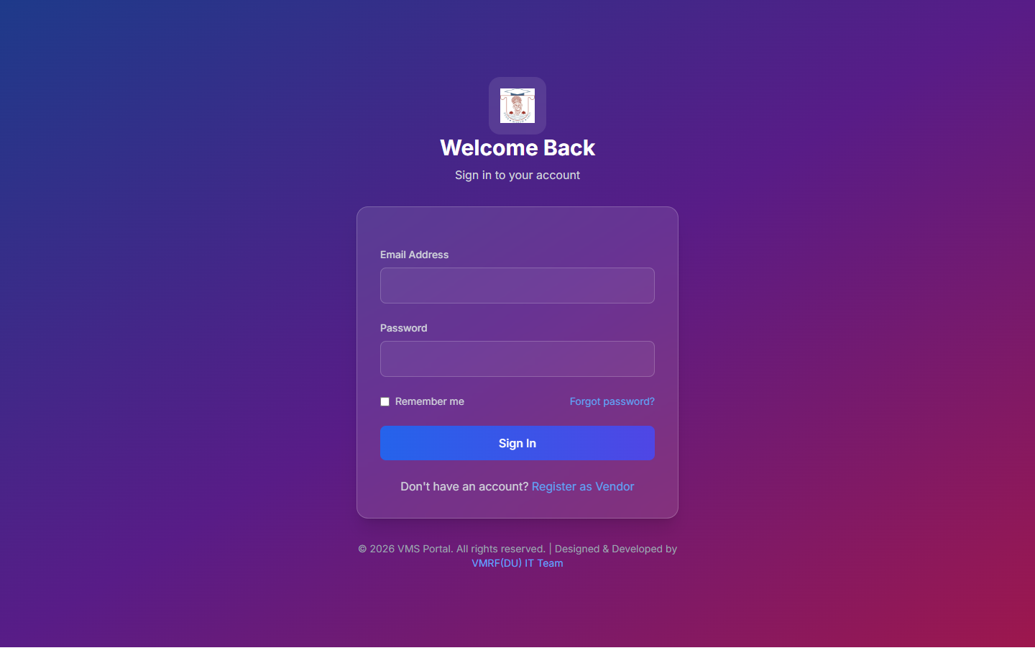
Email + password, "remember me", and a link to password reset. Vendors can self-register from here.

Vendor Self-Registration
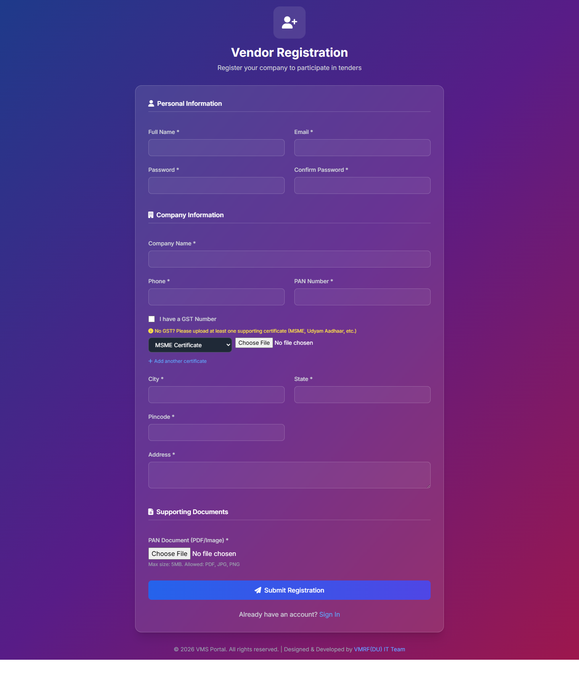
New vendors create an account here; the resulting Vendor record starts in pending status and must be approved before the vendor can apply to tenders. See §13 for this screen used in a real registration.

Forgot Password
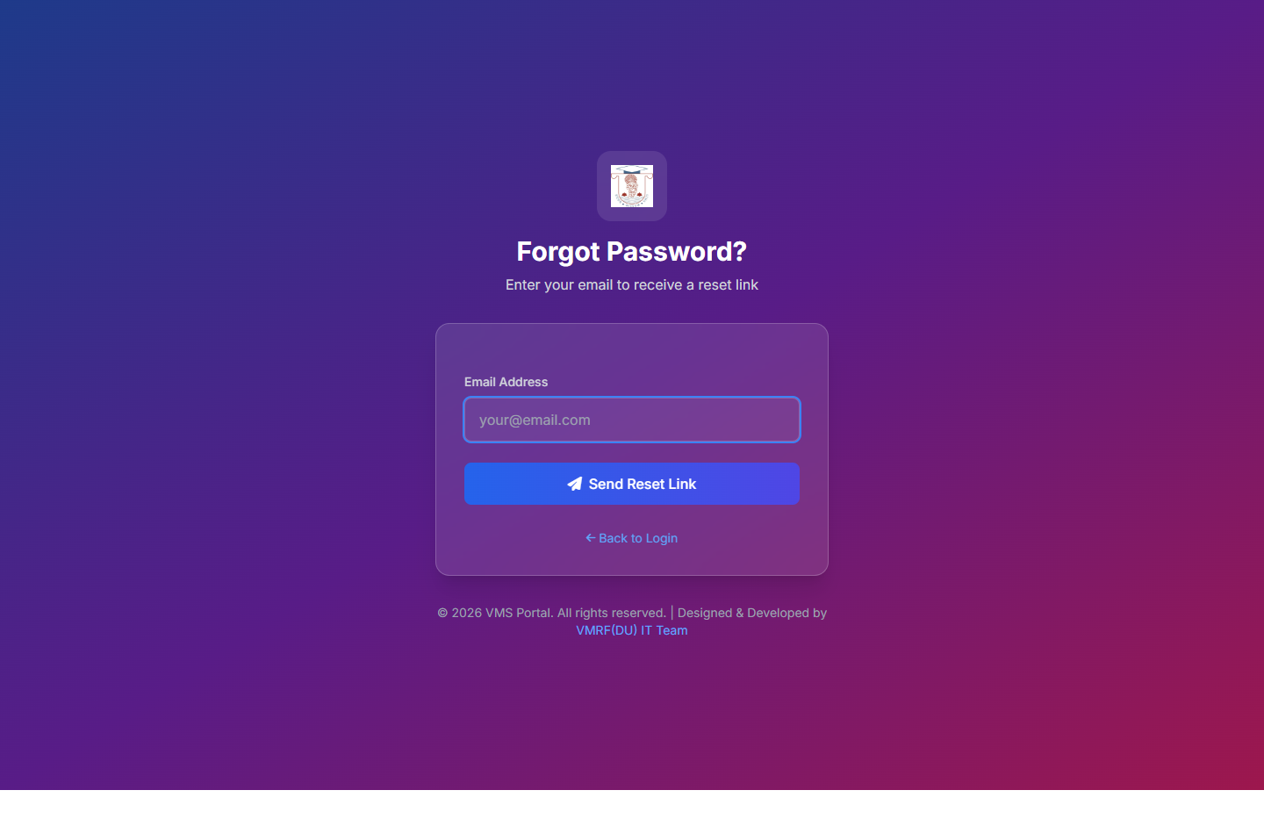
Sends a reset link by email.

Login & Role-Based Redirect Flow
One login form, four different landing dashboards. Verified against AuthController@login — including the account-inactive and vendor-pending-approval gates that log a user back out before they ever see a dashboard.
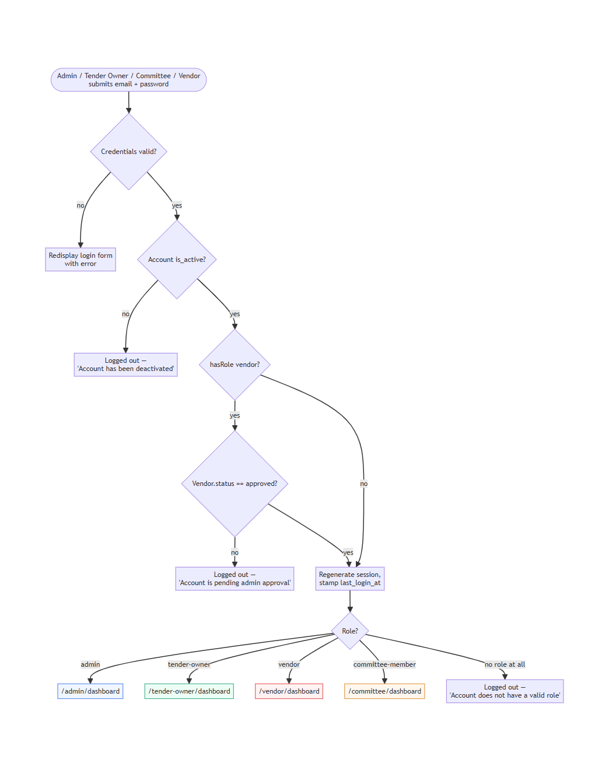

4. Admin Manual
Login: purchaseofficer@vmu.edu.in

Dashboard
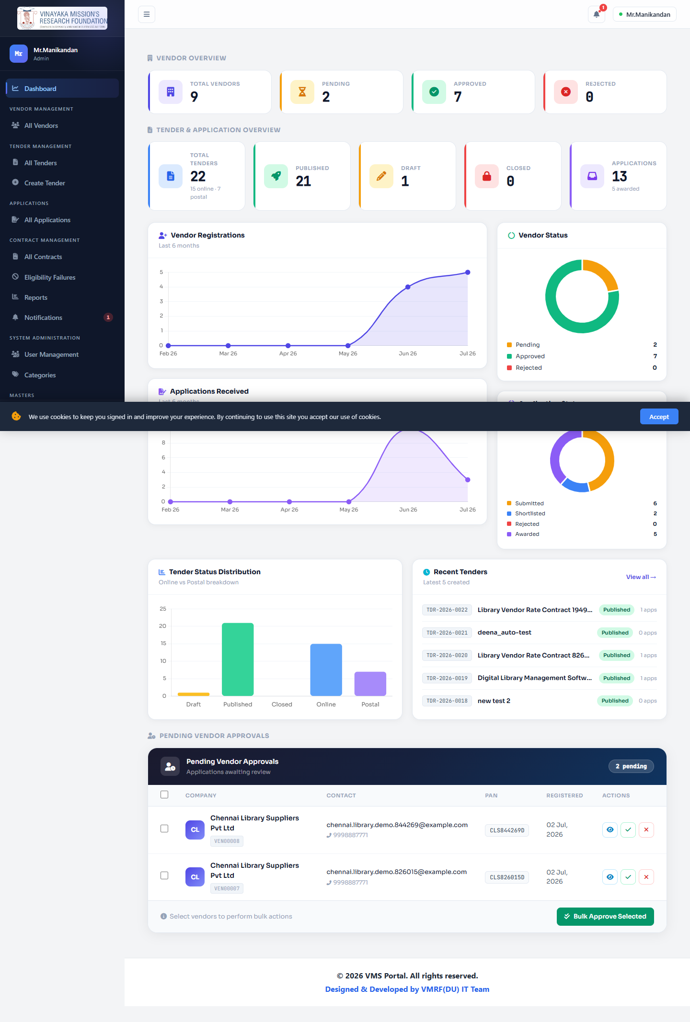
KPI overview: vendor counts by status, tender counts by status/type, application funnel, trend charts, recent tenders, pending vendor approvals.

Vendor Management
All Vendors | Vendor Detail (modal)
Vendors List | Vendor Detail

Approve, reject, suspend/reactivate vendors; assign categories; bulk-approve; export to CSV. See §13 for a real vendor being approved through this screen.

Tender Management
All Tenders — searchable/filterable list with status badges, application counts, and quick actions.
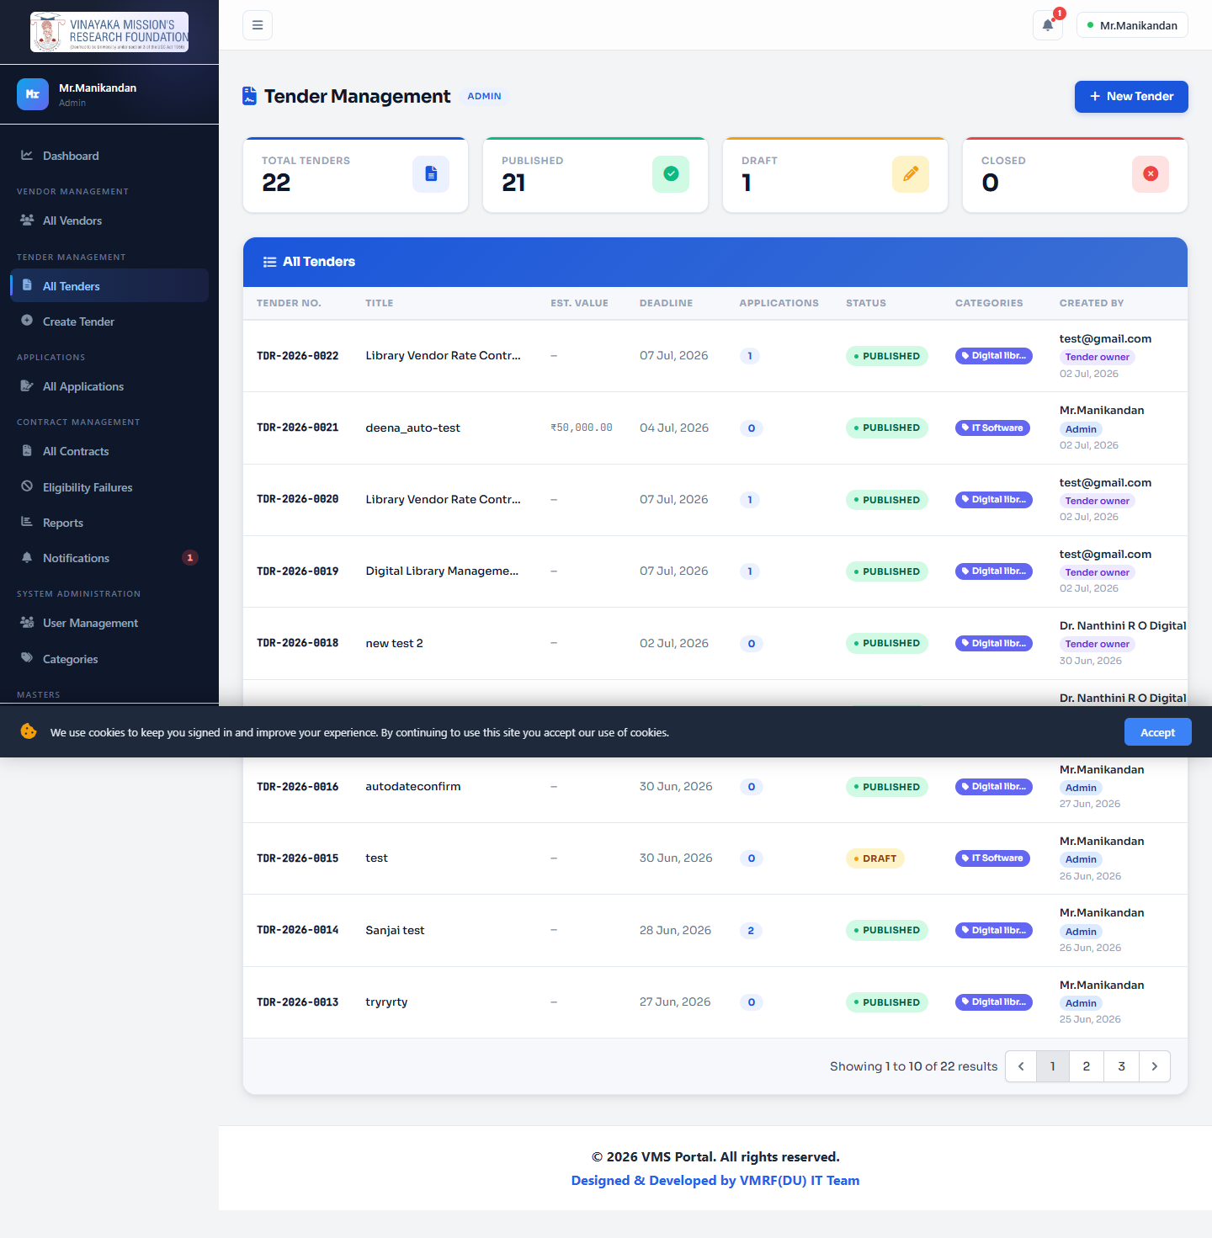
Create Tender — title, description, deadlines, tender type (online/postal), estimated value, EMD amount, private/public visibility, eligibility questions, and vendor notification options — all in one form.
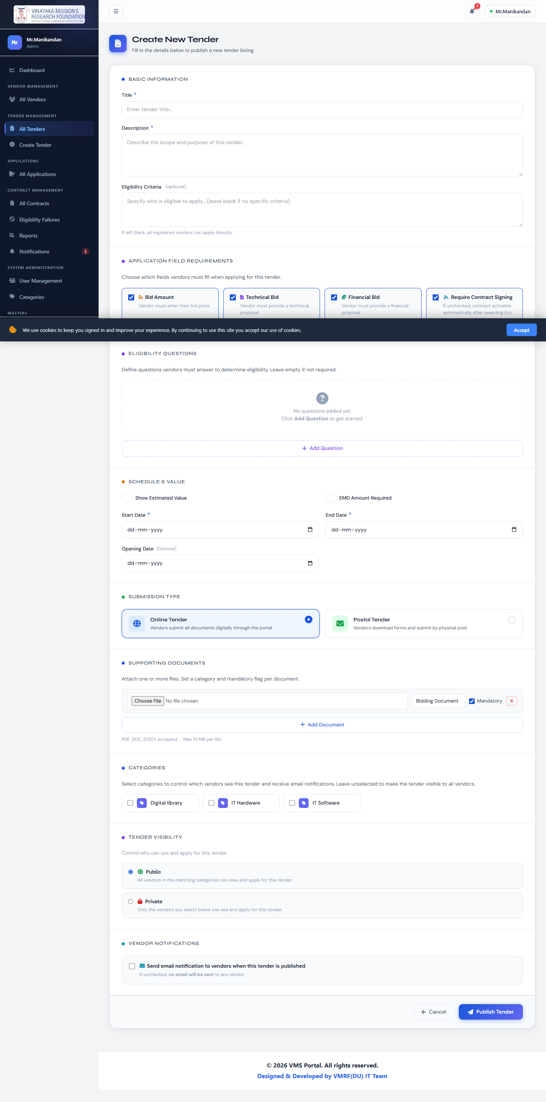
Tender Detail (published)
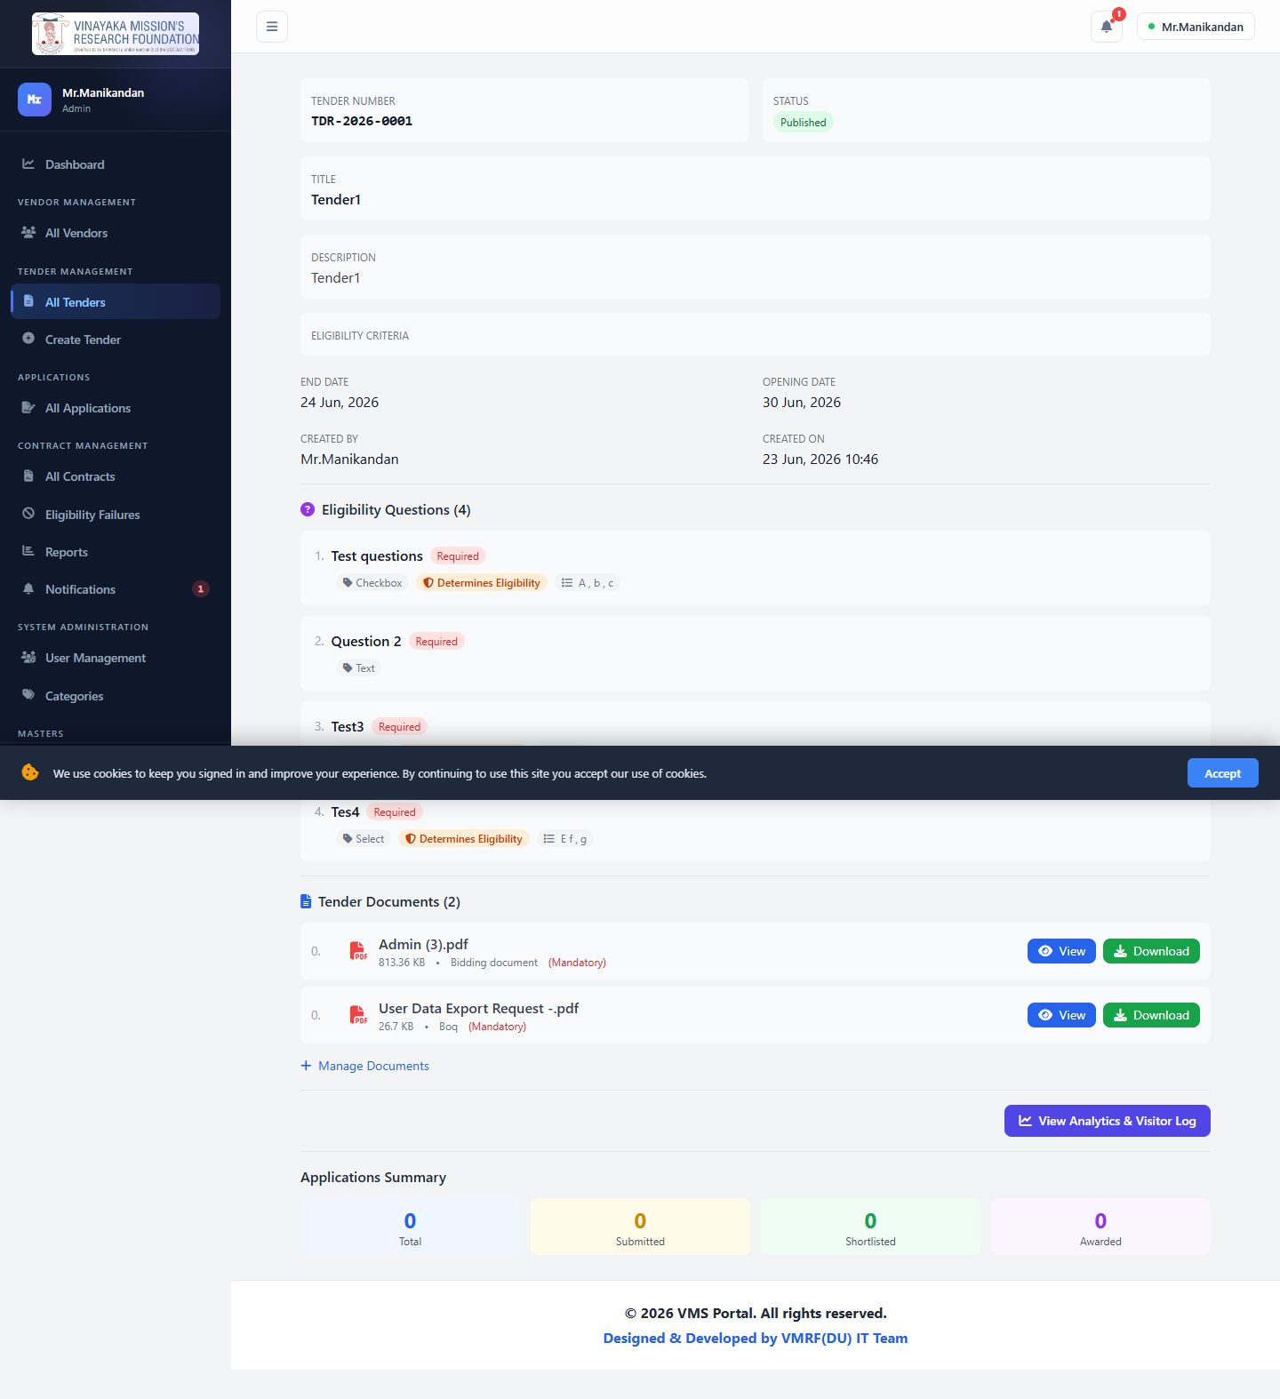
Edit Tender
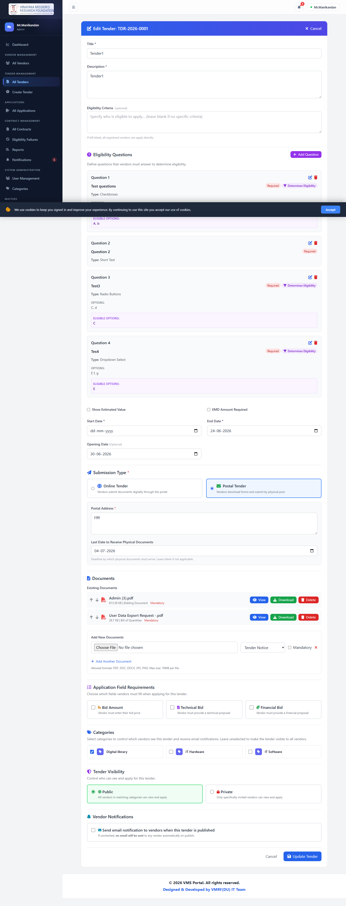
Eligibility Questions — build the pre-bid screening questionnaire (text, dropdown, radio, checkbox, number, date, file), and mark which answers are "eligible". See §8 diagram 3 for exactly how the pass/fail logic works.
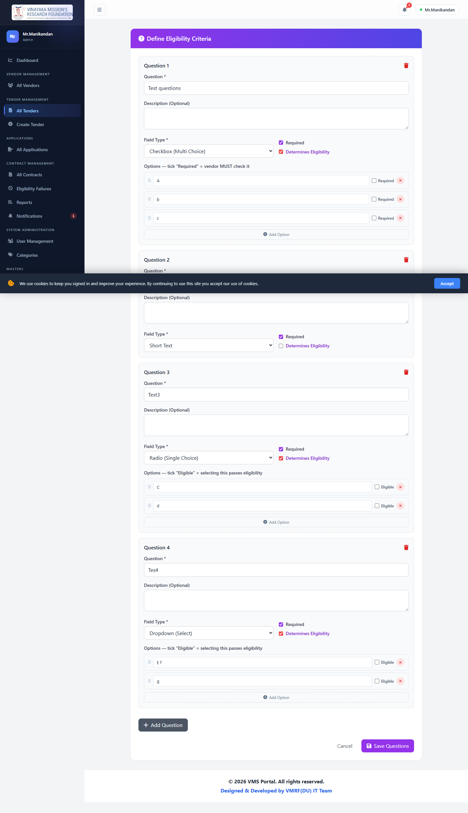
Tender Analytics — views, unique visitors, application funnel for this tender.
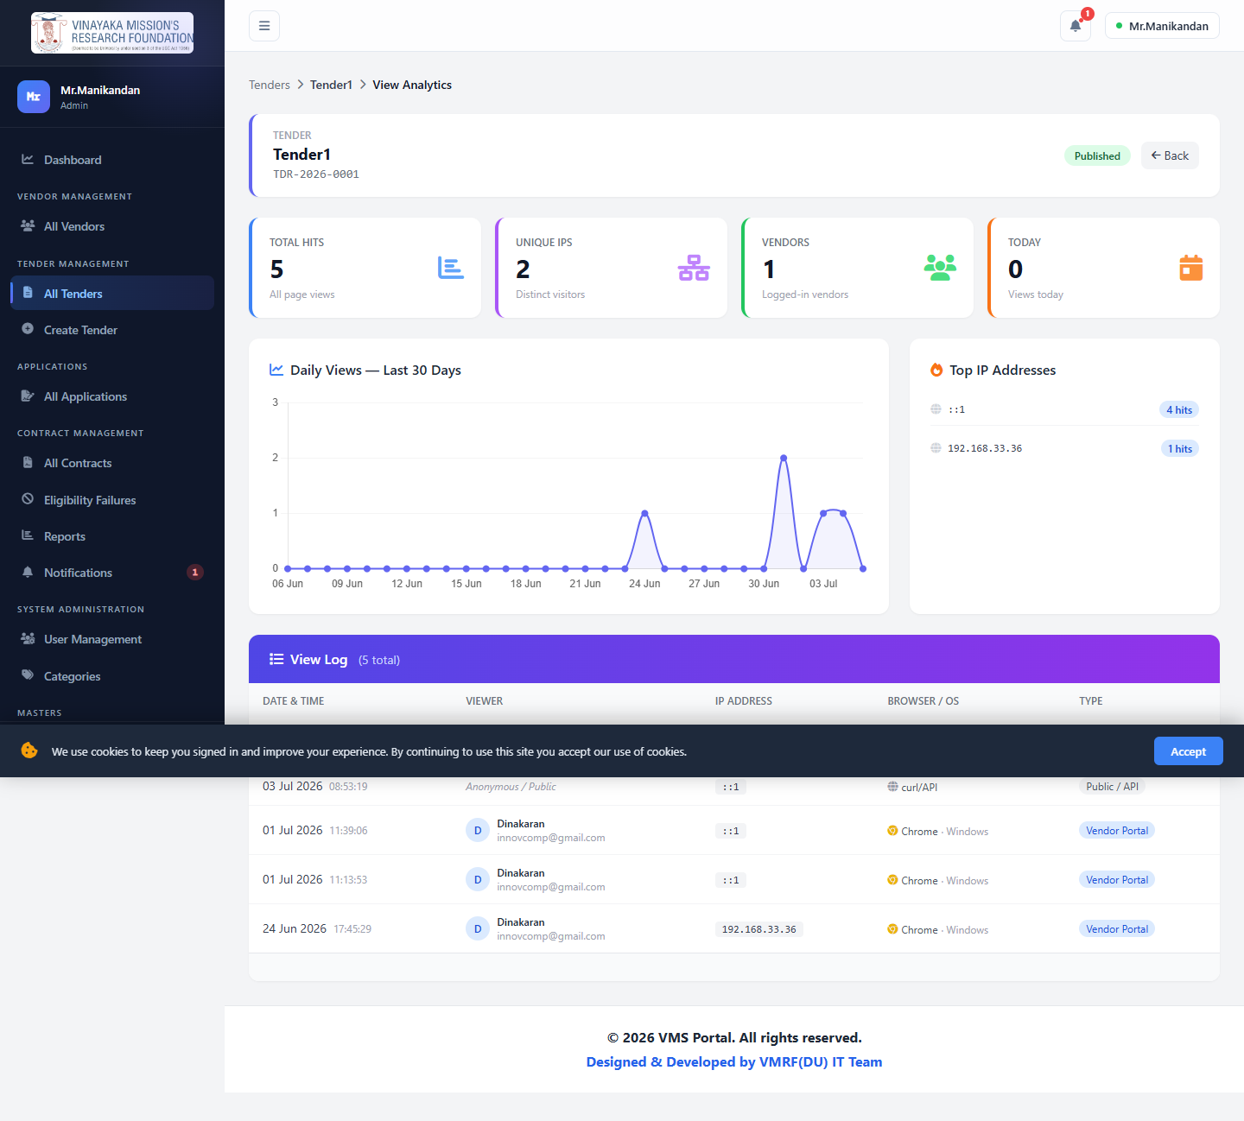
Draft Tender Detail
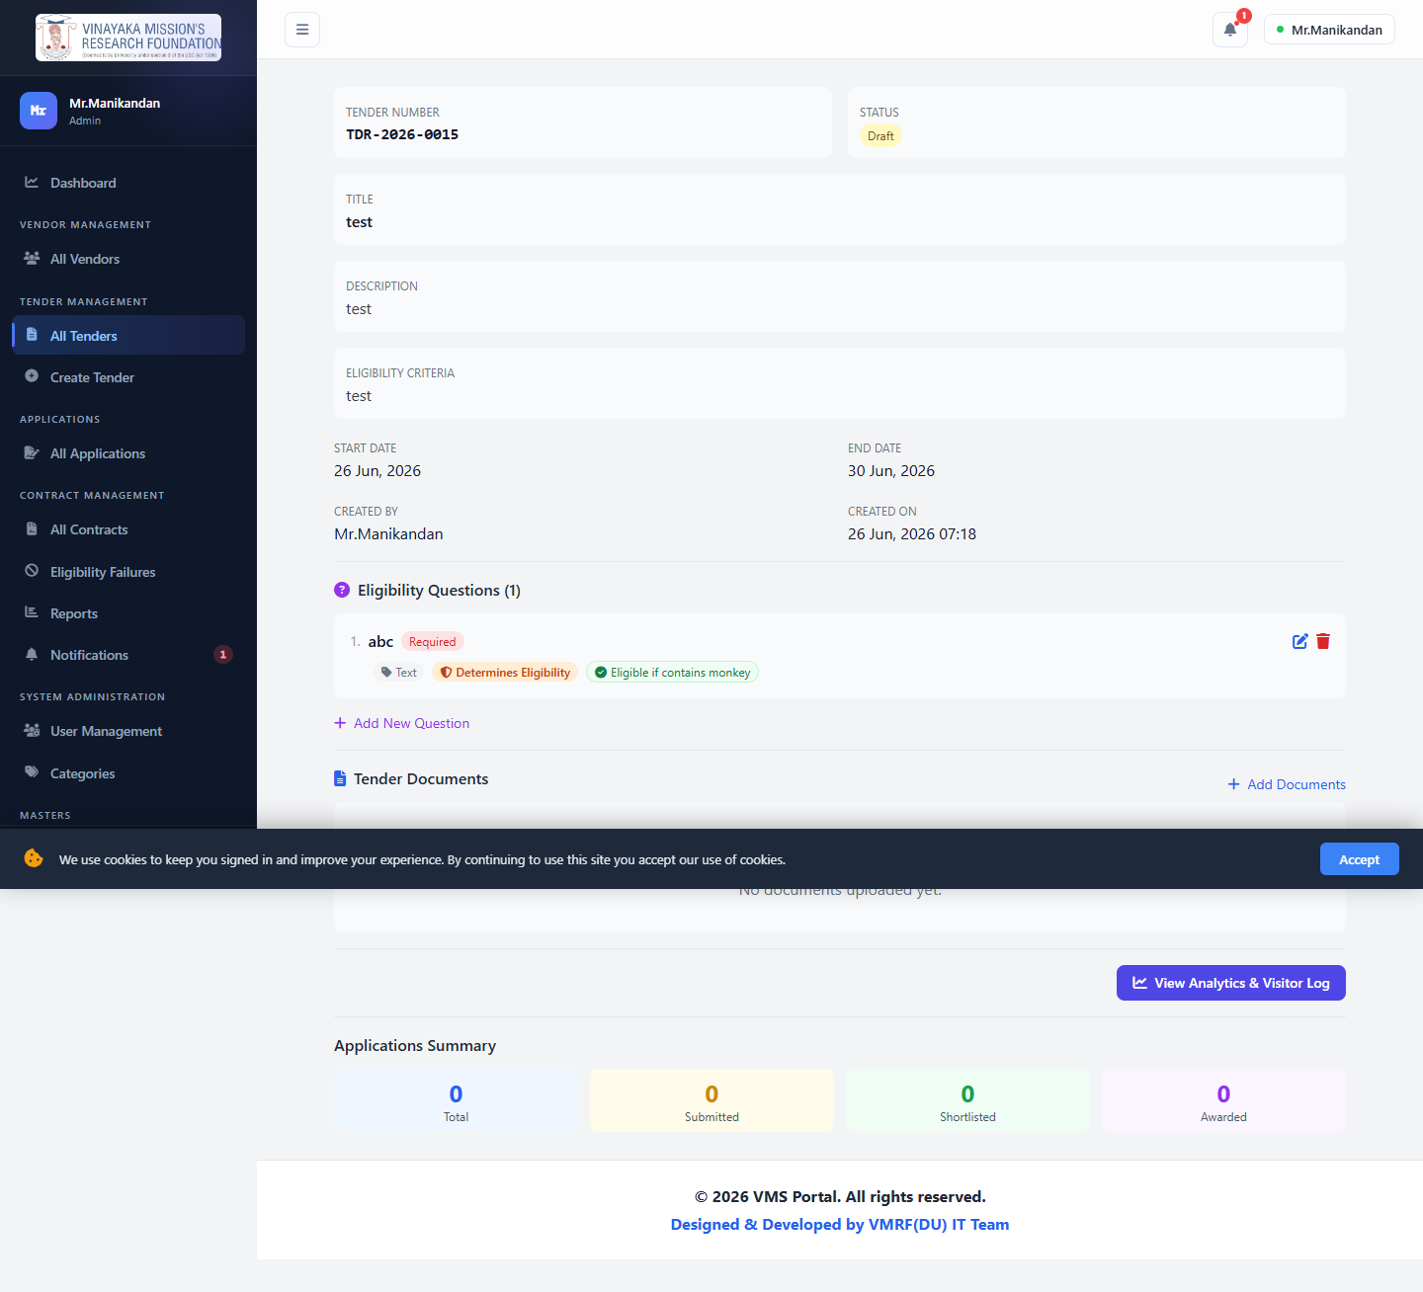
Manage Committee — assign evaluators to this specific tender with scoped permissions.
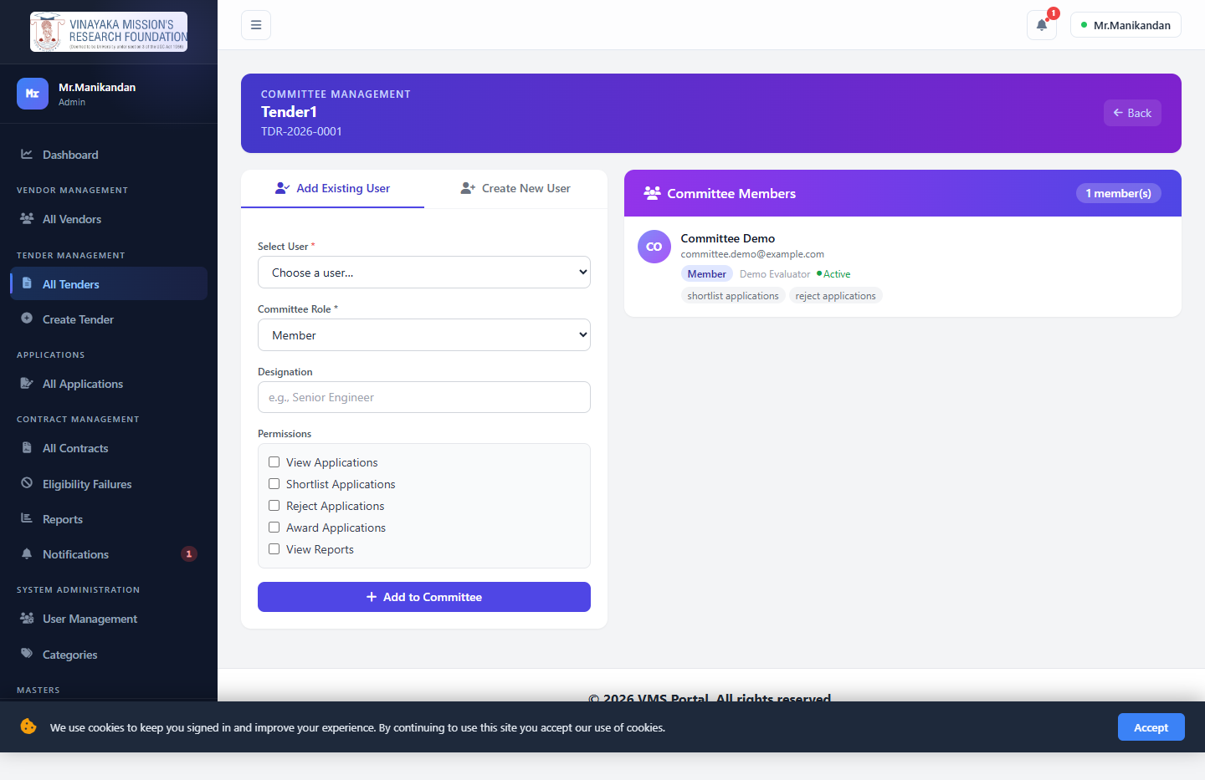

Application Management
All Applications — every application ever received, across all tenders. This is where "application received" turns into a decision: shortlist it, reject it, or (once shortlisted) award it.
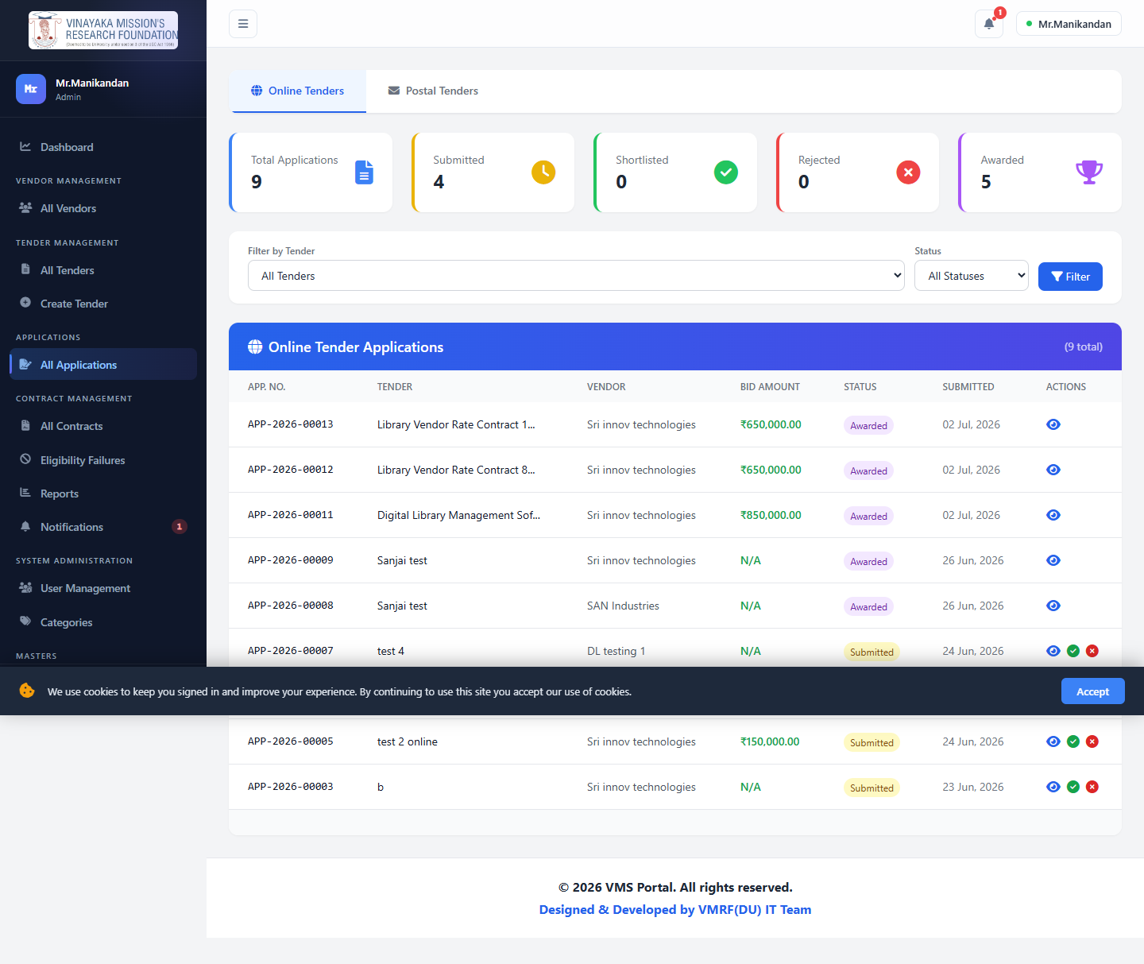
Application Detail — vendor's proposal, status, Shortlist/Reject actions, and the query/discussion thread.
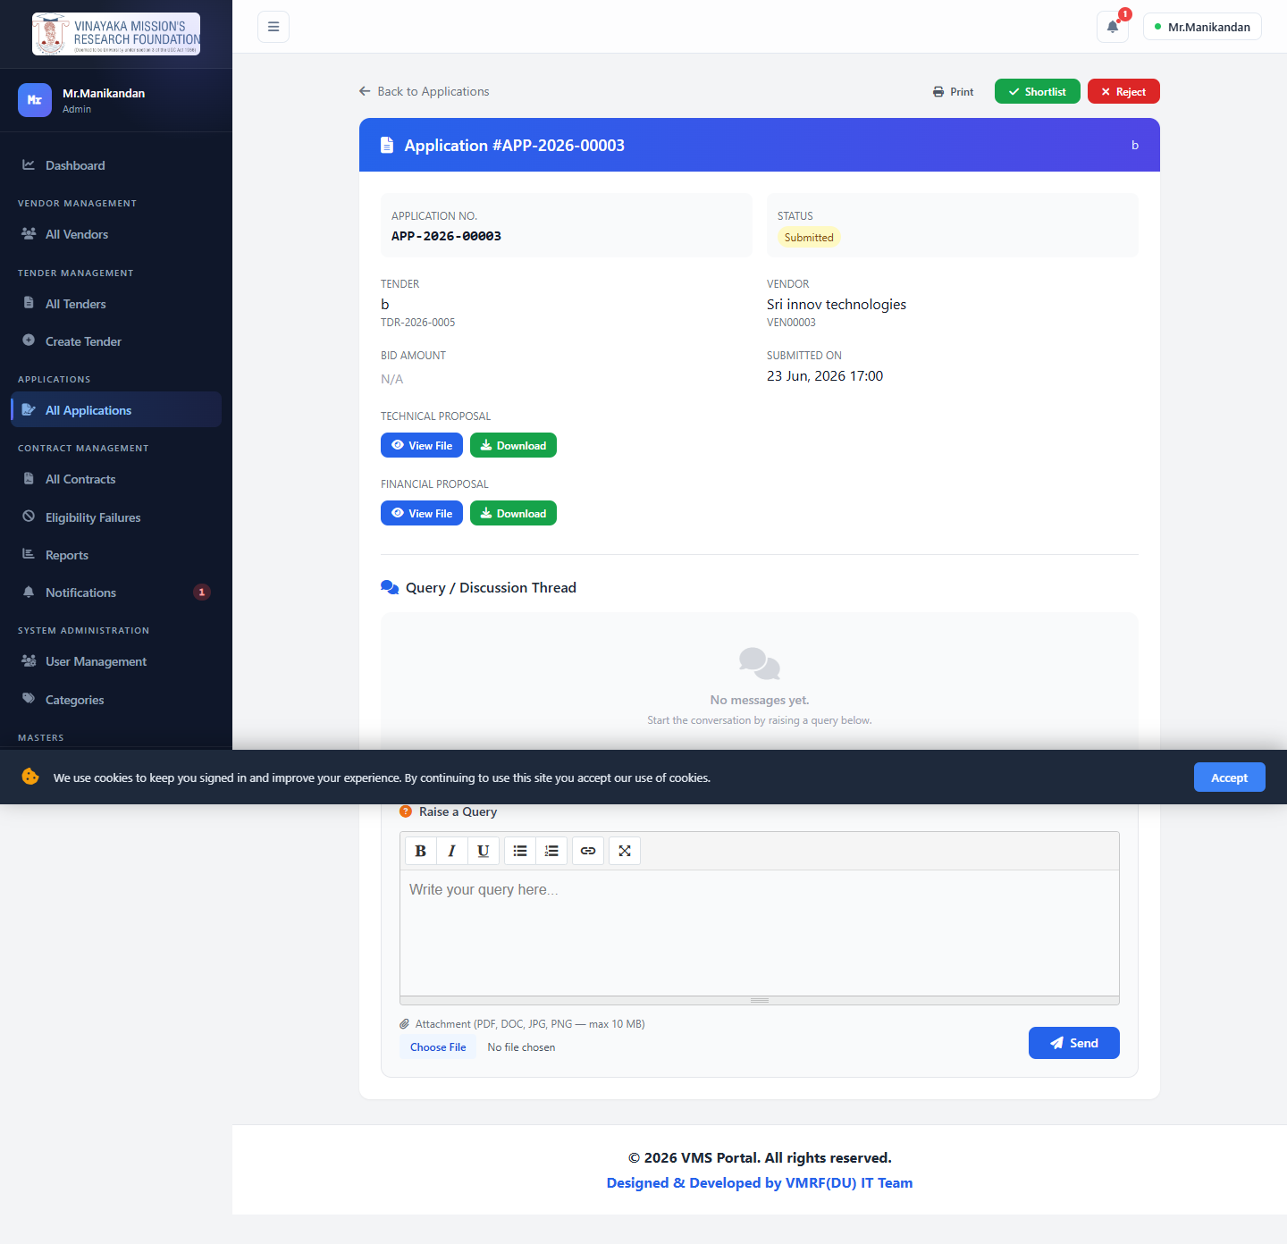
Award Application & Create Work/Purchase Order — turns a shortlisted application into a contract. Signature collection is a per-tender choice the Tender Owner made at creation time, not a fixed requirement — see §8 diagram 5.
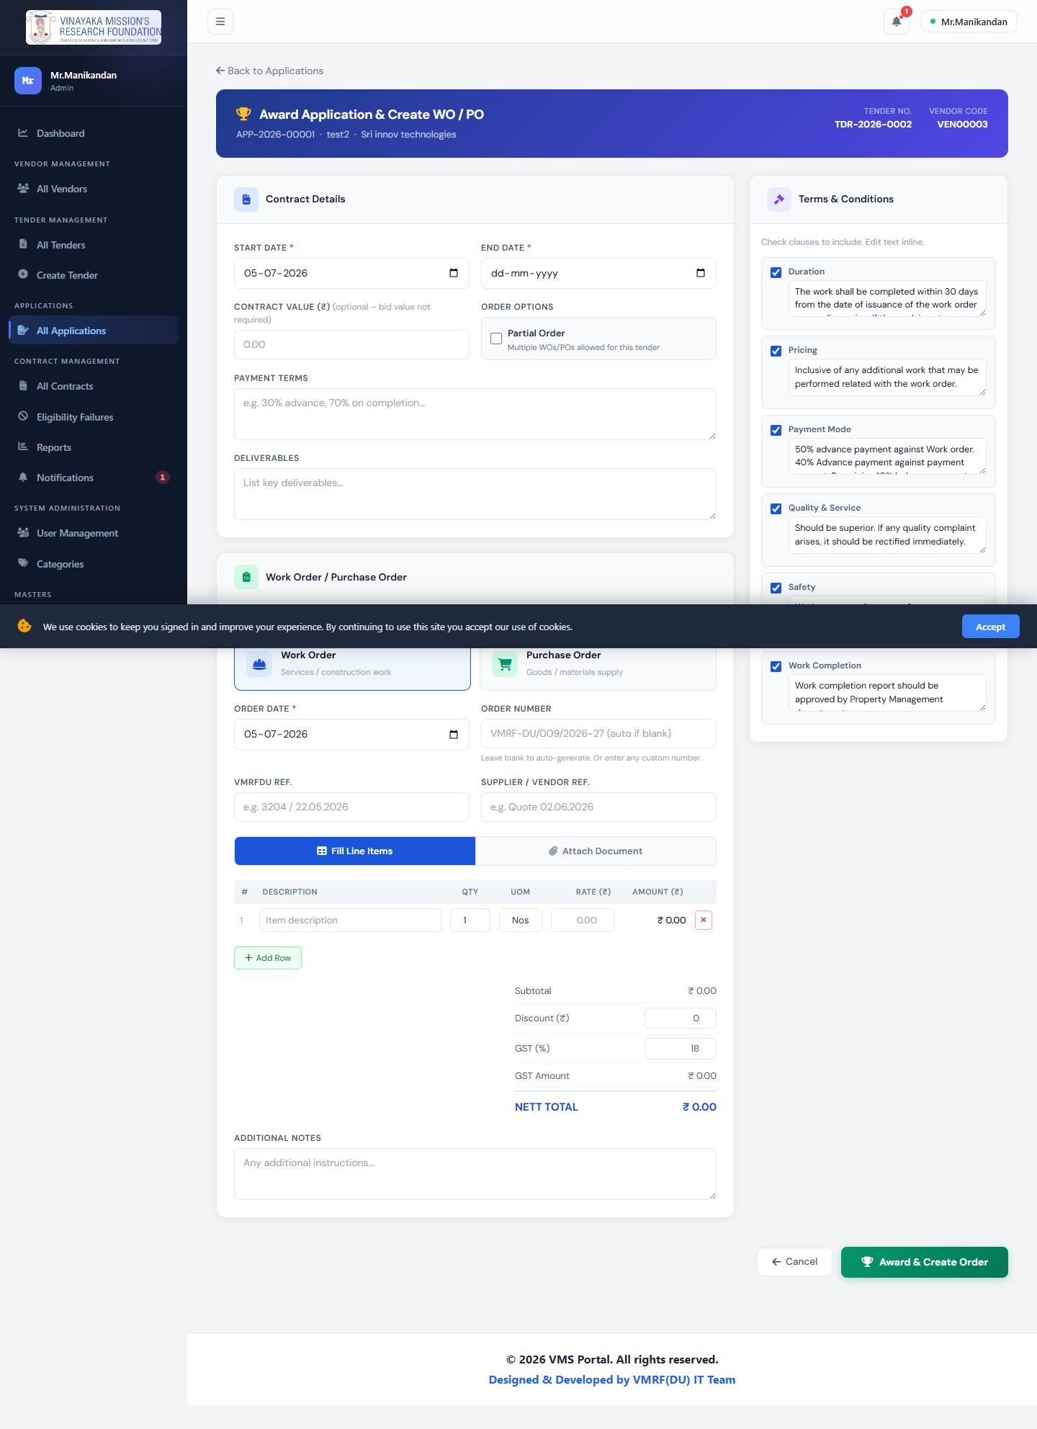

Contract Management
All Contracts
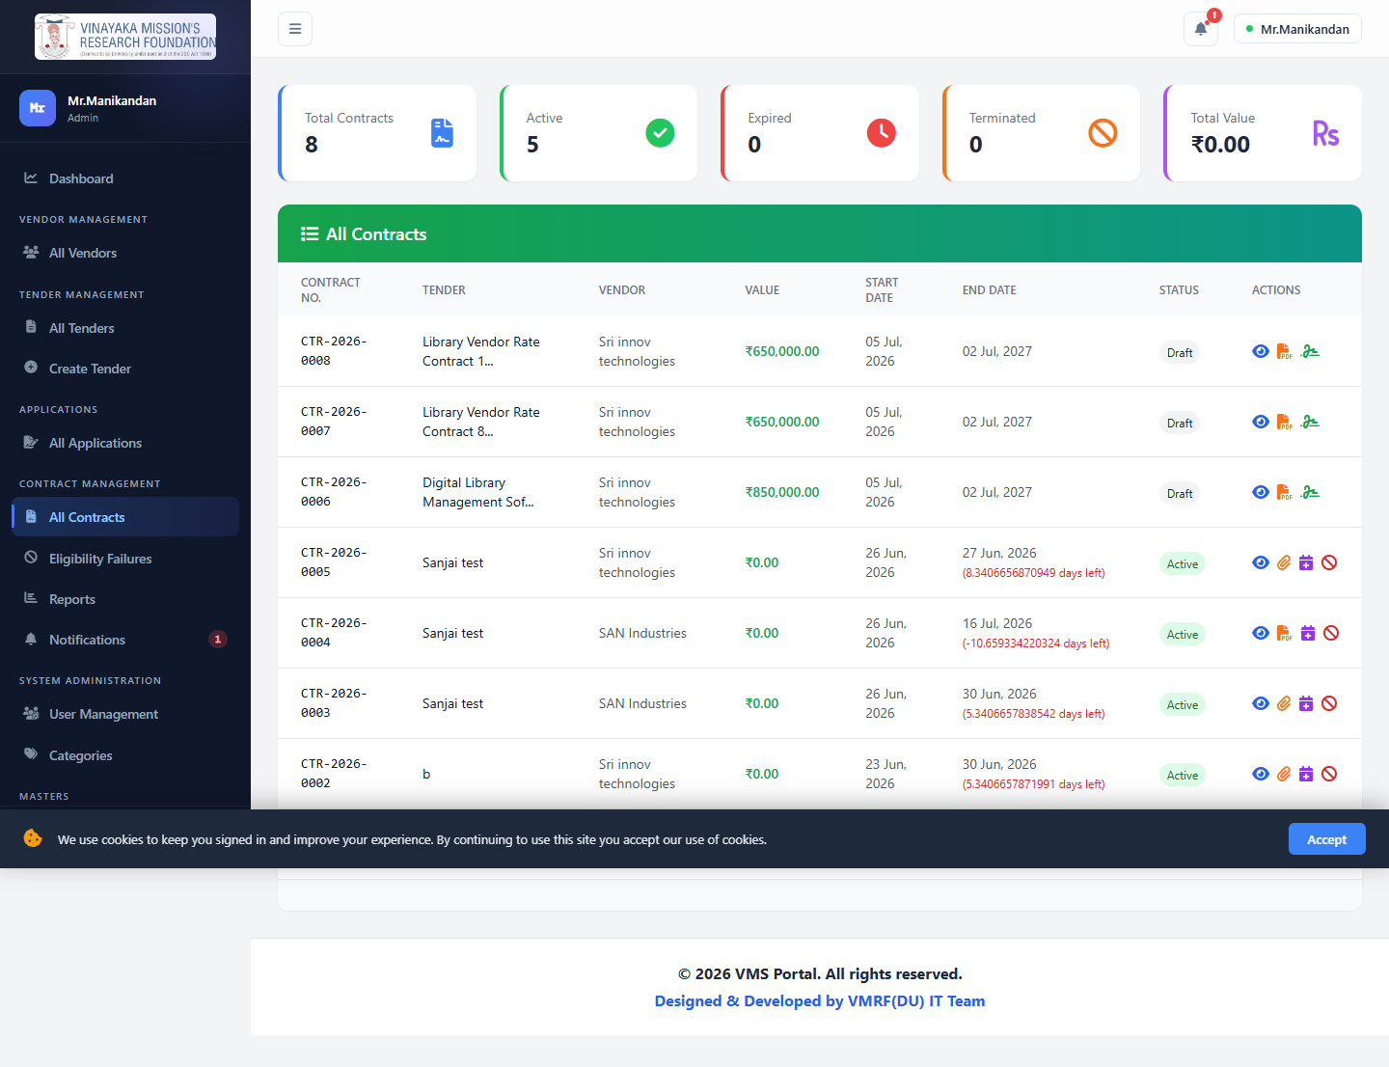
Contract Detail
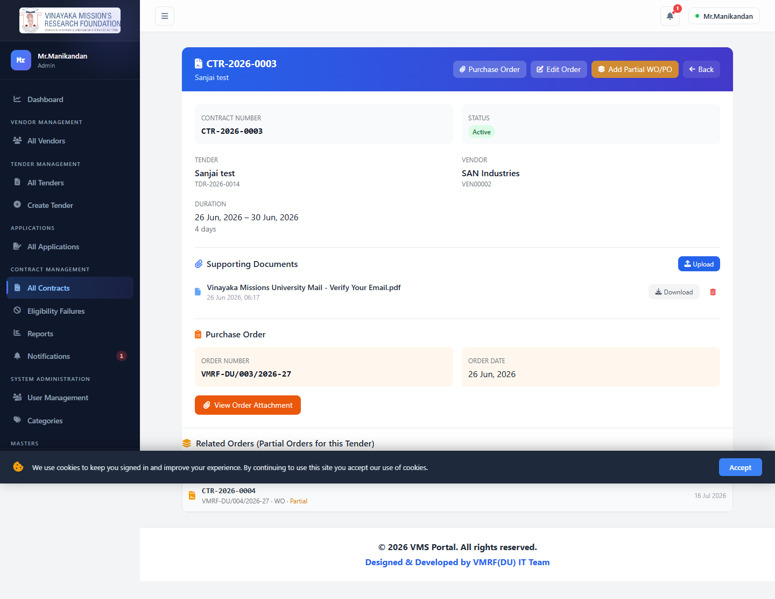
Eligibility Failures — vendors who attempted to apply but failed the eligibility screen.
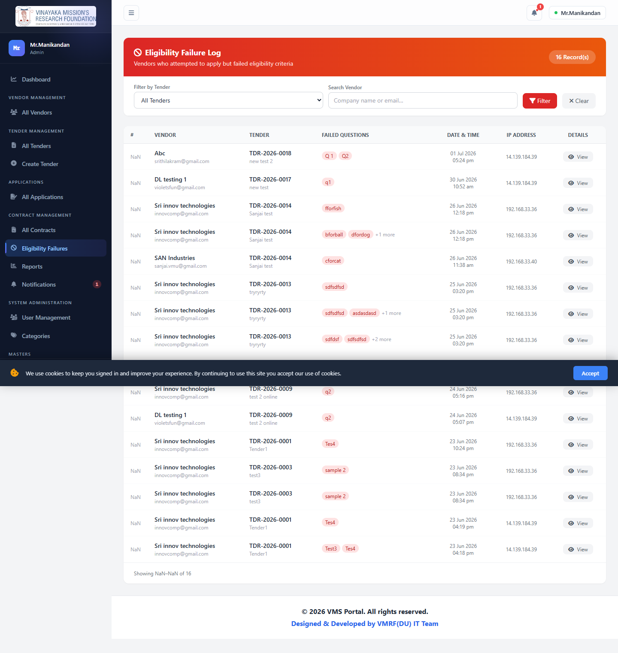
Reports
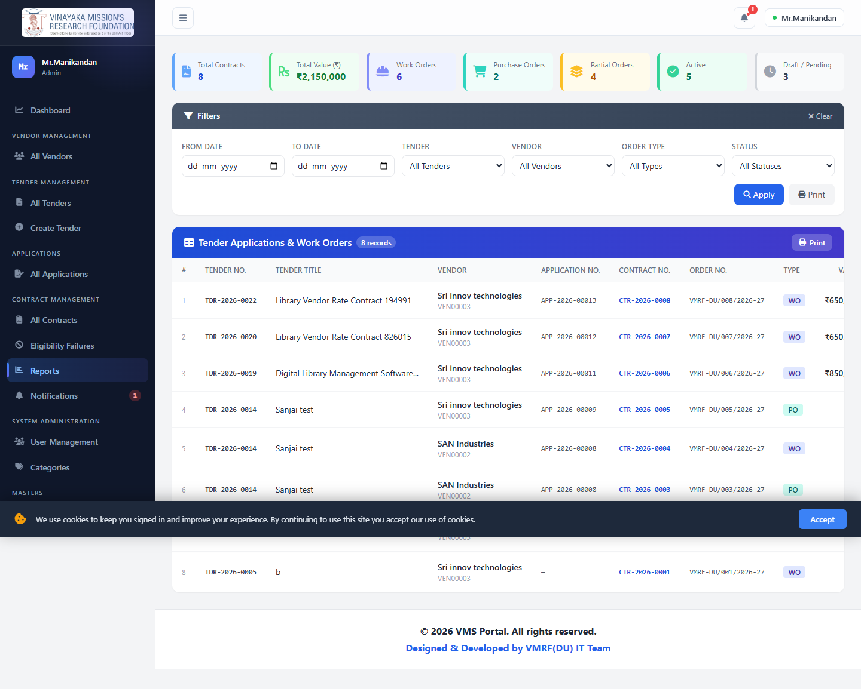
Notifications
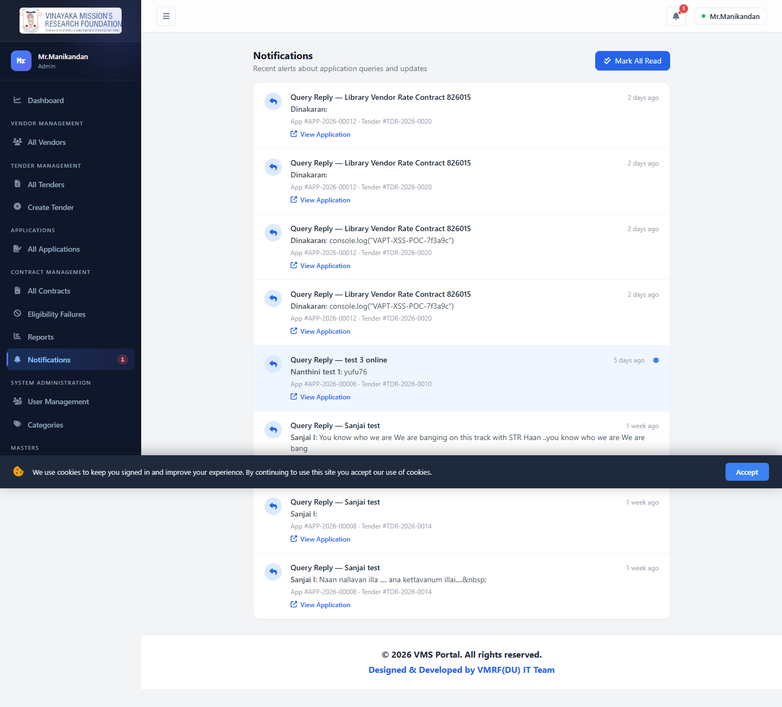

System Administration
Users List | Create User
Users List | Create User

Categories
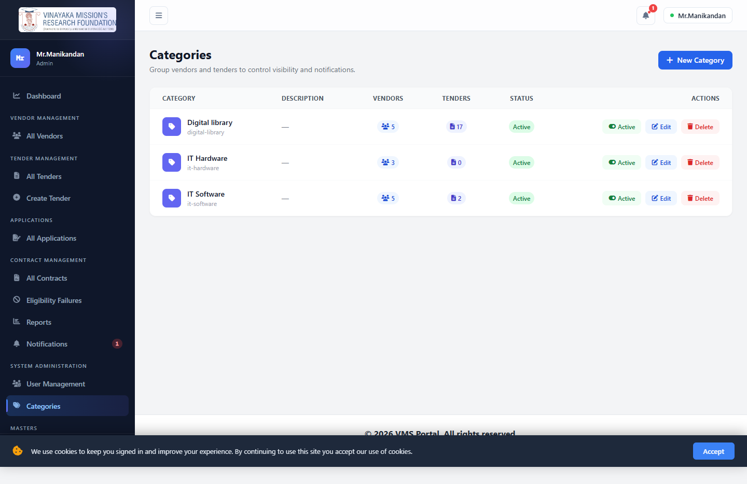
Terms & Conditions (Masters)
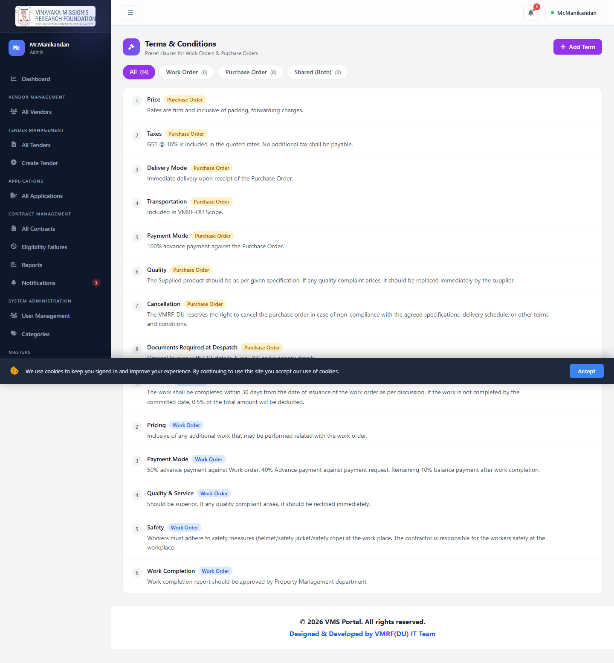
My Profile (shared by all roles)
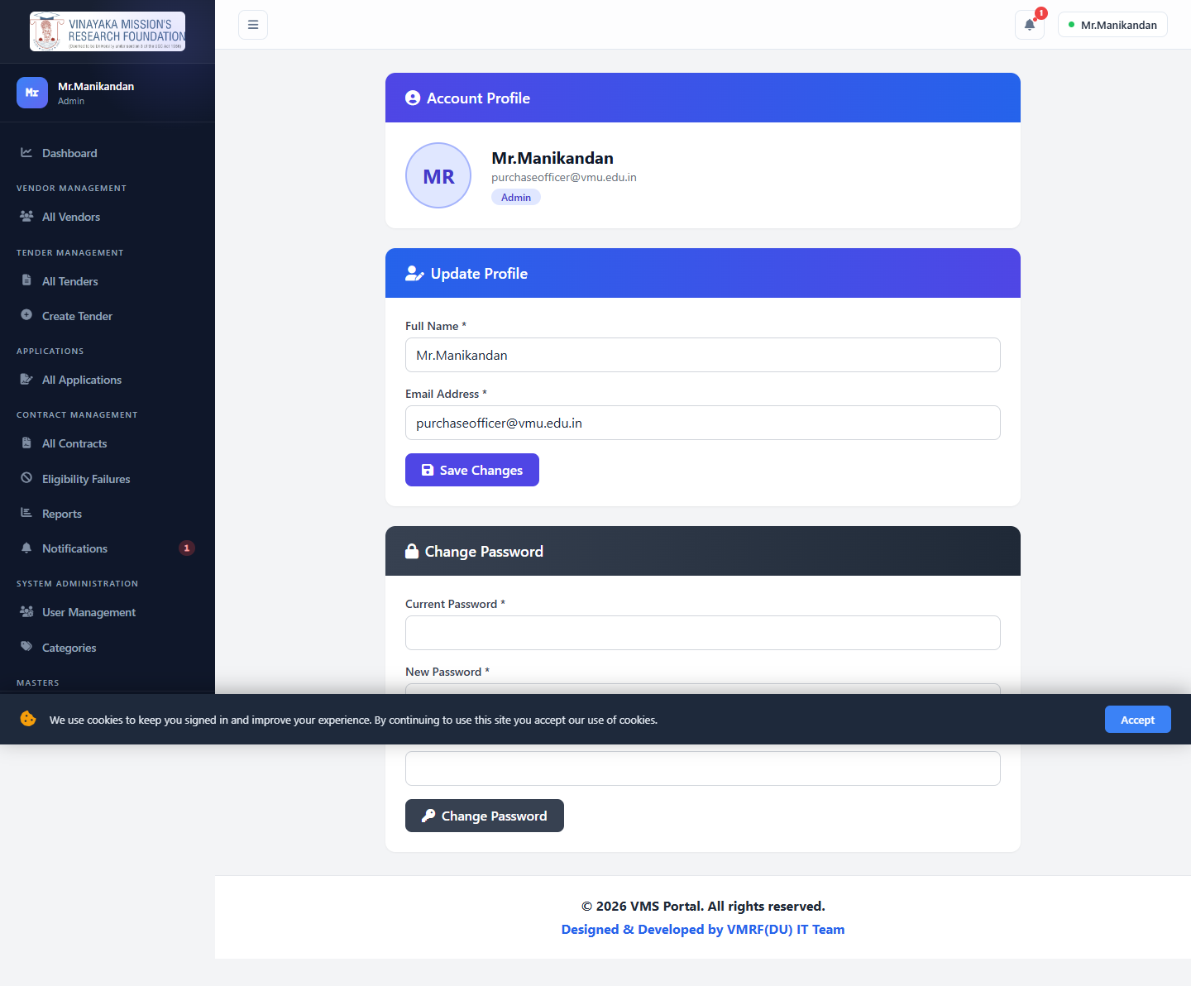

5. Tender Owner Manual
Login: test@gmail.com
Everything below mirrors the Admin tender/application/contract screens, pre-filtered to "my tenders" and enforced server-side via User::canAccessTender() / canManageTender(). §13 walks this role through a complete real tender end-to-end — create, publish, receive an application, shortlist it, award it, and get the contract signed.

Dashboard
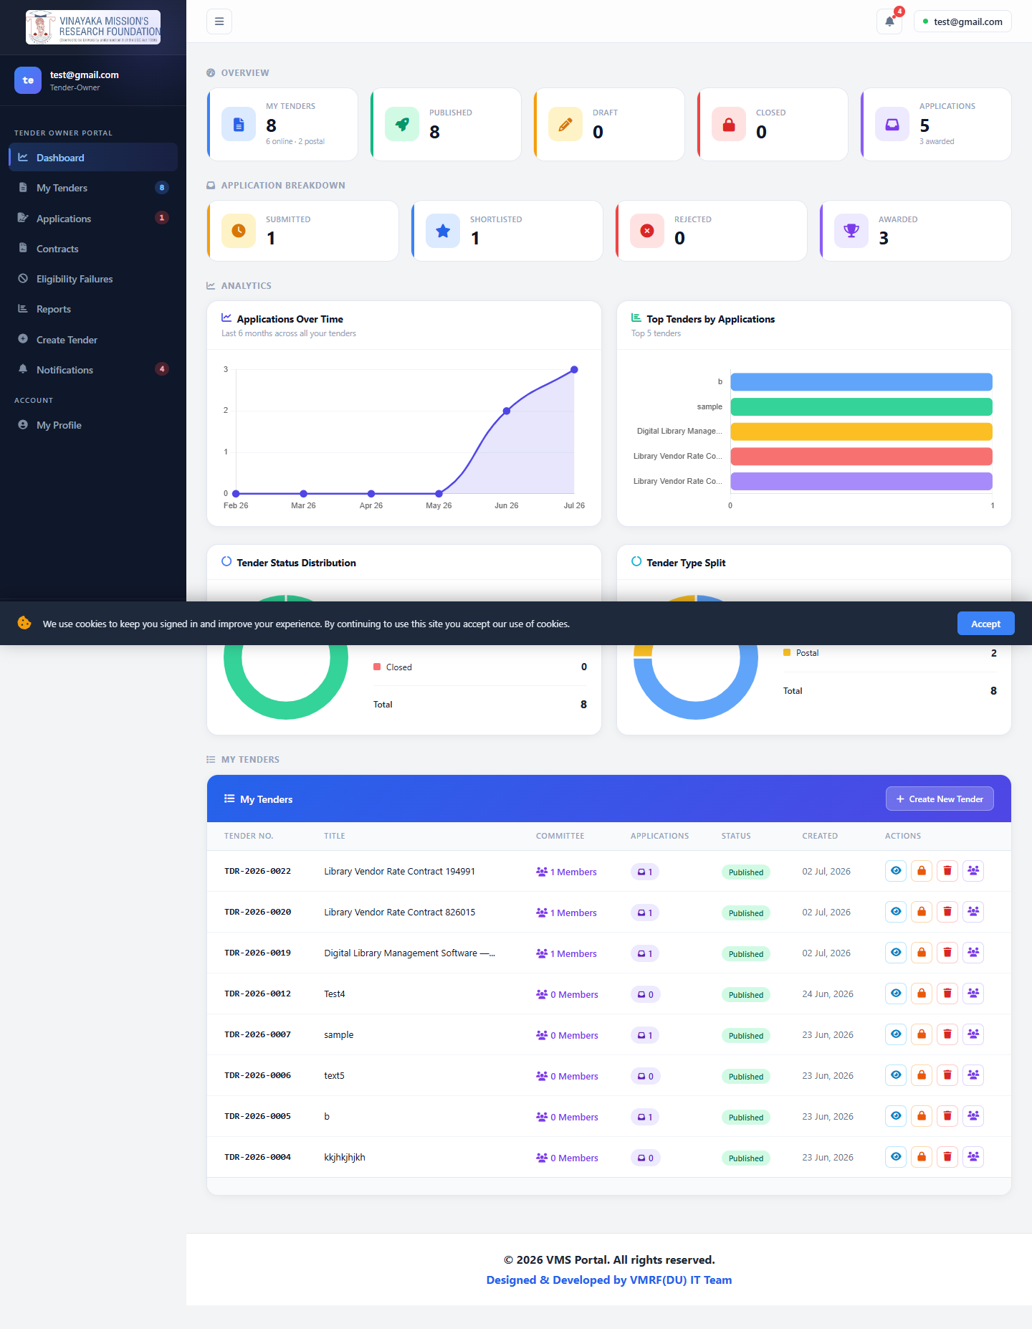

My Tenders
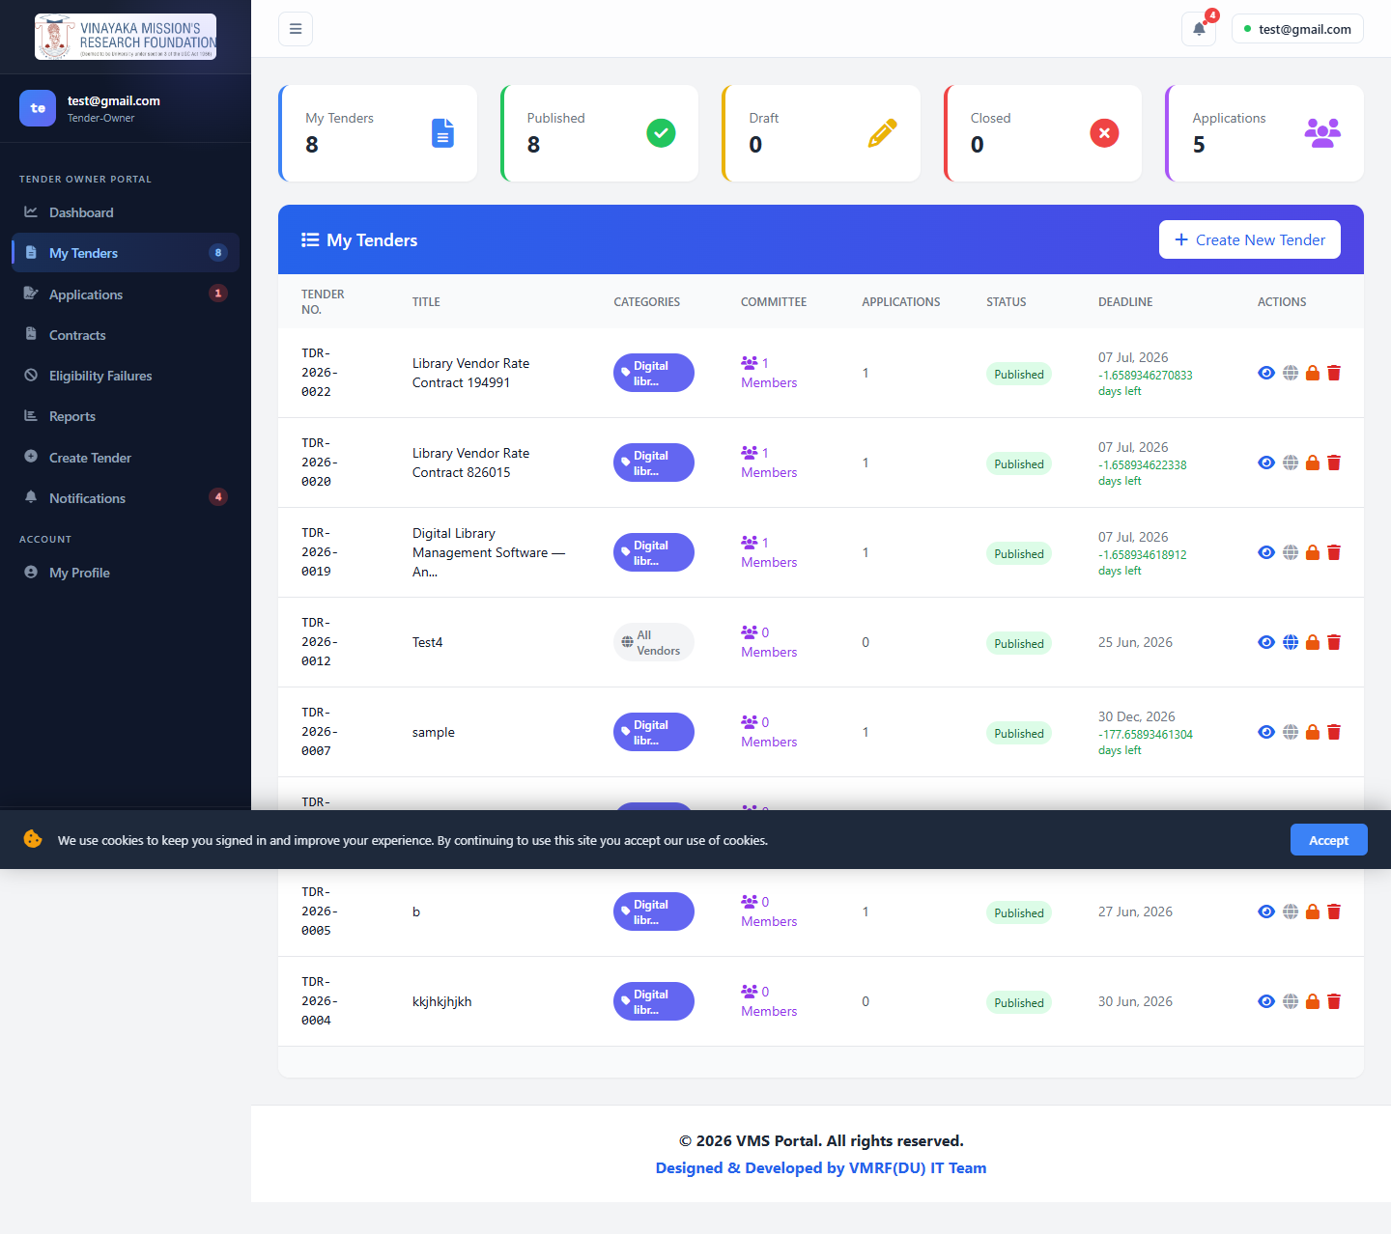

Create Tender
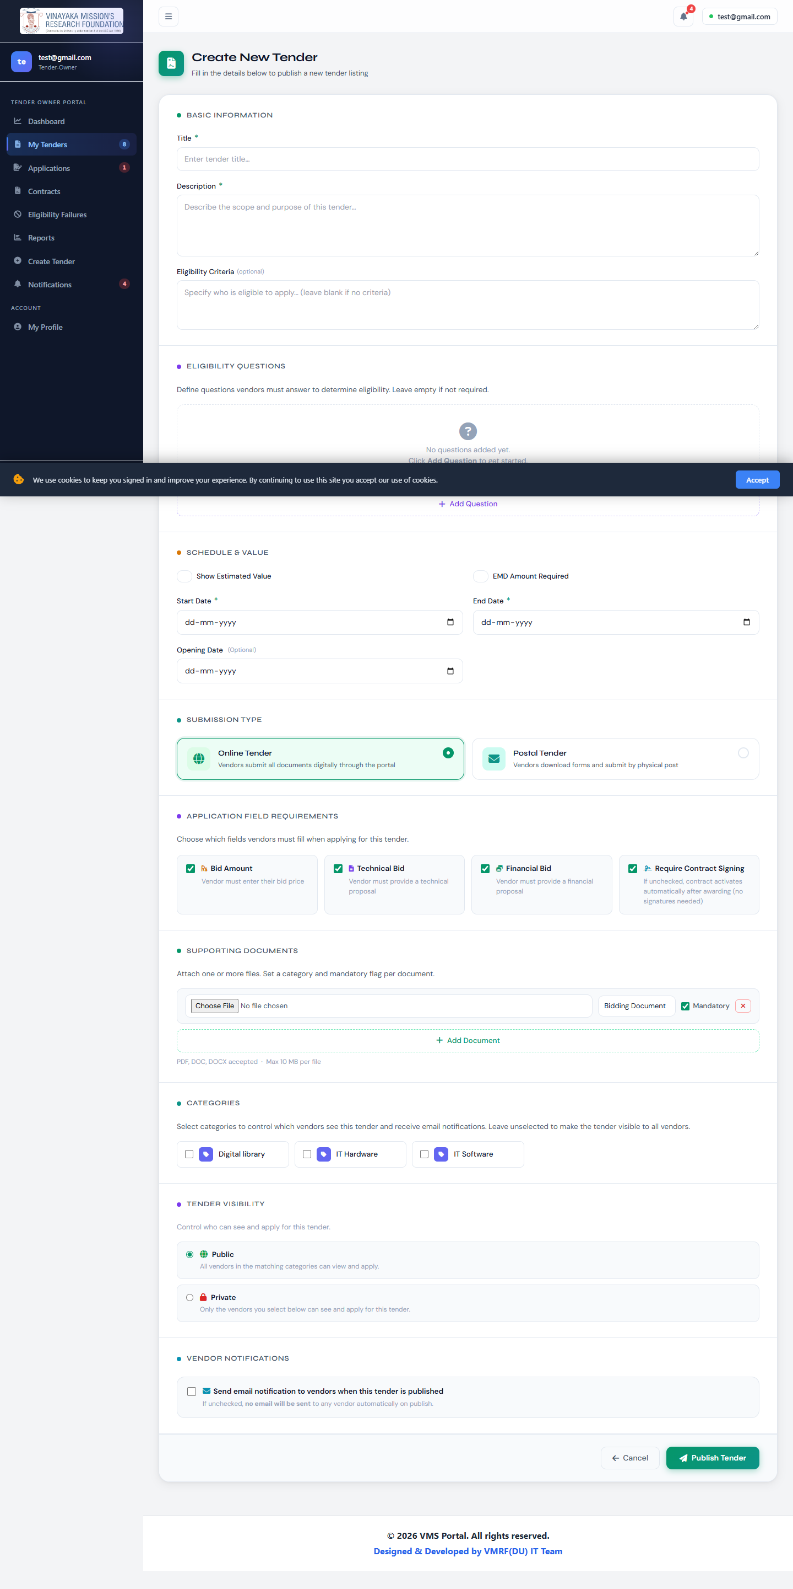

Tender Detail
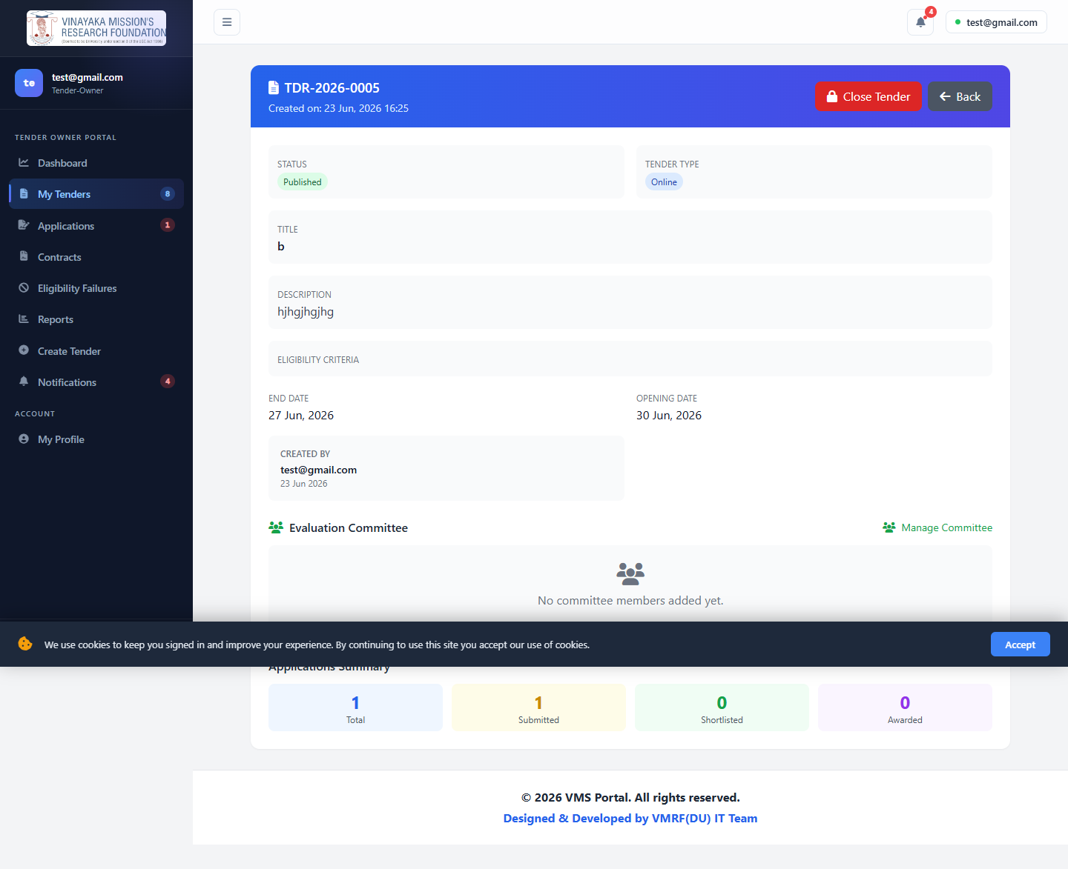

Edit Tender
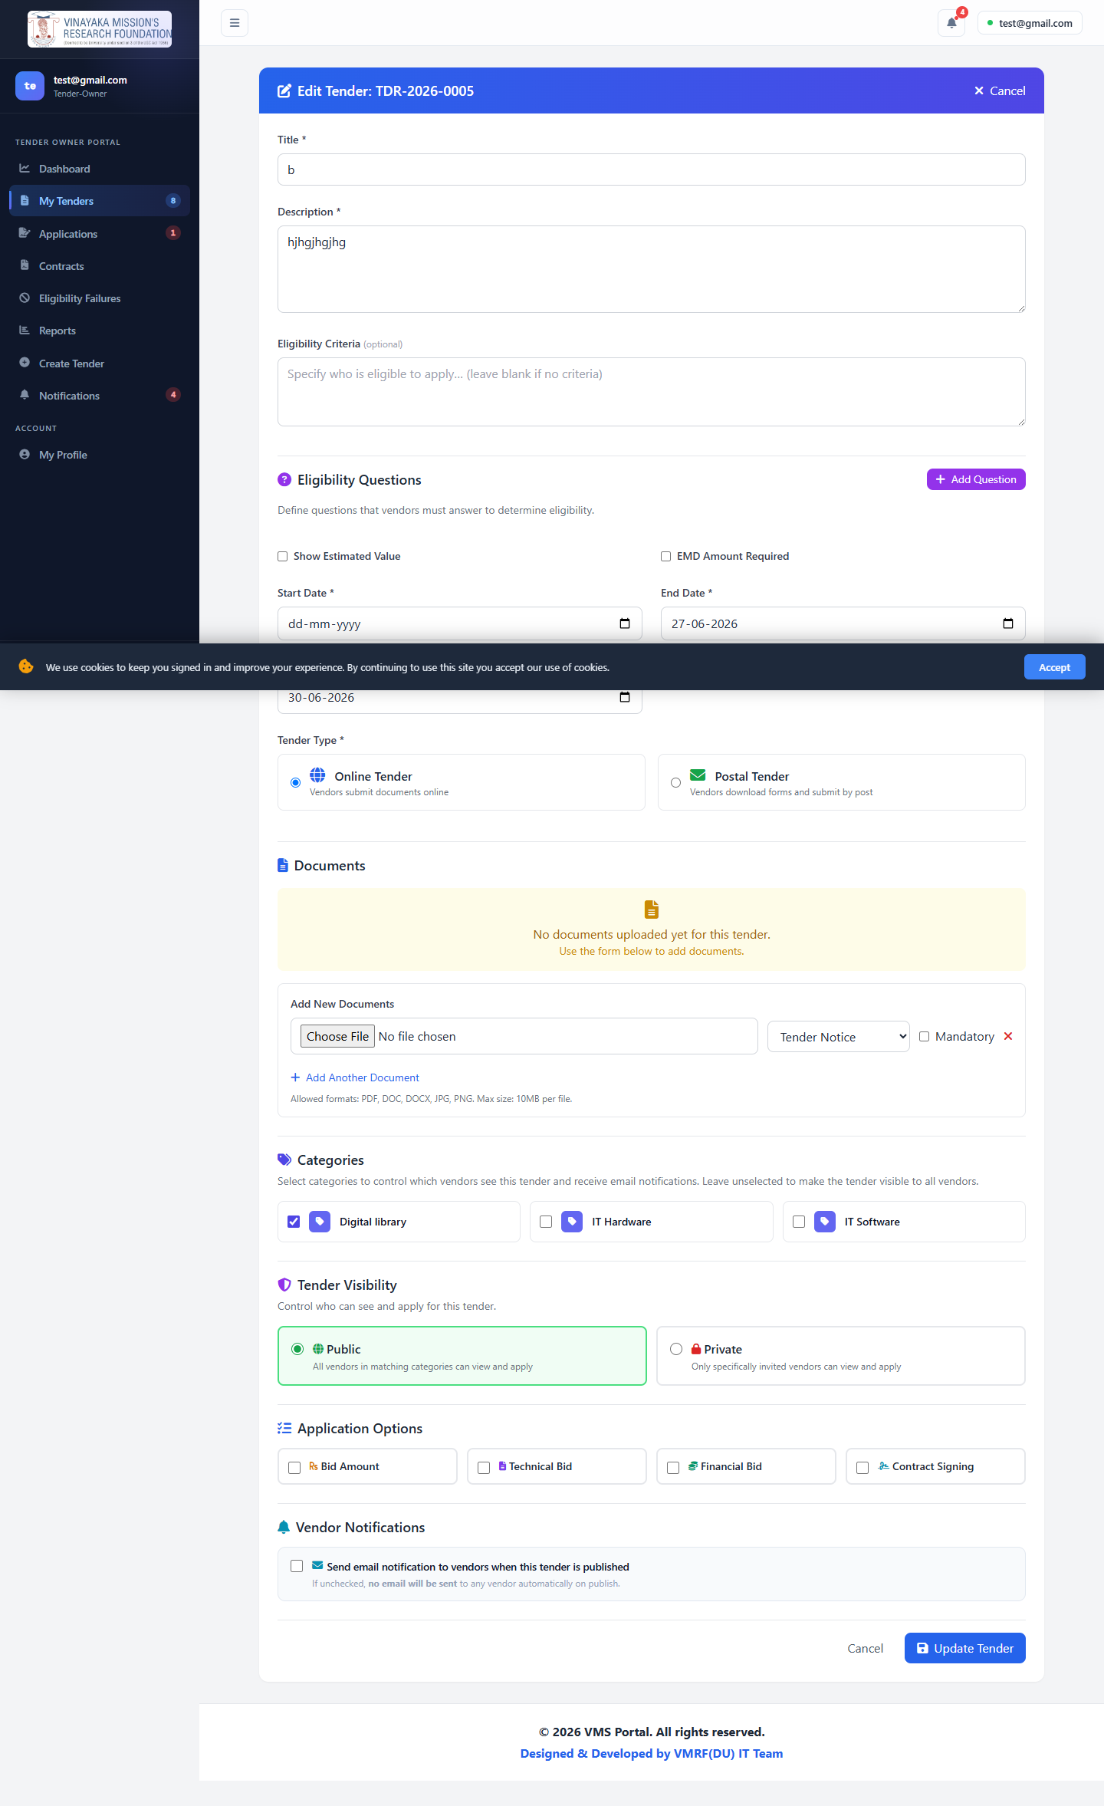

Manage Committee
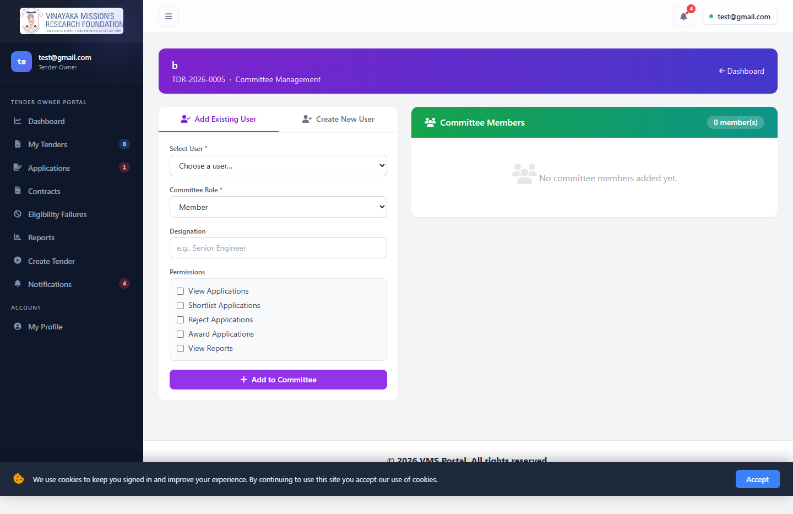

Applications
List | Detail
Applications List | Application Detail

An application arriving here is just the start: from Received (submitted), the Tender Owner can Shortlist it, then Award it from the Applications list (trophy icon) — which is what actually generates the contract and Work/Purchase Order. Awarding requires the application to have been shortlisted first; there's no way to award a raw submission directly.

Contracts
List | Detail
Contracts List | Contract Detail

Eligibility Failures
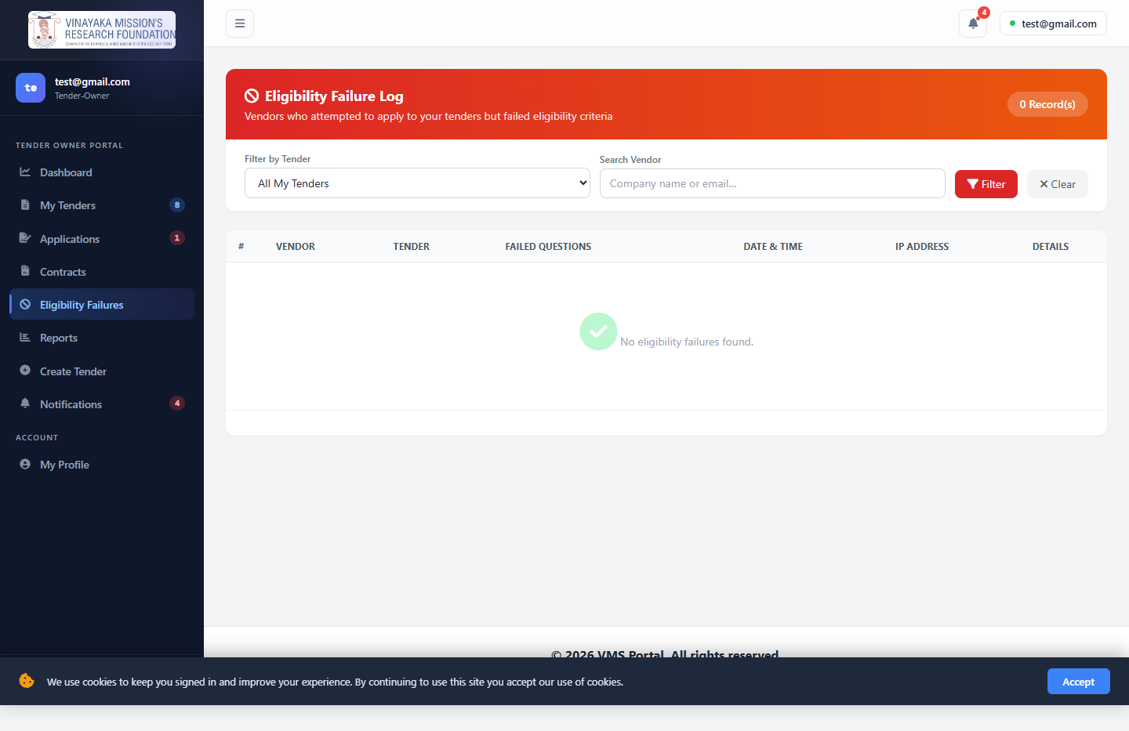

Reports
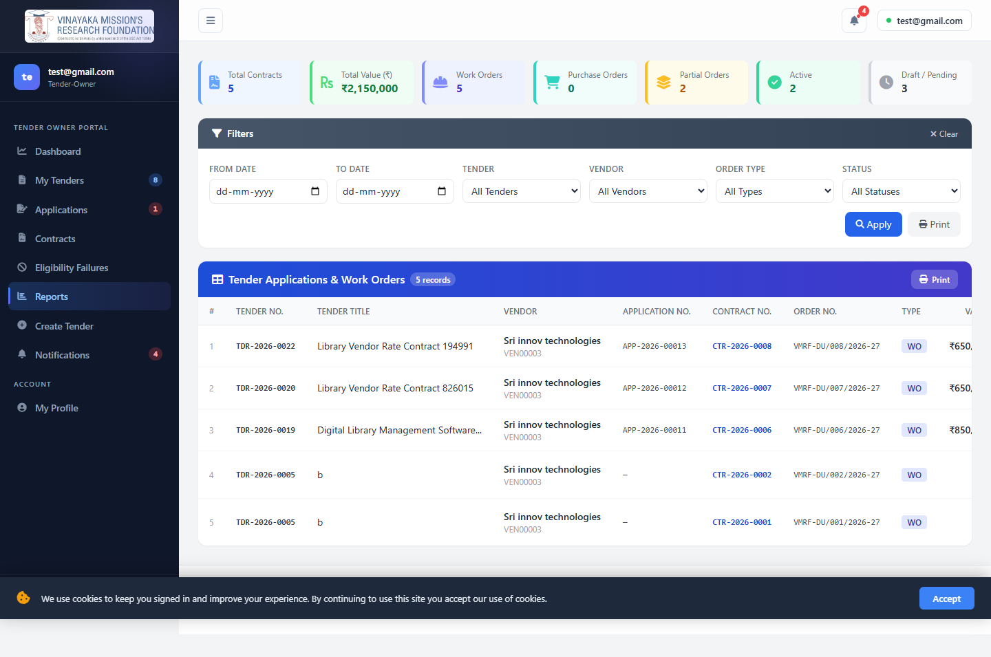

Notifications
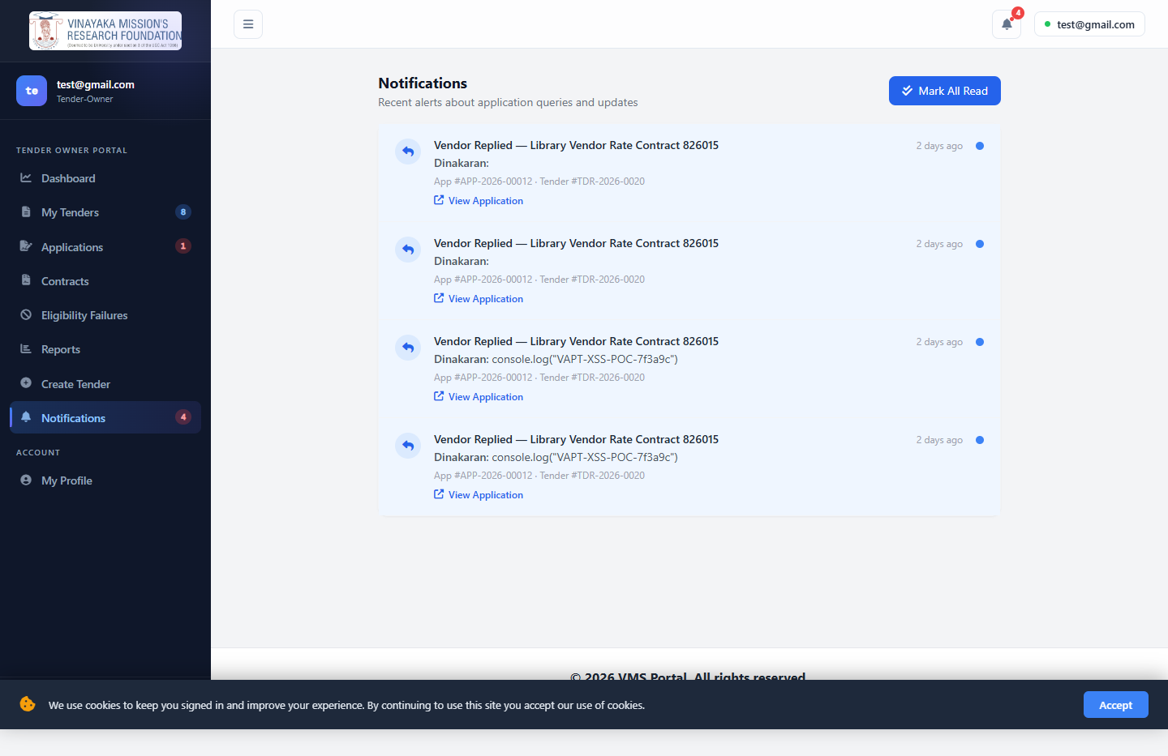

6. Vendor Manual
Login: innovcomp@gmail.com

Dashboard
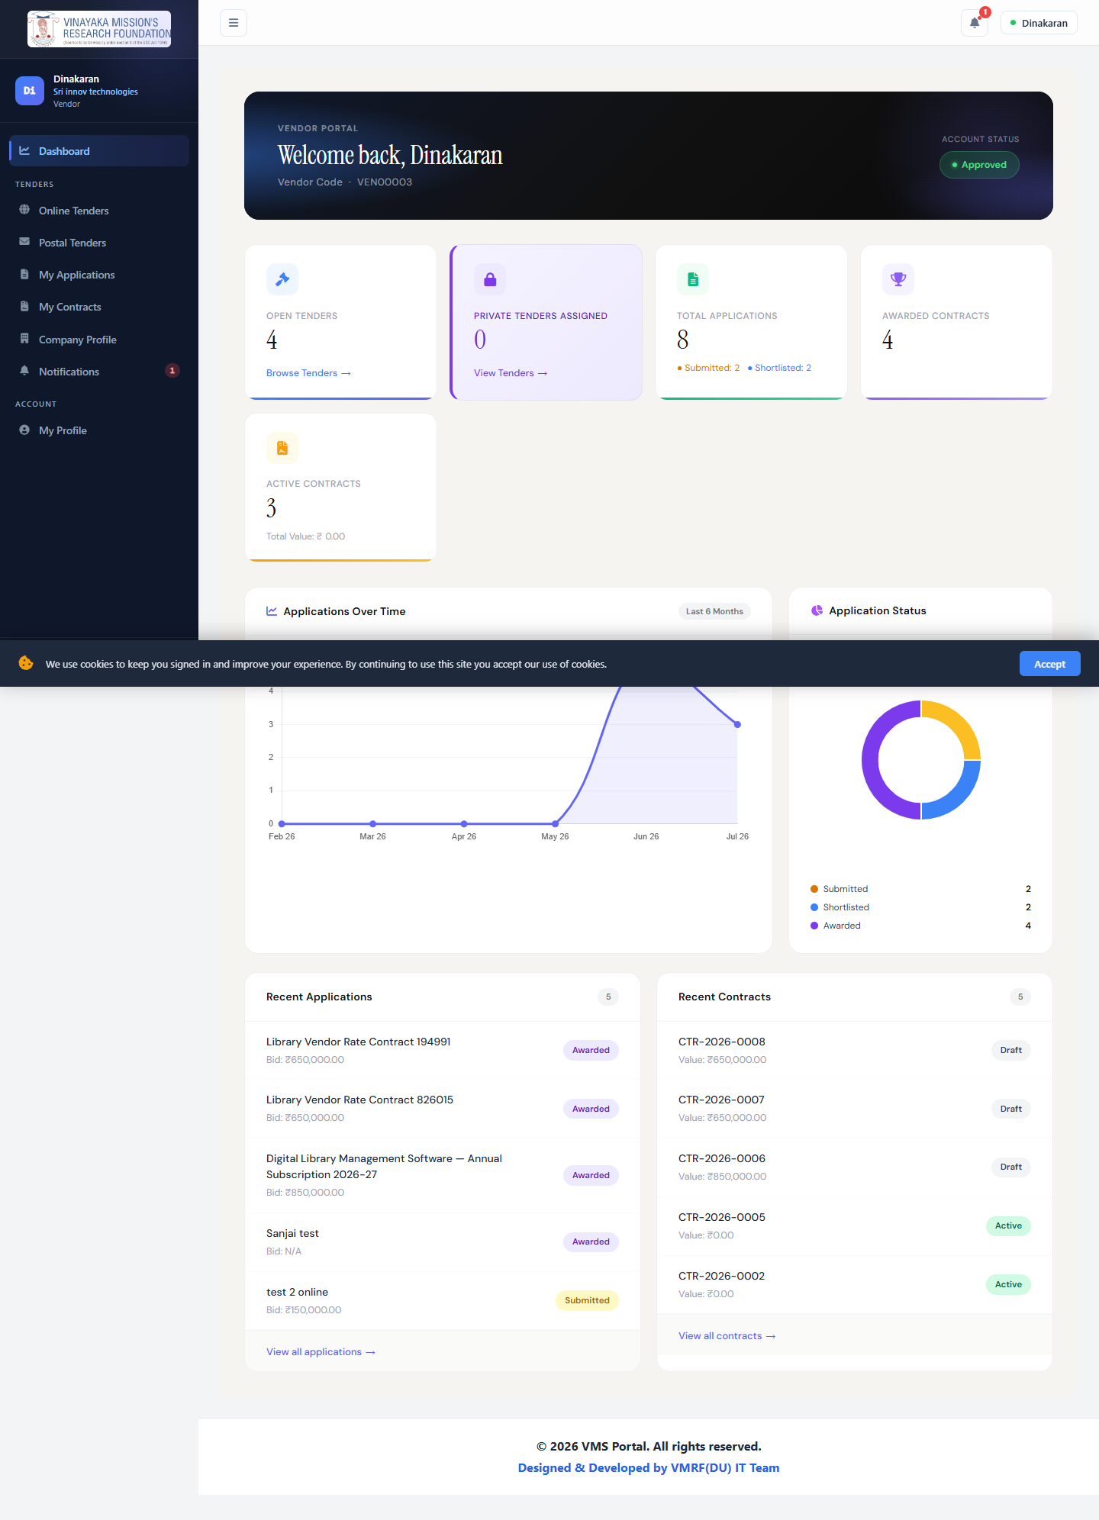

Browse Tenders
Online Tenders | Postal Tenders
Online Tenders | Postal Tenders

Tender Detail
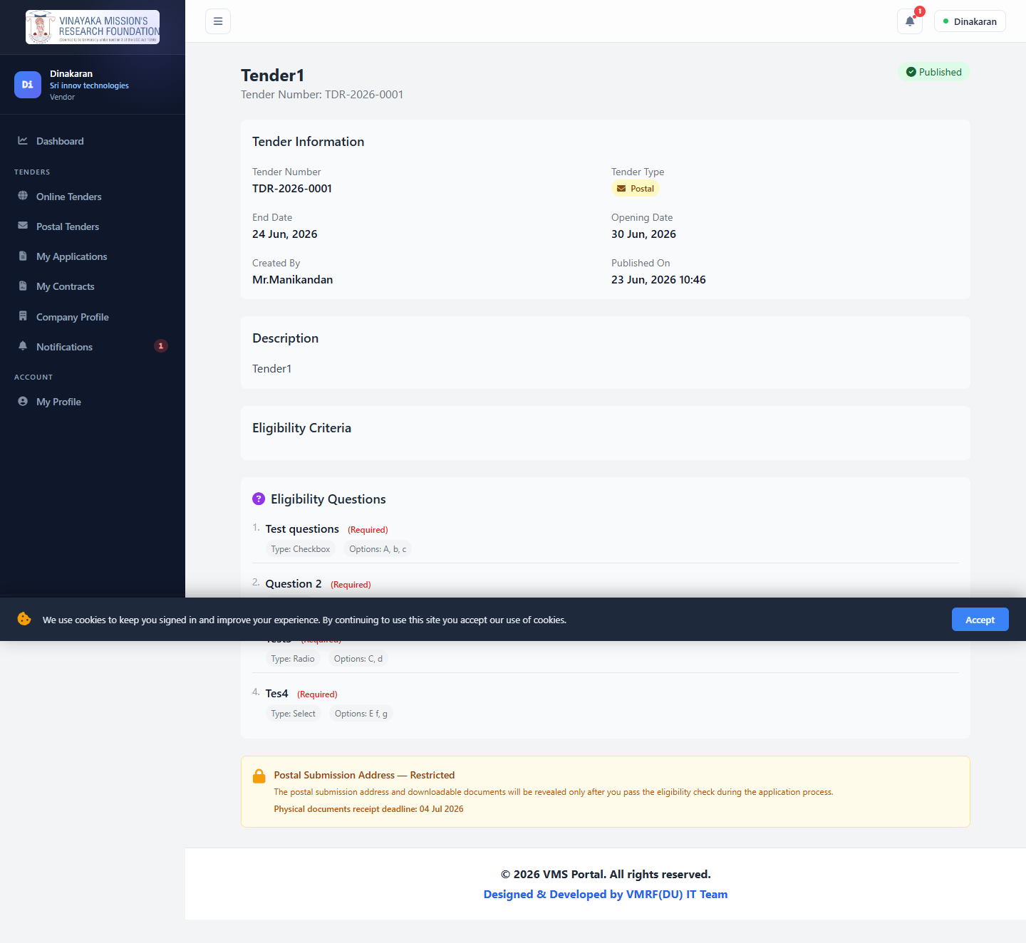
For postal tenders, the submission address and downloadable documents stay locked until the vendor passes the eligibility check.

Apply to a Tender (2–3 step wizard)
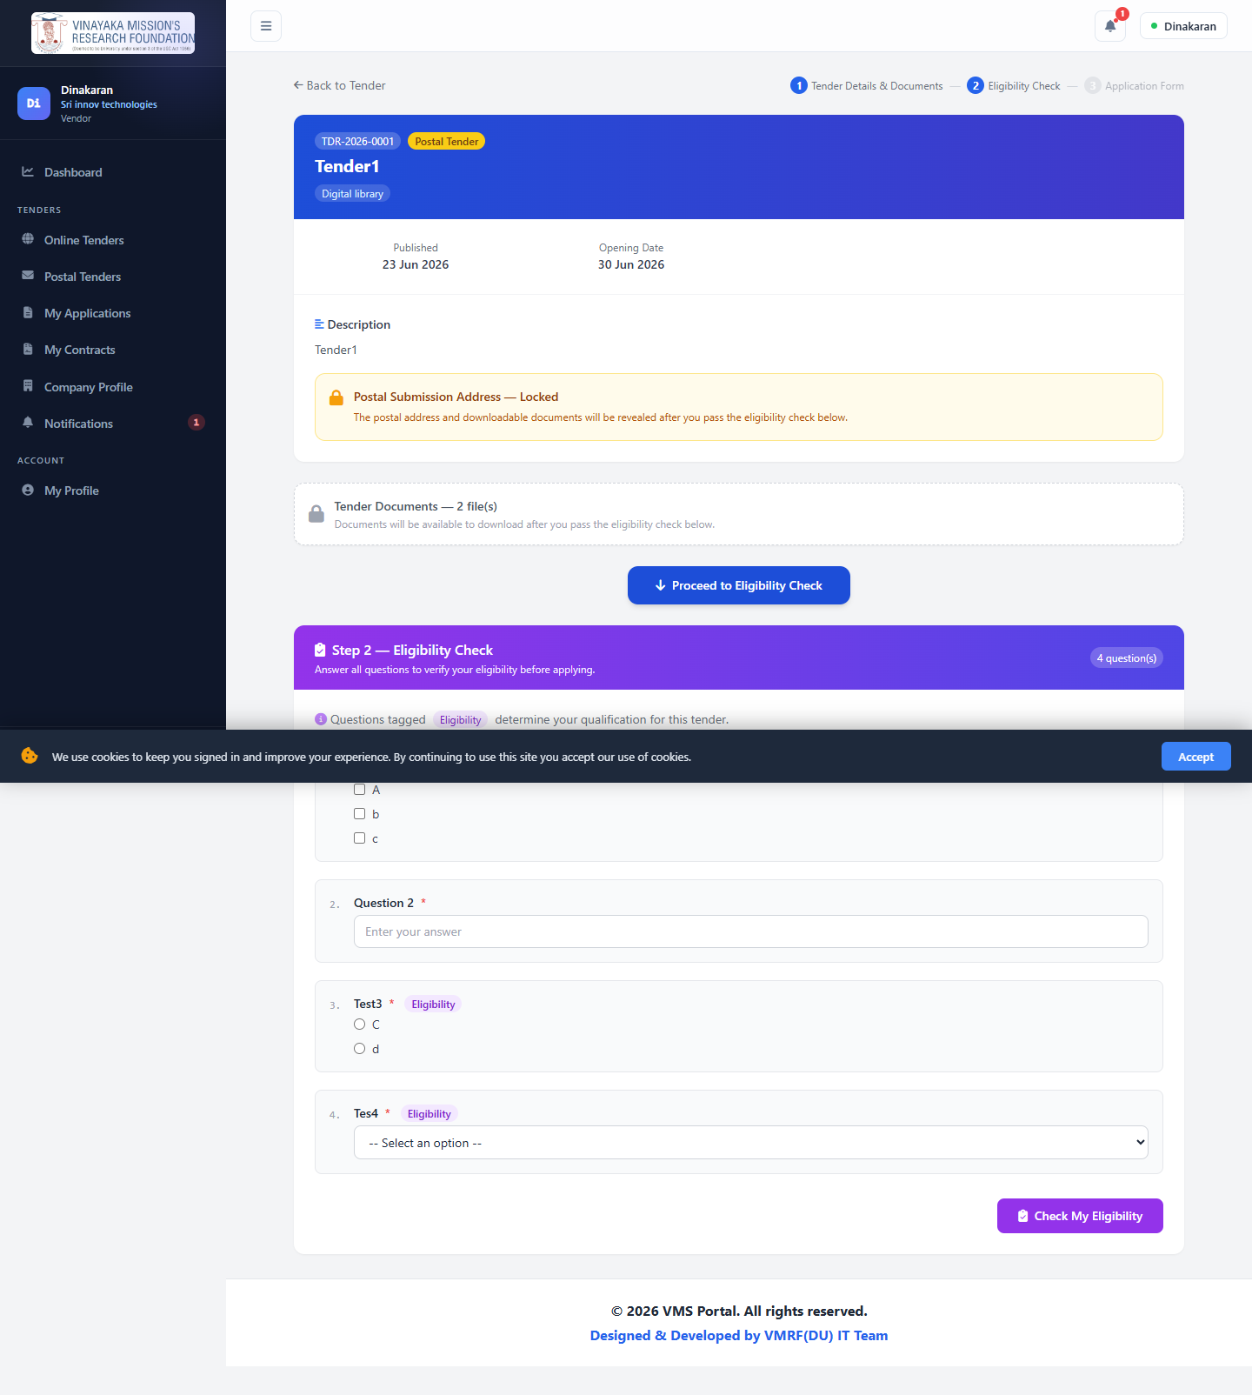
Step 1: tender details/documents. Step 2 (if the tender has eligibility questions): dynamic questionnaire, checked live via AJAX. Step 3: bid/technical/financial proposal, unlocked only after passing. See §13 for this entire flow captured live, step by step.

My Applications
List | Detail
Applications List | Application Detail

My Contracts
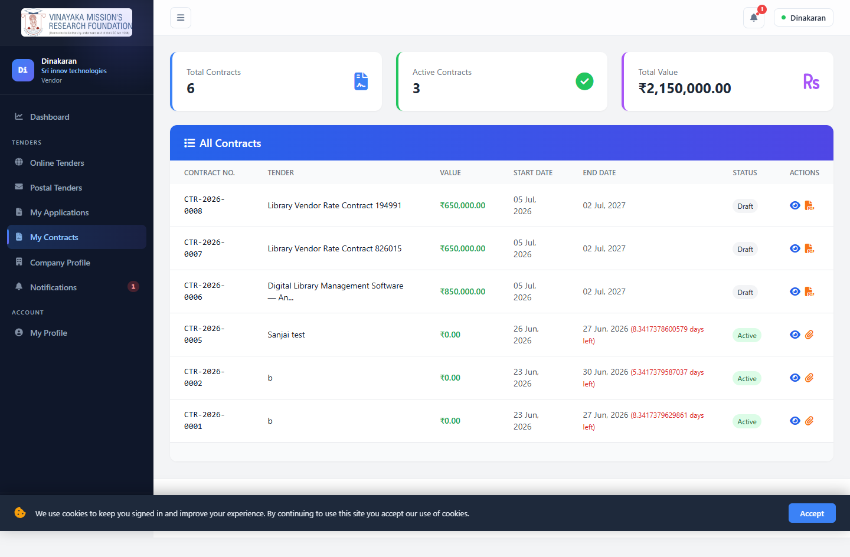
Once awarded, the vendor signs here. Whether a counter-signature from the University is also required depends on how the Tender Owner configured that specific tender (§8 diagram 5) — for a standing rate contract, the Tender Owner may choose to skip formal signing entirely and activate the contract immediately on award.

Company Profile
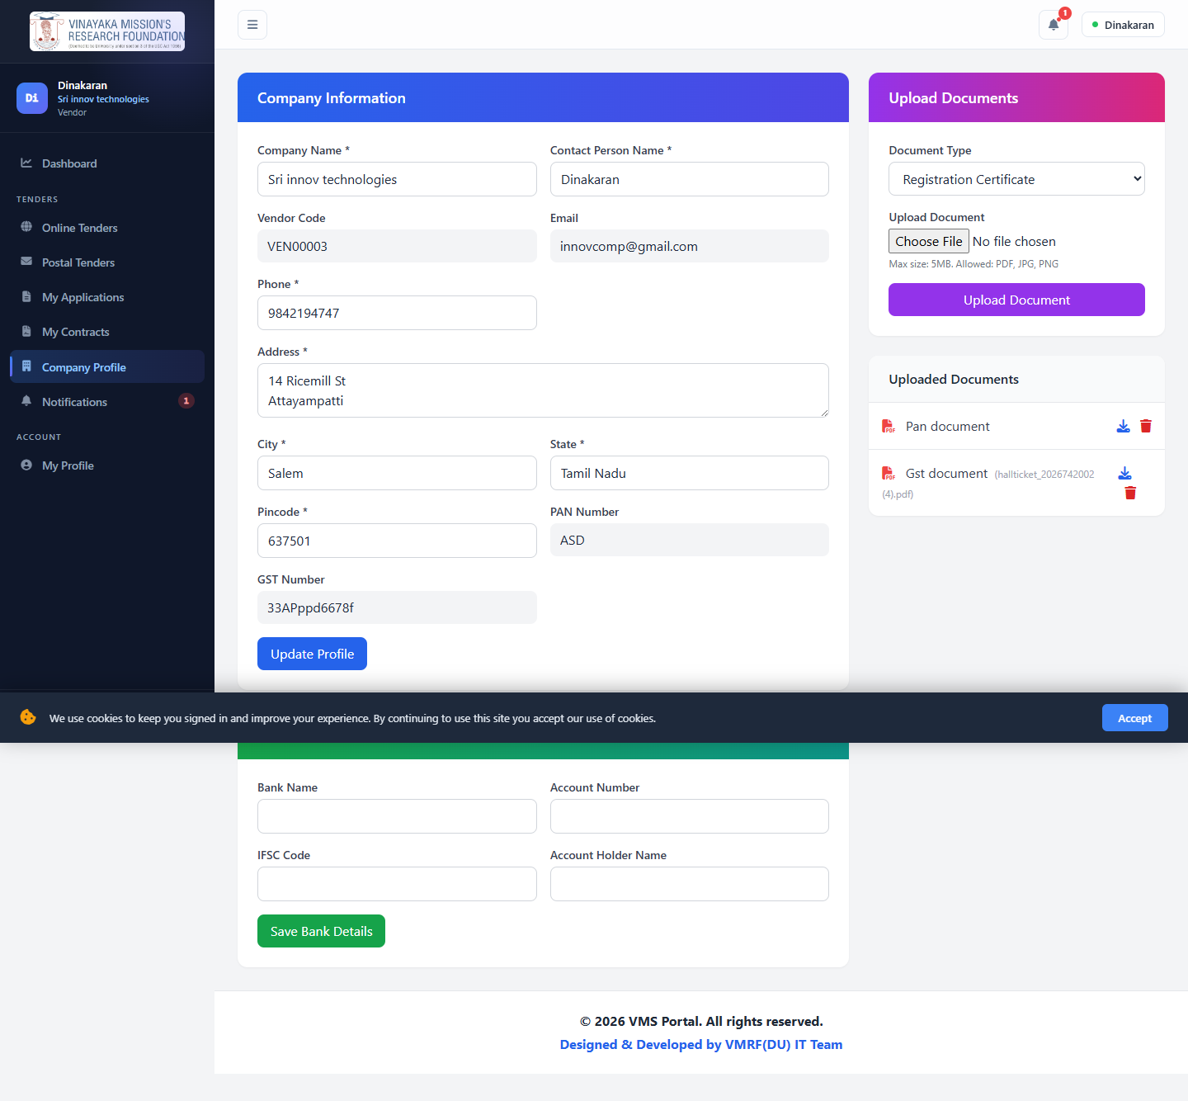

Notifications
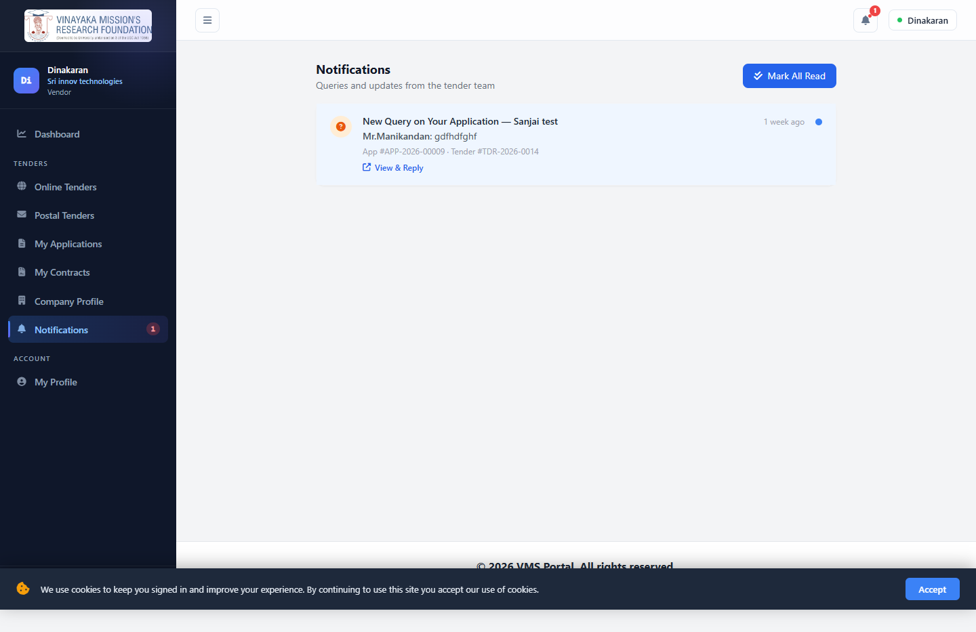

7. Committee Member Manual
Login: a demo account (committee.demo@example.com) for the static screenshots below; §13 shows a second committee member created live through the actual "Manage Committee" UI, the way a Tender Owner would really do it.
Committee members are assigned to specific tenders by the Admin/Tender Owner with a scoped JSON permission set. This role gives evaluators visibility without full tender-management rights.

Dashboard
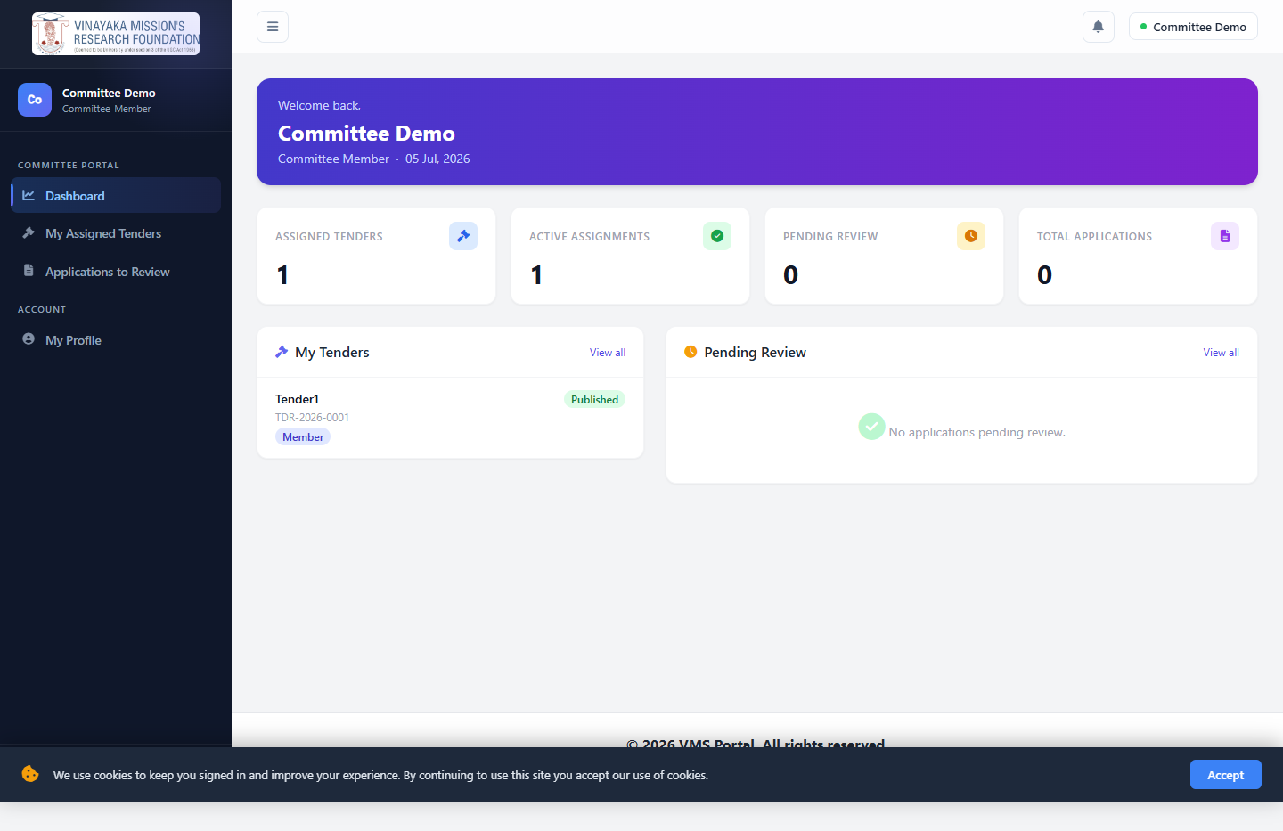

My Assigned Tenders
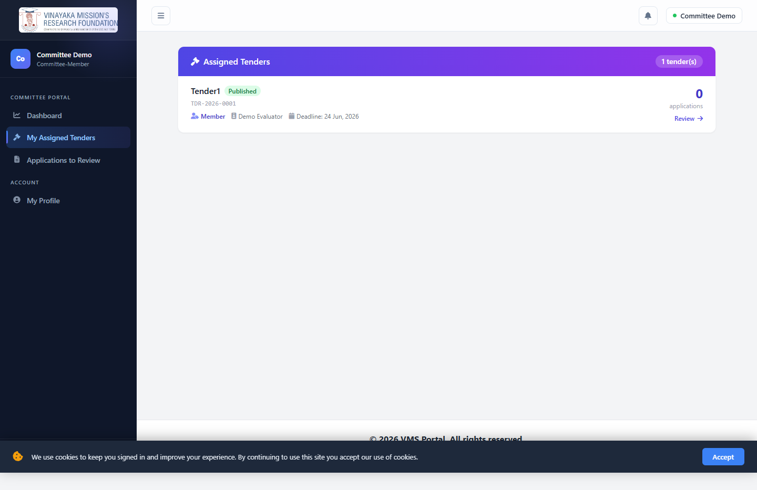

Applications to Review
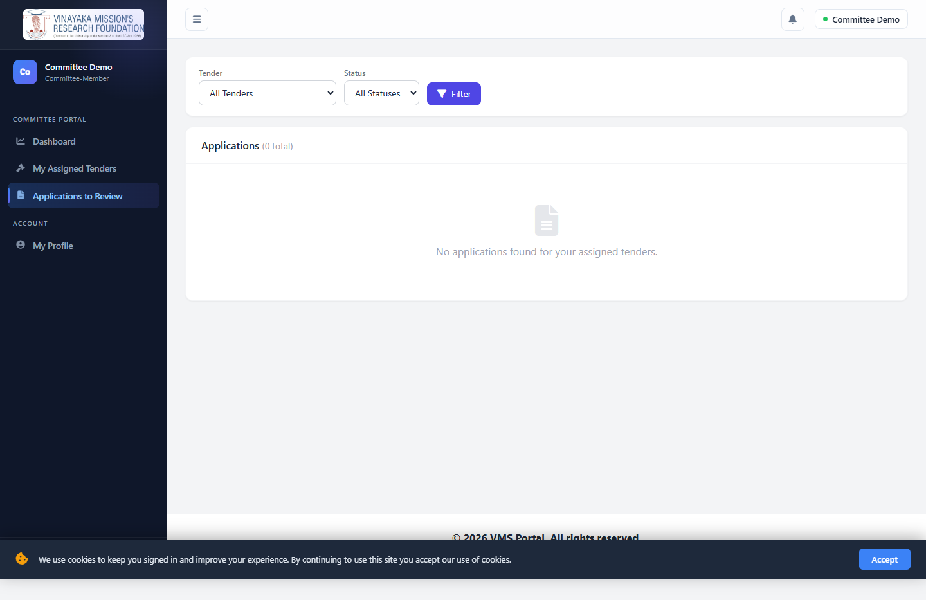

8. Tender → Application → Contract Lifecycle (with flowcharts)
- Tender: draft → published → closed (created with eligibility questions in one form; publishes manually or automatically at start_date if auto-publish was checked — this scheduled job now runs correctly, see §12)
- Application received: vendor passes an eligibility check (or is blocked, logged as an EligibilityFailure) → status becomes submitted ("received")
- Shortlist → Award: the Tender Owner or Admin reviews the received application, shortlists it, then awards it — awarding is what generates the contract
- Contract signing is optional, by design: whether the vendor (and University) must formally sign before the contract activates is a checkbox the Tender Owner sets per tender — see diagram 5 below for both paths and a gap found while testing the "signing required" path

Tender Lifecycle (State Machine)
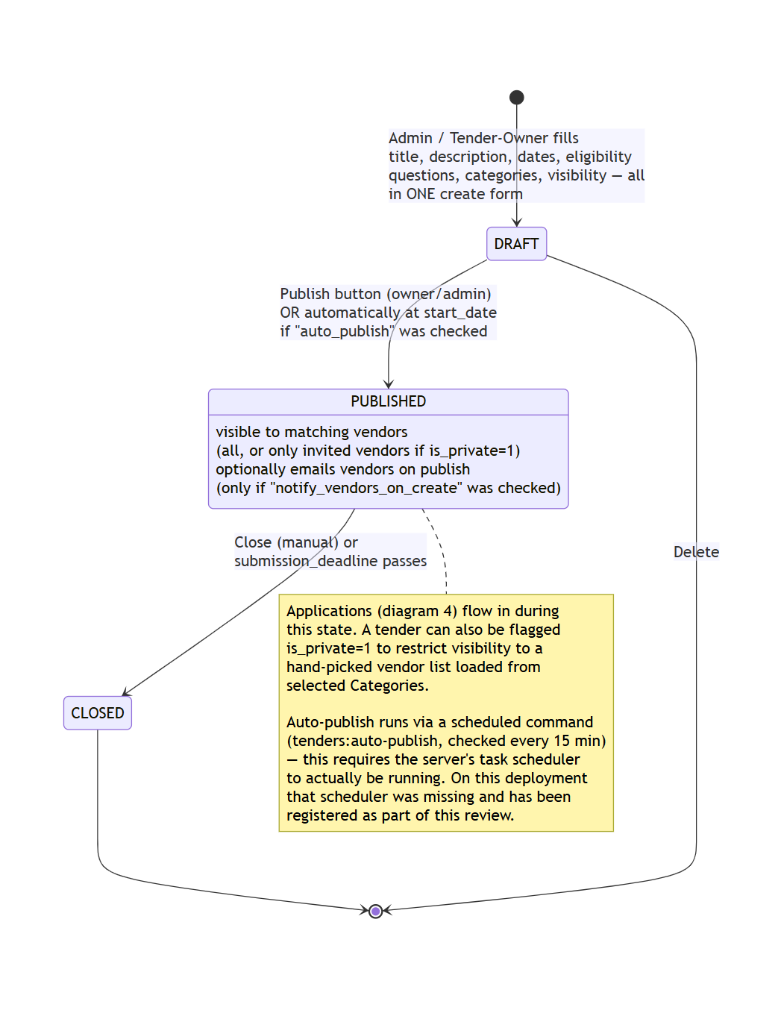

Vendor Eligibility Check — Decision Logic
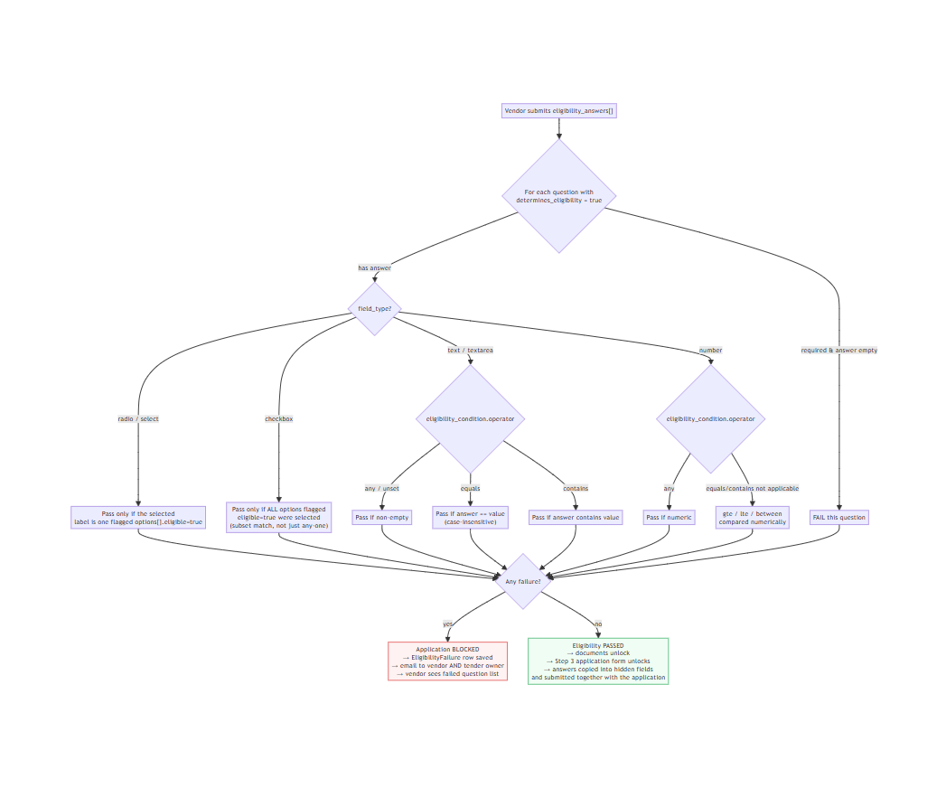

Vendor Application Lifecycle — Received → Shortlisted → Awarded
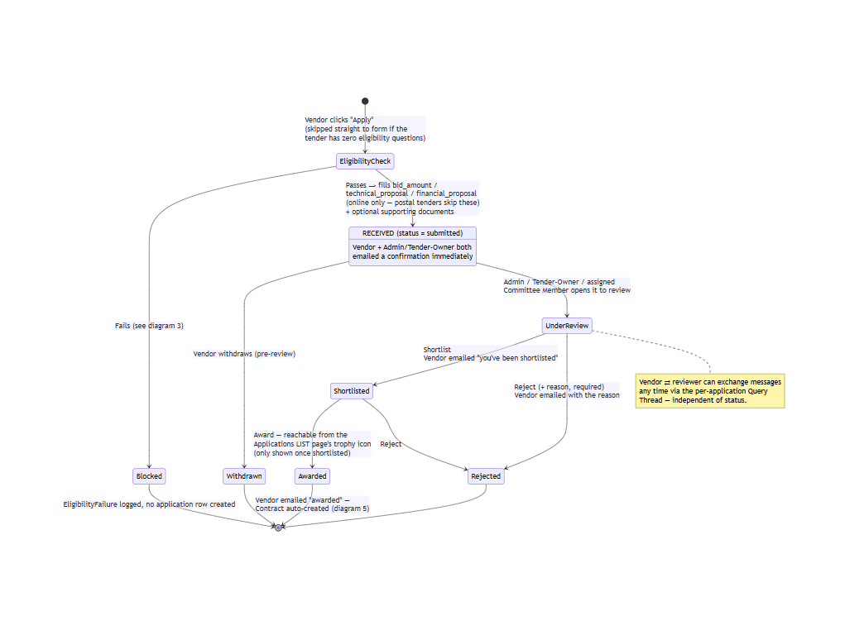

Contract & Work/Purchase Order — Signing Is Optional, By Design
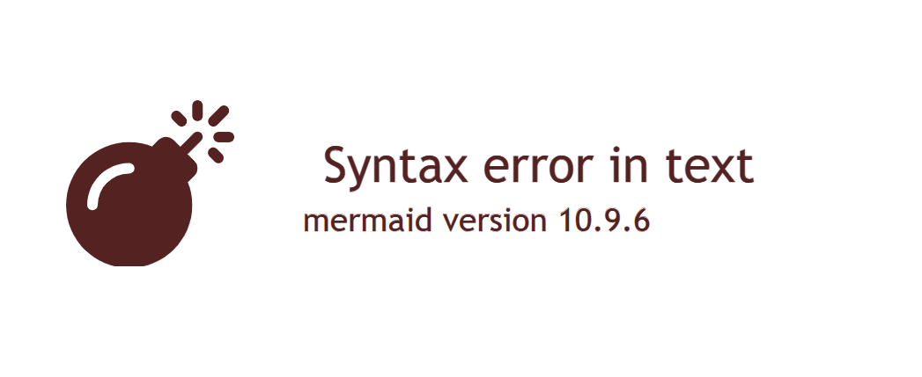

Vendor Registration & Approval
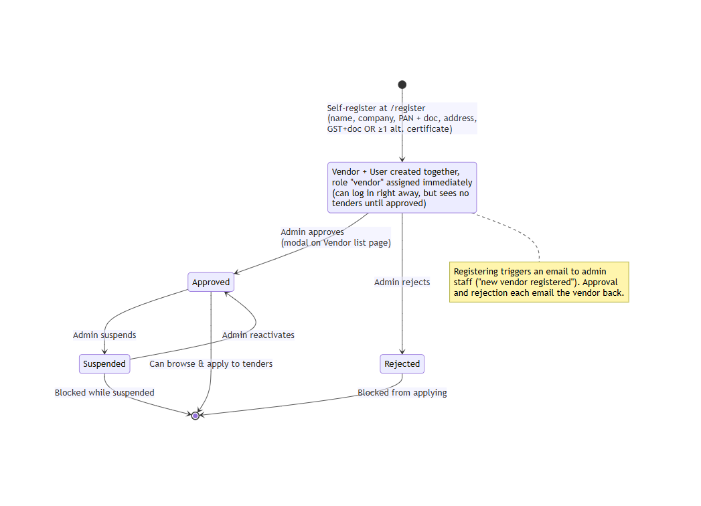

End-to-End Procurement Flow (Sequence Diagram) — as live-verified
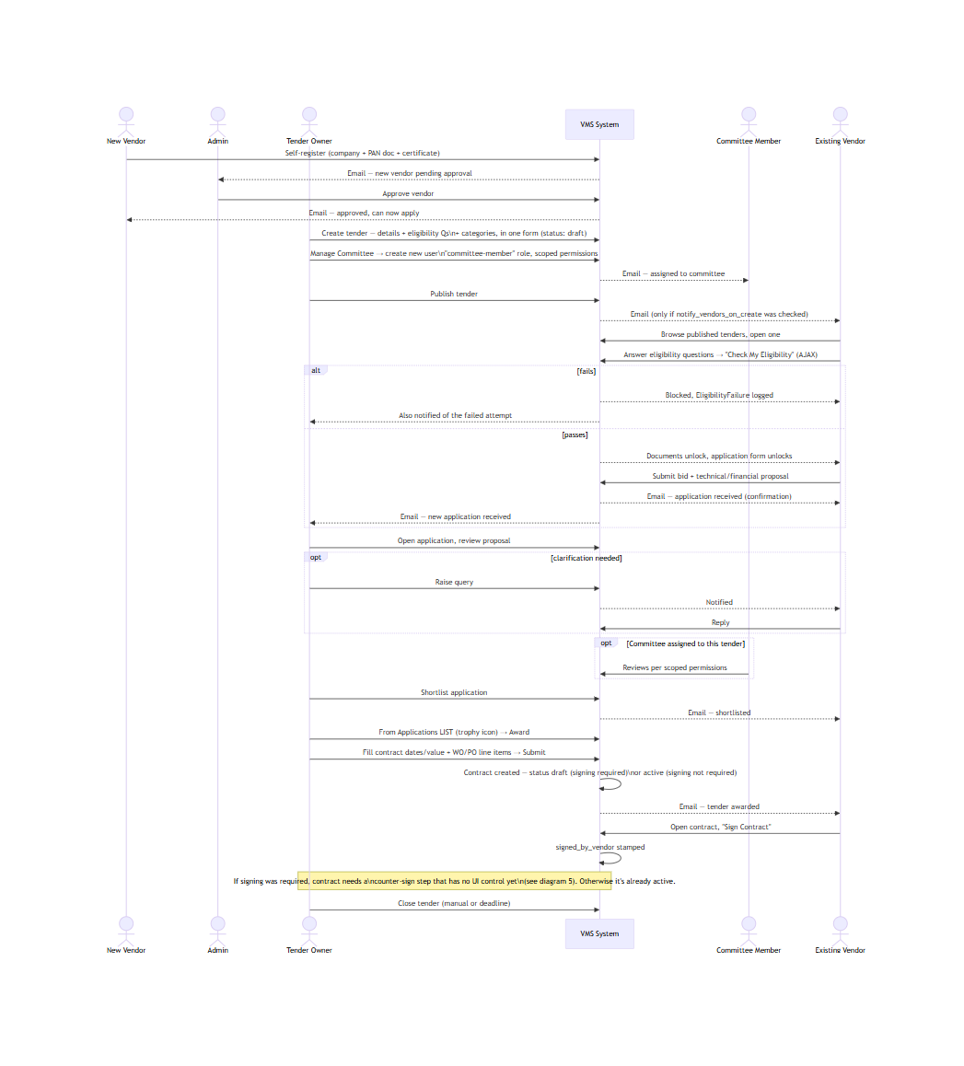

9. Automatic Email Notifications

Every step of the process notifies the right person automatically — nobody has to remember to tell a vendor their application was received, shortlisted, or awarded. This was verified by reading every Mail::to(...)->send(...) call in the codebase, not assumed.
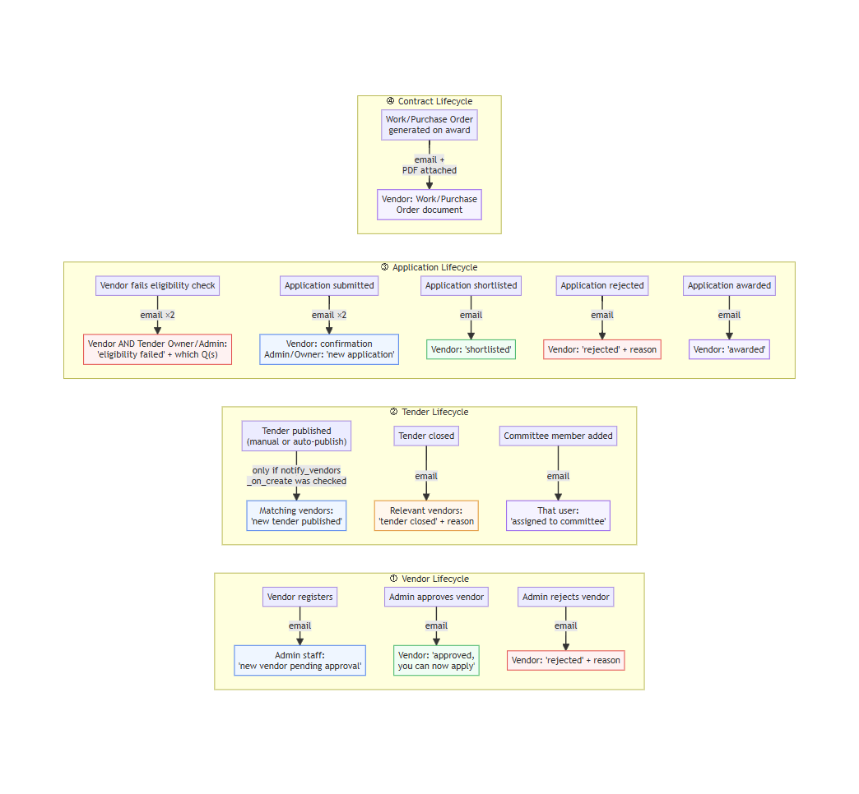
In plain terms:
Trigger | Who gets emailed
Vendor registers | Admin staff — new vendor pending approval
Vendor approved / rejected | The vendor, either way
Tender published | Matching vendors — only if the Tender Owner checked "notify vendors on publish"
Tender closed | Relevant vendors, with the reason
Committee member added | That person, with their role/designation
Vendor fails eligibility check | Both the vendor and the Tender Owner/Admin, naming which question(s) failed
Application submitted | Vendor gets a confirmation; Tender Owner/Admin gets a "new application" alert
Application shortlisted | The vendor
Application rejected | The vendor, with the reason
Application awarded | The vendor
Work/Purchase Order generated | The vendor, with the order document attached as a PDF

Every one of these is wrapped in its own try/catch — a failed email (e.g. a temporary SMTP hiccup) never blocks the underlying action. Approvals, publishes, shortlists, and awards all still go through even if a notification fails to send; the failure is only logged.

10. Future-Ready: Mobile App & Public Website Integration
The portal was built with more than the internal dashboards in mind. It already exposes a public, unauthenticated, CORS-enabled JSON API — the same foundation a mobile app and a live tender feed on the main university website would both need, with no additional backend work required to switch either one on.

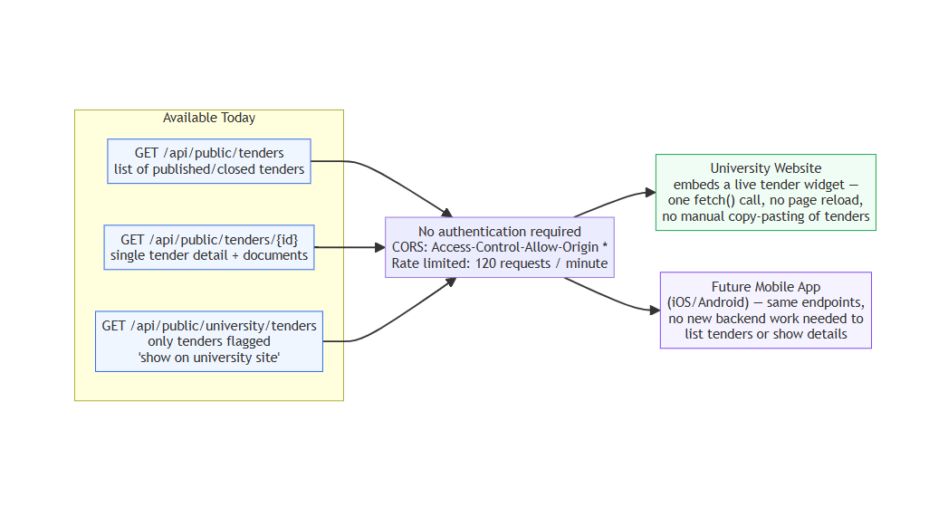
- University website integration: the main site can embed a live "Current Tenders" widget with a single fetch() call to GET /api/public/university/tenders — no manual copying of tender details onto the website, no second place for information to go stale. Only tenders the Tender Owner explicitly flags "show on university site" appear here.
- Mobile app readiness: GET /api/public/tenders and GET /api/public/tenders/{id} already return everything a mobile listing/detail screen would need (title, dates, value, documents), rate-limited to 120 requests/minute per visitor and open to any origin. A future iOS/Android app — or a vendor-facing "apply from your phone" experience — can be built against these same endpoints without touching the server.

11. Data Model

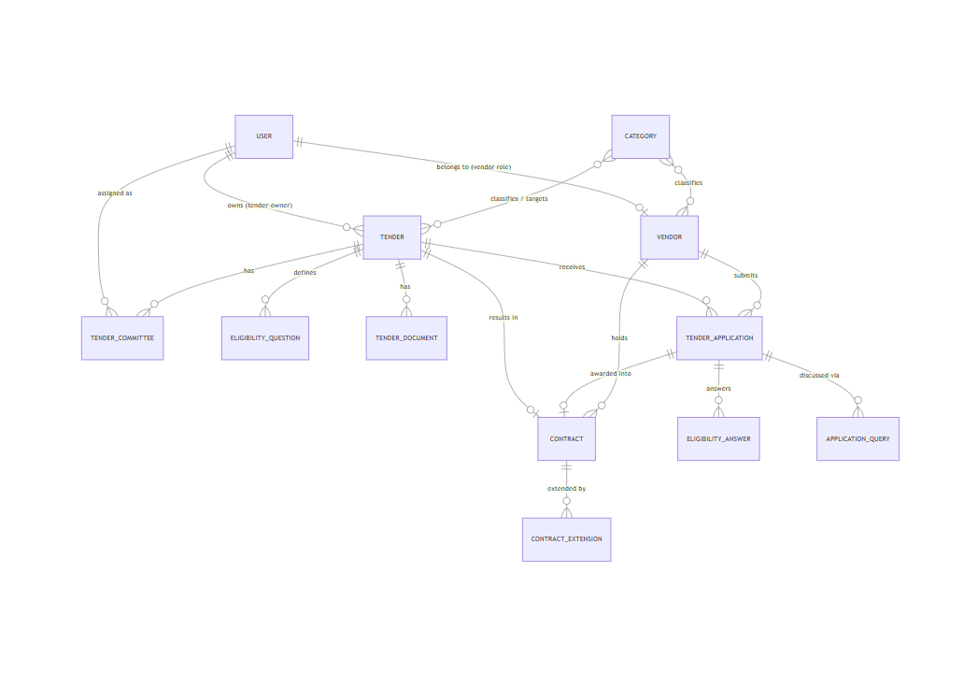

12. Known Issues Found During This Review
Several real, verified bugs were found and fixed live during this review — not just documented. Two remain open.

🟢 Fixed — Auto-publish silently did nothing
Tenders with "auto-publish on start date" checked stayed stuck in Draft indefinitely. The tenders:auto-publish command itself was correct — running it manually published tenders instantly — but nothing on the server was ever calling Laravel's scheduler. On Windows/XAMPP there is no cron; Laravel's Schedule::command(...)->everyFifteenMinutes() only defines what to run, and something external has to trigger php artisan schedule:run every minute for anything to actually fire. That trigger never existed here. Fixed by registering a Windows Scheduled Task ("VMS Laravel Scheduler") that runs php artisan schedule:run every minute — verified live (LastTaskResult: 0, tender auto-published on the next tick).

🟢 Fixed — Vendor approve/reject/suspend/activate/view were all silently broken
This is more serious than a single screen. The vendor list's approve, reject, suspend, activate, view-details, categories, and delete actions all derived their API path from window.location.pathname.split('/')[1]. Because this app is deployed under a /vms-system/ subpath (not domain root), that always evaluated to "vms-system" instead of "admin", so every one of those six actions silently 404'd — clicking "Approve" showed a success-looking modal, but the vendor's status never actually changed in the database. Confirmed live: a vendor approved during an earlier documentation pass was still "Pending" days later. Fixed by deriving the role prefix from the authenticated user's actual role server-side instead of parsing the URL, across all six occurrences in admin/vendors/index.blade.php. Re-verified live — approvals now persist correctly.

🟢 Fixed — Tender Owners shortlisting/rejecting sent no email to the vendor
The Admin-side shortlist/reject endpoints emailed the vendor; the Tender-Owner-side ones (used by the actual "Manage My Tenders" workflow) did not — a vendor applying to a Tender-Owner-run tender got silence instead of a decision email. Fixed by adding the same ApplicationShortlistedMail/ApplicationRejectedByAdminMail notifications to the Tender Owner's controller, matching the Admin path exactly.

🔴 Open — Unauthenticated "force login" route
routes/web.php:433 — GET /force-login/{email} logs in as any user, by email alone, no password check. Combined with an .env APP_URL pointing at a real LAN address rather than localhost, anyone on the network who knows or guesses a user's email gets instant, full-privilege access. Recommend removing it entirely, or gating it behind if (app()->environment('local')), before this instance is reachable from anywhere but a developer's own machine.

🟠 Open — No UI path to counter-sign a contract once signing is required
Confirmed by live-testing the full award → sign flow (§13): when a tender has "Require Contract Signing" checked, awarding creates a contract in draft status. The vendor can sign it, but no button anywhere in the Admin or Tender-Owner contract view calls the counter-sign endpoint — the route exists, it's just never wired to a control. The contract is stuck at draft through the UI unless "Require Contract Signing" was left unchecked at tender creation (which auto-activates on award instead). Fix: add a "Countersign Contract" button to the contract detail view, shown when signed_by_vendor && !signed_by_admin.

13. Live End-to-End Walkthrough
Everything above shows what each screen looks like. This section shows the system actually being used — every screenshot below is a real HTTP request/response against the live app, driven by a script that filled in real forms and clicked real buttons (not just page visits), captured 2026-07-03. Where the app sends real email notifications (Gmail SMTP is configured), those fired for real during this run.
The story: a new vendor registers and gets properly approved (using the now-fixed approval flow) → a Tender Owner creates and publishes a Library Vendor Rate Contract tender, adding a real committee member along the way → an existing vendor discovers it, passes eligibility, and applies → the Tender Owner reviews, shortlists, and awards it, generating a Work Order → the vendor signs the resulting contract.

Step 1 — New vendor self-registers
"Arjun Mehta" registers "Chennai Library Suppliers Pvt Ltd" (no GST, one MSME-style certificate uploaded instead — exercising the alternate-to-GST path).
Empty form | Filled form | Success
Register empty | Register filled | Register success

Step 2 — Admin approves the new vendor
Using the now-fixed approve action — confirmed to actually persist this time, not just show a success toast.
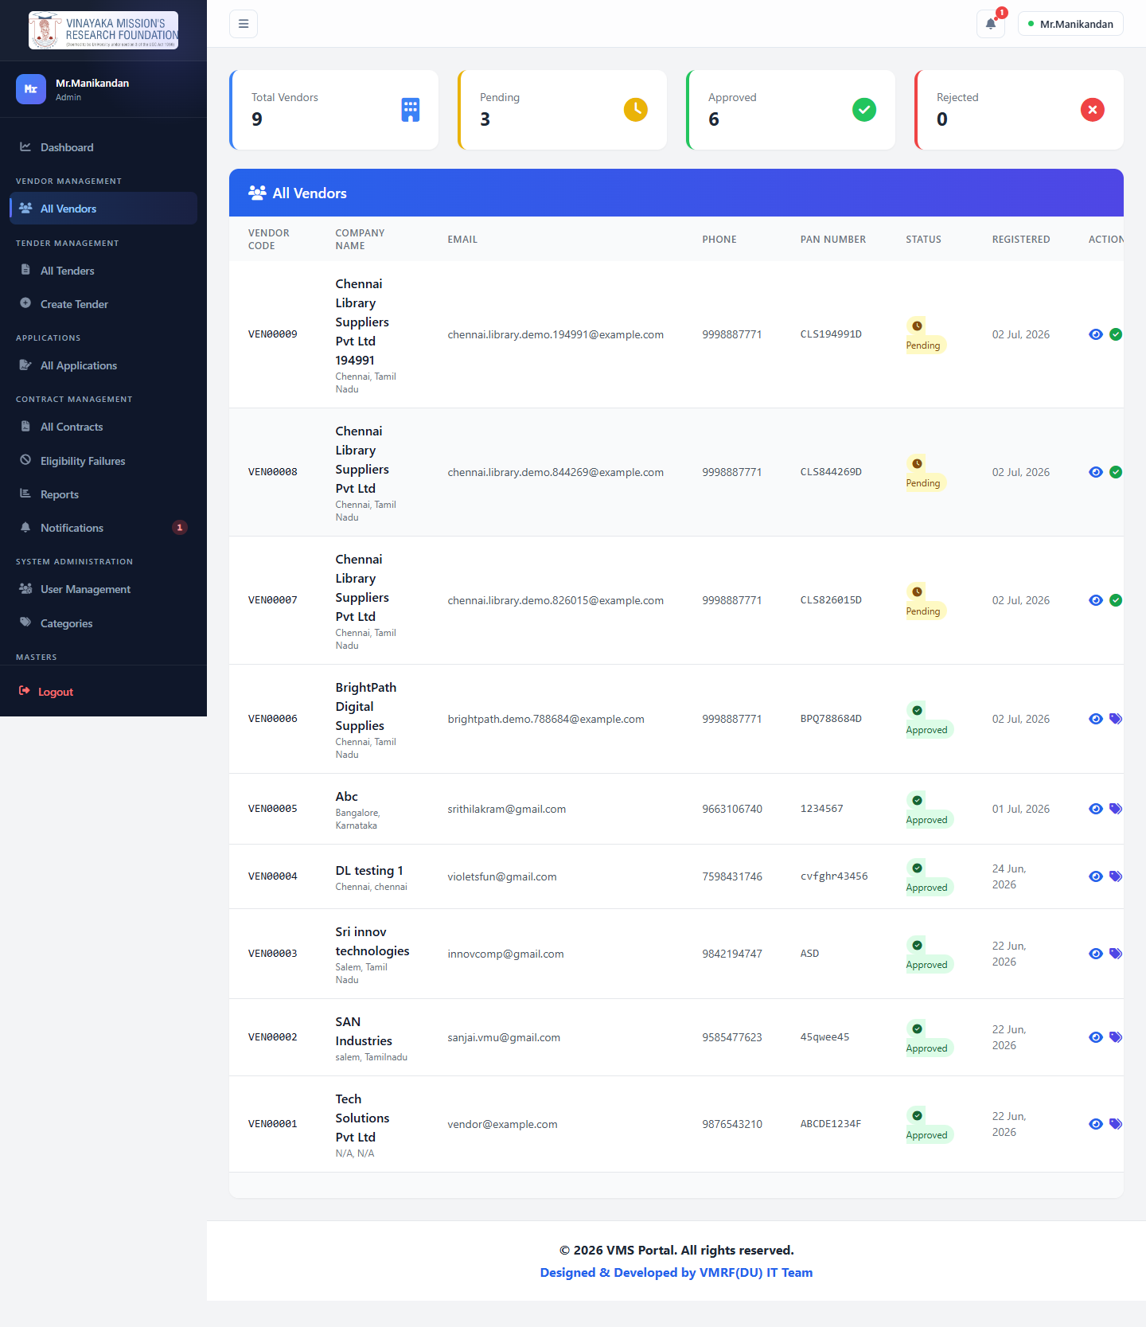

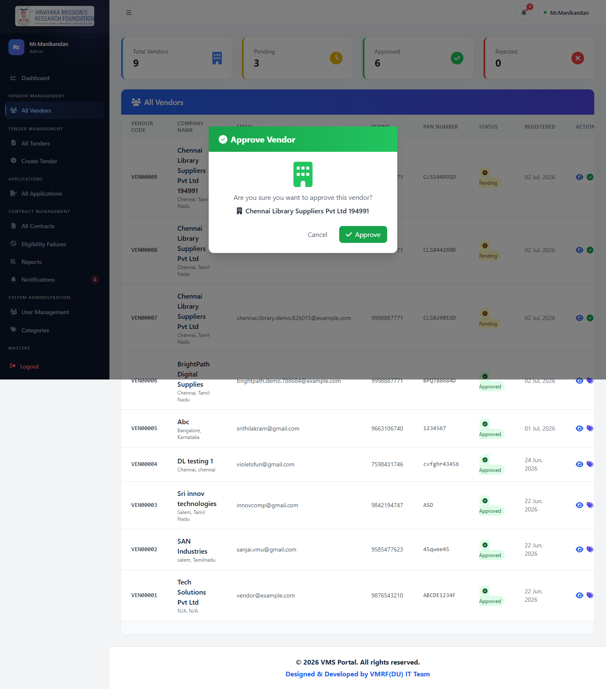

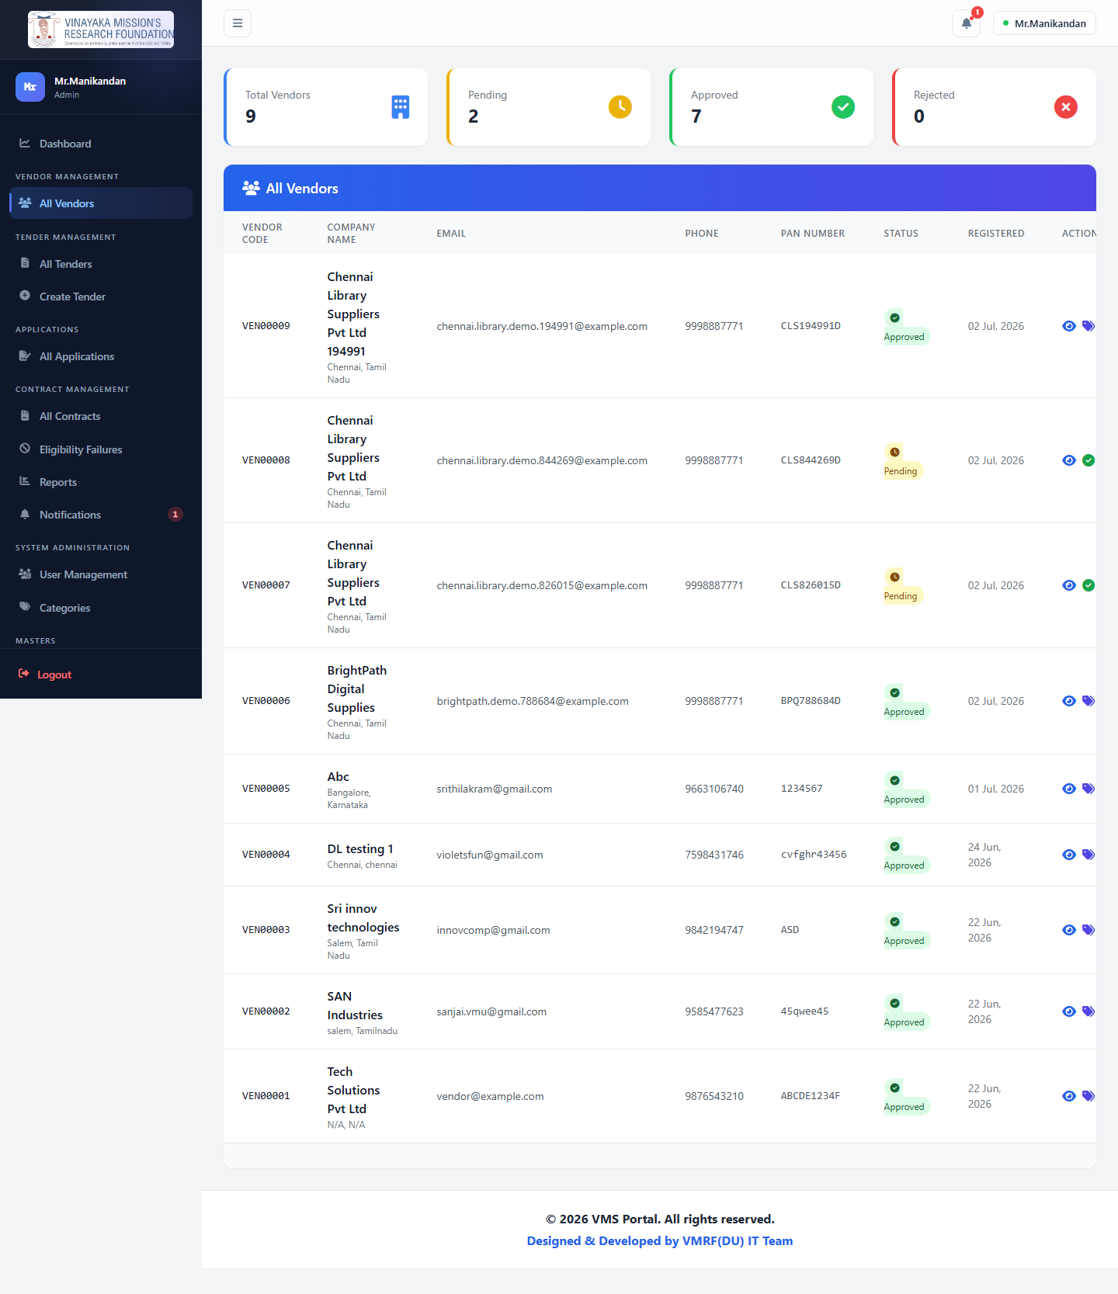

Step 3 — Tender Owner creates a new tender
test@gmail.com creates "Library Vendor Rate Contract" (TDR-2026-0022) — directly mirroring the Digital Librarian's original request that started this whole project (§ project history, presentation deck) — with two eligibility questions built inline: one radio question that gates eligibility, one free-text reference-check question that's required but not eligibility-gating.
Empty | Questions built | Fully filled
Create empty | Questions | Filled

Resulting tender, still in draft — landing back on the Tender Owner's dashboard, which is where tender creation actually redirects to:
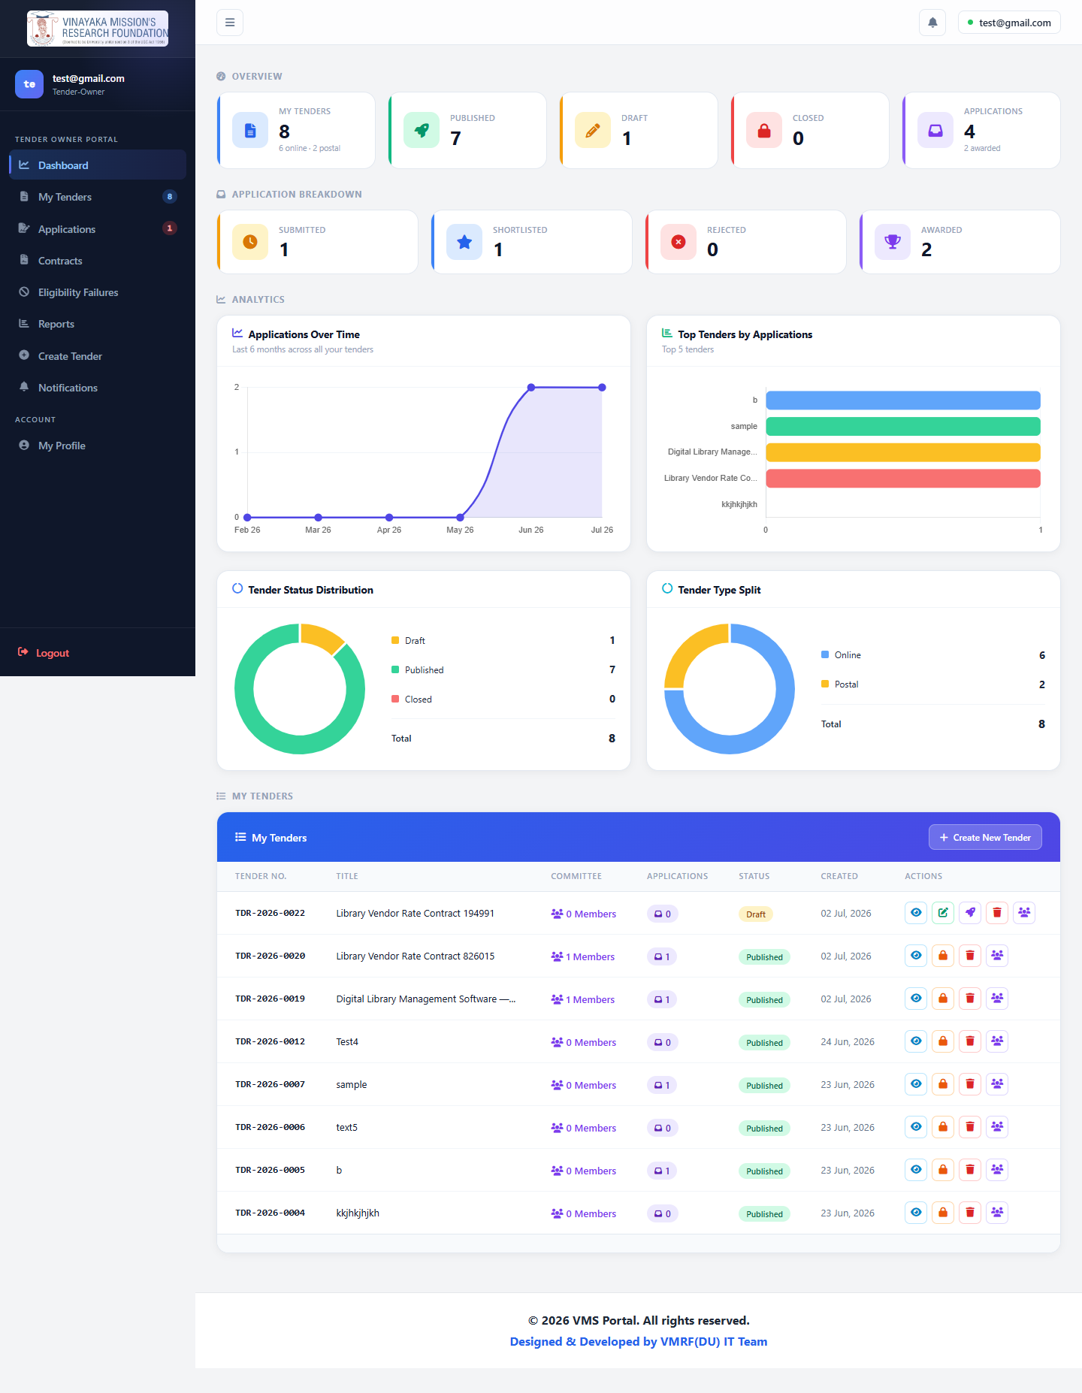

Step 4 — Committee member created live through the UI
Using the "Create New User" tab on Manage Committee (not a shortcut — the real form), the Tender Owner adds Dr. Kavitha Suresh as a committee-member with view_applications + shortlist_applications permissions on this tender specifically.
Empty | Filled | Added
Committee empty | Committee filled | Committee added

Step 5 — Publish
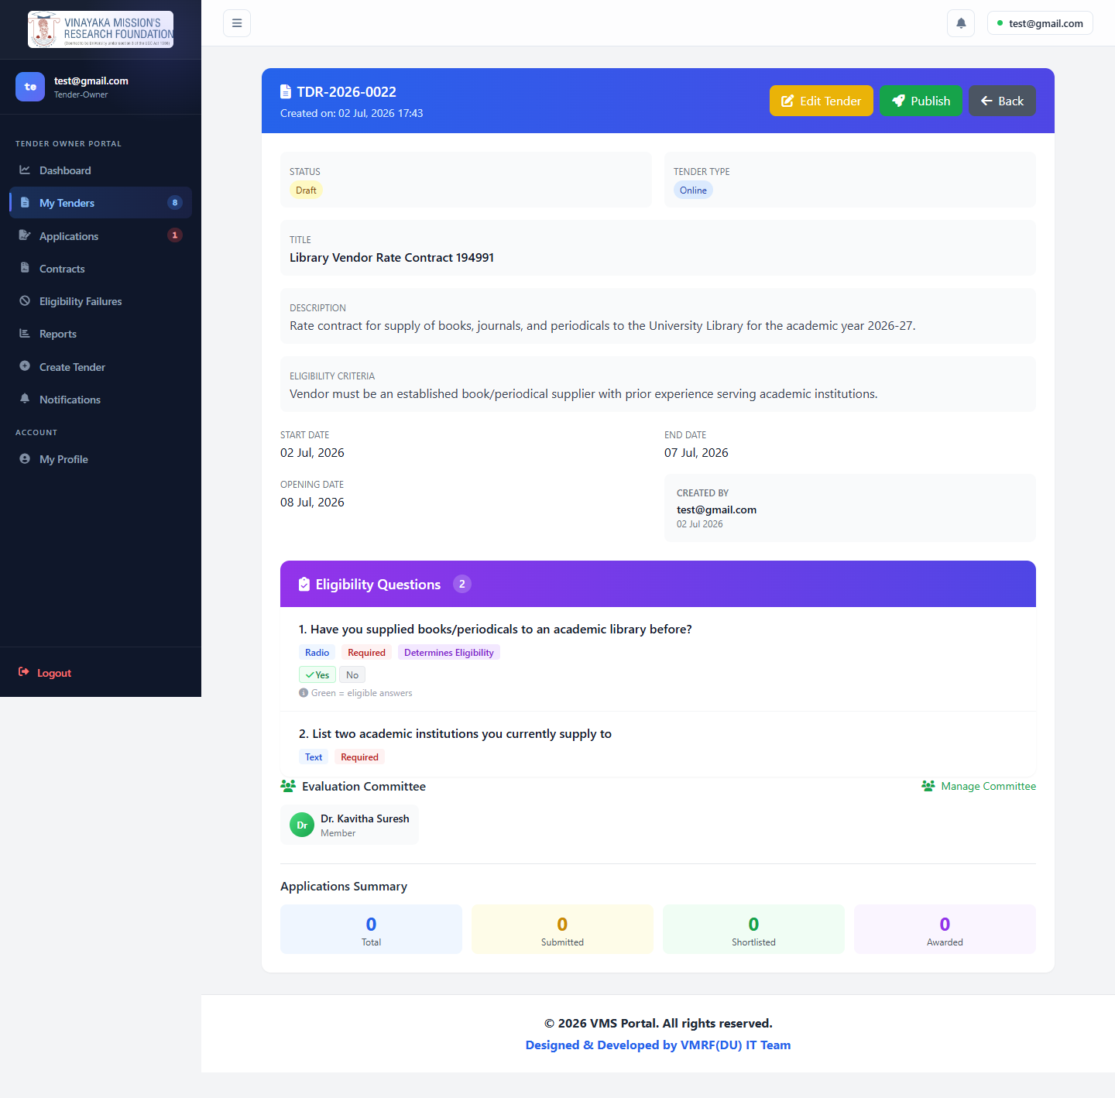

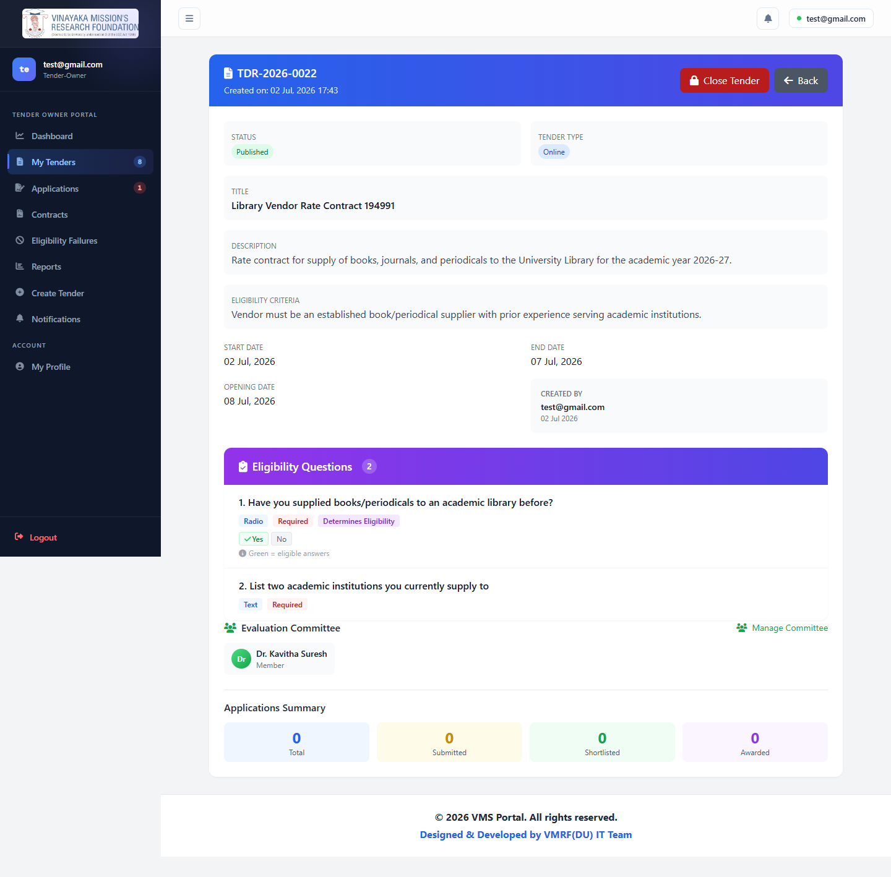

Step 6 — An existing vendor applies
innovcomp@gmail.com ("Sri innov technologies") finds the tender, answers the eligibility question ("Yes, we've supplied to an academic library before"), passes, and submits a ₹6,50,000 rate-contract bid with a written technical and financial proposal.
1. Tender details | 2. Eligibility (empty) | 2. Eligibility (filled)
Step1 | Step2 empty | Step2 filled

Eligibility passed | 3. Application filled | Submitted — application received
Passed | Step3 filled | Submitted

Step 7 — Tender Owner reviews, shortlists, and awards
The application (APP-2026-00013) shows up as Received. From here it's shortlisted, then awarded — exactly the two-step decision the system is built around.
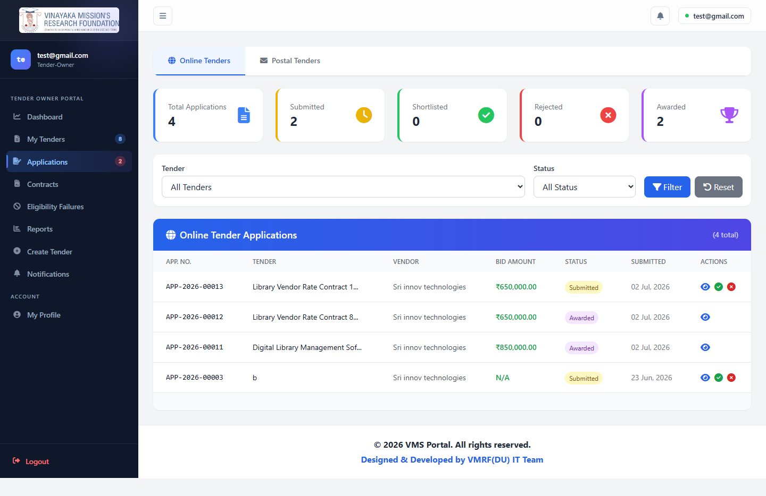

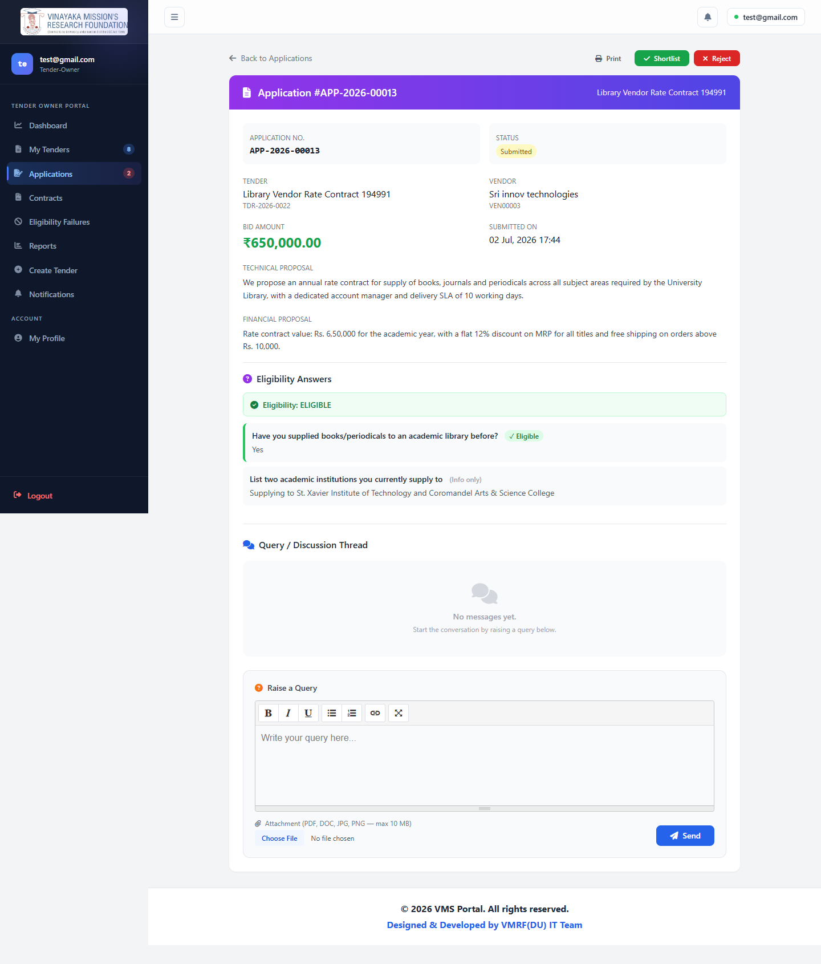

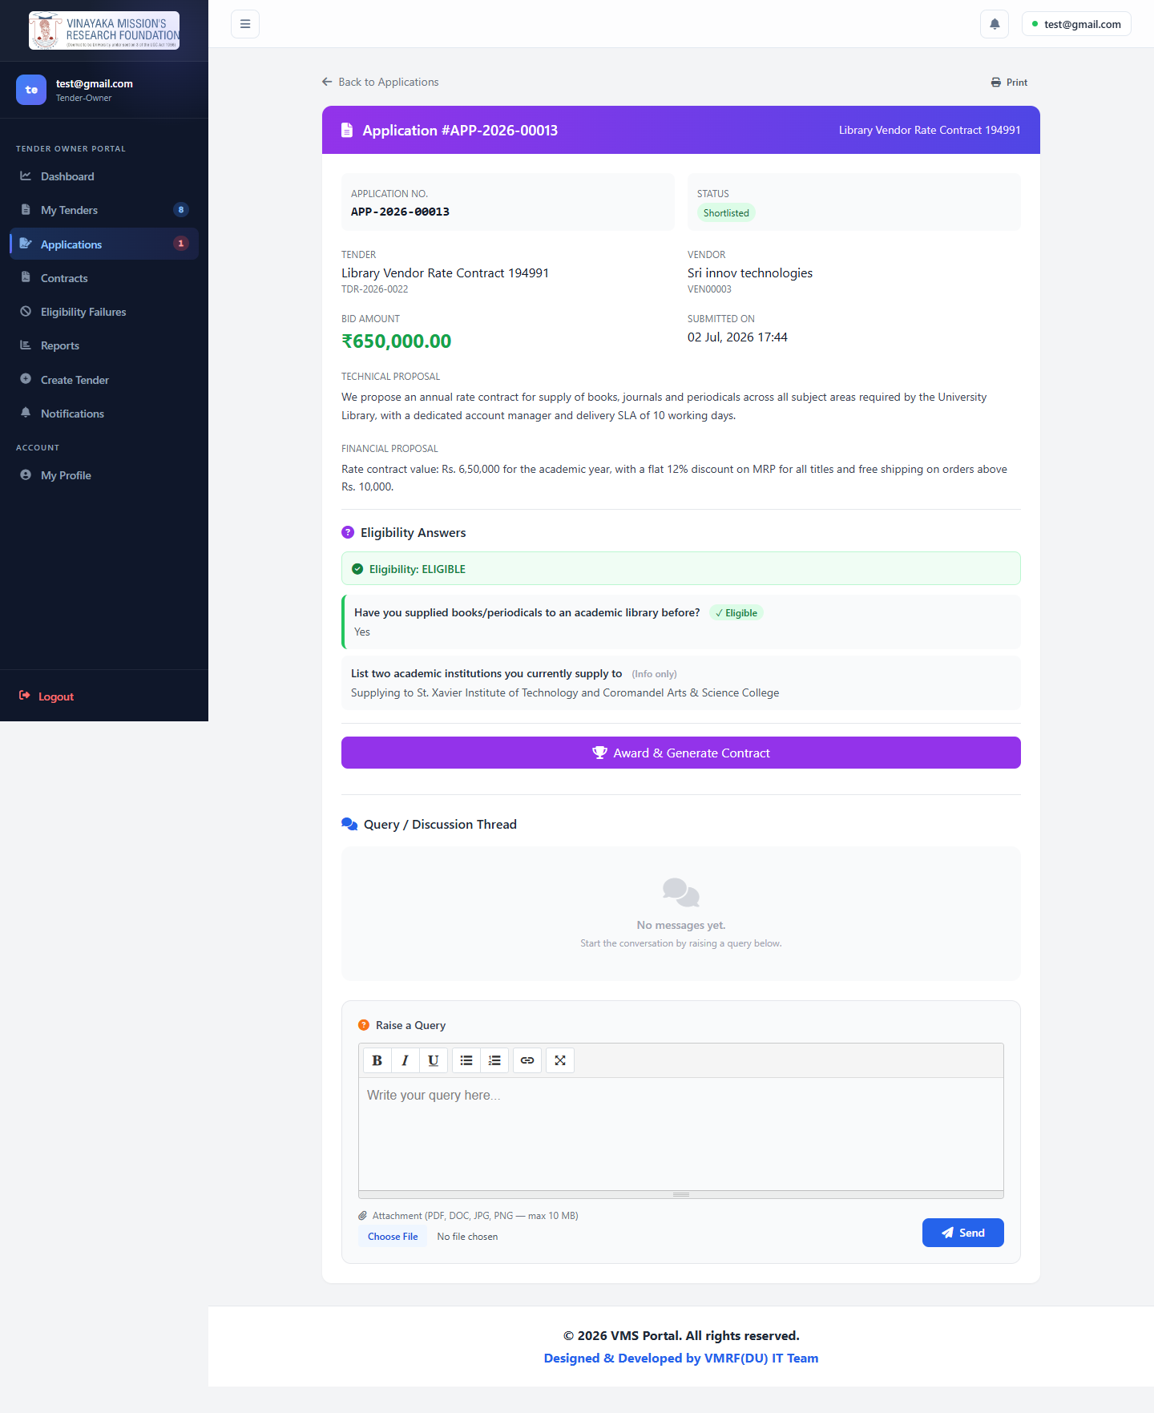
Award reached from the Applications list page's trophy icon (not the detail page — see §8 diagram 5):
Award form (empty) | Award form (filled) | Result: contract + Work Order
Award empty | Award filled | Award result

Step 8 — Vendor signs the contract (and the signing gap becomes visible)
Contract CTR-2026-0008 was created in draft status — this tender had "Require Contract Signing" checked, so it needs a signature before it's active.
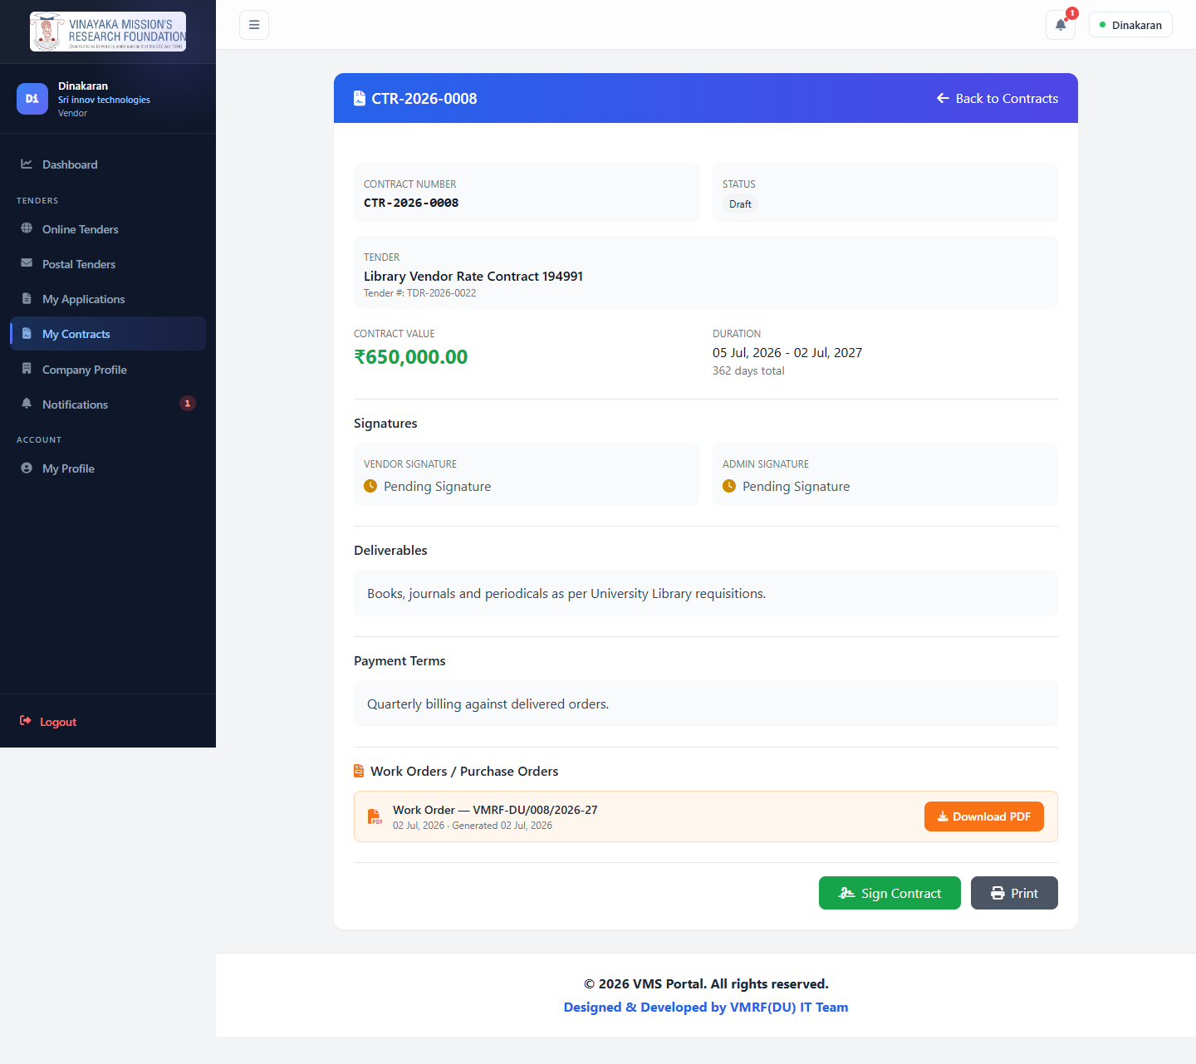

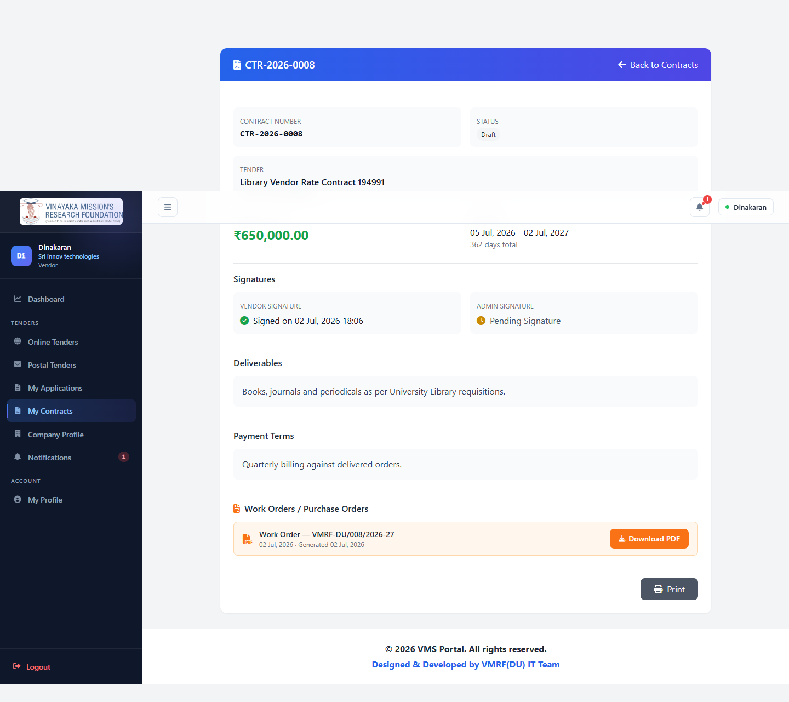
The vendor's signature is recorded immediately. But looking at the same contract from the Tender Owner's side — the exact open issue described in §12:
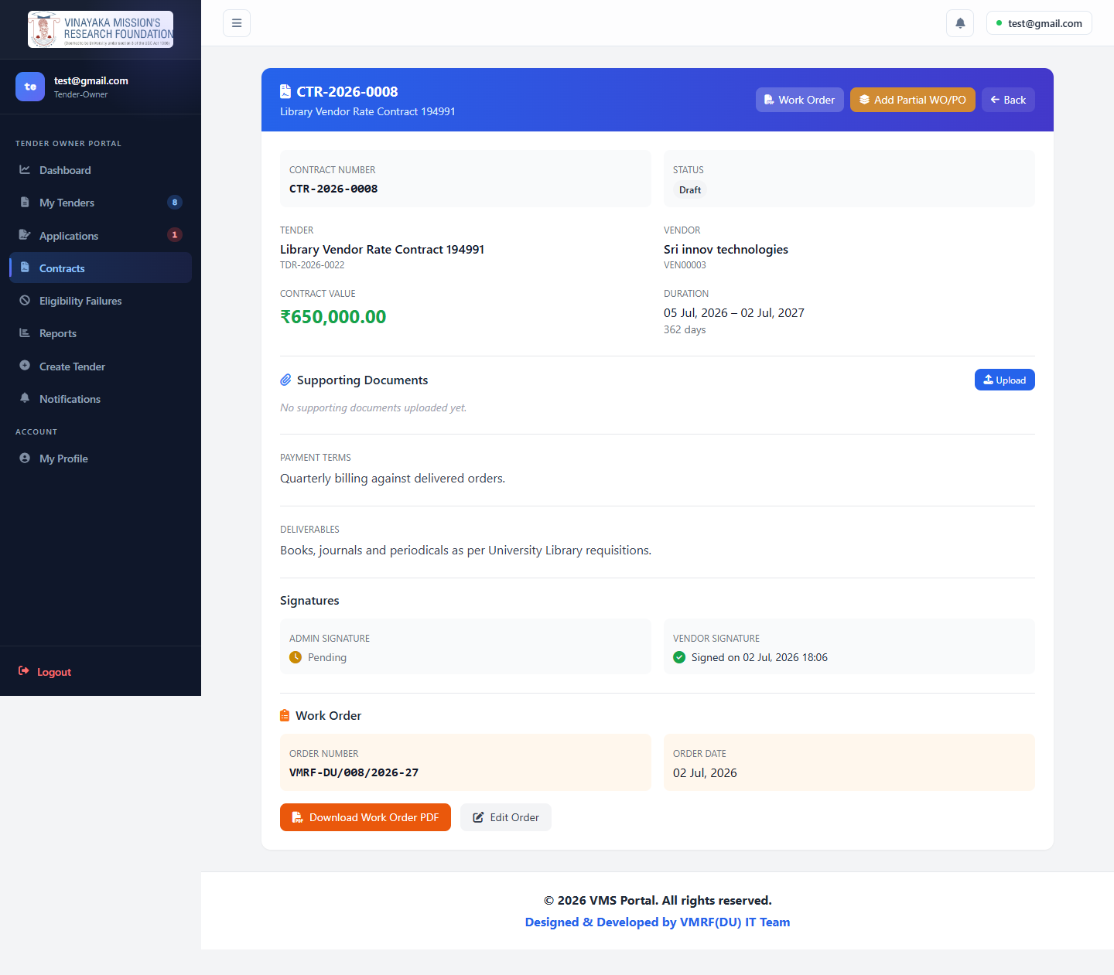
Status: still Draft. Vendor Signature: ✅ Signed. Admin Signature: still shows Pending — and there is no button on this screen to change that. This is the contract-signing gap from §12, caught in the act rather than inferred from reading code.

14. Appendix: Test Credentials & Routes

Credentials used in this review
Role | Email | Password | Notes
Admin | purchaseofficer@vmu.edu.in | password123 | Used for real login + real actions throughout §13
Tender Owner | test@gmail.com | 123456789 | Used for real login + real actions throughout §13
Vendor | innovcomp@gmail.com | 1234567890 | "Sri innov technologies" — used for real login + real application in §13
New Vendor (demo) | (generated, timestamped) | DemoVendor@2026 | "Chennai Library Suppliers Pvt Ltd" — created live in §13, additive only
Committee Member (demo) | committee.demo@example.com | password123 | For static §7 screenshots
Committee Member (live) | (generated, timestamped) | Committee@2026 | "Dr. Kavitha Suresh" — created live in §13 through the real UI

Route prefixes
- /login, /register, /forgot-password — public
- /admin/* — Admin
- /tender-owner/* — Tender Owner
- /committee/* — Committee Member
- /vendor/* — Vendor
- /profile — shared by all authenticated roles
- /api/public/tenders* — unauthenticated public API (rate-limited, CORS-enabled) — see §10

Screenshot inventory
- screenshots/ — 62 static reference screenshots (all roles, every screen), named by role prefix
- screenshots-live/ — 30 screenshots from the real, scripted end-to-end walkthrough in §13
- flowcharts-img/ — 11 rendered diagrams referenced throughout this manual

