# DL_Lab_3

## Images Used

### Database Image

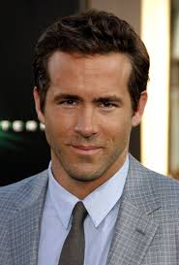

ryanRenolds.jpg

### Verify Image

cameraImage.jpg

## Outputs

### Face verification

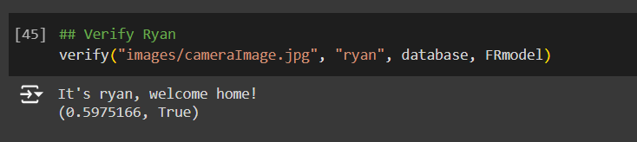

### Face recognition

