## DL – Lab 04 - IT21219252

### Question 7

* The picture originally has 19x19x5(1805) boxes since each cell gives you 5 boxes due to having 5 anchor boxes.
* yolo_filter_boxes function filters these boxes to have a threshold greater than the given threshold. That leaves us with 1785 boxes, each having a shape of (,4) for bw, bh, bx, by.
* The maximum number of boxes will be gained if the score of all the boxes exceeds the threshold. Which will be 19x19x5(1805)
* The minimum number of boxes will be gained if the score of all the boxes is lower than the provided threshold. Which will be (0,4)

### Question 8

* Advantage - When using anchor boxes, you can evaluate all object predictions at once. Anchor boxes eliminate the need to scan an image with a sliding window that computes a separate prediction at every potential position.
* How - You usually do some of it manually, and some of it by looking at your dataset and using a clustering algorithm like K-Means. After all, this kind of algorithm can tell you what are the typical anchor boxes used.

### Question 10

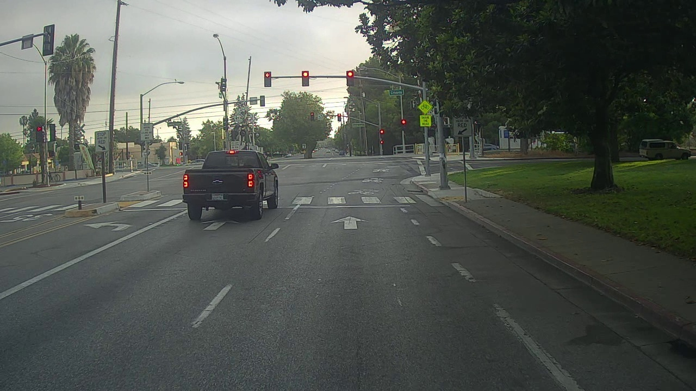

0114.jpg

* Here no boxes were detected even though there were vehicles and traffic lights.
* The vehicle not being not detected may be mainly due to the shape of the vehicle
* Reason for the traffic light for not being detected maybe due to lighting issues

0116.jpg

* Here the vehicle and a traffic light are detected
* The assumptions made in the previous image are supported since the vehicle is detected when only half of the vehicle is shown
* Traffic light score is very close to the threshold in this image therefore that might be the reason they are not detected

### Question 11

Default - max_boxes=10, score_threshold=.6, iou_threshold=.5

#### Decrease score_threshold(score_threshold=.5)

* We can see the assumption about score_threshold was correct since now traffic light detection in 0116.jpg has improved.

#### Increase score_threshold (score_threshold=.7)

* We can see the traffic light does not pass the threshold thus is not detected.

#### Decrease iou_threshold (Iou_threshold=.2)

* No change

#### Increase iou_threshold (iou_threshold=.8)

* No change

#### Decrease max_boxes(max_boxes=2)

* No change

#### Increase max_boxes(max_boxes=20)

* No change